Recommender Systems - Course Project Report
Cumulative report template - Parts 1, 2, and 3
Team | 10
Members | Mikko Kettunen, Carmen Caño Castrodeza, Elena Barrio Maceira
For Part 3 track: select one | A / B / C
GitHub repository link | https://github.com/ElenaBarrioMaceira/Recommender-Systems_Project_Group10

How to use this template
- This is one cumulative report. Extend and revise the same document at each project stage.
- Maximum length: 4 pages at Part 1, 8 pages at Part 2, and 12 pages for the final report, excluding references.
- Keep the section headings below. You may add subsections where useful.
- All explanations and justifications requested in the project specification belong in this report.
- The Results Sheet contains the complete standardized numerical record. In the report, include only the tables and figures needed to support your analysis.
- Delete all italic instructional text before the final submission.

1. Part 1 - Data, Protocol and Baselines

1.1 Data characterization
The distribution of interactions per user illustrated in figure 1 is heavily skewed. 75% of users have given 208 ratings or less, while some have given up to 2314 ratings. The few heavy raters make the mean (165 ratings) far away from the median (96 ratings).
The distribution of interactions per item illustrated in figure 1 is also heavily skewed. 75% of movies have been rated 330 times or less, while some have got up to 3428 ratings. Here the median (109 ratings) is even further away from the mean (257,59 ratings).
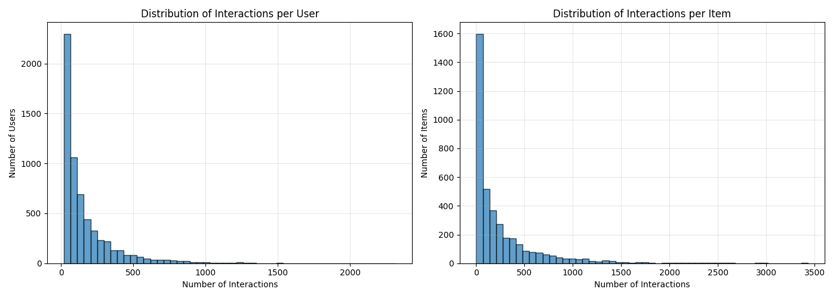
Figure 1. Interactions per users and items
The distribution of ratings illustrated in figure 2 shows that over half of the ratings are either 3s or 4s. 4 is the most popular rating and the number of ratings of 5 is close to the number of ratings of 3. This tells us that, at least in this dataset, people are more willing to rate movies they liked than the movies they didn't like. Of course, the data characterized here does not tell whether this inclination is universal; it might be e.g. that the very active users give a lot of 4s and 5s. This could be an interesting aspect to study further.
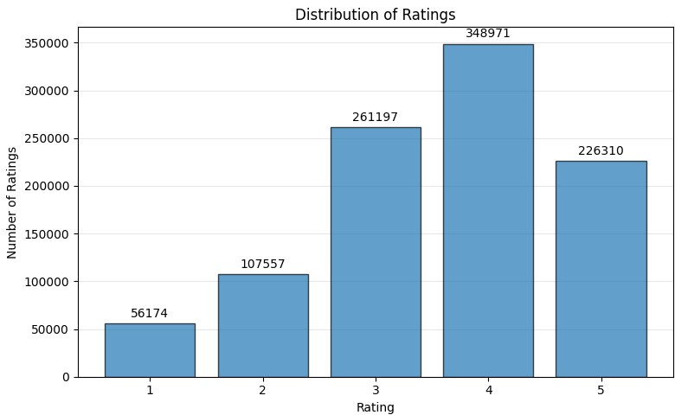
Figure 2. Rating distribution
The distribution of interactions over time illustrated in figure 3 shows that most ratings were given early on the timespan of this dataset.
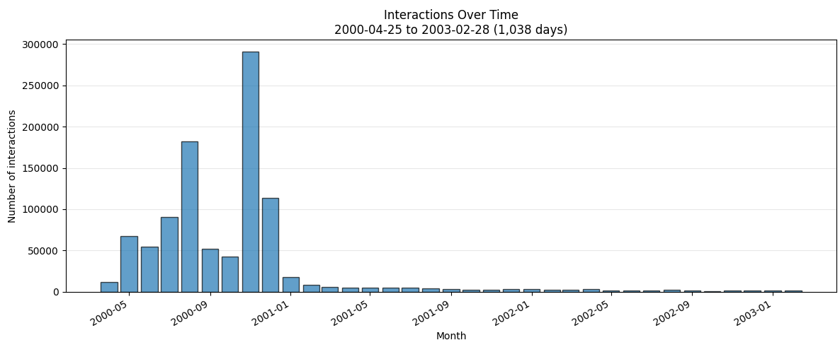
Figure 3. Interactions over time

1.2 Preprocessing and feedback treatment
No preprocessing was done for the training of the models. The only preprocessing concerns the evaluation that will be explained in 1.4.

1.3 Train/validation/test split
The data was split temporally by taking the first 80% of data to training, the next 10% of data to validation, and the last 10% of data to testing. The training data spans from 2000-04-25 23:05:32 to 2000-12-02 14:52:18, the validation data from 2000-12-02 14:52:18 to 2000-12-29 23:42:47 and the test data from 2000-12-29 23:43:34 to 2003-02-28 17:49:50. There is thus a large variation between the timespans for these splits. This was a tradeoff for having enough training data and for keeping the data chronological, which mirrors deployment where we always must predict forward in time.

1.4 Evaluation protocol
The evaluation protocol was designed to ensure a consistent comparison between the Most Popular baselines and the Item-based kNN recommender. Following the chronical train, validation and test split described in Section 1.3, the training set is used to build the recommendation models, while the validation set is used to evaluate the performance and select the most appropriate configurations. The test set is reserved for the final evaluation to avoid using the same data for both model selection and performance assessment.
A warm-start evaluation approach was selected because Item-based kNN requires previous user interactions to generate personalized recommendations. Therefore, only users who appear in the training set and have at least one relevant validation interaction with a known movie are considered. This results in 492 eligible users. The candidate catalogue consists of the 3662 movies present in the training set, excluding those already rated by each user. Movies that appear for the first time in validation are not considered. Although Most Popular can provide recommendations to users without previous interactions, these users are excluded from the main comparison to ensure that all models are evaluated under the same conditions. Consequently, the results represent warm-start performance rather than performance for all users.
For the ranking evaluation, a movie is considered relevant when its rating is 4 or 5. The evaluation focuses on the Top-10 recommendations generated for each user and uses four metrics: Precision@10, Recall@10, NDCG@10 and Catalogue Coverage. Precision@10 measures the proportion of recommended movies that are relevant, whereas Recall@10 measures the proportion of a user's relevant movies that appear in the recommendations. NDCG@10 also considers the position of relevant movies, assigning greater importance to those appearing earlier in the ranking. These three metrics are calculated for each eligible user and then averaged across users. Finally, Catalogue Coverage measures the proportion of distinct movies from the evaluation catalogue that appear in at least one user's recommendation list, providing and indication of how broadly each model distributes its recommendations.

1.5 Baseline methods and settings
The project includes two Most Popular recommendation baselines, which provide simple, non-personalized approaches for comparison with the Item-based kNN model.
The first baseline, Most Popular (All ratings), ranks movies according to the total number of ratings they receive in the training set, regardless of the rating value. This approach assumes that movies receiving more ratings are more likely to attract user's interest. The second baseline, Most Popular (Positive Ratings), considers only ratings of 4 or 5 when calculating movie popularity. Therefore, it prioritizes movies that have received positive feedback rather than those that are simply frequently rated.
Both variants generate recommendations by excluding movies previously rated by the target user in the training set and selecting the ten highest-ranked remaining movies. When two or more movies have the same popularity score, the movie with the smallest MovieID is ranked first to ensure reproducible results. Unlike Item-based kNN, these baselines do not calculate personalized preference scores, since the popularity ranking is the same for all users before excluding previously rated movies.
Item-based k-Nearest Neighbors (ItemKNN) was implemented to generate personalized recommendations from users' previous ratings. The model constructs a sparse user–item rating matrix from the training data and computes pairwise item similarities. Two similarity measures were investigated: cosine similarity, calculated from item rating vectors, and Pearson correlation, calculated using ratings from users who evaluated both items. For Pearson, a minimum of five common ratings was initially required to calculate a correlation; undefined correlations were replaced with zero.
For each candidate movie, the original implementation identifies the positively similar movies previously rated by the target user, selects up to k of the most similar ones, and calculates a similarity-weighted average of their ratings. Negative and zero similarities are excluded. Movies already rated during training are not recommended, and ties are resolved by ascending MovieID.
We tested k ∈ {10,20,50} for both similarity measures, selecting the best configuration by validation NDCG@10, which accounts for both relevance and ranking position. Cosine (k=10) substantially outperformed Pearson (k=20): 0.02918 versus 0.00246 NDCG@10. Increasing k did not consistently improve performance, supporting validation-based selection rather than assuming larger neighborhoods were preferable.
To investigate Pearson's poor results, we implemented Pearson Adjusted, which accounts for differences in movies' average ratings. Instead of directly averaging the user's ratings of similar movies, the adjusted formula calculates how much each rating deviates from that movie's training-set mean, combines these deviations using similarity weights, and adds the result to the candidate movie's mean. Predictions were clipped to the 1–5 rating range. We tested k ∈ {10, 20, 50} and minimum co-rating thresholds of 4 and 5. The best configuration (k=20, minimum overlap 4) increased validation NDCG@10 to 0.02868.
To determine whether this improvement was specific to Pearson similarity, we also applied the same mean-adjusted prediction formula to cosine similarity, keeping cosine-based item similarities and testing the same k values. However, Cosine Adjusted performed worse than Cosine Original (0.01306 versus 0.02918 validation NDCG@10). Thus, mean adjustment improved the selected Pearson configuration but did not consistently benefit ItemKNN. Cosine Original with k=10 was selected as the primary ItemKNN configuration because it achieved the highest validation NDCG@10 across all evaluated variants. This result justified choosing cosine similarity over Pearson and a smaller neighborhood over k=20 or k=50. All four variants were retained for comparison on the untouched test set.

1.6 Results and analysis
Most Popular (Positive Ratings) achieved the highest test Precision@10, Recall@10, and NDCG@10, outperforming all personalized ItemKNN variants. This suggests that recommending widely liked movies is particularly effective under the adopted evaluation protocol, even without personalizing recommendations to individual users. However, its low catalogue coverage indicates that recommendations were concentrated on a small subset of movies.
Among ItemKNN variants, Pearson Adjusted achieved the highest test NDCG@10, narrowly surpassing Cosine Original. The substantial improvement over Pearson Original suggests that mean-adjusted predictions can benefit Pearson-based recommendations, although the change in minimum co-rating threshold prevents attributing the improvement solely to the prediction formula. Conversely, applying the same adjustment to cosine similarity reduced performance, indicating that its effectiveness depends on the similarity measure.
The main trade-off was between recommendation accuracy and catalogue coverage. While Most Popular produced more relevant recommendations according to the evaluation metrics, Cosine Original covered a substantially larger proportion of the movie catalogue, potentially exposing users to a broader range of items. Although Pearson Adjusted slightly outperformed Cosine Original on the test set, Cosine Original remained the selected ItemKNN configuration because model selection was based exclusively on validation NDCG@10, avoiding test-set-driven decisions.
Table 1. Test performance of the recommendation models.
Model | NDCG@10 | Catalogue Coverage
Most Popular (All Ratings) | 0.1865 | 3.71%
Most Popular (Positive Ratings) | 0.1973 | 3.52%
ItemKNN Cosine Original | 0.0442 | 54.59%
ItemKNN Pearson Original | 0.0016 | 18.38%
ItemKNN Cosine Adjusted | 0.0222 | 10.49%
ItemKNN Pearson Adjusted | 0.0467 | 14.45%

2. Part 2 - Models and Honest Comparison

2.1 Models
Describe the additional models and paradigms. Clearly identify the self-implemented algorithm and explain its implementation.

2.2 Hyperparameter tuning and variability
Describe the validation-only tuning procedure, search spaces/budgets, random seeds, and confidence intervals or statistical testing.

2.3 Overall results
Present and discuss the main comparison. Explain important differences and avoid unsupported claims.

2.4 Disaggregated analysis
Report and interpret results broken down by at least two of the required dimensions: items with few vs. many training interactions, low- vs. high-activity users, popular vs. long-tail items, and early vs. late test period. Define any thresholds used and focus on findings that change or qualify the overall conclusions.

2.5 Sparsity ablation
Report and discuss the 100%, 50%, and 20% training-interaction experiments, including changes in the ranking between models.

3. Part 3 - Beyond Accuracy

3.1 Selected track and motivation
State Track A, B, or C and briefly motivate the selected intervention/extension.

3.2 Method
Describe only your selected track. The Track A/B/C guidance below is provided as instructions; delete the guidance for the two tracks you did not select before submission.

If Track A - Diversity and popularity bias
State the base recommender, selected re-ranking method, genre-vector item representation, trade-off parameter, and exact item-distance measure. Describe how the parameter was swept.

If Track B - Fairness
Define the release-decade provider proxy, report and justify the final decade boundaries and group sizes, state and justify the adopted fairness notion, describe the consumer groups based on MovieLens user attributes, and identify the stage and form of the mitigation.

If Track C - Group recommendations
State the selected synthetic group type and justify the chosen group size (3-5). Describe the three aggregation strategies. Identify which strategy was extended to the sequential scenario and explain how satisfaction is carried forward between recommendation rounds.

3.3 Results and trade-offs
Present the required track-specific results. Track A: report intra-list diversity, catalogue coverage, Gini and calibration error across the parameter sweep, and discuss the accuracy-diversity frontier. Track B: report position-weighted exposure against catalogue share, per-group consumer-side accuracy, and the fairness-performance frontier. Track C: compare group satisfaction, disagreement and minimum member satisfaction across the three aggregation strategies, then analyse how member and group satisfaction develop in the sequential scenario.

3.4 Cost and interpretation
State what is gained, what is lost, and who bears the cost where applicable. Explain what operating choice or strategy you would select and why.

3.5 "One number we cannot explain"
Identify one result you do not fully understand and describe how you would investigate it.

4. Discussion and Conclusions
Summarize the main findings across the project. Discuss limitations, failed approaches where relevant, and what the experiments support.

5. Contribution Statement
Elena Barrio Maceira: Implementation of ItemKNN using cosine and Pearson similarities, including the development of mean-adjusted variants and hyperparameter tuning to select the best configurations. Design and automation of experiments, evaluation of model performance, analysis of results, and comparisons with the Most Popular baselines. Preparation of the Part 1 Excel Results Sheet, development of reproducible execution scripts, updates to the GitHub repository and README documentation, and contributions to the methodology and results analysis sections of the report.
Carmen Caño Castrodeza: Implementation of two Most Popular recommendation baselines (All Ratings and Positive Ratings), including Top-N recommendation generation. Development of the evaluation framework using Precision@10, Recall@10, NDCG@10 and Catalogue Coverage, as well as the preparation of a common evaluation protocol for comparing the recommendation models. Contribution to the README documentation and the Part 1 report.
Mikko Kettunen: Implementing the data processing needed for the training of the models. This included loading the data and splitting it into train, validation, and test sets. Data characterization; this included printing and plotting possibly useful information about the dataset. models/data.py, data_loader.py and data_analysis.py is all my code. Small contribution to the README documentation by writing instructions on how to use my code.

6. Use of AI Assistants
Elena Barrio Maceira: AI tools (ChatGPT) were used to assist with README documentation, improve the wording and clarity of the report, review code for potential errors, and suggest improvements to the Pearson-based ItemKNN model.
Carmen Caño Castrodeza: AI tools (ChatGPT) were used to help translate familiar MySQL operations into Python pandas, as I had no previous experience with this library. ChatGPT also assisted for improving the README documentation.
Mikko Kettunen: AI tools (ChatGPT) were used to help with Python pandas syntax.

References
List references used in the report. References do not count toward the page limit.
- Class lectures
- Sarwar et al. (2001), Item-based Collaborative Filtering Recommendation Algorithm

