System access

User: [admins@codetica.com](mailto:admins@codetica.com)

Password: 123456

Url for report is /reporteefectividadnew

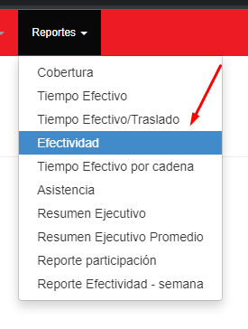Option:

Files to update

Controller: ReporteEfectividadNewController

Model: TableViewModels/TableReporteEfectividadNewViewModel

View: Views/ReporteEfectividadNew/Listado