Assignment 2 Preliminary Discussion

Dataset: https://www.kaggle.com/gopalrameshdahale/country-data

Domain : An exploration of the relationship between crude oil, electricity, natural gas and refined petroleum products and global location for countries. This visualisation is of import to anyone interested in global trends of usage, import and export of these commodities as well as a further exploration on the relationship between a high GDP and the relationship between the industrial production growth rate, population growth rate and carbon emissions.

Columns:

* Capital City
* Latitude of Capital
* Longitude of Capital
* GDP - per capita (PPP)
* Country Code
* Country Name
* Population
* Population growth rate
* Crude oil - exports
* Crude oil - imports
* Crude oil - production
* Crude oil - proved reserves
* Electricity - consumption
* Electricity - from fossil fuels
* Electricity - from hydroelectric plant
* Electricity - from nuclear fuels
* Electricity - from other renewable sources
* Electricity - imports
* Electricity - installed generating capacity
* Electricity - production
* Industrial production growth rate
* Carbon dioxide emissions from consumption of energy
* Natural gas - consumption
* Natural gas - exports
* Natural gas - imports
* Natural gas - production
* Natural gas - proved reserves
* Refined petroleum products - consumption
* Refined petroleum products - exports
* Refined petroleum products - import
* Refined petroleum products - production

Question: Will I be able to use the country names in vega-lite to construct the map information?

Are these too many variables? I could cut it down to just electricity to make my life easier.

I am concerned that I am still stuck on the layout from the previous assignment mentally speaking.

An accordion like approach to the maps?

Accordion Tutorial: <https://www.w3schools.com/howto/howto_js_accordion.asp>

https://vega.github.io/vega-lite/docs/

Buttons for toggling view, layout guides online for css – cross check weekly visualisations

Accordion for vis or for comments.

## Design Sheets

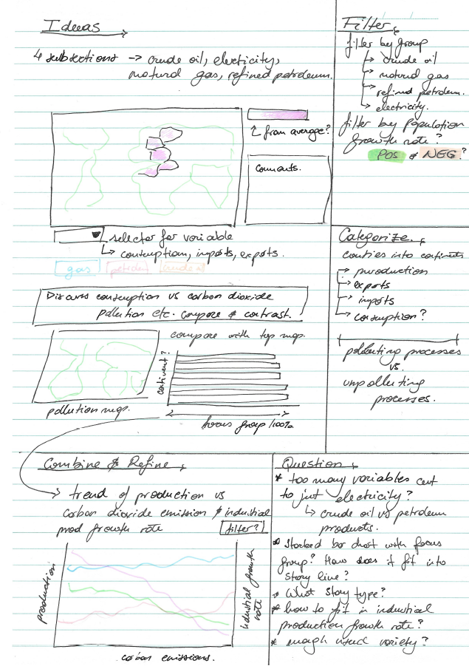

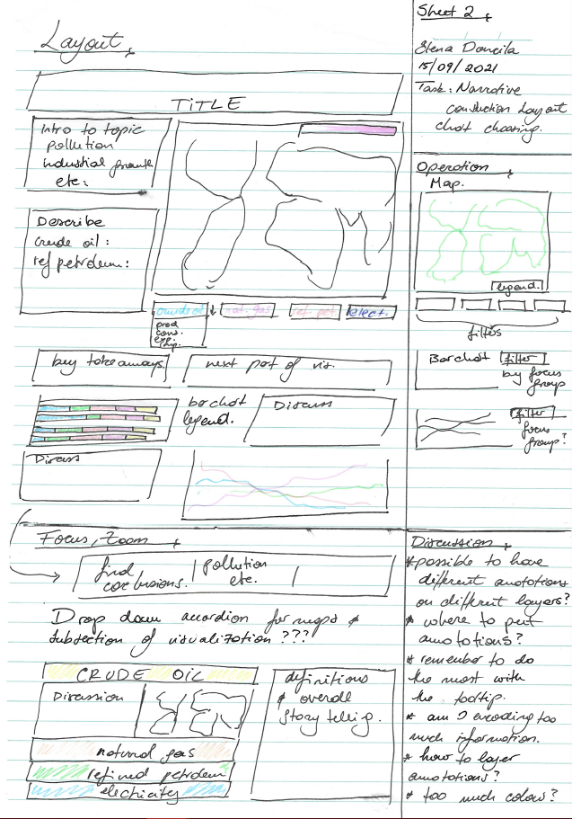

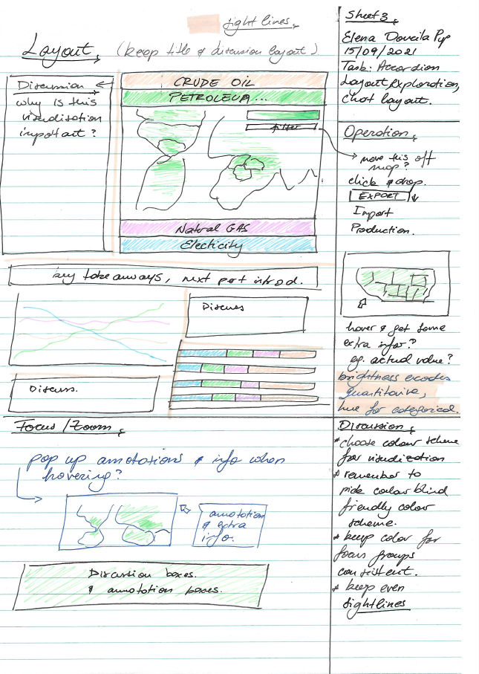

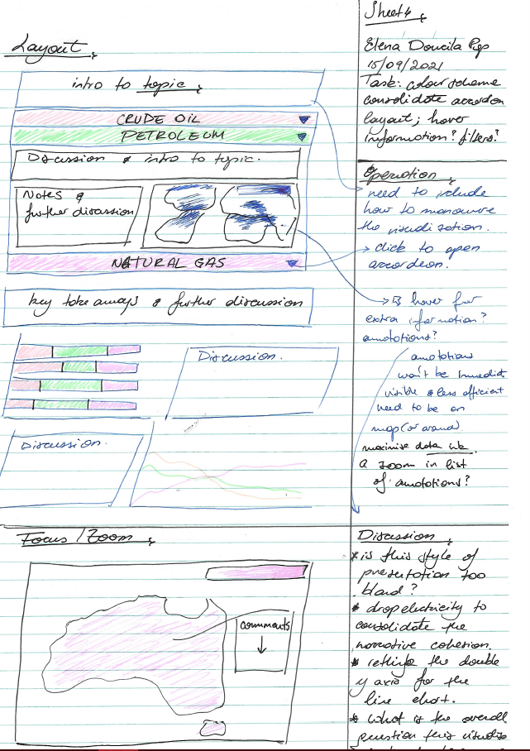

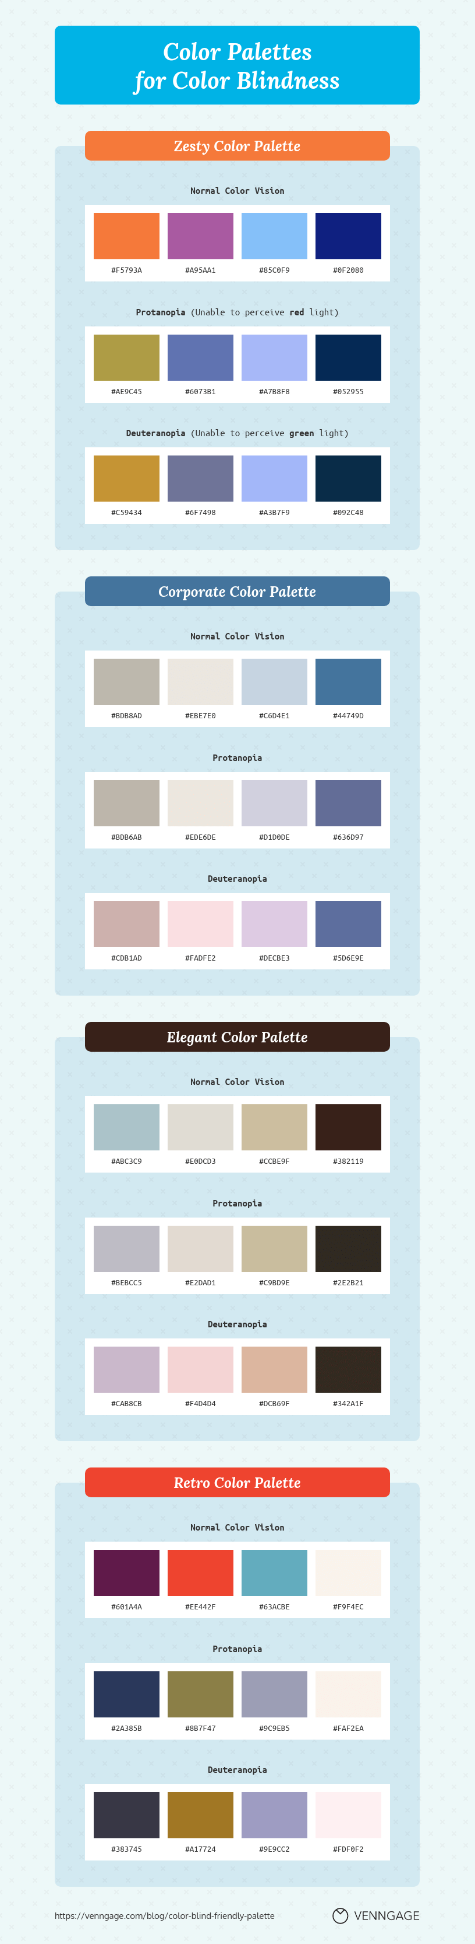Possible colour scheme for visualisation

Colour scheme Origin: <https://venngage.com/templates/infographics/color-palettes-dd1b862e-4294-4dac-bcda-324dd0a05360>