Week 9 Homework: Creating a Map with Vega-Lite

URL of Map: <https://stingyblingy.github.io/Week9Homework/>

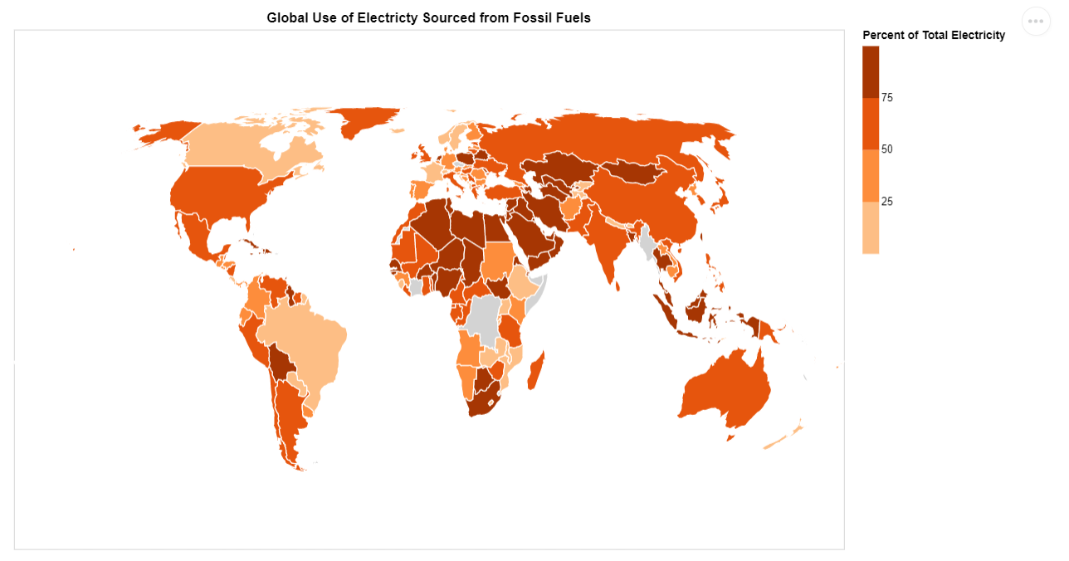

Figure . The choropleth map shows the percentage of electricity used by countries as sourced from fossil fuels.

Domain:

* This chart belongs to the domain of electricity generation and in particular discusses what percentage of generated electricity by a country is sourced from fossil fuels. It is of interest to anyone who wishes to view which countries rely on fossil fuels to generate electricity and by what margin the countries differ amongst themselves.

The visualised dataset:

* Attribute Types:
  + Country – Categorical
  + Percent of Electricity sourced from fossil fuels – ordinal
* Source:
  + https://www.kaggle.com/gopalrameshdahale/country-data
* Author:
  + Gopal Ramesh Dahale

Data Transformation and class limits:

* Data Transformation:
  + No transformation was needed as the data was already normalised as the attribute used is a percentage of the total electricity generation of a country.
* Class Limits:
  + There were 4 classes chosen for this visualisation as this was considered a good choice to represent the 4 quartiles in a percentage i.e. 25,50,75 and 100. This felt intuitive and relies of the viewer’s familiarity with quartiles. The data also has an equal interval and is therefore easy and intuitive to read.

Justification for idiom:

* Choropleth Map:
  + The idiom chosen was a choropleth map as:
    - The data is normalised – percentage per each country
    - The idiom is popular and therefore the viewer is likely to understand it
    - It is appropriate to use as the attribute measured is intrinsically tied to the geographical boundary
    - It is an appropriate idiom for displaying the quantitative data (percentage)
    - It allows the viewer to explore how fossil fuel generated electricity trends across regions of the world