**IDENTIFICACION DE ELEMENTOS DE LA PAGINA SONGS BY SINATRA**

**Validación de los elementos mostrados en pantalla de una canción agregada**

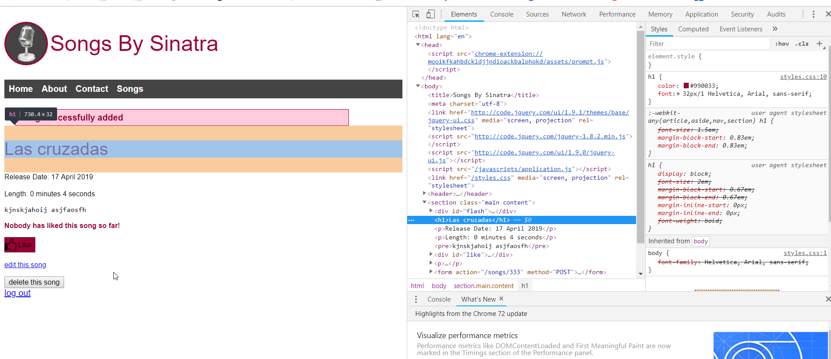

Para la identificación de los elementos se utilizó los siguientes colores:

* Etiqueta
* Texto
* Atributo
* Valor del atributo

<html lang="en">

<head>

<script src="chrome-extension://mooikfkahbdckldjjndioackbalphokd/assets/prompt.js">

</script>

</head>

<body>

<title>Songs By Sinatra</title>

<meta charset="utf-8">

<link href="http://code.jquery.com/ui/1.9.1/themes/base/jquery-ui.css" media="screen, projection" rel="stylesheet">

<script src="http://code.jquery.com/jquery-1.8.2.min.js"></script>

<script src="http://code.jquery.com/ui/1.9.0/jquery-ui.js"></script>

<script src="/javascripts/application.js"></script>

<link href="/styles.css" media="screen, projection" rel="stylesheet">

<header>

<h1>Songs By Sinatra</h1>

<nav><ul>

<li><a href="/" title="Home">Home</a></li>

<li><a href="/about" title="About">About</a></li>

<li><a href="/contact" title="Contact">Contact</a></li>

<li><a href="/songs" title="Songs">Songs</a></li>

</ul></nav>

</header>

<section class="main content"><div id="flash">

<div class="flash notice">Song successfully added</div>

</div>

<h1>Las cruzadas</h1>

<p>Release Date: 17 April 2019</p>

<p>Length: 0 minutes 4 seconds</p>

<pre>kjnskjahoij asjfaosfh</pre>

<div id="like"><p>Nobody has liked this song so far!</p><form action="/songs/333/like" method="POST">

**Validación de los elementos mostrados en pantalla para agregar una canción**

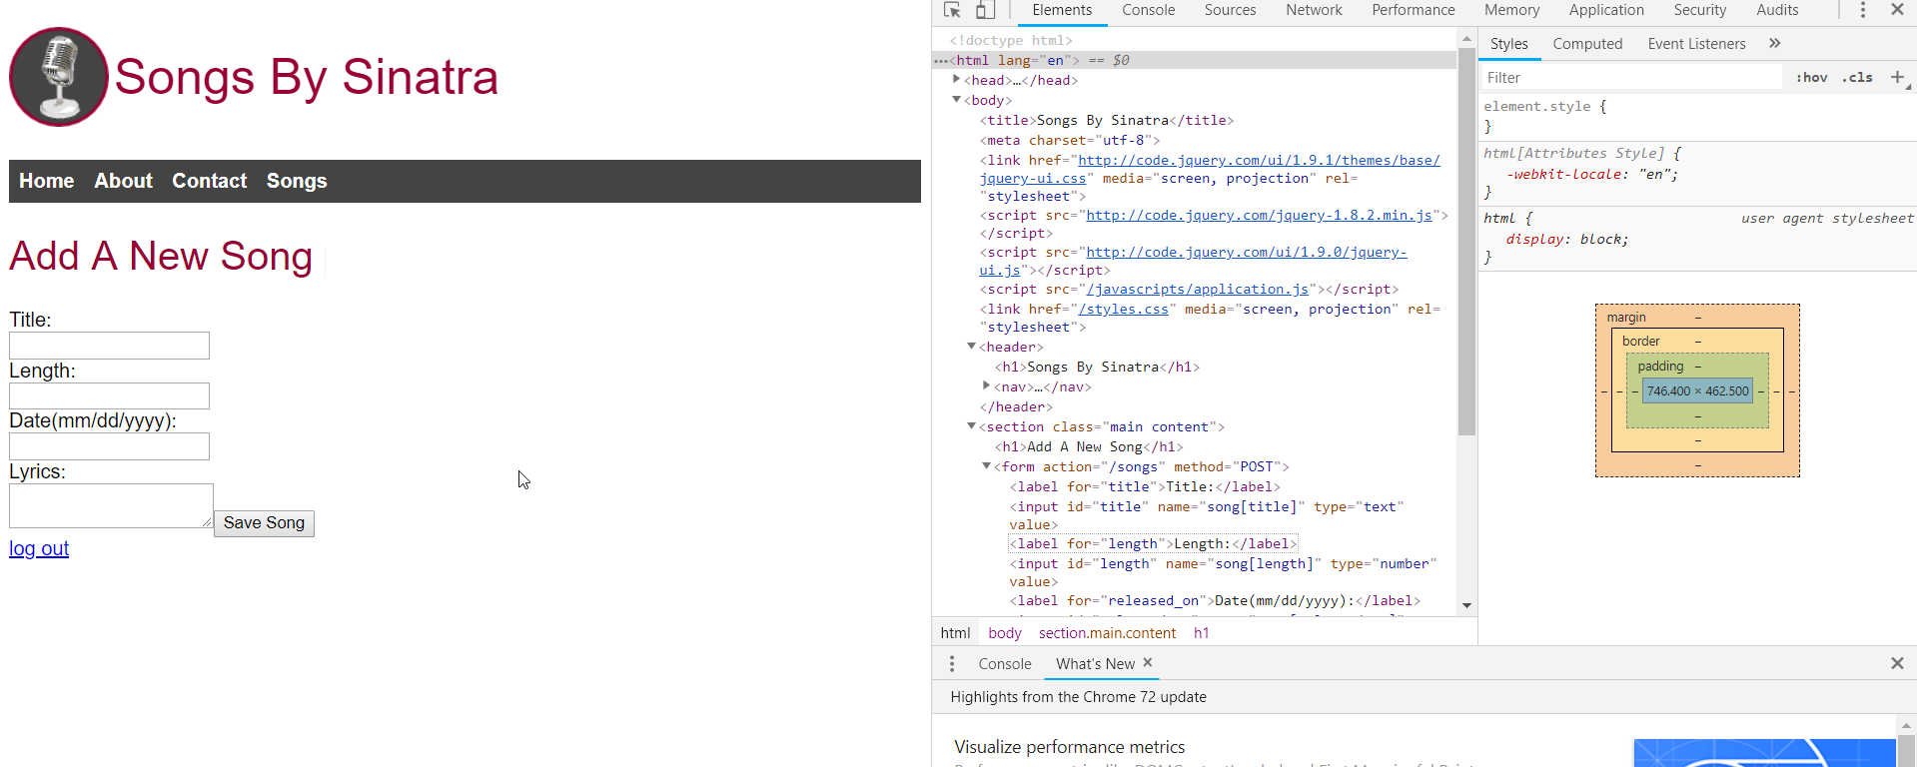

<body>

<title>Songs By Sinatra</title>

<meta charset="utf-8">

<link href="http://code.jquery.com/ui/1.9.1/themes/base/jquery-ui.css" media="screen, projection" rel="stylesheet">

<script src="http://code.jquery.com/jquery-1.8.2.min.js"></script>

<script src="http://code.jquery.com/ui/1.9.0/jquery-ui.js"></script>

<script src="/javascripts/application.js"></script>

<link href="/styles.css" media="screen, projection" rel="stylesheet">

<header>

<h1>Songs By Sinatra</h1>

<nav><ul>

<li><a href="/" title="Home">Home</a></li>

<li><a href="/about" title="About">About</a></li>

<li><a href="/contact" title="Contact">Contact</a></li>

<li><a href="/songs" title="Songs">Songs</a></li>

</ul></nav></header>

<section class="main content">

<h1>Add A New Song</h1>

<form action="/songs" method="POST">

<label for="title">Title:</label>

<input id="title" name="song[title]" type="text" value="">

<label for="length">Length:</label>

<input id="length" name="song[length]" type="number" value="">

<label for="released_on">Date(mm/dd/yyyy):</label>

<input id="released_on" name="song[released_on]" type="text" value="" class="hasDatepicker">

<label for="lyrics">Lyrics:</label>

<textarea id="lyrics" name="song[lyrics]"></textarea>

<input type="submit" value="Save Song">

</form>

</section>