Universitatea Tehnică din Moldova
Facultatea Calculatoare, Informatică și Microelectronică

Raport

Disciplina: Medii interactive de dezvoltare a produselor soft.

Laboratorul nr.2: Realizeaza un simplu GUI Calculator

A efectuat: gr. TI - 141 F/R
Levcenco Elena

A verificat: Cojanu Irina

Chișinău 2016

Scopul lucrării: Realizeaza un simplu GUI calculator care suporta urmatoare functii: +, -, /, *, putere, radical, InversareSemn(+/-), operatii cu numere zecimale.

Obiective:
- Realizeaza un simplu GUI Calculator
- Operatiile simple: +,-,*,/,putere,radical,InversareSemn(+/-),operatii cu numere zecimale.
- Divizare proiectului in doua module - Interfata grafica(Modul GUI) si Modulul de baza(Core Module).

Conditii Necesare:
- IDEs: PyCharm JetBrains
- Limbajul de programare:, Python
- Technologii si Frameworks: Tkinter (GUI)
- Timp de lucru: 8-10 hours

Codul sursa:
#include <windows.h>
LRESULT CALLBACK WndProc (HWND, UINT, WPARAM, LPARAM) ;
int WINAPI WinMain (HINSTANCE hInstance, HINSTANCE hPrevInstance,
PSTR szCmdLine, int iCmdShow)
{
static char szAppName[] = "HelloWin" ;
HWND hwnd ;
MSG msg ;
WNDCLASSEX wndclass ;
wndclass.cbSize = sizeof (wndclass) ;
wndclass.style = CS_HREDRAW | CS_VREDRAW ;
wndclass.lpfnWndProc = WndProc ;
wndclass.cbClsExtra = 0 ;
wndclass.cbWndExtra = 0 ;
wndclass.hInstance = hInstance ;
wndclass.hIcon = LoadIcon (NULL, IDI_APPLICATION) ;
wndclass.hCursor = LoadCursor (NULL, IDC_ARROW) ;
wndclass.hbrBackground = (HBRUSH) GetStockObject (WHITE_BRUSH) ;
wndclass.lpszMenuName = NULL ;
wndclass.lpszClassName = szAppName ;
wndclass.hIconSm = LoadIcon (NULL, IDI_APPLICATION) ;
RegisterClassEx (&wndclass) ;
hwnd = CreateWindow (szAppName, // window class name
"Labroratorul nr.1", // window caption
WS_OVERLAPPEDWINDOW, // window style
CW_USEDEFAULT, // initial x position
CW_USEDEFAULT, // initial y position
CW_USEDEFAULT, // initial x size
CW_USEDEFAULT, // initial y size
NULL, // parent window handle
NULL, // window menu handle
hInstance, // program instance handle
NULL) ; // creation parameters
ShowWindow (hwnd, iCmdShow) ;
UpdateWindow (hwnd) ;
while (GetMessage (&msg, NULL, 0, 0))
{
TranslateMessage (&msg) ;
DispatchMessage (&msg) ;
}
return msg.wParam ;
}
LRESULT CALLBACK WndProc (HWND hwnd, UINT iMsg, WPARAM wParam, LPARAM lParam)
{
HDC hdc ;
PAINTSTRUCT ps ;
RECT rect ;
switch (iMsg)
{
// case WM_CREATE :
//PlaySound ("hellowin.wav", NULL, SND_FILENAME | SND_ASYNC) ;//
//return 0 ;
case WM_PAINT :
hdc = BeginPaint (hwnd, &ps) ;
GetClientRect (hwnd, &rect) ;
DrawText (hdc, "Lucrarea de laborator a studentului gr. TI-062 Gavrilovici Dragos ", -1, &rect,
DT_SINGLELINE | DT_CENTER | DT_VCENTER) ;
EndPaint (hwnd, &ps) ;
return 0 ;
case WM_DESTROY :
PostQuitMessage (0) ;
return 0 ;
}
return DefWindowProc (hwnd, iMsg, wParam, lParam) ;
}

Rezultatele executiei programului:
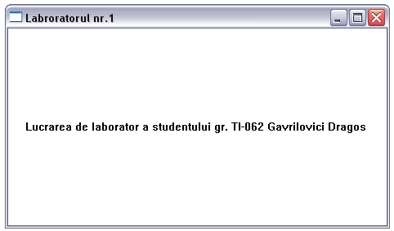

Concluzii:
In urma efectuarii acestei lucrari am facut cunostinta cu crearea aplicatiilor Windows, crearea ferestrelor, prelucrarea mesajelor.

