# Task 1

## Introduction

In the present part of the report, we will investigate to what extent we will be able to classify respondents in their country, and then we will compare the performance of different classifiers.

## Data

The data have been obtained from the $6^{th}$ Wave of the World Value Survey, which was carried out between 2010 and 2013. The data include the standardized scores of 3929 respondents of 3 countries on 32 variables, that have been summarized with 7 factors obtained using exploratory factor analysis with oblique rotation. The 7 factors related to the 32 variables are:

1. **Rights**, that it’s related to homosexuality, prostitution, abortion, divorce, sex before marriage, suicide;
2. **Steal**, that it’s related to claiming benefits, avoiding fare, stealing property, cheating taxes, accept a bribe;
3. **Crime**, that it’s related to robberies, alcohol, police-military, racist behavior, drug sale;
4. **Religion**, that it’s related to attend religious services, pray, the importance of God;
5. **Realize self**, that it’s related to creative, rich, spoil oneself, be successful, exciting life;
6. **Do good**, that it’s related to security, do good, behave properly, protect environment, tradition;
7. **Violence**, that it’s related to beat wife, parents beating children, violenc.

## Methodology

To investigate the possibility to classify the respondents in their country based on the $7$ factors we have used the canonical discriminant analysis. We have applied the linear regression function with $7$ predictors and $1$ dependent variable, the Country. Then to the output, we have applied the Canonical Discriminant Analysis.

lm.out<-lm(cbind(F_rights, F_steal, F_crime,F_religion,F_realizeself,F_dogood,  
 F_violence)~as.factor(country), data=dwvs)  
candisc.out<-candisc(lm.out)  
print(candisc.out)

Canonical Discriminant Analysis for as.factor(country):  
  
 CanRsq Eigenvalue Difference Percent Cumulative  
1 0.80691 4.17882 3.5622 87.142 87.142  
2 0.38142 0.61661 3.5622 12.858 100.000  
  
Test of H0: The canonical correlations in the   
current row and all that follow are zero  
  
 LR test stat approx F numDF denDF Pr(> F)   
1 0.11944 1059.53 14 7834 < 2.2e-16 ***  
2 0.61858 402.65 6 3918 < 2.2e-16 ***  
---  
Signif. codes: 0 '***' 0.001 '**' 0.01 '*' 0.05 '.' 0.1 ' ' 1

As we can see both the Square Canonical Correlation are significant, but the discriminating power to separate between the groups is higher for the first than for the second discriminant function: $0.81$ and $0.38$ respectively. The LR test indicates that the discriminant analysis is meaningful. The first test’s null hypothesis is $H_{0}:λ_{1}=λ_{2}=0$ and this hypothesis as we can see from the *p-value* is rejected. The $null$ hypothesis of the first test it’s equivalent to the test for $H_{0}:μNetherlands=μNigeria=μPhilippines$.

The second LR test indicates that $H_{0}:λ_{2}=0$, and also this null hypothesis is rejected. So even if the second discriminant function has less discriminant power cannot be omitted and it’s statistically meaningful.

On our analysis, we have also applied two different tests for centroids and to test the equal covariance.

To see if the three-country has different centroids and confirm the results of the canonical discriminant analysis we have applied on the linear regression the function *Manova*:

res_t1_2 <- summary(Manova(lm.out), test="Wilks")  
  
summary.default(Manova(lm.out), test="Wilks")

Length Class Mode   
SSP 1 -none- list   
SSPE 49 -none- numeric   
df 1 -none- numeric   
error.df 1 -none- numeric   
terms 1 -none- character  
repeated 1 -none- logical   
type 1 -none- character  
test 1 -none- character

The *p-value* is small, and the test confirms that the analysis is meaningful and that at least there is a pair of centroids that differs significantly. The function *Manova* in r doing the *Wilks Lambda test* uses the Rao approximation. To test the assumption on equal population covariance we have applied to the linear regression the function *boxM*:

boxM(lm.out)

Box's M-test for Homogeneity of Covariance Matrices  
  
data: Y  
Chi-Sq (approx.) = 5479.2, df = 56, p-value < 2.2e-16

The test of Box indicates that $H_{0}$ of equal covariance matrices across groups is not supported by data.

### Plot

To complete the Canonical Discriminant analysis, we have plotted the three countries and the $7$ variables.

Vector scale factor set to 7.827

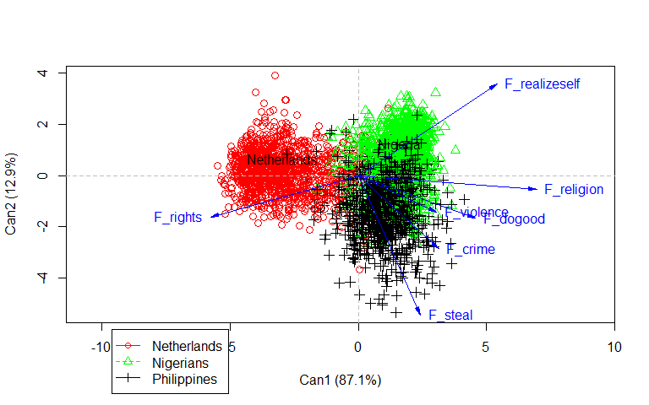

We can see that the group of individuals in *red* are Netherlands citizens, the group of individuals in *green* are Nigerians citizens and the group of individuals in *black* are Philippines citizens. In blue we can see the $7$ explanatory variables. The plot shows a clear separation between Netherlands and the other two countries on the first discriminant function while the second discriminant function could help to separate Nigeria and the Philippines. The first discriminant function especially correlates with the factors: rights, religion, realize self, and do good; whereas the second discriminant function correlates with the factors: steal and realize self. The two-factor crime and violence have a lower correlation on the two factors and so has in this analysis lower importance on separate the $3$ countries.

### Compare the performance of different classifiers

We are going now to compare the performance of different classifiers to classify respondents in their country based on the $7$ factors. To be able to do that we are going to compute the training error and the leave-one-out cross-validation error. The classification method that we are going to compare are: - Linear discriminant analysis; - Quadratic discriminant analysis; - K-nearest neighbors with k ranging from *1 to 100*; - High Dimensional Discriminant Analysis;

### Linear discriminant analysis

This method aims to separate in the clearest possible way different groups using the linear combination of observed independent variables. The linear discriminant analysis method assumes that the covariance structure of the independent variable is the same across groups. In our analysis, we know from the Box test previously computed that this assumption is not supported by the data. It will be an interesting test if in this case the Quadratic discriminant analysis, where the assumption on the equality of covariance matrix is relaxed, will perform better. In the linear discriminant analysis, we have applied the method of Fisher correcting for the different prior probability.

lda.out1<-lda(country ~ F_rights + F_steal + F_crime + F_religion + F_realizeself +  
 F_dogood + F_violence, data=dwvs)  
#print(lda.out1)  
pred.train1 <- predict(lda.out1,dwvs, prior=c(1,1,1)/3)

tab1 <- table(dwvs$country,pred.train1$class)  
#print(tab1)  
kbl(tab1)

Netherlands

Nigeria

Philippines

Netherlands

1145

39

76

Nigeria

10

1327

241

Philippines

17

220

851

#training hit rate  
kbl(sum(diag(tab1))/sum(tab1))

x

0.8464086

#classify test observations using LDA  
pred.loocv2<-lda(country~F_rights+F_steal+F_crime+F_religion+F_realizeself+F_dogood+  
 F_violence,data=dwvs, prior=c(1,1,1)/3, CV=TRUE)  
tab2<-table(dwvs$country,pred.loocv2$class)  
print(tab2)

Netherlands Nigeria Philippines  
 Netherlands 1145 39 76  
 Nigeria 11 1326 241  
 Philippines 17 224 847

#LOOCV hit rate  
kbl(sum(diag(tab2))/sum(tab2))

x

0.845135

We can see that in that case, the difference between the performance for training error and LOOCV error is really small, so there is no evidence for overfitting.

### Quadratic discriminant analysis

The second method that we have applied is Quadratic discriminant analysis. It should perform better considering the difference in the covariance matrix for the different groups. QDA even if has a lower bias with a different covariance matrix, has a larger variance, and as in our case with a small dataset can be problematic.

Even in this case, we have applied the method of Fisher correcting for prior probabilities.

qda.out3<-qda(country ~ F_rights + F_steal + F_crime + F_religion + F_realizeself +   
 F_dogood + F_violence, data = dwvs)   
  
pred.train3<-predict(qda.out3,dwvs, prior=c(1,1,1)/3)  
  
tab3<-table(dwvs$country,pred.train3$class)  
#print(tab3)  
kbl(tab3)

Netherlands

Nigeria

Philippines

Netherlands

1210

21

29

Nigeria

40

1319

219

Philippines

41

219

828

#training hit rate  
kbl(sum(diag(tab3))/sum(tab3))

x

0.8550688

#classify test observations using QDA  
pred.test4 <- qda(country ~ F_rights + F_steal + F_crime + F_religion + F_realizeself +   
 F_dogood + F_violence, data=dwvs,prior=c(1,1,1)/3,CV=TRUE)  
tab4<-table(dwvs$country,pred.test4$class)  
#print(tab4)  
kbl(tab4)

Netherlands

Nigeria

Philippines

Netherlands

1210

21

29

Nigeria

40

1315

223

Philippines

43

223

822

#LOOCV hit rate  
kbl(sum(diag(tab4))/sum(tab4))

x

0.8525217

In that case there is also no evidence of overfitting. We can see from the results that the QDA performs better than the LDA but not with a significant improvement.

### K-nearest Neighbors

The third model that we had analyzed is the K-nearest Neighbors. We have computed the model using all the 3926 observations, and to choose which is the correct number k of parameters to use, we have compared the training error with the Leave one out cross-validation error.

#str(dwvs)  
table(dwvs$country)

Netherlands Nigeria Philippines   
 1260 1578 1088

set.seed(9850) # -> random number generator  
gp<-runif(nrow(dwvs))  
dwvs2<-dwvs[order(gp),]  
#str(dwvs)  
#str(dwvs2)  
#head(dwvs)  
#head(dwvs2)  
  
hitratknn<-function(observed,predicted){  
 tab<-table(observed,predicted)  
 hitratknn<-sum(diag(tab))/sum(tab)  
 return(hitratknn)  
}  
  
knnmax<-100  
err<-matrix(rep(0,knnmax*2), nrow=knnmax)  
  
for(j in 1:knnmax) {  
 predknn.train<-knn(dwvs2[,2:8], dwvs2[,2:8], dwvs2$country, k=j)  
 err[j,1]<-hitratknn(dwvs2$country,predknn.train)  
}  
  
for(j in 1:knnmax) {  
 predknn.train<-knn.cv(dwvs2[,2:8], dwvs2$country, k=j)  
 err [j,2]<-hitratknn(dwvs2$country,predknn.train)  
}  
  
plot('K', 'Hit rate',xlim=c(1,knnmax),ylim=c(0.8,1))

Warning in xy.coords(x, y, xlabel, ylabel, log): NAs introduced by coercion  
  
Warning in xy.coords(x, y, xlabel, ylabel, log): NAs introduced by coercion

lines(c(1:knnmax),err[,1],col="red") # -> training error  
lines(c(1:knnmax),err[,2],col="blue")

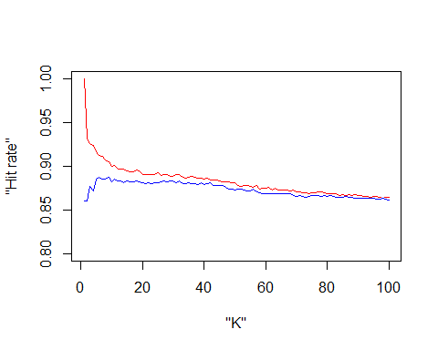

We can see that with K=1 the model is flexible and by definition, we have training hit rate (red line) of 0, but the LOOCV hit rate (blue line) is higher in this case, while with model less flexible, as with k=98, the two errors are similar. Since both the errors increase if we increase the parameter K, probably the model that describes the dataset better is the model with K=30 or K=66.

### High Dimensional Discriminant Analysis

The fourth method that we have used to discriminate between different groups is the HDDA method. This method could be useful while the number of parameters is high compared to the number of data.

w <- dwvs[,-1]  
cls <- dwvs[,1]  
#HDDA on the learning dataset:  
hdda.out7 <- hdda(w, cls, scaling=TRUE, model="all", d="BIC",graph=TRUE,show=TRUE)

# : Model BIC  
 1 : AKJBKQKDK -67912.32   
 2 : AKBKQKDK -68249.76   
 3 : ABKQKDK -69185.72   
 4 : AKJBQKDK -69646.01   
 5 : AKBQKDK -69983.46   
 6 : ABQKDK -70919.41   
 7 : AKJBKQKD -67492.38   
 8 : AKBKQKD -68372.73   
 9 : ABKQKD -68803.13   
10 : AKJBQKD -68044.89   
11 : AKBQKD -68925.24   
12 : ABQKD -69355.63   
13 : AJBQD -71078.02   
14 : ABQD -71609.34   
  
SELECTED: Model AKJBKQKD, BIC=-67492.38.

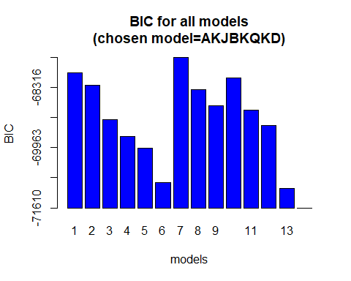

plot(hdda.out7)

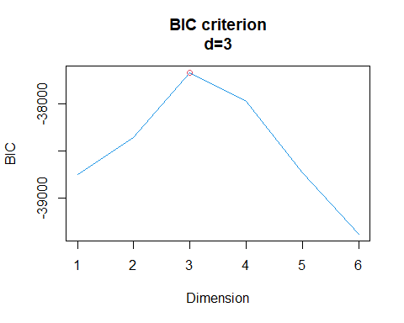

The model used from the HDDA analysis applying the BIC criterion is model $7(A_{kj}K_{j}B_{k}Q_{k}d)$. The decision following the *BIC* criteria is to choose the model with the lowest value, in that case, the reference system is negative, so the lowest value is for model $7$.

plot(hdda.out7,method="BIC")



The dimension choose for the model is $3$. The model chosen by the *BIC* criteria has the same number of principal components for all the three different classes.

pred.train7<-predict(hdda.out7,w,cls)

Correct classification rate: 0.8530311.  
 Initial class  
Predicted class Netherlands Nigeria Philippines  
 Netherlands 1196 20 40  
 Nigeria 26 1356 251  
 Philippines 38 202 797

#print(tab7)  
tab7<-table(dwvs$country,pred.train7$class)  
#training hit rate  
kbl(sum(diag(tab7))/sum(tab7))

x

0.8530311

pred.loocv8 <- hdda(w, cls,scaling=TRUE, d="BIC", LOO=TRUE)  
tab8<-table(cls,pred.loocv8$class)  
#print(tab8)  
kbl(tab8)

Netherlands

Nigeria

Philippines

Netherlands

1197

26

37

Nigeria

22

1378

178

Philippines

44

285

759

#LOOCV hit rate  
kbl(sum(diag(tab8))/sum(tab8))

x

0.8492104

Also with the *HDDA* model, there is rather small evidence of overfitting, but the HDDA model does not perform better than the other models.

### Error comparison for the different models

We have computed for all 4 models the hit rate, for the comparison in the table we will present the training and LOOCV errors computing $1−*hit$ rate:

In all the present models there is little evidence of overfitting, the two errors computed are in all the cases similar. The K-nearest Neighbors is a good model to compare the others and we can see that even if it performs betters it has not a huge difference. The model that performs better between the other $3$ is the Quadratic discriminant analysis, it is the most complex one with the highest number of parameters used.

Confronting the results, we can say that even if there is a difference between the models, no one of the computed ones has outstanding results.

Table of *QDA LOOCV* rate:

As we were expecting in the analysis of the canonical discriminant analysis, the model has a high ability to differentiate between Netherlands and the two other countries, while it has a high error rate discriminating between Nigeria and the Philippines.

### Multinomial logistic regression model

m1<- multinom(country~F_rights+F_steal+F_crime+F_religion+F_realizeself+F_dogood +  
 F_violence, family=multinomial, data=dwvs, maxit=3926, hess=TRUE)

# weights: 27 (16 variable)  
initial value 4313.151845   
iter 10 value 1376.724330  
iter 20 value 1352.584896  
final value 1346.617148   
converged

t1_15_result <- summary (m1)  
t1_15_result

Call:  
multinom(formula = country ~ F_rights + F_steal + F_crime + F_religion +   
 F_realizeself + F_dogood + F_violence, data = dwvs, family = multinomial,   
 maxit = 3926, hess = TRUE)  
  
Coefficients:  
 (Intercept) F_rights F_steal F_crime F_religion F_realizeself  
Nigeria 0.6472240 -2.122889 0.5537755 0.5976742 2.887712 2.8922393  
Philippines 0.9959826 -1.466848 1.5556448 1.0662700 1.932117 0.9680894  
 F_dogood F_violence  
Nigeria -0.01110756 1.2844737  
Philippines 1.16765772 0.7560728  
  
Std. Errors:  
 (Intercept) F_rights F_steal F_crime F_religion F_realizeself  
Nigeria 0.1612100 0.1642741 0.1735127 0.1334749 0.2143403 0.1695936  
Philippines 0.1510987 0.1475679 0.1685630 0.1296852 0.1866007 0.1556415  
 F_dogood F_violence  
Nigeria 0.1218099 0.1534901  
Philippines 0.1197516 0.1470007  
  
Residual Deviance: 2693.234   
AIC: 2725.234

We can see that there are 2 different regression model estimates: the first one compares the probability of Nigeria to the probability of the Netherlands, the second model compares the probability of the Philippines to the probability of the Netherlands. All the parameters are significant except *F_dogood* for Nigeria, which’s not significantly different from 0. The sign of the parameters is the same for all the parameters in both the regressions, except for *F_dogood* where the Nigeria coefficient is not significant. This could be explained because have we analyzed previously Netherlands strongly differs from the other two countries, while Nigeria and the Philippines have not a clear separation. This analysis shows that sample data is more likely to belong to Nigeria and the Philippines than to the Netherlands when it has a higher positive value in the parameters of steal, crime, violence, religion, and a lower negative value in rights These coefficients could be probably well explained from the fact that the Netherlands is one of the most developed countries in all the world, the statistics of the Human Development Index published by the United Nations Development Programme places it in the 8th place in the world, while Nigeria and the Philippines are both considered developing states (161 and 107 respectively in the HDI ranking).

#### compute hitrate training data####  
train.pred<-predict(m1,newdata=dwvs)  
tab<-table(dwvs$country, train.pred)  
kbl(sum(diag(tab))/sum(tab))

x

0.8571065

Error rate: 0.1428935

########compute LOOCV  
nobs<- 3926  
hit<-rep(0,nobs)  
for (i in 1:nobs){  
 train<-c(1:nobs)  
 mod<- multinom(country ~ F_rights + F_steal + F_crime + F_religion +   
 F_realizeself + F_dogood + F_violence, data=dwvs,   
 subset=train[-i], print= FALSE,maxit=3926)  
 pred<- predict(mod, newdata=dwvs[i,])  
 hit[i]<-ifelse(pred==dwvs$country[i],1,0)  
}

#hitrate  
mean(hit) #### LOOCV

Error rate: 0.1444218

The Multinomial logistic regression model has slightly better error values than the other models, except for KNN.