**CHRISTMAS LIGHT SYSTEM**

**Rangu Elena-Daniela, Tabin Alin-Marius**

*Faculty of Automation, Computers and Electronics, Craiova, Romania.*

*Email:* [*rangu.elena.c9t@student.ucv.ro*](mailto:rangu.elena.c9t@student.ucv.ro)*,* [*alintabin98@gmail.com*](mailto:alintabin98@gmail.com)

**Abstract**

Providing the fact that the Christmas is the most wonderful time of the year and everybody is waiting for it, the authors proposed to make a Christmas tree installation for this special occasion. By pressing the push button, the LEDs will light up in different patterns. Also, with the help of a buzzer, Christmas songs will be added. An important point to note is that to simulate this experiment an actual Christmas Tree is not used. It is just a fun little DIY project for anyone who wants to mix Arduino and Christmas.

**Keywords**

Arduino, LED, Buzzer, Arduino IDE.

# 1. Overview

Arduino has been a revolution ever since it struck the market. Arduino, has been a very lucrative option for students designing their first projects. This increase in interest is causing a lot of people to tinker with technology themselves.[1]

There is nothing interesting in the circuit diagram part of the Arduino Christmas Tree Lights Project as all you need to do connect a bunch of LEDs to Arduino.The number of LEDs depends on the size of your tree and in our case, we ended up using 12 LEDs.

**Arduino IDE**

It is a multiple platform application, written in Java, used to load programs on arduino boards. Arduino IDE supports C and C ++ languages. Arduino was selected for this project because of its recomandation and utility in this domain.

A mention is that the circuit part is easy but the construction part is the tricky one.

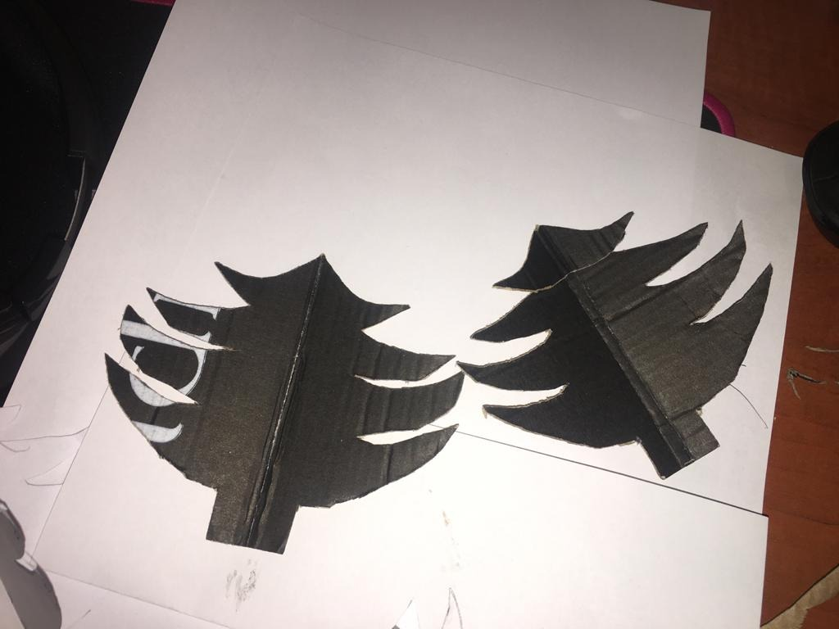

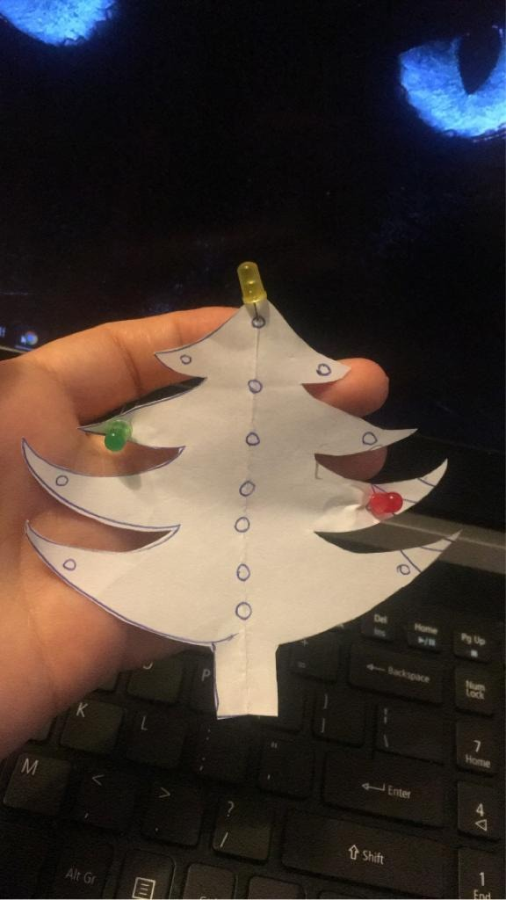

Figure. 1&2. The first stages of the project.

## 2. Hardware components

• Arduino UNO

Arduino Uno is a development board based on the ATmega328P microcontroller. It has

14 digital pins that can be used as input as well as output (of which 6 pins can be used as PWM outputs), 6 analog inputs, a 16 MHz crystal oscillator, a port for USB connection, a power plug, an ICSP header and a reset button.

It contains everything needed to support the microcontroller. It simply connects to a computer via a USB cable, powered by an AC-DC source or from a battery. It is very durable and very reliable due to the possibility of changing the microcontroller, in case of its destruction, at a low price. [2]

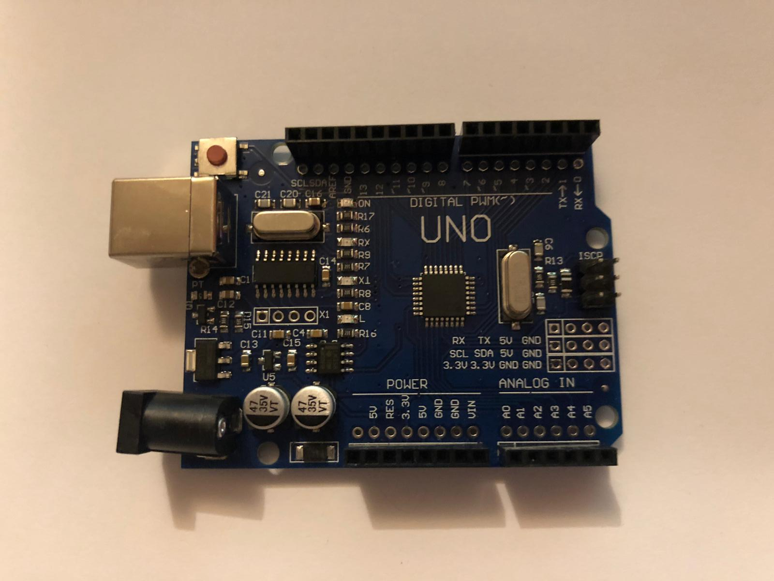

Figure. 3. Arduino UNO

* Breadboard

A breadboard is a rectangular plastic board with a bunch of tiny holes in it. These holes let you easily insert electronic components to prototype (meaning to build and test an early version of) an electronic circuit, like this one with a battery, switch, resistor, and an LED (light-emitting diode). [3]

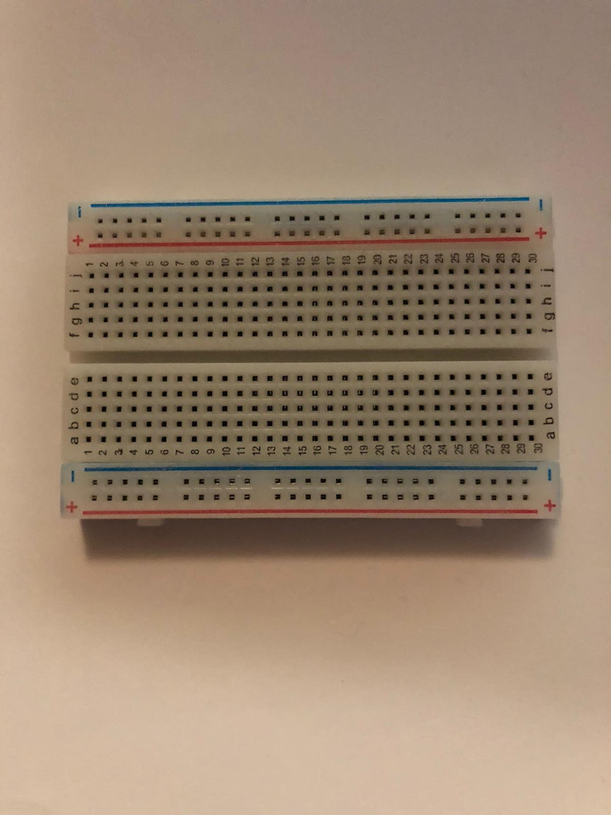

Figure. 4. Breadboard

* LEDs

A light-emitting diode (LED) is a semiconductor device that emits light when an electric current is passed through it. [4]

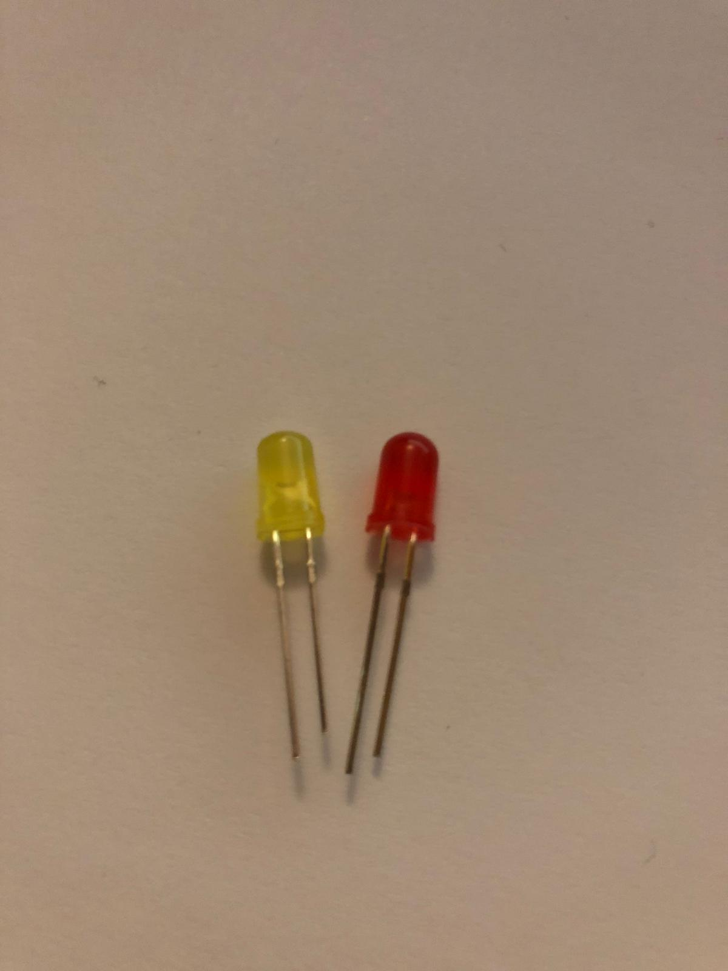

Figure. 5. LEDs

* Buzzer

A buzzer or beeper is an audio signalling device, which may be mechanical, electromechanical, or piezoelectric (piezo for short). [5]

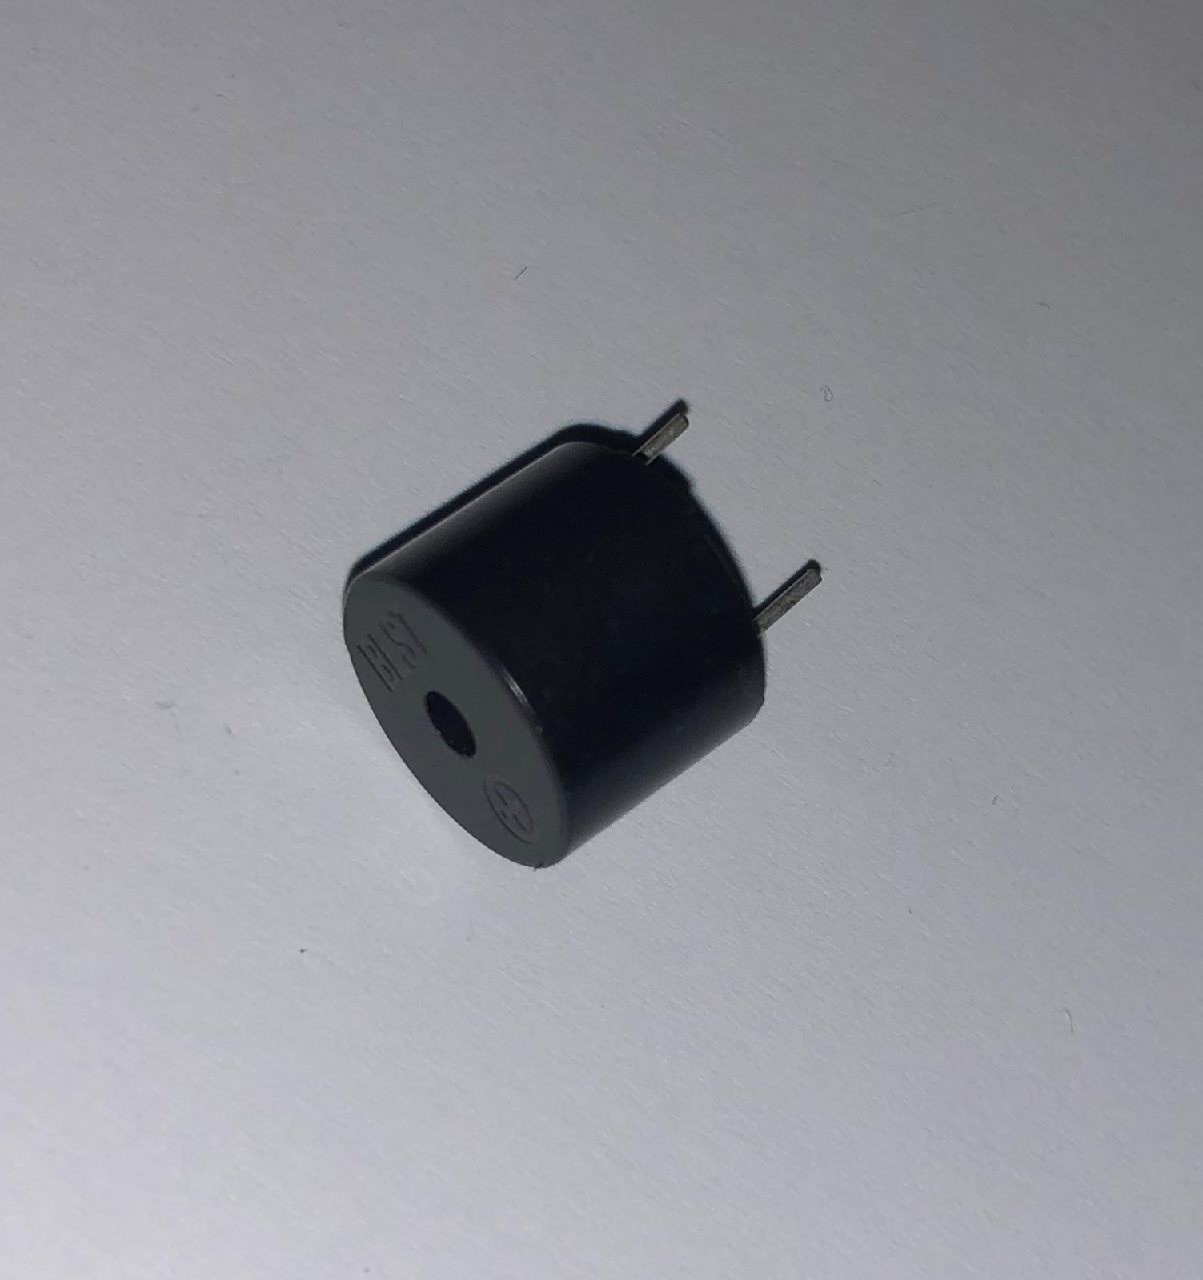

Figure. 6. Buzzer

[Grab your reader’s attention with a great quote from the document or use this space to emphasize a key point. To place this text box anywhere on the page, just drag it.] [AICI SE ADAUGA POZA FINALA]

Figure. 7. Assembled project

## 3. Development and information of the application

First of all, it begins with testing the LEDs and resistors, using as power source an USB cable plugged into a computer.

In order to make it possible to turn the LEDs on and further using the buzzer, first the LEDs have to be put on the positions on the tree, then the wires have to be connected from the Arduino component in the breadboard, which is already linked with the resistors. After this, the connection should be like: Arduino -> Breadboard -> Resistors -> LEDs(interlinked with the wires).

Then the software part of this project starts, which refers to the implementation of the code in C#.

Below is the implementation of the code. After the code is introduced, is going to be uploaded.

[Grab your reader’s attention with a great quote from the document or use this space to emphasize a key point. To place this text box anywhere on the page, just drag it.][AICI SE PUNE O BUCATA IMPORTANTA DIN COD]

Figure. 8. Code implementation for LEDs and buzzer sincronization

# Conclusions

As a conclusion, this project has shown the simplified steps in making a Christmas tree installation and is a very simple but sufficient exercise to get familiarized with the world of arduino projects. Moreover, it was a fun, interactive and a very good test in crafting skills.

# References

1. <https://www.electronicshub.org/diy-arduino-christmas-tree-lights-using-leds/>
2. <https://cleste.ro/arduino-uno-r3-atmega328p.html>
3. <https://en.wikipedia.org/wiki/Breadboard>
4. <https://en.wikipedia.org/wiki/led>
5. <https://en.wikipedia.org/wiki/Buzzer>