**MULTI-COLOR SORTER MACHINE**

**Rangu Elena**

*Faculty of Automation, Computers and Electronics, Craiova, Romania.*

*Email:* [*rangu.elena.c9t@student.ucv.ro*](mailto:rangu.elena.c9t@student.ucv.ro)

**Abstract**

A project can be designed on different levels, encompassing problems of different sizes. Therefore, it is important to detail the concepts related to the project, despite the extreme variety. However, some general features are common, such as robotics programs.

**Keywords**

Arduino, servomotor, color sensor, motor.

# 1. Overview

Arduino has been a revolution ever since it struck the market. Arduino, has been a very lucrative option for students designing their first projects. This increase in interest is causing a lot of people to tinker with technology themselves.[1]

**Arduino IDE**

It is a multiple platform application, written in Java, used to load programs on arduino boards. Arduino IDE supports C and C ++ languages. Arduino was selected for this project because of its recomandation and utility in this domain.

A mention is that the circuit part is easy but the construction part is the tricky one.

## 2. Hardware components

• Arduino UNO

Arduino Uno is a development board based on the ATmega328P microcontroller. It has

14 digital pins that can be used as input as well as output (of which 6 pins can be used as PWM outputs), 6 analog inputs, a 16 MHz crystal oscillator, a port for USB connection, a power plug, an ICSP header and a reset button.

It contains everything needed to support the microcontroller. It simply connects to a computer via a USB cable, powered by an AC-DC source or from a battery. It is very durable and very reliable due to the possibility of changing the microcontroller, in case of its destruction, at a low price. [2]

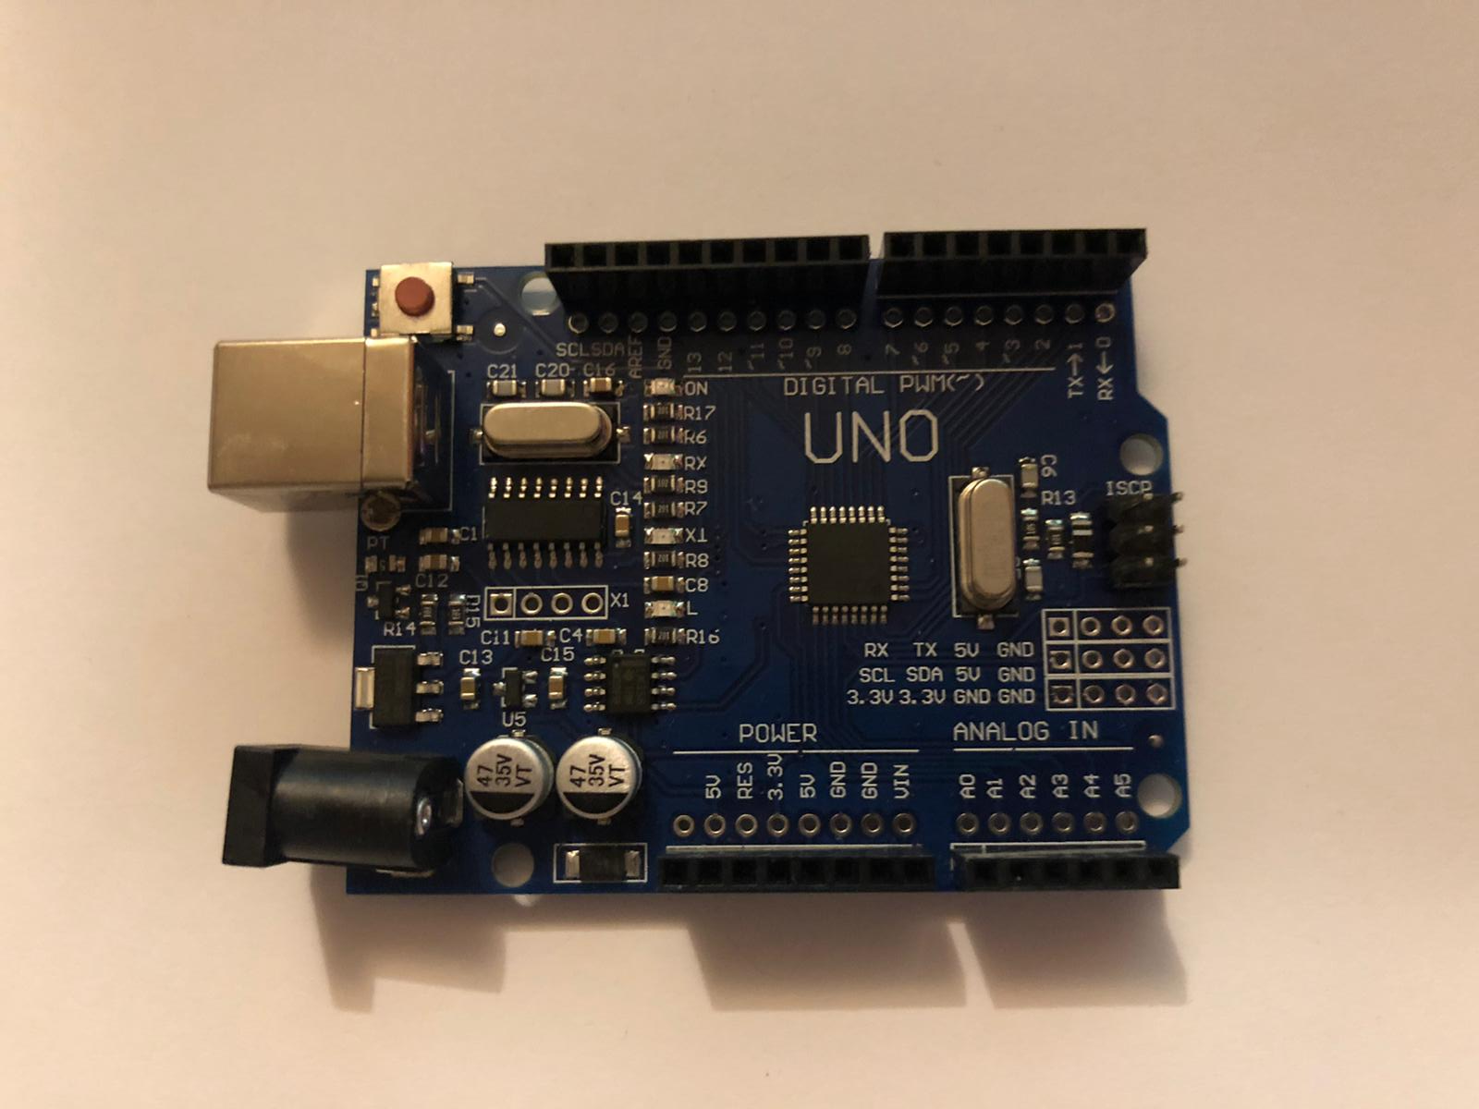

Figure. 3. Arduino UNO

* Servomotor

A servomotor (or servo motor) is a rotary actuator or linear actuator that allows for precise control of angular or linear position, velocity and acceleration.[3]

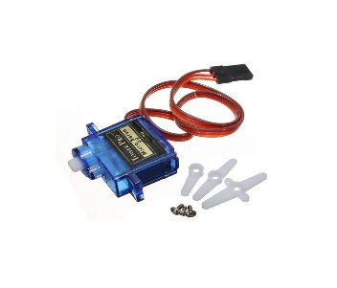

Figure. 4. Servomotor[4]

* Color sensor

The TCS3200 color sensor – shown in the figure below – uses a TAOS TCS3200 RGB sensor chip to detect color. It also contains four white LEDs that light up the object in front of it.[5]

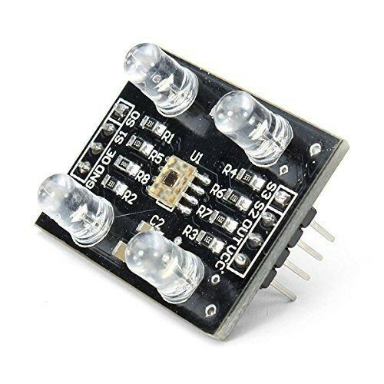

Figure. 5. Color sensor[6]

Figure. 7. Assembled project

## 3. Development and information of the application

The Arduino 1.8.1.5 IDE program was used to carry out this project.

The project is based on the design of microcontroller boards produced by several suppliers, using various types of microcontrollers. These boards provide the user with digital and analog I / O pins and they can be interfaced with a wide range of shields and / or other circuits.

For microcontroller programming, Arduino comes with an environment of integrated development (IDE) based on the Processing project, which includes support for

programming like C and C ++.

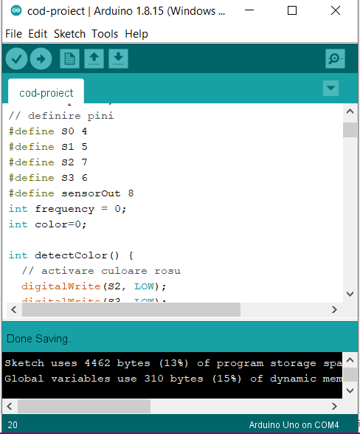

Figure. 8. Code implementation/ Pins define

# Conclusions

When it comes to problems, there are a few. The first problem would be that after assembling the project, nothing worked or did not work as it should, and then, by patience and taking each problem step by step, to be able to carry it out successfully. components, wires (broken), 2 broken motors and a board were lost in this "war". Arduino changed.

In conclusion, most of the requirements of this project have been met, being interactive and putting your mind "to the contribution", it was very interesting to achieve.

# References

1. <https://www.electronicshub.org/diy-arduino-christmas-tree-lights-using-leds/>
2. <https://cleste.ro/arduino-uno-r3-atmega328p.html>
3. <https://articulo.mercadolibre.com.mx/MLM-751033814-10-piezas-de-micro-servomotor-sg90-arduino-servo-16-kg-_JM>
4. <https://en.wikipedia.org/wiki/Servomotor>
5. <https://randomnerdtutorials.com/arduino-color-sensor-tcs230-tcs3200/>
6. <https://www.sigmanortec.ro/Senzor-culoare-TCS230-p125162476?gclid=Cj0KCQjw37iTBhCWARIsACBt1IwSF8-3HlAcLtrOo-tAFdzwK6GK-rEH5_f6hYpBQ742r2vO6p6j7qQaAjPyEALw_wcB>