Table of Contents

AI-Assisted SDLC — Implementation Spec
Pattern: Claude Code agents own requirements, design, build, and deploy. Codex acts as an independent review gate on every artifact. Named humans hold the decision rights.
Field | Value
Version | 0.1 (draft)
Status | For review
Owner | TBD
Applies to | Single repository, single delivery team (pilot scope)

1. Purpose and scope
This spec describes how to run a software delivery lifecycle in which generative agents produce the work product at each phase and a structurally independent agent reviews it before the phase can close.
In scope: requirements, design, build, and deploy-plan generation; automated review; evidence capture; human gate placement.
Out of scope: the CI/CD system itself, production infrastructure, incident response, and model procurement. This spec assumes deterministic pipelines already exist and that agents feed them rather than replace them.

1.1 Why this shape
The phase list is unchanged from a conventional SDLC. What changed is the cost curve: producing code became inexpensive, while specifying and verifying it did not. Three consequences drive every design decision below.
- A defective requirements artifact now propagates into a large volume of code within minutes. Correction has to happen at the left of the pipeline, not at code review.
- A model reviewing its own output shares its blind spots and its rationalisations. Review independence must be structural, not procedural.
- Human attention is the scarcest input. It is spent on specifications and designs, where a change is cheap, rather than on line-by-line inspection of generated diffs.

2. Principles
# | Principle | Implication
P1 | The author never approves | The agent that produced an artifact cannot issue its verdict. Enforced by vendor separation, not by prompt.
P2 | Artifacts are the interface | Each phase emits a versioned file committed to the repository. Conversation transcripts are evidence, never the deliverable.
P3 | Gates shift left | Human sign-off is mandatory at requirements and design. Build and deploy gates may be automated with human exception handling.
P4 | Agents propose, pipelines execute | No agent holds production credentials. Deploy agents write plans; the existing CD system applies them.
P5 | Every phase is auditable | Model, prompt version, artifact hash, reviewer verdict, and human approver are recorded per phase transition.
P6 | Blocking is real | The review gate has a defined hard-fail set. A gate that cannot block is a linting step, not a control.

3. Pipeline overview
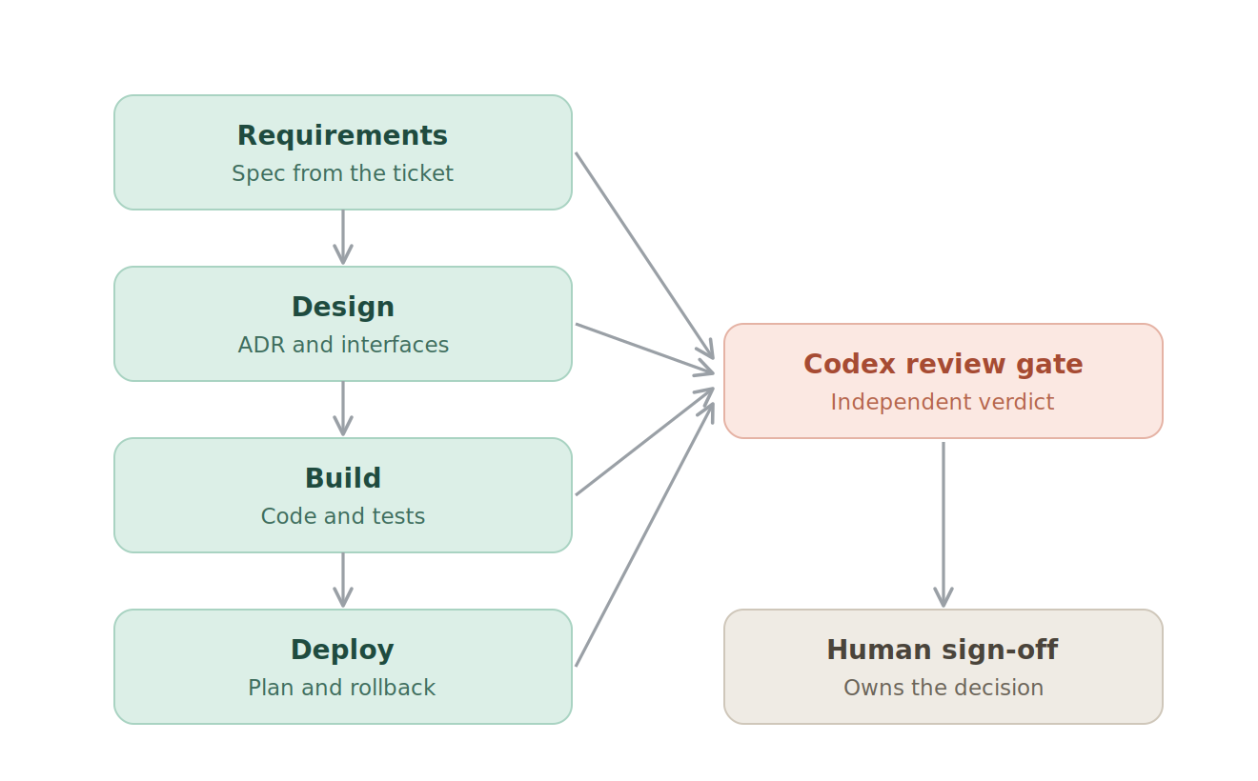
Pipeline overview: four Claude phases feeding a Codex review gate and human sign-off
Reading it. Each phase produces exactly one artifact and stops. The gate reads that artifact and its declared upstream inputs — never the session that produced them. Signature lines sit between phases, not at the end.

4. Roles

4.1 Agents
Role | Runtime | Model family | Write access | Fails the phase when
Requirements agent | Claude Code, headless | Claude | docs/specs/ only | Spec has unresolved ambiguity markers
Design agent | Claude Code, headless | Claude | docs/design/ only | Design contradicts an approved spec clause
Build agent | Claude Code, headless | Claude | src/, tests/ | Tests fail or coverage gate unmet
Deploy agent | Claude Code, headless | Claude | deploy/ only | Plan lacks a rollback path
Review gate | Codex, non-interactive | Non-Claude | reviews/ only | See §8
The review gate deliberately runs on a different vendor’s model. If that is not procurement-viable, the fallback is a different model family from the same vendor with a distinct system prompt and no access to the authoring session’s context — a weaker control that must be recorded as a known limitation.

4.2 Humans
Role | Responsibility | Gate
Product owner | Accepts the requirements spec | R-gate (mandatory)
Tech lead | Accepts the design and ADR | D-gate (mandatory)
Reviewing engineer | Merges the PR; owns the code | B-gate (mandatory)
Release manager | Authorises the release plan | Dep-gate (mandatory for production)
No gate may be satisfied by an agent verdict alone. The verdict is an input to the human decision.

5. Artifact contract
Phase | Artifact | Path | Format | Passes to
Requirements | Specification | docs/specs/<ticket>.md | Markdown, fixed template | Design
Design | Decision record | docs/design/<ticket>-adr.md | Markdown, ADR format | Build
Design | Interface contract | docs/design/<ticket>-api.yaml | OpenAPI / schema | Build
Build | Implementation | branch feat/<ticket> | Source + tests | Deploy
Deploy | Release plan | deploy/<ticket>-release.md | Markdown, fixed template | CD pipeline
All | Verdict | reviews/<ticket>-<phase>.json | JSON, see §8.2 | Human gate
Every artifact carries front-matter recording ticket ID, phase, generating model, prompt version, and upstream artifact hash. A phase agent that cannot resolve its upstream artifact hash must halt rather than proceed on a stale input.

6. Repository layout
.
├── .claude/
│ ├── agents/ # subagent definitions per phase
│ ├── settings.json # permissions, hooks
│ └── prompts/ # versioned phase prompts
├── .codex/
│ └── config.toml # ci profile, MCP servers
├── .mcp.json # MCP servers for the Claude lane
├── docs/
│ ├── specs/
│ └── design/
├── deploy/
├── reviews/ # verdicts, committed as evidence
├── rubrics/ # review criteria per artifact type
└── src/, tests/
Prompts, rubrics, and agent definitions are version-controlled and reviewed like code. A change to a rubric is a change to a control and follows the same approval path as a change to CI configuration.

7. Phase specifications
Each phase runs headless in an isolated git worktree so that a failed phase leaves no partial state on a shared checkout.

7.1 Requirements
- Trigger: ticket labelled ai-sdlc.
- Input: ticket title, body, linked discussion, and the repository’s existing specs for context.
- Tools: read-only on the repository; issue-tracker MCP server; no write access outside docs/specs/.
- Output: a specification containing problem statement, in-scope and out-of-scope lists, functional requirements as testable statements, non-functional requirements, acceptance criteria, and an explicit open-questions section.
- Exit criteria: every requirement is individually testable; the open-questions section is empty or the phase halts and requests human input.
The requirements agent must be instructed to prefer halting over inventing. Fabricated acceptance criteria are the single highest-cost defect class in this pipeline, because everything downstream treats them as ground truth.

7.2 Design
- Trigger: requirements artifact approved at the R-gate.
- Input: approved spec, existing ADRs, current interface definitions.
- Tools: read-only repository; documentation MCP servers; write access to docs/design/.
- Output: an ADR stating the decision, the alternatives considered, and the consequences; plus machine-readable interface definitions.
- Exit criteria: every functional requirement maps to at least one design element; every interface change is backward-compatible or carries a documented migration.

7.3 Build
- Trigger: design approved at the D-gate.
- Input: approved spec and ADR, interface definitions.
- Tools: full workspace write within the worktree; test execution; no network egress beyond declared MCP servers and package registries.
- Output: a branch and a draft pull request linking the spec and ADR.
- Exit criteria: the test suite passes; new code carries tests that map to named acceptance criteria; no interface drift from the approved contract.
Interface drift is checked mechanically by diffing the generated implementation against docs/design/<ticket>-api.yaml. This check is deterministic and is not delegated to a model.

7.4 Deploy
- Trigger: pull request merged.
- Input: merged diff, release history, environment inventory.
- Tools: read-only repository and environment metadata; write access to deploy/ only. No production credentials under any configuration.
- Output: a release plan stating sequence, pre-flight checks, observability signals to watch, defined rollback trigger, and rollback procedure.
- Exit criteria: rollback path is concrete and independently executable; every stated check maps to an existing monitor.

8. Review gate specification

8.1 Operating model
The gate runs once per artifact, on a runner with read-only access to the artifact and its declared upstream inputs. It does not receive the authoring agent’s transcript, reasoning, or self-assessment — only the artifact, its inputs, and the rubric.
Each artifact type has a rubric in rubrics/. The rubric defines advisory findings and a hard-fail set. Without a hard-fail set the gate degrades into commentary.

8.2 Verdict schema
{
"ticket": "PROJ-1234",
"phase": "design",
"artifact_path": "docs/design/PROJ-1234-adr.md",
"artifact_sha256": "…",
"rubric_version": "1.3.0",
"reviewer_model": "…",
"verdict": "pass | pass_with_findings | fail",
"hard_fails": [
{ "rule": "D-HF-02", "detail": "No migration path for the changed interface." }
],
"findings": [
{ "severity": "medium", "location": "§4", "detail": "…", "suggested_fix": "…" }
],
"reviewed_at": "2026-08-03T00:00:00Z"
}
A fail verdict returns the artifact to its authoring phase with the hard-fail list appended to the prompt. Two consecutive failures on the same rule escalate to a human rather than triggering a third attempt — repeated automated retries on the same rule reliably produce cosmetic compliance rather than a fix.

8.3 Hard-fail sets by artifact
Artifact | Hard-fail conditions
Specification | Untestable requirement; unstated assumption presented as fact; missing acceptance criteria for a stated requirement
Design | Requirement with no corresponding design element; breaking interface change without migration; undocumented new external dependency
Implementation | Test asserting on the implementation rather than the requirement; interface drift; a requirement with no covering test; secret or credential in the diff
Release plan | No rollback procedure; rollback trigger not tied to an existing monitor; irreversible step without an explicit human checkpoint

8.4 Known limitation
Automated cross-model review is a quality control, not a segregation-of-duties control. No recognised audit framework accepts one model reviewing another as independent approval. State this explicitly in any control narrative: the human approver at each gate is the control; the review gate reduces the volume and raises the floor of what reaches them.

9. Orchestration

9.1 Sequence
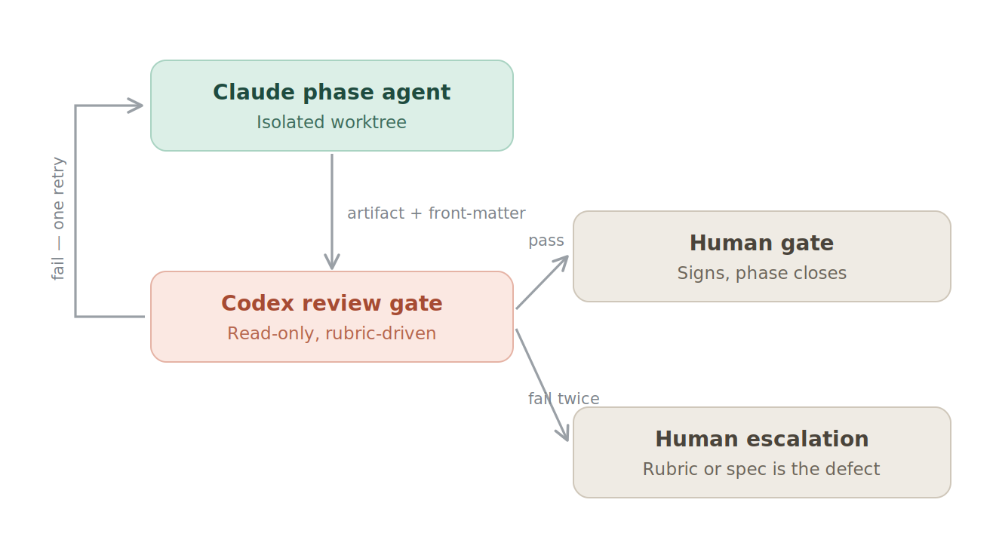
Review loop: phase agent to review gate, with retry and escalation branches

9.2 Orchestrator requirements
The orchestrator is a neutral component — a CI workflow or a shell driver. Neither vendor’s tooling orchestrates the other.
- Each phase and each review runs in its own worktree or ephemeral checkout.
- The orchestrator passes only the declared inputs to each step. It does not forward the authoring transcript to the gate.
- Every step writes its verdict and metadata to the evidence store before the pipeline advances.
- A phase that exceeds its wall-clock or token budget fails closed and notifies a human. It never advances on a partial artifact.

9.3 Illustrative invocation
git worktree add "../wt-$TICKET-$PHASE" -b "agent/$TICKET/$PHASE"
# Phase agent (Claude lane)
( cd "../wt-$TICKET-$PHASE" \
&& claude -p "$(cat .claude/prompts/$PHASE.md)" --permission-mode acceptEdits )
# Review gate (Codex lane, read-only, separate checkout)
( cd "../wt-$TICKET-review" \
&& codex exec --profile ci --sandbox read-only \
"Apply rubrics/$PHASE.md to $ARTIFACT. Emit only JSON per reviews/schema.json." \
> "reviews/$TICKET-$PHASE.json" )
Verify current CLI flags against vendor documentation before adoption; both tools change quickly, and non-interactive approval and sandbox behaviour in particular have moved between releases.

10. Configuration

10.1 MCP servers
Both lanes reach the same servers through separate configuration files: .mcp.json for the Claude lane, .codex/config.toml for the Codex lane. Generate both from a single source of truth to prevent drift; a reviewer with different tool access than the author is a silent source of false verdicts.
The review lane should receive strictly fewer servers than the authoring lane — read access to the tracker and the repository, nothing that can mutate state.

10.2 Permissions
Lane | Sandbox | Network | Credentials
Requirements / Design | Workspace write, scoped to docs/ | Declared MCP servers only | Tracker read token
Build | Workspace write | MCP servers, package registries | None beyond registry read
Deploy | Workspace write, scoped to deploy/ | Read-only environment metadata | None
Review | Read-only | Read-only MCP servers | Read tokens only

10.3 Prompt and rubric versioning
Prompts and rubrics are semantically versioned. The version in force is recorded in every artifact and verdict. Changing a hard-fail rule requires the same approval as a CI configuration change, because it changes what the pipeline is permitted to let through.

11. Evidence and audit trail
Record per phase transition:
- Ticket, phase, timestamp, orchestrator run ID
- Artifact path and SHA-256
- Generating model identifier and prompt version
- Upstream artifact hashes
- Reviewer model identifier, rubric version, full verdict
- Human approver identity and decision, with the verdict they saw
Retain for the period required by the governing framework. The likely first audit question is not whether AI was used but whether a named person approved each change and what evidence they had in front of them. This record answers that directly.

12. Metrics
Metric | Purpose | Warning signal
Gate hard-fail rate by phase | Is the gate doing anything | Near zero suggests rubber-stamping; near 100% suggests a miscalibrated rubric
Escalations after two failures | Retry-loop health | Rising trend indicates rubrics stating preferences rather than defects
Defects escaping to production, by originating phase | Where the pipeline actually leaks | Concentration in one phase directs rubric investment
Human time per gate | Whether attention moved left | Time still concentrated at code review means the shift has not happened
Spec churn after design starts | Requirements quality | High churn means the R-gate is passing incomplete specs
Track defect escape rate against the pre-adoption baseline. Throughput improvements are easy to demonstrate and easy to achieve by lowering the bar; escape rate is what tells you whether the control set holds.

13. Failure modes
Failure mode | Signal | Mitigation
Reviewer rubber-stamps | Hard-fail rate near zero | Seeded defect injection on a sample of runs; audit the gate quarterly
Fabricated requirements | Acceptance criteria with no source in the ticket | Requirements agent halts on ambiguity; product owner gate is mandatory
Cosmetic compliance on retry | Same rule fails twice with superficial edits | Escalate to human after the second failure; never a third automated attempt
Interface drift | Implementation diverges from the contract | Deterministic schema diff, not model review
Prompt or rubric drift | Verdicts change without a rubric change | Version pinning; verdict records the versions in force
Human gate becomes a formality | Approval latency approaches zero | Sample-audit approvals; require a written rationale on any pass_with_findings
The last row is the one that decides whether this pipeline is a control environment or theatre. If approvals become instantaneous, the gate has stopped functioning regardless of what the evidence store contains.

14. Rollout
Stage 1 — shadow (4 weeks). Agents produce artifacts for tickets already being delivered conventionally. Nothing merges from the agent path. Compare agent artifacts against human ones and calibrate the rubrics. Success criterion: hard-fail set catches defects a human reviewer independently identified.
Stage 2 — assisted (6 weeks). Agent artifacts become the starting point for low-risk tickets. All four human gates are mandatory and timed. Success criterion: defect escape rate at or below baseline.
Stage 3 — standard. The pipeline is the default path for tickets within an agreed risk class. Gates remain mandatory. Any expansion of the risk class is a separate decision with its own evidence.
Do not begin at Stage 3 on a regulated workload. The evidence needed to defend the control set is generated during Stages 1 and 2.

15. Open decisions
- Review-gate vendor — confirm procurement and data-handling approval for a second model provider, or accept the weaker same-vendor fallback and record it.
- Risk class eligible for the pipeline at Stage 3.
- Whether the deploy phase applies to production releases or stops at pre-production.
- Evidence retention period and system of record.
- Whether prompt and rubric changes are in scope for the existing change-advisory process.
- Token budget ceiling per ticket and the behaviour on exceeding it.

