SUMMARY

USC ID/s: 3156075023, 8821411907, 6323094966, 9926782893

Datapoints
M+N | Time in MS (Basic) | Time in MS (Efficient) | Memory in KB (Basic) | Memory in KB (Efficient)
16 | 0.093222 | 0.183821 | 2.265625 | 2.210938
64 | 1.811266 | 2.5599 | 42.33789 | 6.72168
128 | 7.697821 | 12.63881 | 169.0449 | 14.18652
256 | 29.3107 | 46.86618 | 659.7754 | 38.56543
384 | 62.01577 | 102.9773 | 1471.557 | 47.71582
512 | 108.8316 | 177.3477 | 2598.309 | 48.20508
768 | 392.1473 | 465.0006 | 5819.674 | 64.13281
1024 | 805.6009 | 917.4676 | 10318.13 | 91.83496
1280 | 1376.633 | 1536.316 | 16105.51 | 111.2178
1536 | 2072.128 | 2554.307 | 23166.14 | 171.9063
2048 | 4429.648 | 4978.802 | 41127.34 | 175.5215
2560 | 7158.844 | 7450.12 | 64213.4 | 220.7646
3072 | 9619.735 | 11296.95 | 92418.3 | 261.5547
3584 | 13120.52 | 15533.91 | 125725 | 302.5146
3968 | 16565.22 | 20092.09 | 154081.5 | 333.876

Insights

Graph1 – Memory vs Problem Size (M+N)

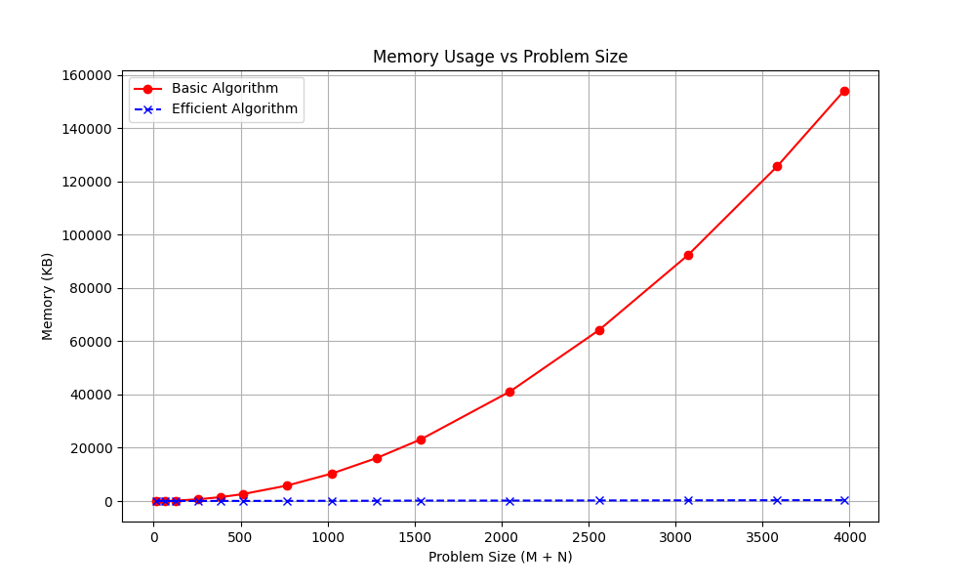

Nature of the Graph (Logarithmic/ Linear/ Polynomial/ Exponential)
Basic: Polynomial (Quadratic)
Efficient: Linear

Explanation:
The graph shown above clearly demonstrates the theoretical space complexity differences between the two algorithms. The basic algorithm (red line) utilizes a full 2D Dynamic Programming Table which results in memory usage that grows quadratically (O(MN)) as the problem size increases.

In contrast, efficient algorithm employs Hirschberg’s divide and conquer algorithm approach where it only requires storing two rows of the DP table at any given time. Therefore, it results in linear space complexity (O(M+N)). Consequently, the memory usage is flat compared to the basic algorithm.

Graph2 – Time vs Problem Size (M+N)

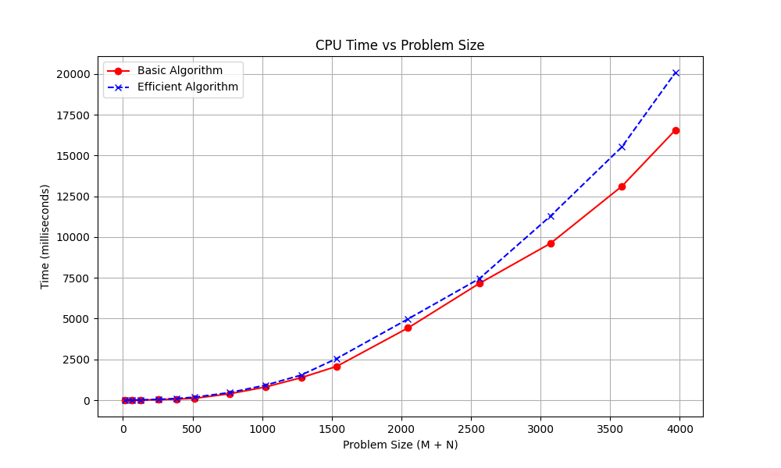

Nature of the Graph (Logarithmic/ Linear/ Polynomial/ Exponential)
Basic: Polynomial (Quadratic)
Efficient: Polynomial (Quadratic)

Explanation:
Both algorithms are polynomial time complexity (O(MN)). The graph grows as the problem size increases. The execution time for both algorithms grow at a similar rate.

However, the efficient algorithm (blue line) is consistently slightly higher (slower) than the basic algorithm (red line). This is expected because the memory efficient divide and conquer method involves re-calculating optimal scores for the split points, which introduces constant factor compared to the single-pass basic approach.

Contribution
(Please mention what each member did if you think everyone in the group does not have an equal contribution, otherwise, write “Equal Contribution”)
<USC ID/s>: <Equal Contribution>
3156075023:
8821411907:
6323094966:
9926782893: <Equal Contribution>

