# BIBLIOGRAFIE

BIBLIOGRAFIE 1

1-Compulsive buying behavior on the internet - 4

**Abstract** 4

**Introduction** 4

**Literature review** 4

Compulsive buying behaviour 4

Compulsive and impulsive buying 4

E-commerce compulsive shopping 4

Data and methodology 5

Conclusions 5

2 – **Consumer behaviour in a digital environment** 6

**Executive summary** 6

**Basic facts about consumers in the digital environment** 6

**Consumer behaviour and behavioural biases** 6

**Firm behaviour in the digital environment** 7

**Consumer purchasing behaviour in the digital environment** 7

Accesing information 7

Assesment and analysis of information 7

Acting on assessment and analysis 8

Complaints and redress 8

**I.** **Introduction** 8

**II.** **Basic facts about consumers in the digital environment** 8

**2.1 Access to the internet** 8

**2.2. Purchases online** 8

**2.3 Trends in consumer demand of relevance for understanding the consumer in the digital environment.** 9

**2.4.Legal and regulatory environment for e-commerce in EU-27** 9

**2.5** **The rise of “prosumer”** 9

**2.6** **Access to legal content** 9

**2.7. Access to illegal content** 9

III. Consumer behaviour and Behavioural Biases 10

**3.1.The “rational” consumer** 10

3.2 Behavioural economics literature has identified the following behavioural biases: 10

3.3.Business responses to behavioural bias 11

**IV.** **Firm Behaviour** 11

Strategies used by sellers in the digital market 11

**Online intermediaries** 12

**Barriers to e-commerce for business** 12

**V.** **The consumer purchasing process- accesing information** 13

**VI.** **The consumer purchasing process – ASSESMENT AND ANALYSIS** 14

**VII.** **THE CONSUMER PURCHASING PROCESS- ACTING ON ASSESMENT AND ANALYSIS** 15

BARRIERS TO E-COMMERCE 15

BENEFITS OF SHOPPING IN THE DIGITAL ENVIRONMENT 16

**VIII.** **THE CONSUMER PURCHASING PROCESS- COMPLAINTS AND REDRESS MECHANISMS** 17

PROBLEMS FACED BY CONSUMERS ONLINE 17

IX. The consumer purchasing process- POST-SALE SERVICE AND OTHER POST-SALE INTERACTIONS 17

X. CONCLUSIONS AND RECOMMENDATIONS 18

**3- Electronic Word-of-Mouth for Online Retailers: Predictors of Volume and Valence** 18

I. Introduction 18

1. Customer satisfaction 19

RESULTS 20

**KOTLER, ARMSTRONG- PRINCIPLES OF MARKETING** 20

**Cultural factors** 20

**Social factors** 20

**Personal Factors** 21

**Psychological Factors** 22

**Types of Buying Decision Behavior** 23

**The Buyer Decision Process** 24

**Direct marketing - p.496** 25

**Forms of Direct Marketing** 26

**New Digital Direct MarketingTechnologies** 27

**Public Policy Issues in Direct Marketing** 28

4. PARTICULARITIES OF THE EUROPEAN CONSUMER`S BEHAVIOUR IN ONLINE ENVIRONMENTS 29

Characteristics of the online purchasing behavior 30

Secondary data sources research on online purchasing behavior of the European consumers 31

**Conclusions** 31

5. A study of online user`s behaviour towards facebook social network. 31

Literature review – the concept of marketing online 32

The social network- specific instruments used in online marketing communication 32

Conclusions 32

7. THE LOYAL CONSUMER`S PERCEPTION REGARDING THE ONLINE BUYING PROCESS 32

Introduction 33

Research sampling 33

Research results 34

8. PSYCHOLOGICAL AND SOCIAL FACTORS THAT INFLUENCE ONLINE CONSUMER BEHAVIOUR 35

**Factors the influence consumer behaviour** 35

. Literature Review of Factors that Influence Online Consumer Behavior 35

Psychological Factors that Influence Online Consumer Behavior 35

Social Factors that Influence Online Consumer Behavior 35

# 1-Compulsive buying behavior on the internet -

## **Abstract**

* CBD – consumer buying disorder
* applied to 100 students attending the Faculty of Economics and Business Administration of Iasi. compulsive buyers are majoritarian women

## **Introduction**

* Shopping- a socially acceptable addiction
* The study is about identifying whether the Romanian student population suffers to a certain degree of CBD in their online shopping behavior and what are the factors that favor it: the internet history, personality, or income level or other.
* This is particularly important both from a sociological point of view and a marketing point of view. Knowing what determines consumers to buy without having a prolonged decisional process is helpful in designing promotions for online sites that sell, for example, vouchers

## **Literature review**

### Compulsive buying behaviour

* beginning of the 20th century the German psychiatrist Emil Kraepelin invented the term **“oniomania”** to describe the unstoppable impulse to buy.
* ***McElroy*** (1994) has described it **as a chronic and repetitive behavior developed as a primary response to unhappy events,** while ***Faber and O’Guinn*** (1992) define **CBD** as a **“type of consumer behaviour which is inappropriate, typically excessive, and clearly disruptive to the lives of individuals who appear impulsively driven to consume”.**

### Compulsive and impulsive buying

* Impulsive – determined by outside stimuli
* Compulsive- the desire comes from within
* Most compulsive buyings are for improving appearance.
* Cause of compulsive buying: unhappiness, materialism.

### E-commerce compulsive shopping

* UE- e-commerce = “any form of business transaction in which the parties interact electronically rather than by physical exchanges or direct physical contact”
* Other data shows that Tuesday, Wednesday and Thursday are the days in which the sales are higher and the preferred hour for shopping are between 10 and 11 am and 8 and 11 pm while the most expensive purchase are done around 3 and 5 pm.
* their behaviour is poorly researched – Romanians
* From the research conducted by Garcia and Donthu (1999) it can be concluded that online consumers are more impulsive compared to those “offline”.

## Data and methodology

* Nowadays, the purchase of goods is not necessarily linked to necessity and more than often we buy and consume products without having a real need to. This research proposes to identify whether among the young population of Romanian students this compulsive buying behavior is present.
* We hope to shed light on the following questions through my research:

1) What is the average number of years since the respondents have been using internet?

2) What products are more frequently purchased and what is the average number of product/ services purchased monthly and annually?

3) What is the payment plan used by the respondents and how much income is assigned only to shopping?

* Research exploratory than explanatory, online survey, online questionnaire designed using Google forms. The questionnaire was “borrowed” from the research of Angela Ojetti, on Italian students 2012.
* **The Faber and O`Guinn compulsive buying scale**
* A percentage of **13% of the respondents proved to have a score consistent to Compulsive Buying Disorder**. Out of these, **84, 6% were women and the rest of 15, 4 % men confirming Guerreschi’ (2012)** research results that the majority of compulsive buyers are women
* Notwithstanding the relevance of this “disorder” and the increasing number of people purchasing online, **there are few if none researches to study this phenomenon.** That is why, through this research, I tried to bring empirical data to test the existence of CBD among Romanian online shoppers.

## Conclusions

* Out of the 100 respondents, 13 present this addiction and the number is quite high considering the economic and social consequences associated with this type of behavior.
* On the whole, these results may be useful in **understanding better the behavior of people**, and especially of students, and the **factors that may determine them to purchase from online stores**. **For example, companies may use this information to influence the frequency and quantity of sales.**
* Limitations and particular limitations

Reference : Bighiu, Georgiana, Adriana Manolică, and Cristina Teodora Roman. "Compulsive buying behavior on the internet." *Procedia Economics and Finance* 20 (2015): 72-79.

# 2 – **Consumer behaviour in a digital environment**

## **Executive summary**

* and e-commerce in particular, is central to the development of the European Single Market. The digital environment is also likely to have wider economic benefits in terms of increased innovation, creativity, learning, instant and unlimited access to information sources, and reduced environmental costs associated with transactions.
* The purpose of this study is to analyse European consumers’ behaviour in the digital

environment based on a review of existing literature and data, and a limited stakeholder consultation exercise

## **Basic facts about consumers in the digital environment**

* Forty percent of EU consumers had purchased goods or services online in a 12 month period in 2009/10. Between 2005 and 2010, this figure doubled from just 20%.
* Internet access is a key facilitator of e-commerce and there is a strong positive association between internet up-take in a country and the share of consumers who have purchased goods and services online.
* E-commerce facilitates transactions in tangible goods and services but also gives online access to content and digital services (intangible goods).
* Opening access to information and content could also lead to increased creativity and innovation.
* Despite all the advantages of the digital environment and e-commerce, the internet has

also given consumers easier access to illegal content and made distribution easier for sellers.

* The internet has led to emergence of a **“prosumer”** (an individual who is both a consumer and a producer).

## **Consumer behaviour and behavioural biases**

* Traditional economic theory predicts that **consumers are rational consumers who systematically search for and analyse information in the market before making a purchase** and seek **redress** in the event of problems with the purchase. However, obtaining and analysing information may be costly and **as a result rational consumers may not search the entire market before making a decision.**
* **firms may have incentives to try to exploit these behavioural biases for their own benefit** (for instance by trying to encourage inertia or by making complaining or redress seem very costly). As a result, the higher level of competition online compared to the offline market-place may not necessarily benefit consumers.

## **Firm behaviour in the digital environment**

* Around 14% of EU enterprises sell goods or services online and this figure has remained relatively constant over the last 5 years
* evidence that firms may charge price premiums if they can make shopping more convenient e.g by making websites easier to navigate or by appearing at the top of search results on search engines.
* **Price transparency, for example, may be reduced if firms use drip-pricing and hence only show part of the price up-front, but then add additional charges further along the purchasing process.**
* Obsolete =**not in use any more having been**[**replaced**](https://dictionary.cambridge.org/dictionary/english/replace)**by something**[**newer**](https://dictionary.cambridge.org/dictionary/english/new)**and**[**better**](https://dictionary.cambridge.org/dictionary/english/better)**or more**[**fashionable**](https://dictionary.cambridge.org/dictionary/english/fashionable)
* Many of the new intermediaries act as information intermediaries or provide platforms bringing together sellers and buyers.
* Firms face some important barriers to e-commerce. For example, the costs of developing and maintaining a website, the lack of technical skills and fear of fraud seem to deter a number of businesses.

## **Consumer purchasing behaviour in the digital environment**

### Accesing information

* **The internet provides consumers with much better access to information and sellers than other sales channels.** **This improved access to information** about products, services and prices has been shown to have positive benefits for consumers. However, some consumers may find the information overwhelming.
* **the internet is essentially equivalent to Google**
* consumers **d**o not utilise online search and filtering tools fully and **only consider websites that appear among the top search results.**

### Assesment and analysis of information

* **Price comparison** websites and **recommendations** from other consumers and friends through review sites and social media **are also important sources of information**. While price comparison **websites are not always trusted** sources of information, **recommendations and consumer reviews are highly trusted** sources that have been shown to influence actualconsumer behaviour.
* Consumers perceive **the risk fraud as being greater online** than offline.
* **some consumers find online ads annoying** and have privacy concerns about targeted ads

### Acting on assessment and analysis

* consumers feel that they benefit from e commerce **through better deals and more product variety** and some consumers feel e **commerce gives them a better shopping experience**.
* there is still a large share of consumers who prefer to shop in person rather than online,
* Computer and electronic goods are the least likely to be bought online, which may reflect the high value associated with these goods.
* 63% consumers – risk of online fraud, 56% consumers -risk of gaining access to pers info.
* Barriers for e-commerce : 62% fear of fraud, 59% what to do if a problem, 49% delivery may be an issue.

### Complaints and redress

* Most typically, problems with e commerce **are related to delivery or the quality of the product or service**.
* **The main frustration** - poor communication levels they may encounter with online traders
* **Post-sale advertising may increase e loyalty**, particularly if the consumer has opted in to the email service.
* **Recommendations**

## **Introduction**

* E-commerce is central to the development of the Internal Market.
* At the core of the study of the consumer in the digital **environment is the purchasing process that rational consumers would be expected to go through when acquiring a good or service**. The analysis focuses on **consumer behaviour at the different stages of the purchasing process and contrasts consumer behaviour in the online environment with consumer behaviour in an offline environment.**
* This study shows- How sellers adjusted their behaviour in the digital environment

## **Basic facts about consumers in the digital environment**

### **2.1 Access to the internet**

* 70% of household has access to internet in 2010

### **2.2. Purchases online**

* **Overall, online purchasing has doubled between 2005 and 2010 across the EU-27,** with an increase in the share of individuals having made internet purchases increasing by 20 percentage points from 20% in 2005 to 40% in 2010.
* **There is also indication that men are more likely to buy online than women.** In 2010, 46% of men aged 25-64 made at least one online purchase compared with 41% of women in the same age group

### **2.3 Trends in consumer demand of relevance for understanding the consumer in the digital environment.**

* Domestication and mobilization
* Globalization
* Personalization
* In Sweden, 58% of consumer respondents said that their mobile phone subscription allowed them to do this, **whilst in Romania this figure was only 12%.** This shows that there is still **a wide gulf in the availability of these services across the EU**, whilst the average proportion of consumers able to use the internet on their mobile phones across the EU is 33%.

### **2.4.Legal and regulatory environment for e-commerce in EU-27**

Consumer issues:

* EU consumer protection rules may not apply if a consumer interacts with an online operator who is legally established and located outside the EU/EEA
* Another issue with the current legal framework are the questions of who is a consumer and who should be protected?
* Copyright is another major problem in the digital environment

### **The rise of “prosumer”**

* **a prosumer** is an individual who acts not only as consumer but also as producer.
* **Auction websites such as eBay have made it easier for consumers to sell products and the platform allows users to be consumers and sellers at the same time.**
* Further analysis shows that men sold more on the internet than women.

### **Access to legal content**

* **One of the main benefits of the digital environment** is arguably that it provides users with **easier access to content** (whether information, services or products).
* There is also evidence that individuals use the internet more frequently and there is evidence of an increasing number of consumer transactions online .
* **Market fragmentation is potentially a greater barrier for consumers** of purely digital goods than for consumers of tangible goods.
* **The digital environment has provided wider benefits** such as increased innovation, creativity, learning, and reduced environmental costs.
* **if employees are able to work from home using the internet which would lead to reduced environmental costs.**

### **2.7. Access to illegal content**

* One of the factors affecting the benefits associated with using illegal content is the price.
* Challenges for the legal copyright framework

## Consumer behaviour and Behavioural Biases

### **3.1.The “rational” consumer**

* A fundamental assumption in traditional economic theory is that individuals act as rational decision makers.
* **At the core of our analysis of consumer behaviour in a digital environment is the rational purchasing process depicted in Figure:**
* Firstly, rational consumers would be expected to search for and access information.
* Consumers would then be expected to assess and analyse the information they have acquired.
* Thirdly, consumers would be expected to act on their assessment of the available information.
* After the purchase, there may be a problem and rational consumers would be expected to seek or consider seeking redress through a complaints process.
* 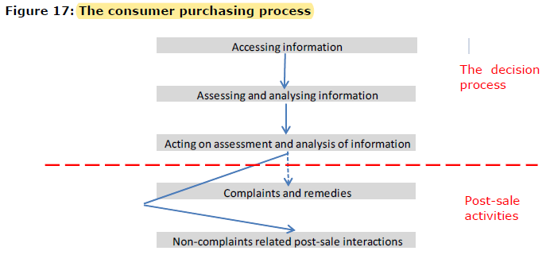 Furthermore, additional post-sale non-complaint interactions may occur. Such interactions may in turn influence the consumer purchasing process for future purchases.

### 3.2 Behavioural economics literature has identified the following behavioural biases:

* Cognitive limitations
* Default positions
* Hyperbolic discounting
* Loss aversion
* Framing of information

These can impact the steps in the decision process

* Accesing the information (good-enough solution rather than continue to search to find the best solution.)
* Assessing and analysing information
* Acting on information and analysis
* Complaints and remedies

### 3.3.Business responses to behavioural bias

* Firms may try to exploit behavioural biases at each step of the purchasing process, for example, through the way information is presented to consumers.
* E-commerce would generally be associated with increased competition (i.e., e-commerce is likely to increase the number of firms facing a consumer in the market for a specific

product/service) and improved transparency in the market

* Note that there may be allocative inefficiencies if consumers pay "too" high a price for some goods because what they are willing to pay for a given good is affected by their biases.

## **Firm Behaviour**

* Business stakeholders have pointed out a number of advantages of the digital environment for businesses
* Business models:
  + Pure play
  + Bricks and clicks
  + Sales via a third party site

### Strategies used by sellers in the digital market

Advertising strategies

* Some industry stakeholders argue that a combination of offline and different online advertising strategies is most effective and necessary.
* As a result, the online advertising industry has observed a trend towards online advertising strategies that increase the relevance of advertisements to potential consumers and hence target ads.
* The main techniques for targeting people through advertisements include:

1. Rule based
2. Comparative filtering
3. Behaviour targeting

Advertising through review sites and recommendations

* Businesses may also try to influence consumer decision making through hidden advertisements.
* As discussed above there is some evidence that prices typically are lower online than

Offline

* Pricer`s paradise
* **Drip- pricing** - Drip pricing takes advantage of consumers’ loss aversion and the endowment effect associated with these situations (OFT, 2010b). This may lead consumers to complete the purchase, even at the higher price and even if it is not optimal given other deals available in the market, etc.
* **Bundled offers**
* **Reference prices**
* **Dynamic pricing and baiting**- Consumers may feel **that the product is theirs as soon as they see a good offer**, and because they fear losing it by being too late, they may make a purchase too soon; Finally, **some firms will advertise discounts to attract visitors**, but will have very few of the advertised products available, known as baiting sales.

### **Online intermediaries**

While some intermediaries such as travel agents have almost disappeared, other intermediaries have appeared. Examples include price comparison sites, access and storage providers, marketplace exchanges, search engines, advertising networks and social networking sites.

* According to Perset (2010), the main functions of internet intermediaries are …

Online intermediaries business models

* Advertising model
* Paid subscription/charging for premium services
* Brokerage fees
* Voluntary contributions

### **Barriers to e-commerce for business**

* Lack of relevance
* Cost
* Fear of fraud
* Lack of IT skills

Meier-Pesti found that cross-border orders failed in this respect for 3 reasons: registration; shipment; and payment:

* Problems with registration for cross-border e-commerce related to failed registration, due to not having the required personal information.
* While it was possible to receive shipment for 98% of domestic offers, only 48% of cross-border offers could be shipped.
* While it was possible to receive shipment for 98% of domestic offers, only 48% of cross-border offers could be shipped

Business stakeholders highlighted similar barriers to cross-border e-commerce and provided further insights:

* Legal fragmentation across the EU with respect to consumer rights
* Delivery costs.
* Language barriers
* Tehnical search limitations
* Lack of trust in non domestic consumers
* Non unified means of payment across the EU

## **The consumer purchasing process- accesing information**

Accesing information: the first step of the purchasing process

* When a consumer starts thinking about purchasing a product or service, it may be initiated by a need or desire for a particular product or service or for certain attributes or aspects of a product or service.
* the consumer uses all available information to make the purchasing decision.
* Goods can be categorised in terms of how difficult it is for a consumer to gather information about their quality
* Search goods, experience goods, credence goods
* For the same reason, one might expect consumers to search less when making repeat purchases.

**Searching for information online**

* Consumers are better able to identify the cheapest offer, and as a result, online consumers tend to be more sensitive to price changes.
* In addition, consumers may limit search effort because of the large amounts of information available
* find that consumers with a low
* level of digital literacy spend less time searching online and rely more on brand names as a signal of quality than consumers who are more familiar with the internet.
* consumers tend to be willing to pay a premium to shop with suppliers they trust or find more convenient

Personal recommendations (32%) and online recommendations and reviews (26%) are

other important sources of information for consumers choosing where to shop online. In

comparison, online advertising only helps 18% of online shoppers to choose an online

shopping site, while print or TV advertising only helps 12% of consumers decide where to

shop. Special offers are nevertheless quite effective and 30% of consumers worldwide use

this information to decide where to shop online.

* Advertising and surfing
* Search engines and price comparison sites

## **The consumer purchasing process – ASSESMENT AND ANALYSIS**

* Brand, quality perception, price, ease of access, reputation, and speed of accessibility, etc. are important factors that the consumer may consider at this stage.
* In practice, the assessment and analysis stage may be closely interlinked with both the ‘access information’ stage and the ‘act on assessment and analysis stage’.
* ability to assess and analyse information may be affected by cognitive limitations
* note that although consumers use search engines, these tools are not necessarily used in depth.
* This analysis illustrated that the product, brand and site that were listed first in the search results were chosen by most commonly by consumers.
* For example, a recent empirical study by the OFT (2010b) showed that consumers pay higher prices and search less when the first seller they visit uses drip pricing
* This may imply that it is more difficult for consumers to assess the information they find online about product quality
* The lack of personal contact, and the separation of the purchase from delivery, may also imply that there is greater scope or a perception of a greater scope for fraud and scams online than in the offline environment.
* show that brand loyalty is greater online than offline.
* Romanian consumer research also supports the argument that consumers value seeing trusted brands and trust-enhancing certificates on online shopping sites
* Trust of Sources of information
* consumers are more likely to trust recommendations from people they know, for example, recommendations provided through social networks.
* Price comparison sites
* Trust in online advertising information is low
* Misleading and unclear information - information relating to the quality of the good or service may be misleading - if companies use drip-pricing or scams where consumers are not informed properly of the total cost.
* Impact of advertising on the decision making: The analysis showed that drip-pricing, time-limited offers, baiting and complex pricing all impact consumer decision making.
* Finally, if the consumer is exposed to an advertisement on several websites and pages, compared to just one page, there is a higher probability they will purchase the product.

## **THE CONSUMER PURCHASING PROCESS- ACTING ON ASSESMENT AND ANALYSIS**

* In standard economic theory consumers make consistent and fully rational decisions based on full information. However, in the process of actually purchasing the product, consumers may choose the wrong product or service, or fail to choose at all, due to behavioural biases.
* For example, if a retailer displays messages such as ‘last in stock’ or ‘only two hotel rooms remaining’, the consumer may act too soon and purchase the product because they fear losing it, even if there are better deals available elsewhere.
* In the case of e-commerce, it could be the case that consumers do not buy a product today because they believe that it may be cheaper tomorrow.
* Computer and electronic goods are the least likely to be bought online, which may be due to the fact that there is a higher perceived risk associated with these goods. This risk originates from the relatively high value of the goods
* e-supermarkets show that 39% buy their groceries online to save time and 37% shop online because it is convenient
* findings of a Swedish study, which shows that consumers consider not having to travel to the physical shop and the ease and speed of product delivery as some of the main benefits of online shopping

## BARRIERS TO E-COMMERCE

* Data from Eurostat show that the most common reason for not shopping online is that consumers prefer to shop in person (62%) or say they have no need
* The Eurostat data also suggests that security, privacy and trust concerns are relatively common barriers to e-commerce for many consumers, and that concerns over the risk of problems
* It is also worth noting that only 8% of consumers mentioned that the lack of product information prevented them from ordering goods and services online.
* Other reasons why non-adopters do not shop online include privacy and security, lack of customer service and lack of social interaction
* These risks are typically associated with consumers providing personal details to sellers as part of the purchasing process
* Online consumers are also worried that the information will be used without their knowledge
* concern about privacy is potentially one of the most prevalent barriers found in the data and literature.
* For example, survey results show that 68% of online consumers feel that they have control over the data they provide
* If individuals have incomplete information about security risks or are unable to calculate the risks and benefits of buying privacy protection software, they may not take out privacy protection, even if they are worried about their privacy.
* The European Commission report (2011) shows that of the consumers that have not made a cross-border distance purchase, 62% said the fear of fraud had stopped them; 59% were worried about what to do if they encountered a problem; and 49% thought delivery may be an issue.
* Although the consumer is protected by his or her local consumer protection legislation, consumers may be confused and uncertain about the implications of the national differences in consumer law and practices

Google (2008) also find that the channel through which a product is purchased may depend

on the nature of the product. For example, for automotive products and technology

products, online research is likely to result in offline purchases for a large proportion of

consumers. However, travel and financial products are more likely to be purchased online if

they have been researched online.

Consumers do not always carry out their research online. In a survey conducted by the OFT

(2007a), some businesses noted how shoppers go into offline stores to receive face to face

advice before buying the item at a lower cost online.

## BENEFITS OF SHOPPING IN THE DIGITAL ENVIRONMENT

Stakeholders consulted for this study have pointed out a number of ways in which

consumers benefit from e-commerce:

• Opportunity to pay lower prices.

• Access to wider variety of goods and sellers. This is particularly, important in remote

areas poorly served by ‘bricks-and-mortar’ retailers.

• Increased ease of comparing product specifications and prices.

• Greater convenience of online shopping.

• Ability to share/receive consumer information on consumer forums.

We note that transaction and distribution costs are likely to be considerably lower in the online environment than in the offline environment for purely digital products and services for which physical delivery is not required.

Another benefit for consumers is associated with e-shopping is a better shopping

experience. According to a Flash Eurobarometer survey from 2008, 49% of consumers in

EU-27 think that the internet has improved the way they shop and in the UK, Poland,

Malta, Denmark, Ireland, the Czech Republic and France, more than 50% of consumers

think so. However, there are still many consumers who do not feel that the internet has

improved their shopping experience.

## **THE CONSUMER PURCHASING PROCESS- COMPLAINTS AND REDRESS MECHANISMS**

* A consumer’s propensity to complain may change when they order a good online as opposed to buying the same good in a bricks and mortar store. There are a number of reasons for this, such as the ease of complaint procedure; how introverted the consumer is; and the success rates of previous complaints.
* A rational consumer would complain to the seller or consumer authority if they experienced a problem with their good or service. However, in reality not all consumers choose to complain. Behavioural economics suggests that this may be because consumers place too much emphasis on potential losses associated with making a complaint and seeking redress.

## PROBLEMS FACED BY CONSUMERS ONLINE

• non-delivery or late delivery of goods;

• goods not as described;

• problems with guarantees;

• problems with the ‘cooling off period’ rule; and

• prices, hidden costs or incorrect display of prices.

* Often these problems are due to miscommunication or insufficient language skills and some problems arise because of consumers’ lack of knowledge about the terms of the contract they enter into.
* For example, 38% of non-online shoppers were afraid of giving card details online, however only 1% of shoppers actually had problems in this area
* quality of the product or service (59% of problems)
* ONLINE SCAMS
* consumers are more likely to complain if they have experience of a product or service or if they have a higher purchase frequency
* Complaint handling is the organisational response to a complaint after the decision to complain has already been made and carried out.
* **Redress** is the compensation received by the consumer after they have made a complaint.
* This may be because consumers want to know that extra effort has been incurred by the company to resolve their complaint.

## The consumer purchasing process- POST-SALE SERVICE AND OTHER POST-SALE INTERACTIONS

* Customer care occurs where the retailer pays the customer attention after the purchase to encourage an immediate and long term relationship.
* Sending e-mails without permission can be anti-social
* If consumers believe they have a lack of control over personal privacy, they are less likely to provide businesses with reliable data.
* finds that other post-purchase strategies can increase firm credibility and consumers’ willingness to revisit the website.

## CONCLUSIONS AND RECOMMENDATIONS

The main barriers for businesses’ engagement in e-commerce are the costs associated with

trading online:

* START-UP COSTS
* OPERATIONAL COSTS
* LEGAL AND COMPLIANCE COSTS
* UNCERTAINTY ABOUT COSTS

Empirical evidence suggests that consumers mostly pick a seller among the top two or three search results and rarely look at results beyond the first page.

The study has identified the following barriers for consumer take-up of e-commerce:

* LACK OF ACCESS AND SKILLS
* SECURITY AND PRIVACY CONCERNS
* RISKS OF PROBLEMS
* UNCERTAINTY ABOUT LEGAL RIGHTS
* LANGUAGE AND CULTURAL BARRIERS

**RECOMMENDATIONS**

# **3- Electronic Word-of-Mouth for Online Retailers: Predictors of Volume and Valence**

## Introduction

* Sustainable marketing is not only meant to promote the product and increase profits, but also to create a positive change in society, in the sense of emotionally influencing the consumer to opt for responsible brands.
* approaches the relationship between social media involvement level and sustainable behaviors
* different social media (Facebook and Twitter) appeal to different sustainable behavior motives.
* Rajesh [4] advances the idea that social media can be a platform for sustainability, because it delivers the information people need in order to make better buying decisions and empowers customers to demand quality and accountability from companies.
* Social media is primarily a communication tool, where customers can share their comments and opinions about products and brands.
* Studies show that consumer choice is more strongly influenced by this form of communication than others
* With the arrival of the Internet age customers became able to give and receive product-related advice in the online environment, which led to the birth of **electronic word-of-mouth (eWOM) communication.**
* Research has shown that other sources of information on the Internet have lesser credibility and empathy for clients than eWOM
* WOM as a two-dimensional construct in which word-of-mouth activity combines with word-of-mouth praise.
* One of the most important eWOM drivers is the customer satisfaction or dissatisfaction.
* In the model proposed by [38], consumer engagement and quality of service are very important for WOM**. The consumer’s commitment is made up of two components:** affectivity and high-sacrifice.
* Zhou and Duan [51] showed that the software sales rank at Amazon is affected by two eWOM factors: number of reviews (volume) and rating (valence).
* In consequence, **eWOM is a powerful driver of sales**, since it diminishes the perceived purchase risk, increases the product credibility, and the customer purchase intention. This is why it is important to study the factors that could stimulate eWOM for the online retail companies.
* **In the following section we discuss two possible influencers of volume and valence:** customer satisfaction and customer commitment.

### Customer satisfaction

* Companies are traditionally interested in customer satisfaction
* Increasing consumer satisfaction is important in improving consumer retention rates, increased market share, and profitability [61–63]. This is the reason why customer satisfaction has become an increasing emphasis of corporate strategy [64].
* These authors develop two constructs for measuring satisfaction in e-retail: information satisfaction (that comprises variables like website relevancy and understandability) and system satisfaction (that includes items like interface, security, navigability or personalization).
* He et al. [73] propose a complex model of evaluating the satisfaction in e-retail. This model is composed by four indices: business index (that mainly concerns products quality and price), function index (related to the e-store functionality like speed, easy search capabilities etc.), service index (that regards fulfillment) and whole situation index (concerning the e-commerce platform image and popularity).
* Halstead proved that the dissatisfied consumers engage in significantly more WOM behavior than satisfied consumers by telling more people about their negative experiences. Furthermore, satisfied customers deliver positive eWOM while dissatisfied customers generate negative eWOM.
* **There are two different types of commitment**: ***affective commitment***, which is “a kind of emotional affection towards a commercial name or an organization” [82], and ***highsacrifice commitment*** (or cost-based commitment), which means that the customer stays in relation with a brand or organization, because either there are no better options, or switching to a better option involves a high cost.

## RESULTS

As a conclusion, we could say that the biggest amount of positive electronic word-of-mouth for an online store is generated by people who are involved with the store, who have a special relationship with it.

On the other hand, the biggest quantity of negative word-of-mouth online comes from dissatisfied customers that either stopped buying from the store, or continue to buy because it would be difficult for them to make a change.

# **KOTLER, ARMSTRONG- PRINCIPLES OF MARKETING**

CONSUMER BUYING BEHAVIOUR

Consumer purchases are influenced strongly by cultural, social, personal, and psychological

characteristics, as shown in **Figure 5.2**. For the most part, marketers cannot control

such factors, but they must take them into account.

## **Cultural factors**

**Culture**

* is the most basic cause of a person’s wants and behavior. Human behavior is largely

learned. Growing up in a society, a child learns basic values, perceptions, wants, and behaviors

from his or her family and other important institutions.

**Subculture**

**Social Class**

Social class is not determined by a single factor, such as income, but is measured as a combination of occupation, income, education, wealth, and other variables. In some social systems, members of different classes are reared for certain roles and cannot change their social positions.

## **Social factors**

Groups and Social Networks

***Word-of-Mouth Influence and Buzz Marketing.*** Word-of-mouth influence can have a

powerful impact on consumer buying behavior. The personal words and recommendations

of trusted friends, associates, and other consumers tend to be more credible than those coming

from commercial sources, such as advertisements or salespeople.

**Online social Networks**

Online social networks are online communities where people socialize or exchange information and opinions. Social networking media range from blogs (Gizmodo) and message boards (Craigslist) to social networking Web sites (Facebook and Twitter) and virtual worlds (Second Life).

**Family**

Family members can strongly influence buyer behavior. The family is the most important consumer buying organization in society, and it has been researched extensively. Marketers are interested in the roles and influence of the husband, wife, and children on the purchase of different products and services.

**Roles and Status**

A person belongs to many groups—family, clubs, organizations, online communities. Theperson’s position in each group can be defined in terms of both role and status. A role consists of the activities people are expected to perform according to the people around them.Each role carries a status reflecting the general esteem given to it by society.

## **Personal Factors**

Age and Life-Cycle Stage

People change the goods and services they buy over their lifetimes. Tastes in food, clothes,

furniture, and recreation are often age related. Buying is also shaped by the stage of the family

life cycle—the stages through which families might pass as they mature over time. Lifestage changes usually result from demographics and life-changing events—marriage, having children, purchasing a home, divorce, children going to college, changes in personal income, moving out of the house, and retirement.

**Occupation**

A person’s occupation affects the goods and services bought. Blue-collar workers tend to buy more rugged work clothes, whereas executives buy more business suits. Marketers try to identify the occupational groups that have an above-average interest in their products and services. A company can even specialize in making products needed by a given occupational group.

Lifestyle

People coming from the same subculture, social class, and occupation may have quite different

lifestyles. **Lifestyle** is a person’s pattern of living as expressed in his or her psychographics.

It involves measuring consumers’ major AIO dimensions—activities (work, hobbies, shopping, sports, social events), interests (food, fashion, family, recreation), and opinions (about themselves, social issues, business, products).

Personality and Self-Concept

Each person’s distinct personality influences his or her buying behavior. **Personality** refers

to the unique psychological characteristics that distinguish a person or group. Personality

is usually described in terms of traits such as self-confidence, dominance, sociability, autonomy, defensiveness, adaptability, and aggressiveness. Personality can be useful in analyzing

consumer behavior for certain product or brand choices.

## **Psychological Factors**

**Motivation**

Aperson has many needs at any given time. Some are biological, arising from states of tension

such as hunger, thirst, or discomfort. Others are psychological, arising from the need for recognition, esteem, or belonging. Aneed becomes a motive when it is aroused to a sufficient level of intensity. A **motive** (or **drive**) is a need that is sufficiently pressing to direct the person to seek satisfaction.

**Perception**

Amotivated person is ready to act. How the person acts is influenced by his or her own perception of the situation. All of us learn by the flow of information through our five senses:

sight, hearing, smell, touch, and taste. However, each of us receives, organizes, and interprets

this sensory information in an individual way. Perception is the process by which

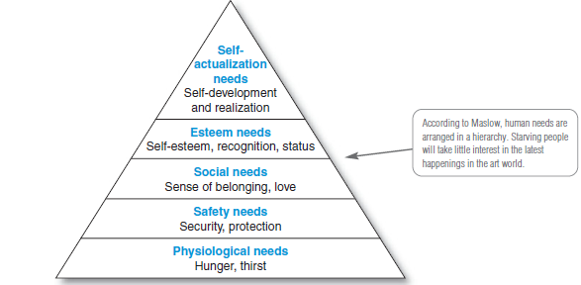people select, organize, and interpret information to form a meaningful picture of the world.

**Learning**

When people act, they learn. Learning describes changes in an individual’s behavior arising

from experience. Learning theorists say that most human behavior is learned. Learning occurs through the interplay of drives, stimuli, cues, responses, and reinforcement. Adrive is a strong internal stimulus that calls for action. **A drive becomes a motive when it is directed toward a particular stimulus object.**

**Beliefs and Attitudes**

Through doing and learning, people acquire beliefs and attitudes. These, in turn, influence their buying behavior. Abelief is a descriptive thought that a person has about something. Beliefs may be based on real knowledge, opinion, or faith and may or may not carry an emotional charge. Marketers are interested in the beliefs that people formulate about specific products and services because these belie fs make up product and brand images that affect buying behavior. If some of the beliefs are wrong and prevent purchase, the marketer will want to launch a campaign to correct them.

People have attitudes regarding religion, politics, clothes, music, food, and almost

everything else. Attitude describes a person’s relatively consistent evaluations, feelings, and tendencies toward an object or idea. Attitudes put people into a frame of mind of liking or disliking things, of moving toward or away from them.

## **Types of Buying Decision Behavior**

Complex Buying Behavior

Consumers undertake complex buying behavior when they are highly involved in a purchase and perceive significant differences among brands. Consumers may be highly involved when the product is expensive, risky, purchased infrequently, and highly self-expressive. Typically, the consumer has much to learn about the product category

Dissonance-Reducing Buying Behavior

Dissonance-reducing buying behavior occurs when consumers are highly involved with an expensive, infrequent, or risky purchase but see little difference among brands. For example, consumers buying carpeting may face a high-involvement decision because carpeting is expensive and self-expressive.

**Habitual Buying Behavior**

Habitual buying behavioroccurs under conditions of low-consumer involvement and little significant brand difference. For example, take table salt. Consumers have little involvement in this product category—they simply go to the store and reach for a brand. If they keep reaching for the same brand, it is out of habit rather than strong brand loyalty. Consumers appear to have low involvement with most low-cost, frequently purchased products.

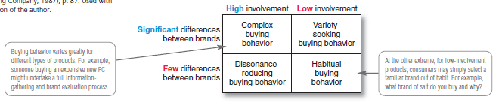**Variety-Seeking Buying Behavior**

Consumers undertake variety-seeking buying behavior in situations characterized by low consumer involvement but significant perceived brand differences. In such cases, consumers

often do a lot of brand switching. For example, when buying cookies, a consumer may hold some beliefs, choose a cookie brand without much evaluation, and then evaluate that brand during consumption. But the next time, the consumer might pick another brand out of boredom or simply to try something different. Brand switching occurs for the sake of variety rather than because of dissatisfaction.

## **The Buyer Decision Process**

Now that we have looked at the influences that affect buyers, we are ready to look at how consumers make buying decisions. Figure 5.6 shows that the buyer decision process consists of **five stages: need recognition, information search, evaluation of alternatives, purchase decision,and postpurchase behavior**. Clearly, the buying process starts long before the actual purchase and continues long after. Marketers need to focus on the entire buying process rather than on the purchase decision only.

**Need Recognition**

The buying process starts with need recognition—the buyer recognizes a problem or need.

The need can be triggered by internal stimuli when one of the person’s normal needs—for example, hunger or thirst—rises to a level high enough to become a drive. A need can also be

triggered by external stimuli.

**Information Search**

An interested consumer may or may not search for more information. If the consumer’s drive

is strong and a satisfying product is near at hand, he or she is likely to buy it then. If not, the consumer may store the need in memory or undertake an information search related to the need

**Evaluation of Alternatives**

We have seen how consumers use information to arrive at a set of final brand choices. How does the consumer choose among alternative brands? Marketers need to know about alternative evaluation, that is, how the consumer processes information to arrive at brand choices. Unfortunately, consumers do not use a simple and single evaluation process in all buying situations. Instead, several evaluation processes are at work.

**Purchase Decision**

In the evaluation stage, the consumer ranks brands and forms purchase intentions. Generally,

the consumer’s purchase decision will be to buy the most preferred brand, but two factors can come between the purchase intention and the purchase decision. The first factor is the attitudes of others. If someone important to you thinks that you should buy the lowestpriced car, then the chances of you buying a more expensive car are reduced.

**Postpurchase Behavior**

The marketer’s job does not end when the product is bought. After purchasing the product,

the consumer will either be satisfied or dissatisfied and will engage in postpurchase behavior of interest to the marketer. What determines whether the buyer is satisfied or dissatisfied with a purchase? The answer lies in the relationship between the consumer’s expectations and the product’s perceived performance. If the product falls short of expectations, the consumer is disappointed; if it meets expectations, the consumer is satisfied; if it exceeds expectations, the consumer is delighted.

**The Buyer Decision Process for New Products**

Stages in the Adoption Process

Consumers go through **five stages** in the process of adopting a new product:

**Awareness**: The consumer becomes aware of the new product but lacks information about it.

**Interest**: The consumer seeks information about the new product.

**Evaluation**: The consumer considers whether trying the new product makes sense.

**Trial:** The consumer tries the new product on a small scale to improve his or her estimate of

its value.

**Adoption**: The consumer decides to make full and regular use of the new product

# **Direct marketing - p.496**

Direct marketing consists of connecting directly with carefully targeted consumers,

often on a one-to-one, interactive basis. Using detailed databases, companies tailor their

marketing offers and communications to the needs of narrowly defined segments or individual

buyers.

**Growth and Benefits of Direct Marketing**

**Benefits to Buyers**

* For buyers, direct marketing is convenient, easy, and private. Direct marketers never close their doors, and customers don’t have to trek to and through stores to find products. From their homes, offices, or almost anywhere else, customers can shop the Web at any time of the day or night. Business buyers can learn about products and services without tying up time with salespeople.
* Direct marketing channels also give buyers access to a wealth of comparative information about companies, products, and competitors.

**Customer Databases and Direct Marketing (pp 499–500)**

* Effective direct marketing begins with a good customer database. A**customer database** is an organized collection of comprehensive data about individual customers or prospects. A good customer database can be a potent relationship-building tool. The database gives companies a 360-degree view of their customers and how they behave. A company is no better than what it knows about its customers.

**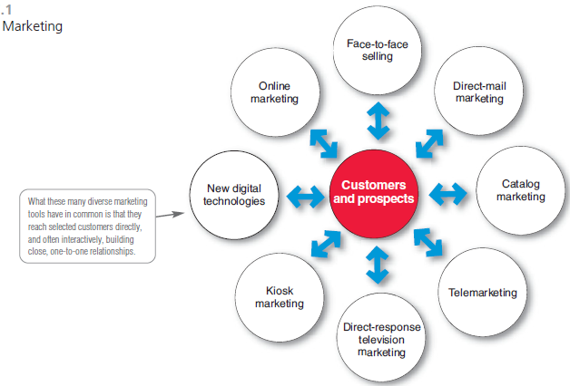****Forms of Direct Marketing (pp 500–508)**

**Direct-Mail Marketing**

Direct-mail marketing involves sending an offer, announcement, reminder, or other item

to a person at a particular physical or virtual address. Using highly selective mailing lists,

direct marketers send out millions of mail pieces each year—letters, catalogs, ads,

brochures, samples, DVDs, and other “salespeople with wings.” Direct mail is by far the

largest direct marketing medium. The DMA reports that U.S. marketers spent $44.4 billion

on direct mail last year (including both catalog and noncatalog mail), which accounted for

32 percent of all direct marketing spending.

**Catalog Marketing**

Advances in technology, along with the move toward personalized, one-to-one marketing,

have resulted in exciting changes in catalog marketing. Catalog Age magazine used to define

a catalog as “a printed, bound piece of at least eight pages, selling multiple products, and

offering a direct ordering mechanism.” Today this definition is

sadly out of date.

**Telephone Marketing**

Telephone marketing involves using the telephone to sell directly to consumers and business

customers. Last year, telephone marketing accounted for more than 19 percent of all direct

marketing-driven sales. We’re all familiar with telephone marketing directed toward

consumers, but B-to-B marketers also use telephone marketing extensively, accounting for

more than 55 percent of all telephone marketing sales.

**Direct-Response Television Marketing**

Direct-response television (DRTV) marketing takes one of two major forms. The first is

direct-response television advertising. Direct marketers air television spots, often 60 or 120 seconds

in length, which persuasively describe a product and give customers a toll-free number

or a Web site for ordering. Television viewers also often encounter full 30-minute or longer

advertising programs, called infomercials, for a single product.

**Kiosk Marketing**

As consumers become more and more comfortable with digital and touch-screen technologies,

many companies are placing information and ordering machines—called kiosks

(good old-fashion vending machines but so much more)—in stores, airports, hotels, college

campuses, and other locations. Kiosks are everywhere these days, from self-service

hotel and airline check-in devices to in-store ordering devices that let you order merchandise

not carried in the store.

## **New Digital Direct MarketingTechnologies**

**Mobile Phone Marketing**

With more than 285 million Americans (91 percent) now subscribing to

wireless services, many marketers view mobile phones as the next big direct

marketing medium. Currently, 21 percent of cell phone subscribers

use their phones to access the Web. Some 23 percent of cell phone users

have seen advertising on their phones in the last 30 days, and about half

of them responded to the ads

**Podcasts and Vodcasts**

Podcasting and vodcasting are on-the-go, on-demand technologies. The name podcast derives from Apple’s now-everywhere iPod. With podcasting, consumers can download audio files (podcasts) or video files (vodcasts) via the Internet to a handheld device and then listen to or view them whenever and

wherever they wish.

**Online Marketing (pp 508–513)**

As noted earlier, online marketing is the fastest-growing form of direct marketing. Widespread

use of the Internet is having a dramatic impact on both buyers and the marketers

who serve them.

**Marketing and the Internet**

Much of the world’s business today is carried out over digital networks that connect people

and companies. The Internet, a vast public web of computer networks, connects users of

all types all around the world to each other and an amazingly large information repository.

The Internet has fundamentally changed customers’ notions of convenience, speed, price,

product information, and service.

**Online Marketing Domains**

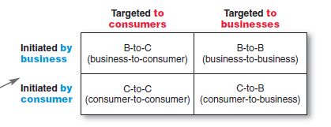

**Setting Up an Online Marketing Presence**

In one way or another, most companies have now moved online. Companies conduct online marketing in any of the four ways shown in Figure 17.3: creating a Web site, placing ads and promotions online, setting up or participating in online social networks, or using e-mail.

## **Public Policy Issues in Direct Marketing**

Direct marketers and their customers usually enjoy mutually rewarding relationships. Occasionally, however, a darker side emerges. The aggressive and sometimes shady tactics of a few direct marketers can bother or harm consumers, giving the entire industry a black eye. Abuses range from **simple excesses that irritate consumers to instances of unfair practices or even outright deception and fraud**. The direct marketing industry has **also faced growing invasion-of-privacy concerns**, and online marketers must deal **with Internet security issues.**

# PARTICULARITIES OF THE EUROPEAN CONSUMER`S BEHAVIOUR IN ONLINE ENVIRONMENTS

* Concept of e-consumer
* Furthermore, the e-consumer is more concerned by the functional characteristics of the products, and implicitly by the utility entailed by the consumption.
* 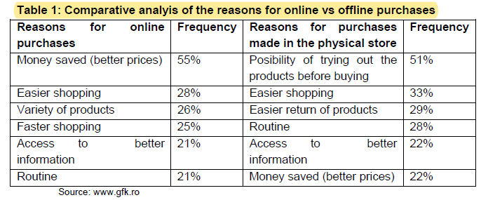Extremely interesting is the fact that four of the motives that determine online purchases are found among the top five determinants of offline purchases:

## Characteristics of the online purchasing behavior

* 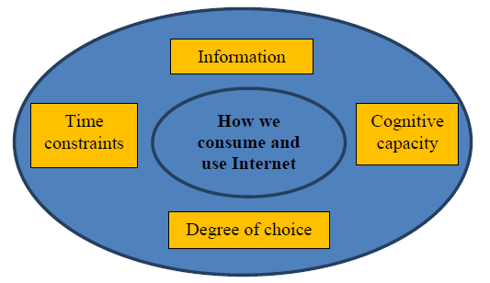A study published by GfK reveals that 67% of these consumers use the Internet for information while 38% actually go see the actual product in the store after they purchase it online or from another retailer.

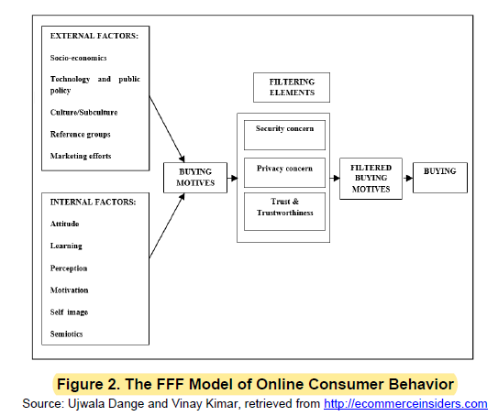

## Secondary data sources research on online purchasing behavior of the European consumers

* 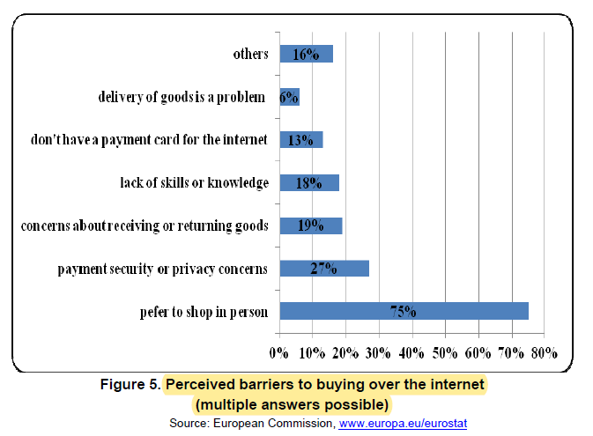The increased interest in recent years regarding the use of the online environment both by consumers and by bidders, has led to the emergence of a real concern for creating a digital single market in Europe.
* In Romania, the preferences of the consumer in terms of goods and services purchased online broadly follow the same ordering, for the first and second place, while book and magazine purchases rank third in the top of the Romanian online purchases.

## **Conclusions**

* while the marketing of both online and offline products gives the consumer the opportunity to choose the right product, at the right price, using the most suitable marketing method and employing the appropriate promotional manner in line with their needs.

# A study of online user`s behaviour towards facebook social network.

Therefore the main objective monitored in this paper is emphasized by the significance of the online user’s behaviour, the reasons and future intention to access this socialisation platform.

## Literature review – the concept of marketing online

**A first definition of Cybermarketing was proposed by Imber Jane**, which means *"the process of creating and maintaining customer relationships through online activities by facilitating the exchange of ideas, products and services to meet the needs of both parties".*

One of the most comprehensive definitions of online marketing is **provided by Mohammed and others (2002, p.4), they had defined marketing online** as *“the process of building and maintain customer relationships through online activities in order to facilitate the exchange of ideas, products and services so that can be obtained the buyers but also from sales perspective*”.

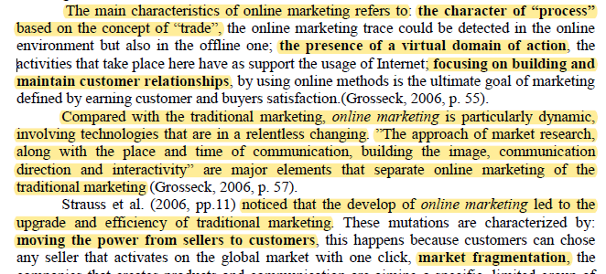

## The social network- specific instruments used in online marketing communication

* The social platforms like Facebook, Tweeter, LinkedIn etc. are selling advertising space to companies that can use the information from the users profile in order to provide specific targeted publicity.
* **The purpose** of this research is to identify the reasons, behaviours and intentions of online users of continuing to socialize through Facebook's using various applications.

## Conclusions

After careful analysis and results interpretation, the current paper shows that, among the respondents of this study, there is a great number of Romanian online users who own an active account on the Facebook social network.

As shown in this study, online users prefer interactive applications which offer them

the opportunity to get directly involved and share things which are of interest to them.

# THE LOYAL CONSUMER`S PERCEPTION REGARDING THE ONLINE BUYING PROCESS

## Introduction

* Once the Internet became a tool used for communication, promotion and transactions, new platforms for competitive strategies were developed (Celuch *et al.*, 2007).
* Electronic commerce includes any form of commercial transaction where involved parts interact in an electronic manner
* “although Internet penetration in Romania is still low compared to the European average of 70%, by 2018,
* Regarding preferences in the online shopping context, Romanians mostly buy electronics and video games, apparel, beauty and personal care products.
* With more and more customers switching to online shopping and a constantly growing rate of retailers’ online presence in Romanian market, a great challenge for managers it to attract new clients, while forming loyal customers as well.

**The research objectives are**:

(1) To identify the advantages and disadvantages of buying from the Internet;

(2) To identify the reasons of buying from the Internet;

(3) To identify the reasons of frequently buying from the same website.

* The reasons for buying from the Internet can be justified by the benefits the online shopping offers: accessibility without time or space restrictions, convenience, a good product selection.
* The Euromonitor research report on Internet Retailing in Romania (2014) reveals as the main reasons for Romanians buying from website the comfort of accessing online stores, the wide range of products available and the lower price comparing with traditional stores.

## Research sampling

The investigated population is represented by Romanian online customers who use to buy

products from a specific website. The sample consisted in 30 persons who usually buy products from the Internet, between the ages of 19 and 26 years, who bought products from a specific website at least three times in the last six months and consider themselves loyal to that Internet site.

## Research results

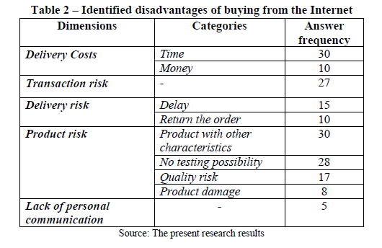

**The most important reasons for the participants use to buy from online stores are**:

space accessibility, access convenience, evaluation convenience, delivery convenience, time savingand money saving.

**The motivations for repeating the purchase from the same website are:** product quality, product diversity, quick delivery, easy to use, recommendations, good deals, safety, reputation and interactivity.

# PSYCHOLOGICAL AND SOCIAL FACTORS THAT INFLUENCE ONLINE CONSUMER BEHAVIOUR

## **Factors the influence consumer behaviour**

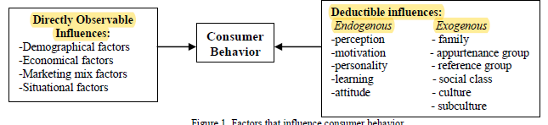

## . Literature Review of Factors that Influence Online Consumer Behavior

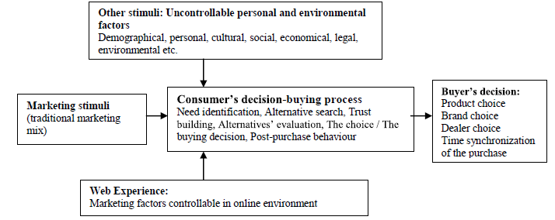

### Psychological Factors that Influence Online Consumer Behavior

* The most representative psychological factors that influence online consumer behavior are online perception,trust, personality and website`s aesthetics. *Perception* is the interpretation process by which consumers make sense of their own environment.

Social Factors that Influence Online Consumer Behavior

* Social factors that influence consumer behavior are: reference groups, family and social roles and statuses. In the online environment consumer behavior is mostly influenced by the virtual groups they are part of and, therefore, by WOM (Word-of-mouth).