# **Comportamentul consumatorului online – continut si tendinte**

In the international context of the digital communication era, online commerce becomes an important part of business systems. It is a business model which has a major impact on the entire society. Once the Internet became a tool used for communication, promotion and transactions, new platforms for competitive strategies were developed.

**Electronic commerce includes any form of commercial transaction where involved parts interact in an electronic manner**

In a global economy developed in a highly competitive market, consumer orientation is no longer a trend but a necessity for business success.

A good understanding of the way consumers leverage the Internet features, to make purchasing decisions in the e-commerce environment, brings a significant advantage for managers in order to develop suitable marketing strategies (Wu and Lin, 2006). Online buyers have unlimited access to the information they require and have the opportunity to choose from a wide range of options in selecting products and services with highly competitive prices.

The digital market is by now a sector of interest at European level, as this market has recorded a growth rate seven times higher than other economic sectors in recent years. The increased interest in recent years regarding the use of the online environment both by consumers and by bidders, has led to the emergence of a real concern for creating a digital single market in Europe.

## **Comert electronic**

**The digital environment** has changed the way consumers and businesses interact, provided new opportunities by facilitating access to information and reduced transaction costs. Furthermore, by allowing easier interaction between consumers and sellers in different locations, the digital environment, and e-commerce in particular, is central to the development of the European Single Market. The digital environment is also likely to have wider economic benefits in terms of increased innovation, creativity, learning, instant and unlimited access to information sources, and reduced environmental costs associated with transactions.

The purpose of this study is to analyse European consumers’ behaviour in the digital environment based on a review of existing literature and data, and a limited stakeholder consultation exercise.

**Internet access is a key facilitator of e-commerce** and there is a strong positive association between internet up-take in a country and the share of consumers who have purchased goods and services online.

E-commerce is central to the development of the Internal Market. The digital market-place provides wider opportunities for consumers and businesses but at the same time may involve additional risks. Trust and confidence in the digital market-place will only improve if basic rights as well as obligations in the digital environment are clear.

**In this context, it is worth noting that e-commerce includes both transactions involving tangible goods** such as electronics, groceries and toys which need to be physically delivered to the consumer **and transactions involving access to digital content**, services and products which can be delivered digitally to the consumer (intangible goods). It is worth noting that some goods exist as both tangible and intangible goods. For example, books, newspapers and magazines, music, videos, online software and games.

Eurostat data on online purchases show that the most common items bought over the internet are clothes and travel-related goods and services (Table 5). Computer and electronic goods are the least likely to be bought online, which may be due to the fact that there is a higher perceived risk associated with these goods. This risk originates from the relatively high value of the goods.

**Barriers to e-commerce**

* Data from Eurostat show that the most common reason for not shopping online is that consumers prefer to shop in person (62% or say they have no need.
* The Eurostat data also suggests that security, privacy and trust concerns are relatively common barriers to e-commerce for many consumers, and that concerns over the risk of problems.
* It is also worth noting that only 8% of consumers mentioned that the lack of product information prevented them from ordering goods and services online.

## **Tranzactie online**

**Online transaction** is a payment method in which the transfer of fund or money happens **online** over electronic fund transfer. **Online transaction** process (OLTP) is secure and password protected. Three steps involved in the **online transaction** are Registration, Placing an order, and, Payment.

Online transactions are familiar to most people. Examples include: ATM machine transactions such as **deposits**, withdrawals, inquiries, and transfers. Supermarket payments with debit or credit cards.

## **Comportamentul consumatorului online**

Consumers’ acceptance of the Internet as a means to inform, compare and purchase various products and services has resulted in what the specialized literature defines by the concept of e-consumer.

Unlike the traditional consumers, who are more conservative and more constant in their choices, the e-consumers manifest a greater openness to change, being more available to try new possibilities. (Belingher & Călin, 2011)

Furthermore, the e-consumer is more concerned by the functional characteristics of the products, and implicitly by the utility entailed by the consumption. (Brown et al, 2003).

Therefore, a portrait of the e-consumer describes them as an innovative person with above-average education levels and with a relatively high socioeconomic status. (Dennis et al, 2008)

### **Trends in consumer demand of relevance for understanding the consumer in the digital environment**

A recent study for the European Commission identified a number of trends in consumer demand (Helsper, et al., 2010):

* ***Domestication and mobilisation of consumption***. Consumers increasingly consume at home or on the move. In 2008, 12% of consumers have undertaken e-commerceactivity in the office (Gallup Organisation, 2008a) and 7% of EU citizens had accessed the internet on their mobile phone. Interestingly, only 5% of women accessed the internet on a mobile device compared with double the amount of men at 10%. In total, 33% of consumers in the EU have access to the internet on their mobile phone. In addition, there is a trend that consumption takes place not only *where* the consumer wants but also *when* the consumer wants. These trends are facilitated by new technologies such as internet and mobile phone services with 24 hour access to sales platforms making it possible for consumers to make orders whenever they find it convenient (e.g. NRC, 2009).
* ***Globalisation***. Just as production has become increasingly international, demand is also affected by globalisation trends. Consumers now expect products from all over the world to be delivered to their doorstep. Information and communication technologies have made cross-border trade easier and consumers in very different parts of the world now have access to very similar products.
* ***Personalisation***. While mass production is an important part of globalisation, an important counter trend is customisation of products and services to individual needs and wishes. An example of this trend is the increasing importance of tailor made travel packages.

**FACTORS OF INFLUENCE ON CONSUMER ONLINE**

Another approach of the factors influencing the online purchasing behavior

belongs to teachers Ujwala Dange and Vinay Kimar (figure 2), who founded the so called “FFF” model, starting from the three categories of influences exerted on buyer behavior in online environments, namely: internal and external factors that may cause the buyer to make online purchases, information filter factors through the prism of the risk perceived by the online purchaser, and purchase decision filtering factors, related to the manner in which the consumer evaluates their own expectations and motives as a result of the action of all the influences mentioned above.

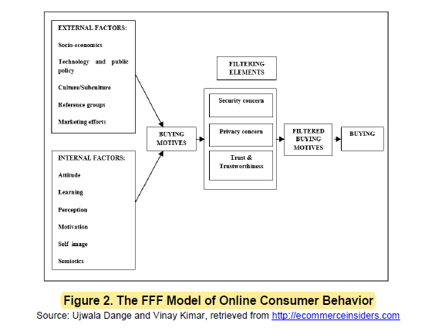

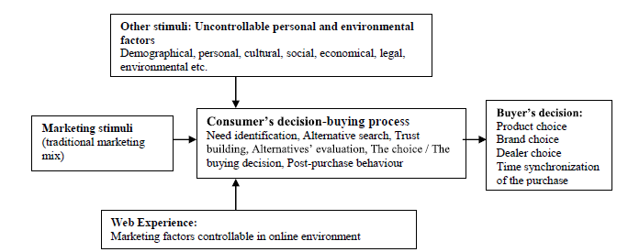

**The consumer purchasing process**

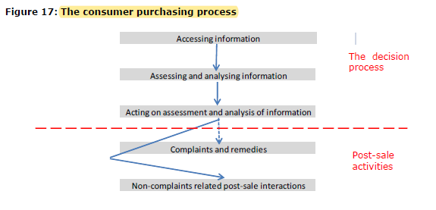1 **Accessing information**

* When a consumer starts thinking about purchasing a product or service, it may be initiated by a need or desire for a particular product or service or for certain attributes or aspects of a product or service. The consumer may begin by reflecting on what his or her needs and desires are, and assuming that consumers are rational decision makers, traditional economic theory would then predict that the consumer uses all available information to make the purchasing decision.
* Improved access to information about products, services and prices has been shown to have positive benefits for consumers, however, some consumers may find volume of information available overwhelming.
* In the digital environment, consumers are affected by social influence from online reviews and online social networks, as well as from offline sources. The digital environment allows consumers to tap into recommendations and information from a much wider group of consumers, including people they do not know personally.

### **2.Assesment and Analysis**

* Based on the information gathered and assimilated during the first stage of the consumers purchasing process and given her/his preferences, the consumer then engages in a more narrow consideration of which type of product or service to buy and from which seller.
* Consumers do not utilise online search and filtering tools fully and only consider websites that appear among the top search results. Online consumers trust well-known brands and, as a result, established brands are gaining market share.
* While the internet offers consumers access to large volumes of detailed information, information on some product attributes is not available. Consumers are not able to touch and smell products before they purchase.
* This may imply that it is more difficult for consumers to assess the information they find online about product quality.
* Recommendations and consumer reviews are highly trusted sources of information that have been shown to influence consumer behaviour.

**3. Acting on Assesment and Analysis**

* Consumers benefit from e-commerce through the opportunity to pay lower prices, access to wider variety of goods and sellers.
* stage of the purchase process where the consumer acts on the assessment of information and makes the actual purchase online.
* In standard economic theory consumers make consistent and fully rational decisions based on full information. Therefore, consumers buy a product that maximises their utility.
* Consumers do not always carry out their research online. In a survey conducted by the OFT (2007a), some businesses noted how shoppers go into offline stores to receive face to face advice before buying the item at a lower cost online.

**4. Complaints and Redress Mechanisms**

* This stage applies only when the consumer has a problem with the good or service and complains to the seller. The purchasing pr ocess in the digital market place differs from the one used offline. Consequently, when consumers purchase in the digital environment they may experience a change in the type and magnitude of problem incurred compared to purchasing offline.
* When consumers purchase in the digital environment they may experience a change in the type of problem incurred compared to purchasing offline. Most typically, problems with e-commerce are related to delivery or the quality of the product or service.

**Problems faced by consumers online**

According to representatives from ECC-Net, problems experienced by consumers online are

typically related to:

* non-delivery or late delivery of goods;
* goods not as described;
* problems with guarantees;
* problems with the ‘cooling off period’ rule; and
* prices, hidden costs or incorrect display of prices.

**Benefits of shopping in the digital environment**

* Stakeholders consulted for this study have pointed out a number of ways in which
* consumers benefit from e-commerce:
* • Opportunity to pay lower prices.
* • Access to wider variety of goods and sellers. This is particularly, important in remote
* areas poorly served by ‘bricks-and-mortar’ retailers.
* • Increased ease of comparing product specifications and prices.
* • Greater convenience of online shopping.
* • Ability to share/receive consumer information on consumer forums.

# **KOTLER, ARMSTRONG- PRINCIPLES OF MARKETING**

CONSUMER BUYING BEHAVIOUR

Consumer purchases are influenced strongly by cultural, social, personal, and psychological

characteristics, as shown in **Figure 5.2**. For the most part, marketers cannot control

such factors, but they must take them into account.

## **Cultural factors**

**Culture**

* is the most basic cause of a person’s wants and behavior. Human behavior is largely

learned. Growing up in a society, a child learns basic values, perceptions, wants, and behaviors

from his or her family and other important institutions.

**Subculture**

**Social Class**

Social class is not determined by a single factor, such as income, but is measured as a combination of occupation, income, education, wealth, and other variables. In some social systems, members of different classes are reared for certain roles and cannot change their social positions.

## **Social factors**

Groups and Social Networks

***Word-of-Mouth Influence and Buzz Marketing.*** Word-of-mouth influence can have a

powerful impact on consumer buying behavior. The personal words and recommendations

of trusted friends, associates, and other consumers tend to be more credible than those coming

from commercial sources, such as advertisements or salespeople.

**Online social Networks**

Online social networks are online communities where people socialize or exchange information and opinions. Social networking media range from blogs (Gizmodo) and message boards (Craigslist) to social networking Web sites (Facebook and Twitter) and virtual worlds (Second Life).

**Family**

Family members can strongly influence buyer behavior. The family is the most important consumer buying organization in society, and it has been researched extensively. Marketers are interested in the roles and influence of the husband, wife, and children on the purchase of different products and services.

**Roles and Status**

A person belongs to many groups—family, clubs, organizations, online communities. Theperson’s position in each group can be defined in terms of both role and status. A role consists of the activities people are expected to perform according to the people around them.Each role carries a status reflecting the general esteem given to it by society.

## **Personal Factors**

Age and Life-Cycle Stage

People change the goods and services they buy over their lifetimes. Tastes in food, clothes,

furniture, and recreation are often age related. Buying is also shaped by the stage of the family

life cycle—the stages through which families might pass as they mature over time. Lifestage changes usually result from demographics and life-changing events—marriage, having children, purchasing a home, divorce, children going to college, changes in personal income, moving out of the house, and retirement.

**Occupation**

A person’s occupation affects the goods and services bought. Blue-collar workers tend to buy more rugged work clothes, whereas executives buy more business suits. Marketers try to identify the occupational groups that have an above-average interest in their products and services. A company can even specialize in making products needed by a given occupational group.

Lifestyle

People coming from the same subculture, social class, and occupation may have quite different

lifestyles. **Lifestyle** is a person’s pattern of living as expressed in his or her psychographics.

It involves measuring consumers’ major AIO dimensions—activities (work, hobbies, shopping, sports, social events), interests (food, fashion, family, recreation), and opinions (about themselves, social issues, business, products).

Personality and Self-Concept

Each person’s distinct personality influences his or her buying behavior. **Personality** refers

to the unique psychological characteristics that distinguish a person or group. Personality

is usually described in terms of traits such as self-confidence, dominance, sociability, autonomy, defensiveness, adaptability, and aggressiveness. Personality can be useful in analyzing

consumer behavior for certain product or brand choices.

## **Psychological Factors**

**Motivation**

Aperson has many needs at any given time. Some are biological, arising from states of tension

such as hunger, thirst, or discomfort. Others are psychological, arising from the need for recognition, esteem, or belonging. Aneed becomes a motive when it is aroused to a sufficient level of intensity. A **motive** (or **drive**) is a need that is sufficiently pressing to direct the person to seek satisfaction.

**Perception**

Amotivated person is ready to act. How the person acts is influenced by his or her own perception of the situation. All of us learn by the flow of information through our five senses:

sight, hearing, smell, touch, and taste. However, each of us receives, organizes, and interprets

this sensory information in an individual way. Perception is the process by whic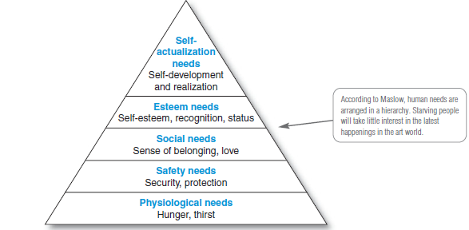h people select, organize, and interpret information to form a meaningful picture of the world.

**Learning**

When people act, they learn. Learning describes changes in an individual’s behavior arising

from experience. Learning theorists say that most human behavior is learned. Learning occurs through the interplay of drives, stimuli, cues, responses, and reinforcement. Adrive is a strong internal stimulus that calls for action. **A drive becomes a motive when it is directed toward a particular stimulus object.**

**Beliefs and Attitudes**

Through doing and learning, people acquire beliefs and attitudes. These, in turn, influence their buying behavior. Abelief is a descriptive thought that a person has about something. Beliefs may be based on real knowledge, opinion, or faith and may or may not carry an emotional charge. Marketers are interested in the beliefs that people formulate about specific products and services because these belie fs make up product and brand images that affect buying behavior. If some of the beliefs are wrong and prevent purchase, the marketer will want to launch a campaign to correct them.

People have attitudes regarding religion, politics, clothes, music, food, and almost

everything else. Attitude describes a person’s relatively consistent evaluations, feelings, and tendencies toward an object or idea. Attitudes put people into a frame of mind of liking or disliking things, of moving toward or away from them.

## **Types of Buying Decision Behavior**

Complex Buying Behavior

Consumers undertake complex buying behavior when they are highly involved in a purchase and perceive significant differences among brands. Consumers may be highly involved when the product is expensive, risky, purchased infrequently, and highly self-expressive. Typically, the consumer has much to learn about the product category

Dissonance-Reducing Buying Behavior

Dissonance-reducing buying behavior occurs when consumers are highly involved with an expensive, infrequent, or risky purchase but see little difference among brands. For example, consumers buying carpeting may face a high-involvement decision because carpeting is expensive and self-expressive.

**Habitual Buying Behavior**

Habitual buying behavioroccurs under conditions of low-consumer involvement and little significant brand difference. For example, take table salt. Consumers have little involvement in this product category—they simply go to the store and reach for a brand. If they keep reaching for the same brand, it is out of habit rather than strong brand loyalty. Consumers appear to have low involvement with most low-cost, frequently purchased products.

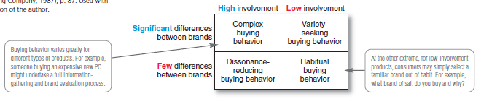**Variety-Seeking Buying Behavior**

Consumers undertake variety-seeking buying behavior in situations characterized by low consumer involvement but significant perceived brand differences. In such cases, consumers

often do a lot of brand switching. For example, when buying cookies, a consumer may hold some beliefs, choose a cookie brand without much evaluation, and then evaluate that brand during consumption. But the next time, the consumer might pick another brand out of boredom or simply to try something different. Brand switching occurs for the sake of variety rather than because of dissatisfaction.

## **The Buyer Decision Process**

Now that we have looked at the influences that affect buyers, we are ready to look at how consumers make buying decisions. Figure 5.6 shows that the buyer decision process consists of **five stages: need recognition, information search, evaluation of alternatives, purchase decision,and postpurchase behavior**. Clearly, the buying process starts long before the actual purchase and continues long after. Marketers need to focus on the entire buying process rather than on the purchase decision only.

**Need Recognition**

The buying process starts with need recognition—the buyer recognizes a problem or need.

The need can be triggered by internal stimuli when one of the person’s normal needs—for example, hunger or thirst—rises to a level high enough to become a drive. A need can also be

triggered by external stimuli.

**Information Search**

An interested consumer may or may not search for more information. If the consumer’s drive

is strong and a satisfying product is near at hand, he or she is likely to buy it then. If not, the consumer may store the need in memory or undertake an information search related to the need

**Evaluation of Alternatives**

We have seen how consumers use information to arrive at a set of final brand choices. How does the consumer choose among alternative brands? Marketers need to know about alternative evaluation, that is, how the consumer processes information to arrive at brand choices. Unfortunately, consumers do not use a simple and single evaluation process in all buying situations. Instead, several evaluation processes are at work.

**Purchase Decision**

In the evaluation stage, the consumer ranks brands and forms purchase intentions. Generally,

the consumer’s purchase decision will be to buy the most preferred brand, but two factors can come between the purchase intention and the purchase decision. The first factor is the attitudes of others. If someone important to you thinks that you should buy the lowestpriced car, then the chances of you buying a more expensive car are reduced.

**Postpurchase Behavior**

The marketer’s job does not end when the product is bought. After purchasing the product,

the consumer will either be satisfied or dissatisfied and will engage in postpurchase behavior of interest to the marketer. What determines whether the buyer is satisfied or dissatisfied with a purchase? The answer lies in the relationship between the consumer’s expectations and the product’s perceived performance. If the product falls short of expectations, the consumer is disappointed; if it meets expectations, the consumer is satisfied; if it exceeds expectations, the consumer is delighted.

**The Buyer Decision Process for New Products**

Stages in the Adoption Process

Consumers go through **five stages** in the process of adopting a new product:

**Awareness**: The consumer becomes aware of the new product but lacks information about it.

**Interest**: The consumer seeks information about the new product.

**Evaluation**: The consumer considers whether trying the new product makes sense.

**Trial:** The consumer tries the new product on a small scale to improve his or her estimate of

its value.

**Adoption**: The consumer decides to make full and regular use of the new product

# **Direct marketing - p.496**

Direct marketing consists of connecting directly with carefully targeted consumers,

often on a one-to-one, interactive basis. Using detailed databases, companies tailor their

marketing offers and communications to the needs of narrowly defined segments or individual

buyers.

**Growth and Benefits of Direct Marketing**

**Benefits to Buyers**

* For buyers, direct marketing is convenient, easy, and private. Direct marketers never close their doors, and customers don’t have to trek to and through stores to find products. From their homes, offices, or almost anywhere else, customers can shop the Web at any time of the day or night. Business buyers can learn about products and services without tying up time with salespeople.
* Direct marketing channels also give buyers access to a wealth of comparative information about companies, products, and competitors.

**Customer Databases and Direct Marketing (pp 499–500)**

* Effective direct marketing begins with a good customer database. A**customer database** is an organized collection of comprehensive data about individual customers or prospects. A good customer database can be a potent relationship-building tool. The database gives companies a 360-degree view of their customers and how they behave. A company is no better than what it knows about its customers.

**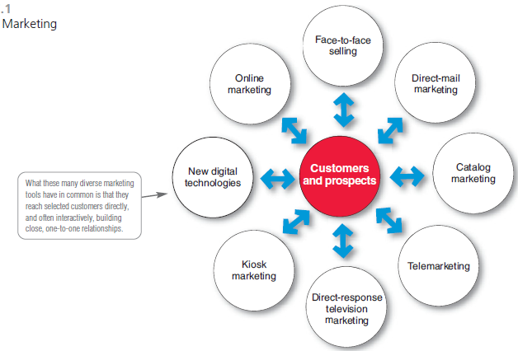****Forms of Direct Marketing (pp 500–508)**

**Direct-Mail Marketing**

**Catalog Marketing**

**Telephone Marketing**

**Direct-Response Television Marketing**

**Kiosk Marketing**

## **New Digital Direct MarketingTechnologies**

**Mobile Phone Marketing**

With more than 285 million Americans (91 percent) now subscribing to

wireless services, many marketers view mobile phones as the next big direct

marketing medium. Currently, 21 percent of cell phone subscribers

use their phones to access the Web. Some 23 percent of cell phone users

have seen advertising on their phones in the last 30 days, and about half

of them responded to the ads

**Podcasts and Vodcasts**

Podcasting and vodcasting are on-the-go, on-demand technologies. The name podcast derives from Apple’s now-everywhere iPod. With podcasting, consumers can download audio files (podcasts) or video files (vodcasts) via the Internet to a handheld device and then listen to or view them whenever and

wherever they wish.

**Online Marketing (pp 508–513)**

As noted earlier, online marketing is the fastest-growing form of direct marketing. Widespread

use of the Internet is having a dramatic impact on both buyers and the marketers

who serve them.

**Marketing and the Internet**

Much of the world’s business today is carried out over digital networks that connect people

and companies. The Internet, a vast public web of computer networks, connects users of

all types all around the world to each other and an amazingly large information repository.

The Internet has fundamentally changed customers’ notions of convenience, speed, price,

product information, and service.

**Online Marketing Domains**

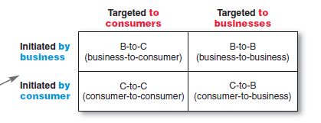

**Setting Up an Online Marketing Presence**

In one way or another, most companies have now moved online. Companies conduct online marketing in any of the four ways shown in Figure 17.3: creating a Web site, placing ads and promotions online, setting up or participating in online social networks, or using e-mail.

## **Public Policy Issues in Direct Marketing**

Direct marketers and their customers usually enjoy mutually rewarding relationships. Occasionally, however, a darker side emerges. The aggressive and sometimes shady tactics of a few direct marketers can bother or harm consumers, giving the entire industry a black eye. Abuses range from **simple excesses that irritate consumers to instances of unfair practices or even outright deception and fraud**. The direct marketing industry has **also faced growing invasion-of-privacy concerns**, and online marketers must deal **with Internet security issues.**

**Cap 2 consumer online Romania**

In Romania, the preferences of the consumer in terms of goods and services

purchased online broadly follow the same ordering, for the first and second place,

while book and magazine purchases rank third in the top of the Romanian online

purchases.

1. Compulsive buying behavior on the internet(1)
2. Nowdays online consumer`s rights and interests
3. The loyal customers perception (9)

The electronic commerce became more and more present **on Romanians list of shopping options**, in the context of a growing Internet penetration rate: “although Internet penetration in Romania is still low compared to the European average of 70%, by 2018, rates are expected to be significantly more balanced with over two thirds of the population having home access to the Interne” (Euromonitor, 2014).

**Regarding preferences in the online shopping context, Romanians mostly buy electronics and video games, apparel, beauty and personalcare products.** With more and more customers switching to online shopping and a constantly growing rate of retailers’ online presence in **Romanian market**, a great challenge for managers it to attract new clients,while forming loyal customers as well. With more access to information and having already some buying experience, the online shopping habits of Romanians are evolving. The new generation of young people is more familiar with online technology, has more experience in using the Internet and is more willing to face perceived risk.