API

# What is API

* API helps two programs or applications to communicate with each other by providing them with the necessary tools and functions
* uses APIs in his software to implement various features by using an API call without writing complex codes

# How does API work

* the client sends the request via a medium to the server and receives the response through the same medium

# Types of APIs

* WEB APIs
* Local APIs
* Program APIs

# API lifecycle

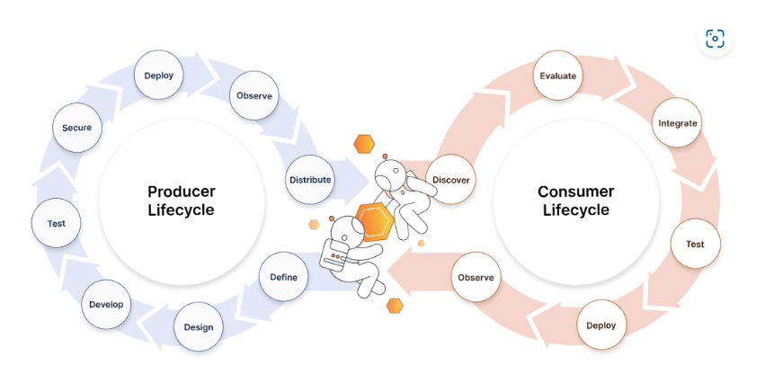

# How to Deploy a Machine Learning Model

[Source code](https://github.com/Davisy/Model-Deployment-by-using-Flask)

## Algorithmia

* Algorithmia is a MLOps (machine learning operations) tool founded by Diego Oppenheimer and Kenny Daniel that provides a simple and faster way to deploy your machine learning model into production.
* Algorithmia specializes in "algorithms as a service". It allows users to create code snippets that run the ML model and then host them on Algorithmia. Then you can call your code as an API.

## PythonAnywhere

* Python web framework like Flask to deploy your machine learning model and run it on the pythonAnywhere platform in just a few minutes.
* Does not support GPU

## Heroku

* If you want to deploy your model for the first time, I recommend that you try Heroku because it is flexible and easy to use
* It offers a wide range of services and tools to speed up your development and helps you avoid starting everything from scratch. It also supports several widely used programming languages like Python, Java, PHP, Node, Go, Ruby, Scala, and Clojure.

# ML deployment by venv python

* Set Up the Virtual Environment
* Install Required Packages
* Prepare Your Model for Deployment
* Create a Flask API for the Model
* Run the Flask App
* Access Your API
* Deactivating the Virtual Environment