**Scalefocus Homework – Linux Commands**

**Mihail Elencevski**

1. Create a file friends.txt with a list of names of three of your friends on separate lines.

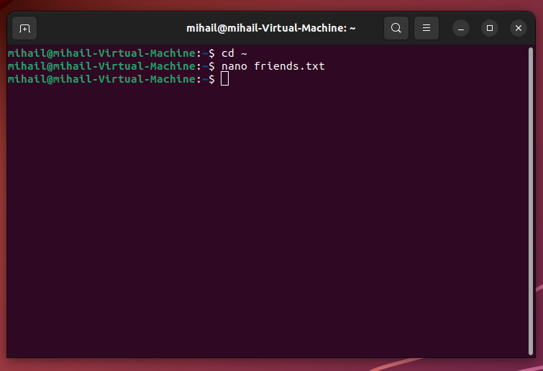

1. Display the contents of friends.txt on the console.

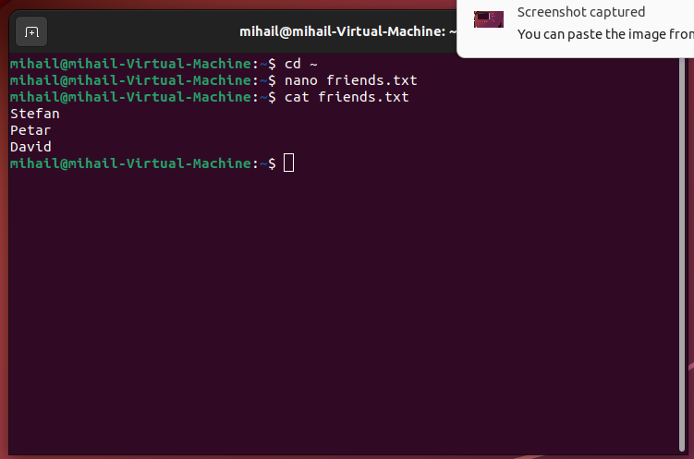

1. Rename file friends.txt to bestfriends.txt

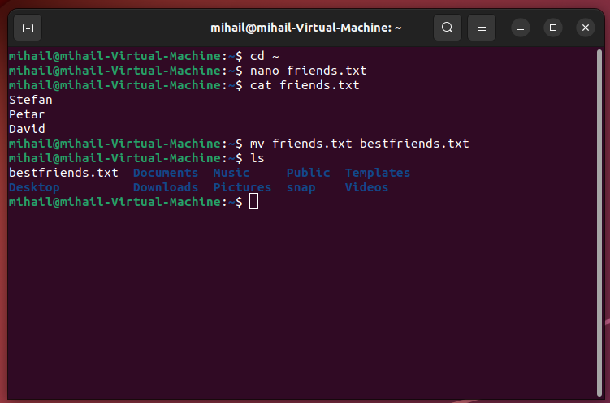

1. Make a copy of bestfriends.txt under the name sysadmins.txt

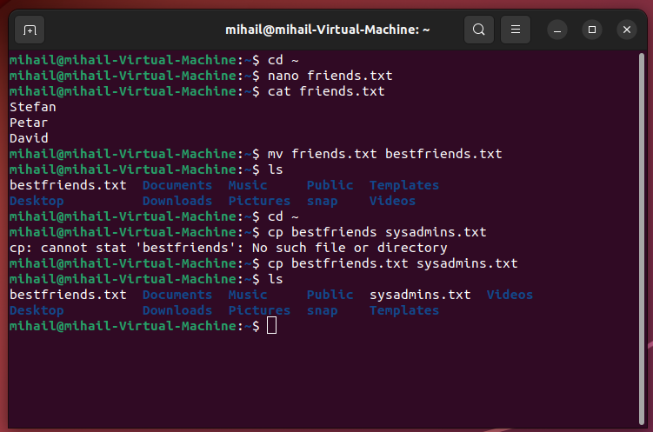

5. List all files whose name begins with letter 'b' and ends with extension txt.

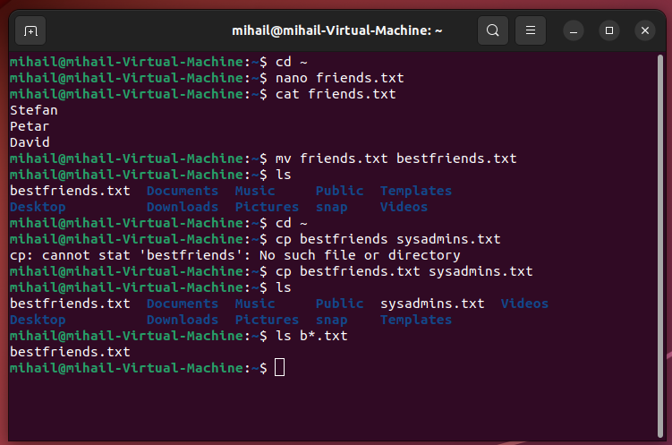

6. Write a command that will tell you how many bytes are taken up by file sysadmins.txt

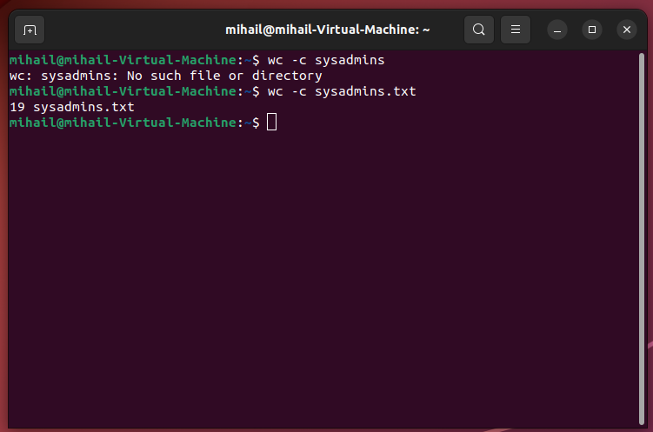

7. Create file cars.txt with a list of 5 brands of cars on separate lines

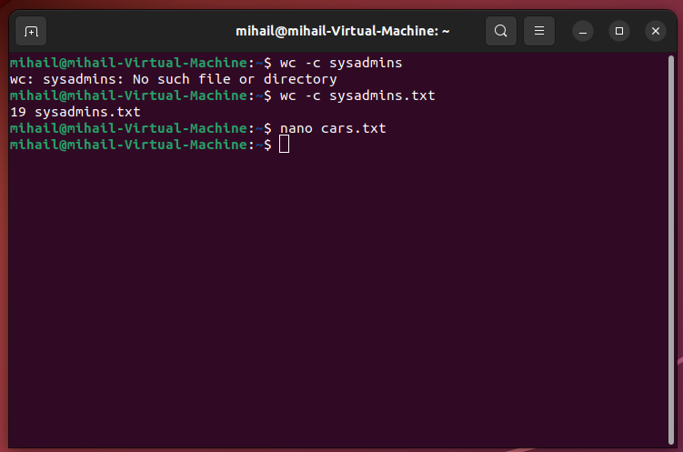

8. Check how many bytes are taken up by the file.

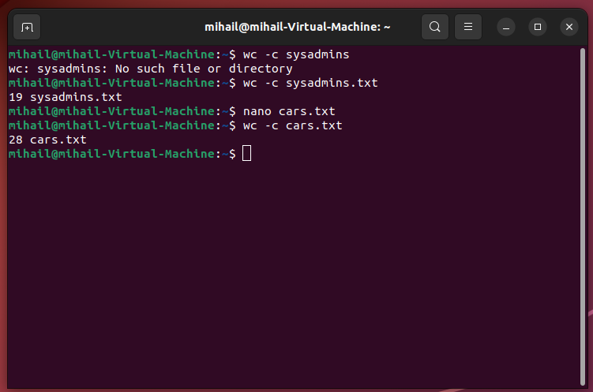

9. Copy the file cars.txt into directory /tmp

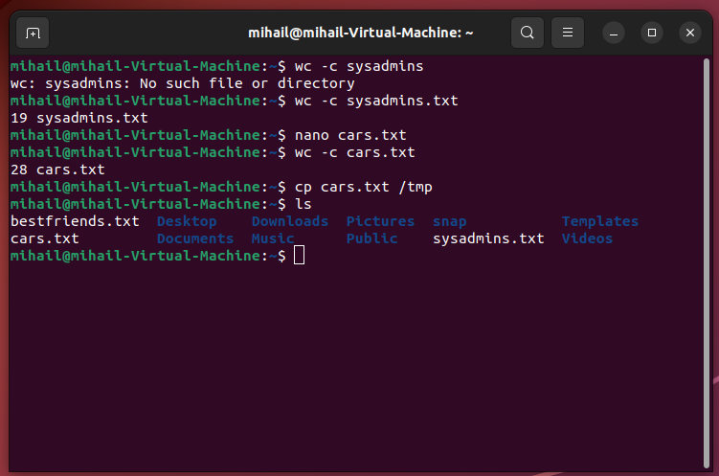

10. List all files with extension *.txt in directory /tmp and verify that the file was copied properly.

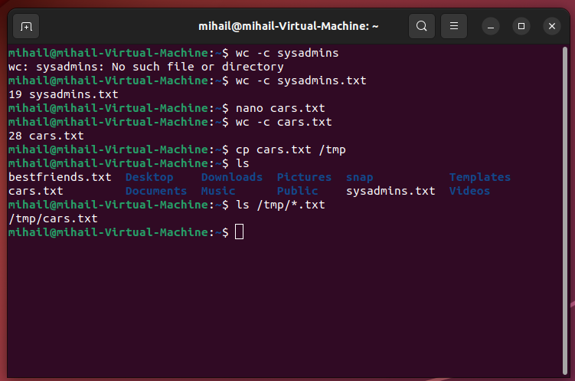

11. Without leaving your home directory rename file cars.txt located in /tmp to vehicles.txt in /tmp

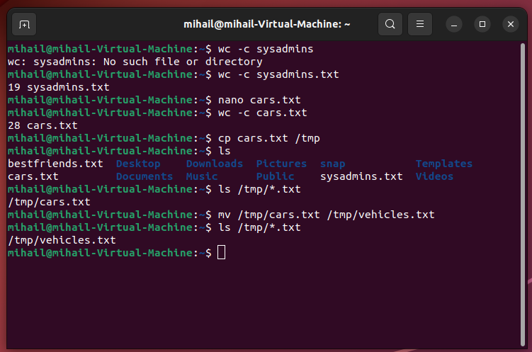

12. Display the contents of /etc/passwd file on the screen interactively (so you can search, scroll up and down)

