**Lab 08 - Manage Virtual Machines**

***Mihail Elencevski***

#### Task 1: Deploy zone-resilient Azure virtual machines by using the Azure portal and an Azure Resource Manager template

*Here I am succesfully deploying a zone resilient VM. (A zone-resilient virtual machine is designed to withstand failures at the zone level, ensuring high availability and reliability. If one zone fails It will go to the other deployed zone)*

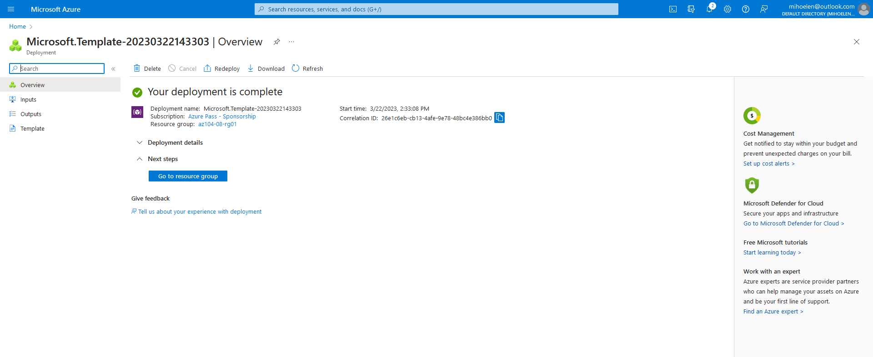

#### Task 2: Configure Azure virtual machines by using virtual machine extensions

This task involved configuring Azure virtual machines by installing the Windows Server Web Server role with the Custom Script virtual machine extension. Prior to the final step, I deployed two virtual machines, created a "scripts" container in a diagnostics storage account, and uploaded a PowerShell script named "az104-08-install_IIS.ps1" to the container. Than I just ran the script.

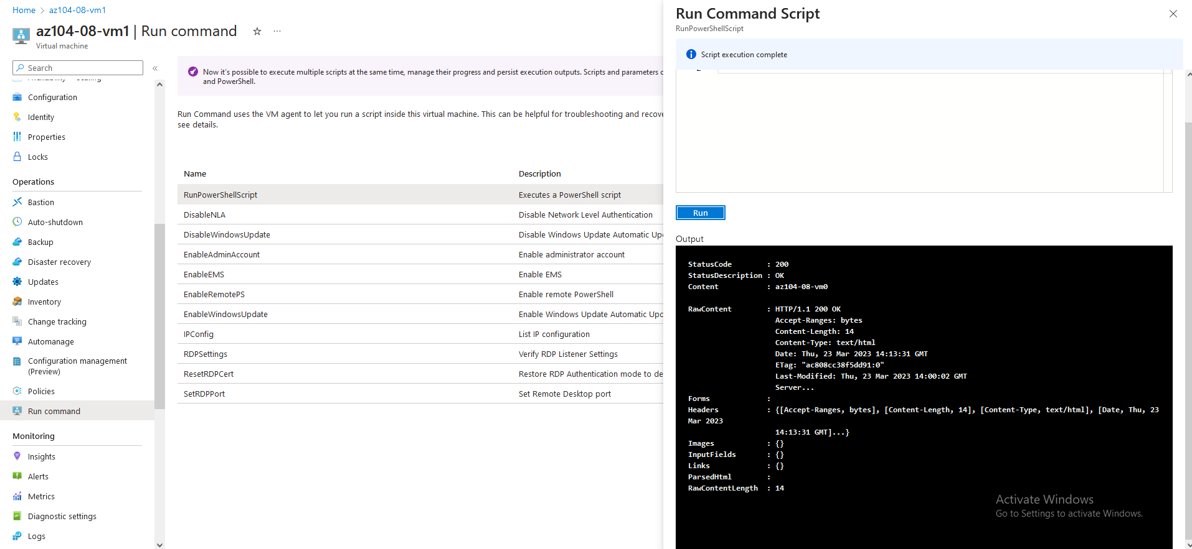

#### Task 3: Scale compute and storage for Azure virtual machines

*This Azure task involves scaling Azure virtual machines by changing their size and scaling their storage by attaching and configuring data disks, creating a new disk, and running a PowerShell script to create a drive.*

*In this picture I am running a powershell script to create a drive. On the* ***az104-08-vm0***

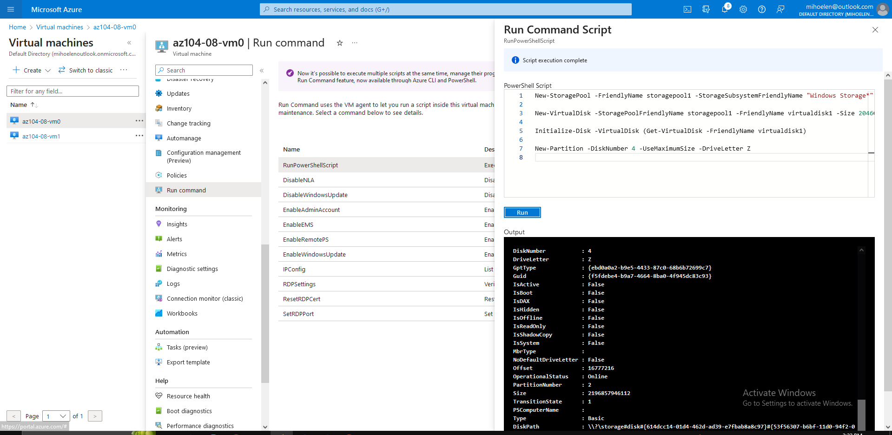

*In this picture I am running a powershell script to create a drive. On the* ***az104-08-vm01.***

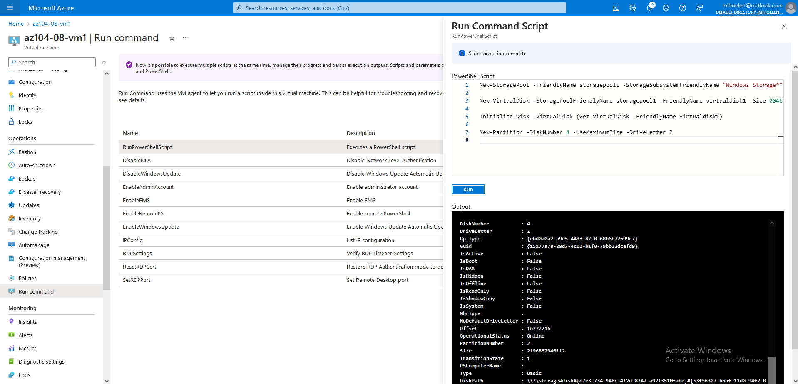

#### Task 4: Register the Microsoft.Insights and Microsoft.AlertsManagement resource providers

*Here I am successfully running 2 commands to register the Microsoft.Insights and Microsoft.AlertsManagement resource providers.*

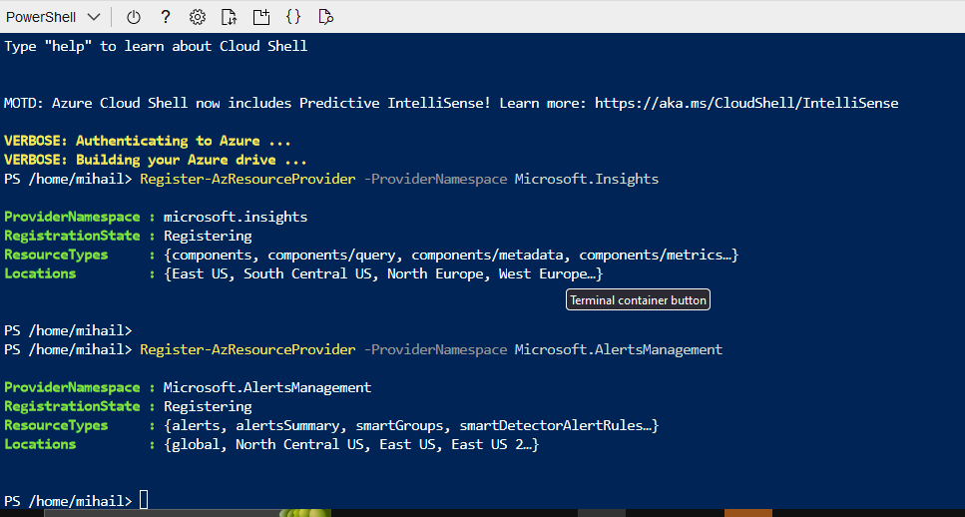

#### Task 5: Deploy zone-resilient Azure virtual machine scale sets by using the Azure portal

*In this task I am deploying zone-resilient Azure virtual machine scale sets using the Azure portal, including configuring settings for availability zones, networking, and security.*

Keep in mind that the the zone in this VMSS is UK South(it was the only one that supported the 1 2 3 zones).

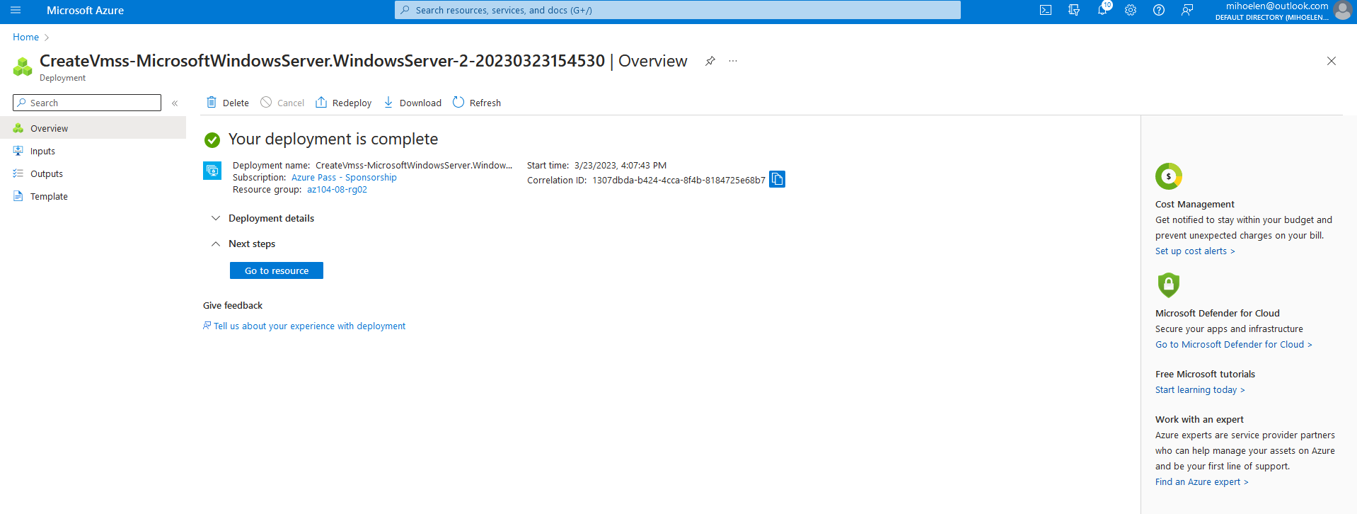

#### Task 6: Configure Azure virtual machine scale sets by using virtual machine extensions

*Here I am installing Windows Server Web Server role on Azure virtual machine scale set instances by uploading az104-08-install_IIS.ps1 script to a private container in a diagnostics storage account and using Custom Script extension. Upgrade instances and access the load balancer's frontend public IP address.*

*In this picture I am upgrading the 2 instances.*

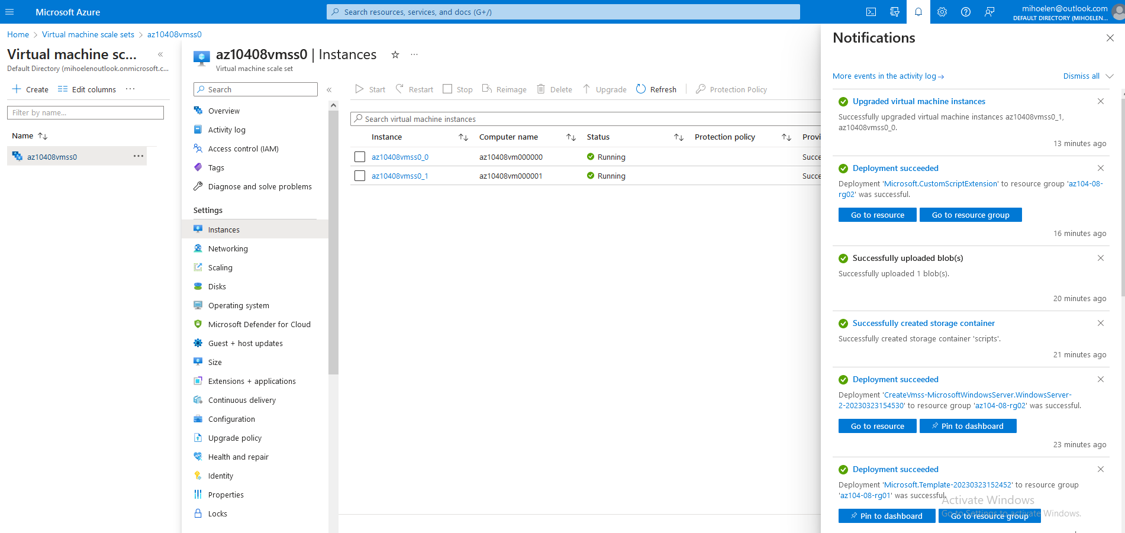

This was the last step and the first time I tried it, it worked, but than I got this error, I watched couple of youtube videos and none worked. But the error didnt affect the rest of the lab. I am going to resolve it with the mentor.

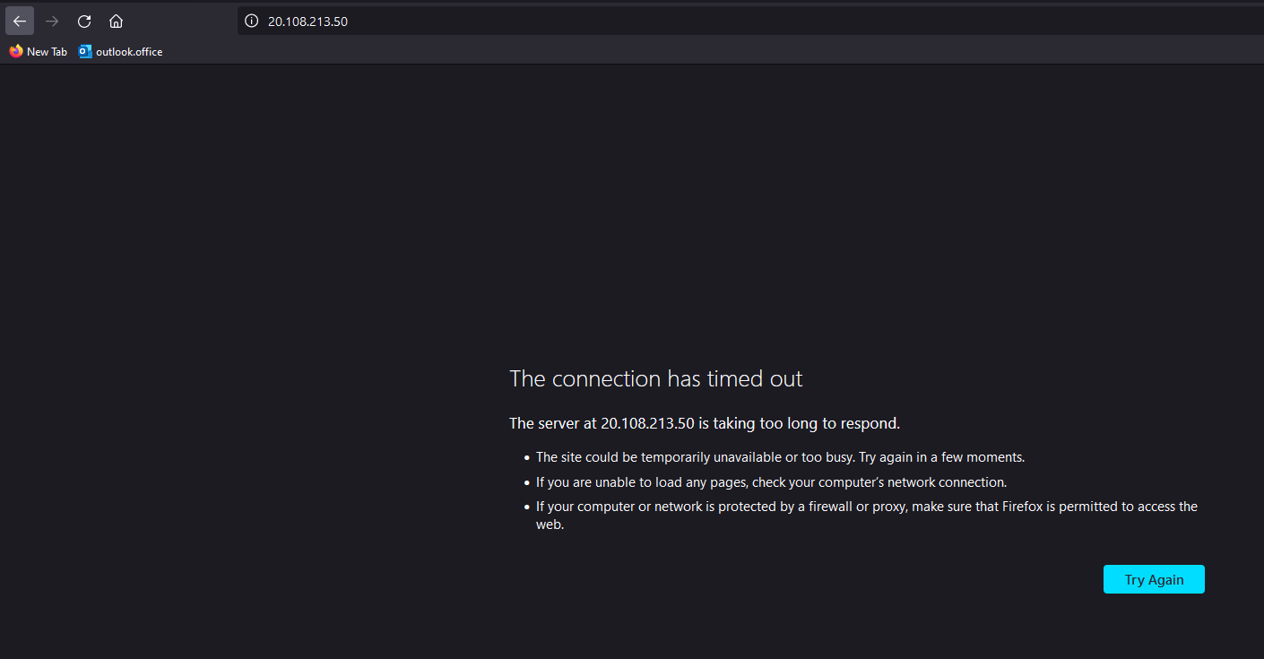

#### Task 7: Scale compute and storage for Azure virtual machine scale sets

*In this scenario I am changing the VM size, configure autoscaling, and attach disks to Azure VM scale set: resize to Standard DS1_v2, configure custom autoscale, and set instance limits.*

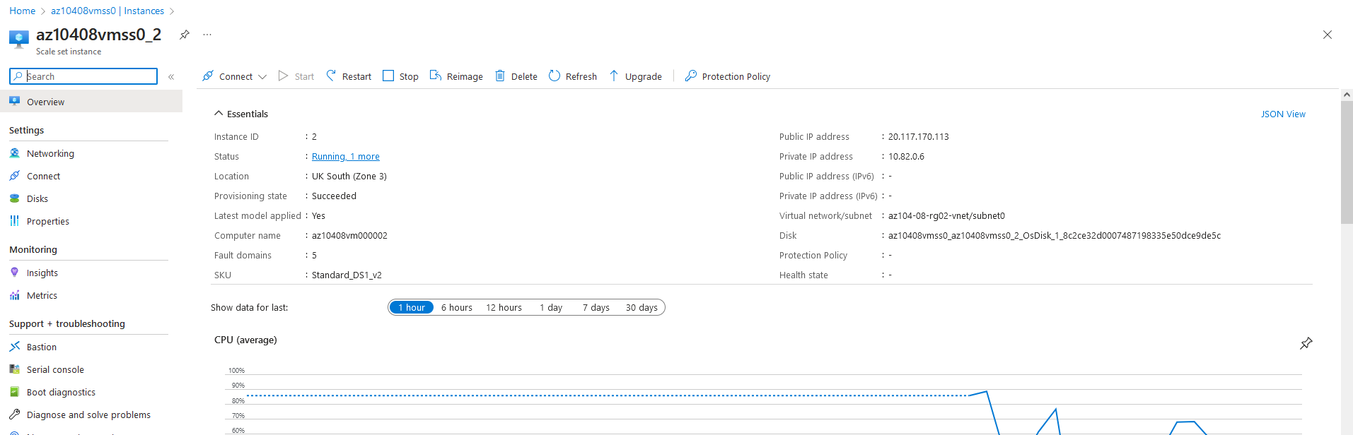

*Here I am upgrading the instances which are in different zones. All of them are in differnet zone. The first 0_0 is in Zone 1 Uk South. The 0_1 is in Zone 2 Uk South, and 0_2 is in Zone 3 Uk South*

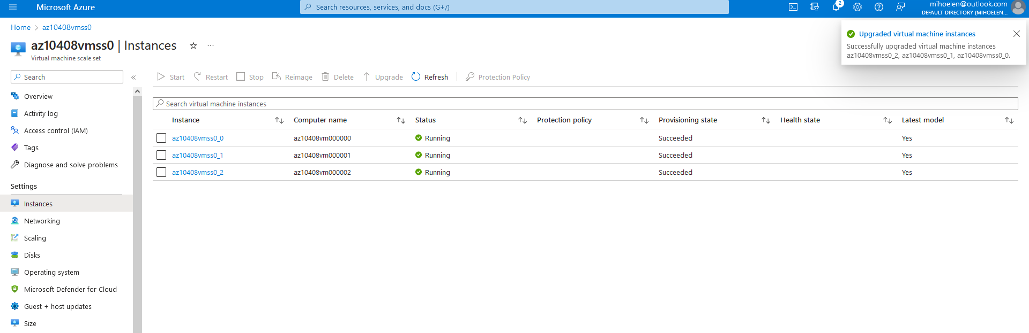

*In here I am adding the disk* ***az104-08-configure_VMSS_disks.ps1*** *from the* ***\Allfiles\Labs\08\*** *folder.*

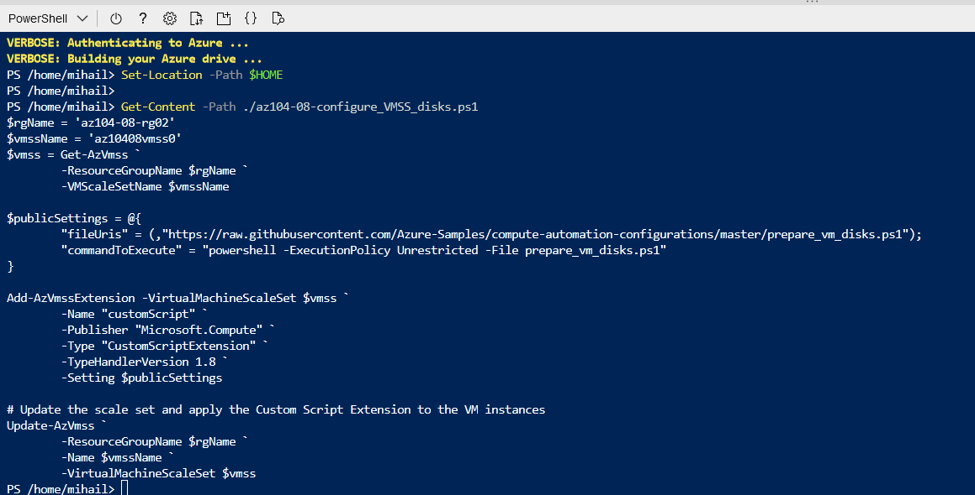

*An then I am upgrading the instances again.*

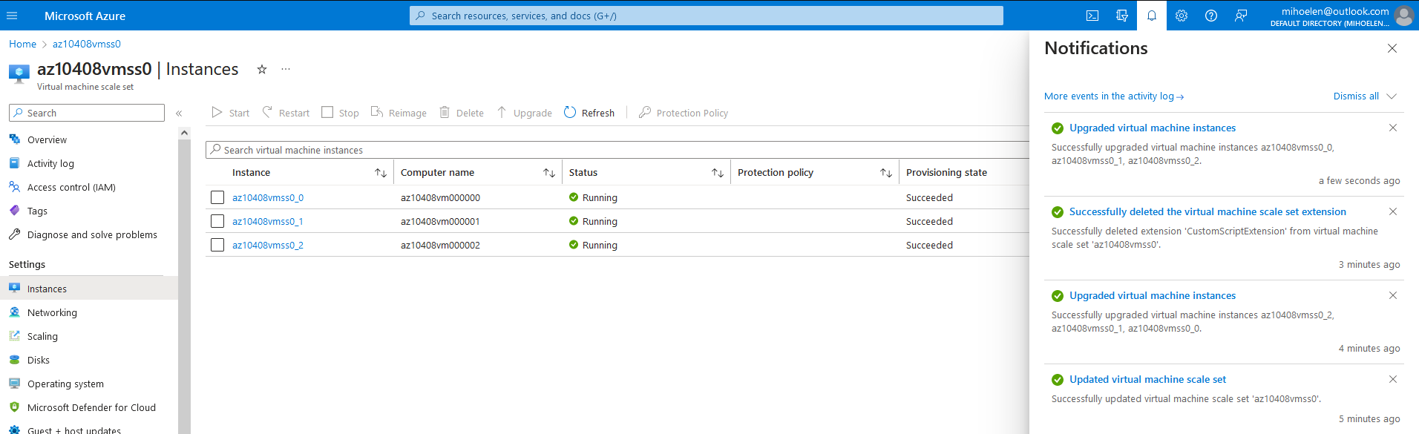

**I succesfully deleted the resources**

