**Task 5.1 Identify Windows Networking Diagnostic Commands with their syntax and examples.**

1. **Ipconfig**

Is a Console Command which can be issued to the Command Line Interpreter (or command prompt) to display the network settings currently assigned to any or all network adapters in the machine.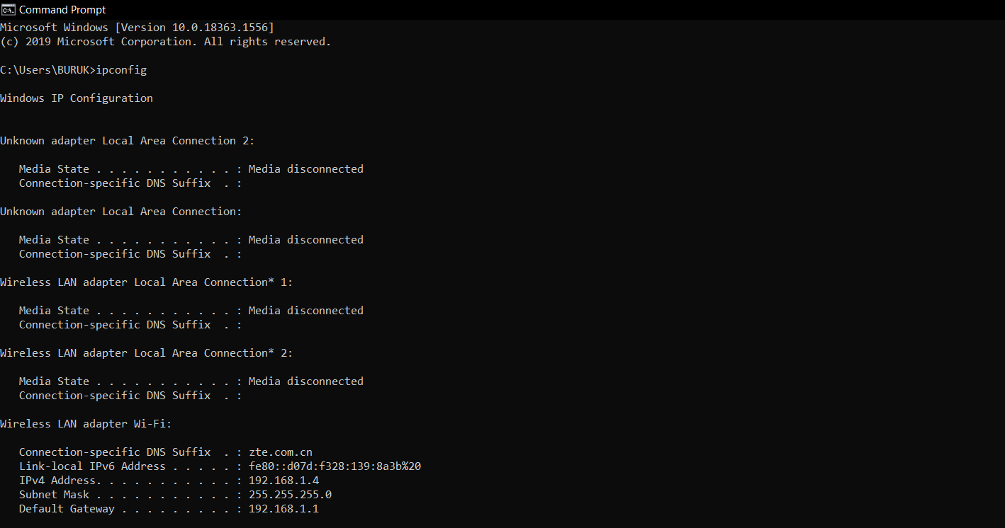

#### **Ping**

It is used detecting devices on network and troubleshooting network problems. It will help to see the connection between your device and another device on the network.

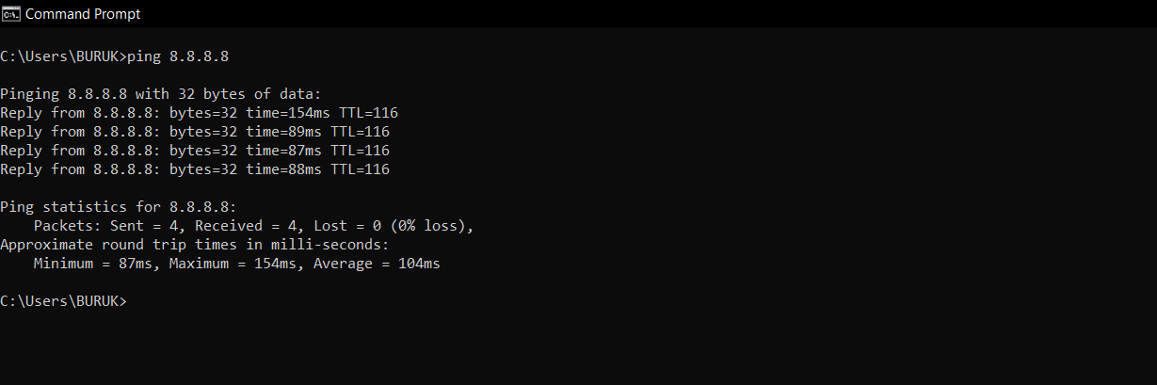

#### 3.**Host name**

It will show us the host name of the machine.

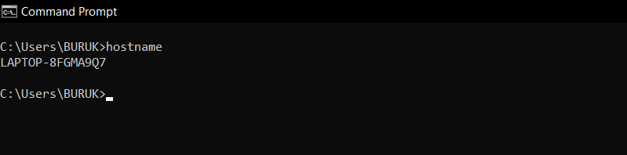

#### **4. getmac**

It will give you the MAC address of the network interface. People might use this to control which device can connect to the network. Each device has a unique MAC address and it is assigned by the manufacturer, store in the device hardware. You can observe in below image 3 different mac address is assigned to the different media.

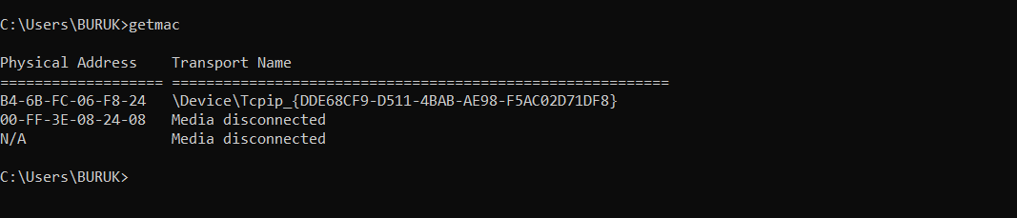

#### **Tracert**

When we face any network issue and to troubleshoot this issue Tracer route will send that is the route of the packet from server to server as hope. It will show a delay between user and hop. The IP address of the hop will be shown.

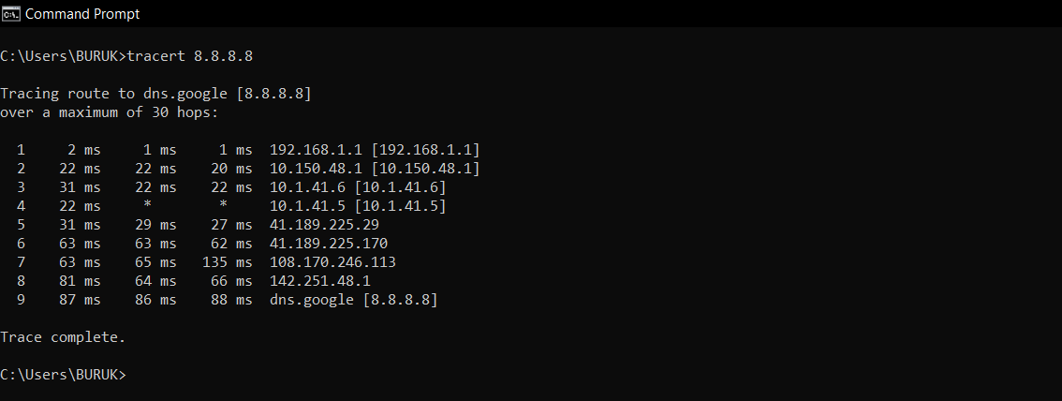

#### **nslookup**

It stands for name server lookup. When we want to know the IP address of the domain we can use this command. Fact is if we run this command over and over, we will get different IP addresses for a website like google, yahoo, you tube because these domains have spread to different machines.

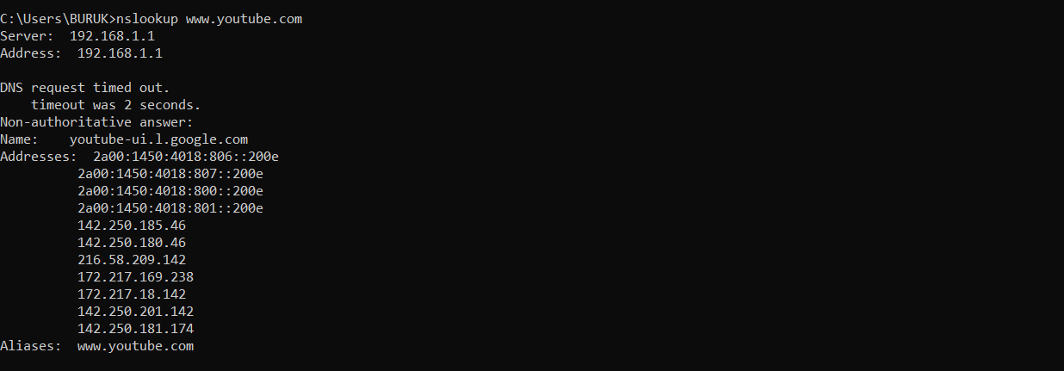

**Task 5.2 View the configuration details, including addresses, of your computers network interfaces.**

1. **Ipconfig all**

**To show all the information about your network adapter, you will need to use the /all parameter. This is the MAC address of your network adapter. The ipconfig /all command is often used to troubleshoot network connection problems.**

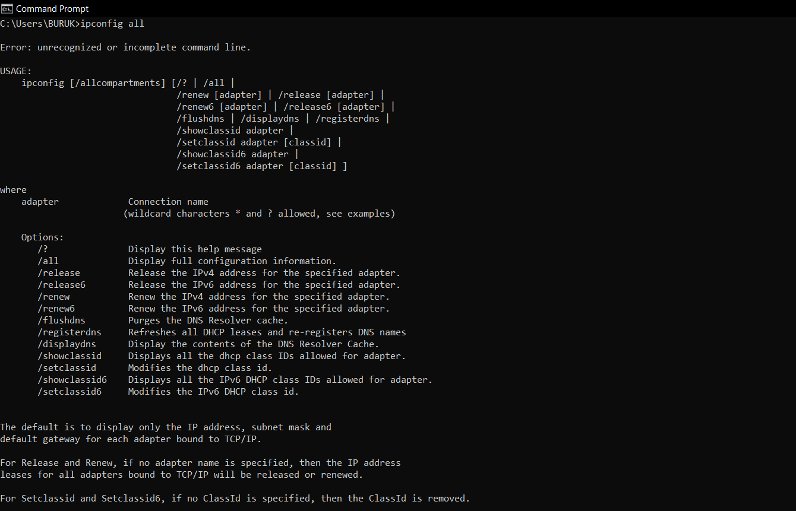

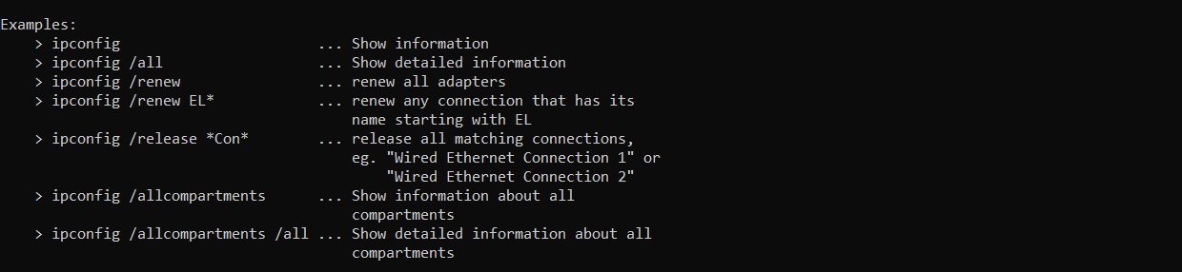

**Task 5.3 Test the network connectivity between your computer and several other computers: another PC in the lab; external web servers.**

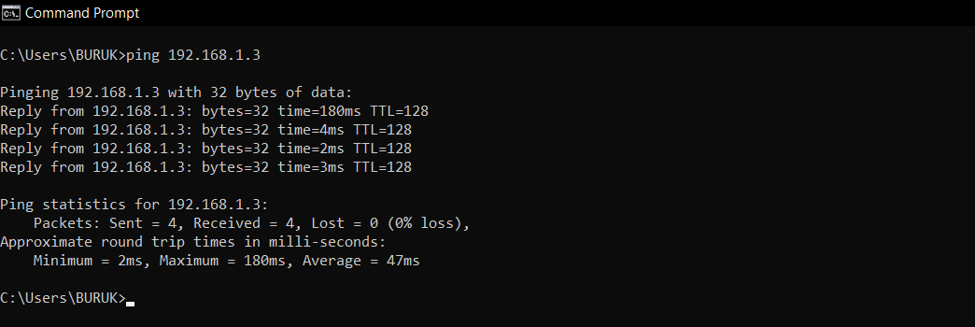

**Task 5.4 Using one of the publicly available websites for ping/traceroute, test the connectivity to several external websites.**

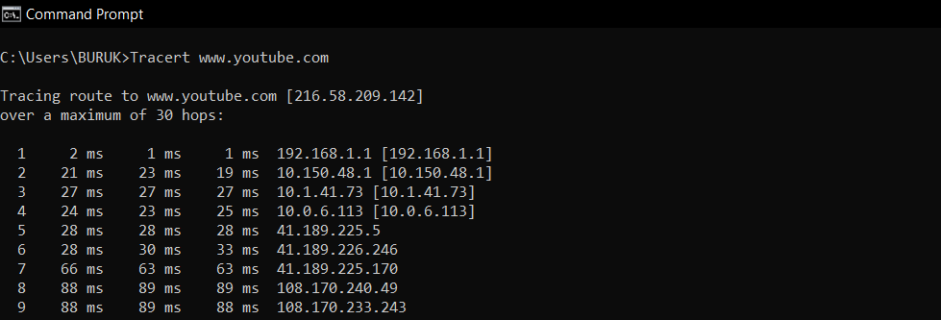

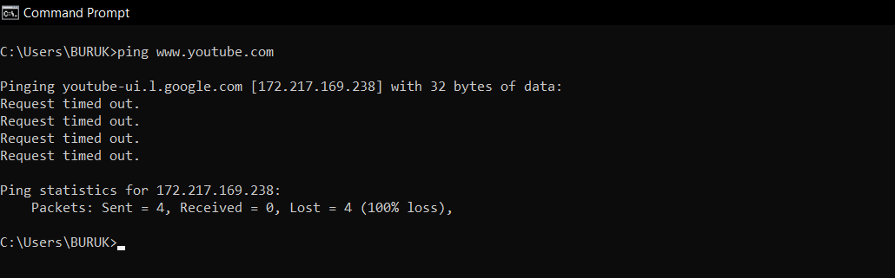

**Task 5.5 Trace the path between several pairs of source/destination nodes.**



**Task 5.6 Find the IP addresses of several web servers (domains), using several different DNS servers.**

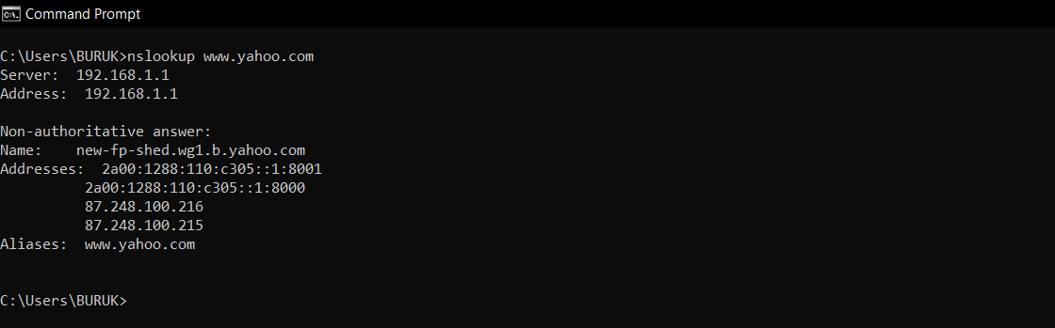

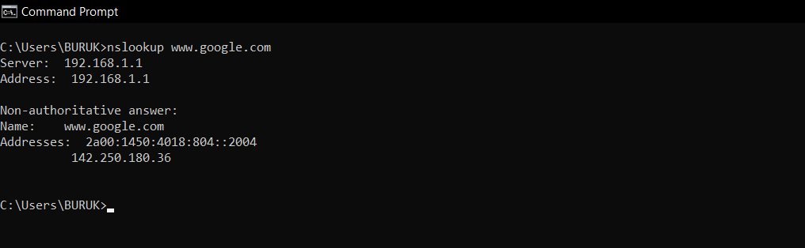

**Task 5.7 Try a reverse DNS lookup.**

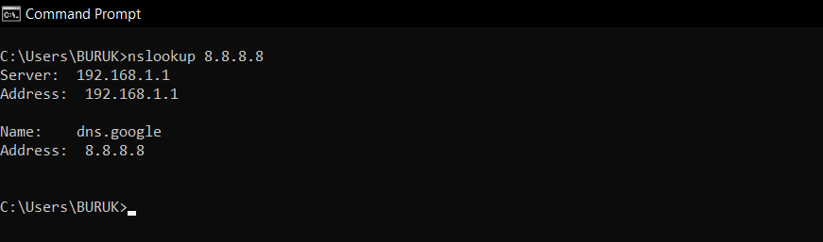

If the website doesn't have rDNS set up, the command returns an error.

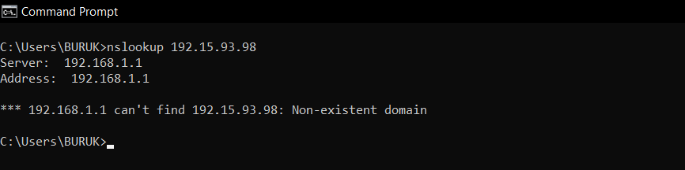

**Task 5.8 View your routing table and routing cache.**

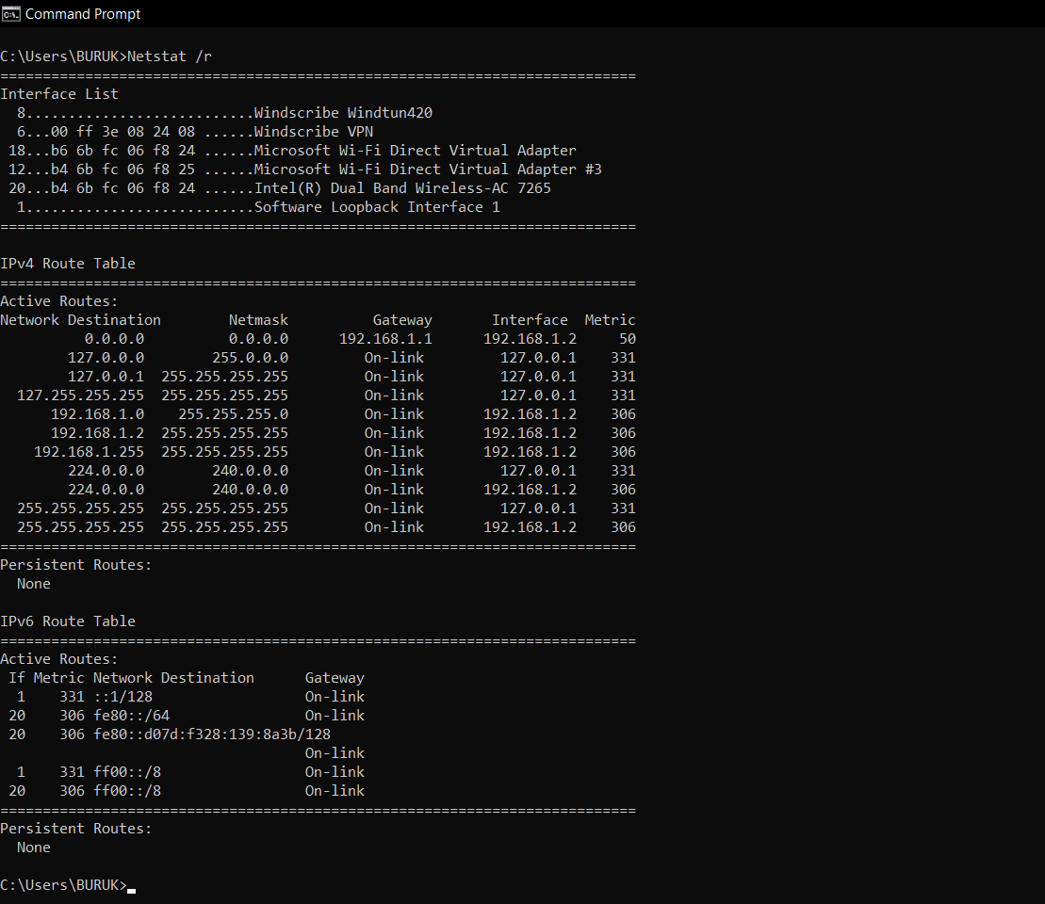

**Task 5.9 View your ARP cache. Find the hardware address of another computer in the lab using ARP.**

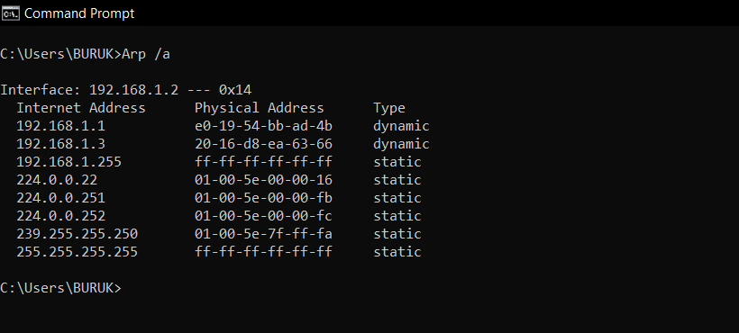

**Task 5.10 View the active TCP connections that your computer has, especially after you visited a website.**

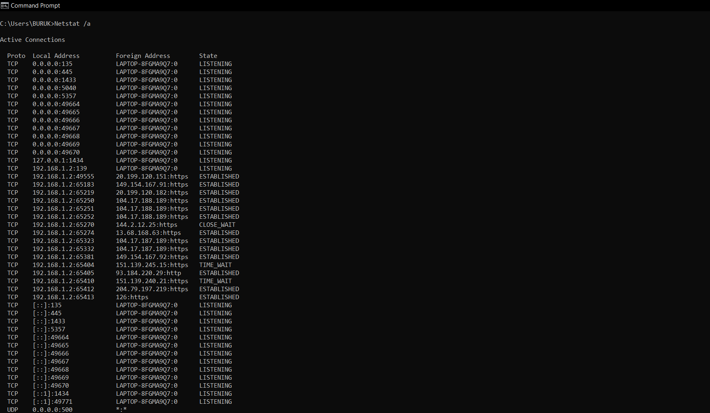

**Task 5.11 View and browse through the summary network statistics.**

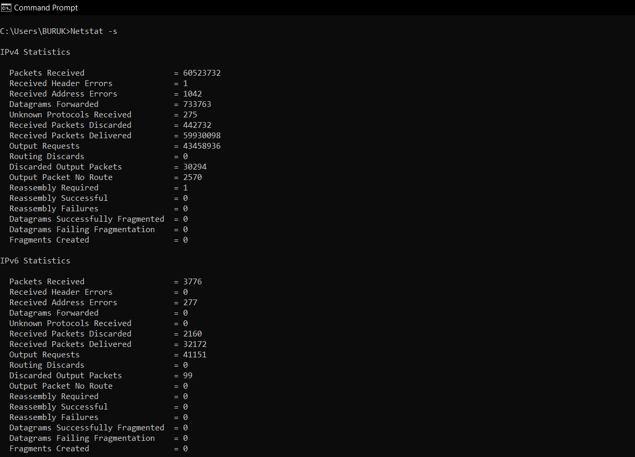

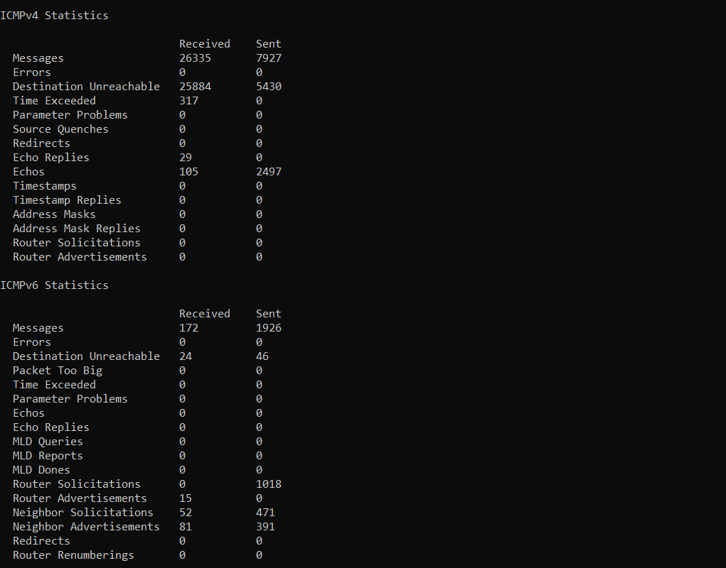

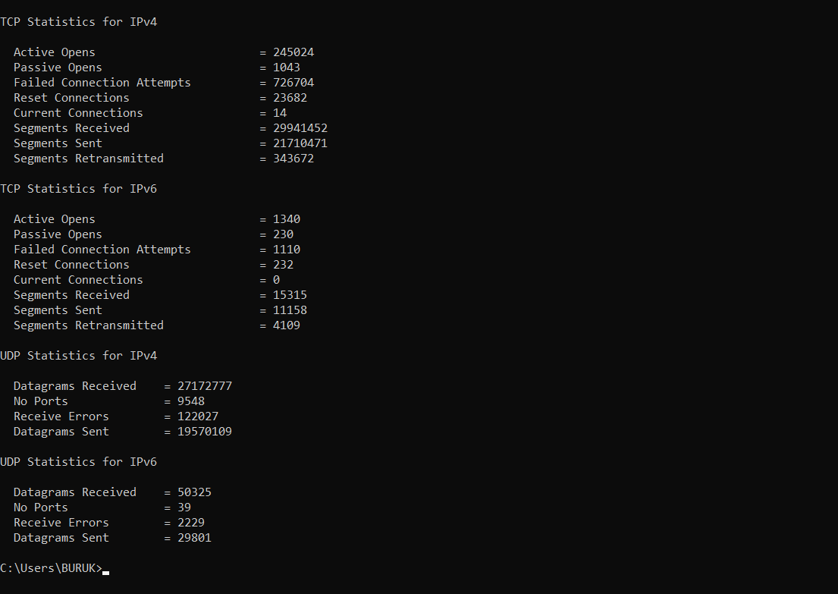

**Task 5.12 View the DHCP lease information for your computer, and see how it changes as you renew/refresh the lease.**

