Machine Learning
Classification Pipeline
Architecture, Methodology and User Manual
Geospatial / parcel-level multiclass classification
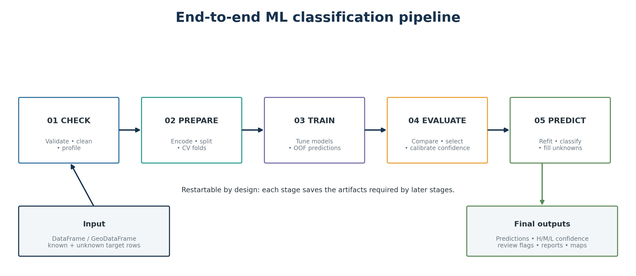
Architecture overview of the implemented five-stage workflow.
Document type | Architectural design + operational manual
Source basis | Latest uploaded implementation (src(3).zip)
Pipeline output schema | 1.2.0
Code snapshot date | 23 August 2026

Contents
1. Purpose and intended audience
2. Pipeline at a glance
3. Input data and prerequisites
4. Data leakage safeguards and spatial validation
5. Step 1 — CHECK: validate, clean and profile
6. Step 2 — PREPARE: encode, split and create CV folds
7. Step 3 — TRAIN: tune candidate models and produce OOF predictions
8. Step 4 — EVALUATE: compare, select and validate
9. Ensemble prediction: soft voting and optional class multipliers
10. Rank-based HIGH / MEDIUM / LOW confidence methodology
11. Step 5 — PREDICT: refit, classify and fill unknown labels
12. Output architecture and artifact reference
13. How to interpret the main outputs
14. Advanced and optional features
15. Operational runbook
16. Troubleshooting and quality red flags
17. Glossary
Navigation tip The DOCX uses Word heading styles, so the Navigation Pane can be used to jump between sections.

1. Purpose and intended audience
This document explains the implemented machine-learning classification pipeline in plain language while preserving enough technical detail for analysts, reviewers and developers to understand what is happening and why. The pipeline is designed for parcel-level or other row-based multiclass classification and can operate on a standard pandas DataFrame or a GeoDataFrame with geometry.
The pipeline does not download satellite imagery itself. It expects an ML-ready table whose feature columns have already been created. In an Earth-observation workflow, those features may be monthly band statistics, vegetation/water indices, texture measures, ancillary data, or other parcel summaries.
Core idea Known labels are used to train and validate models. Unknown labels are left untouched until the final prediction stage, where the selected strategy fills them. Every stage saves its own artifacts so that the workflow is auditable and restartable.

1.1 Who should use which parts
Role | Most useful sections
Analyst / domain expert | Steps 1–5, confidence interpretation, output guide, quality red flags
ML engineer | Training/search, CV selection, OOF calibration, probability optimization, tests
Reviewer / project manager | Architecture, leakage safeguards, holdout metrics, confidence validation
Developer / maintainer | Artifact contracts, module mapping, advanced options and runbook

2. Pipeline at a glance
The workflow is implemented as five ordered stages. A later stage consumes the persisted outputs of earlier stages, rather than relying on objects still held in memory. This is why individual steps can be rerun or resumed.
Figure 1. Five-stage workflow and the main responsibility of each stage.
Stage | Plain-language purpose | Primary question answered
01 CHECK | Make sure the input is usable and understand its quality. | “Is this dataset safe to model?”
02 PREPARE | Create a fair train/test split and cross-validation folds. | “How will we train and test without cheating?”
03 TRAIN | Try model families and tune their settings. | “Which version of each model works best in CV?”
04 EVALUATE | Compare trained models, freeze the final strategy, and calibrate confidence. | “Which strategy should be trusted, and how well does it generalize?”
05 PREDICT | Refit the frozen strategy on all labeled data and classify the complete dataset. | “What label and confidence should each parcel receive?”

Important separation Model selection is based on training cross-validation. The holdout test set is used for final unbiased verification; it does not choose the winning model or train the confidence calibration.

3. Input data and prerequisites

3.1 Required logical columns
Element | Meaning | Requirement
ID column | Unique parcel / entity identifier. | Created from the row index if missing; stored as text. Unique IDs are enforced by default.
Target column | The class to learn (for example crop code). | Known for training rows; may be null for rows to classify later.
Feature columns | Measurements used by ML. | At least one feature. ID, target and geometry cannot be model features.
Geometry | Parcel polygon/geometry. | Optional in general; required for spatial split/interpolation and spatial maps.

3.2 Grain and label requirements
- By default there must be one row per ID. Duplicate parcel IDs cause an error because the pipeline assumes one modeling record per entity.
- At least two target classes are required.
- Every class must have at least as many labeled parcels as the configured number of CV folds; otherwise a fold could have no examples of that class.
- Rows with a missing target are preserved in Step 1 but excluded from training and evaluation. They re-enter in Step 5 for final classification.

3.3 Typical Earth-observation features
For parcel crop classification, the feature table can contain time-series summaries such as monthly Sentinel-2 bands, NDVI, NDWI, red-edge indices, cloud-free observation counts, phenological descriptors, or categorical ancillary attributes. The pipeline treats these as columns; it does not assume one specific satellite sensor.
Time-series note The upstream zonal-statistics workflow is expected to pivot time-series measurements into an ML-ready one-row-per-parcel table. The optional Keras LSTM model can parse temporal feature columns into ordered timesteps using its own temporal schema.

4. Data leakage safeguards and spatial validation
A classification model can look excellent when training and testing records are too similar. This is especially dangerous for geospatial data because neighboring parcels often share soil, weather, management practices and satellite signal. The pipeline therefore separates three concepts: training, cross-validation/OOF, and the final holdout test.
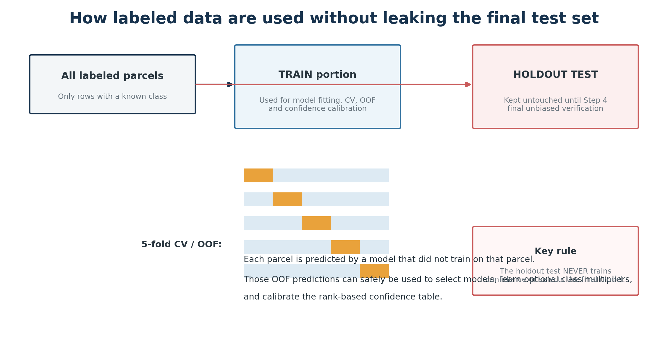
Figure 2. Training, OOF predictions and the untouched holdout test play different roles.

4.1 OOF means “out-of-fold”
During cross-validation, the training portion is divided into folds. A parcel receives an OOF prediction only from a model that was fitted without that parcel. OOF predictions are therefore suitable for model-selection diagnostics, optional class-probability optimization, and the confidence calibration without using the holdout test.

4.2 Spatial splitting
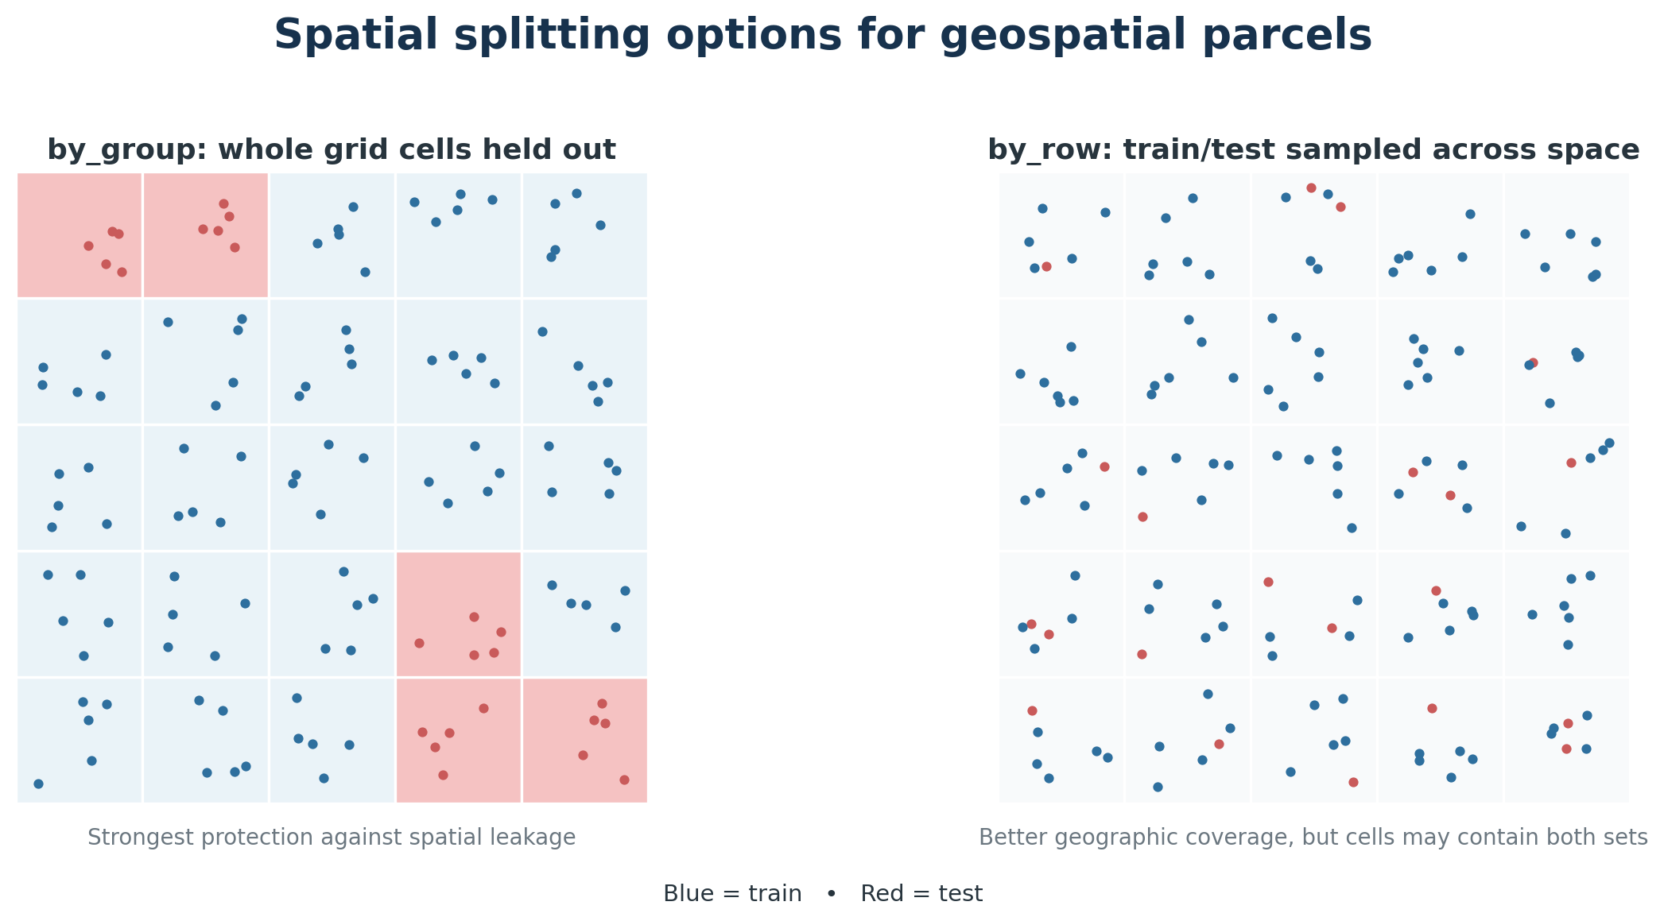
Figure 3. Spatial by_group and by_row splitting strategies.
Option | How it works | When to prefer it
spatial_split=False | Standard stratified random train/test split; every class keeps a similar proportion. | Non-spatial problems or when spatial independence is not required.
by_group | Builds a regular grid and holds out complete occupied cells. Train and test cannot share grid cells. | Preferred when you want the strongest test of transfer to unseen geography.
by_row | Samples rows spatially across the grid within each class. A grid cell can contain both train and test rows. | Useful when each class must be geographically represented in both sets, but it is less strict against local leakage.

Recommendation for EO parcel models If the objective is to claim geographic generalization, use by_row and inspect the spatial split map. by_row is a compromise for data with limited spatial support.

5. Step 1 — CHECK: validate, clean and profile
Step 1 is the data-quality gate. It performs inexpensive checks before any model training begins, then saves a normalized copy of the input for all later stages.

5.1 What Step 1 does
- Copies the input table and ensures the ID column exists and is stored as text.
- Validates required columns and prevents target/ID/geometry leakage into the feature list.
- Checks unique IDs (when enabled) and verifies each class has enough labeled examples for CV.
- Optionally applies an IQR outlier filter to numeric features.
- Optionally fills numeric nulls using spatial nearest, IDW or kriging interpolation.
- Optimizes data types/memory use and identifies numeric versus categorical features.
- Removes all-null and constant features from the active modeling set.
- Profiles features, missingness and target distribution, then writes maps/plots when geometry is available.

5.2 IQR outlier filtering
If enabled, the interquartile-range (IQR) rule identifies unusually extreme numeric values. The pipeline does not delete the parcel. Instead, it replaces the outlying cell with a null value. This is safer because the row remains available and the missing value can later be spatially interpolated or imputed by a model preprocessor.
Interpretation A high total_outliers_replaced value is not automatically bad. It is a prompt to inspect the configured IQR bounds and confirm that valid phenological extremes are not being treated as errors.

5.3 Spatial interpolation
When configured, the pipeline can fill missing numeric feature cells from nearby parcels using nearest-neighbor, inverse-distance weighting (IDW), or kriging. Geometry is required. Non-numeric features and completely empty columns are skipped. The original geometry is preserved.

5.4 Main Step 1 outputs and how to read them
Output | What it contains | How to interpret it
check_summary.json | Rows, labeled/unknown counts, active features, class distribution, IQR/interpolation summaries, configuration snapshot. | Start here. Verify row counts and that expected features remain active.
feature_profile.csv | Data type, missingness, uniqueness and descriptive feature profile. | Look for very high missingness, suspiciously constant features or unexpected types.
missing_values.png | Visual missing-value pattern. | Structured gaps by month/region may indicate upstream EO availability issues.
target_distribution.png | Number of labeled examples per class. | Large imbalance suggests macro-F1, balanced accuracy and/or balancing options are important.
known_labels_map.* | Spatial distribution of known labels. | Check whether classes are geographically clustered or absent from regions.

Quality gate before Step 2 Do not proceed blindly if expected features are missing, classes have very few samples, or the known-label map reveals extreme geographic concentration.

6. Step 2 — PREPARE: encode, split and create CV folds
Step 2 freezes the experimental design. It uses only rows with known labels, converts text labels to integer codes for model libraries, and creates the train/test and CV partitions that later stages must respect.

6.1 Label encoding
Class labels are stored as strings for reporting, but many estimators require integers. LabelEncoder creates a deterministic mapping such as Wheat → 0, Barley → 1. The mapping is saved so predictions can always be converted back to the original labels.

6.2 Holdout train/test split
The test split is frozen here. With standard splitting it is stratified by class. With spatial splitting it uses the configured spatial strategy. Later model selection is not allowed to “peek” at the test result.

6.3 Cross-validation folds
CV folds are created only inside the training portion. Standard projects use StratifiedKFold. Spatial projects use StratifiedGroupKFold with grid-cell groups, so validation folds can test spatial generalization inside training as well.

6.4 Main Step 2 outputs
Output | Purpose | Interpretation
train_dataset.joblib | Frozen training partition. | Used for CV, tuning, OOF predictions and final strategy selection.
test_dataset.joblib | Frozen holdout partition. | Used in Step 4 only for unbiased final evaluation.
labeled_dataset.joblib | All rows with known labels. | Used in Step 5 to refit the already-selected strategy before production prediction.
prepare_summary.json | Active features, split strategy, labels and exact CV indices. | Audit trail proving how the data were partitioned.
label_mapping.csv | Original labels and encoded integers. | Use when reading encoded model artifacts.
train_test_distribution.png | Class counts in train and test. | Train/test proportions should be sensible; missing classes are a serious problem.
feature_distributions_train_vs_test.png | Feature distribution comparison. | Large shifts may mean the test set represents a different domain.
spatial_train_test_split.png | Map of spatial partition (when possible). | Verify geographic separation and coverage.

7. Step 3 — TRAIN: tune candidate models and produce OOF predictions
Step 3 gives each candidate model family a fair “audition.” It searches multiple hyperparameter combinations, evaluates them across the frozen CV folds, keeps the best version of each model, and writes the evidence used to rank models later.
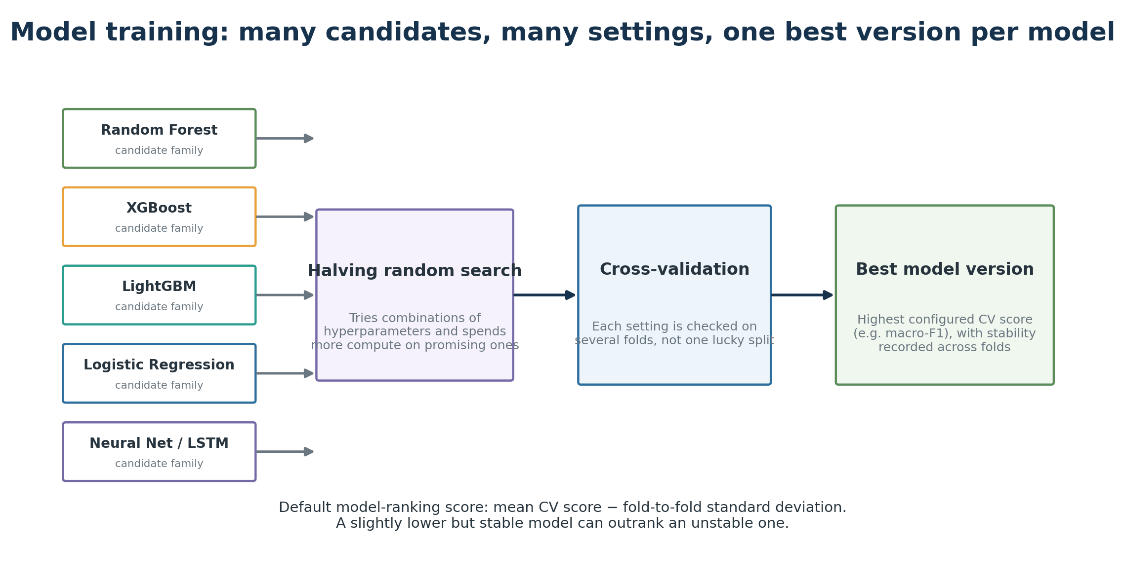
Figure 4. Hyperparameter search and cross-validation for each candidate model family.

7.1 Candidate model families
Model family | Plain-language view
Logistic Regression / SGD | Linear decision boundaries; useful baselines and often robust with many features.
Decision Tree | A sequence of if/then splits; easy conceptually but can overfit.
Random Forest / Extra Trees / Bagging | Many trees vote together; robust nonlinear baselines.
Gradient Boosting / HistGradientBoosting | Trees are added sequentially to correct previous errors.
XGBoost / LightGBM | High-performance gradient boosting, available when optional libraries are installed.
KNN | Looks at similar training parcels in feature space.
MLP / TensorFlow dense network | Learns nonlinear combinations of features through neural-network layers.
Keras LSTM | Neural network specialized for ordered temporal sequences.
Gaussian Naive Bayes | Simple probabilistic baseline with strong independence assumptions.

7.2 Preprocessing is part of each model pipeline
Data type / model need | Implemented preprocessing
Numeric features | Median imputation. Linear/KNN/neural pipelines also scale numeric values; tree models generally do not.
Categorical features | Most-frequent imputation plus one-hot encoding; infrequent categories are handled explicitly.
Class imbalance | Optional random oversampling or SMOTE inside the modeling pipeline. Many estimators also use balanced class weights.
LSTM | Temporal feature columns are parsed into an ordered tensor; the winning temporal schema is saved.

7.3 Hyperparameter search
HalvingRandomSearchCV starts with several parameter combinations and progressively concentrates resources on more promising configurations. The primary scoring metric is configurable; the default is macro-F1, which gives each class equal importance rather than allowing large classes to dominate the score.

7.4 Model ranking: performance plus stability
By default, models are ranked using:
CV selection score = mean CV score − CV score standard deviation
This favors models that are both accurate and stable across folds. A model with a slightly higher mean but highly variable folds can rank below a more consistent model. The alternative ranking method uses mean score only.

7.5 OOF probabilities
For probability-capable models, OOF probabilities are generated when probability optimization or rank confidence is enabled. Each training parcel is predicted without being used to fit the model that produced its OOF probability. These probabilities later support leakage-safe class multiplier learning and confidence calibration.

7.6 Main Step 3 outputs
Output | How to interpret it
training_summary.csv | Authoritative per-model CV ranking. Focus on best_cv_score, cv_score_std, cv_score_minus_std / cv_ranking_metric and supports_predict_proba.
best_cv_fold_scores.csv | Shows fold-to-fold stability. Large spread means the model is sensitive to the split.
training_failed_models.csv | Failure isolation. One candidate can fail without stopping the others; investigate repeated or important failures.
model_specs.json | Best hyperparameters and metadata used to reconstruct models later.
models/<model>/cv_results.csv | Full tuning history. Useful when diagnosing whether the search space was adequate.
models/<model>/best_model.joblib | Best fitted estimator for evaluation and incremental reuse.
models/<model>/oof_probabilities.joblib | Leakage-safe probabilities used by downstream OOF optimization/calibration.

Incremental workflow When model artifacts already exist and force_retrain_models is false, the training stage can reuse fully trained models and train only new/missing candidates. This makes experimentation with additional model families cheaper.

8. Step 4 — EVALUATE: compare, select and validate
Step 4 has two separate responsibilities: (1) report how the trained models perform, and (2) freeze the final prediction strategy based on cross-validation evidence. It also creates the rank-confidence diagnostics and, when possible, fits the class-aware OOF confidence calibration.

8.1 Base-model evaluation
Every selected trained model is loaded and evaluated on both train and holdout test data. Per-class classification reports, confusion matrices and ROC-related plots are written. Probability-column order is explicitly checked against the canonical label order before probabilities are used.

8.2 Metrics used
Metric | Plain-language meaning | When it matters most
Accuracy | Fraction of all parcels classified correctly. | Easy headline metric, but can hide poor minority-class performance.
Balanced accuracy | Average recall across classes, with equal class weight. | Useful when classes are imbalanced.
Macro-F1 | F1 calculated per class, then averaged equally. | Default primary metric; strong choice when every crop class matters.
Weighted F1 | Per-class F1 weighted by number of samples. | Reflects overall volume but favors common classes.
Weighted precision / recall | Global summaries weighted by class support. | Useful supporting diagnostics.
Weighted ROC AUC | Ability of probabilities to rank true classes above alternatives. | Useful probability-quality indicator; not identical to final accuracy.

8.3 Train vs test
A large train–test gap is a warning sign for overfitting or domain shift. The holdout test is the most important performance view because it was not used for tuning or confidence fitting. In spatial projects, the test result is especially meaningful when by_group is used.

8.4 Model selection is frozen from CV
Probability-capable models are ordered using the Step 3 CV ranking. If soft voting is configured and at least two eligible models exist, the top models become the voting ensemble. If only one is available, the pipeline falls back to a single-model strategy. The test metrics are displayed but do not change which model wins.
Why this matters Selecting the model that happens to score best on the test set would turn the test set into another tuning set and make the reported generalization performance optimistic.

8.5 Interpretability outputs
For the top CV-ranked models, tree-based estimators can produce feature-importance tables/plots. SHAP summaries are optional. These outputs help explain what a model uses, but they do not affect model selection or predictions.

9. Ensemble prediction: soft voting and optional class multipliers
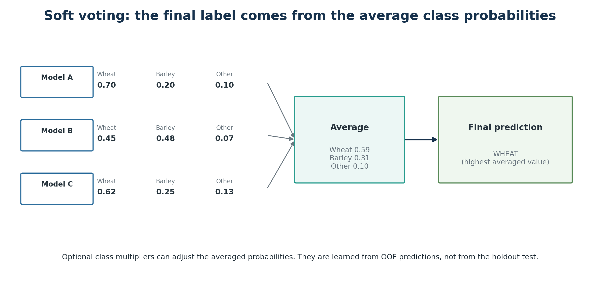
Figure 5. Soft voting averages the selected models’ class probabilities and chooses the largest average.
In soft voting, each selected model provides a probability-like score for every class. The pipeline aligns the class columns, averages model probabilities with equal weight, and chooses the class with the highest final average. This is the production label unless the project is configured for a single model.

9.1 Why the probabilities are not used directly as “confidence”
Different model families have different probability calibration. A neural network may routinely output 0.98 where a random forest outputs 0.72 for a prediction of similar reliability. Therefore the winning averaged probability is stored as prediction_max_probability for diagnostics, but HIGH/MEDIUM/LOW confidence is determined separately.

9.2 Optional class probability multipliers
When optimize_class_probabilities is enabled, the pipeline searches per-class multipliers using OOF averaged probabilities. The objective is to improve OOF macro-F1 while preventing overall accuracy from dropping more than the configured tolerance (0.02 by default). Multipliers are then frozen inside the selected strategy and applied after model-probability averaging.
Important Class multipliers change the soft-voting prediction but do not change the raw within-model rankings used as confidence evidence. This allows the confidence layer to detect when the adjusted soft-vote winner is not supported by the independent model rankings.

10. Rank-based HIGH / MEDIUM / LOW confidence methodology
The confidence methodology answers a different question from soft voting: “How much evidence do the selected models provide for the final label, and how reliable was this kind of evidence during OOF validation?” The design deliberately avoids treating heterogeneous raw probabilities as directly comparable confidence values.
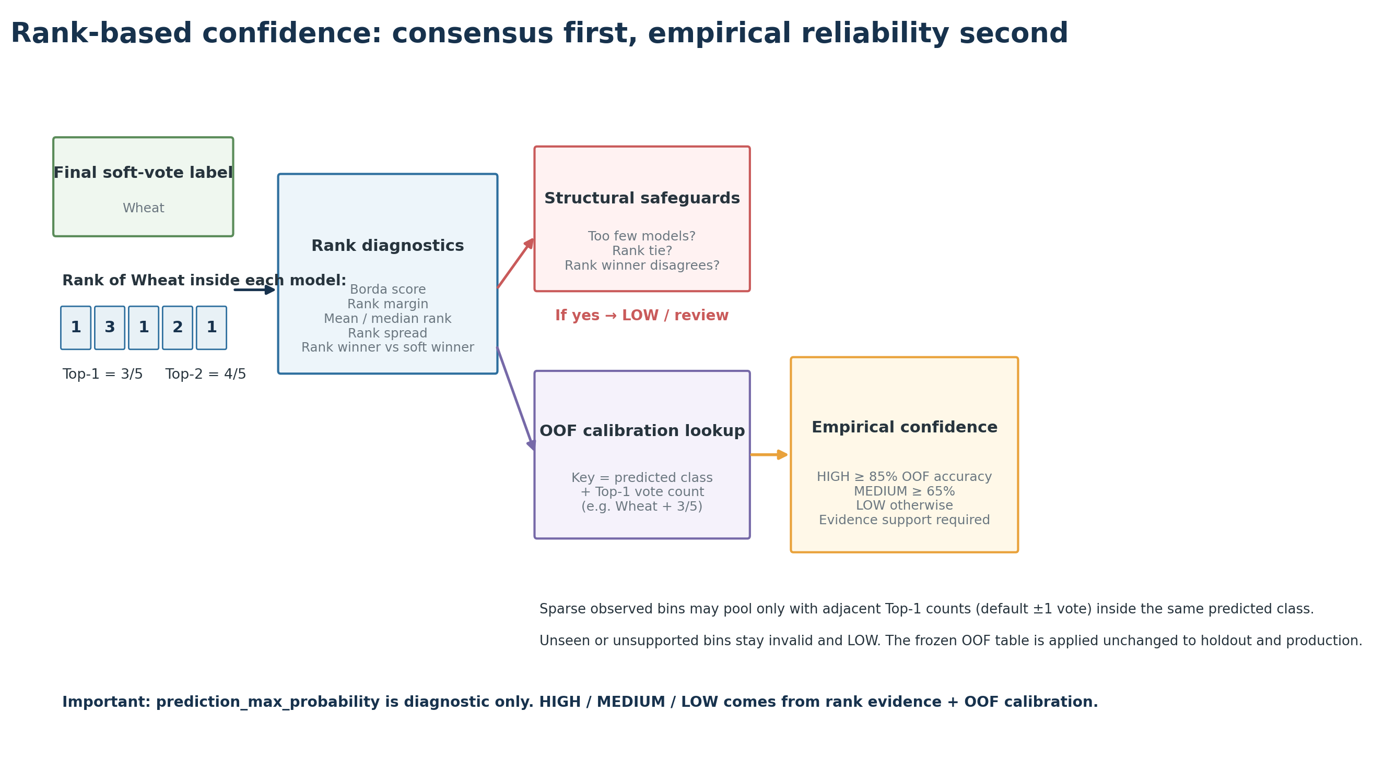
Figure 6. Rank evidence is calculated first; OOF calibration converts supported patterns to empirical HIGH/MEDIUM/LOW reliability.

10.1 Step A — rank each class inside every model
For each parcel, every model sorts its own classes from most likely to least likely. Rank 1 means that model’s first choice, rank 2 means second choice, and so on. Probability ties receive average ranks, so two equal first-place scores become rank 1.5 rather than an arbitrary rank 1 and 2.

10.2 Step B — calculate rank evidence for the actual final label
Diagnostic | Meaning
Top-1 agreement | Fraction of selected models that rank the final predicted class first.
Top-2 / Top-3 agreement | Fraction that keep the final class within their first two / three choices.
Normalized Borda score | Converts ranks to a 0–1 scale and averages them across models. Higher means consistently better rank.
Rank margin | Rank score of the actual final class minus the strongest competing class. Can be negative when rank consensus prefers another class.
Mean / median rank | Typical position of the final class across models. Lower is better.
Rank standard deviation / IQR | How much model rankings disagree. Larger values mean less consistent support.
Rank prediction | The class preferred by aggregate ranks, independent of the soft-voting winner.

10.3 Borda normalization
With K classes and rank r, the normalized rank score is:
score = (K − rank) / (K − 1)
Rank 1 therefore receives score 1.0 and the last rank receives 0.0. This makes rank evidence comparable even when raw model probabilities have different scales.

10.4 Structural safeguards
- If fewer than rank_confidence_minimum_models are available (default 3), confidence is LOW and invalid because ensemble agreement is not meaningful.
- If aggregate rank scores tie for the winner, confidence is LOW. A deterministic label may still be required technically, but a tie is not evidence for one class.
- If the soft-voting final class differs from the independent rank winner, confidence is LOW. The disagreement is preserved in the output.

10.5 Step C — class-aware OOF calibration
The ranking pattern alone is not enough. Some classes can be systematically easy or difficult: five models agreeing on one class may be highly reliable, while five models agreeing on another may still be wrong often. The implemented calibration therefore learns empirical correctness separately by predicted class and Top-1 vote count.
The lookup key is: predicted class + number of models that ranked that class first. For a five-model ensemble, Top-1 agreement values correspond to 0/5, 1/5, …, 5/5 votes.

10.6 Evidence and pooling rules
Situation | Implemented behavior
Exact class/vote bin has at least minimum support | Use its exact OOF empirical accuracy.
Exact bin exists but is sparse | May pool only observed Top-1 bins from the same predicted class within the configured vote distance (default ±1).
Bounded pooled support reaches the minimum | Use the pooled empirical accuracy and record included bins/distance.
Exact bin was never seen in OOF | Do not extrapolate from other vote patterns. Mark invalid and LOW.
Bounded pooling is still below minimum support | Mark invalid and LOW even if the small-sample point accuracy looks high.

10.7 Mapping empirical accuracy to H/M/L
Level | Default empirical rule | Operational meaning
HIGH | OOF empirical accuracy ≥ 0.85 with valid support. | This predicted-class/agreement pattern was usually correct in OOF data.
MEDIUM | 0.65 ≤ OOF empirical accuracy < 0.85 with valid support. | Useful prediction, but with materially higher historical error.
LOW | OOF empirical accuracy < 0.65, or structural/empirical validity failure. | Treat cautiously; review or downstream safeguards are appropriate.

What HIGH is — and is not HIGH is an empirical reliability category learned from OOF behavior for the predicted class and agreement pattern. It is not a classical 95% confidence interval, and prediction_max_probability is not interpreted as a statistical confidence level.

10.8 Calibration lifecycle and leakage control
- Generate OOF member-model probabilities only from training data.
- Create OOF rank features and determine whether each OOF prediction was correct.
- Fit the class-aware predicted-class / Top-1 empirical calibration table.
- Freeze the complete table and minimum-model rules in selection_summary.json.
- Apply that frozen table to the untouched holdout test for independent verification.
- In Step 5, apply the exact same frozen table to production parcels. Never refit confidence from the production rows.
How to validate confidence The holdout confidence table should normally show accuracy(HIGH) > accuracy(MEDIUM) > accuracy(LOW). If not, the confidence categories are not separating reliable from ambiguous predictions well enough and should be reviewed.

11. Step 5 — PREDICT: refit, classify and fill unknown labels
Step 5 is the production inference stage. It does not re-select models. It loads the frozen selection_summary.json and model_specs.json, rebuilds the selected estimators with their winning hyperparameters, fits them on all labeled rows, then predicts every row in the original checked dataset.

11.1 Why refit on all labeled rows?
Once the final strategy has been selected and verified, the held-out labels no longer need to remain withheld for the final production model. Refitting on all known labels gives the deployed model the maximum available labeled evidence. This does not change the already-reported holdout metrics; those remain the historical validation of the strategy.

11.2 Prediction and filling logic
- Every row receives a model prediction and per-class probability columns.
- Known target labels are preserved in the filled target column.
- Only rows whose original target was null are filled from the prediction.
- prediction_max_probability stores the largest final probability as a diagnostic.
- Rank confidence is calculated from the raw probabilities of each selected member model, then the frozen OOF calibration is applied.
- prediction_needs_review becomes true when rank confidence is LOW or invalid. If rank confidence is unavailable, the legacy maximum-probability threshold is the fallback review rule.
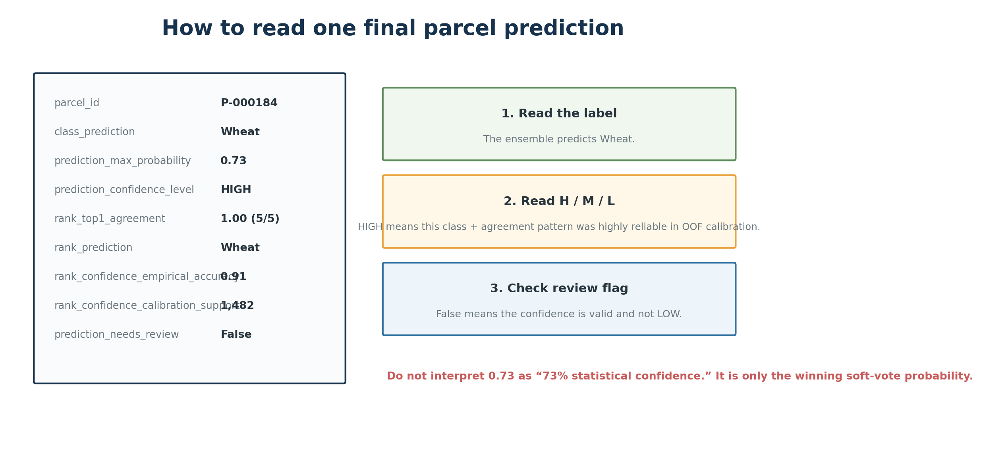
Figure 7. Example of how to read one row in the final prediction output.

12. Output architecture and artifact reference
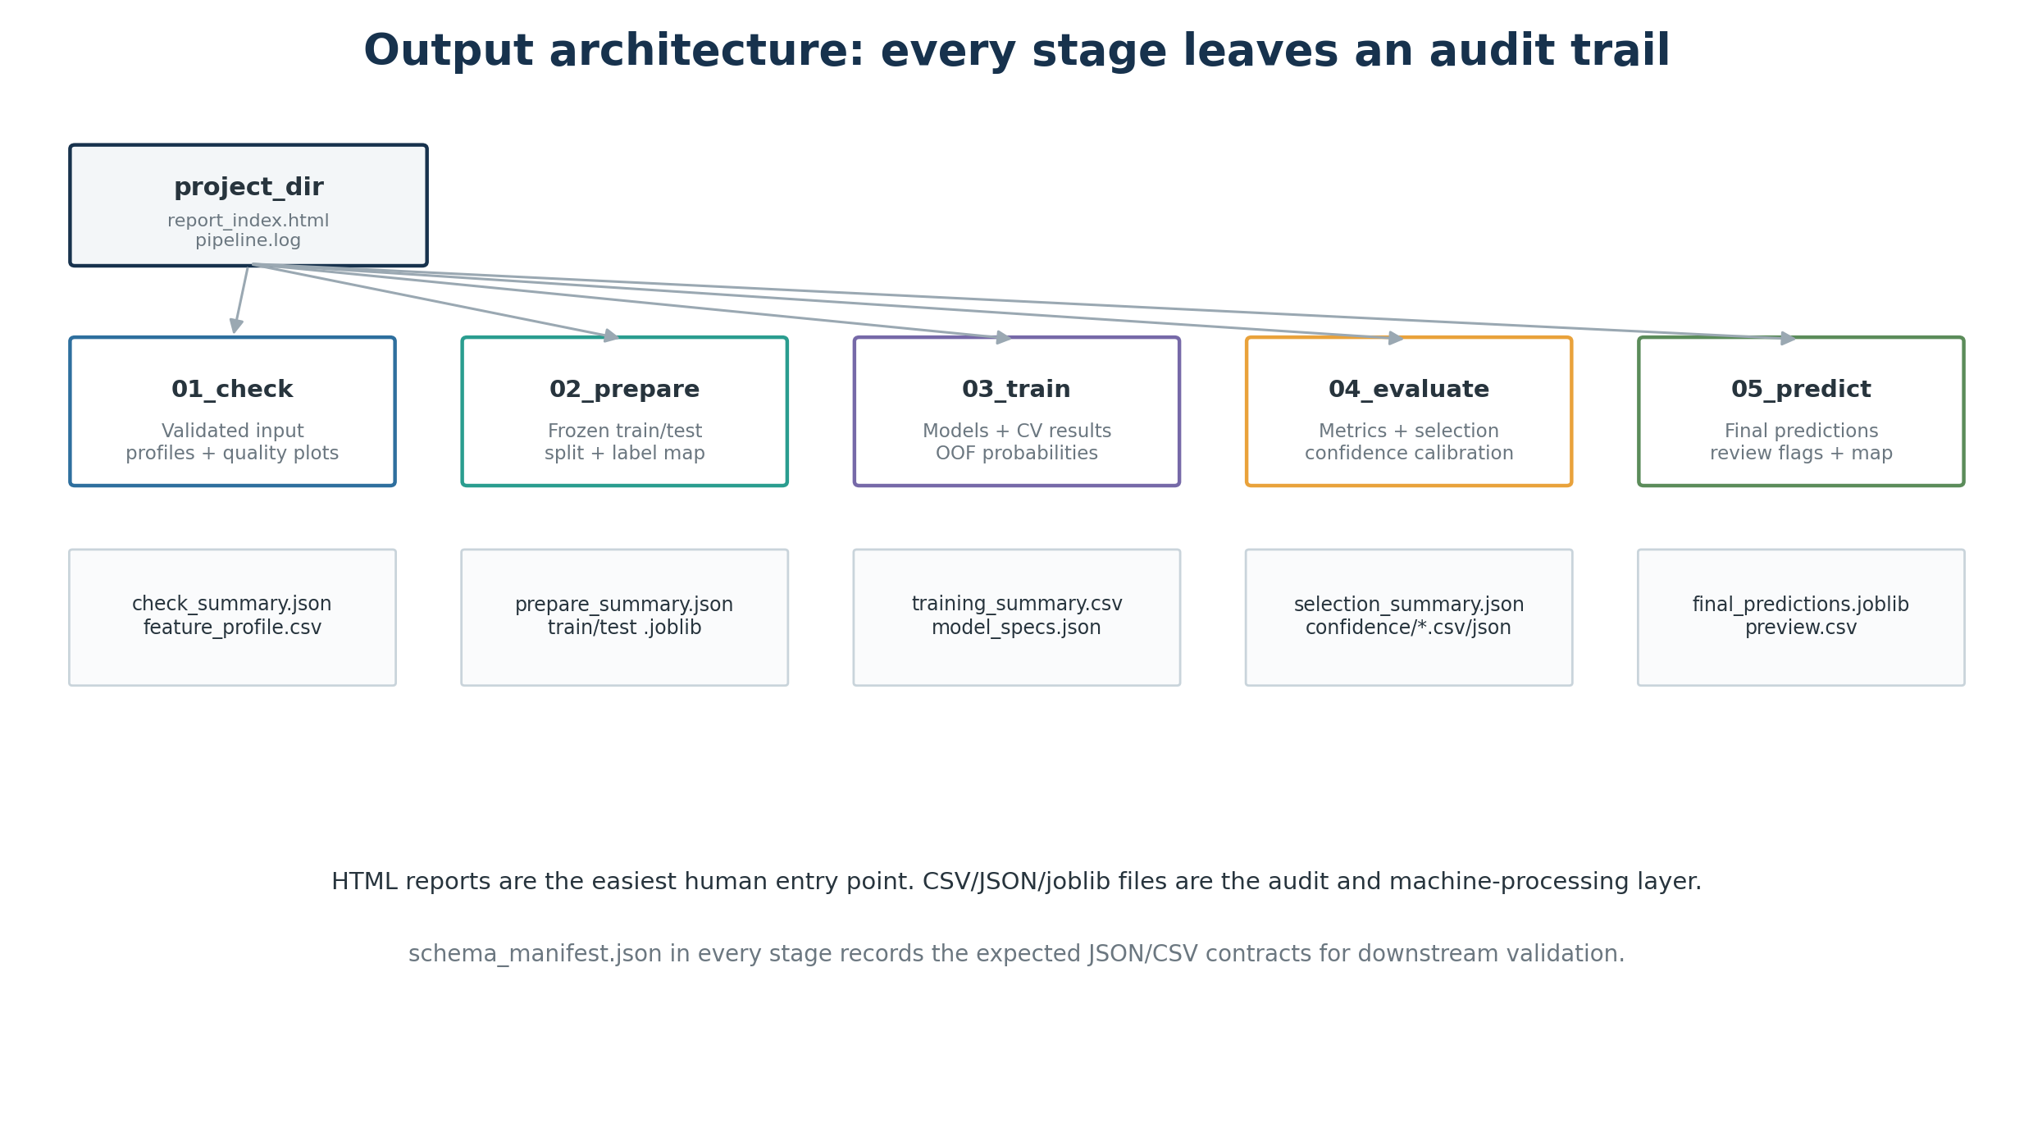
Figure 8. Major output directories and the most important audit artifacts.
The easiest human entry point is report_index.html, which links the step reports. The CSV/JSON/joblib files are the machine-readable and audit layer. Every step also writes schema_manifest.json describing expected JSON/CSV contracts.

12.1 Step 1 — 01_check
Artifact | Use
input_dataset.joblib | Validated/cleaned dataset consumed downstream.
check_summary.json | Data-quality and configuration summary.
feature_profile.csv | Feature-level diagnostic profile.
report.html | Human-readable Step 1 report.
plots/* | Missingness, class distribution and optional label maps.

12.2 Step 2 — 02_prepare
Artifact | Use
train_dataset.joblib | Training/CV partition.
test_dataset.joblib | Untouched final evaluation partition.
labeled_dataset.joblib | All known-label rows for final refit.
prepare_summary.json | Split strategy, class list and exact CV folds.
label_mapping.csv | Original ↔ encoded label mapping.
plots/* | Split balance, feature shift, correlations and spatial split map.

12.3 Step 3 — 03_train
Artifact | Use
training_summary.csv | Authoritative CV ranking of model families.
training_failed_models.csv | Candidate failures.
best_cv_fold_scores.csv | Fold stability diagnostics.
model_specs.json | Winning hyperparameters and reconstruction metadata.
models/<name>/best_model.joblib | Best fitted search estimator.
models/<name>/cv_results.csv | Complete tuning results.
models/<name>/oof_probabilities.joblib | OOF probabilities for calibration/optimization.
models/keras_lstm/temporal_schema.json | Exact LSTM temporal input contract, when applicable.

12.4 Step 4 — 04_evaluate
Artifact | Use
model_metrics_train/test.csv | Base-model train/holdout performance.
*_with_voting.csv | Adds the soft-voting ensemble where available.
selection_summary.json | Authoritative frozen strategy, labels, selected models, multipliers and confidence contract.
reports/*classification_report.csv | Per-class precision/recall/F1/support.
confusion_matrices/* | Where true classes are being confused.
ranking/* | Probability-average/median and rank-average/median parcel diagnostics.
confidence/rank_confidence_test.csv | Holdout parcel-level confidence evidence.
confidence/rank_confidence_oof.csv | OOF calibration evidence (not independent validation).
confidence/rank_confidence_calibration.* | Frozen class/vote empirical accuracy lookup and support provenance.
confidence/confidence_level_metrics.csv | Holdout accuracy/coverage for H/M/L.
confidence/confidence_by_class.csv | Confidence performance split by predicted class.
interpretability/* | Feature importance and optional SHAP for top models.

12.5 Step 5 — 05_predict
Artifact | Use
final_predictions.joblib | Complete final DataFrame/GeoDataFrame with all original columns, prediction, probabilities and confidence diagnostics.
final_predictions_preview.csv | Compact human-readable prediction extract.
predict_summary.json | Counts, selected strategy, confidence distribution and output path.
plots/filled_target_distribution.png | Shows how unknown labels changed the complete target distribution.
plots/predicted_labels_map.png | Spatial view of final/filled labels when geometry is available.

13. How to interpret the main outputs

13.1 Model selection outputs
Field / plot | Interpretation guide
best_cv_score | Mean validation performance of the winning hyperparameter setting for that model.
cv_score_std | Fold-to-fold instability. Lower is better, all else equal.
cv_ranking_metric | Actual value used to rank/select models. With score_minus_std it rewards performance and stability.
model_metrics_test.csv | Unbiased holdout comparison. Prefer macro-F1 / balanced accuracy when class imbalance matters.
confusion matrix | Rows are true labels and columns predicted labels (as generated by sklearn plotting). Look for systematic off-diagonal blocks.
classification report | Inspect per-class recall/F1, not only overall averages.

13.2 Confidence output columns
Column | How to read it
prediction_max_probability | Largest final soft-voting probability. Diagnostic only; do not read as calibrated confidence.
prediction_confidence_level | Primary user-facing H/M/L category after structural safeguards and OOF calibration.
prediction_needs_review | Operational flag. With rank confidence present, true for LOW or invalid confidence.
rank_top1_agreement | Example 0.8 with five models means 4/5 ranked the final class first.
rank_top2_agreement | Fraction of models keeping final class in their first two choices.
rank_aggregate_score | Normalized Borda support for the actual final class; higher is stronger rank support.
rank_margin | Final-class rank score minus strongest alternative. Negative means rank consensus prefers another class.
rank_prediction | Class selected by aggregate rank evidence.
rank_winner_tied | True means top aggregate rank scores tied; this triggers LOW.
rank_agrees_with_prediction | Whether independent rank winner equals final soft-vote label.
rank_confidence_empirical_accuracy | Frozen OOF empirical correctness estimate for this class/agreement calibration bin.
rank_confidence_calibration_support | Number of OOF parcels underlying the empirical estimate after allowed pooling.
rank_confidence_calibration_valid | Whether that empirical estimate met support/eligibility rules.
rank_confidence_calibration_source | Exact bin, adjacent pooled bins, structural safeguard or unsupported fallback provenance.
rank_confidence_reason | Explanation when LOW or invalid, e.g. disagreement, tie, unseen bin or insufficient support.

13.3 Interpreting confidence metrics
Question | What to inspect
Does confidence add value? | In holdout confidence_level_metrics.csv, check that HIGH accuracy > MEDIUM accuracy > LOW accuracy.
Is HIGH too rare? | Check coverage/percentage. Very low coverage may mean empirical thresholds/support rules are too strict or data are sparse.
Is a class systematically unreliable? | Use confidence_by_class.csv and the confusion matrix. Model agreement cannot fix systematic class bias by itself.
Is a confidence estimate well supported? | Use calibration_support, calibration_valid and calibration_source.
Can I trust OOF H/M/L accuracy as final validation? | OOF rows fit the calibration, so use the holdout test for independent confirmation.

Practical reading order For a new run: open report_index.html → Step 1 quality → Step 2 split → Step 3 CV ranking → Step 4 holdout metrics/confusion → Step 4 confidence holdout table → Step 5 final predictions.

14. Advanced and optional features

14.1 Label balancing
The pipeline supports no balancing, random oversampling, or SMOTE. Balancing is applied inside model fitting/CV so validation rows are not synthetically duplicated. LSTM has a separate balanced class-weight option. Always judge balancing by per-class holdout metrics, not by training performance.

14.2 LSTM temporal classification
The optional Keras LSTM interprets temporal feature columns as an ordered sequence. Configuration controls which statistics are temporal, whether timesteps must be complete, expected frequency, minimum timesteps, architecture size, dropout and bidirectionality. The winning temporal schema is saved so production input matches training.

14.3 Feature importance and SHAP
Tree-based top models can export feature importance. SHAP is opt-in because it is heavier computationally. These tools explain associations used by a fitted model; they do not prove causal relationships between an EO index and a crop class.

14.4 Incremental training and filtered evaluation
The training stage can detect reusable model artifacts and skip models that are already fully trained. selected_models can also restrict which models are active/evaluated, while force_retrain_models forces retraining when needed. This supports iterative experimentation without discarding all prior work.

14.5 Restartable artifact contracts
Each step persists the context required by the next one and writes schema metadata. This architecture improves auditability, reproducibility and recovery from interruptions. If artifacts are manually edited, however, frozen contracts such as selection_summary.json can become inconsistent; treat them as controlled pipeline outputs.

15. Operational runbook

15.1 Minimal execution sequence
from ml_classification_pipeline import (
GeospatialClassificationPipeline,
ClassificationPipelineConfig,
)
config = ClassificationPipelineConfig(
project_dir="my_project",
target_column="class",
id_column="parcel_id",
feature_columns=features,
spatial_split=True,
spatial_split_method="by_group",
selection_type="soft_voting",
rank_confidence_enabled=True,
)
pipeline = GeospatialClassificationPipeline(config)
pipeline.run_check(df)
pipeline.run_prepare()
pipeline.run_train()
pipeline.run_evaluate()
pipeline.run_predict()

15.2 Recommended human checkpoints
After step | Before continuing, confirm…
CHECK | Row counts are correct; active features make sense; no catastrophic miserliness; label map/distribution is plausible.
PREPARE | All classes exist in train/test; spatial partition is appropriate; feature distributions do not show unexplained shift.
TRAIN | Important candidate models did not fail; CV ranking is stable; no model is selected based on test performance.
EVALUATE | Holdout macro-F1/balanced accuracy are acceptable; confusion matrix is understood; confidence categories separate accuracy monotonically; calibration support is adequate.
PREDICT | Unknown rows were filled as expected; review count is acceptable; confidence/review fields are present; map/distribution shows no obvious spatial anomaly.

15.3 Rerun guidance
- Changing raw input cleaning, feature columns, label definitions, split settings or CV folds should normally trigger a new CHECK/PREPARE/TRAIN chain.
- Adding a new model family can use the incremental-training path while reusing valid existing artifacts.
- Changing model-selection logic, top_voting_models, probability optimization or confidence settings requires a new EVALUATE at minimum, and often new OOF outputs if the selected members change.
- Do not manually copy an old confidence calibration to a different ensemble size or different class definition; deployment explicitly checks model count because the vote bins would no longer mean the same thing.

16. Troubleshooting and quality red flags
Symptom | Likely meaning / action
Duplicate ID error | Input is not one row per entity. Fix upstream aggregation or deliberately change the modeling grain.
A class has fewer rows than cv_folds | CV cannot represent the class reliably. Add data, merge unsupported classes, or reduce folds with caution.
Spatial split cannot keep a class in training | The class is too geographically concentrated for the chosen grid/test design.
Large train score, much lower test score | Possible overfitting, spatial leakage, domain shift or inadequate regularization.
CV score standard deviation is high | Model performance is unstable across folds; inspect geography/class composition and prefer stable alternatives.
Many failed models | Check optional libraries, memory, invalid hyperparameter combinations, feature types, and training_failed_models.csv.
HIGH/MEDIUM/LOW accuracy is not monotonic on holdout | Confidence calibration is not separating reliability well enough; inspect class bins/support and the confusion matrix.
Many confidence rows invalid | Ensemble too small, unseen class/vote bins, insufficient OOF support, rank ties or soft/rank disagreement.
A class is often wrong even at strong agreement | Systematic model bias/class confusion. Confidence cannot repair a bad class model; revisit features, labels, balancing and class definition.
prediction_max_probability is high but confidence LOW | Possible overconfident model probabilities or disagreement with rank/OOF evidence. The LOW rank confidence is intentional.

Do not “fix” confidence by only lowering thresholds If a class remains inaccurate when all models agree, the issue is model/class discrimination, not confidence strictness. Use per-class holdout diagnostics to distinguish these cases.

17. Glossary
Term | Meaning in this pipeline
Class / target | The category being predicted, e.g. crop code.
Feature | Input measurement used by a model.
Labeled row | Parcel whose true class is known.
Unknown row | Parcel whose target is null and must be filled in Step 5.
Train set | Data used for fitting, CV and OOF.
Holdout test | Data reserved for unbiased final verification.
Cross-validation (CV) | Repeated training/validation splits inside the training data.
OOF prediction | Prediction for a training row made by a model that did not train on that row.
Hyperparameter | Model setting selected during search, e.g. tree depth or learning rate.
Macro-F1 | Average F1 giving every class equal weight.
Soft voting | Average selected models’ aligned class probabilities.
Borda rank score | Normalized score derived from within-model class rank.
Top-1 agreement | Fraction of ensemble models ranking the final class first.
Calibration | Mapping model evidence to observed correctness using separate/OOF evidence.
Confidence support | Number of OOF rows underlying an empirical calibration estimate.
Schema manifest | Machine-readable description of output JSON/CSV contracts.

Appendix A — Implementation map
For maintainers, the main responsibilities are intentionally separated. Computation lives in core modules; steps orchestrate persistence; reporting/visuals format outputs but do not decide model selection.
Module | Responsibility
pipeline.py | Composes the five stages and exposes run_all(df).
steps/check_step.py | Step 1 orchestration.
steps/prepare_step.py | Step 2 split and CV orchestration.
steps/train_step.py | Search, training, OOF generation and incremental reuse.
steps/evaluate_step.py | Base evaluation, selection, ranking/confidence artifacts and reporting.
steps/predict_step.py | Frozen-strategy full inference and final output.
core/models.py | Candidate model/preprocessing definitions.
core/selection.py | CV model ranking, soft voting, optional class multipliers and final refit.
core/rank_confidence.py | Within-model ranking, Borda scores and structural confidence diagnostics.
core/rank_confidence_calibration.py | OOF class-aware empirical H/M/L calibration and bounded pooling.
core/spatial_split.py | Geospatial train/test and group CV utilities.
core/spatial_interpolation.py | Optional spatial missing-value filling.
reporting/* and visuals/* | HTML reports, plots, maps and interpretability graphics.

Document scope This manual describes the behavior present in the reviewed source snapshot. Configuration choices can materially change training cost, split strictness, model selection and confidence coverage; the saved configuration and selection_summary.json are the authoritative record for a particular run.

