Exploratory Data Analysis
Pipeline
Architecture, Methodology and User Manual
DataFrame / GeoDataFrame profiling, target-aware diagnostics and ML feature screening
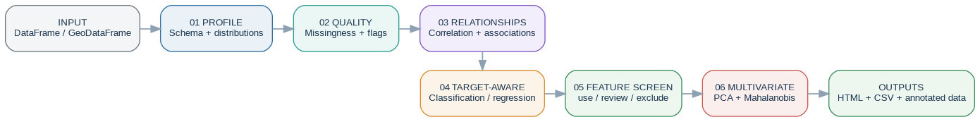
Architecture overview of the implemented EDA workflow.
Document type | Value
Document type | Architectural design + methodology + operational manual
Source basis | Latest uploaded implementation (src(5).zip)
Pipeline schema | EDA artifact schema 1.5.0
Reviewed source | 24 August 2026

Contents
1. Purpose and intended audience
2. Pipeline at a glance
3. Architecture and execution model
4. Inputs, logical data types and prerequisites
5. Dataset overview and column profiling
6. Data quality and missingness
7. Numeric analysis: descriptive, robust and normality diagnostics
8. Outlier diagnostics: univariate and multivariate
9. Correlation and multicollinearity
10. Categorical analysis and associations
11. Target-aware analysis: classification vs regression
12. Feature-selection methodology: ordered decision gates
13. Plot prioritization and visual diagnostics
14. PCA and multivariate structure
15. Geospatial diagnostics
16. Output architecture and artifact reference
17. HTML report architecture
18. How to interpret the main outputs
19. Configuration reference
20. Operational runbook
21. Troubleshooting and quality red flags
22. Integration with the ML classification pipeline
23. Glossary
Appendix A — Implementation map

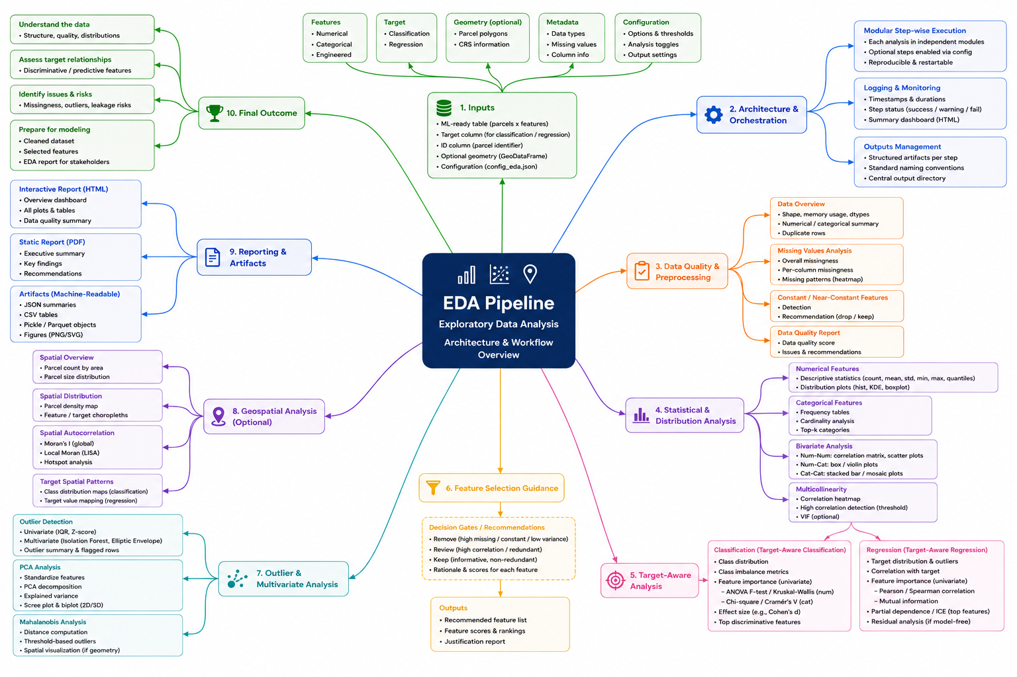
Figure 1. Functional mindmap of the EDA pipeline and its analytical branches.

1. Purpose and intended audience
The EDA pipeline provides a reusable exploratory-analysis layer for pandas DataFrame and GeoPandas GeoDataFrame inputs. It supports human review and downstream machine-learning preparation while preserving a machine-readable audit trail.
Core idea The pipeline analyzes the supplied dataset as-is, writes auditable evidence, and proposes an initial feature shortlist. It does not train the final predictive model; the final feature decision belongs to train-only validation.

1.1 Intended users
Role | Most useful sections
Analyst / domain expert | Data quality, target-aware diagnostics, feature proposal, plots, geospatial checks
Data scientist | Association tests, FDR, redundancy, PCA/outliers, feature screening and ML hand-off
Reviewer / project manager | Architecture, report structure, output contracts, interpretation and red flags
Developer / maintainer | Configuration, module map, serialization, artifact names and execution lifecycle

1.2 What the pipeline does not claim
- It does not prove causality or domain relevance from statistical association.
- It does not treat the automated feature proposal as the definitive model feature set.
- It does not fit model-selection decisions inside CV folds; that belongs to the downstream ML workflow.
- It does not recommend automatic deletion of multivariate outliers, especially from an independent test set.

2. Pipeline at a glance
Figure 2. End-to-end analytical flow from input table to persisted EDA artifacts.
Stage | Plain-language purpose | Primary evidence
01 Profile | Understand shape, data types, distributions and memory footprint. | eda_summary.json, column_profile.csv
02 Quality | Identify missingness, constant/quasi-constant, ID-like and rare-category issues. | data_quality_flags.csv, missingness_summary.csv
03 Relationships | Measure numeric correlation, categorical association and multicollinearity. | correlation matrices, Cramér V, VIF
04 Target-aware | Measure how each feature relates to a configured target. | Kruskal/ANOVA, Cramér V, Spearman, FDR q-values
05 Feature screen | Apply ordered gates to create use/review/exclude proposal. | feature_selection_proposal.csv
06 Multivariate | Characterize joint structure and flag unusual rows diagnostically. | PCA summary, Mahalanobis scores
07 Report / persist | Save evidence, plots, HTML report and annotated data. | report.html, tables/*, plots/*, GeoParquet

Important separation The EDA feature proposal ends before model validation. The final criterion is explicitly train-only model validation and is not automated by the EDA pipeline.

3. Architecture and execution model
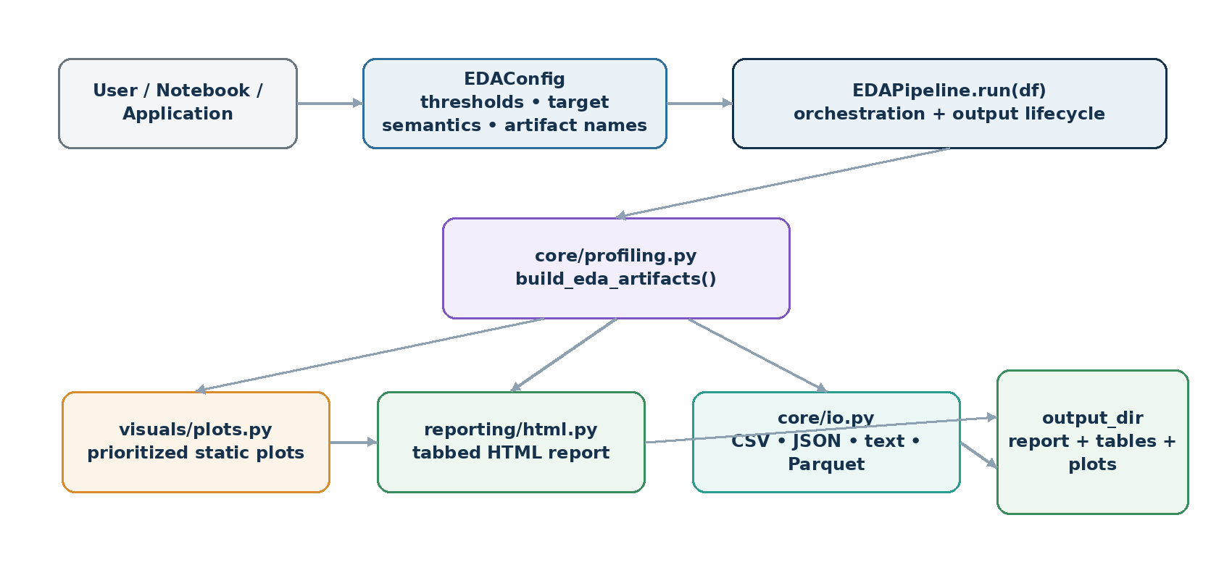
Figure 3. Software architecture: orchestration, analytical core, presentation and persistence.

3.1 Orchestrator
EDAPipeline.run(df) validates the input type, resets or creates the output directory, builds analytical artifacts, optionally prints the feature-selection summary, creates plots, persists artifacts, optionally writes the HTML report, and returns the in-memory result contract.

3.2 Analytical core
core/profiling.py contains the statistical computation. build_eda_artifacts() copies the source dataset, infers analytical column groups, computes tabular evidence, builds the feature-screening proposal, creates PCA and multivariate-outlier outputs, and returns one artifact dictionary.

3.3 Presentation and persistence
- visuals/plots.py creates static PNG diagnostics, limited to max_features_per_plot where appropriate.
- reporting/html.py renders a tabbed report from already-computed artifacts; report rendering does not decide feature selection.
- core/io.py serializes JSON, CSV, UTF-8 text and Parquet/GeoParquet via the shared write_data helper.
Design characteristic CSV/JSON/Parquet artifacts remain the authoritative machine-readable evidence even when plots show only the configured top feature subset.

4. Inputs, logical data types and prerequisites
The pipeline accepts any non-empty pandas DataFrame or GeoPandas GeoDataFrame. A target is optional; target-aware tests and the automated feature proposal require a valid configured target.
Element | Requirement / behavior
Rows | At least one row; an empty dataframe raises ValueError.
Columns | Any mixture of numeric, categorical, boolean, datetime and optional geometry.
Target column | Optional. If configured but absent, summary records target_status='missing' and target-aware artifacts remain empty.
Target task | auto, classification, or regression. auto treats numeric targets as regression and other dtypes as classification.
ID column | Optional; excluded from feature-only analyses, pairwise categorical association, target tests and the proposal when configured.
Geometry | Optional. Geospatial diagnostics require GeoDataFrame-like geometry and include_geospatial=True.

4.1 Logical type inference
Logical type | Rule
geometry | Column name is exactly geometry.
boolean | Pandas boolean dtype.
numeric | Pandas numeric dtype.
datetime | Pandas datetime64-compatible dtype.
categorical | All remaining non-geometry columns.

4.2 Duplicate rows
The high-level summary counts duplicate rows after excluding geometry. Duplicate IDs are not automatically rejected by the EDA pipeline; ID uniqueness remains a domain/data-model review item.

5. Dataset overview and column profiling
The first layer describes the dataset before specialized tests are run.

5.1 Dataset summary
Field | Meaning
rows / columns | Overall dimensions.
numeric_columns / categorical_columns / datetime_columns | Detected analytical column groups.
geometry_column_present | Whether geometry exists.
target_status / target_task | Target availability and resolved semantics.
duplicate_rows_excluding_geometry | Exact duplicate rows after geometry removal.
total_missing_values / total_missing_percent | Global missingness.
memory_usage_mb | Deep pandas memory usage.
config | Complete configuration snapshot embedded in the summary.

5.2 Column profile
Every input column receives dtype, logical type, non-null count, missing count/percentage, unique count/percentage, constant flag and deep memory usage. Geometry uniqueness is represented by the number of geometry types when available.
Interpretation Start with eda_summary.json and column_profile.csv. If the inferred type or missingness of a key EO feature is unexpected, fix the upstream table before interpreting association or feature-selection results.

6. Data quality and missingness
Column-level quality flags use explicit thresholds and feed both the automated feature proposal and plot ordering.
Issue | Default trigger | Severity | Selection impact
constant | One or zero distinct non-missing values. | high | Excluded.
high_missing | Missing percentage >= 40%. | medium | Excluded.
id_like_or_nearly_unique | Unique ratio >= 95%. | medium | Warning; not a hard proposal exclusion unless configured as ID/leakage.
quasi_constant | Most common value >= 98%. | medium | Excluded.
rare_category_heavy | At least half the categories occur no more than ~1% of rows. | low | Review item; not a hard exclusion.

6.1 Missingness summary
For every column with missing data, the pipeline records missing/non-missing counts and the five columns most frequently missing on the same rows.

6.2 Missingness vs classification target
For classification targets, each feature's missing/present indicator is tested against the target using chi-square. Conventional and finite-sample bias-corrected Cramér's V are reported, and p-values are Benjamini-Hochberg adjusted.
EO interpretation Class-dependent missingness may reflect geography, cloud climatology, acquisition coverage or processing artifacts. Treat it as a representativeness/leakage question, not only an imputation problem.

7. Numeric analysis: descriptive, robust and normality diagnostics
Numeric columns receive conventional and robust summaries because EO parcel statistics are often skewed, heavy-tailed or bounded.

7.1 Standard descriptive statistics
- count, missingness, mean, standard deviation, min/max, Q1/median/Q3 and IQR;
- skewness, kurtosis and coefficient of variation when the mean is non-zero;
- zero and negative counts; and
- IQR lower/upper fences plus the IQR outlier count.

7.2 Robust summary
- 10% trimmed mean and median;
- normalized median absolute deviation (MAD);
- 1st, 5th, 95th and 99th percentiles; and
- 95% t-based confidence interval around the mean when enough data exist.

7.3 Normality tests
Finite values are sampled without replacement up to normality_sample_size (default 5,000). Shapiro-Wilk is computed with at least 3 observations. With at least 8, D'Agostino, Jarque-Bera and Anderson-Darling are also calculated. normality_hint is likely_normal only when both D'Agostino and Jarque-Bera p-values are at least 0.05.
Caution With large samples, formal normality tests can reject small deviations. Read them together with QQ plots, skew/kurtosis and model assumptions.

8. Outlier diagnostics: univariate and multivariate
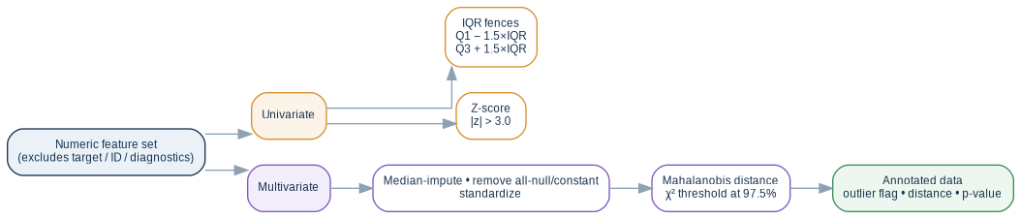
Figure 4. Univariate and multivariate outlier paths and diagnostic annotation.

8.1 Univariate outliers
The shared OutlierAnalysis layer applies IQR fences Q1 − iqr_multiplier×IQR and Q3 + iqr_multiplier×IQR (default 1.5), plus an absolute sample z-score threshold of 3.0. Missing and infinite values are absent/invalid values, not detected outliers.

8.2 Multivariate Mahalanobis scoring
Up to max_multivariate_features numeric predictors are selected after excluding target, ID and prior EDA diagnostics. Infinities become missing; all-null features are removed; remaining missing values are median-imputed; constants are dropped; retained variables are standardized. Mahalanobis squared distance is compared with a chi-square threshold at 97.5% confidence using a pseudo-inverse covariance matrix.

8.3 Annotated dataset
Column added | Meaning
is_outlier_97_5pct | Boolean multivariate diagnostic flag.
mahalanobis_distance | Square-root Mahalanobis distance.
mahalanobis_pvalue | Upper-tail chi-square p-value for squared distance.

Do not use as a predictor The README treats these as diagnostic metadata. They are calculated from the complete supplied dataset and must not be used as ML predictors or to automatically delete holdout/test rows.

9. Correlation and multicollinearity
Diagnostic | Implementation | Default interpretation
Pearson matrix | All numeric columns; linear association. | Strong-pair table retains |r| >= 0.75.
Spearman matrix | All numeric columns; monotonic rank association. | Used for numeric redundancy screening.
VIF | Standardized prioritized numeric subset. | <5 low; 5–<10 moderate; >=10 high multicollinearity.

9.1 VIF implementation
Each selected feature is regressed on the other selected numeric features with an intercept. R² is clamped below 1 for numerical stability, tolerance = 1 − R², and VIF = 1/tolerance. VIF is calculated only for the prioritized numeric subset up to max_features_per_plot.
Redundancy vs usefulness A redundant feature is moved to review rather than permanently excluded because downstream model validation may show useful nonlinear or interaction information.

10. Categorical analysis and associations

10.1 Categorical summary
- non-missing and missing counts/percentages;
- unique category count and top category share;
- rare-value count using an approximately 1% frequency threshold;
- Shannon entropy; and
- top value counts limited by max_categories for display.

10.2 Pairwise association
Eligible categorical pairs are tested with chi-square and summarized by Cramér's V. Near-row-unique fields are excluded from this test: a candidate needs at least two non-null observations, at least two levels, and a unique ratio below categorical_association_max_unique_ratio (default 0.95). The configured ID is excluded.

11. Target-aware analysis: classification vs regression
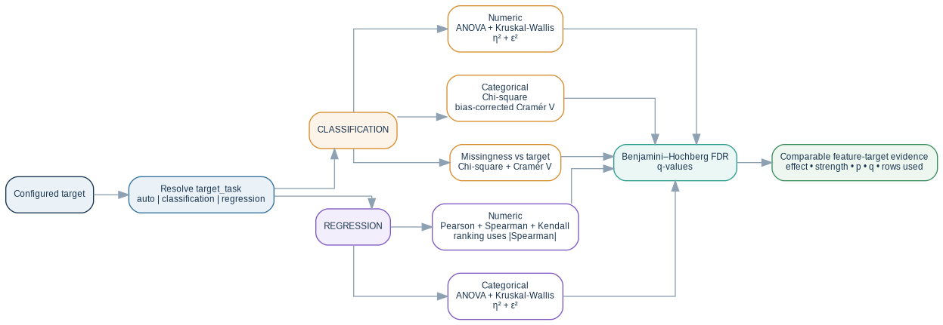
Figure 5. Target task determines the statistical evidence generated for each predictor type.

11.1 Classification target
Predictor type | Tests / effect sizes | Ranking effect
Numeric | ANOVA + Kruskal-Wallis; η² + ε². | ε²
Categorical | Chi-square; conventional + bias-corrected Cramér's V. | bias-corrected Cramér's V
Missingness | Present/missing vs target chi-square + Cramér's V. | Separate diagnostic

11.2 Regression target
Predictor type | Tests / effect sizes | Ranking effect
Numeric | Pearson, Spearman and Kendall correlations. | absolute Spearman
Categorical | ANOVA + Kruskal-Wallis across feature levels; η² + ε². | ε²

11.3 Multiple-testing control
P-values are adjusted with Benjamini-Hochberg FDR. The default alpha is 0.05. q-values are combined with method-specific effect sizes to create cautious screening labels.
Effect | Strength thresholds used
Kruskal ε² | large >= 0.14; moderate >= 0.06; small >= 0.01; otherwise negligible
Cramér V / |Spearman| | strong >= 0.50; moderate >= 0.30; weak >= 0.10; otherwise negligible

12. Feature-selection methodology: ordered decision gates
The automated proposal is sequential rather than a weighted composite score. Every screened feature receives use, review or exclude plus an auditable reason.
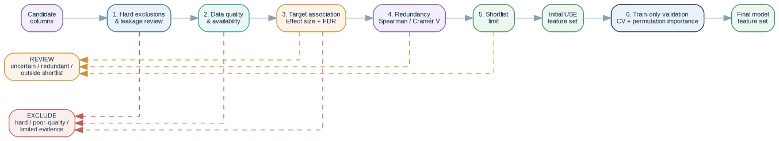
Figure 6. Ordered feature-screening workflow derived from the source implementation and guide.

12.1 Gate 1 — hard exclusions and leakage review
The target, configured ID, geometry, EDA diagnostics, columns starting with eda_, and manually configured feature_selection_exclude_columns are excluded. Known post-outcome/leaky variables must be specified manually because EDA cannot infer future availability.

12.2 Gate 2 — data quality and availability
Constant, quasi-constant and high-missing features are excluded. Rare-category-heavy and ID-like warnings remain review context.

12.3 Gate 3 — target association
Strong/large/moderate effects with q <= feature_selection_alpha become priority candidates. Meaningful effects without sufficient FDR evidence become review. Statistically detectable but weak effects also become review. Limited effect plus limited evidence becomes exclude.

12.4 Gate 4 — redundancy
Priority numeric features are checked against retained numeric features using absolute Spearman correlation; categorical features use Cramér's V. At or above the default 0.90 threshold, the later feature moves from use to review and redundant_with identifies the retained feature.

12.5 Gate 5 — parsimonious shortlist
feature_selection_max_features defaults to 50. Qualifying features beyond the cap become review rather than exclude. Set the option to None to disable the cap.

12.6 Gate 6 — train-only model validation
Final criterion Cross-validation, permutation importance, model-specific importance and feature-set comparisons happen after the train/test split. This criterion is intentionally not automated by EDA.

13. Plot prioritization and visual diagnostics
CSV artifacts retain the complete analysis. Multi-feature plots use max_features_per_plot (default 12) and follow the same screening priority as feature_selection_proposal.csv.

13.1 Plot ordering
- use features in evidence-ranked order;
- review features;
- exclude features;
- remaining features ordered by blocking quality issues, other flags, missingness and original position.

13.2 Main generated plots
Scope | Examples
Data quality | missing_values, missingness_heatmap, data_quality_flags
Numeric | distributions, QQ plots, scatter matrix, Pearson/Spearman heatmaps, VIF
Classification target | target distribution, target-profile heatmap, distribution comparison, categorical composition, association ranking
Regression target | numeric target correlations/scatter, numeric target by categorical features, association ranking
Multivariate | PCA explained variance and PCA score plot
Geospatial | geometry overview and target heatmap when available

Key contract A plot limit is a display choice, not an analytical truncation. Use the CSV tables when all features must be reviewed.

14. PCA and multivariate structure
PCA is used as an exploratory summary of joint numeric structure, not as an automatic feature transformer for downstream modeling.

14.1 Preparation
- Restrict to the configured multivariate feature limit.
- Coerce to numeric; convert infinities to missing.
- Drop all-null features; median-impute remaining missing values.
- Remove constant features.
- Standardize retained variables using population standard deviation.

14.2 Explained variance
The implementation performs singular-value decomposition of the standardized matrix and records component explained-variance ratios plus cumulative explained variance.
Interpretation A steep variance curve can indicate redundancy or lower-dimensional structure, but PCA alone does not determine which original features predict the target.

15. Geospatial diagnostics
When include_geospatial=True and the input behaves like a GeoDataFrame, the pipeline adds geometry diagnostics without treating geometry as an ordinary feature.
Metric / plot | Meaning
crs | CRS string.
missing / empty / invalid geometries | Basic integrity counts.
geometry_type_* | Counts by geometry type.
min_x, min_y, max_x, max_y | Total bounds when available.
is_projected_crs | Whether the CRS reports projected coordinates.
area_mean / area_total | Only when CRS is projected.
length_mean / length_total | Only when CRS is projected.
geometry_overview.png | Spatial footprint overview.
geometry_target_heatmap.png | Target-aware spatial heatmap when supported.

CRS caution The pipeline does not reproject automatically. Area and length are only summarized when the CRS reports itself as projected; users remain responsible for selecting meaningful units.

16. Output architecture and artifact reference
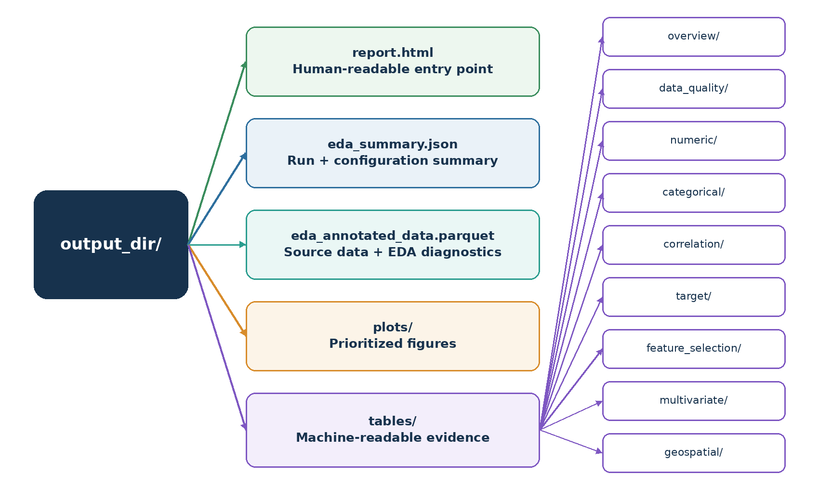
Figure 7. Output directory structure and analytical grouping.

16.1 Root-level outputs
Artifact | Use
report.html | Primary human-readable tabbed report.
eda_summary.json | Dataset shape, configuration snapshot, plot order and multivariate metadata.
eda_annotated_data.parquet | Complete source DataFrame/GeoDataFrame plus multivariate diagnostic columns; geometry metadata is preserved.

16.2 CSV table groups
Directory | Main contents
tables/overview | column_profile.csv, datetime_summary.csv
tables/data_quality | data_quality_flags.csv, missingness_summary.csv
tables/numeric | numeric_summary.csv, robust_numeric_summary.csv, normality_tests.csv, outlier_summary.csv
tables/categorical | categorical_summary.csv, categorical_associations.csv
tables/correlation | Pearson/Spearman matrices, strong pairs, multicollinearity.csv
tables/target | target summary and classification/regression target tests
tables/feature_selection | feature-target associations, ordered criteria, proposal CSV and text
tables/multivariate | pca_summary.csv, multivariate_outliers.csv
tables/geospatial | geospatial_summary.csv

17. HTML report architecture
report.html begins with the dataset summary, followed by expandable data-quality details. Main tabs are grouped by feature type; Feature Selection is inserted when target-aware analysis exists, and Geometry appears when geospatial diagnostics are available.
Tab / section | Contents
Feature Selection | Initial proposal, ordered criteria, target-association ranking and target comparison plots.
Categorical | Column profile, datetime/categorical summaries, pairwise association and target tests.
Numerical / General | Numeric profile, standard summary, robust summary and target summary when relevant.
Numerical / Normality | Formal tests and prioritized QQ plot.
Numerical / Outliers | Univariate summary plus all rows flagged at the 97.5% Mahalanobis threshold.
Numerical / Correlation | Strong Pearson pairs, heatmaps and VIF.
Numerical / Multivariate | Scatter matrix, PCA and target-aware multivariate displays.
Geometry | Geometry profile, summary and optional target heatmap.

18. How to interpret the main outputs
Question | Inspect | Interpretation
Is the table structurally usable? | eda_summary.json + column_profile.csv | Check dimensions, types, missingness and duplicates.
Which columns are unsafe or weak? | data_quality_flags.csv | Constant/quasi/high-missing are automated blockers; ID-like/rare-heavy require context.
Are numeric features redundant? | correlation pairs + VIF | High pairwise correlation or VIF indicates shared information.
Which features show target signal? | feature_target_associations.csv | Read effect size + q-value + rows used; do not use p-value alone.
What enters the first ML experiment? | feature_selection_proposal.csv | Start with use, inspect review, understand every exclude reason.
Are there unusual multivariate rows? | multivariate_outliers.csv + annotated Parquet | Investigate errors/domain extremes; do not delete automatically.
Does geography reveal artifacts? | geospatial summary + maps | Inspect geometry integrity, spatial clustering and coverage patterns.

18.1 Feature proposal columns
Column | Meaning
proposed_action | use, review or exclude.
primary_reason | Reason for the current decision.
association_method | Method used for target evidence.
effect_size / association_strength | Magnitude and cautious qualitative category.
qvalue | Benjamini-Hochberg adjusted p-value.
missing_percent | Availability evidence.
redundant_with / redundancy_measure | Retained feature triggering the redundancy gate and its association.
passes_* | Audit flags for each ordered gate.

19. Configuration reference
Parameter | Default | Purpose
output_dir | required | Root output directory.
report_title | Exploratory Data Analysis Report | HTML report title.
target_column | None | Optional supervised target.
target_task | auto | auto / classification / regression.
id_column | None | Optional ID excluded from feature analyses.
max_features_per_plot | 12 | Shared display and VIF feature limit.
max_categories | 15 | Maximum displayed categories.
categorical_association_max_unique_ratio | 0.95 | Near-unique categorical cutoff.
high_missing_percent_threshold | 40.0 | High-missing exclusion threshold.
quasi_constant_threshold | 0.98 | Dominant-value ratio for quasi-constant flag.
max_target_levels_for_plots | 8 | Displayed target-class limit.
max_multivariate_features | 8 | Maximum PCA/Mahalanobis features.
correlation_threshold | 0.75 | Absolute Pearson strong-pair threshold.
normality_sample_size | 5000 | Maximum sample for normality tests.
outlier_zscore_threshold | 3.0 | Absolute z-score threshold.
iqr_multiplier | 1.5 | IQR fence multiplier.
feature_selection_alpha | 0.05 | FDR q-value threshold.
feature_selection_redundancy_threshold | 0.90 | Spearman/Cramér V redundancy gate.
feature_selection_max_features | 50 | Maximum automated use shortlist; None disables cap.
feature_selection_exclude_columns | () | Manual leakage/post-outcome exclusions.
print_feature_selection_summary | True | Print proposal message when target configured.
include_html_report | True | Generate report.html.
include_plots | True | Generate plots.
include_geospatial | True | Generate geospatial diagnostics.
reset_output_dir | True | Delete/recreate output directory before run.
random_state | 42 | Sampling/stochastic reproducibility.
schema_version | 1.5.0 | Recorded artifact schema version.

20. Operational runbook

20.1 Minimal execution
from eda_pipeline import EDAConfig, EDAPipeline
config = EDAConfig(
output_dir="outputs/eda",
target_column="class",
target_task="classification",
id_column="parcel_id",
report_title="Parcel Feature EDA",
)
result = EDAPipeline(config).run(df)
report = result["report_path"]
features = result["proposed_features"]
ml_ready = result["annotated_data"]

20.2 Recommended checkpoints
Checkpoint | Before continuing, confirm…
Dataset summary | Expected rows/columns, target semantics, ID and logical types.
Data quality | No unexplained constant/quasi/high-missing features; missingness patterns understood.
Relationships | Strong correlations/VIF and category associations have plausible explanations.
Target evidence | Top effects have adequate rows, sensible effect size and FDR evidence.
Feature proposal | Every exclude/review decision is understood; leakage exclusions are complete.
Outliers / PCA | Unusual rows are investigated, not automatically removed.
Geospatial | CRS/geometry integrity are appropriate; spatial clustering is recognized before ML splitting.

20.3 Rerun guidance
- Changing target semantics, ID, quality thresholds or leakage exclusions should trigger a full EDA rerun.
- Changing max_features_per_plot mainly changes display coverage and the VIF subset; complete tabular artifacts remain broader.
- Changing FDR alpha, redundancy threshold or shortlist limit changes the proposal and should trigger a rerun.
- With reset_output_dir=True, the previous output tree is deleted before each run; archive important runs separately.

21. Troubleshooting and quality red flags
Symptom | Likely meaning / action
Target-aware tables are empty | Target is absent/not configured, target_task is incompatible, or there is insufficient valid variation.
Almost every feature is excluded | Check missingness/quasi-constant thresholds, leakage exclusions, target semantics and upstream feature construction.
Many significant q-values but tiny effects | Large samples can make weak effects statistically detectable; prioritize effect size and model validation.
Strong effects but q > 0.05 | Potential signal with limited evidence; review rather than automatic use.
VIF is very high | Selected numeric features are strongly explained by one another.
Normality tests reject everything | Common in large EO datasets; inspect QQ plots/skew and model assumptions.
Many multivariate outliers | May reflect errors, heterogeneity, mixed phenology or correlated extremes; inspect spatial/target patterns.
Area/length metrics are absent | CRS is missing/non-projected or geometry calculations failed.
Plots omit features present in CSV | Expected when feature count exceeds max_features_per_plot.
Annotated outlier columns look useful for ML | Do not use them as predictors; they are complete-dataset diagnostics.

Do not tune EDA thresholds to force a desired feature list The proposal is evidence for review, not a target outcome. Keep domain-critical but weak/redundant variables as explicit review candidates and validate them downstream.

22. Integration with the ML classification pipeline
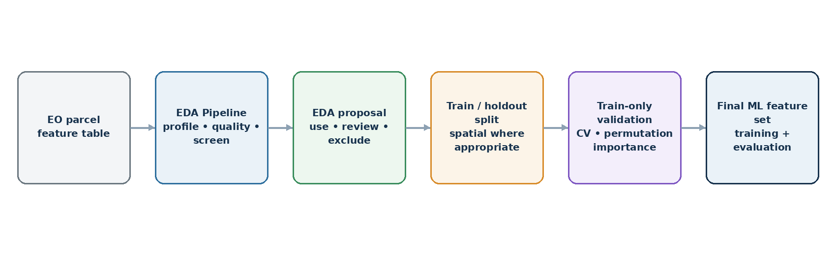
Figure 8. Boundary between complete-dataset EDA and train-only feature validation/model selection.
The EDA pipeline is a natural upstream component for parcel-level EO classification: it identifies quality problems, prioritizes candidate features and exposes spatial/data-distribution risks before training. The final predictive feature set must still be chosen after the train/test split using training-only evidence.
EDA output | Downstream ML use
feature_selection_proposal.csv | Seed the candidate feature list; use as a starting point, not a frozen contract.
correlation / VIF tables | Guide redundancy experiments and compact feature subsets.
data_quality_flags.csv | Drive upstream fixes or training-only preprocessing choices.
annotated Parquet | Convenient hand-off dataset, but exclude EDA diagnostic columns from predictors.
geospatial maps / summary | Inform spatial split design and leakage assessment.

Leakage rule EDA may inspect the complete supplied dataset for exploration. Any model-tuning, feature-selection fitting, imputation fitting or performance-based decision intended to estimate generalization must be repeated inside the training partition only.

23. Glossary
Term | Meaning in this pipeline
EDA | Structured examination of data quality, distributions and relationships before modeling.
Target task | Classification or regression semantics applied to the configured target.
FDR | False discovery rate.
q-value | Benjamini-Hochberg adjusted p-value used by the screening logic.
Effect size | Magnitude of association, separate from statistical significance.
Cramér's V | Categorical association strength; target tests also report a finite-sample bias-corrected form.
eta-squared (η²) | ANOVA-style fraction of total variation explained by group membership.
epsilon-squared (ε²) | Kruskal-Wallis effect size.
Spearman correlation | Rank-based measure of monotonic numeric association.
VIF | Variance Inflation Factor: 1/(1−R²).
PCA | Orthogonal components summarizing multivariate variance.
Mahalanobis distance | Distance accounting for covariance among features.
use / review / exclude | Automated proposal actions for the first ML experiment.
Leakage | Information unavailable at prediction time or held-out information improperly influencing model construction.
GeoParquet | Parquet storage preserving GeoPandas geometry metadata.

Appendix A — Implementation map
Module | Responsibility
eda_pipeline/pipeline.py | Public EDAPipeline orchestration, run_eda convenience function, persistence and return contract.
eda_pipeline/core/config.py | EDAConfig defaults, validation and artifact naming.
eda_pipeline/core/profiling.py | Dataset summary, profiles, quality flags, statistical tests, feature screening, PCA, Mahalanobis annotation and geospatial summary.
eda_pipeline/core/io.py | Directory lifecycle and JSON/CSV/text/Parquet serialization.
eda_pipeline/visuals/plots.py | Prioritized plots for quality, distributions, relationships, target diagnostics, PCA and geometry.
eda_pipeline/reporting/html.py | Tabbed HTML report assembled from existing artifacts and plots.
eda_pipeline/FEATURE_SELECTION_GUIDE.md | Ordered feature-screening criteria and train-only validation boundary.
common_libraries/data_cleaning/outliers.py | Shared IQR, z-score and Mahalanobis calculations used by EDA.

Document scope
Source snapshot This manual describes behavior present in the reviewed src(5).zip implementation. The saved eda_summary.json configuration and schema version are the authoritative record for an individual run.

