Machine Learning
Classification Pipeline
Architecture, Methodology and User Manual
Geospatial / parcel-level multiclass classification
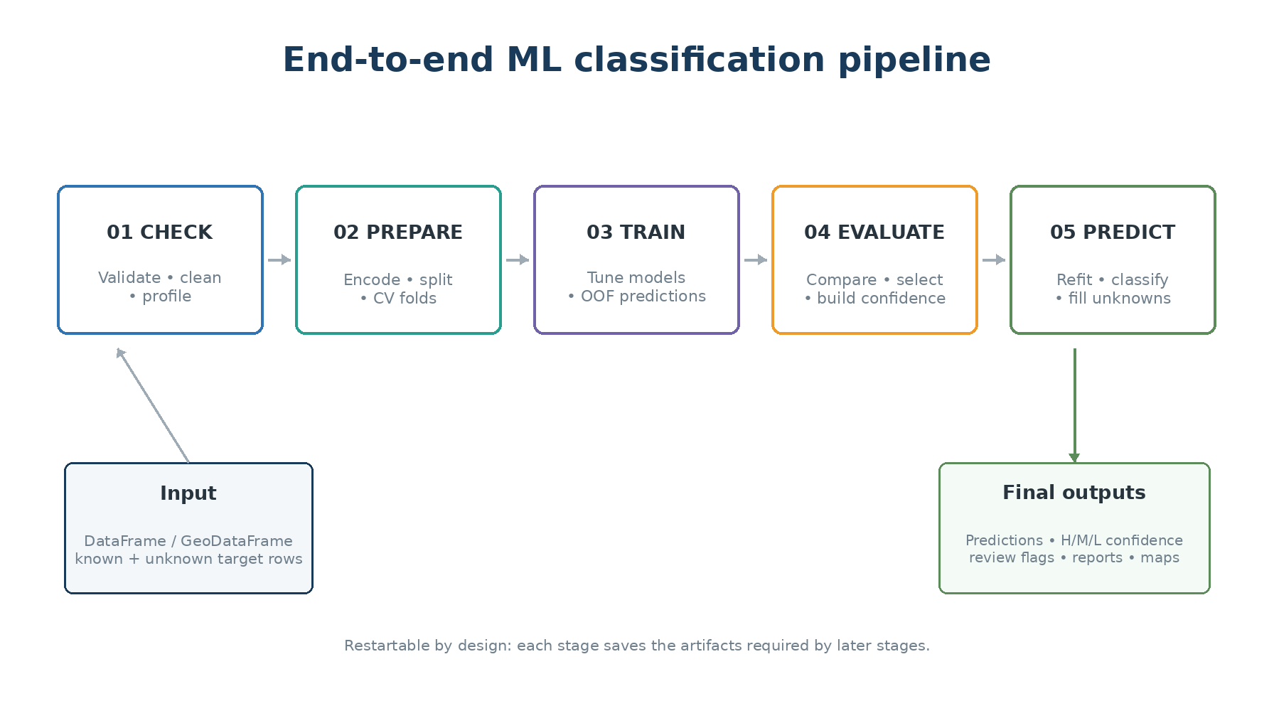
Architecture overview of the implemented five-stage workflow.
Document type | Architectural design + operational manual
Source basis | Latest uploaded implementation (src(4).zip)
Pipeline output schema | 1.2.0
Code snapshot date | 24 August 2026

Contents
1. Purpose and intended audience
2. Pipeline at a glance
3. Input data and prerequisites
4. Data leakage safeguards and spatial validation
5. Step 1 — CHECK: validate, clean and profile
6. Step 2 — PREPARE: encode, split and create CV folds
7. Step 3 — TRAIN: tune candidate models and produce OOF predictions
8. Step 4 — EVALUATE: compare, select and validate
9. Ensemble prediction: soft voting and optional class multipliers
10. Confidence methodology: rank support + OOF class reliability
11. Step 5 — PREDICT: refit, classify and fill unknown labels
12. Output architecture and artifact reference
13. How to interpret the main outputs
14. Advanced and optional features
15. Operational runbook
16. Troubleshooting and quality red flags
17. Glossary

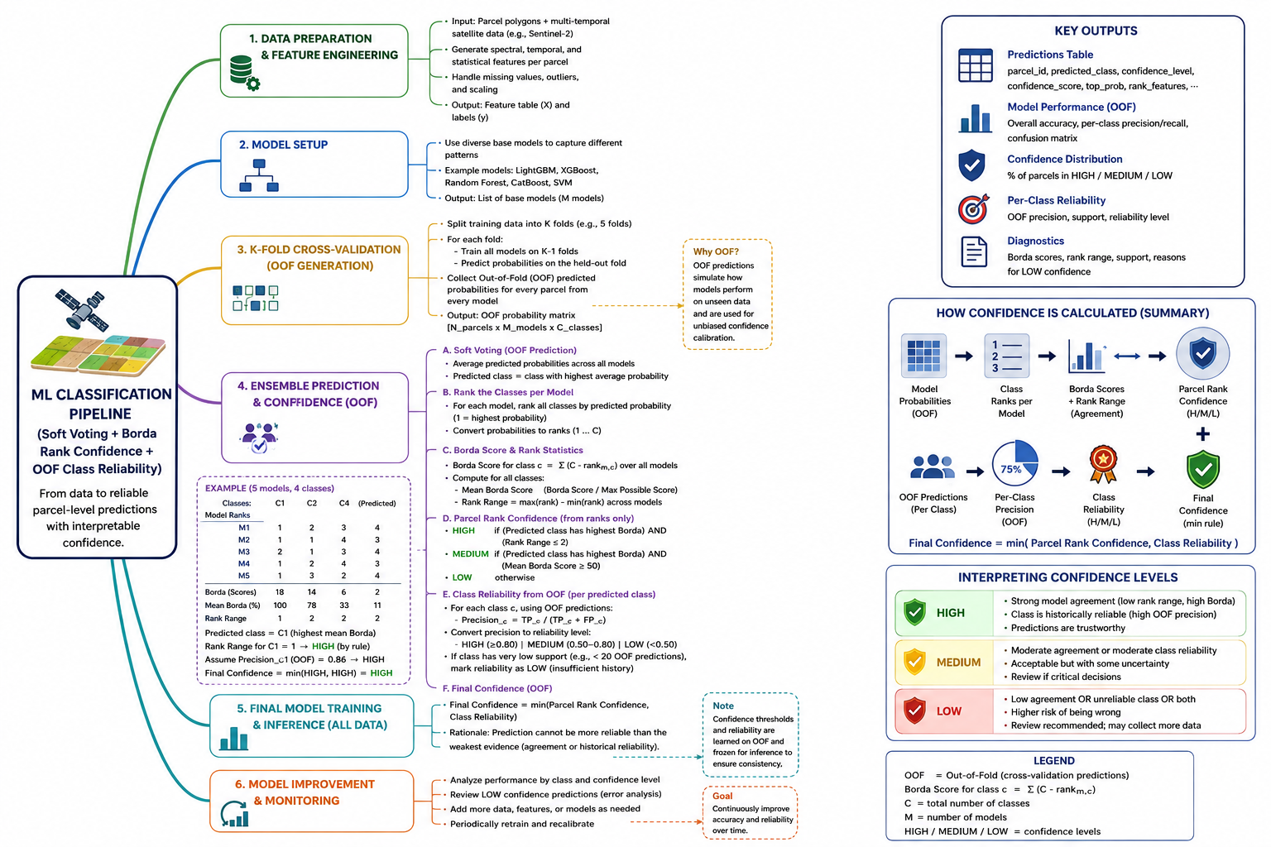

1. Purpose and intended audience
This document explains the implemented machine-learning classification pipeline in plain language while preserving enough technical detail for analysts, reviewers and developers to understand what is happening and why. The pipeline is designed for parcel-level or other row-based multiclass classification and can operate on a standard pandas DataFrame or a GeoDataFrame with geometry.
The pipeline does not download satellite imagery itself. It expects an ML-ready table whose feature columns have already been created. In an Earth-observation workflow, those features may be monthly band statistics, vegetation/water indices, texture measures, ancillary data, or other parcel summaries.
Core idea Known labels are used to train and validate models. Unknown labels are left untouched until the final prediction stage, where the selected strategy fills them. Every stage saves its own artifacts so that the workflow is auditable and restartable.

1.1 Who should use which parts
Role | Most useful sections
Analyst / domain expert | Steps 1–5, confidence interpretation, output guide, quality red flags
ML engineer | Training/search, CV selection, OOF class reliability, probability optimization, tests
Reviewer / project manager | Architecture, leakage safeguards, holdout metrics, confidence validation
Developer / maintainer | Artifact contracts, module mapping, advanced options and runbook

2. Pipeline at a glance
The workflow is implemented as five ordered stages. A later stage consumes the persisted outputs of earlier stages, rather than relying on objects still held in memory. This is why individual steps can be rerun or resumed.
Figure 1. Five-stage workflow and the main responsibility of each stage.
Stage | Plain-language purpose | Primary question answered
01 CHECK | Make sure the input is usable and understand its quality. | “Is this dataset safe to model?”
02 PREPARE | Create a fair train/test split and cross-validation folds. | “How will we train and test without cheating?”
03 TRAIN | Try model families and tune their settings. | “Which version of each model works best in CV?”
04 EVALUATE | Compare trained models, freeze the final strategy, and build the confidence contract. | “Which strategy should be trusted, and how reliable are its parcel predictions?”
05 PREDICT | Refit the frozen strategy on all labeled data and classify the complete dataset. | “What label and confidence should each parcel receive?”

Important separation Model selection is based on training cross-validation. OOF predictions from the training partition are used to estimate per-class reliability. The holdout test set is used only for unbiased verification; it does not choose the winning model or alter the class-reliability table.

3. Input data and prerequisites

3.1 Required logical columns
Element | Meaning | Requirement
ID column | Unique parcel / entity identifier. | Created from the row index if missing; stored as text. Unique IDs are enforced by default.
Target column | The class to learn (for example crop code). | Known for training rows; may be null for rows to classify later.
Feature columns | Measurements used by ML. | At least one feature. ID, target and geometry cannot be model features.
Geometry | Parcel polygon/geometry. | Optional in general; required for spatial split/interpolation and spatial maps.

3.2 Grain and label requirements
- By default there must be one row per ID. Duplicate parcel IDs cause an error because the pipeline assumes one modeling record per entity.
- At least two target classes are required.
- Every class must have at least as many labeled parcels as the configured number of CV folds; otherwise a fold could have no examples of that class.
- Rows with a missing target are preserved in Step 1 but excluded from training and evaluation. They re-enter in Step 5 for final classification.

3.3 Typical Earth-observation features
For parcel crop classification, the feature table can contain time-series summaries such as monthly Sentinel-2 bands, NDVI, NDWI, red-edge indices, cloud-free observation counts, phenological descriptors, or categorical ancillary attributes. The pipeline treats these as columns; it does not assume one specific satellite sensor.
Time-series note The upstream zonal-statistics workflow is expected to pivot time-series measurements into an ML-ready one-row-per-parcel table. The optional Keras LSTM model can parse temporal feature columns into ordered timesteps using its own temporal schema.

4. Data leakage safeguards and spatial validation
A classification model can look excellent when training and testing records are too similar. This is especially dangerous for geospatial data because neighboring parcels often share soil, weather, management practices and satellite signal. The pipeline therefore separates three concepts: training, cross-validation/OOF, and the final holdout test.
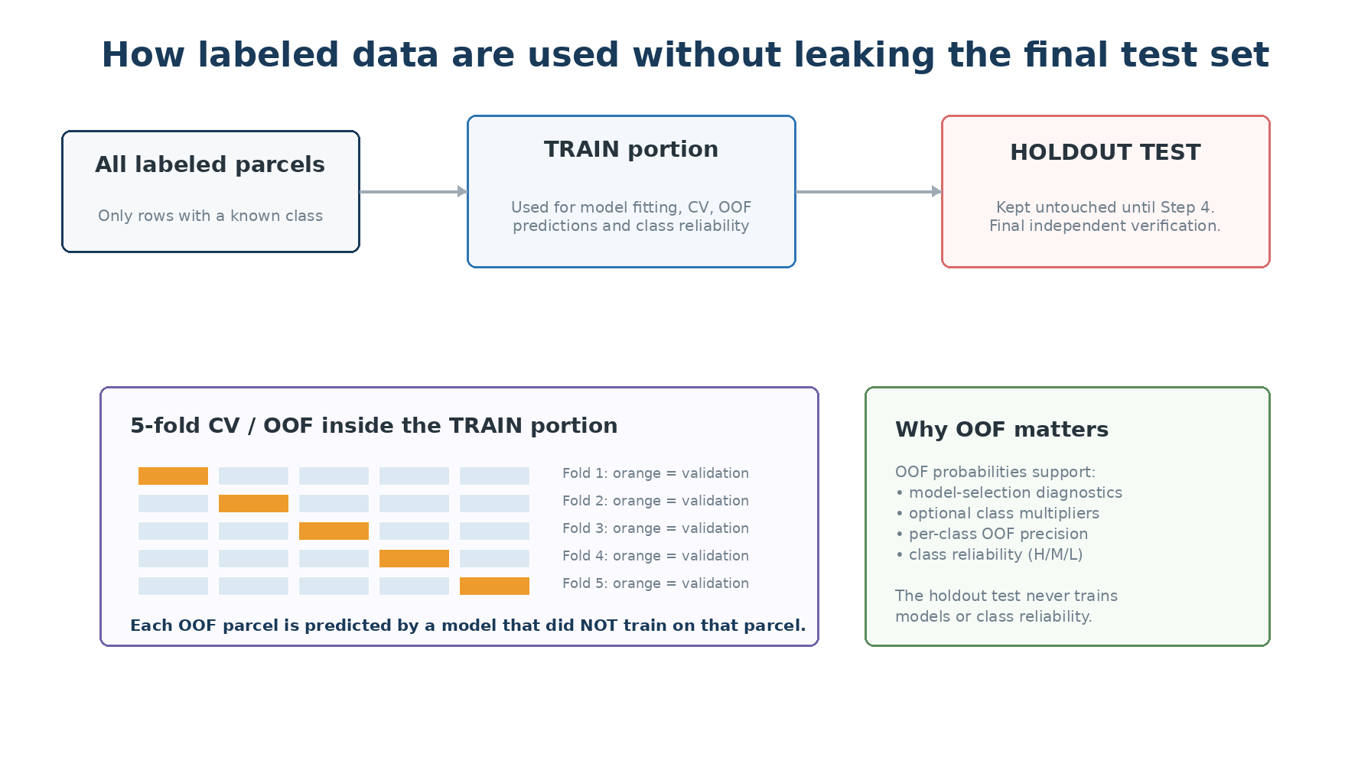
Figure 2. Training, OOF predictions and the untouched holdout test play different roles.

4.1 OOF means “out-of-fold”
During cross-validation, the training portion is divided into folds. A parcel receives an OOF prediction only from a model that was fitted without that parcel. OOF predictions are therefore suitable for model-selection diagnostics, optional class-probability optimization, and the confidence contract without using the holdout test.

4.2 Spatial splitting
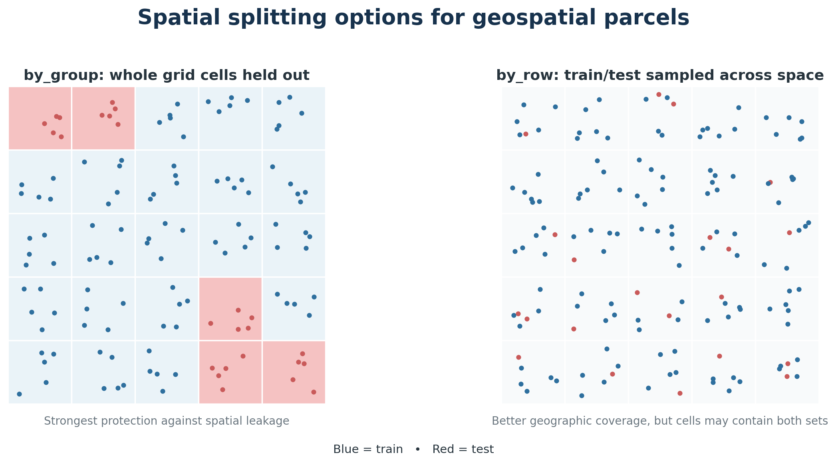
Figure 3. Spatial by_group and by_row splitting strategies.
Option | How it works | When to prefer it
spatial_split=False | Standard stratified random train/test split; every class keeps a similar proportion. | Non-spatial problems or when spatial independence is not required.
by_group | Builds a regular grid and holds out complete occupied cells. Train and test cannot share grid cells. | Preferred when you want the strongest test of transfer to unseen geography.
by_row | Samples rows spatially across the grid within each class. A grid cell can contain both train and test rows. | Useful when each class must be geographically represented in both sets, but it is less strict against local leakage.

Recommendation for EO parcel models If the objective is to claim geographic generalization, use by_group and inspect the spatial split map. by_row is a compromise for data with limited spatial support.

5. Step 1 — CHECK: validate, clean and profile
Step 1 is the data-quality gate. It performs inexpensive checks before any model training begins, then saves a normalized copy of the input for all later stages.

5.1 What Step 1 does
- Copies the input table and ensures the ID column exists and is stored as text.
- Validates required columns and prevents target/ID/geometry leakage into the feature list.
- Checks unique IDs (when enabled) and verifies each class has enough labeled examples for CV.
- Optionally applies an IQR outlier filter to numeric features.
- Optionally fills numeric nulls using spatial nearest, IDW or kriging interpolation.
- Optimizes data types/memory use and identifies numeric versus categorical features.
- Removes all-null and constant features from the active modeling set.
- Profiles features, missingness and target distribution, then writes maps/plots when geometry is available.

5.2 IQR outlier filtering
If enabled, the interquartile-range (IQR) rule identifies unusually extreme numeric values. The pipeline does not delete the parcel. Instead, it replaces the outlying cell with a null value. This is safer because the row remains available and the missing value can later be spatially interpolated or imputed by a model preprocessor.
Interpretation A high total_outliers_replaced value is not automatically bad. It is a prompt to inspect the configured IQR bounds and confirm that valid phenological extremes are not being treated as errors.

5.3 Spatial interpolation
When configured, the pipeline can fill missing numeric feature cells from nearby parcels using nearest-neighbor, inverse-distance weighting (IDW), or kriging. Geometry is required. Non-numeric features and completely empty columns are skipped. The original geometry is preserved.

5.4 Main Step 1 outputs and how to read them
Output | What it contains | How to interpret it
check_summary.json | Rows, labeled/unknown counts, active features, class distribution, IQR/interpolation summaries, configuration snapshot. | Start here. Verify row counts and that expected features remain active.
feature_profile.csv | Data type, missingness, uniqueness and descriptive feature profile. | Look for very high missingness, suspiciously constant features or unexpected types.
missing_values.png | Visual missing-value pattern. | Structured gaps by month/region may indicate upstream EO availability issues.
target_distribution.png | Number of labeled examples per class. | Large imbalance suggests macro-F1, balanced accuracy and/or balancing options are important.
known_labels_map.* | Spatial distribution of known labels. | Check whether classes are geographically clustered or absent from regions.

Quality gate before Step 2 Do not proceed blindly if expected features are missing, classes have very few samples, or the known-label map reveals extreme geographic concentration.

6. Step 2 — PREPARE: encode, split and create CV folds
Step 2 freezes the experimental design. It uses only rows with known labels, converts text labels to integer codes for model libraries, and creates the train/test and CV partitions that later stages must respect.

6.1 Label encoding
Class labels are stored as strings for reporting, but many estimators require integers. LabelEncoder creates a deterministic mapping such as Wheat → 0, Barley → 1. The mapping is saved so predictions can always be converted back to the original labels.

6.2 Holdout train/test split
The test split is frozen here. With standard splitting it is stratified by class. With spatial splitting it uses the configured spatial strategy. Later model selection is not allowed to “peek” at the test result.

6.3 Cross-validation folds
CV folds are created only inside the training portion. Standard projects use StratifiedKFold. Spatial projects use StratifiedGroupKFold with grid-cell groups, so validation folds can test spatial generalization inside training as well.

6.4 Main Step 2 outputs
Output | Purpose | Interpretation
train_dataset.joblib | Frozen training partition. | Used for CV, tuning, OOF predictions and final strategy selection.
test_dataset.joblib | Frozen holdout partition. | Used in Step 4 only for unbiased final evaluation.
labeled_dataset.joblib | All rows with known labels. | Used in Step 5 to refit the already-selected strategy before production prediction.
prepare_summary.json | Active features, split strategy, labels and exact CV indices. | Audit trail proving how the data were partitioned.
label_mapping.csv | Original labels and encoded integers. | Use when reading encoded model artifacts.
train_test_distribution.png | Class counts in train and test. | Train/test proportions should be sensible; missing classes are a serious problem.
feature_distributions_train_vs_test.png | Feature distribution comparison. | Large shifts may mean the test set represents a different domain.
spatial_train_test_split.png | Map of spatial partition (when possible). | Verify geographic separation and coverage.

7. Step 3 — TRAIN: tune candidate models and produce OOF predictions
Step 3 gives each candidate model family a fair “audition.” It searches multiple hyperparameter combinations, evaluates them across the frozen CV folds, keeps the best version of each model, and writes the evidence used to rank models later.
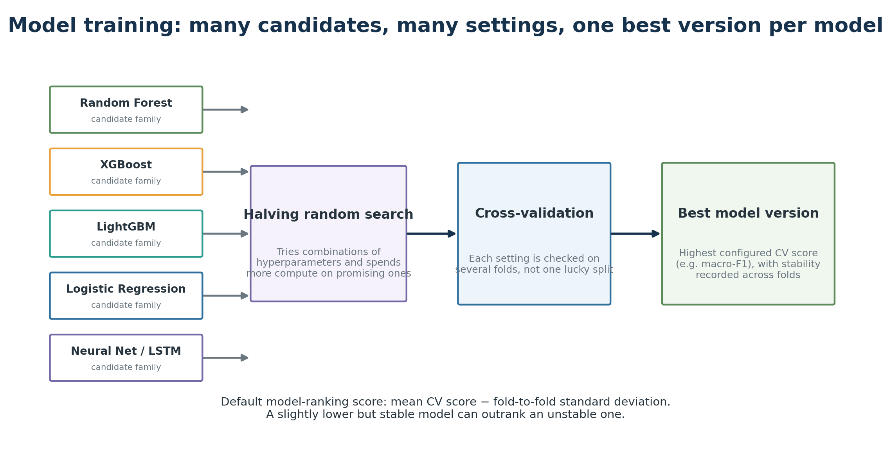
Figure 4. Hyperparameter search and cross-validation for each candidate model family.

7.1 Candidate model families
Model family | Plain-language view
Logistic Regression / SGD | Linear decision boundaries; useful baselines and often robust with many features.
Decision Tree | A sequence of if/then splits; easy conceptually but can overfit.
Random Forest / Extra Trees / Bagging | Many trees vote together; robust nonlinear baselines.
Gradient Boosting / HistGradientBoosting | Trees are added sequentially to correct previous errors.
XGBoost / LightGBM | High-performance gradient boosting, available when optional libraries are installed.
KNN | Looks at similar training parcels in feature space.
MLP / TensorFlow dense network | Learns nonlinear combinations of features through neural-network layers.
Keras LSTM | Neural network specialized for ordered temporal sequences.
Gaussian Naive Bayes | Simple probabilistic baseline with strong independence assumptions.

7.2 Preprocessing is part of each model pipeline
Data type / model need | Implemented preprocessing
Numeric features | Median imputation. Linear/KNN/neural pipelines also scale numeric values; tree models generally do not.
Categorical features | Most-frequent imputation plus one-hot encoding; infrequent categories are handled explicitly.
Class imbalance | Optional random oversampling or SMOTE inside the modeling pipeline. Many estimators also use balanced class weights.
LSTM | Temporal feature columns are parsed into an ordered tensor; the winning temporal schema is saved.

7.3 Hyperparameter search
HalvingRandomSearchCV starts with several parameter combinations and progressively concentrates resources on more promising configurations. The primary scoring metric is configurable; the default is macro-F1, which gives each class equal importance rather than allowing large classes to dominate the score.

7.4 Model ranking: performance plus stability
By default, models are ranked using:
CV selection score = mean CV score − CV score standard deviation
This favors models that are both accurate and stable across folds. A model with a slightly higher mean but highly variable folds can rank below a more consistent model. The alternative ranking method uses mean score only.

7.5 OOF probabilities
For probability-capable models, OOF probabilities are generated when probability optimization or rank confidence is enabled. Each training parcel is predicted only by a fold model that did not train on that parcel. These probabilities are therefore appropriate for later estimating class reliability without using in-sample predictions.

7.5.1 How Step 3 contributes to confidence
Step 3 does not assign the final HIGH / MEDIUM / LOW confidence level. Its role is to create leakage-safe member-model OOF probabilities. In Step 4, those OOF probabilities are combined with the same soft-voting strategy used in production. The pipeline then asks, for each predicted class, “When OOF soft voting predicted this class, how often was it actually correct?” That answer becomes the class-reliability guard.
Example: if OOF soft voting predicts class 119 for 1,000 training parcels and 870 of those parcels truly belong to class 119, the OOF precision of class 119 is 870 / 1,000 = 0.87 (87%). With the default thresholds and sufficient support, class 119 receives HIGH class reliability.

7.6 Main Step 3 outputs
Output | How to interpret it
training_summary.csv | Authoritative per-model CV ranking. Focus on best_cv_score, cv_score_std, cv_score_minus_std / cv_ranking_metric and supports_predict_proba.
best_cv_fold_scores.csv | Shows fold-to-fold stability. Large spread means the model is sensitive to the split.
training_failed_models.csv | Failure isolation. One candidate can fail without stopping the others; investigate repeated or important failures.
model_specs.json | Best hyperparameters and metadata used to reconstruct models later.
models/<model>/cv_results.csv | Full tuning history. Useful when diagnosing whether the search space was adequate.
models/<model>/best_model.joblib | Best fitted estimator for evaluation and incremental reuse.
models/<model>/oof_probabilities.joblib | Leakage-safe member-model probabilities used in Step 4 for OOF soft voting, class reliability, and optional probability optimization.

Incremental workflow When model artifacts already exist and force_retrain_models is false, the training stage can reuse fully trained models and train only new/missing candidates. This makes experimentation with additional model families cheaper.

8. Step 4 — EVALUATE: compare, select and validate
Step 4 has three responsibilities: (1) report how the trained models perform, (2) freeze the final prediction strategy based on cross-validation evidence, and (3) build the confidence contract. The contract contains the parcel-rank thresholds and a simple per-class OOF reliability table based on precision. The untouched holdout set is then used only to verify that HIGH / MEDIUM / LOW separate more-reliable from less-reliable predictions.

8.1 Base-model evaluation
Every selected trained model is loaded and evaluated on both train and holdout test data. Per-class classification reports, confusion matrices and ROC-related plots are written. Probability-column order is explicitly checked against the canonical label order before probabilities are used.

8.2 Metrics used
Metric | Plain-language meaning | When it matters most
Accuracy | Fraction of all parcels classified correctly. | Easy headline metric, but can hide poor minority-class performance.
Balanced accuracy | Average recall across classes, with equal class weight. | Useful when classes are imbalanced.
Macro-F1 | F1 calculated per class, then averaged equally. | Default primary metric; strong choice when every crop class matters.
Weighted F1 | Per-class F1 weighted by number of samples. | Reflects overall volume but favors common classes.
Weighted precision / recall | Global summaries weighted by class support. | Useful supporting diagnostics.
Weighted ROC AUC | Ability of probabilities to rank true classes above alternatives. | Useful probability-quality indicator; not identical to final accuracy.

8.3 Train vs test
A large train–test gap is a warning sign for overfitting or domain shift. The holdout test is the most important performance view because it was not used for tuning or confidence fitting. In spatial projects, the test result is especially meaningful when by_group is used.

8.4 Model selection is frozen from CV
Probability-capable models are ordered using the Step 3 CV ranking. If soft voting is configured and at least two eligible models exist, the top models become the voting ensemble. If only one is available, the pipeline falls back to a single-model strategy. The test metrics are displayed but do not change which model wins.
Why this matters Selecting the model that happens to score best on the test set would turn the test set into another tuning set and make the reported generalization performance optimistic.

8.5 Interpret ability outputs
For the top CV-ranked models, tree-based estimators can produce feature-importance tables/plots. SHAP summaries are optional. These outputs help explain what a model uses, but they do not affect model selection or predictions.

9. Ensemble prediction: soft voting and optional class multipliers
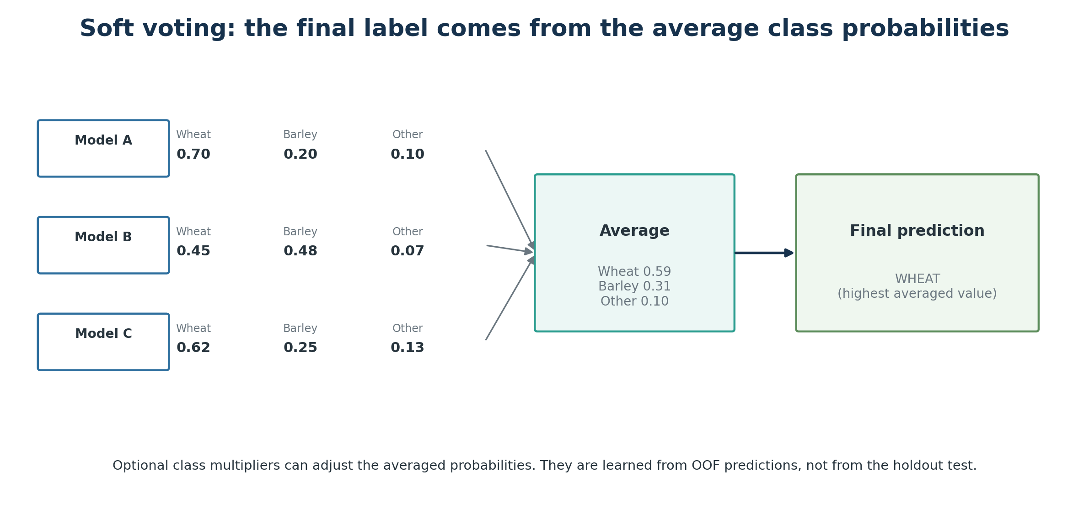
Figure 5. Soft voting averages the selected models’ class probabilities and chooses the largest average.
In soft voting, each selected model provides a probability-like score for every class. The pipeline aligns the class columns, averages model probabilities with equal weight, and chooses the class with the highest final average. This is the production label unless the project is configured for a single model.

9.1 Why the probabilities are not used directly as “confidence”
Different model families have different probability calibration. A neural network may routinely output 0.98 where a random forest outputs 0.72 for a prediction of similar reliability. Therefore the winning averaged probability is stored as prediction_max_probability for diagnostics, but HIGH/MEDIUM/LOW confidence is determined separately.

9.2 Optional class probability multipliers
When optimize_class_probabilities is enabled, the pipeline searches per-class multipliers using OOF averaged probabilities. The objective is to improve OOF macro-F1 while preventing overall accuracy from dropping more than the configured tolerance (0.02 by default). Multipliers are then frozen inside the selected strategy and applied after model-probability averaging.
Important Class multipliers change the soft-voting prediction but do not change the raw within-model rankings used as confidence evidence. This allows the confidence layer to detect when the adjusted soft-vote winner is not supported by the independent model rankings.

10. Confidence methodology: rank support + OOF class reliability
The confidence system is intentionally simpler than the prediction system. Soft voting chooses the final class. Confidence does not choose another class; it only measures how trustworthy the soft-voting result appears. The implemented method combines two independent questions: (A) do the selected models consistently rank this parcel’s predicted class near the top, and (B) when the ensemble predicts this class in leakage-safe OOF data, how often is it correct?
The proposed confidence framework combines established concepts from rank-based classifier aggregation and class-wise empirical reliability. Borda-based rank aggregation and ensemble agreement have previously been used for classifier combination and uncertainty assessment; however, the present implementation uses these concepts specifically as an auxiliary confidence layer over a soft-voting classifier and constrains parcel-level rank confidence using out-of-fold class-specific precision.
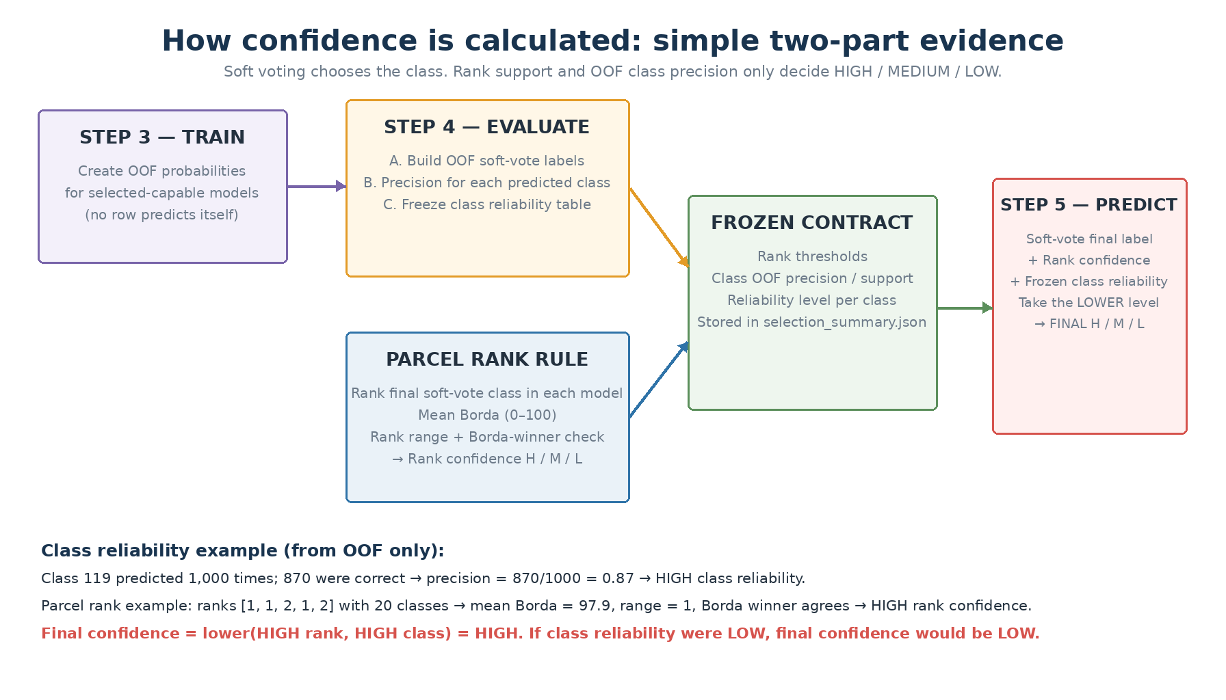
Figure 6. Confidence uses two simple components: parcel rank support and frozen OOF precision of the predicted class.

10.1 The two components
Component | Question answered | Where it comes from
Parcel rank confidence | Do the selected models consistently support this parcel’s final soft-voting class? | Raw probability ordering of the selected models for the parcel.
Class reliability | When OOF soft voting predicts this class, how often is that class prediction correct? | OOF predictions from the training partition only.
Final confidence | What is the safer of the two conclusions? | The lower of parcel rank confidence and class reliability.
This separation is important. Models may agree strongly and still share the same systematic mistake for a difficult class. Conversely, a generally reliable class can still receive LOW confidence for a particular parcel when the models disagree.

10.2 Part 1 — calculate parcel rank confidence
First, soft voting determines the final class. Then the pipeline looks back at each selected model separately and asks where that final class appeared in that model’s own probability ranking. Rank 1 means the model placed the class first, rank 2 means second, and so on. The absolute probability values are not compared between models. Probability ties use average ranks.

Worked example — five models, 20 classes
Assume soft voting predicts Wheat. The five selected models place Wheat at ranks [1, 1, 2, 1, 2]. The pipeline converts each rank to a 0–100 Borda score using:
Borda = 100 × (K − rank) / (K − 1)
where K is the number of classes. With K = 20, rank 1 becomes 100.00 and rank 2 becomes 94.74.
Model | M1 | M2 | M3 | M4 | M5
Rank of Wheat | 1 | 1 | 2 | 1 | 2
Borda score | 100.00 | 100.00 | 94.74 | 100.00 | 94.74
Mean Borda = (100 + 100 + 94.74 + 100 + 94.74) / 5 = 97.89. Rank range = highest rank − lowest rank = 2 − 1 = 1. The pipeline also calculates the Borda winner across all classes. If Wheat has the highest aggregate Borda score, then the independent rank winner agrees with the soft-voting prediction.

10.3 Rank-confidence rules implemented in the code
Rank confidence | Default rule
HIGH | At least 3 models; soft-vote class = Borda winner; Borda winner is not tied; mean Borda ≥ 90; rank range ≤ 2.
MEDIUM | Not HIGH, but at least 3 models; soft-vote class = Borda winner; no Borda tie; mean Borda ≥ 75; rank range ≤ 4.
LOW | Everything else, including soft-vote/Borda disagreement, Borda tie, weak Borda support, large rank range, or too few models.
For the Wheat example above, mean Borda = 97.89, rank range = 1, and the Borda winner agrees with Wheat. Therefore the parcel rank confidence is HIGH.
Why the range matters: [1, 1, 2, 1, 2] shows stable support. A pattern such as [1, 1, 2, 6, 8] may still have some first-place votes, but its large range shows strong disagreement between models and will be downgraded.

10.4 Part 2 — calculate class reliability from OOF precision
Parcel rank confidence alone cannot detect a systematic class problem. If all selected models learned the same confusion, they may unanimously rank the wrong class first. The second component therefore uses one simple statistic per predicted class: OOF precision.
OOF precision(class c) = correct OOF predictions of c / all OOF predictions of c
OOF means that each training parcel is predicted by a model fold that did not train on that parcel. The precision therefore estimates how trustworthy a prediction of that class was on unseen training-fold data.
Example class | OOF predicted as class | Actually correct | OOF precision | Default class reliability
119 | 1,000 | 870 | 0.87 (87%) | HIGH
111 | 1,000 | 720 | 0.72 (72%) | MEDIUM
129 | 1,000 | 240 | 0.24 (24%) | LOW
The implemented default mapping is:
Class reliability | Default rule
HIGH | OOF support ≥ 100 and precision ≥ 0.80.
MEDIUM | OOF support ≥ 100 and 0.60 ≤ precision < 0.80.
LOW | OOF support ≥ 100 and precision < 0.60.
LOW + invalid | OOF support < 100. The pipeline does not borrow evidence from another class.
The support rule is important: 90% precision based on only a few examples should not be treated as equally trustworthy as 90% precision based on hundreds or thousands of OOF predictions.

10.5 Final confidence = the lower of the two levels
The final user-facing confidence is deliberately conservative. It is the lower of parcel rank confidence and class reliability:
Final confidence = min(rank confidence, class reliability)
Rank confidence | Class reliability | Final confidence
HIGH | HIGH | HIGH
HIGH | MEDIUM | MEDIUM
HIGH | LOW | LOW
MEDIUM | HIGH | MEDIUM
MEDIUM | MEDIUM | MEDIUM
MEDIUM | LOW | LOW
LOW | Any level | LOW

10.6 Worked examples
Case | Parcel rank evidence | Class reliability | Final result
A — strong parcel, reliable class | Ranks [1,1,2,1,2] → Borda 97.9, range 1, winner agrees → HIGH | OOF precision 87%, support 1,000 → HIGH | HIGH
B — strong parcel, difficult class | Ranks [1,1,1,1,1] → Borda 100, range 0 → HIGH | OOF precision 24%, support 1,000 → LOW | LOW
C — moderate parcel, reliable class | Borda 82, range 3, winner agrees → MEDIUM | OOF precision 91% → HIGH | MEDIUM
D — voting/rank disagreement | Soft voting predicts Wheat but Borda winner is Barley → LOW | Even if Wheat reliability is HIGH | LOW
E — too little class history | Parcel rank confidence HIGH | Only 45 OOF predictions for the class (<100) → LOW + invalid | LOW / review
Case B is the key reason the class-reliability guard exists: perfect model agreement is not enough when a class is historically unreliable.

10.7 How confidence is calculated at each pipeline step
Pipeline step | Confidence-related calculation | What is saved / used later
Step 3 — TRAIN | Creates member-model OOF probabilities. It does not assign the final confidence category. | OOF probabilities for each probability-capable model.
Step 4 — EVALUATE | Reproduces OOF soft voting, calculates OOF precision/support for every predicted class, calculates parcel rank confidence, combines the two, and freezes the contract. The holdout test only verifies it. | selection_summary.json confidence contract; class_reliability_oof.csv; rank_confidence_oof/test.csv; confidence-level summaries.
Step 5 — PREDICT | Refits the selected models on all labeled data, makes the soft-vote label, calculates rank confidence from raw member rankings, looks up the frozen class reliability, and takes the lower level. | Final per-parcel HIGH / MEDIUM / LOW, reasons, diagnostics, and review flag.

10.8 Structural safeguards and reasons for LOW
Condition | Behavior
Fewer than minimum models (default 3) | Rank confidence = LOW and invalid; reason = insufficient_models.
Borda winner tied | Rank confidence = LOW; reason = borda_winner_tie.
Soft-vote label differs from Borda winner | Rank confidence = LOW; reason = soft_vote_borda_disagreement.
Class has <100 OOF predictions | Class reliability = LOW and invalid; reason = insufficient_oof_class_support.
Any confidence component invalid | Final confidence = LOW and prediction_needs_review = True.

10.9 What HIGH / MEDIUM / LOW means
Level | Plain-language interpretation
HIGH | The parcel has strong, consistent rank support and the predicted class has historically high OOF precision.
MEDIUM | The evidence is useful but at least one component is only moderate: parcel agreement, class reliability, or both.
LOW | The models disagree, the class is historically unreliable, evidence is insufficient, or a structural safeguard was triggered.
These are operational confidence categories, not classical statistical confidence intervals. prediction_max_probability remains a useful diagnostic but must not be read as “73% statistical confidence”.
Validation rule: on the untouched holdout set, HIGH predictions should normally be more accurate than MEDIUM predictions, and MEDIUM should be more accurate than LOW. If this ordering does not hold, inspect class reliability, rank thresholds, confusion matrices, and class definitions before changing the thresholds.

11. Step 5 — PREDICT: refit, classify and fill unknown labels
Step 5 is the production inference stage. It does not re-select models. It loads the frozen selection_summary.json and model_specs.json, rebuilds the selected estimators with their winning hyperparameters, fits them on all labeled rows, then predicts every row in the original checked dataset.

11.1 Why refit on all labeled rows?
Once the final strategy has been selected and verified, the held-out labels no longer need to remain withheld for the final production model. Refitting on all known labels gives the deployed model the maximum available labeled evidence. This does not change the already-reported holdout metrics; those remain the historical validation of the strategy.

11.2 Prediction and filling logic
- Every row receives a model prediction and per-class probability columns.
- Known target labels are preserved in the filled target column.
- Only rows whose original target was null are filled from the prediction.
- prediction_max_probability stores the largest final probability as a diagnostic.
- Rank confidence is calculated from the raw probability ordering of each selected member model using mean Borda, predicted-class rank range, and Borda-winner agreement. The frozen OOF precision of the predicted class is then looked up as the class-reliability guard; final confidence is the lower of the two levels.
- prediction_needs_review becomes true when final confidence is LOW or invalid. If the simplified rank-confidence system is unavailable, the legacy maximum-probability threshold is only a fallback review rule.
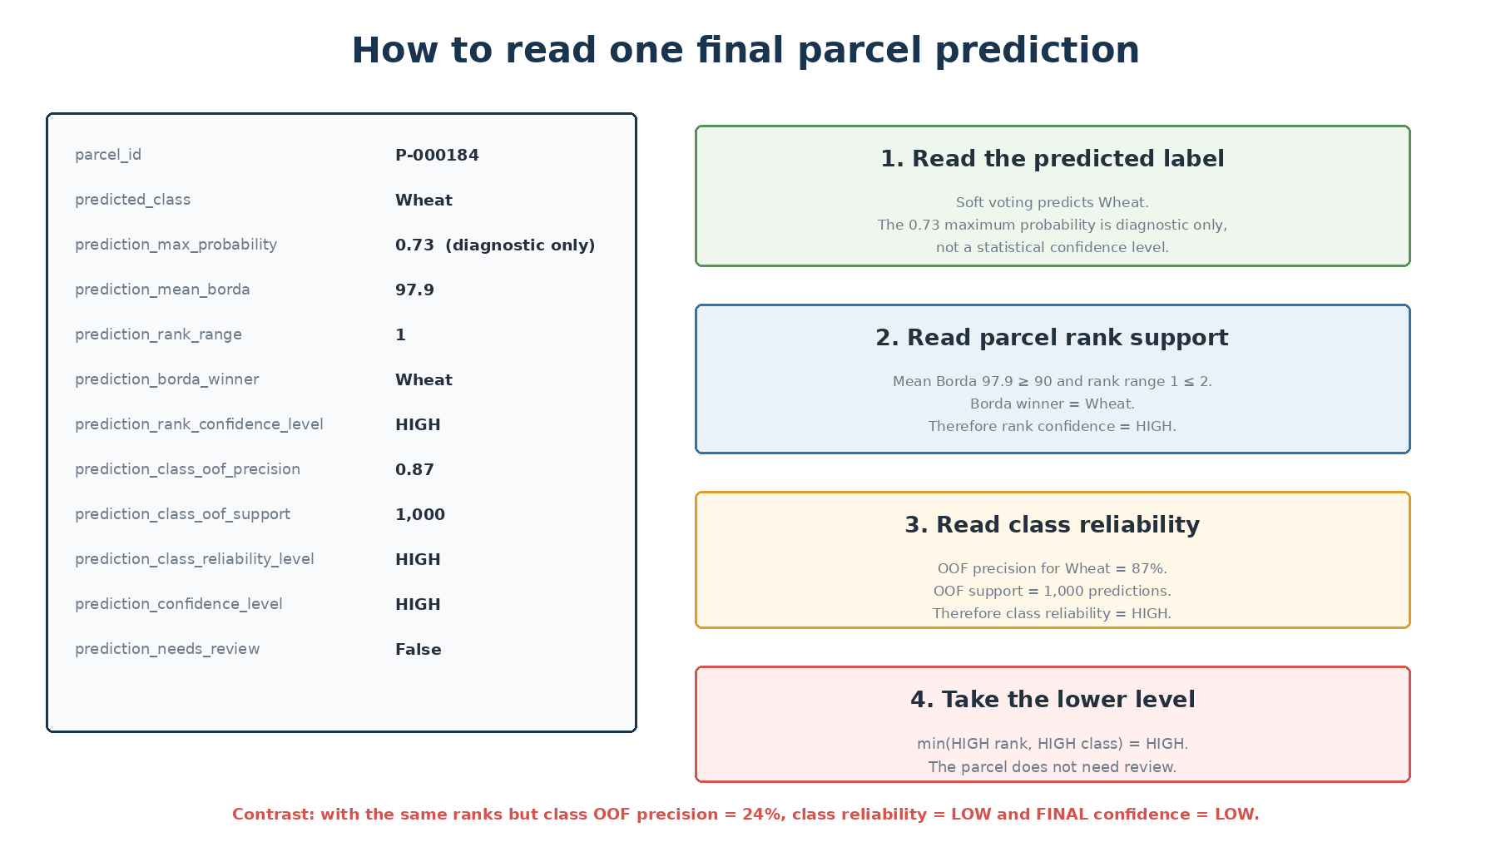
Figure 7. Example of how to read one row in the final prediction output.

12. Output architecture and artifact reference
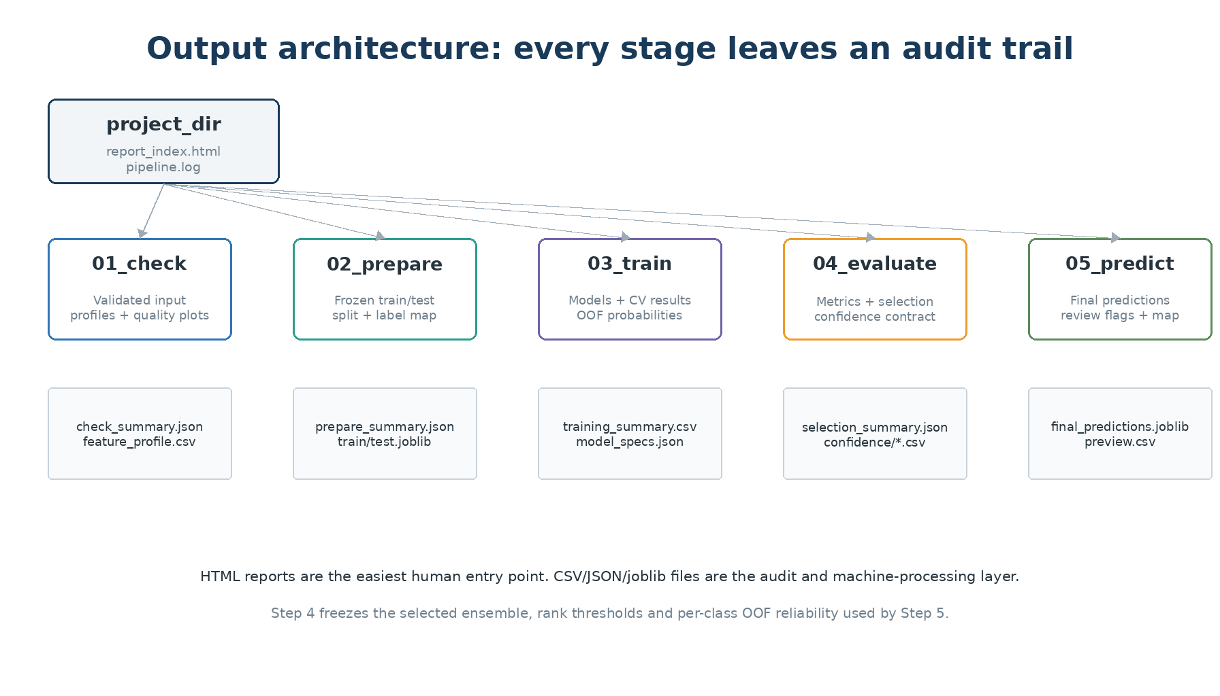
Figure 8. Major output directories and the most important audit artifacts.
The easiest human entry point is report_index.html, which links the step reports. The CSV/JSON/joblib files are the machine-readable and audit layer. Every step also writes schema_manifest.json describing expected JSON/CSV contracts.

12.1 Step 1 — 01_check
Artifact | Use
input_dataset.joblib | Validated/cleaned dataset consumed downstream.
check_summary.json | Data-quality and configuration summary.
feature_profile.csv | Feature-level diagnostic profile.
report.html | Human-readable Step 1 report.
plots/* | Missingness, class distribution and optional label maps.

12.2 Step 2 — 02_prepare
Artifact | Use
train_dataset.joblib | Training/CV partition.
test_dataset.joblib | Untouched final evaluation partition.
labeled_dataset.joblib | All known-label rows for final refit.
prepare_summary.json | Split strategy, class list and exact CV folds.
label_mapping.csv | Original ↔ encoded label mapping.
plots/* | Split balance, feature shift, correlations and spatial split map.

12.3 Step 3 — 03_train
Artifact | Use
training_summary.csv | Authoritative CV ranking of model families.
training_failed_models.csv | Candidate failures.
best_cv_fold_scores.csv | Fold stability diagnostics.
model_specs.json | Winning hyperparameters and reconstruction metadata.
models/<name>/best_model.joblib | Best fitted search estimator.
models/<name>/cv_results.csv | Complete tuning results.
models/<name>/oof_probabilities.joblib | Leakage-safe OOF member probabilities used for OOF soft voting, class reliability, and optional probability optimization.
models/keras_lstm/temporal_schema.json | Exact LSTM temporal input contract, when applicable.

12.4 Step 4 — 04_evaluate
Artifact | Use
model_metrics_train/test.csv | Base-model train/holdout performance.
*_with_voting.csv | Adds the soft-voting ensemble where available.
selection_summary.json | Authoritative frozen strategy, labels, selected models, multipliers, rank thresholds, and per-class OOF reliability contract.
reports/*classification_report.csv | Per-class precision/recall/F1/support.
confusion_matrices/* | Shows which true classes are being confused.
ranking/* | Probability-average/median and rank-average/median parcel diagnostics.
confidence/rank_confidence_test.csv | Holdout parcel-level rank evidence, class reliability and final H/M/L.
confidence/rank_confidence_oof.csv | OOF parcel-level evidence used to build/describe class reliability; not independent validation.
confidence/class_reliability_oof.csv | One row per class: OOF prediction support, correct count, precision, reliability level and validity.
confidence/confidence_level_metrics_test.csv | Holdout accuracy, error rate and coverage for HIGH / MEDIUM / LOW.
confidence/confidence_level_metrics_oof.csv | OOF confidence distribution and correctness summary.
confidence/confidence_by_class_test.csv | Holdout confidence accuracy by predicted class, with OOF vs test class precision.
interpretability/* | Feature importance and optional SHAP for top models.

12.5 Step 5 — 05_predict
Artifact | Use
final_predictions.joblib | Complete final DataFrame/GeoDataFrame with all original columns, prediction, probabilities and confidence diagnostics.
final_predictions_preview.csv | Compact human-readable prediction extract.
predict_summary.json | Counts, selected strategy, confidence distribution and output path.
plots/filled_target_distribution.png | Shows how unknown labels changed the complete target distribution.
plots/predicted_labels_map.png | Spatial view of final/filled labels when geometry is available.

13. How to interpret the main outputs

13.1 Model selection outputs
Field / plot | Interpretation guide
best_cv_score | Mean validation performance of the winning hyperparameter setting for that model.
cv_score_std | Fold-to-fold instability. Lower is better, all else equal.
cv_ranking_metric | Actual value used to rank/select models. With score_minus_std it rewards performance and stability.
model_metrics_test.csv | Unbiased holdout comparison. Prefer macro-F1 / balanced accuracy when class imbalance matters.
confusion matrix | Rows are true labels and columns predicted labels (as generated by sklearn plotting). Look for systematic off-diagonal blocks.
classification report | Inspect per-class recall/F1, not only overall averages.

13.2 Confidence output columns
Column | How to read it
prediction_max_probability | Largest final soft-voting probability. Diagnostic only; it is not the H/M/L confidence calculation.
prediction_confidence_level | Primary final user-facing HIGH / MEDIUM / LOW after combining parcel rank confidence and class reliability.
prediction_confidence_valid | False when rank evidence or class reliability is insufficient/invalid; invalid rows are final LOW.
prediction_confidence_reason | Short explanation of what limited confidence.
prediction_mean_borda | 0–100 average Borda support for the final soft-voting class. Higher means models usually rank that class near the top.
prediction_rank_range | Highest minus lowest rank assigned to the final class across selected models. Smaller means more consistent agreement.
prediction_borda_winner | Class with the highest aggregate Borda score.
prediction_borda_winner_tied | True if multiple classes tie for the highest Borda score; rank confidence becomes LOW.
prediction_rank_agrees_with_final | True when Borda winner equals the soft-voting label. False forces rank confidence LOW.
prediction_rank_confidence_level | Parcel-only H/M/L based on mean Borda, rank range, Borda winner/tie and minimum model count.
prediction_class_oof_precision | Frozen OOF precision of the predicted class: when OOF soft voting predicted this class, fraction that were correct.
prediction_class_oof_support | Number of OOF predictions used for that class precision. Default minimum support is 100.
prediction_class_reliability_level | H/M/L derived from OOF precision: HIGH ≥ 0.80, MEDIUM ≥ 0.60, otherwise LOW, if support is sufficient.
prediction_class_reliability_valid | False when the class has insufficient OOF prediction support.
prediction_class_reliability_reason | Why the class reliability level/validity was assigned.
rank_top1_agreement / rank_top2_agreement | Useful diagnostics retained for analysis; they do not directly determine the simplified H/M/L rule.
prediction_needs_review | True when final confidence is LOW or invalid.

13.3 Interpreting confidence metrics
Question | What to inspect
Does confidence add value? | In confidence_level_metrics_test.csv, check that holdout accuracy(HIGH) > accuracy(MEDIUM) > accuracy(LOW).
Why is a parcel LOW even though all models agree? | Check prediction_class_oof_precision and prediction_class_reliability_level. The predicted class may be systematically difficult.
Why is a reliable class only MEDIUM/LOW for this parcel? | Check prediction_mean_borda, prediction_rank_range and whether Borda winner agrees with soft voting. Parcel-level evidence may be weak.
Is class reliability well supported? | Check prediction_class_oof_support. Below the minimum support (default 100), class reliability is invalid and LOW.
Can I treat prediction_max_probability as confidence? | No. It is a diagnostic of soft voting, not a calibrated probability of correctness.
Can I trust OOF class precision as final validation? | OOF precision builds the reliability guard; use the untouched holdout metrics for independent confirmation.

Practical reading order For a new run: open report_index.html → Step 1 quality → Step 2 split → Step 3 CV ranking → Step 4 holdout metrics/confusion → Step 4 confidence holdout table → Step 5 final predictions.

14. Advanced and optional features

14.1 Label balancing
The pipeline supports no balancing, random oversampling, or SMOTE. Balancing is applied inside model fitting/CV so validation rows are not synthetically duplicated. LSTM has a separate balanced class-weight option. Always judge balancing by per-class holdout metrics, not by training performance.

14.2 LSTM temporal classification
The optional Keras LSTM interprets temporal feature columns as an ordered sequence. Configuration controls which statistics are temporal, whether timesteps must be complete, expected frequency, minimum timesteps, architecture size, dropout and bidirectionality. The winning temporal schema is saved so production input matches training.

14.3 Feature importance and SHAP
Tree-based top models can export feature importance. SHAP is opt-in because it is heavier computationally. These tools explain associations used by a fitted model; they do not prove causal relationships between an EO index and a crop class.

14.4 Incremental training and filtered evaluation
The training stage can detect reusable model artifacts and skip models that are already fully trained. selected_models can also restrict which models are active/evaluated, while force_retrain_models forces retraining when needed. This supports iterative experimentation without discarding all prior work.

14.5 Restartable artifact contracts
Each step persists the context required by the next one and writes schema metadata. This architecture improves auditability, reproducibility and recovery from interruptions. If artifacts are manually edited, however, frozen contracts such as selection_summary.json can become inconsistent; treat them as controlled pipeline outputs.

15. Operational runbook

15.1 Minimal execution sequence
from ml_classification_pipeline import (
GeospatialClassificationPipeline,
ClassificationPipelineConfig,
)
config = ClassificationPipelineConfig(
project_dir="my_project",
target_column="class",
id_column="parcel_id",
feature_columns=features,
spatial_split=True,
spatial_split_method="by_group",
selection_type="soft_voting",
rank_confidence_enabled=True,
)
pipeline = GeospatialClassificationPipeline(config)
pipeline.run_check(df)
pipeline.run_prepare()
pipeline.run_train()
pipeline.run_evaluate()
pipeline.run_predict()

15.2 Recommended human checkpoints
After step | Before continuing, confirm…
CHECK | Row counts are correct; active features make sense; no catastrophic missingness; label map/distribution is plausible.
PREPARE | All classes exist in train/test; spatial partition is appropriate; feature distributions do not show unexplained shift.
TRAIN | Important candidate models did not fail; CV ranking is stable; no model is selected based on test performance.
EVALUATE | Holdout macro-F1/balanced accuracy are acceptable; confusion matrix is understood; HIGH/MEDIUM/LOW holdout accuracy is monotonic; class_reliability_oof.csv has adequate support for important classes.
PREDICT | Unknown rows were filled as expected; review count is acceptable; confidence/review fields are present; map/distribution shows no obvious spatial anomaly.

15.3 Rerun guidance
- Changing raw input cleaning, feature columns, label definitions, split settings or CV folds should normally trigger a new CHECK/PREPARE/TRAIN chain.
- Adding a new model family can use the incremental-training path while reusing valid existing artifacts.
- Changing model-selection logic, top_voting_models, class multipliers, rank-confidence thresholds or class-reliability thresholds requires a new EVALUATE at minimum; if selected members or OOF predictions change, rerun TRAIN OOF generation as well.
- Do not manually copy an old class-reliability contract to a different ensemble, class definition, label mapping or training population. OOF precision is specific to the frozen prediction strategy and training data.

16. Troubleshooting and quality red flags
Symptom | Likely meaning / action
Duplicate ID error | Input is not one row per entity. Fix upstream aggregation or deliberately change the modeling grain.
A class has fewer rows than cv_folds | CV cannot represent the class reliably. Add data, merge unsupported classes, or reduce folds with caution.
Spatial split cannot keep a class in training | The class is too geographically concentrated for the chosen grid/test design.
Large train score, much lower test score | Possible overfitting, spatial leakage, domain shift or inadequate regularization.
CV score standard deviation is high | Model performance is unstable across folds; inspect geography/class composition and prefer stable alternatives.
Many failed models | Check optional libraries, memory, invalid hyperparameter combinations, feature types, and training_failed_models.csv.
HIGH/MEDIUM/LOW accuracy is not monotonic on holdout | The simplified confidence rule is not separating reliability well enough; inspect rank thresholds, per-class OOF precision/support, and the confusion matrix.
Many confidence rows invalid | Ensemble may be too small or important predicted classes may have insufficient OOF support. Also inspect Borda ties and soft-vote/Borda disagreement.
A class is often wrong even at strong agreement | Systematic model bias/class confusion. The class-reliability guard should cap confidence, but the underlying model problem still requires better features, labels, balancing or class definitions.
prediction_max_probability is high but confidence LOW | Possible overconfident probabilities, weak rank support, or low historical OOF precision for the predicted class. LOW is intentional.

Do not “fix” confidence by only lowering thresholds If a class remains inaccurate when models agree, the issue is class discrimination, not parcel rank strictness. Check class_reliability_oof.csv and holdout per-class results before adjusting rank thresholds.

17. Glossary
Term | Meaning in this pipeline
Class / target | The category being predicted, e.g. crop code.
Feature | Input measurement used by a model.
Labeled row | Parcel whose true class is known.
Unknown row | Parcel whose target is null and must be filled in Step 5.
Train set | Data used for fitting, CV and OOF.
Holdout test | Data reserved for unbiased final verification.
Cross-validation (CV) | Repeated training/validation splits inside the training data.
OOF prediction | Prediction for a training row made by a model that did not train on that row.
Hyperparameter | Model setting selected during search, e.g. tree depth or learning rate.
Macro-F1 | Average F1 giving every class equal weight.
Soft voting | Average selected models’ aligned class probabilities.
Borda rank score | 0–100 score derived from a model’s within-parcel class rank; rank 1 = 100 and the last rank = 0.
Top-1 agreement | Fraction of selected models ranking the final class first. Retained as a diagnostic, but not a direct H/M/L threshold in the simplified method.
Class reliability | Per-class OOF precision guard: when OOF soft voting predicts a class, how often that prediction is correct.
Confidence support | Number of OOF predictions of a class underlying its OOF precision estimate.
Schema manifest | Machine-readable description of output JSON/CSV contracts.
Final confidence | The lower of parcel rank confidence and predicted-class reliability: LOW < MEDIUM < HIGH.

Appendix A — Implementation map
For maintainers, the main responsibilities are intentionally separated. Computation lives in core modules; steps orchestrate persistence; reporting/visuals format outputs but do not decide model selection.
Module | Responsibility
pipeline.py | Composes the five stages and exposes run_all(df).
steps/check_step.py | Step 1 orchestration.
steps/prepare_step.py | Step 2 split and CV orchestration.
steps/train_step.py | Search, training, OOF generation and incremental reuse.
steps/evaluate_step.py | Base evaluation, selection, ranking/confidence artifacts and reporting.
steps/predict_step.py | Frozen-strategy full inference and final output.
core/models.py | Candidate model/preprocessing definitions.
core/selection.py | CV model ranking, soft voting, optional class multipliers and final refit.
core/rank_confidence.py | Within-model average ranks, 0–100 Borda scores, rank range, Borda-winner checks and parcel rank H/M/L.
core/rank_confidence_calibration.py | Legacy class × Top-1 calibration retained only for import compatibility; Steps 4 and 5 do not use it.
core/spatial_split.py | Geospatial train/test and group CV utilities.
core/spatial_interpolation.py | Optional spatial missing-value filling.
reporting/* and visuals/* | HTML reports, plots, maps and interpretability graphics.
core/class_reliability.py | OOF per-class precision/support table, frozen reliability lookup, and final min(rank, class) confidence combination.

Document scope This manual describes the behavior present in the reviewed source snapshot. Configuration choices can materially change training cost, split strictness, model selection and confidence coverage; the saved configuration and selection_summary.json are the authoritative record for a particular run.

