openEO Parcel Statistics
Pipeline
Architecture, Methodology and User Manual
Sentinel-1 / Sentinel-2 temporal parcel features through CDSE openEO

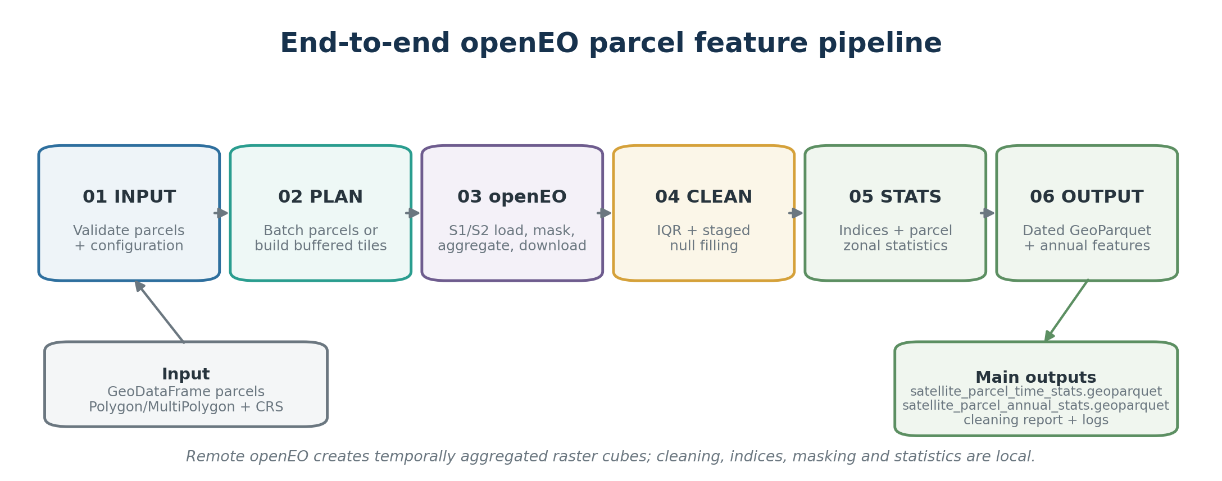
Architecture overview of the implemented remote-to-local parcel feature workflow.
Document type | Architectural design + operational manual
Source basis | Latest uploaded implementation (src(5).zip)
Primary backend | Copernicus Data Space Ecosystem openEO
Primary output grain | One row per parcel with dated temporal features
Code snapshot date | 24 August 2026

Contents
1. Purpose and intended audience
2. Pipeline at a glance
3. Input data and prerequisites
4. Architectural design and component boundaries
5. Parcel preparation and spatial work planning
6. Remote openEO sensor processing
7. Raster cleaning and staged null filling
8. Sentinel-2 spectral indices and observation semantics
9. Parcel masking and zonal statistics
10. Derived parcel features and ML-ready reshaping
11. Execution modes: base batching and job manager
12. Multi-user parallel extraction
13. Caching, checkpointing and restartability
14. Output architecture and artifact reference
15. Parameter reference
16. Operational runbook
17. Interpretation and quality-control checkpoints
18. Performance and concurrency guidance
19. Troubleshooting and red flags
20. Glossary
Appendix A - Implementation map
Appendix B - Current snapshot notes and source-guide differences

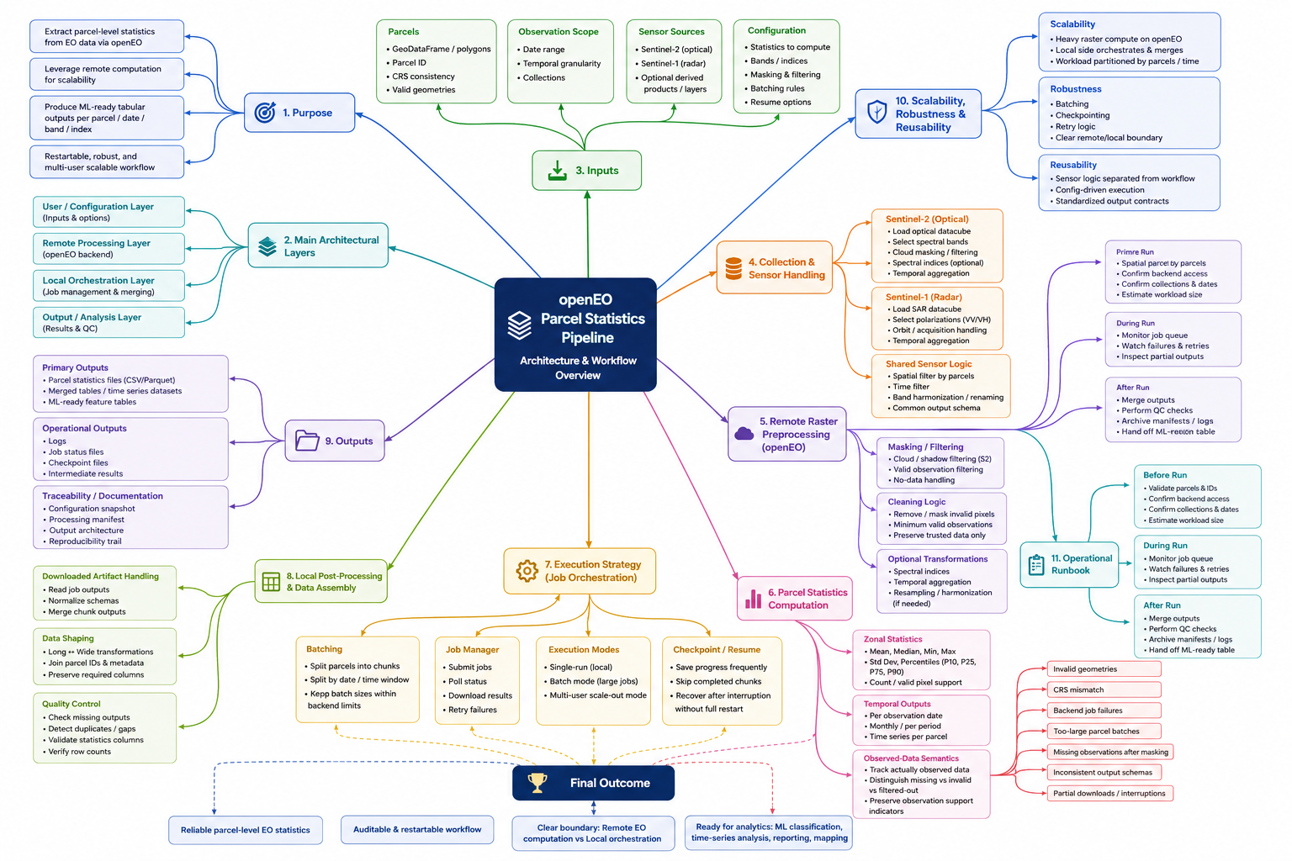

1. Purpose and intended audience
This document describes the implemented openeo_parcel_stats_pipeline as both an architectural design and an operational manual. The package extracts Sentinel-1 and Sentinel-2 observations from the Copernicus Data Space Ecosystem (CDSE) openEO backend, creates temporally aggregated raster cubes remotely, and performs raster cleaning, spectral-index calculation, parcel masking, zonal reduction, derived-feature construction and final persistence locally.
The intended output is a machine-learning-ready parcel table: one row per parcel, original parcel attributes and geometry retained once, and temporal features expanded into dated columns such as NDVI_median__20240401 or VV_mean__20240501. The same processing engine can be run with parcel-count-bounded batches, restartable geographic tile jobs, or an optional outer multi-user partitioning layer.
Core architectural idea Use openEO for sensor access and temporal raster aggregation; keep quality-control decisions and parcel-level semantics local, explicit and restartable.

1.1 Who should use which parts
Role | Most useful sections
EO / geospatial analyst | Input/CRS, sensor processing, cleaning, zonal statistics, output interpretation and QC.
Python developer | Component boundaries, cache/checkpoint contracts, execution modes, multi-user orchestration and troubleshooting.
ML analyst | Dated feature schema, annual reduction, count/observation semantics and output quality flags.
Operator / reviewer | Runbook, logs, manager job database, restart rules, concurrency and red flags.

2. Pipeline at a glance
The implemented workflow has six logical stages. The first three decide what raster data must exist; the next three turn those rasters into parcel features. Remote and local work are deliberately separated so that expensive satellite access happens in CDSE while scientific cleaning and parcel aggregation remain inspectable in Python.
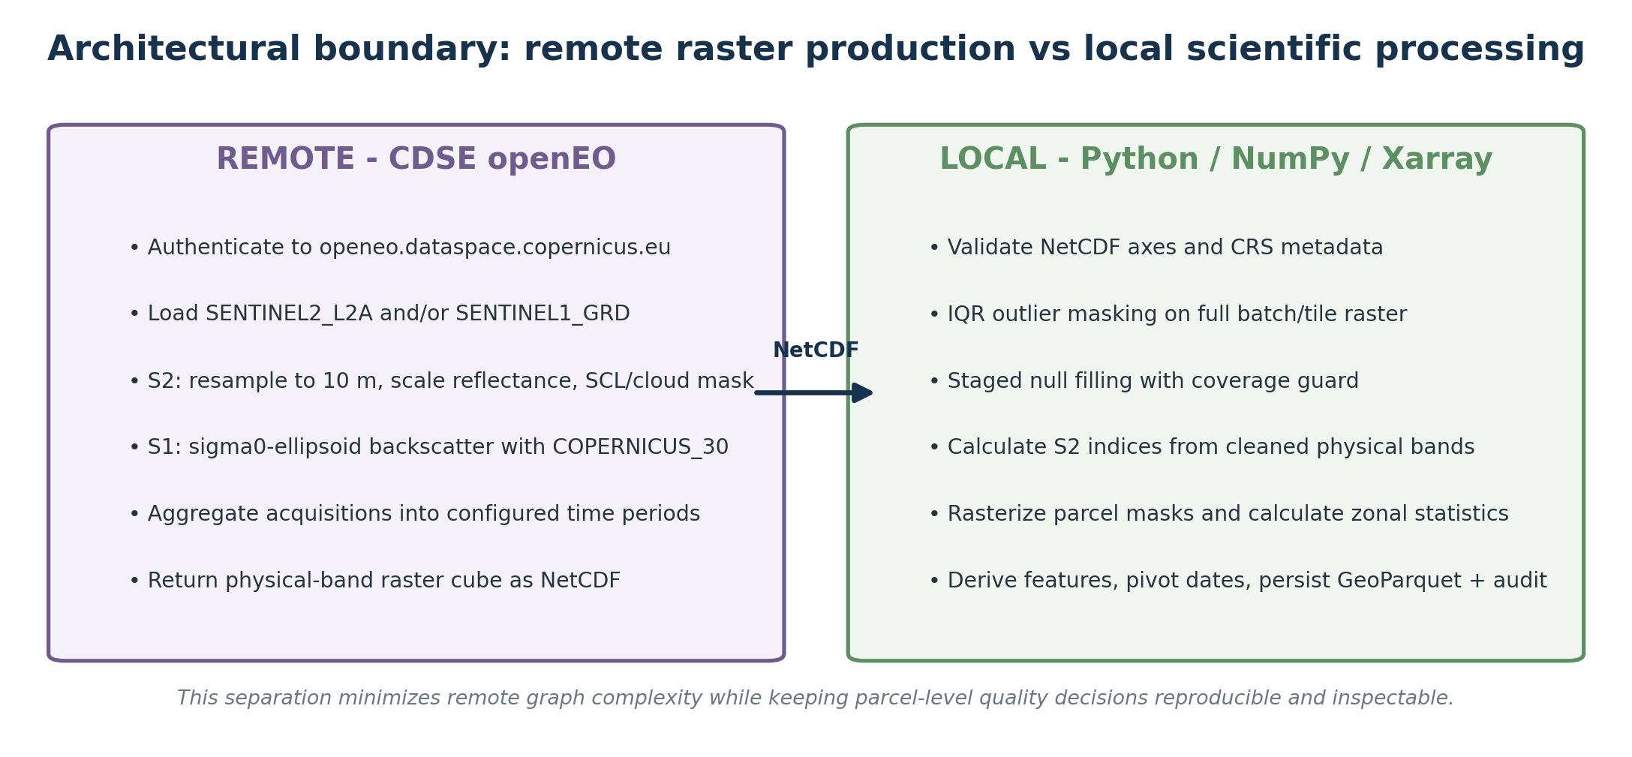
Figure 1. Remote CDSE responsibilities and local Python responsibilities.
Stage | Plain-language purpose | Primary implementation
01 INPUT | Validate configuration, CRS, parcel IDs and polygon geometry. | configuration.py + parcel_batches.py
02 PLAN | Create deterministic parcel batches or fixed buffered tiles. | parcel_batches.py or zonal_stats_job_manager.py
03 openEO | Load S1/S2, mask/transform, temporally aggregate and download NetCDF. | openeo_pipeline.py or job-manager override
04 CLEAN | Remove raster outliers and fill eligible null pixels. | raster_cleaning.py
05 STATS | Calculate local S2 indices, parcel masks, zonal statistics and derived features. | parcel_statistics.py
06 OUTPUT | Pivot temporal fields, attach geometry/attributes and persist wide/annual GeoParquet. | zonal_stats.py + feature_reduction.py

3. Input data and prerequisites

3.1 Parcel GeoDataFrame contract
parcels must be a geopandas.GeoDataFrame with a defined CRS and polygonal geometry. Polygon and MultiPolygon inputs are accepted. Invalid geometry is repaired with shapely.make_valid; GeometryCollection results keep only polygonal parts. Null, empty and non-polygonal geometries are removed. Construction fails if no valid polygons remain.
Requirement | Implemented behavior
Parcel identifier | parcel_id_field defaults to 'parcel_id'. If absent, stable string IDs are created from the input index.
Uniqueness | Duplicate parcel IDs raise ValueError; one output row is expected per unique parcel.
Input attributes | All non-geometry parcel attributes are preserved and reattached to the final output.
Input CRS | Required. Geometry is internally normalized to EPSG:4326 for the base openEO feature-collection workflow.
working_epsg | Must be projected. Used for metric grids, area, 10 m output grid, tiling/buffer calculations and final output geometry.

CRS rule working_epsg is not a reporting-only parameter. It controls metric operations and the target 10 m raster grid. A geographic CRS such as EPSG:4326 is rejected.

3.2 Runtime dependencies and authentication
The source expects GeoPandas, pandas, NumPy, Xarray, rioxarray, Rasterio, PyProj, Shapely, openEO Python client, NetCDF support, PyArrow and SciPy. IDW/kriging routes depend on the repository interpolation helper and, for kriging, its PyKrige stack. CDSE access requires an active account and OIDC authentication.
- If openeo_username and openeo_password are both omitted, connection.authenticate_oidc() is used and can reuse normal cached/interactive OIDC state.
- If explicit credentials are provided, both must be present. The code uses resource-owner-password credentials with client_id="cdse-public".
- The uploaded source snapshot references common_libraries.data_cleaning.fill_null_values_using_interpolation, but common_libraries/data_cleaning.py is not present in this zip. The runtime environment must provide that module or the import must be restored.

3.3 Sensor and feature selection
Parameter | Default | Accepted / important behavior
sentinel2_bands | None | None -> B02,B03,B04,B05,B08. [] disables standalone S2 bands. Supported: B01,B02,B03,B04,B05,B06,B07,B08,B8A,B09,B11,B12.
calculate_sentinel2_indices | False | Must be True when sentinel2_indices is non-empty.
sentinel2_indices | None | NDVI, NDWI, MNDWI, NDMI, NBR, GNDVI, EVI, SAVI, MSAVI, NDRE, PSRI, CI.
sentinel1_bands | None | VV and/or VH. None or [] disables S1.
spatial_statistics | None | mean always included; optional median, sd, min, max, count, p10, p25, p75, p90.

At least one S2 band, S2 index or S1 band must be selected. When an index needs a source band that is not requested as a standalone output, that physical source band is still downloaded and cleaned automatically.

4. Architectural design and component boundaries
SatelliteZonalStats is the backward-compatible public facade. It uses multiple inheritance to compose narrowly scoped components while keeping the established private method names available to existing integrations. JobManagerSatelliteZonalStats subclasses the facade and changes only the remote planning/execution layer; the local raster cleaning and parcel-statistics engine is reused unchanged.
Module | Responsibility
configuration.py | Validation of dates, projected CRS, temporal intervals, sensors/statistics, cleaning options and raw-cache signatures.
parcel_batches.py | Geometry repair, parcel-ID normalization and base-class 50 km / 5,000-parcel batching.
openeo_pipeline.py | OIDC authentication, S1/S2 process graphs, temporal aggregation, remote jobs, downloads and raw-cache reuse.
raster_cleaning.py | NetCDF variable selection, raster IQR masking, temporal/spatial filling, interpolation and per-layer audit rows.
parcel_statistics.py | Checkpoint lifecycle, local index calculation, parcel raster masks, zonal reducers, derived stats and wide temporal reshape.
feature_reduction.py | Optional/automatic reduction of dated monthly median fields into compact annual mean/min/max/std features.
zonal_stats.py | Public constructor, component orchestration, local multiprocessing, output persistence and automatic annual reduction.
zonal_stats_job_manager.py | Fixed tiles, representative-point ownership, buffers, MultiBackendJobManager state and remote concurrency.
zonal_stats_multiuser_manager.py | Optional outer spatial partitions, round-robin credentials, concurrent partition extraction and merge.

Facade contract Both primary extractor classes expose the same scientific processing options and produce the same parcel feature schema. Their main difference is how remote openEO work is partitioned and managed.

5. Parcel preparation and spatial work planning

5.1 Geometry normalization
1. Copy the input GeoDataFrame so source attributes are retained.
2. Create the configured parcel ID from the index only when the ID column is absent, then cast IDs to string.
3. Run make_valid and retain Polygon/MultiPolygon content; union polygonal pieces from GeometryCollection results.
4. Remove null/empty/non-polygonal results and reject duplicate parcel IDs.
5. Reproject prepared parcels to EPSG:4326 for internal storage and base-class openEO feature collections.

5.2 Base spatial batching
SatelliteZonalStats reprojects prepared parcels to working_epsg, calculates parcel centroids, assigns them to a regular 50 km grid using integer floor division, orders parcel centroids deterministically inside each cell, and then chunks each cell into groups of at most 5,000 parcels. Each group becomes one remote openEO job and one local statistics batch.

5.3 Fixed-tile job-manager planning
JobManagerSatelliteZonalStats covers the full parcel bounding extent with fixed square core tiles. Each parcel is owned by the one core tile intersecting its representative interior point. The core tile is then buffered only for remote raster loading; ownership remains tied to the unbuffered core tile so overlapping buffers do not create duplicate parcel outputs. Empty core tiles do not create jobs.
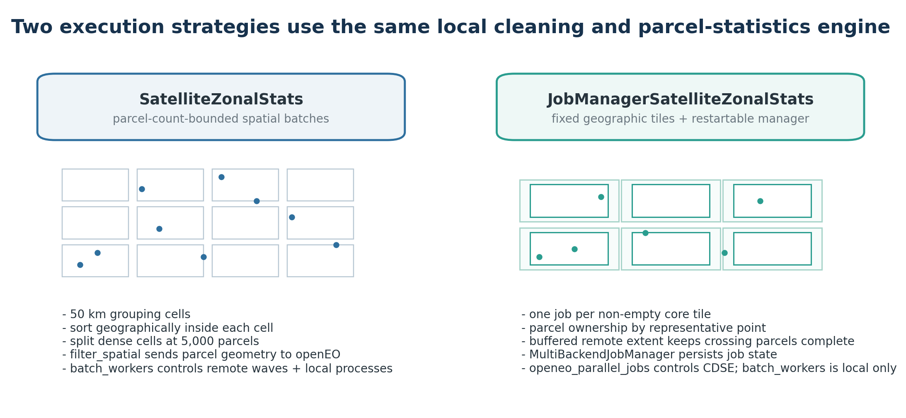
Figure 2. Base parcel-count batching and job-manager geographic tiling.
Buffer safety check Planning verifies that every owned parcel is fully covered by its buffered tile. If not, uncovered_buffered_tile_parcels.csv is written and the run stops until tile_buffer_metres is increased.

6. Remote openEO sensor processing
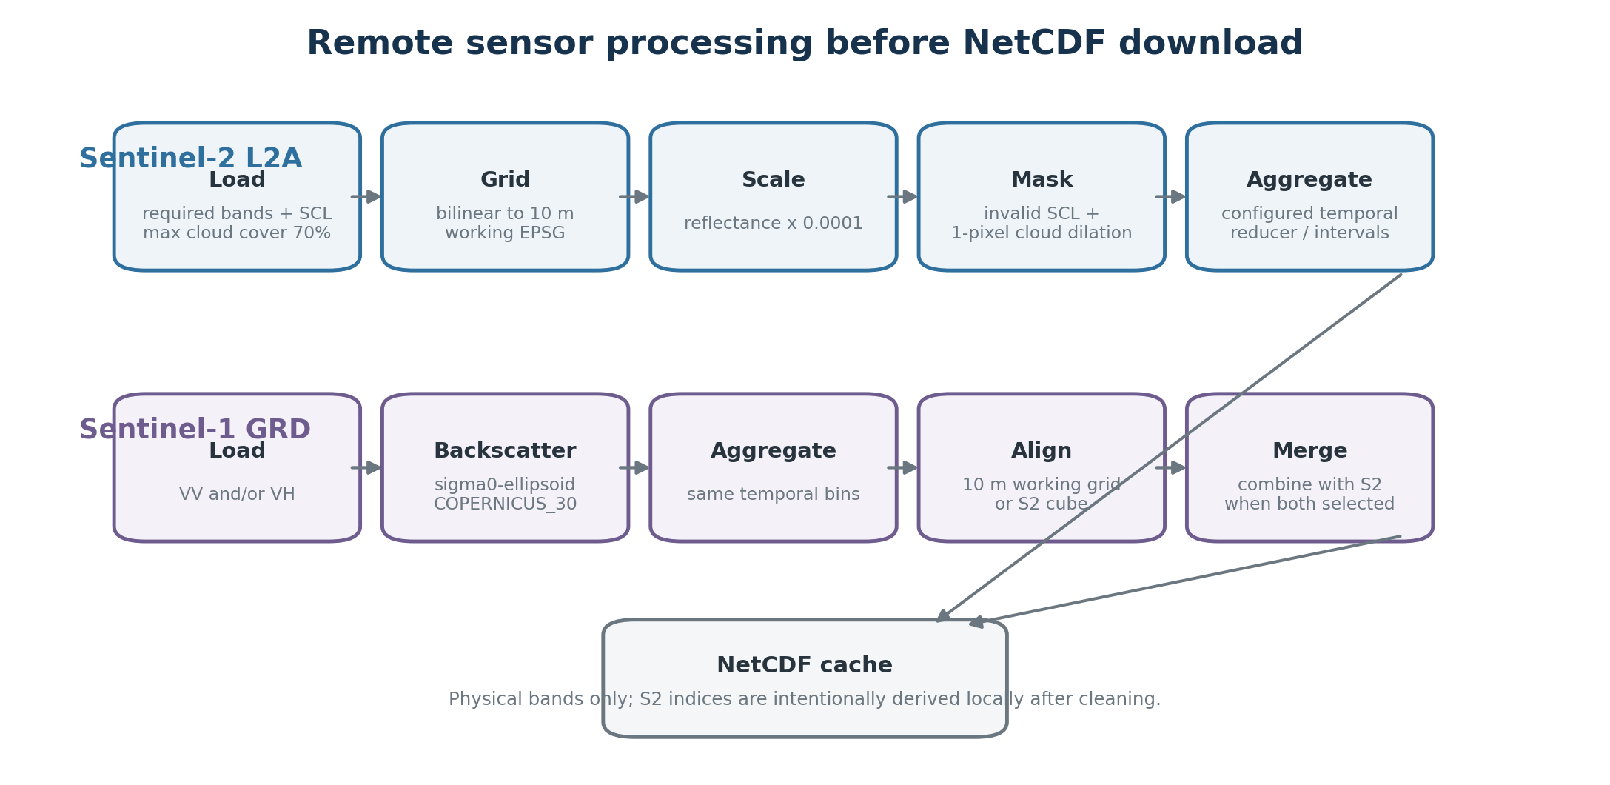
Figure 3. Sentinel-2 and Sentinel-1 remote processing before NetCDF download.

6.1 Sentinel-2 L2A path
1. Load SENTINEL2_L2A over the requested dates with all physical source bands required for requested outputs/indices plus SCL. Scene-level max_cloud_cover is fixed at 70.
2. Resample reflectance to 10 m in working_epsg with bilinear interpolation and multiply by 0.0001.
3. Resample SCL to the reflectance grid with nearest-neighbor interpolation.
4. Mask SCL classes 0, 1, 3, 8, 9, 10 and 11. Cloud-related classes 3, 8, 9, 10 and 11 are additionally dilated by one pixel with a 3x3 kernel, and the dilated cloud mask is also removed.
5. Keep physical source bands in the remote output. Spectral indices are intentionally not computed here.
6. Aggregate acquisitions into the configured temporal periods with mean, median, min, max or sum.

6.2 Sentinel-1 GRD path
1. Load SENTINEL1_GRD with VV and/or VH over the same requested dates.
2. Apply sar_backscatter with coefficient="sigma0-ellipsoid", local_incidence_angle=False and elevation_model="COPERNICUS_30".
3. Aggregate into the same temporal periods.
4. For S1-only runs, resample the temporal radar cube to 10 m in working_epsg. For mixed S1/S2 runs, align S1 to the S2 temporal cube and merge the sensor cubes.

6.3 Temporal interval semantics
temporal_period accepts positive D, M or Y intervals such as 15D, 1M, 2M, 3M or 1Y. If temporal_period is exactly 1M and start_date is the first day of a month, the code uses the backend aggregate_temporal_period("month") operation. Otherwise it creates explicit half-open intervals beginning at start_date and clips the last interval after the inclusive end_date. Period labels are the interval start dates.

7. Raster cleaning and staged null filling
After a raw NetCDF is available, local processing first validates the temporal/spatial axes and CRS, materializes the physical-band cube as float32, and cleans the complete batch/tile raster before any parcel mask is applied. This means adjacent parcels can contribute neighboring source pixels during spatial filling.
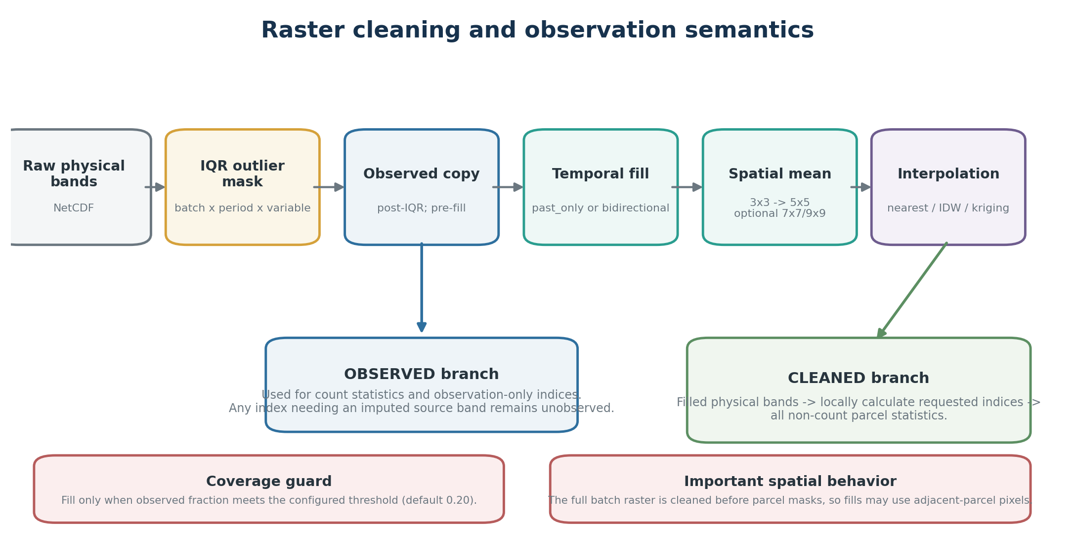
Figure 4. Cleaning stages and the separate observed/cleaned semantics.

7.1 IQR outlier masking
IQR bounds are calculated independently for every temporal layer and physical variable across the full eligible batch raster. When remove_outliers is enabled and at least iqr_min_valid_pixels finite values exist, the configured lower/upper quantiles define the IQR and values outside Qlower - multiplier*IQR and Qupper + multiplier*IQR are replaced by NaN. The audit scope recorded by the code is batch_interval_variable.
Important distinction The implemented IQR scope is not per parcel. Outlier detection occurs once on the full raster for each batch/tile x period x variable, before parcel masking.

7.2 Observation coverage guard
For each variable and period, observed_count is measured after IQR masking. Filling is allowed only when observed_count / eligible_pixel_count is at least minimum_observed_fraction_for_fill (default 0.20). A rejected period is also hidden as a temporal source, preventing a low-coverage slice from contaminating better periods.

7.3 Temporal filling
Mode | Behavior
past_only | Carry the most recent earlier finite value forward at each pixel. Missing periods without an earlier observation remain missing.
bidirectional | Build nearest earlier and nearest later candidates. If both exist, fill with their midpoint; if only one direction exists, use that value.

7.4 Sequential spatial means
After temporal filling, remaining eligible nulls are filled once per configured odd window using the mean of finite neighboring pixels. Supported ordered prefixes are (3,), (3,5), (3,5,7) and (3,5,7,9). The default is 3x3 followed by 5x5. Larger windows are opt-in because they smooth over a wider neighborhood.

7.5 Final interpolation
Method | Implementation
nearest | Raster-native nearest observed pixel using scipy distance_transform_edt; no geometry objects are built.
idw | Delegates eligible pixel centers to fill_null_values_using_interpolation; interpolation_max_distance_in_meters is required.
kriging | Uses the same interpolation helper with configured variogram lags and required variogram maximum distance.

Filling never overwrites finite observations. The merge step only inserts candidate values where the original pixel is null, the pixel is inside the eligible raster mask, and the period passed the observed-fraction guard.

7.6 Cleaning audit
satellite_pixel_cleaning_report.csv contains one row per batch x period x physical variable. It records null counts before/after IQR, each temporal/spatial/interpolation stage, how many pixels each stage filled, final null count/rate, observed fraction, whether filling was allowed, IQR bounds/reference size and the interpolation method. Optional 7x7/9x9 columns remain in the schema even when those stages are not enabled.

8. Sentinel-2 spectral indices and observation semantics
Indices are calculated locally only after physical bands have completed IQR filtering and any permitted null filling. This ordering keeps all indices that share a source band algebraically consistent and prevents one anomalous reflectance value from independently propagating through several indices.
Index | Implemented formula
NDVI | (B08 - B04) / (B08 + B04)
NDWI | (B03 - B08) / (B03 + B08)
MNDWI | (B03 - B11) / (B03 + B11)
NDMI | (B08 - B11) / (B08 + B11)
NBR | (B08 - B12) / (B08 + B12)
GNDVI | (B08 - B03) / (B08 + B03)
EVI | 2.5*(B08-B04) / (B08 + 6*B04 - 7.5*B02 + 1)
SAVI | 1.5*(B08-B04) / (B08 + B04 + 0.5)
MSAVI | (2*B08+1 - sqrt((2*B08+1)^2 - 8*(B08-B04))) / 2
NDRE | (B08 - B05) / (B08 + B05)
PSRI | (B04 - B02) / B06
CI | B08 / B05 - 1

Safe-ratio operations emit NaN when numerator/denominator is invalid or the denominator is zero. MSAVI also emits NaN where its square-root discriminant is negative.

8.1 Why the pipeline keeps two raster states
State | Meaning | Used for
cleaned | Post-IQR physical bands after any permitted temporal/spatial/interpolation fill. | Requested indices and all non-count parcel statistics.
observed | Post-IQR values before filling; reconstructed from observed_mask in checkpoints. | count statistics and observation-only indices.

Count semantics An index can have a filled value but still be excluded from its count. If any required source band was imputed, the same index calculated from the observed branch is NaN, so that pixel is not counted as an observation.

9. Parcel masking and zonal statistics
Parcel statistics are calculated after the full raster is cleaned and indices have been created. Parcel geometry is reprojected to the raster CRS. For each parcel, the code computes only the raster window intersecting the parcel bounds and rasterizes the polygon with all_touched=False, meaning pixel-center membership controls whether a pixel belongs to the parcel.
Statistic | Implementation detail
mean | nansum / finite count.
median | numpy.nanmedian.
sd | Sample standard deviation: denominator n-1; NaN when fewer than two valid pixels.
min / max | numpy.nanmin / nanmax.
count | Special: finite pixel count from the observed branch, not the filled cleaned branch.
p10/p25/p75/p90 | numpy.nanquantile with linear interpolation.

eligible_pixel_count is the number of raster pixel centers inside the parcel mask and is constant across periods. meets_minimum_pixel_count is a quality flag comparing that count with minimum_parcel_pixels (default 3). Small parcels are retained; the flag does not filter them out.

10. Derived parcel features and ML-ready reshaping

10.1 Derived statistics
Derived field | Created when source statistics exist
<variable>_range | max - min
<variable>_variance | sd^2
<variable>_coefficient_of_variation | sd / abs(mean), only when abs(mean) > 1e-12
<variable>_iqr | p75 - p25
<variable>_bowley_skewness | (p75 + p25 - 2*median) / IQR, when |IQR| > 1e-12
<variable>_p90_p10_spread | p90 - p10
<variable>_valid_pixel_fraction_approx | count / (parcel_area_m2 / 10^2), clipped to [0,1]
<variable>_valid_pixel_fraction | count / eligible_pixel_count, clipped to [0,1]

parcel_area_m2 is calculated in working_epsg. approx_pixel_count is parcel_area_m2 divided by 100 m2 because the target raster resolution is fixed at 10 m.

10.2 Wide temporal feature schema
Before persistence, the parcel-period table is checked to ensure at most one row exists per parcel and period and that fields designated static do not vary over time. All remaining statistics are pivoted into dated columns using the period-start label as YYYYMMDD. Original parcel attributes and projected geometry are then joined once in a one-to-one merge.
Column type | Examples / behavior
Parcel attributes | Any non-geometry input attributes, including a class/label column if supplied.
Static extraction fields | batch_number, eligible_pixel_count, meets_minimum_pixel_count, parcel_area_m2, approx_pixel_count.
Temporal fields | B04_mean__20240401, NDVI_median__20240401, VV_p90__20240501, plus derived temporal statistics.
Geometry | Original parcel geometry reprojected to working_epsg.

Collision guard If an input parcel attribute has the same name as a generated zonal-statistics field, the final merge raises an error rather than silently overwriting data.

10.3 Automatic annual reduction
run() also creates satellite_parcel_annual_stats.geoparquet. The reducer searches specifically for dated monthly median columns named <SOURCE>_median__YYYYMMDD and creates four features per configured S2 band/index/S1 band: annual mean, annual minimum, annual maximum and population standard deviation (ddof=0) of the period medians. All dated columns are removed from the reduced table while non-dated attributes and geometry are preserved.
Operational requirement The automatic annual reducer is median-based. If spatial_statistics does not include median, the current run() still creates annual fields but their source column sets are empty, so the generated annual satellite features are NaN. Request median whenever the automatic annual dataset is intended for use.

11. Execution modes: base batching and job manager
Aspect | SatelliteZonalStats | JobManagerSatelliteZonalStats
Remote grouping | 50 km spatial cells, then max 5,000 parcels per batch. | One job per non-empty fixed core tile; parcel count can be highly imbalanced.
Remote spatial filter | Detailed parcel feature collection via filter_spatial. | Buffered rectangular tile extent; parcel masks are local only.
Remote concurrency | batch_workers controls each job wave. | openeo_parallel_jobs controls CDSE active jobs.
Local concurrency | batch_workers ProcessPool. | batch_workers ProcessPool.
Persistence | Raw NetCDF cache only; rerun skips existing files. | Raw cache + tile_jobs.parquet + MultiBackendJobManager status/error artifacts.
Best use | General processing and explicit parcel-count bounds. | Restartable geographic jobs, explicit extents and controlled remote concurrency.

11.1 Tile-size and buffer helpers
compute_tile_width tests 5, 10, 20, 30, 40, 50 and 60 km tiles and returns the smallest tested size for which all parcels fall within a core tile according to its within join. This helper expects parcel coordinates already expressed in working_epsg. Its objective is containment, not workload balancing. compute_tile_buffer_metres can accept any defined input CRS; it reprojects internally, measures each parcel from representative point to farthest bounding-box corner, multiplies the maximum radius by a default safety factor of 2.5 and rounds upward to 50 m.
Manager workload The manager intentionally does not balance parcel counts per tile. A dense tile can own tens of thousands of parcels while neighboring tiles own very few. Tile size controls geographic raster area, not parcel-count equality.

12. Multi-user parallel extraction
zonal_stats_multiuser_manager.py adds an optional outer orchestration layer. It spatially partitions a parcel GeoDataFrame, assigns one openEO credential pair to each partition in round-robin order, runs one JobManagerSatelliteZonalStats instance per partition inside a ThreadPoolExecutor, and later merges the partition GeoParquets.
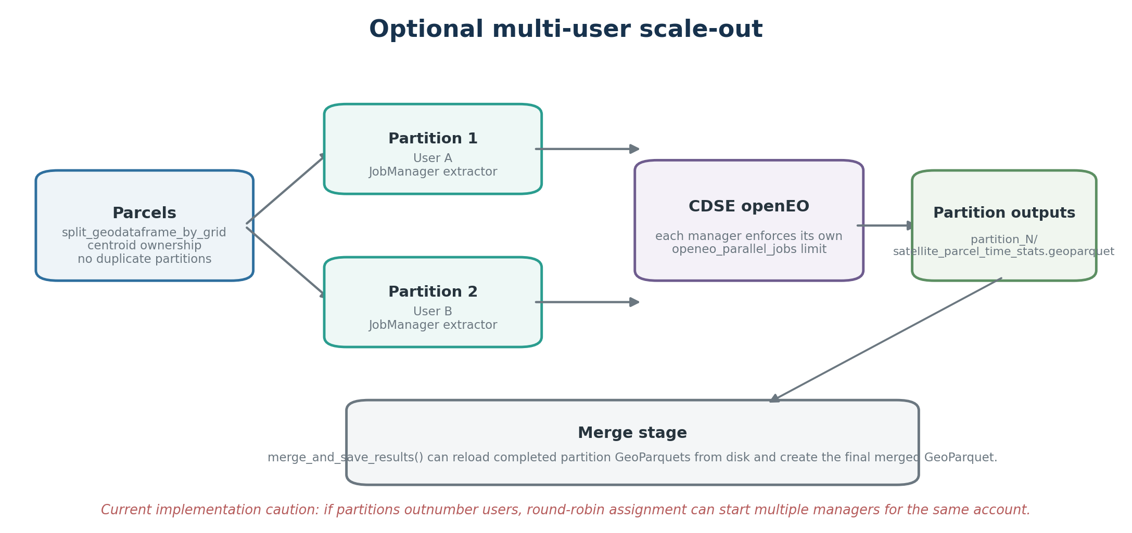
Figure 5. Multi-user outer partitioning around independent job-manager extractors.
1. split_geodataframe_by_grid assigns each parcel to exactly one regular grid cell based on its centroid.
2. load_openeo_users_from_env parses OPENEO_USERS in username,password;username,password format.
3. run_parallel_extractions starts all supplied spatial partitions concurrently and writes each partition to output_dir/partition_N/.
4. merge_and_save_results can be called later, even in a new Python session. If all_results is omitted, it discovers partition_*/satellite_parcel_time_stats.geoparquet and merges them.
Current API behavior In the reviewed source, run_parallel_extractions() returns None; it does not return an in-memory results dictionary. merge_and_save_results() is the persistence boundary and returns (merged_gdf, output_geoparquet).

Quota caution Round-robin assignment does not serialize partitions that reuse the same user. If partitions outnumber accounts, more than one manager may run for the same CDSE user and each manager can independently request openeo_parallel_jobs slots. Keep partition/account planning consistent with account quotas.

13. Caching, checkpointing and restartability
The pipeline uses deterministic final paths plus temporary .partial files so a path ending in .nc is treated as a completion marker only after an atomic rename. Local raster processing has its own compatibility signature, allowing stale cleaned/final checkpoints to be rejected safely.
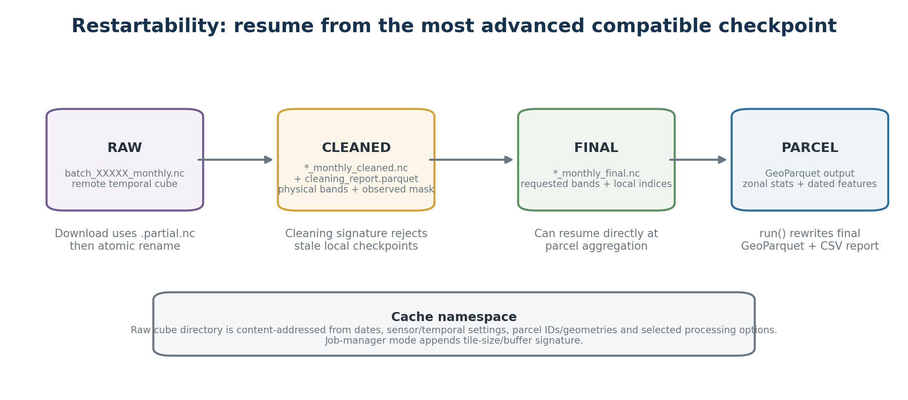
Figure 6. Checkpoint progression and restart behavior.

13.1 Raw cube cache
Raw NetCDF files live under output_dir/monthly_cubes/<run_signature>/. The base run signature hashes major temporal, sensor, projection, masking and selected cleaning options, then incorporates every parcel ID and exact geometry WKB. The job-manager implementation appends a separate tile-size/tile-buffer suffix. Existing raw NetCDF paths are reused and .partial.nc files are never treated as completed cache items.

13.2 Cleaning checkpoint
After physical-band IQR/filling, the code atomically writes *_cleaned.nc and *_cleaning_report.parquet. The NetCDF stores one float32 cleaned array and one uint8 observed_mask rather than duplicating a second float raster. The local cleaning signature includes IQR/fill settings, window sequence and interpolation/variogram settings. By default, keep_cleaned_checkpoint=False removes the intermediate cleaned NetCDF after the final checkpoint is committed; the raw cube and cleaning report remain.

13.3 Final post-index checkpoint
*_final.nc stores the requested output variables after local index calculation, again as cleaned + observed_mask. If its cleaning signature, variable list, period list and shape match, a restart can skip both raster cleaning and index calculation and proceed directly to parcel aggregation.

13.4 Current cache-signature behavior
The executable code is more specific than the prose guides. For example, changing spatial_fill_window_sizes or kriging lag/distance settings leaves the base raw-cache namespace unchanged but invalidates the local cleaning signature, while changing interpolation_method or interpolation_max_distance_in_meters currently changes the base run signature as well. Treat the actual cache directory name and checkpoint cleaning_signature as the authoritative compatibility contract for a run.

14. Output architecture and artifact reference
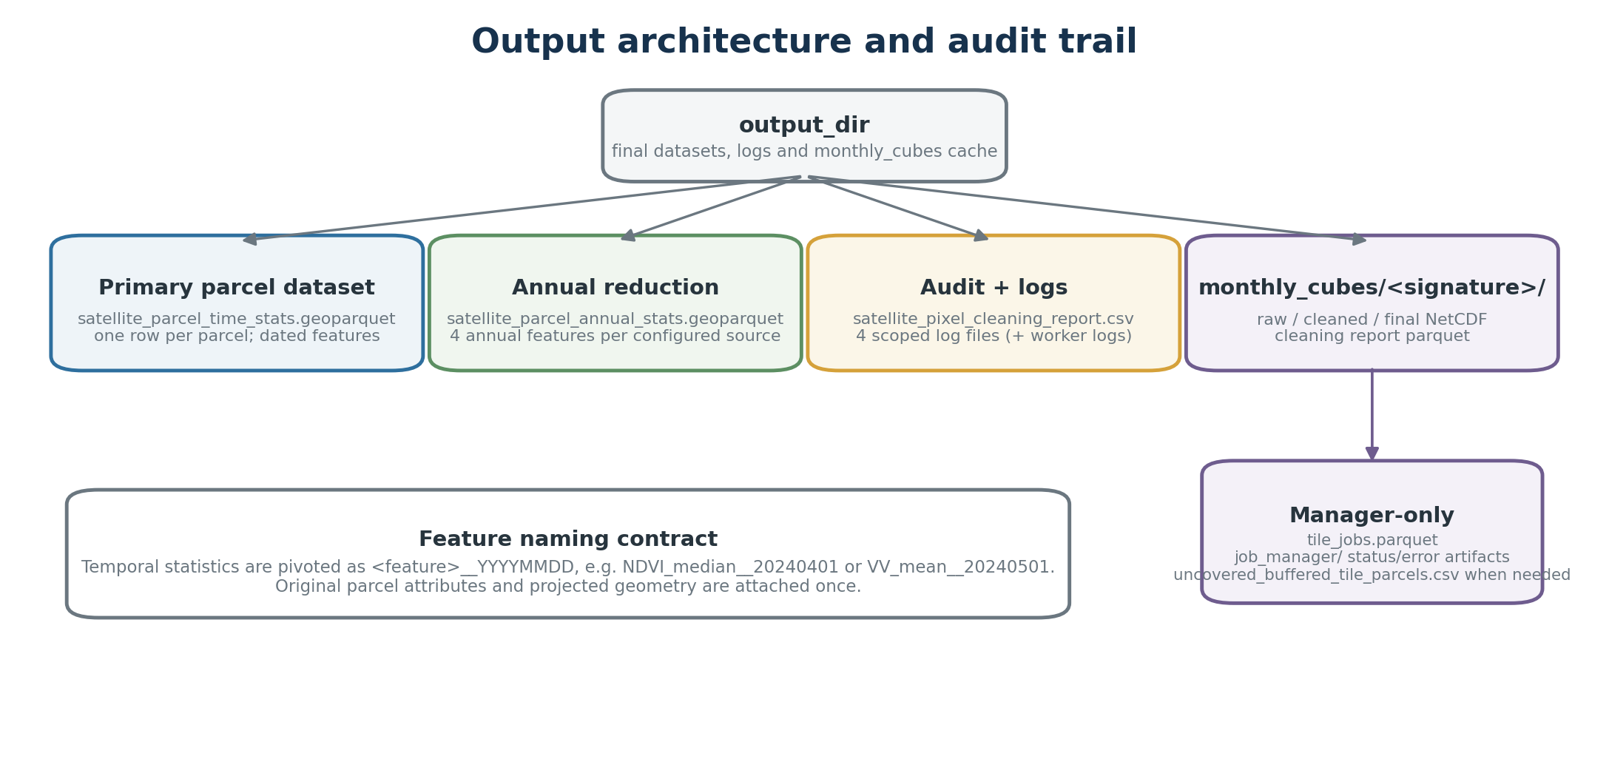
Figure 7. Primary datasets, cache files and audit artifacts.

14.1 Primary outputs
Path | Purpose
satellite_parcel_time_stats.geoparquet | Authoritative wide parcel dataset: original attributes + static metrics + dated temporal features + projected geometry.
satellite_parcel_annual_stats.geoparquet | Automatic compact reduction based on period median fields; four annual features per configured sensor source.
satellite_pixel_cleaning_report.csv | Per batch/period/physical-variable audit of IQR and every filling stage.

14.2 Logs
Log | Scope
satellite_zonal_stats.log | Construction, configuration and high-level orchestration.
satellite_openeo.log | CDSE connection, job creation, waves/manager execution and downloads.
satellite_raster_filling.log | Per variable/period null filling start/end counts.
satellite_parcel_statistics.log | Checkpoint reuse, NetCDF reading, parcel aggregation and reshaping.
*.worker-<pid>.log | Per-process filling/parcel logs when batch_workers > 1, avoiding concurrent writes to one file.

14.3 Cache / manager artifacts
Artifact | Meaning
monthly_cubes/<signature>/batch_XXXXX_monthly.nc | Completed raw temporal cube.
*_monthly_cleaned.nc | Intermediate cleaned physical bands + observed mask; optional retention.
*_monthly_cleaning_report.parquet | Checkpoint audit paired with the cleaned raster.
*_monthly_final.nc | Final requested bands + local indices + observed mask.
tile_jobs.parquet | Job-manager database for uncached tile jobs.
job_manager/ | MultiBackendJobManager status/error files.
uncovered_buffered_tile_parcels.csv | Diagnostic written only when manager tile buffer does not cover owned parcels.

15. Parameter reference

15.1 Common temporal / sensor parameters
Parameter | Default | Operational meaning
parcel_id_field | parcel_id | Unique ID; created from index only when column absent.
temporal_period | 1M | Positive nD/nM/nY interval.
temporal_reducer | median | mean / median / min / max / sum.
batch_workers | 1 | Base: remote job-wave size + local process count. Manager: local process count only.
minimum_parcel_pixels | 3 | Quality-flag threshold; does not remove small parcels.

15.2 Cleaning parameters
Parameter | Default | Operational meaning
remove_outliers | False | Enable batch-period-variable IQR masking.
iqr_quantiles | (0.25, 0.75) | Lower/upper quantiles used for IQR.
iqr_multiplier | 1.5 | Non-negative Tukey extension.
iqr_min_valid_pixels | 20 | Minimum finite raster pixels before IQR applies.
fill_nulls | False | Enable temporal -> spatial windows -> interpolation stages.
temporal_fill_mode | past_only | past_only or bidirectional.
minimum_observed_fraction_for_fill | 0.20 | Minimum post-IQR observed share for a period to be filled or used as temporal source.
spatial_fill_window_sizes | (3,5) | One of (3,), (3,5), (3,5,7), (3,5,7,9).
keep_cleaned_checkpoint | False | Keep intermediate cleaned physical-band NetCDF after final checkpoint commits.
interpolation_method | nearest | nearest / idw / kriging.
interpolation_max_distance_in_meters | None | Required for IDW.
interpolation_variogram_lags | 15 | Positive kriging lag count.
interpolation_variogram_max_distance_in_meters | None | Required for kriging.

15.3 Job-manager parameters
Parameter | Default | Meaning
tile_size_metres | 50000 | Core square tile width/height in working_epsg.
tile_buffer_metres | 500 | Buffer added to the remote raster extent, not to parcel ownership.
openeo_parallel_jobs | 2 | Maximum active CDSE jobs in this manager.
job_poll_seconds | 30 | Manager polling interval.
run_identifier | generated timestamp | Human-readable label (<=80 chars) included in openEO job titles.

16. Operational runbook

16.1 Minimal base-class run
from openeo_parcel_stats_pipeline import SatelliteZonalStats
extractor = SatelliteZonalStats(
parcels=parcels,
start_date="2024-03-01",
end_date="2024-10-31",
output_dir="parcel_stats_run",
working_epsg=32634,
parcel_id_field="parcel_id",
sentinel2_bands=["B02", "B03", "B04", "B08"],
calculate_sentinel2_indices=True,
sentinel2_indices=["NDVI", "NDMI"],
sentinel1_bands=["VV", "VH"],
spatial_statistics=["mean", "median", "sd", "count"],
remove_outliers=True,
fill_nulls=True,
temporal_period="1M",
temporal_reducer="median",
batch_workers=2,
)
result = extractor.run()
cleaning_report = extractor.cleaning_report

16.2 Restartable manager run
from openeo_parcel_stats_pipeline import JobManagerSatelliteZonalStats
from openeo_parcel_stats_pipeline.zonal_stats_job_manager import (
compute_tile_buffer_metres, compute_tile_width,
)
working_epsg = 32634
metric_parcels = parcels.to_crs(epsg=working_epsg)
tile_size = compute_tile_width(metric_parcels, "parcel_id", working_epsg)
tile_buffer = compute_tile_buffer_metres(parcels, working_epsg)
extractor = JobManagerSatelliteZonalStats(
parcels=parcels,
start_date="2023-01-01",
end_date="2024-12-31",
output_dir="parcel_stats_manager",
working_epsg=working_epsg,
parcel_id_field="parcel_id",
sentinel2_bands=[],
sentinel1_bands=["VV", "VH"],
spatial_statistics=["mean", "median", "sd", "count"],
tile_size_metres=tile_size,
tile_buffer_metres=tile_buffer,
openeo_parallel_jobs=2,
job_poll_seconds=30,
batch_workers=2,
run_identifier="parcels-2023-2024-S1",
)
result = extractor.run()

16.3 Current multi-user sequence
from pathlib import Path
from openeo_parcel_stats_pipeline.zonal_stats_multiuser_manager import (
split_geodataframe_by_grid,
load_openeo_users_from_env,
run_parallel_extractions,
merge_and_save_results,
)
spatial_parts = split_geodataframe_by_grid(parcels, rows=1, cols=2)
users = load_openeo_users_from_env()
run_parallel_extractions(
spatial_parts=spatial_parts,
users_list=users,
config=extraction_config,
)
merged, output_path = merge_and_save_results(
output_dir=Path(extraction_config["output_dir"]),
parcel_id_column=extraction_config["parcel_id_field"],
working_epsg=extraction_config["working_epsg"],
)

16.4 Recommended checkpoints before a large run
Checkpoint | Confirm before scaling up
Input | CRS is correct; IDs are unique; polygon count after repair matches expectations.
Small openEO test | Authentication works; variables/period labels and CRS metadata are present in NetCDF.
Cleaning | Observed fractions and final null counts are plausible; IQR is not removing valid extremes.
Parcel stats | eligible_pixel_count is sensible for parcel sizes; count is understood as observed count.
Output | Median is requested if annual reduction will be used; dated columns and geometry CRS are correct.
Manager | Tile buffer covers parcels; remote concurrency is within quota; monthly_cubes is preserved for restart.

17. Interpretation and quality-control checkpoints

17.1 Read the cleaning report first
Question | Fields to inspect
Did IQR remove many pixels? | iqr_outlier_count, iqr_lower_bound, iqr_upper_bound, iqr_reference_value_count.
Was a period too sparse to fill? | observed_fraction and fill_allowed.
Which stage actually repaired gaps? | filled_count_by_temporal_fill, filled_count_by_3x3_fill, ... filled_count_by_interpolation.
Are gaps still unresolved? | final_null_count, final_null_rate, has_remaining_nulls.

17.2 Interpret parcel quality fields
- eligible_pixel_count is geometry/grid support: how many 10 m pixel centers fell inside the parcel mask.
- meets_minimum_pixel_count flags whether the parcel meets the configured support threshold; the parcel is still retained if False.
- <variable>_count is an observation count after IQR and before fill. It is intentionally not the number of finite filled values used by mean/median/etc.
- <variable>_valid_pixel_fraction uses observed count divided by eligible_pixel_count and is therefore a direct observation-coverage indicator.
- <variable>_valid_pixel_fraction_approx uses area/100 m2 as an approximate denominator; border geometry can make it differ from the exact fraction.

17.3 Spatial sanity checks
Because raster filling occurs before parcel masking, neighboring valid pixels can cross parcel boundaries. This is an intentional implementation choice that improves local gap filling but may be inappropriate when parcel boundaries are semantically strict. For sensitive applications, compare outputs with fill_nulls=False or restrict/alter the cleaning design before treating imputed pixels as within-parcel evidence.

18. Performance and concurrency guidance
Control | Effect | Trade-off
batch_workers (base) | Number of concurrently started/downloaded openEO jobs and local ProcessPool workers. | Higher values increase remote pressure and local memory/CPU.
batch_workers (manager) | Local statistics ProcessPool only. | Independent from CDSE job concurrency.
openeo_parallel_jobs | Active manager jobs on CDSE. | Keep within account quota; 2 is the intended general-user setting in source guidance.
tile_size_metres | Raster area per manager job and number of jobs. | Larger tiles: fewer jobs but more raster memory/compute; smaller tiles: more management overhead.
tile_buffer_metres | Extra raster area around each core tile. | Must cover crossing parcels but unnecessarily large buffers download extra data.
spatial_fill_window_sizes | Number and radius of local mean passes. | Larger windows cost more and smooth over a broader neighborhood.
nearest interpolation | Raster-native distance transform. | Fast and deterministic but can propagate the nearest value over a long distance when no distance threshold exists.

Process memory Local parallel workers receive the extractor configuration and independently open/materialize their batch NetCDF cubes. Size batch_workers according to raster dimensions and available RAM, not only CPU count.

19. Troubleshooting and red flags
Symptom | Likely meaning / action
No valid Polygon or MultiPolygon parcels | Input is empty/non-polygonal after repair; inspect geometry types and null/empty features.
Duplicate parcel IDs | The output grain is ambiguous. Make parcel_id_field unique before construction.
working_epsg rejected | A geographic or invalid EPSG code was supplied; choose an appropriate projected metric CRS.
No sensor output selected | Select at least one S2 band/index or S1 band.
Indices supplied while calculation disabled | Set calculate_sentinel2_indices=True.
IDW / kriging validation error | Provide the required maximum-distance parameter for the selected interpolation method.
NetCDF CRS metadata missing | Do not force an assumed CRS; parcel/raster alignment cannot be guaranteed.
Unexpected NetCDF period labels | Backend temporal labels do not match the pipeline interval contract; inspect raw cube.
Many periods fill_allowed=False | Satellite availability/cloud masking leaves less than the configured observed fraction; consider acquisition period, threshold or data source.
Large IQR outlier counts | Quantile/multiplier may be too aggressive for seasonal or radar distributions; inspect layer bounds before accepting.
Manager buffer error | Increase tile_buffer_metres using the diagnostic CSV and compute_tile_buffer_metres.
Manager finishes but NetCDF missing | Inspect tile_jobs.parquet and job_manager/ status/error files.
Annual output mostly NaN | The automatic annual reducer needs *_median__YYYYMMDD columns; include median in spatial_statistics.
Import error for common_libraries.data_cleaning | The interpolation helper module is not included in the reviewed zip snapshot; restore/provide it in PYTHONPATH.

Do not treat filled pixels as observations Use count / valid_pixel_fraction when you need observation support. Mean/median/etc. may include imputed values whenever filling is enabled.

20. Glossary
Term | Meaning in this pipeline
Batch | Base-class spatial parcel group, bounded to at most 5,000 parcels.
Core tile | Unbuffered fixed geographic cell used to own parcels in manager mode.
Buffered tile | Remote raster extent around a core tile; buffers can overlap without duplicating parcel ownership.
Representative point | Interior point used by manager mode to assign one parcel owner tile.
Temporal reducer | Reducer applied remotely to acquisitions within one temporal interval.
Physical band | S1/S2 source band downloaded in the raw cube and eligible for local cleaning.
Observed | Post-IQR, pre-fill pixel state used for count/coverage semantics.
Cleaned | Post-IQR pixel state after permitted fills; used for final indices and non-count statistics.
Eligible pixel | Raster pixel center inside a parcel mask; all_touched=False.
IQR scope | One batch/tile raster x temporal period x physical variable.
Cleaning checkpoint | Restart-safe cleaned physical-band NetCDF + observed mask + audit.
Final checkpoint | Restart-safe requested-band/index NetCDF after local index calculation.
Run signature | Content-addressed raw-cache namespace generated from configuration and parcel identity/geometry.
Cleaning signature | Fingerprint used to decide whether local cleaned/final checkpoints are compatible.
Dated feature | Column named <feature>__YYYYMMDD after temporal pivot.

Appendix A - Implementation map
For maintainers, the public facade delegates computation to focused component classes. The table below maps the current source files to their main responsibilities and the important methods that establish the architectural contracts.
Module | Key implementation points
zonal_stats.py | SatelliteZonalStats constructor; constants; logging; _run_batch_statistics(); run() orchestration and persistence.
configuration.py | Validators; _temporal_intervals(); sensor-variable lists; _run_signature().
parcel_batches.py | _prepare_parcels(); _iter_spatial_batches().
openeo_pipeline.py | _authenticate_openeo_connection(); _build_multisensor_temporal_cube(); _run_openeo_jobs().
raster_cleaning.py | _calculate_iqr_bounds(); _clean_monthly_pixels(); _fill_variable_cube(); cleaning audit.
parcel_statistics.py | checkpoint load/save; _calculate_local_index(); _calculate_local_statistics(); _add_derived_stats(); _reshape_time_series_for_ml().
feature_reduction.py | reduce_annual_median_features(); save_reduced_annual_parcel_features().
zonal_stats_job_manager.py | compute_tile_width/buffer; _build_tile_plan(); _build_tile_cube(); MultiBackendJobManager-based _run_openeo_jobs().
zonal_stats_multiuser_manager.py | outer grid partition, credential loading, concurrent partition runs, disk reload and merged GeoParquet.
__init__.py | Exports SatelliteZonalStats, JobManagerSatelliteZonalStats and annual-reduction helpers; multi-user helpers are imported from their submodule.

Appendix B - Current snapshot notes and source-guide differences
This manual treats the executable Python source in src(5).zip as authoritative when its bundled Markdown examples differ. The following differences are relevant to operators and notebook code.
Area | Current executable behavior
Primary output names | zonal_stats.py writes satellite_parcel_time_stats.geoparquet and satellite_parcel_annual_stats.geoparquet. Some README text still mentions satellite_parcel_ml_features.geoparquet.
Multi-user return value | run_parallel_extractions() currently returns None and writes partition outputs; older Markdown examples expect a result dictionary.
Multi-user merge | merge_and_save_results() currently returns (merged_gdf, output_geoparquet) and does not create the CSV preview described in older guide text.
IQR wording | README parameter prose refers to parcel/variable/period bounds, but raster_cleaning.py records and implements batch_interval_variable scope over the complete raster.
Interpolation helper | raster_cleaning.py imports common_libraries.data_cleaning.fill_null_values_using_interpolation; that source file is absent from the reviewed zip.
Annual reduction | run() always invokes the median-based annual reducer with expected_periods=None; request median in spatial_statistics to populate those annual features.

Document scope This manual describes behavior present in the reviewed source snapshot. For any production run, the saved output files, cache signature, manager database and logs are the authoritative record of what actually executed.

