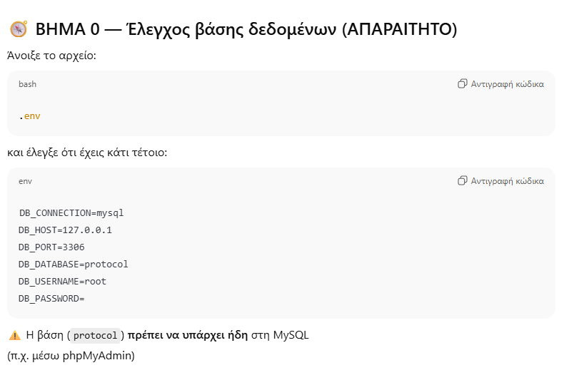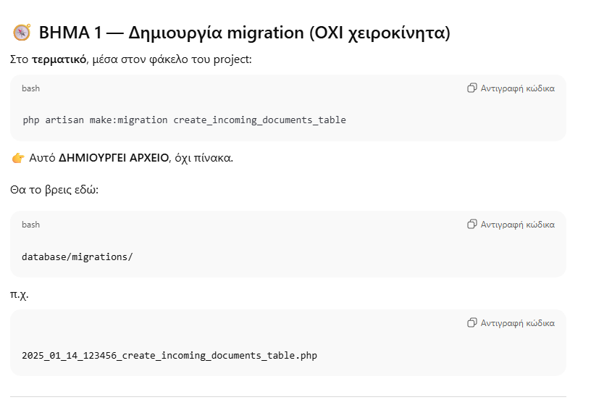
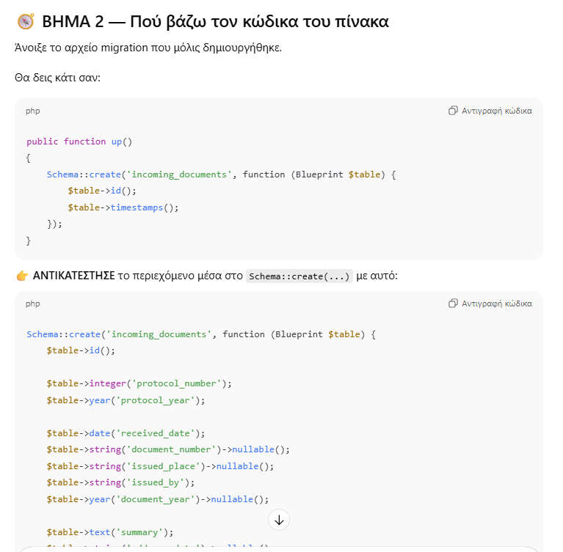
Schema::create('incoming_documents', function (Blueprint $table) {
$table->id();

$table->integer('protocol_number');
$table->year('protocol_year');

$table->date('received_date');
$table->string('document_number')->nullable();
$table->string('issued_place')->nullable();
$table->string('issued_by');
$table->year('document_year')->nullable();

$table->text('summary');
$table->string('addressed_to')->nullable();

$table->string('file_path')->nullable();
$table->text('notes')->nullable();

$table->foreignId('user_id')->constrained()->onDelete('cascade');

$table->timestamps();

$table->unique(['protocol_number', 'protocol_year']);
});

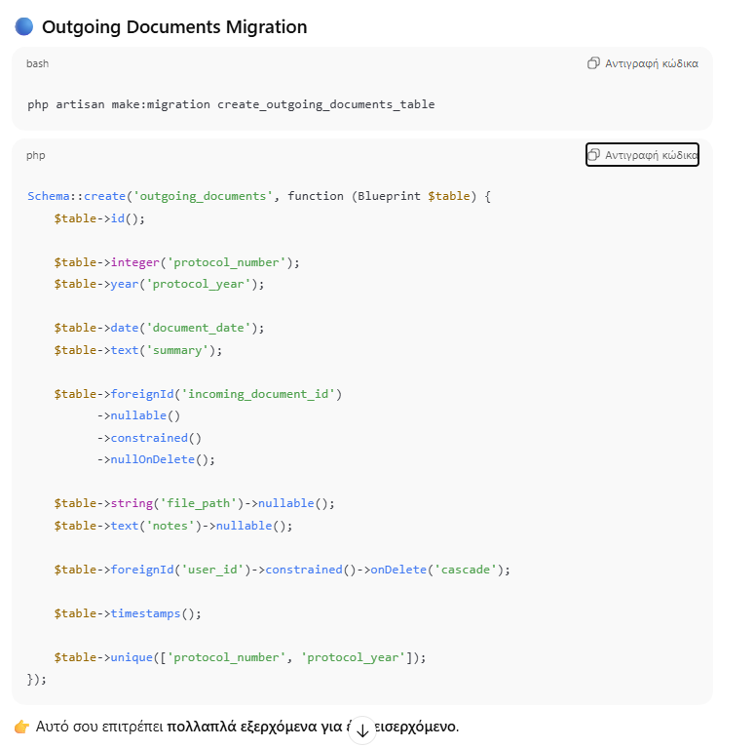

Schema::create('outgoing_documents', function (Blueprint $table) {
$table->id();

$table->integer('protocol_number');
$table->year('protocol_year');

$table->date('document_date');
$table->text('summary');

$table->foreignId('incoming_document_id')
->nullable()
->constrained()
->nullOnDelete();

$table->string('file_path')->nullable();
$table->text('notes')->nullable();

$table->foreignId('user_id')->constrained()->onDelete('cascade');

$table->timestamps();

$table->unique(['protocol_number', 'protocol_year']);
});

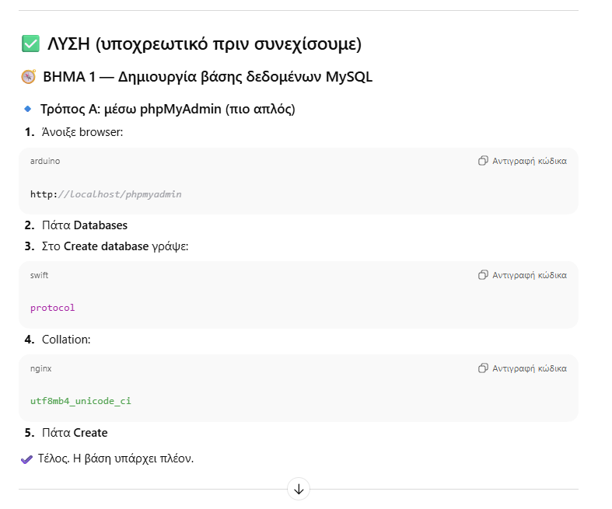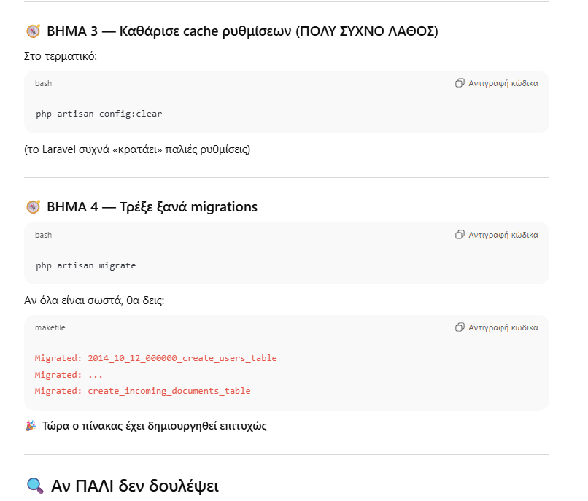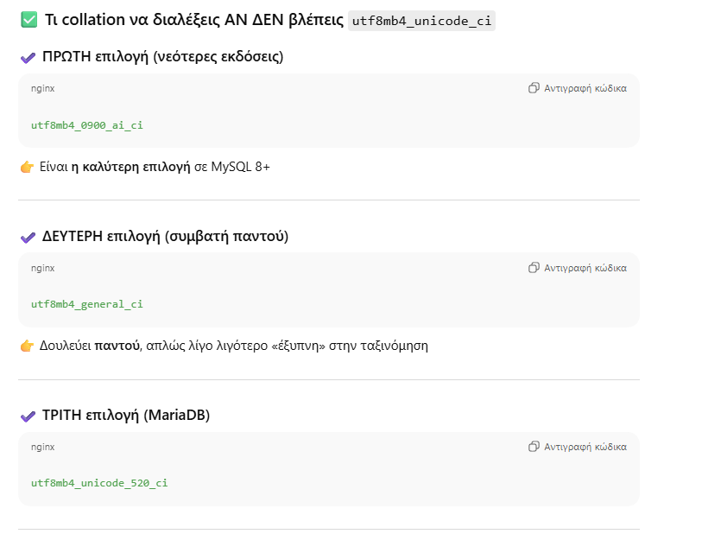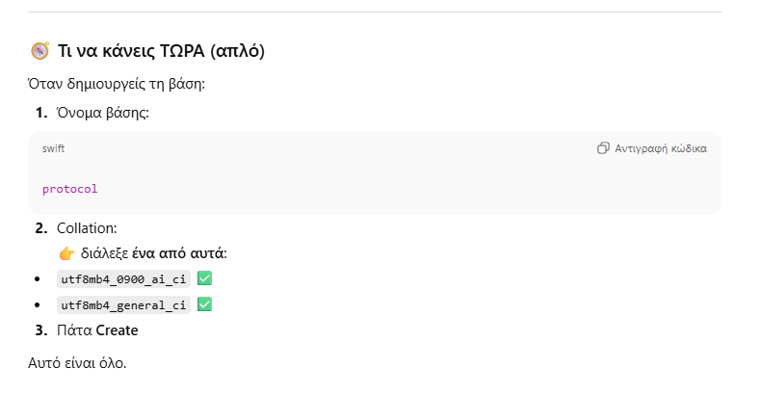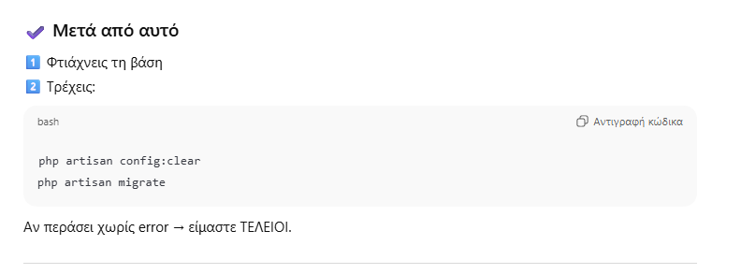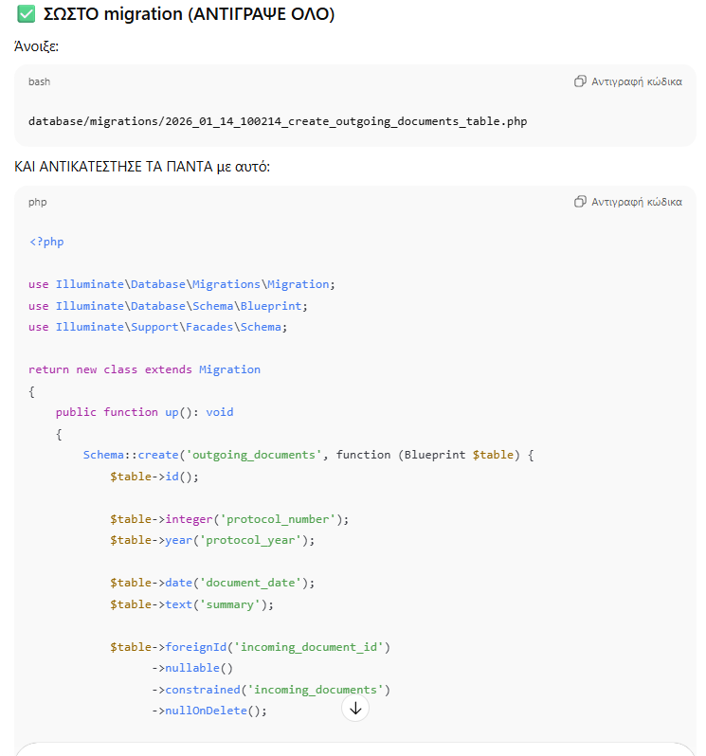

<?php

use Illuminate\Database\Migrations\Migration;
use Illuminate\Database\Schema\Blueprint;
use Illuminate\Support\Facades\Schema;

return new class extends Migration
{
/**
* Run the migrations.
*/
public function up(): void
{
Schema::create('outgoing_documents', function (Blueprint $table) {
$table->id();

$table->integer('protocol_number');
$table->year('protocol_year');

$table->date('document_date');
$table->text('summary');

$table->foreignId('incoming_document_id')
->nullable()
->constrained()
->nullOnDelete();

$table->string('file_path')->nullable();
$table->text('notes')->nullable();

$table->foreignId('user_id')->constrained()->onDelete('cascade');

$table->timestamps();

$table->unique(['protocol_number', 'protocol_year']);
}); // ← ΜΟΝΟ ΕΝΑ ΤΕΛΕΙΩΜΑ
}

/**
* Reverse the migrations.
*/
public function down(): void
{
Schema::dropIfExists('outgoing_documents');
}
};
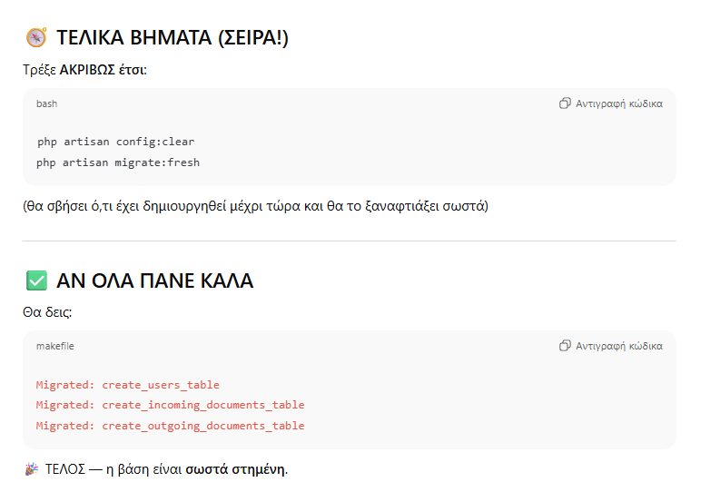
php artisan config:clear
php artisan migrate:fresh

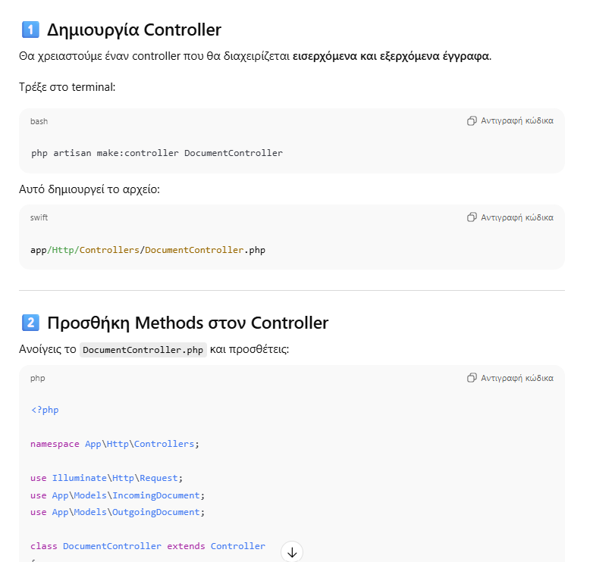
<?php

namespace App\Http\Controllers;

use Illuminate\Http\Request;
use App\Models\IncomingDocument;
use App\Models\OutgoingDocument;

class DocumentController extends Controller
{
public function createIncoming()
{
return view('documents.create_incoming');
}

public function storeIncoming(Request $request)
{
$data = $request->validate([
'protocol_number' => 'required|integer',
'protocol_year' => 'required|digits:4',
'document_date' => 'required|date',
'summary' => 'required|string',
'incoming_document_id' => 'nullable|exists:incoming_documents,id',
'file_path' => 'nullable|string',
'notes' => 'nullable|string',
'user_id' => 'required|integer',
]);

IncomingDocument::create($data);

return redirect()->back()->with('success', 'Εισερχόμενο έγγραφο αποθηκεύτηκε!');
}

public function createOutgoing()
{
return view('documents.create_outgoing');
}

public function storeOutgoing(Request $request)
{
$data = $request->validate([
'protocol_number' => 'required|integer',
'protocol_year' => 'required|digits:4',
'document_date' => 'required|date',
'summary' => 'required|string',
'incoming_document_id' => 'nullable|exists:incoming_documents,id',
'file_path' => 'nullable|string',
'notes' => 'nullable|string',
'user_id' => 'required|integer',
]);

OutgoingDocument::create($data);

return redirect()->back()->with('success', 'Εξερχόμενο έγγραφο αποθηκεύτηκε!');
}
}

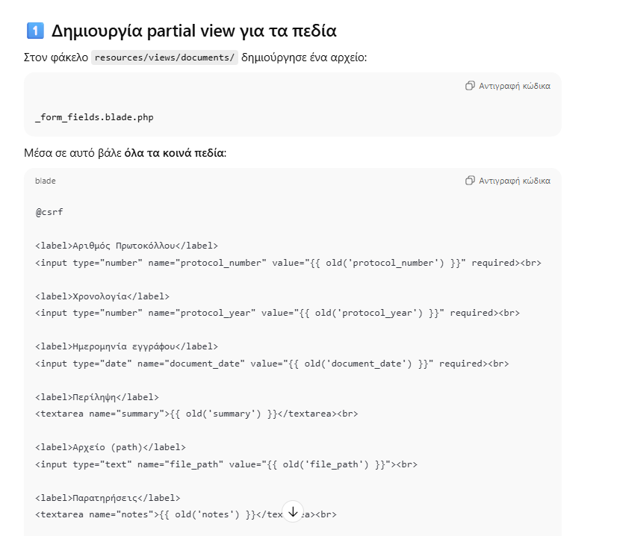

@csrf

<label>Αριθμός Πρωτοκόλλου</label>
<input type="number" name="protocol_number" value="{{ old('protocol_number') }}" required><br>

<label>Χρονολογία</label>
<input type="number" name="protocol_year" value="{{ old('protocol_year') }}" required><br>

<label>Ημερομηνία εγγράφου</label>
<input type="date" name="document_date" value="{{ old('document_date') }}" required><br>

<label>Περίληψη</label>
<textarea name="summary">{{ old('summary') }}</textarea><br>

<label>Αρχείο (path)</label>
<input type="text" name="file_path" value="{{ old('file_path') }}"><br>

<label>Παρατηρήσεις</label>
<textarea name="notes">{{ old('notes') }}</textarea><br>

<input type="hidden" name="user_id" value="1">

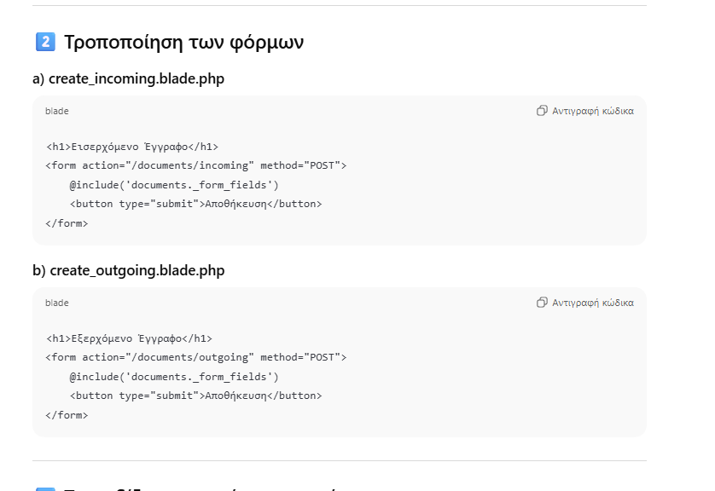

<h1>Εισερχόμενο Έγγραφο</h1>
<form action="/documents/incoming" method="POST">
@include('documents._form_fields')
<button type="submit">Αποθήκευση</button>
</form>

<h1>Εξερχόμενο Έγγραφο</h1>
<form action="/documents/outgoing" method="POST">
@include('documents._form_fields')
<button type="submit">Αποθήκευση</button>
</form>

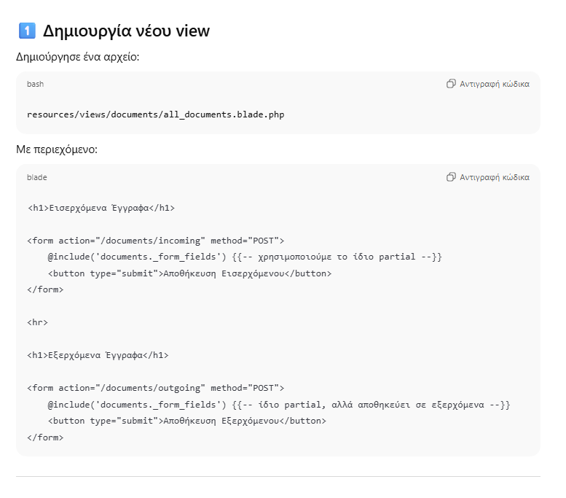

<h1>Εισερχόμενα Έγγραφα</h1>

<form action="/documents/incoming" method="POST">
@include('documents._form_fields') {{-- χρησιμοποιούμε το ίδιο partial --}}
<button type="submit">Αποθήκευση Εισερχόμενου</button>
</form>

<hr>

<h1>Εξερχόμενα Έγγραφα</h1>

<form action="/documents/outgoing" method="POST">
@include('documents._form_fields') {{-- ίδιο partial, αλλά αποθηκεύει σε εξερχόμενα --}}
<button type="submit">Αποθήκευση Εξερχόμενου</button>
</form>

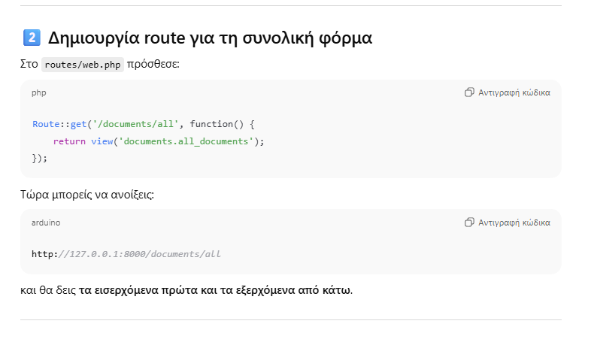
Route::get('/documents/all', function() {
return view('documents.all_documents');
});

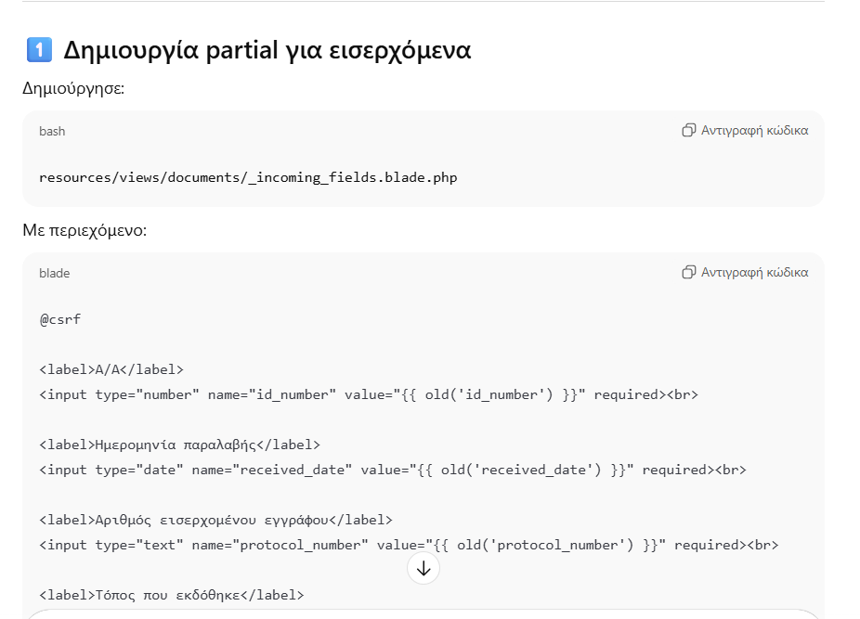
@csrf

<label>Α/Α</label>
<input type="number" name="id_number" value="{{ old('id_number') }}" required><br>

<label>Ημερομηνία παραλαβής</label>
<input type="date" name="received_date" value="{{ old('received_date') }}" required><br>

<label>Αριθμός εισερχομένου εγγράφου</label>
<input type="text" name="protocol_number" value="{{ old('protocol_number') }}" required><br>

<label>Τόπος που εκδόθηκε</label>
<input type="text" name="place_issued" value="{{ old('place_issued') }}"><br>

<label>Αρχή που το έχει εκδόσει</label>
<input type="text" name="issuing_authority" value="{{ old('issuing_authority') }}"><br>

<label>Χρονολογία εγγράφου</label>
<input type="number" name="document_year" value="{{ old('document_year') }}" required><br>

<label>Περίληψη</label>
<textarea name="summary">{{ old('summary') }}</textarea><br>

<label>Φάκελος αρχείου</label>
<input type="text" name="file_folder" value="{{ old('file_folder') }}"><br>

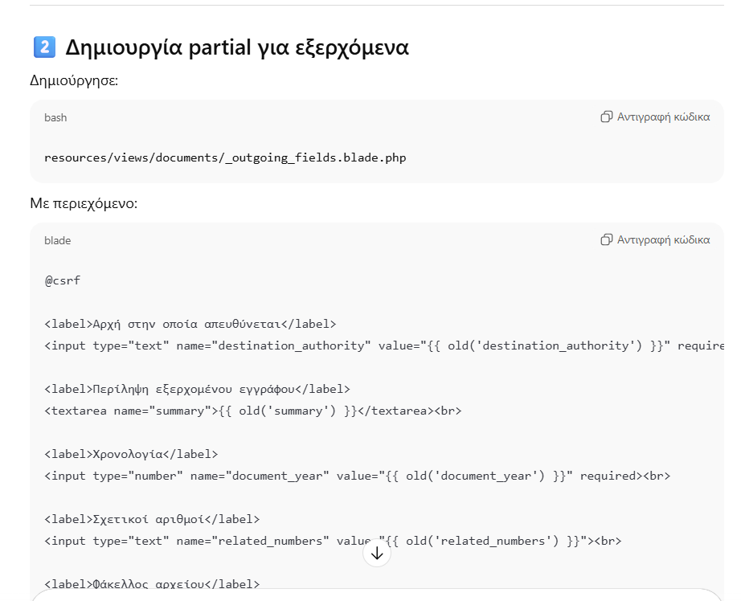

@csrf

<label>Α/Α</label>
<input type="number" name="id_number" value="{{ old('id_number') }}" required><br>

<label>Αρχή στην οποία απευθύνεται</label>
<input type="text" name="destination_authority" value="{{ old('destination_authority') }}" required><br>

<label>Περίληψη εξερχομένου εγγράφου</label>
<textarea name="summary">{{ old('summary') }}</textarea><br>

<label>Χρονολογία</label>
<input type="number" name="document_year" value="{{ old('document_year') }}" required><br>

<label>Σχετικοί αριθμοί</label>
<input type="text" name="related_numbers" value="{{ old('related_numbers') }}"><br>

<label>Φάκελος αρχείου</label>
<input type="text" name="file_folder" value="{{ old('file_folder') }}"><br>

<label>Παρατηρήσεις</label>
<textarea name="notes">{{ old('notes') }}</textarea><br>

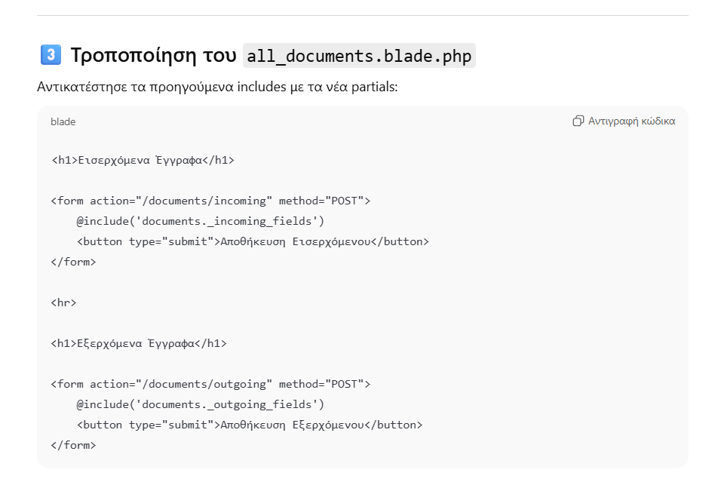<h1>Εισερχόμενα Έγγραφα</h1>

<form action="/documents/incoming" method="POST">
@include('documents._incoming_fields')
<button type="submit">Αποθήκευση Εισερχόμενου</button>
</form>

<hr>

<h1>Εξερχόμενα Έγγραφα</h1>

<form action="/documents/outgoing" method="POST">
@include('documents._outgoing_fields')
<button type="submit">Αποθήκευση Εξερχόμενου</button>
</form>

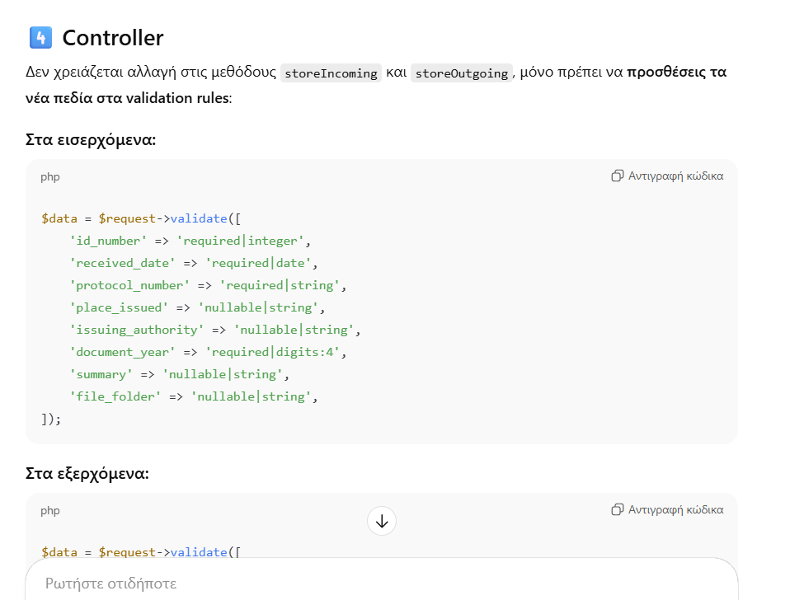 $data = $request->validate([
'id_number' => 'required|integer',
'received_date' => 'required|date',
'protocol_number' => 'required|string',
'place_issued' => 'nullable|string',
'issuing_authority' => 'nullable|string',
'document_year' => 'required|digits:4',
'summary' => 'nullable|string',
'file_folder' => 'nullable|string',
]);

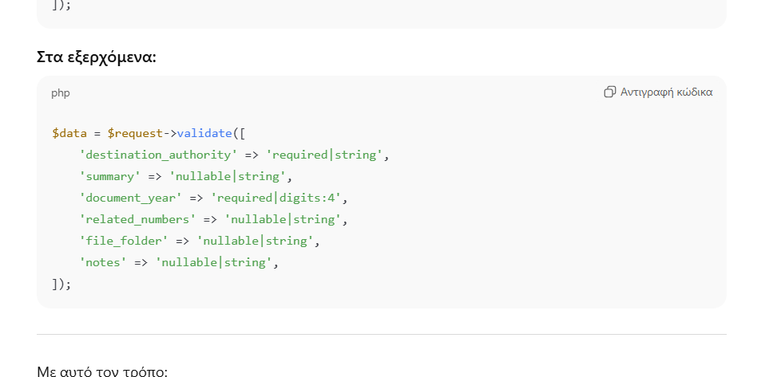$data = $request->validate([
'destination_authority' => 'required|string',
'summary' => 'nullable|string',
'document_year' => 'required|digits:4',
'related_numbers' => 'nullable|string',
'file_folder' => 'nullable|string',
'notes' => 'nullable|string',
]);

