**Project : Web datamining & semantics**

GROUP: Adèle MONTOYA, Paul RUNAVOT, Eleonor KIOULOU

The Semantic Web project is a large and long practical exercise that consists in integrating all the pieces that have been seen during the first sessions into a consolidated application.

**Main objectives**

* **Design a movie application** that follows the Linked Data principles: the application should be represented in a standard vocabulary that any application can process. As a starting point, movie instances should be described as instances of [schema:Movie](https://schema.org/Movie" \t "_blank). [Schema.org for Developers](https://schema.org/docs/developers.html)
* Schema.org en [schemaorg.owl](https://devinci-online.brightspace.com/d2l/common/dialogs/quickLink/quickLink.d2l?ou=90045&type=coursefile&fileId=schemaorg.owl" \t "_blank)
* Develop an application to create, query and validate calendar events.

**Pedagogical objectives**

* Do a little software development, using Semantic Web programming frameworks
* Setup and interact with an RDF database
* Exploit multiple sources of heterogeneous data
* Present information online with rich metadata

**Part I: Modeling the ontology**

In this part, we aim to create an ontology, using the Protégé editor, which models movies.

A movie has one or several directors, writers and actors. It also has a title, one or several genres, a year, a country and a language. Actors, directors and writers are persons. Persons have a gender (male or female), a name, an age and a nationality. Movies are scheduled in theaters that have locations.

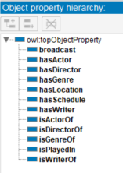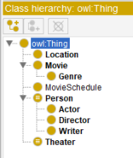Classes : Object properties Data properties

Domains and range :

**Part II: Populating the ontology**

Create some individuals to the Movie class such as:

* Une image contenant texte

  Description générée automatiquementPulp Fiction, Genre: Crime Thriller, 1994, USA, English :

Create some individuals to the Person class such as:

* Une image contenant texte

  Description générée automatiquementQuentin Tarantino, American, 53 years old, writer and director of Pulp Fiction and Kill Bill (volume1). He also played a role in that movie :

Create some individuals to the different classes: actors, theater locations,  etc :

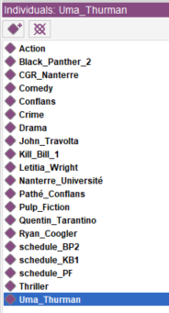

**Part III: Querying the ontology**

1. List the instances of the class Actor

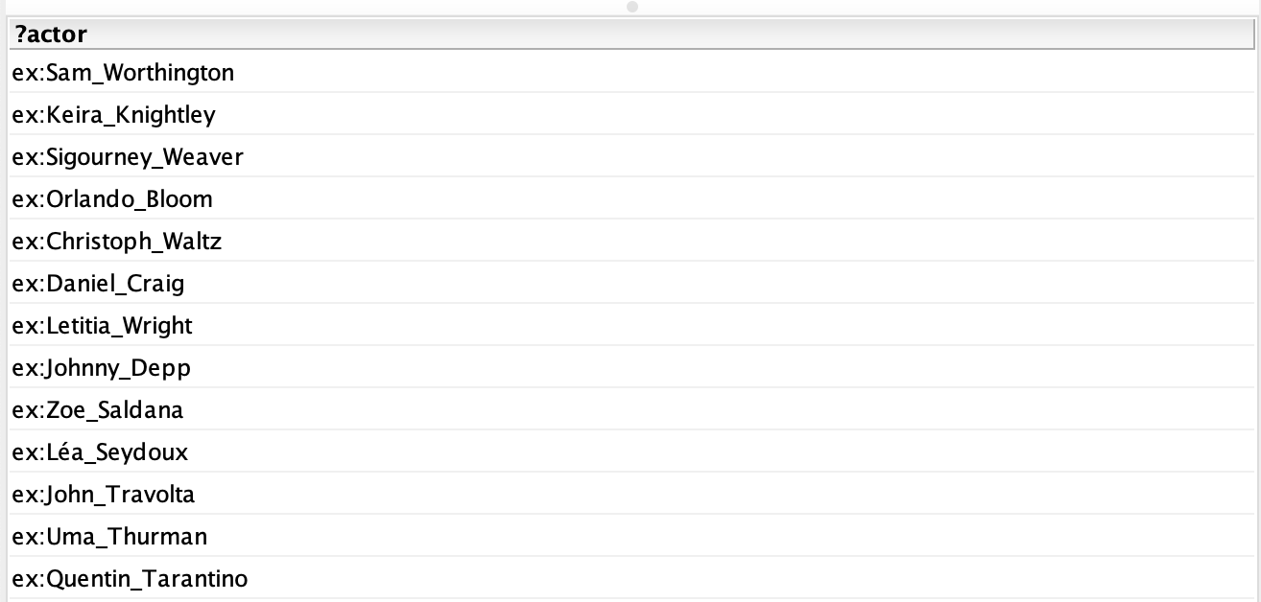

1. List the name of all Thriller movies. For each one, display its director.

1. List the name of all Crime Thriller movies.



1. List the name of Actors older than 51 years.



1. List of movies that are played in theater for a specific day and where and until when

1. A query that contains at least 2 Optional Graph Patterns :

1. A query that contains at least 2 alternatives and conjunctions

This query retrieves the title and year of release of the films that have a genre "Action" or "Thriller" and were directed by "Ryan Coogler". The query uses a filter to retrieve movies released between 2000 and 2009 or after 2015. The two alternatives are combined in a conjunction to recover films that have a kind of action or thriller. The second conjunction is used to retrieve the films that were made by "Ryan Coogler".



1. A query that contains a CONSTRUCT query form

This query builds an RDF graph to represent movies and actors and establishes relationships between them using specific properties defined in the user-specified ontology.

1. A query that contains an ASK query form

1. A query that contains a DESCRIBE query form

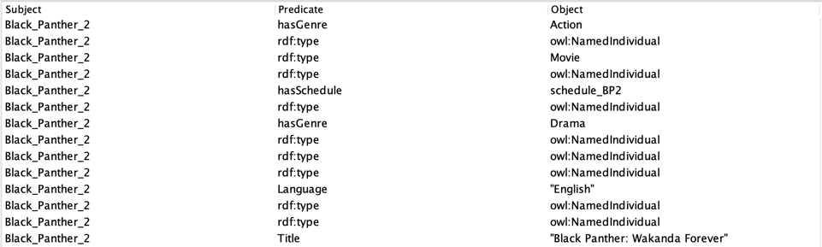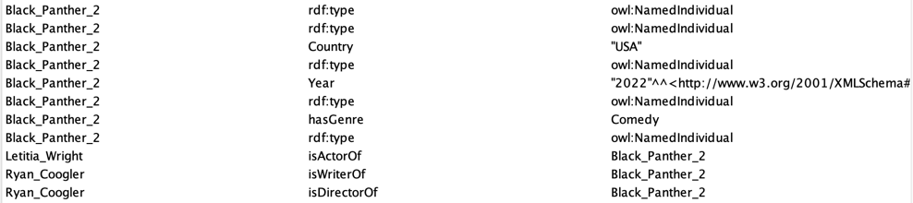

**Part IV: Manipulating the ontology using Jena**

Using Jena develop the following functionalities that:

1. Loads the ontology and displays all the Persons (without usingqueries, without inference).
2. Loads the ontology and displays all the Persons (using a query, without inference). Create the used query in text file under the data folder.
3. Loads the ontology and displays all the Actors (without using queries, using inference).
4. Develops a program that :
   1. Reads a name of a movie
   2. If it doesn’t exist displays an error message
   3. Else, display its year, country, genres and actors
   4. Display their program where and when
5. Displays all persons that are actors and directors. Do this using a rule that defines a new class ActorDirector. The rule file must be saved in the data folder.
6. Specifies 3 different rules and implement them in a java program