**The program`s purpose**

Program`s purpose is to translate user interface on different languages.

**How to use program**

When you open a program you see 8 buttons, each of them responsible for a different language. You can see it for flag color or when you put cursor on the button.

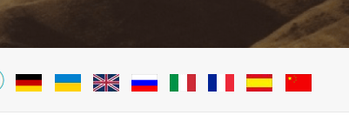When you click on the button your interface will be changed.