FS_Tool v0.6.0

This is the bare essentials doco for the joystick mapping functionality built into this version of FS_Tool, with specific reference to the Honeycomb Bravo throttle configuration included with the release.

The app has a Windows task bar tray icon and is controlled by a right-click context menu from this icon.

Note that joystick mapping can only occur when the app is running and the “Enable SimConnect” and “Enable Joystick Mappings” menu options are ticked.
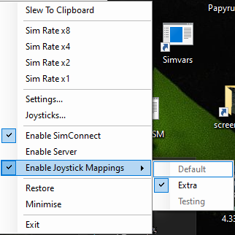

To enable a joystick profile select its name in the “Enable Joystick Mappings” sub-menu. To enable a different profile you first must select the current profile to un-tick it, and then select the new profile you wish to activate.

The app will remember the last profile in use and will reload this profile when restarted.

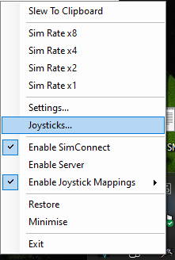

The “Joysticks…” menu option will open a joystick diagnostic window which will allow you to examine the HID events reported by the system for the selected joystick. You cannot close the window or select a different joystick until you close the currently selected Joystick by clicking the “Close” button.

The HID event names reported in this window are what is required in the XML configuration file which details the mappings for each joystick. You can set up your own custom mappings by editing this file using any text editor. The file is called JoystickMappings.xml and must be in the same folder as the application executable file.

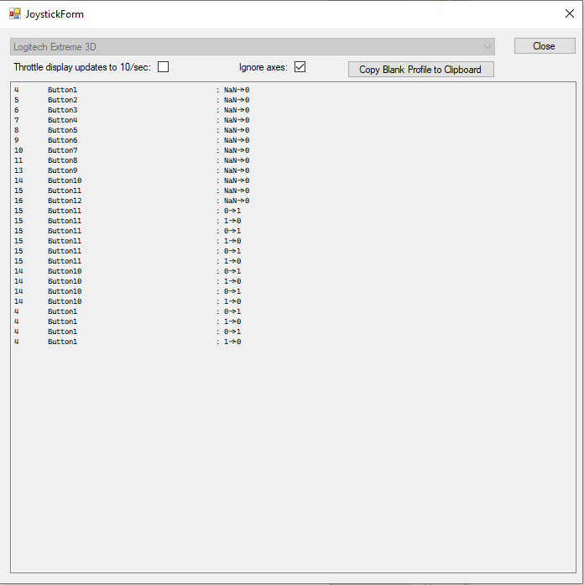

There are two profiles provided for the Bravo, Default and Extra.

Default is a simple configuration that simply maps all the Toggle Switches, the rotary 5-way switch and the Gear Lever to SimConnect events. This will stop the 10deg and 1000ft bug but won’t provide any additional functionality.
To use this profile you need to remove all the in-game mappings for the rocker switches, the rotary 5-way switch, the Gear Lever and the INC/DEC knob. Failure to do this will not fix the bug and may provide unpredictable behaviour.

The following toggle switch mappings are made in the Default profile.
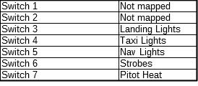

Extra is a complex configuration that does all the above as well as a lot more besides.
This configuration utilises the two left hand toggle switches as a combined mode selector providing four different modes of operation.

N.B. The Extra profile requires that the MobiFlight WASM module is installed to the Community folder and running correctly and none of this extra funcionality will be available without it. Instructions for getting and running this module can be found at this link https://pastebin.com/fMdB7at2.

To use this profile you need to remove all the in-game mappings for the rocker switches, the rotary 5-way switch, the Gear Lever, all the push buttons and the INC/DEC knob. Failure to do this will not fix the bug and may provide unpredictable behaviour.

With release 0.6.0 this profile controls both the G-1000 and GNS 530/GNS 430 at the same time. That is events for each GPS unit are sent for each joystick event. This is possible because the sim will simply ignore any events for units that are not installed in the current aircraft.

Mode one is both switches off (down). This mode provides the same AP mapping as the default configuration.

Mode two is left switch on (up) and right switch off (down). This mode changes the function of the rotary switch and push buttons to adjust the PFD NAV and COM radio controls.

Mode three is left switch off (down) and right switch on (up). This mode lets the rotary switch and push buttons adjust the G1000 PFD controls.

Mode four is left switch on (up) and right switch on (up). This mode lets the rotary switch and push buttons adjust the G1000 MFD controls.

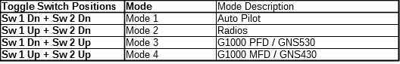

The details for each of these modes are in the following tables.

These tables show which in sim rotary knobs are affected by the Bravo INC/DEC knob.
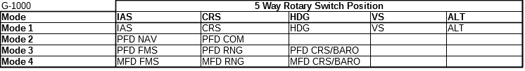
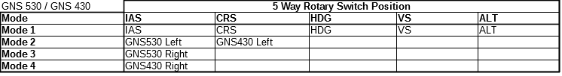
Note that whenever one of the Sim Dual-Concentric knobs is being adjusted then it is the small inner knob that receives the events. To adjust the large outer knob you need to hold the flaps lever up while turning the INC/DEC knob.
You need to be aware that this will also send the real flaps up event so be careful when you have modes 2, 3 or 4 selected and only use these modes when you don’t need the flaps extended.

There is an acceleration function built in to the SimConnect code that is utilised by both profiles.
When adjusting the ALT, HDG and CRS the number of pulses sent to the sim varies depending on how fast the INC/DEC knob is turned. If the knob is turned slowly then the normal 1 pulse is sent to the sim for each click of the knob. If the knob is turned fast enough then 10 pulses are sent to the sim for each click of the knob.
This allows a rough value to be quickly dialed in before fine tuning to the desired value.

These tables shows which in sim buttons are clicked when one of the Bravo push buttons is pressed.

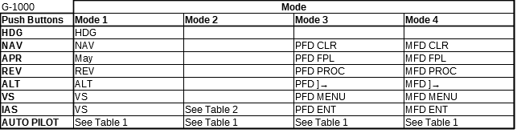

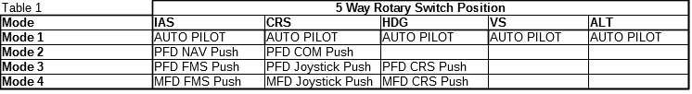
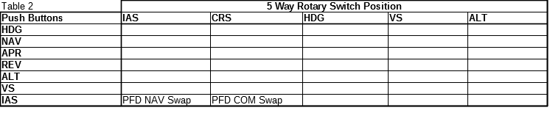
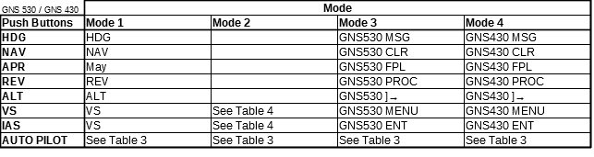

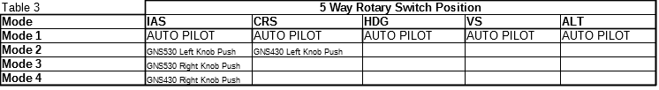
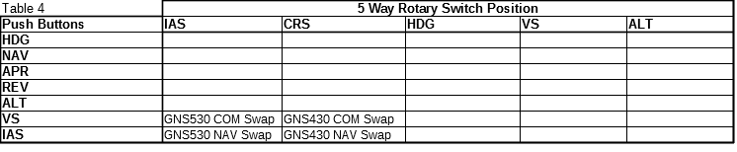
Note that in modes 3 and 4 if you quickly press the CLR button then you will get a normal CLR event but if you press the CLR button for longer than .5s then you will get the Long CLR event which has the same effect as holding down the CLR button in the sim.

The following toggle switch mappings are made.
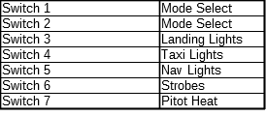

Notes on the format of the JoystickMappings.xml file.

The file is mostly self explanatory however the following points may be of use.

There is no limit to how many joystick maps or profiles may be configured however each <Profile> “Name” must be unique and each <<Joystick> “MappingName” must be unique.

Each joystick device can have multiple mapping configurations.

The <Joystick> “Name” attribute must exactly match the device name as reported by the Joystick diagnostic window.

Each joystick map consists of one or more <JoyMap> elements and descriptions of the attributes possible in these elements is as follows:

JoyEvent="" This is the name of the HID event as reported by the diagnostic window. It must be an exact match. This will usually be of the form ButtonNN but may be something else.
JoyEnableEvents="" This is a comma separated list of joystick events that must be true in order for this map to be active.
LongPushSimEvent="" regergoriwifrweiopwiro iw euruwe rweru wf whf wfh wef hwehf wfehiwfhiwfhiwfhiw fhiwfhiwfhiuwhefiuhwiefhwihiwhfiwfe

SimEvent="" SimVar="" ActiveState="True"

If there are several maps that match a particular combination of buttons then the one with the highest number of JoyEnableEvents will take priority. This allows for combinations such as event1 for Button1, event2 for Button1+Button2, event3 for Button1+Button2+Button3 etc.

