CS 325 – Winter 2015

Project 3

Problem 1: Transshipment Model

**Part A: Determine the number of refrigerators to be shipped plants to warehouses and then warehouses to retailers to minimize the cost.**

1. **Formulate the problem as a linear program with an objective function and all constraints.**
2. **Determine the optimal solution for the linear program using any software you want. Include a copy of the code/file in the report.**
3. **What are the optimal shipping routes and minimum cost?**

The minimum cost is $17,100.

The optimal shipping routes are sending 150 units from Plant 1 to Warehouse 1, 200 from Plant 2 to Warehouse 1, 250 units from Plant 2 to Warehouse 2, 150 from Plant 3 to Warehouse 2, 100 from Plant 3 to Warehouse 3, and 150 from Plant 4 to Warehouse 3.

From there, we send 100 from W1 to Retailer 1, 150 from W1 to R2, 100 from W1 to R3, from W2 200 each to R4 and R5, and from W3 150 units to R6 and 100 to R7.

Since the MIN equation is cut off, it looks like this:

MIN 10 P11 + 15 P12 + 11 P21 + 8 P22 + 13 P31 + 8 P32 + 9 P33 + 14 P42 + 8 P43 + 5 W11 + 6 W12 + 7 W13 + 10 W14 + 12 W23 + 8 W24 + 10 W25 + 14 W26 + 14 W34 + 12 W35 + 12 W36 + 6 W37

This is the LINDO set I used:

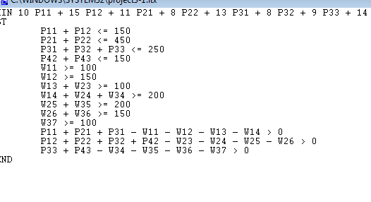

And these are the results I got from LINDO:

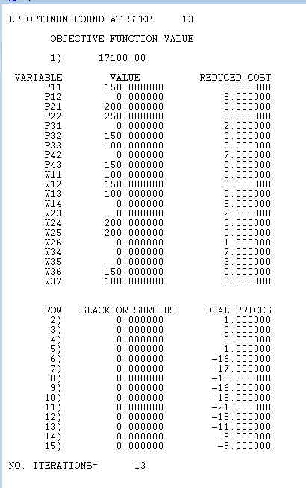

**Part B: Due to old infrastructure Warehouse 2 is going to close eliminating all of the associated routes. What is the optimal solution for this modified model? Is it feasible to ship all the refrigerators to either warehouse 1 or 3 and then to the retailers without using warehouse 2? Why or why not?**

Using the following LINDO inputs we got the result that this is not feasible:

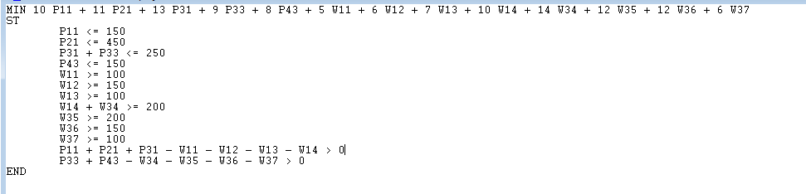

This is not feasible:

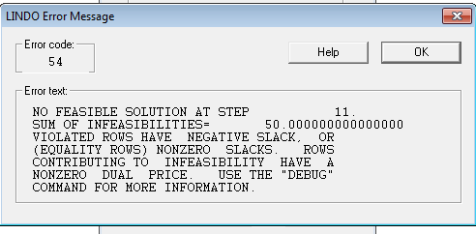

**Part C: Instead of closing Warehouse 2 management has decided to keep a portion of it open but limit shipments to 100 refrigerators per week. Is this feasible? If so what is the optimal solution when warehouse 2 is limited to 100 refrigerators?**

This solution is feasible however, not optimal.

The minimum cost in this solution is $18,300.

The routes are as follows: Plant 1 sends 150 units to W1. Plant 2 sends 350 units to W1 and 100 units to W2. Plant 3 sends 250 units to W3, and Plant 4 sends 150 units to Plant 3.

From there, W1 sends 100 units to R1, 150 to R2, 100 to R3, and 150 to R4. W2 sends 50 units to R4 and 50 to R5. W3 sends 150 units to R5, 150 to R6, and 100 to R7.

Below are the LINDO inputs I used:

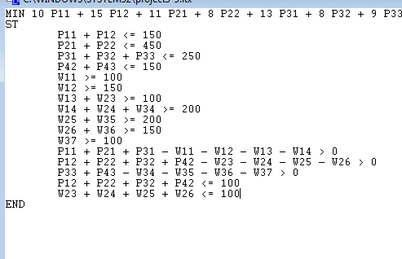

And the output:

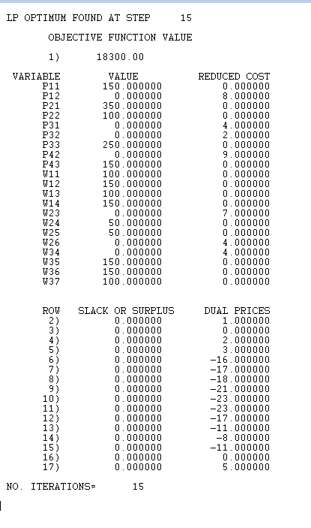

**Part D: Formulate a generalized linear programming model for the transshipment problem. Give the objective function and constraints as mathematical formulas.**