

**Solar Populace of Acquisition, Colonization, and Exploration**

Greetings Commander! Welcome to the S.P.A.C.E. It is my understanding the Supreme Leader of Earth has selected you, out of many candidates to lead our very first mission into the unknown universe that our explorer ships have detected. We have highlighted using a red laser barrier for you to explore and colonize, and acquire resources. Your goal is, at twenty minutes to colonize at least three planets, and achieve a lunar city on each of those planets, you will also need to acquire 110,000 resources in your bank. Be careful! Planets only have a limited amount of resources, and tampering with them as we are, shortens the planets lifespan, all planets, like Earth, will eventually decay into nothing. Do not fail; the human race’s continued evolution depends on your success!! Good luck.  
  
  
  
  
  
  
Loading the Game

* Make sure you unzip the spaceGame folder, into the folder of the same name in your desired location.
* Open the runPlanet folder, and launch the runPlanet.pde file through Processing.
  + This was built in Processing v2.0b7, and is designed to run on that platform, The Developers do not guarantee proper execution on any other version of processing.
* Run the runPlanet class.

Controls

* *Title Screen*
  + **Spacebar**: Pressing the spacebar at any time during the title screen will cause the title sequence to end, and the game to start.
* *Game World*
  + **Mouse to edge of window:** moves the camera towards the mouse location
* *Colonized Planets*
  + **Right Click**: Brings up the menu(see Display: Planet Menu)
  + **Left Click**:(While menu is open) purchase upgrade/ship
* *Ships*
  + **Click and Drag:** Selection tool
    - Selects multiple units, will overlap these units as endpoints, looking like one disappears, units will still function properly.
  + **Left Click:** Select Ship (will highlight the ship)
  + **Right Click:** move ship to desired location. (If ship is settler and location is on planet) Colonize Planet.

The Game

*Ships*

* + Explorer Ship, used to remove the Unknown Parts of the Universe

* + Settler Ship, used to colonize Planets that are located

*Planets*



From Right to Left: Large, medium, and small planets. These planets change their surface look, and will have different types of cities on them as you increase the city level on the planet. The planet will also disappear completely if the decay reached 100% Beware.

*The HUD*

**Time Bar partly visible planet Ships Resource bar**

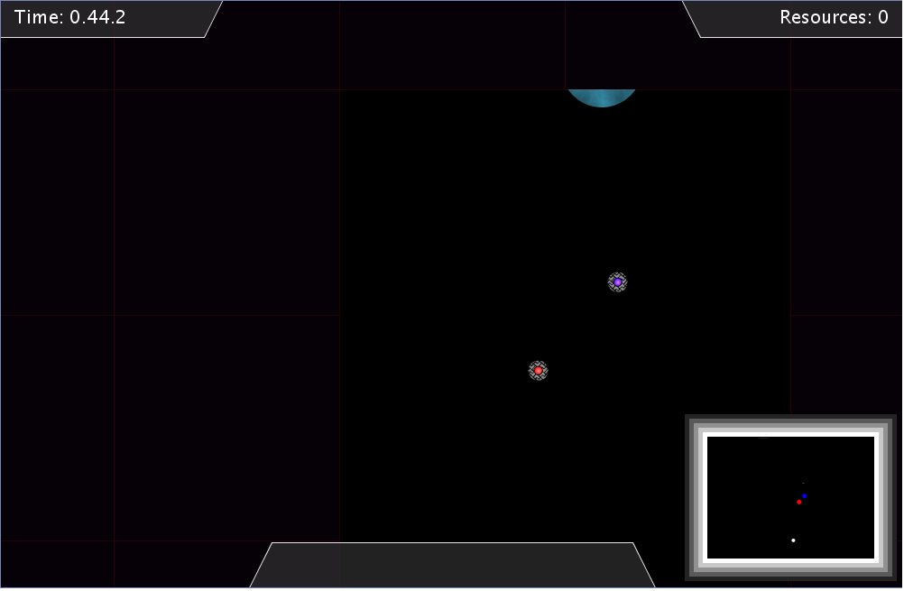

**Unknown Universe Event bar MiniMap**

* **Time Bar**: This shows the time displayed in Minutes.seconds.miliseconds
* **Partly Visible Planet**:This is a planet that has been partly seen by the explorer ship; you can colonize it, and make it completely visible by sending your ships over to it.
* **Resource bar**: This is where your resources accumulated are displayed.
* **Unknown Universe:** The parts of the map that are dark purple, they have not been explored yet, and you must use the explorer ship to remove them.
* **Event Bar**: messages are displayed on this event bar when a natural disaster hits one of your planets
* **MiniMap:** The minimap displays discovered planets(in white circles), settlers ships(in red) and explorer ships (in blue).

Suggested Tips

* S.P.A.C.E. was to be designed as a completely optional, unique expansion and colonization game, as such there are many ways of playing it.
* The easiest way to start is to send your explorer ship upward, as there are 2 small planets, and a large planet on a general line up to the edge of the field.
* Send your settler ship to the nearest planet to start accumulating resources right away.
* Work to recruit another settler ship and send it upwards destined for the large planet, this will be your “main planet”. Now send your explorer ship from the large planet, to the right, coming across a medium planet.
* You should now have found at least 4 planets.
* A good strategy is to increase the large planet city and research by one, before colonizing another planet.
* Upgrade the defenses of the large planet to level one or two, in case of disaster, you will lose less resources
* Another strategy is to leave the two small planets at base starting levels while focusing on upgrading your large first then your medium. This is so you can maximize your money on the higher producing planets.
* These are only tips and suggestions! The game is meant to be played anyway (rushing resources ignoring research rate) making a full home base by upgrading everything.

Test Reports

* This is a summary of what play testers communicated with us while playing our game.

*Playtest 1*

* **Fun and interesting**: a lot expressed their fan of strategy games, and the idea of populating planets was a great concept for a game.
* **Easy to get lost**: Players requested a mini-map to be able to better manage where they were in the game.
* **More to do/more depth**: During the initial build, Decay rate and Unknown universe/explorer ships were omitted from the test.

*Playtest 2*

* **Incredible**: multiple players stated that the game was one of the most polished and fun games they got to play.
* **More to do**: players thoroughly enjoyed using the explorer ship as it gave them something to focus on while waiting for resources.
* **Little easy**: Players expressed that the decay rate penalty was a little low, and they were never worried about losing a planet.

Implementation and Design Notes

* **Fog and Explorer ships**: The fog is just blanketed across the whole screen at the beginning, and the explorer ships are placed at starting location, the game then checks the location of the explorer ship, and if they are within range of the Fog, the fog is turned off, every time the loop is called (60times a second) the game checks whether the ship is within range of fog, and acts accordingly.
* **Natural Disasters**: Natural Disasters are called every 400 loops of the game, and are sent a random number from 1-8, there is a 25% chance of a natural disaster, 1/8th chance of asteroid, and 1/8th chance of a quake.
* **Decay Rate:** Decay rate is ticked every 450 loops of the game. All planets start at 0, and upon colonization increase by 1 every 450 loops, once the decay is at 100, the planet disappears.
* **City Upgrades:** City upgrades increase the amount of resources collected, and the decay rate tick speed, meaning the decay rate goes up faster.
* **Research:** improving research makes the decay rate tick slower, which means slower increase of decay.
* **Defenses:** Defenses decrease the amount of resources removed from Natural disasters.

Developer Reflection

*Extremely Satisfied with*

* **The in game visuals**: The ships, HUD, planets, planet menus and upgrades all look incredible and go along with our space theme.
* **Real time** resource rate was a great success over a turn based option, and we are happy with how that turned out.
* **The amount of exploratio**n: with the addition of the Unknown Universe(FOG) and explorer ships, it added a decent amount of exploration, and replay-ability to the game, if you explored up before, next game explore down.
* **Different Build Option**: The ability to focus on a couple of main planets, expand rapidly, use planets and ditch them, or keep them forever, so far feedback has shown that all these options work, and we are very pleased about how many options of carrying out the task there are for the player.

*Satisfied with*

* **Decay Mechanic**: The Decay mechanic idea is something we are very happy with! And the usage/manipulation of it inside the game, and how the player interacts with the decay rate is more then we could have hoped for, and many players seemed very excited by this idea, however the decay rate was finalized and implemented very late into the development cycle and the specific balance numbers may not be perfect, and may need to be changed (decay rate to hard or easy for players? Ticks increase too much? Not an issue?).

Further updates/improvements

If we were given more time on this project, further improvements and features would be built on top of the core feature we have now.

* Audio added to the main game itself(ran out of time to manage a suitable audio for the space theme we were going for)
* Statistics displayed to players, let the players see lists of stats for all their planets in one window, vs individual planets.
* Improvement on natural disasters: make further distinctions between asteroids and quakes(do different things instead of just take away resources)
* Further communication with the event bar (communicate when planets reach certain decay rate, etc.)

Bug Report

* Slight visual bug making the edges of large planets visual sometimes on the minimap (when moving the camera)

External Credits

Title Screen Ambiance: http://freesound.org

Audio code from: <http://code.compartmental.net/tools/minim/>

Internal Credits

Nick Chaisson: Creation and implementation of all in-game artwork (HUD, menu, ships, planets, minimap etc.) Contribution: 42%

Luke Harper: Programming of Game Mechanics, Game Architecture, algorithms, story and creative design, audio implementation, documentation. Contribution: 48%

Jacob Dyck: Story and Creative elements, audio voice recording, Unknown Universe implementation. Contribution: 10%