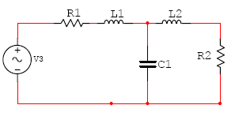
X3 => C*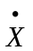3 = i
L1*1 = VL1

X1 = C*3 + X2 => C*3 = X1 –X2

U = R1*X1 – L1*1 – X3 = 0
L1*1 = U – R1X1 – X3
VL1 = U – R1X1 – X3

c)Mudar de Base

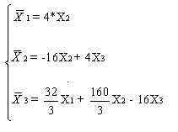
Logo,

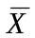= 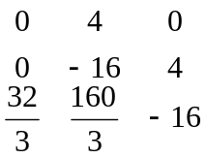

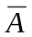 = QAQ
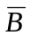 = QB
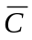 = CQ
D = [0] = 0;

