RELATÓRIO DE LAB 06 – CONTROLABILIDADE

ALUNOS:

Felipe Augusto Mariano da Silva – 20610251.
Lucas Carvalho Leal – 250610253.
Marcelo Felipe Mazini dos Santos – 20610245.
Paulo Renato de Barros Mendonça – 20610024.

1º) a)
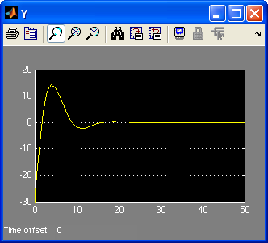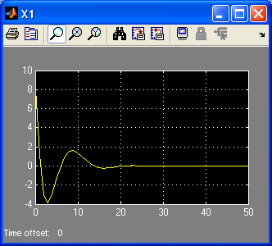

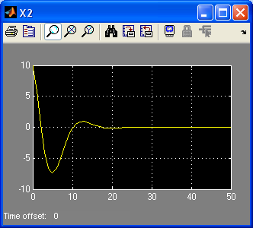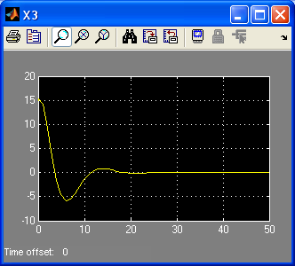

B)

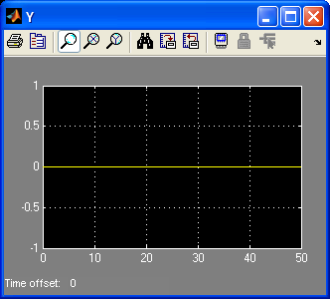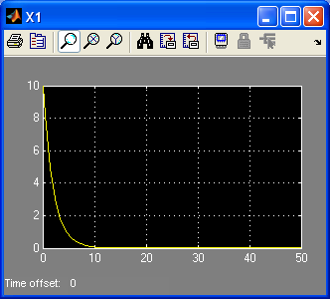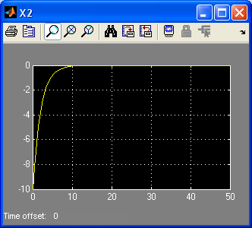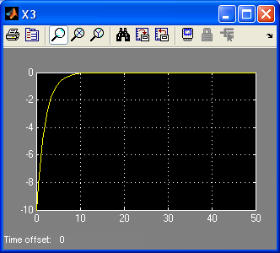

C)
T=OBSV(A,C)

T =

-1.5000 -1.5000 0
0.7500 -0.7500 1.5000
0 0.7500 -0.7500

>> RANK(T)

ans =

2

Comentário:

d) teta = [-1.5 -1.5 0; 0.75 -0.75 1.5]

teta =

-1.5000 -1.5000 0
0.7500 -0.7500 1.5000teta =

-1.5000 -1.5000 0
0.7500 -0.7500 1.5000

E)
F c obsv
Det[ΩI-A] = Ω³+Ω²+0,5Ω+0,125

Q = [ 1 0 0; 1 1 0;5 1 1]
Q1 = Q.Q*
Q1 = [-1,5 -1,5 0;-0,75 -2,25 1,5; 0 -0,75 0,75]
X/. = [-0,5 -0,433;0 0,5]X/ + [0,866;1]*u
Y = [0 0,75]x/ + [-1]u

G(s) = 1,5s³ + 0,755s² + 0,375s + 0,1875/s³+s2+0,5s+0,125

3)
a)
T = [C; C*A; C*(A^2)]

T =

[-1-k, -1-k, 0]

[-(-1-k)/RC*(2-k) + (-1-k)*k/RC, 2*(-1-k)*k/RC, -2*(-1-k)/RC]

[(-1-k)*(1/RC^2*(2-k)^2 + k^2/RC^2-1/2/RC^2*(1+k)) + (-1-k)*(-1/RC^2*(2-k)*k + k^2/RC^2-1/2/RC^2*( 1+k)), (-1-k)*(-1/RC^2*(2-k)*k+k^2/RC^2-1/2/RC^2*(1+k)) + (-1-k)*(2*k^2/RC^2-1/2/RC^2*(1+k)), (-1-k)*(1/RC^2*(2-k)-k/RC^2+1/RC^2)+(-1-k)*(-2*k/RC^2+1/RC^2)]

simplify (T)

ans =

[ -1-k, -1-k, 0]
[ -2/RC*(-1+k^2), -2*(1+k)*k/RC, 2/RC*(1+k)]
[ -(1+k)*(3-7*k+4*k^2)/RC^2, -(1+k)*(-3*k+4*k^2-1)/RC^2, 4/RC^2*(-1+k^2)]

b)
>> simplify (A2)

ans =

[ -1/RC, 0, 1/RC]
[ 0, 0, -2/RC]
[ 0, -1/2*(k-1)/RC, 2*(k-1)/RC]

>> simplify (B2)

ans =

(-2+k)/RC
-2*(k-1)/RC
2*(-2*k+k^2+1)/RC

>> simplify (C2)

ans =

[ 0, -1-k, 0]

>> simplify (D)

ans =

1+k

d)
>> poly (A2)

ans =

-(x*RC+1)*(-x^2*RC^2+2*x*RC*k-2*x*RC+k-1)/RC^3

4)

