ML-Based Student
Academic Performance
Prediction System
B. Vignesh Reddy and P. Karthik
T. Nishanth and H. Niranjan Reddy

Department of Computer Science and Engineering, KL University, Hyderabad, India.
Abstract
Purpose – This study describes a student academic performance prediction workflow intended to help educators identify learners who may need timely support. The project uses the UCI Student Performance mathematics records and frames prediction as a checkpoint-level classification task. The purpose is to connect a risk estimate with educator review while making the target, data limitations and scope of the application explicit.
Design/methodology/approach – The supplied working file contains 395 mathematics records. Final grade G3 is used only to define Good Performance (G3 ≥ 10) and At Risk (G3 < 10); it is excluded from model inputs. Eleven source attributes are transformed into 19 model columns, including grade history, absence, study-habit and support-related features. TabPFN is used for binary classification. The project materials describe stratified five-fold validation and a separate holdout evaluation. The supplied Flask code evidences individual predictions, probability-based risk scoring, a teacher dashboard and four what-if scenarios.
Findings – The project abstract reports holdout accuracy of 89.87%, precision of 82.14%, recall of 88.46% and F1-score of 85.19%. These values are reproduced as project-reported results and were not independently rerun for this paper. A separate archived cross-validation search file reports a selected TabPFN configuration with 16 estimators, at-risk F1 of 0.8673, accuracy of 0.9051, recall of 0.9423 and a 0.33 decision threshold. These are training-fold selection results and must not be merged with or treated as the abstract's holdout metrics.
Research limitations/implications – The study uses one small mathematics cohort and a project-defined binary threshold. G1 and G2 are predictors, so the tool operates only after those grade checkpoints rather than at the start of a term. Model evaluation, calibration, fairness and external validity require further verification. The project materials describe explanations and intervention recommendations, but their end-to-end implementation is not established by the supplied Flask code.
Practical implications – A probability-based risk score and dashboard can help staff prioritize records for human review. What-if changes show how the trained model responds to altered inputs, but they do not estimate the causal effects of tutoring, attendance support or other interventions. Predictions should be considered one source of evidence in a support conversation.
Originality/value – The work integrates a small-tabular-data classifier with a student risk score, educator dashboard and input-level scenario review. Its contribution is the project-specific workflow and transparent accounting of evidence, not a claim that TabPFN or any individual feature-engineering method is new.
Keywords Student academic performance, Educational data mining, TabPFN, At-risk prediction, Early warning, Risk scoring, What-if analysis
Paper type Research article
Funding: No external funding is identified in the supplied project materials.
Declaration of competing interest: The supplied project materials do not include a competing-interest statement.

1. Introduction
Student performance prediction is studied as a way to identify academic difficulty early enough for educators to respond. Historical grades, attendance and learner context can contain useful signals, but a prediction is only meaningful when its target and timing are defined. A model using end-of-term information cannot be described as an early warning at the beginning of the term, and a high aggregate score alone does not establish that a system improves student outcomes.
This paper describes an ML-Based Student Academic Performance Prediction System developed around the UCI Student Performance dataset introduced by Cortez and Silva [1]. The project uses the mathematics subset and derives a binary label from final grade G3: values of 10 or above are labeled Good Performance, and values below 10 are labeled At Risk. The supplied working file contains 395 records, 265 labeled Good Performance and 130 At Risk. G3 defines the label but is removed from the model inputs to avoid direct target leakage.
The implemented classification model is TabPFN, a transformer-based method designed for small tabular classification tasks [2]. The supplied transformation code begins with six numerical attributes—study time, absences, first-period grade G1, second-period grade G2, age and prior failures—and five categorical attributes—family educational support, internet access, sex, paid extra classes and extracurricular activities. Binary encodings and eight engineered variables yield 19 model columns. The engineered variables include grade average, grade trend, a grade gap, a weighted grade, study-to-absence ratio, a support sum, a failure/absence interaction and a project-defined risk indicator. Because G1 and G2 are required inputs, the prediction point is after these grades are available.
The application returns a class prediction and uses predicted probability for risk scoring. The supplied Flask code also contains a teacher dashboard and four what-if scenarios: G2 increased by two points, absences reduced by five, study time increased by one category and the combined G2/absence change. These scenarios are model-input comparisons. They do not show that a real-world intervention causes a grade improvement. The project abstract additionally describes factor explanations and intervention recommendations; those functions are discussed as planned or description-level capabilities because the inspected application code does not establish their complete implementation.
The literature covers several complementary lines of work. Systematic reviews by Balaji et al. [3] and Alalawi et al. [4] synthesize the range of predictive methods and commonly used student features. Individual studies examine hybrid neural networks [5], learning from spiking-neural models [6], a belief-rule-base method [7], quantitative machine-learning prediction [8], online and offline academic performance [9], and fairness and explanation in prediction [10]. Recent work also studies transparent early-warning design [11]. These papers differ in datasets, target definitions, validation and intended use; their reported metrics cannot be ranked directly against the values reported for this project.
Table 1 compares the selected studies by research focus, method, evidence and relevance to the project workflow. The comparison is qualitative. The cited papers are not treated as a shared benchmark because they use different populations, tasks and evaluation protocols.
The reviewed work shows that student prediction is an established field rather than an unexplored problem. A defensible project gap is narrower: connecting a clearly defined, checkpoint-specific risk classification to educator-facing review and bounded what-if inspection in a compact tabular-data prototype, while documenting limitations and avoiding causal interpretations. Prior reviews and studies address prediction, feature selection, fairness, interpretability or early-warning systems; therefore the present work does not claim that these functions have not previously existed.
The study has four objectives. First, define a binary performance target from G3 while excluding G3 from predictors. Second, transform academic, behavioral and support-related fields into a tabular feature set and apply TabPFN. Third, present the predicted class and risk probability through an individual view and teacher dashboard. Fourth, examine what-if inputs as scenario analysis and describe the boundary between code-evidenced functions and functions mentioned only in the project abstract.
The contribution is an integrated prototype and a transparent account of its data, prediction point, reported metrics and implementation evidence. A small UCI secondary-school mathematics dataset is not equivalent to an institutional higher-education cohort, and the reported holdout metrics are not independently reproduced in this paper.
Table 1. Qualitative comparison of selected student-performance studies and the proposed project
Study / source | Focus and data | Method / approach | Reported evidence | Relevant system coverage | Limitation relative to this project
Balaji et al. [3] | Systematic review of student academic prediction | Reviews algorithms, datasets and feature groups | Synthesizes prior studies; not one model result | Prediction methods and feature practices | Review-level findings do not validate this project's cohort or application
Alalawi et al. [4] | Systematic review, 2010–2022 literature | Reviews ML use for student performance prediction | Reports patterns across reviewed studies | Highlights prediction context and student features | Broad synthesis; does not establish this prototype's deployment effects
Liu et al. [6] | Student achievement prediction | Spiking neural network approach | Study-specific evaluation; not compared numerically here | Alternative model architecture | Different method and protocol; no direct benchmark equivalence
Kesgin et al. [10] | Prediction with fairness and explanation focus | ML evaluation with fairness/explanation analysis | Study-specific results; not comparable to project metrics | Connects interpretability and fairness to prediction | Does not evaluate this UCI/TabPFN workflow
Proposed project | UCI mathematics records; G3 threshold | TabPFN with 19 transformed inputs | Abstract-reported holdout metrics; archived CV results reported separately | Risk score, teacher dashboard, four what-if scenarios | Single cohort; no external validation or verified causal intervention benefit

The research gap therefore concerns integration and validation in this project context. Existing literature already includes prediction methods, feature studies, fairness analyses and early-warning research. The proposed system connects a binary risk estimate to a teacher-facing dashboard and input-level what-if scenarios, but the current evidence does not establish causal intervention benefit, external validity, fairness across student groups or a fully implemented explanation-and-recommendation layer. These limitations define the claims made in the remainder of the paper.
The project is organized around an auditable workflow: use the mathematics data; derive the target from G3; exclude G3 from predictors; construct model inputs with the supplied transformation code; train TabPFN; report project-provided evaluation values with their provenance; and present the output for educator review. No study-level metric is used as a direct baseline unless the dataset, target and evaluation protocol are aligned.
The main contribution is not a new classifier. It is the project-specific combination of (i) an explicit G3 threshold, (ii) leakage-aware use of G1 and G2 as checkpoint inputs, (iii) a probability-derived risk score, (iv) a dashboard for teacher review and (v) four input perturbation scenarios. The paper also records a discrepancy between the abstract's holdout figures and an archived CV-selection file and flags it for reconciliation rather than treating distinct results as interchangeable.
The remainder of the paper describes the system architecture, data and features, target construction, TabPFN workflow, risk score, scenarios and application in Section 2. Section 3 presents the metrics reported in the project materials and separates them from independently verified findings. Section 4 discusses the research gap, practical scope and limitations. Section 5 concludes.

2. Methodology

2.1 System architecture and workflow
The system transforms a student record into a binary outcome estimate and an educator-facing view. Its stages are data loading, target derivation, predictor transformation, TabPFN inference and presentation of the resulting label and probability. G3 is held outside the predictor set. A teacher dashboard scores multiple records, while the individual form supports four bounded what-if input changes. The model output is advisory; educators retain responsibility for interpreting the record and deciding whether support is appropriate (Figure 1).
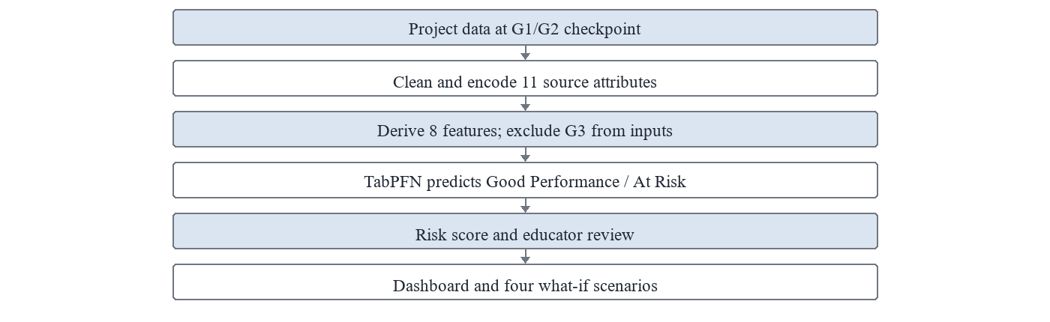
Figure 1. Project workflow from grade-checkpoint data to prediction and educator review

2.2 Dataset and cohort
The project uses the UCI Student Performance data, which records student attributes and grades for secondary-school mathematics and Portuguese courses [1]. The supplied project materials select the mathematics records and provide a 395-row working CSV. The paper's analysis follows that project file rather than reconstructing a cohort from the original repository. Its class distribution is 265 Good Performance records and 130 At Risk records under the project threshold. The records are not a representative sample of all schools or student populations, and the data's original collection context should be considered when interpreting the model.

2.3 Source attributes and engineered features
The transformation code retains 11 source attributes. Numerical inputs are studytime, absences, G1, G2, age and failures. Categorical inputs are famsup, internet, sex, paid and activities. The five categorical variables are mapped to binary values; numerical variables are converted to numeric values and missing or unparsable values are filled with zero by the supplied transform. Eight derived columns capture grade summary or change, study and absence relationship, a support count and project-defined interactions. The resulting 19-column representation is shown in Table 2. The project-defined academic_risk_score feature is derived from input fields; it is not the model output probability and should not be described as an independently validated risk scale.
Table 2. Source attributes used to construct the model input
Role | Source field | Meaning / transformation
Input | studytime | Weekly study-time category
Input | absences | Number of school absences
Input | G1 | First-period grade; checkpoint input
Input | G2 | Second-period grade; checkpoint input
Input | age | Student age in years
Input | failures | Prior class failures
Input | famsup | Family educational support; binary coded
Input | internet | Home internet access; binary coded
Input | sex | Source category; binary coded
Input | paid | Paid extra classes; binary coded
Input | activities | Extracurricular activities; binary coded
Target only | G3 | Final grade; defines class and is excluded from predictors

2.4 Target definition and leakage control
The target is derived as a binary variable from final mathematics grade G3. A record is labeled Good Performance when G3 ≥ 10 and At Risk when G3 < 10. The working file contains 265 and 130 records in these classes, respectively. In the transformation pipeline, the performance label is inverted to use 1 for At Risk and 0 for Good Performance. G3 is not included in the input feature list. This prevents direct inclusion of the outcome-defining grade, but it does not remove all forms of temporal dependence because G1 and G2 are prior grades closely related to G3.
The use of G1 and G2 determines the system's prediction timing. It can assess risk after the first- and second-period grades are available; it cannot support a claim of prediction before the first assessment. Evaluation should therefore use a split that mirrors the intended decision point and should avoid information from the test records influencing feature selection, threshold choice or training.
AtRisk = 1 if G3 < 10; otherwise Good = 0 (1)
This coding makes the positive class explicit for precision, recall and F1 calculations. The 10-point boundary is a project choice applied to the dataset's grade scale; conclusions may change under another threshold. The binary target also compresses the distinction between students near the boundary and those with substantially different grades, so the probability and label should be interpreted alongside the original academic context.

2.5 TabPFN model and training protocol
TabPFN is used as the classifier for the structured input columns. The project materials describe stratified five-fold cross-validation and a separate holdout test set. The supplied top-level training script first creates an 80/20 stratified split with random state 42, then evaluates candidate estimator counts on five folds of the training partition. It chooses a decision threshold using a combined selection rule involving at-risk F1, accuracy and recall, before evaluating the selected model on the holdout partition.
risk score = 100 × P(At Risk | transformed student inputs) (2)
The application converts the model's estimated probability for the At Risk class into a percentage risk score. The teacher dashboard groups the scores into low (<25%), moderate (25% to <60%) and high (≥60%) bands, as specified in the supplied code. These cutoffs are operational display bands, not validated decision thresholds. Their usefulness and calibration should be assessed before deployment, particularly because a score can be miscalibrated even when aggregate classification metrics appear favorable.
The supplied archive contains two training paths. The top-level script searches among 4, 8 and 16 TabPFN estimators and stores cross-validation selection rows; the component trainer is fixed to eight estimators and calculates metrics on supplied train/test arrays. The archived CV results identify 16 estimators and a threshold near 0.33 as the selected configuration, while the project abstract reports a separate holdout metric set. Without a run manifest tying the abstract metrics to one exact model, split, threshold and software version, the holdout result cannot be independently reconstructed from these materials.

2.6 Risk presentation and intervention context
The system returns a predicted category and risk score and orders dashboard records by risk. A score can help staff prioritize a review queue, but it does not establish why a student is struggling. The project abstract describes explanations and intervention recommendations; the inspected Flask routes establish risk scoring, dashboard aggregation and what-if predictions, not an end-to-end feature-attribution or intervention recommendation module. Any such functionality should be reported only after it is implemented, documented and verified.
P(At Risk) < 0.25 → low display band (3)
0.25 ≤ P(At Risk) < 0.60 → moderate display band (4)
P(At Risk) ≥ 0.60 → high display band (5)
The three bands are presentation rules in the supplied application. They are not clinical-style risk categories or empirically established cut points. Schools should not use them as automatic grounds for discipline, exclusion or resource denial. A risk flag should prompt a supportive, human-led review and should be checked for unequal error rates and consequences across groups.
Table 3. What-if scenarios present in the individual prediction workflow
Scenario | Input modification | Recomputed inputs | Returned output | Interpretation
G2 change | Increase G2 by 2 (bounded) | Grade trend and derived grade fields | New class and risk probability | Model response only
Attendance change | Reduce absences by 5 (floor at 0) | Study/absence and failure/absence features | New class and risk probability | Not causal evidence
Study + combined | Studytime +1; combined case also G2 +2 and absences −5 | Affected engineered columns recalculated | New class and risk probability | Scenario inspection, not a recommendation

The four implemented scenarios modify the submitted inputs and call the prediction pipeline again. They include increasing G2 by two points, reducing absences by five, increasing study time by one category and combining the G2 and absence changes. Input bounds are applied in the code. The changed predictions are conditional on the model and the synthetic input change; they do not represent causal effects, a promise of improved grades or a recommended intervention.

2.7 Explanation and what-if interpretation
Feature explanation and scenario analysis answer different questions. A valid local explanation would describe how model inputs contribute to one prediction under an identified method; the supplied application source does not demonstrate a complete explanation interface or report its outputs. What-if analysis instead changes selected input values and observes the model's response. The project materials mention factor explanations, but without code and example outputs the paper does not attribute specific decisions to individual features.
Δp = P(At Risk | x*) − P(At Risk | x) (6)
Here x denotes the submitted feature vector and x* a modified scenario vector. A negative Δp would mean that the model assigns a lower At Risk probability to the altered inputs, but it would not show that the corresponding real-world change causes a lower risk. Correlated features, data support and the model's learned associations all affect the comparison. Educators should not translate a favorable what-if score into a causal recommendation without a separate intervention study.

2.8 Application implementation
The project archive contains Python code for data transformation, TabPFN training and prediction, plus a Flask web application. The individual prediction route accepts the six numerical and five categorical source attributes. The application has a separate teacher-dashboard route that calculates risk summaries and ranks student records. Four scenario variants are generated for the individual form. The supplied code supports these described functions; full operational readiness, accessibility, security, school-system integration and deployment validation are outside the evidence in the project archive.

3. Results
This section reports project-supplied evaluation evidence and the implementation functions that can be traced to the archived source. It does not present a newly executed model run. Reported holdout values, cross-validation configuration-search values and dataset counts are labeled separately to prevent unlike quantities from being conflated.

3.1 Project-reported holdout performance
The project abstract reports holdout accuracy of 89.87%, precision of 82.14%, recall of 88.46% and F1-score of 85.19%. Table 4 and Figure 2(a–b) reproduce these values as stated. They are project-reported metrics, not independently reproduced in this paper. The materials do not provide the holdout confusion matrix, confidence intervals, a saved split manifest or metric averaging details with the abstract. The scores therefore require confirmation against the final model run before being treated as publication-ready evidence.
Table 4. Holdout metrics reported in the project abstract
Metric | Project-reported value | Positive class / definition | Evidence status
Accuracy | 89.87% | Overall holdout correctness | Reported in supplied abstract; not independently reproduced
Precision | 82.14% | At Risk | Reported in supplied abstract; averaging detail not supplied
Recall | 88.46% | At Risk | Reported in supplied abstract; not independently reproduced
F1-score | 85.19% | At Risk | Reported in supplied abstract; not independently reproduced

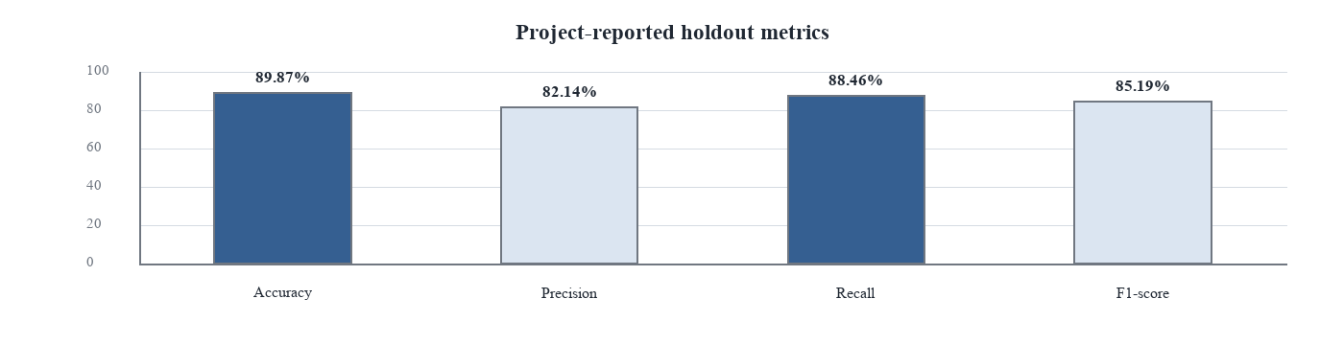
(a)
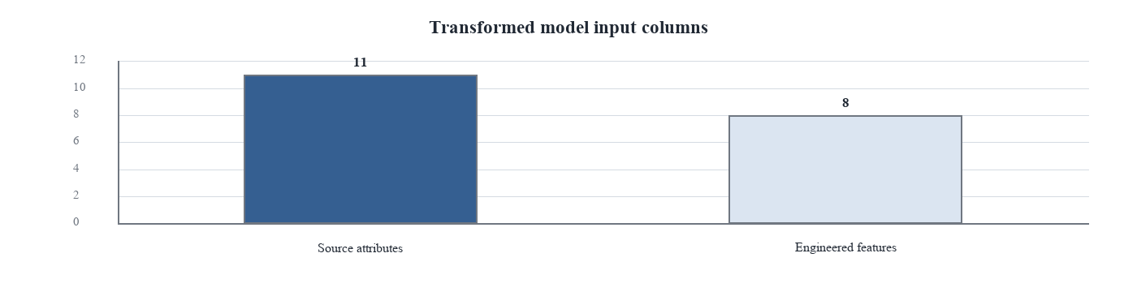
(b)
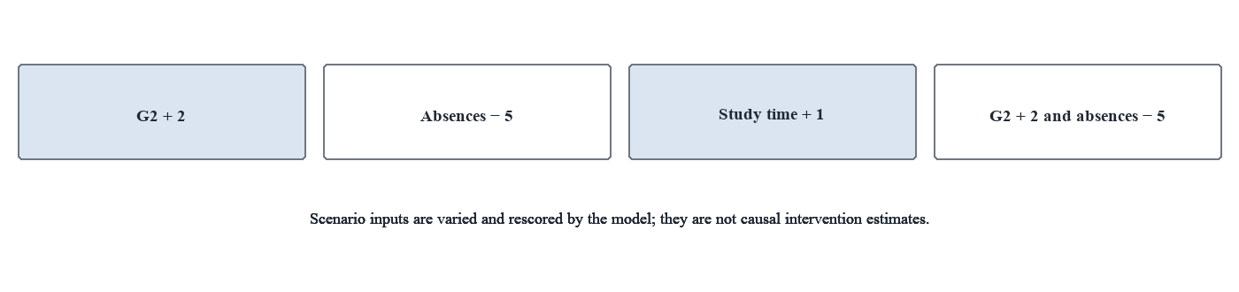
(c)
Figure 2. (a) Project-reported holdout metrics; (b) source and engineered model columns; (c) what-if scenarios present in the application

3.2 Archived cross-validation selection results
A separate archived model_results.csv records a TabPFN configuration-search result with 16 estimators, five-fold cross-validation accuracy of 0.9051, At Risk F1 of 0.8673 and At Risk recall of 0.9423 at a threshold of 0.33. This file contains results used for configuration selection on the training partition, not an independent holdout estimate. It is therefore reported as provenance information and is not plotted as if it were directly comparable with the abstract's holdout metrics.

3.3 Feature and implementation coverage
The working data transformation produces 19 columns from 11 source attributes: six numerical and five categorical fields, plus eight engineered columns. Figure 3 summarizes the count by broad feature family using the explicit transformation code. These counts describe pipeline construction, not predictive importance. The application code also evidences probability-based risk scoring, a teacher dashboard and four what-if scenarios; explanation and intervention recommendations are described in the project abstract but are not verified as implemented outputs.

4. Discussion

4.1 Comparison with the selected literature
The selected literature demonstrates a range of approaches to student performance prediction. The reviews by Balaji et al. [3] and Alalawi et al. [4] organize methods, datasets and feature practices across a broad field. Individual works include hybrid neural prediction [5], a spiking-neural approach [6], an automatically constructed belief-rule base [7], quantitative ML analysis [8] and online/offline comparison [9]. Kesgin et al. [10] place fairness and explanation alongside prediction, while El Jihaoui et al. [11] explicitly address fair and transparent early warning. Together, these studies make it untenable to claim that the current project is the first risk-prediction or explanation system.
The proposed project differs in its specific configuration and application boundary: a small UCI mathematics cohort; a G3 threshold that defines two outcome classes; TabPFN with 19 transformed input columns; probability-derived risk bands; a teacher dashboard; and four model-input scenarios. The main research gap supported by this comparison is an integration and reporting gap within this prototype: connecting a threshold-defined prediction with educator review and scenario inspection while clearly stating when the prediction can be made and which system functions are actually evidenced. The cross-study numerical scores are not compared because the underlying outcomes, cohorts and evaluation procedures are different.

4.2 Practical implications and responsible use
A dashboard can reduce the effort needed to scan a cohort, but a risk score does not identify the appropriate support by itself. Staff need relevant context, an opportunity to correct data, and a process for supportive follow-up. The what-if panel may help explain model sensitivity to altered inputs, yet it cannot answer whether a tutoring session, attendance intervention or extra study time would cause a change in performance. Recommendations should be developed with educators and students and evaluated prospectively.

4.3 Limitations and future directions
The study is limited to 395 mathematics records from one public secondary-school dataset. It uses a project-defined threshold and includes prior grades G1 and G2, which constrains its timing and may make prediction strongly dependent on earlier academic performance. The single holdout metric set appears in the abstract but is not linked to a reproducible saved run in the supplied evidence. The archived CV results are distinct, and the project archive contains two training entry points with different estimator settings. This discrepancy should be resolved before making claims about the final selected model.
Future work should record one canonical training command, library versions, random seeds, split indices, threshold-selection rule and class-wise confusion matrix. The holdout metrics should be regenerated from the documented pipeline, with confidence intervals and probability-calibration analysis. Comparisons against logistic regression, decision tree, random forest and other suitable baselines should use the same split and target. Further validation should examine fairness and error patterns across student subgroups and a separate school or cohort. Finally, feature explanations and intervention recommendations should be implemented and evaluated with educators; any claim of intervention benefit requires prospective or causal evidence.

5. Conclusion
This paper described an ML-based student academic performance prediction prototype using the UCI mathematics records and TabPFN. It derives Good Performance and At Risk labels from final grade G3, excludes G3 from the model inputs and uses six numerical and five categorical source attributes transformed into 19 columns. Since G1 and G2 are included, the model operates after those grade checkpoints. The supplied Flask application supports individual prediction, probability-based risk scoring, a teacher dashboard and four what-if scenarios.

Data and software availability
The Student Performance dataset is publicly available through the UCI Machine Learning Repository [1]. The project-specific working data, code and archived results were supplied in the project materials. No public repository or DOI was identified in those materials.

References
1. P. Cortez and A. M. G. Silva. Using data mining to predict secondary school student performance. In Proceedings of the 5th Future Business Technology Conference, 2008. UCI Machine Learning Repository dataset: Student Performance, DOI: 10.24432/C5TG7T.
2. N. Hollmann, S. Muller, K. Eggensperger, and F. Hutter. TabPFN: A transformer that solves small tabular classification problems in a second. International Conference on Learning Representations, 2023.
3. P. Balaji, S. Alelyani, A. Qahmash, and M. Mohana. Contributions of machine learning models towards student academic performance prediction: A systematic review. Applied Sciences, 11(21), 10007, 2021.
4. K. Alalawi, R. Athauda, and R. Chiong. Contextualizing the current state of research on the use of machine learning for student performance prediction: A systematic literature review. Engineering Reports, 5(12), e12699, 2023.
5. B. K. Yousafzai et al. Student-Performulator: Student academic performance using hybrid deep neural network. Sustainability, 13(17), 9775, 2021.
6. C. Liu, H. Wang, Y. Du, and Z. Yuan. A predictive model for student achievement using spiking neural networks based on educational data. Applied Sciences, 12(8), 3841, 2022.
7. M. Liu, W. He, G. Zhou, and H. Zhu. A new student performance prediction method based on belief rule base with automated construction. Mathematics, 12(15), 2418, 2024.
8. L. Zhao, J. Ren, L. Zhang, and H. Zhao. Quantitative analysis and prediction of academic performance of students using machine learning. Sustainability, 15(16), 12531, 2023.
9. B. Holicza and A. Kiss. Predicting and comparing students online and offline academic performance using machine learning algorithms. Behavioral Sciences, 13(4), 289, 2023.
10. K. Kesgin, S. Kiraz, S. Kosunalp, and B. Stoycheva. Beyond performance: Explaining and ensuring fairness in student academic performance prediction with machine learning. Applied Sciences, 15(15), 8409, 2025.
11. M. El Jihaoui, O. E. K. Abra, and K. Mansouri. Towards a fair and transparent early warning system for identifying students at risk of academic failure. Frontiers in Education, 11, 1878686, 2026.

