DOCUMENTATION

ASSIGNMENT 1

Student Name: Gherasim Teodor-Samuel
GROUP: 30421

CUPRINS

1. Assignment objective 3
2. Problem analysis, modeling, scenarios, use-cases 3
3. Design 6
4. Implementation 8
5. Results 11
6. Conclusions 12
7. Bibliography 12

Assignment objective
Main objective
- Design and implement a polynomial calculator with a dedicated graphical interface through which the user can insert polynomials, select the mathematical operation to be performed and view the result.

Sub-objectives
- Analyze the problem and identify the requirements ;
- Model the solution, according to the functional and non-functional requirements;
- Design the polynomial calculator
- Implement the polynomial calculator
- Test the polynomial calculator

Problem analysis, modeling, scenarios, use-cases
The calculator works with polynomials, which are mathematical objects that consist of a sum of monomials. The monomial with the highest degree gives the polynomial its own degree.
Addition and subtraction between polynomials are done by adding and subtracting termwise monomials, with the condition that they share the same degree.
Multiplication of polynomials is also done through termwise multiplication, however the result needs to be simplified by adding like terms together.
Division for polynomials is a lot trickier, because it requires following a certain algorithm. The algorithm for division that I want to use in this solution is:
1. Divide the first monomial of the first polynomial to the first monomial of the second polynomial and obtain the first term of the quotient;
2. Multiply the quotient with the second polynomial and subtract the result of the multiplication from the first polynomial, storing the result in it;
3. Repeat the procedure until the degree of the remainder is lower than that of the second polynomial.
Differentiation and Integration are done according to the mathematical rules regarding polynomials:
There is only one actor for this polynomial calculator: the user. He interacts with the program according to the following use-case diagram: 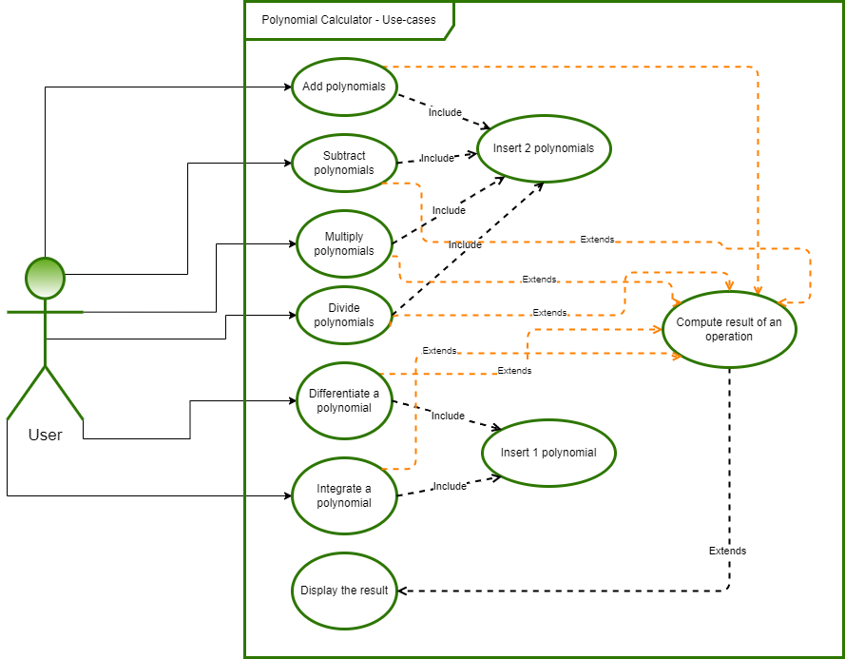

Use Case #1: Add polynomials
Primary Actor: user
Main Success Scenario:
1. The user inserts the 2 polynomials in the graphical user interface.
2. The user selects the “addition” (+) operation
3. The user clicks on the “compute” (=) button
4. The polynomial calculator performs the addition of the two polynomials and displays the result
Alternative Sequence: Incorrect polynomials
- The user inserts incorrect polynomials (e.g. with 2 or more variables)
- The scenario returns to step 1
Use Case #2: Subtract polynomials
Primary Actor: user
Main Success Scenario:
1. The user inserts the 2 polynomials in the graphical user interface.
2. The user selects the “subtraction” (-) operation
3. The user clicks on the “compute” (=) button
4. The polynomial calculator performs the addition of the two polynomials and displays the result
Alternative Sequence: Incorrect polynomials
- The user inserts incorrect polynomials (e.g. with 2 or more variables)
- The scenario returns to step 1

Use Case #3: Multiply polynomials
Primary Actor: user
Main Success Scenario:
1. The user inserts the 2 polynomials in the graphical user interface.
2. The user selects the “multiplication” (*) operation
3. The user clicks on the “compute” (=) button
4. The polynomial calculator performs the subtraction of the two polynomials and displays the result
Alternative Sequence: Incorrect polynomials
- The user inserts incorrect polynomials (e.g. with 2 or more variables)
- The scenario returns to step 1

Use Case #4: Divide polynomials
Primary Actor: user
Main Success Scenario:
1. The user inserts the 2 polynomials in the graphical user interface.
2. The user selects the “division” (/) operation
3. The user clicks on the “compute” (=) button
4. The polynomial calculator performs the division of the two polynomials and displays the result
Alternative Sequence: Incorrect polynomials
- The user inserts incorrect polynomials (e.g. with 2 or more variables)
- The scenario returns to step 1

Use Case #5: Differentiate polynomial
Primary Actor: user
Main Success Scenario:
1. The user inserts one polynomials in the graphical user interface, in any of the two slots.
2. The user selects the “differentiation” (d/dx) operation
3. The user clicks on the “compute” (=) button
4. The polynomial calculator performs the differentiation of the two polynomials and displays the result
Alternative Sequence: Incorrect polynomial
- The user inserts incorrect polynomials (e.g. with 2 or more variables)
- The scenario returns to step 1
Alternative Sequence: Multiple polynomials
- The user inserts too many polynomials in the user interface
- The scenario returns to step 1

Use Case #6: Integrate polynomials
Primary Actor: user
Main Success Scenario:
1. The user inserts one polynomials in the graphical user interface, in any of the two slots.
2. The user selects the “integration” (∫) operation
3. The user clicks on the “compute” (=) button
4. The polynomial calculator performs the integration of the two polynomials and displays the result
Alternative Sequence: Incorrect polynomials
- The user inserts incorrect polynomials (e.g. with 2 or more variables)
- The scenario returns to step 1
Alternative Sequence: Multiple polynomials
- The user inserts too many polynomials in the user interface
- The scenario returns to step 1

Design
The black box of the program is the following (to be interpreted as analyzed in step 2):

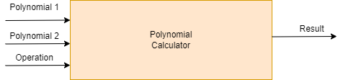
To easily clasify elements and for portability reasons, I have decided to use a Model-View-Controller architecture.
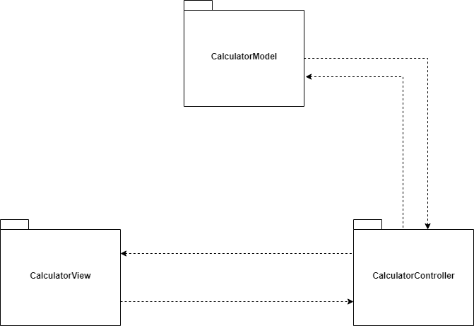
The Controller is responsible for all the communication done between packages. It sends and receives data from both the View and the Model, and it is responsible for parsing the user input and generating the required output. Communication is done via method calling from each of the packages.
The CalculatorModel package is the most complex one. It is described by the following UML Class Diagram:
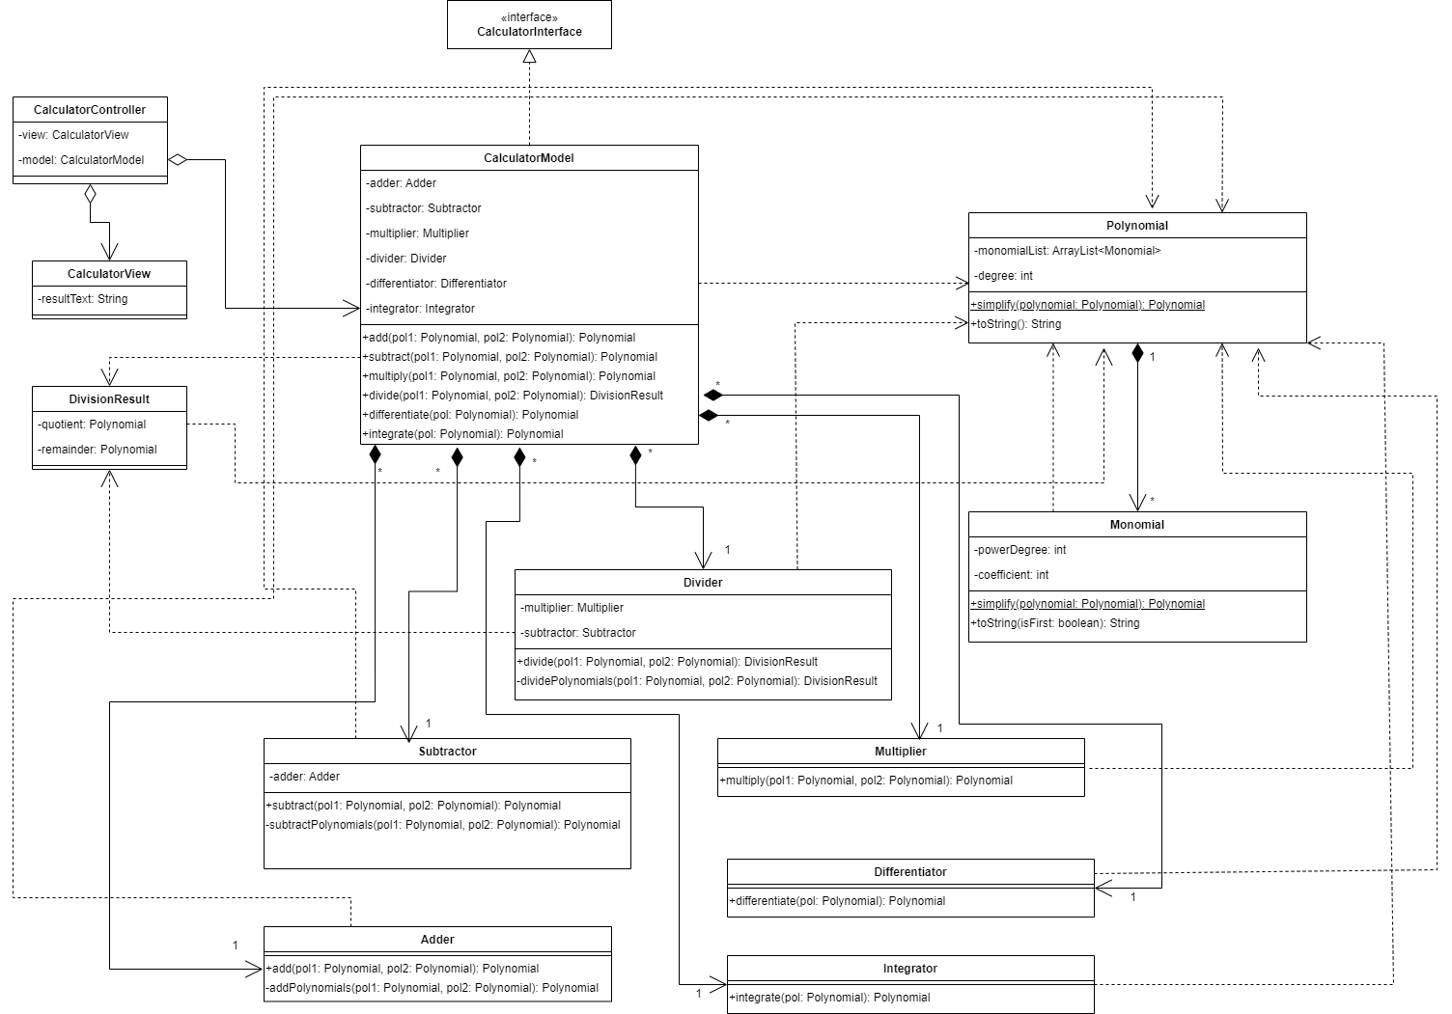
The only data structure of note from the ones used is the ArrayLists of monomials that define a Polynomial. Every Polynomial is constructed of at least one Monomial in order to be valid, therefore there is a composition type relationship between them.
Every Monomial has a degree and a coefficient, and all operations done by the calculator are going to be implemented by manipulating these two fields in every Monomial that composes a Polynomial.

Implementation
Calculator Model
To be ablle to build different types of calculators in the future, I established an interface called CalculatorInterface, which establishes that any calculator should add, subtract, multiply, divide, differentiate and integrate and that they should all work on polylomials. Here are the most important methods of the implemented classes:
The Monomial class has the following important method:
- toString() – it generates a string according to the coefficient and the power degree of the monomial. This is done through String concatenation and String parsing into integers and doubles. I have decided give the coefficient a double type as to account for division and integration, which can have rational values for the coefficients of the result. Any coefficient that is not an integer is automatically represented as a double.
The Polynomial class has two important methods.
- simplify() – static method used to reduce a polynomial given as parameter to its smallest and most readable form. It adds together all composing monomials that share a degree, and then sorts them in descending order according to the given degree.
- toString() – is mainly used for printing the class into its readable form. It appends monomials by using the toString() method in the Monomial class.
The Adder class has two important methods.
- add() – this method is mainly used to sort the given polynomials descendingly in the order of their degree. Afterwards, it calls the private addPolynomials() method to generate the result.
- addPolynomials() – is the actual method doing the hard work in this class. It adds monomials term by term (according to their degree) by computing the sum of their coefficients. It then generates a new monomial that has the sum of coefficients and the degree of the added polynomials as characteristics. This result is added into an ArrayList of Monomials, which is then used to generate the returned Polynomial.
The Subtractor class has two important methods.
- subtract() – this method is mainly used to sort the given polynomials descendingly in the order of their degree. If the first polynomial given has a lower degree than the second one, the add() method of the Adder class is used according to the following mathematical expression: P(x)-Q(x)=P(x)+(-1)*(Q(x)
Therefore, the second polynomial is multiplied by -1 and added to the first polynomial, generating the result.
If the first polynomial given as parameter has a higher degree than the second one, then the subtractPolynomials() private method is used
- subtractPolynomials() – is the actual method doing the hard work in this class. It subtracts monomials term by term (according to their degree) by computing the difference of their coefficients. It then generates a new monomial that has the difference of coefficients and the degree of the added polynomials as characteristics. This result is added into an ArrayList of Monomials, which is then used to generate the returned Polynomial.

The Multiplier class has only one method.
- multiply() – the method is given two Polynomials as parameters. The polynomials are multiplied term by term, all of the results are added to an ArrayList, a Polynom is generated from the given ArrayList, then the result is simplified by calling the static Polynomial.simplify() method.
The Divider class has only one method.
- divide() – this method simplifies the given polynomials before passing them on to the dividePolynomials() private method.
- dividePolynomials() – this method does step by step the algorithm described in the problem analysis chapter. The quotient and the remainder are computed simultaneously and are used to generate an instance of DivisionResult, which is then returned.
The Differentiator class has only one method.
- differentiate() – this method traverses the ArrayList of Monomials of the given Polynomial, generates for each the corresponding differentiated term, then generates a new Polynomial with these terms. The resulting Polynomial is then returned.
The Integrator class has only one method.
- integrate() – this method traverses the ArrayList of Monomials of the given Polynomial, generates for each the corresponding integrated term, then generates a new Polynomial with these terms. The resulting Polynomial is then returned.
GUI (Calculator View)
As a model for the window with which the user interacts, I have considered the following design:
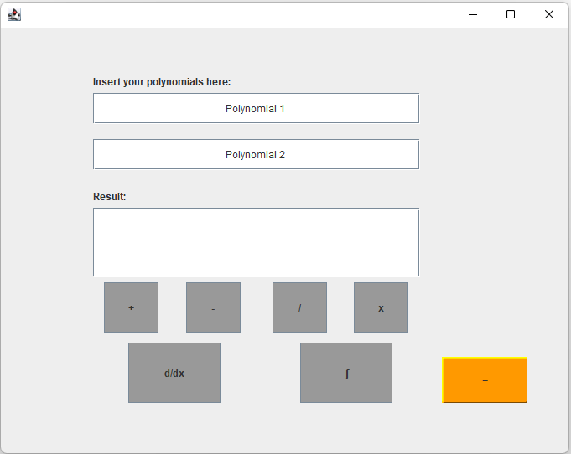
The Polynomial 1 and Polynomial 2 text fields are editable. The user can insert the desired polynomial calculation in those fields, then press one of the operation buttons and finally display the result in the result text field by pressing the = button. The Result text field has multiple rows due to the fact that it needs to display both the quotient and the remainder of any division, which is done by writing them on multiple lines.

For implementing this GUI, I have used Java Swing and the Apache NetBeans IDE 12.6. More specifically, I have used the JFrame and JPanel forms provided by this IDE. It enabled me to set the positions, sizes, colors and fonts for the JButtons, JLabels, JTextFields via intuitive drag and drop methods.
The resulting code was then copied into my IDE, which was used to generate the JFrame window with a JPane, 2 JLabels, 7 JButtons and 3 JTextFields.
Calculator Controller
This class implements action listeners for the GUI buttons in the CalculatorView class. It also has the roles of reading the information in the text fields of the CalculatorView class via getter methods, and passing the results to the CalculatorModel class via setter methods. The result for each button press is then computed by calling the corresponding method of the CalculatorModel class and writing the result in a private field in the CalculatorView class. The result is only shown to the user upon pressing of the “=” button.
The inputs are parsed by using regular expressions and separating them into corresponding monomials.

Results
I have used Junit to test the operations done in the CalculatorModel class. The cases that I treated were only correct input formats for the polynomials and correspond to the following filled fields of the program, with the following values:
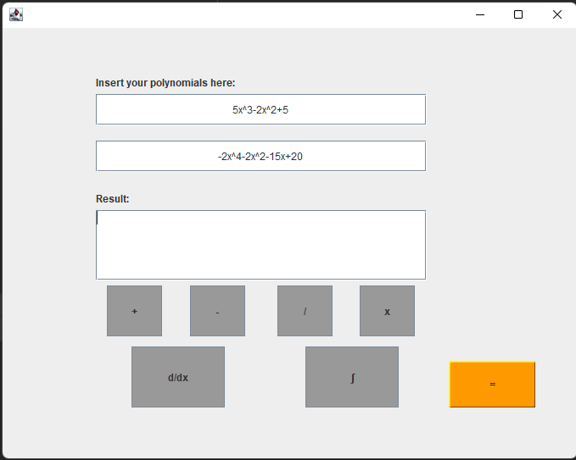

The division has them interchanged, as to generate a more complex result.
The methods are called and are checked to the expected result via the assertEquals() method found in the org.junit.jupiter.api.Assertions.assertEquals package.

Conclusions
I have created a Polynomial Calculator that does several simple operations on polynomials. Contrary to its apparent simplicity, this project required much time and effort to implement, but I am pleased with the result. The operations all function correctly.
For the future, I also wish to implement a better parser for recognizing the polynomial format, one that does not use regular expressions to identify groups of monomials. I also wish to add more functionalities, like exponentiating with an integer and writing the polynomial in matrix form.

Bibliography
[1] Lecture 1, Design View: UML Diagrams; T.Cioara , C. Pop, 2021 2022
[2] https://dsrl.eu/courses/pt/materials/A1_Support_Presentation.pdf

