COMP CO710 HTML & CSS

Lab 6 – Multimedia, Image Maps and WAI
Create the following Web page:
Images are available on MyCanvas in Modules Labs Lab 6.
Create an apartment rental Web using best practices for HTML5 and Web design in general. This is a multi-page solution. All Web pages must satisfy the following WCAG 2.0 conformance rules to Level 1 (basic) compliance. (http://www.w3.org/TR/2006/WD-WCAG20-20060427/appendixB.html).
Guideline 1.1: Provide text alternatives for all non-text content
Guideline 1.2: Provide synchronized alternatives for multimedia
1.2.7 For prerecorded multimedia, a full multimedia text alternative including any interaction is provided.
Guideline 1.3: Ensure that information and structure can be separated from presentation.
Guideline 1.4 Make it easy to distinguish foreground information from its background.
Guideline 2.1: Make all functionality operable via a keyboard interface.
Guideline 2.2: Allow users to control time limits on their reading or interaction.
Guideline 2.3: Allow users to avoid content that could cause seizures due to photosensitivity.
Guideline 2.4: Provide mechanisms to help users find content, orient themselves within it, and navigate through it.
Guideline 2.5: Help users avoid mistakes and make it easy to correct mistakes that do occur.
Guideline 3.1: Make text content readable and understandable.
Guideline 3.2: Make the placement and functionality of content predictable.
Guideline 4.1: Support compatibility with current and future user agents (including assistive technologies).
Guideline 4.1: Ensure that the content is accessible or provide an accessible alternative.

Horizontal layout – apartment.html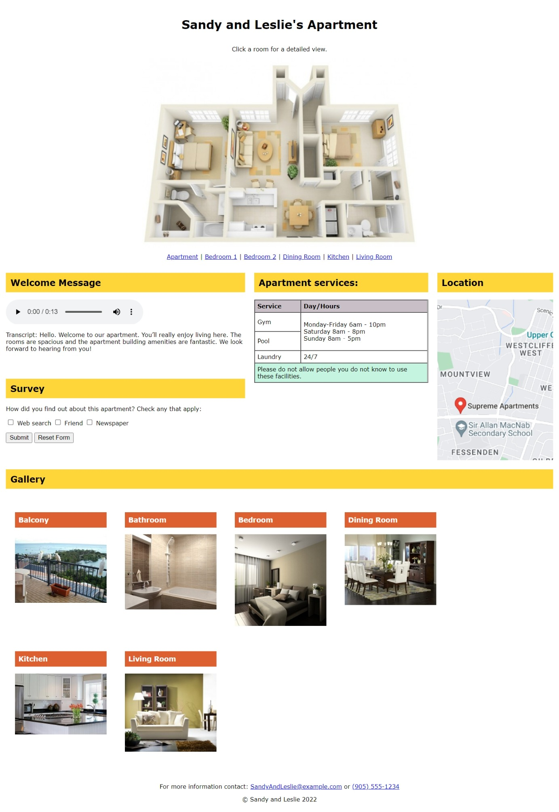
The floor plan is a client-side image map. The image below shows the hotspots in the floor plan:
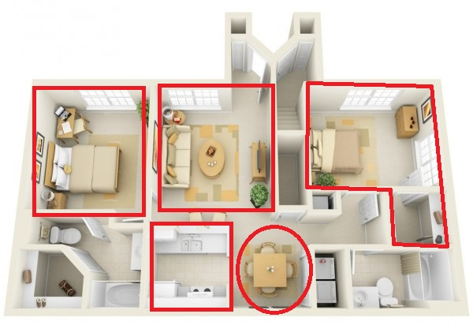
Requirements for content are as follows:
  - Title "Sandy and Leslie's apartment"
  - CSS styles should be as follows:
    - External stylesheet called apartment_layout.css that is suitable for larger screen viewing and contains all styles that are used in all Web pages. Use an embedded stylesheet for styles that are used only for individual Web pages, if need be.
    - External stylesheet that will print the apartment.html page without the image and image map.
    - External stylesheet called mobile.css for the apartment.html. For small devices such that the image map will not be visible, and the text menu will display each room link on a separate line, vertically, and the vertical lines will be removed ( | ). Use a media query with a 600px breakpoint. That is, 600px and less should display the vertical layout, and 601 pixels and more should display the horizontal layout. Examples of the horizontal and vertical layouts are shown below. The room pages can use a vertical design only, to maximize functionality for small devices. The room pages do not require a media query and modified layout for different size displays.
      - If you'd like to extend the responsive design to the room pages, feel free to do so for extra practice, but it is not required for this assignment.
  - Create an image map using the floor plan image. Create the hotspots shown above. Pay attention to the shapes (rectangle, circle, poly). Rooms should link to the following pages, as appropriate: diningroom.html, bedroom.html, livingroom.html, kitchen.html. You can link both bedrooms to the bedroom.html page. The image should link to apartment.html (outside the hotspots).
You may use one of the free image map creation tools or you may code the image map by hand, finding the coordinates using Paint. You should have the following shaped hotspots:
Bedrooms - 1 rectangle, 1 polygon (both bedrooms should link to the same bedroom.html page)
Dining room - circle (position the center of the circle near the center of the dining room table in the image)
Living Room - rectangle
Kitchen – rectangle
  - Include a text menu below the image map with links to appropriate Web pages as follows:
Apartment | Bedroom 1 | Bedroom 2 | Dining Room | Kitchen | Living Room
  - Include a table on the apartment.html and each room page that provides the following information. You may choose a suitable layout and colours.

Gym and Pool Hours: Monday - Friday 6am - 10pm, Saturday 8am - 8pm, Sunday 8am - 5pm

Laundry: 24 hours, 7 days per week

  - Include a gallery of pictures, as shown in the sample apartment.html image.

  - Include a contact email address, apartment@example.com and phone number (905) 555-1234.

  - Use the <audio> element to include the audio description apartment.mp3 on the apartment.html Web page. The transcript of the audio file is below:

Hello. Welcome to our apartment. You’ll really enjoy living here. The rooms are spacious and the apartment building amenities are fantastic. We look forward to hearing from you!

- Each of the room pages should include a heading and image for each room (bedroom.html, diningroom.html, kitchen.html, livingroom.html), plus the table and contact information. An example is shown below.

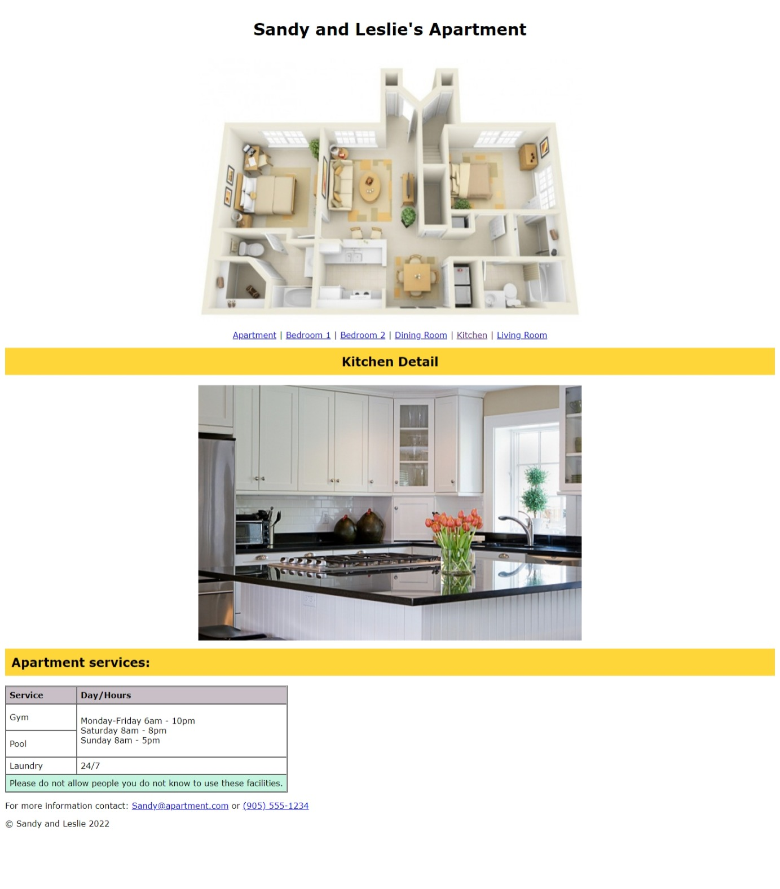
Vertical Layout – apartment.html
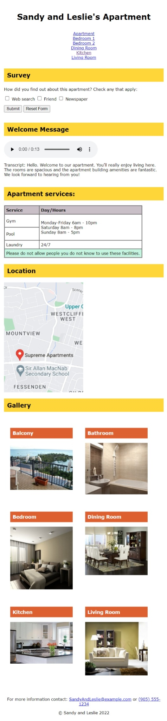

Submitting the Lab
- Create a .zip file called YourNameLab6.zip that contains ALL files required for the lab, including subfolders with files. Upload the zip file to the Lab 6 Assignment on myCanvas.
- On csunix.mohawkcollege.ca:
  - Edit the anchor tag in ~/public_html/private/index.html so that Lab Six link points to ~/public_html/private/Lab6/apartment.html. (~ is a short form of /home/saNNNNNNNNN)
  - Create the directory named images under ~/public_html/private/Lab6/
  - Transfer the html and image files for this lab to the appropriate locations.
  - Test your Lab Six link to the apartment.html file and confirm everything looks good on csunix. The work on csunix will be graded. MyCanvas is a backup, it will not be graded.
  - Point your browser at https://csunix.mohawkcollege.ca/~saNNNNNNNNN/private/, that url will automatically display ~/public_html/private/index.html

Since all work submitted to your professor is assumed to be your own original work, you must include the following “Statement of Authorship” in EVERY file you submit for grading:
All labs must contain the authorship in the HTML source code. Place this code in the <head> element.
<!-- CO710 Statement of Authorship
I F-name L-name, 000123456 certify that this material is
my original work. No other person's work has been used
without due acknowledgment. I have not made my work
available to anyone else.

Date and General Description -->
Replace F-name L-name with your name and the number 000123456 with your student ID.
Place this text as a comment at the top of the code for each submitted web page
Failure to include this statement means your work may receive a deduction of a maximum of 10% of the Lab grade.
All labs must be created this semester. A lab from a previous semester that is submitted for this semester will be graded as 0.

