Artificial Intelligence in Aging Research:
A Comprehensive Review of Current Applications,
Technologies, and Leading Companies

A Systematic Overview of AI-Driven Approaches to Biological Age Estimation,
Drug Target Discovery, Generative Molecular Design, Foundation Models,
Personalized Longevity Medicine, and the Global Biotech Ecosystem

Prepared: May 2026 | Language: English | Format: Comprehensive Review

TABLE OF CONTENTS
(Right-click → Update Field to populate page numbers)

Abstract
The global aging population presents one of the most complex challenges in modern medicine, demanding analytical frameworks capable of integrating high-dimensional, multi-modal biological data at unprecedented scale. Artificial intelligence (AI) — encompassing classical machine learning, deep learning, generative models, large language models (LLMs), and foundation models — has emerged as a transformative force in aging research, enabling capabilities that were previously unattainable through conventional statistical approaches. This review provides a comprehensive, in-depth examination of the current state of AI applications across the full spectrum of aging science: from the development of biological age clocks spanning epigenomic, proteomic, wearable, and single-cell modalities, to AI-powered target discovery platforms, generative molecular design, and combination drug prediction. We further examine the emergence of foundation models trained on tens of millions of single cells, the integration of AI with digital twins for personalized longevity medicine, and the optimization of clinical trial design. A dedicated section profiles the global ecosystem of AI-driven longevity companies — including Insilico Medicine, Gero, Calico, BioAge Labs, Recursion Pharmaceuticals, Altos Labs, Isomorphic Labs, Unity Biotechnology, and others — detailing their platforms, pipelines, and clinical milestones. We critically assess current limitations including data heterogeneity, interpretability gaps, causal inference challenges, and regulatory barriers, and outline a roadmap for the next generation of AI-integrated longevity medicine. The convergence of generative AI, multi-omics biology, and precision medicine is poised to fundamentally reshape how we understand, measure, and intervene upon the aging process.
Keywords: artificial intelligence; aging clocks; biological age; drug discovery; generative AI; foundation models; senolytics; digital twins; longevity biotechnology; multi-omics

1. Introduction
Aging is the single greatest risk factor for the majority of chronic diseases afflicting modern populations — including cardiovascular disease, neurodegeneration, cancer, type 2 diabetes, and musculoskeletal disorders. By 2050, the global population aged 65 and over is projected to reach 1.6 billion, representing a profound demographic shift with enormous implications for healthcare systems worldwide [53]. Despite decades of research, the molecular and cellular mechanisms underlying aging remain incompletely understood, in part because aging is not a single process but a complex, multi-dimensional phenomenon involving the progressive deterioration of numerous interconnected biological systems simultaneously [52].
Traditional approaches to aging research — relying on single-omics analyses, small cohort studies, and linear statistical models — are fundamentally ill-suited to capture the non-linear, high-dimensional nature of biological aging. The advent of large-scale multi-omics technologies has generated datasets of extraordinary richness and complexity: a single UK Biobank participant may contribute genomic, epigenomic, proteomic, metabolomic, imaging, and longitudinal clinical data spanning decades. Extracting actionable biological insight from such data requires computational approaches that can model non-linear interactions across thousands of features simultaneously — a task ideally suited to modern AI [1].
Artificial intelligence, broadly defined as the use of computational algorithms to perform tasks that would otherwise require human intelligence, encompasses a spectrum of methodologies with distinct strengths in aging research. Classical machine learning methods — including elastic net regression, random forests, and support vector machines — excel at feature selection and interpretable prediction from structured tabular data. Deep learning architectures, including convolutional neural networks (CNNs), recurrent neural networks (RNNs), and transformer-based models, can learn hierarchical representations from raw biological sequences, images, and time-series data. Generative AI models — variational autoencoders (VAEs), generative adversarial networks (GANs), and diffusion models — enable the de novo design of molecular structures with desired properties. Most recently, foundation models pre-trained on massive biological datasets have demonstrated remarkable versatility across diverse downstream tasks [2], [3].
The history of AI in aging research can be traced to the development of the first epigenetic aging clocks in 2013, when Horvath demonstrated that DNA methylation patterns at 353 CpG sites could predict chronological age with remarkable accuracy across diverse tissues [9]. This foundational work established the principle that biological age — distinct from chronological age — could be quantified from molecular data, opening the door to measuring the effects of interventions on the aging process itself. Over the subsequent decade, AI methods have progressively transformed every stage of the aging research pipeline: from biomarker discovery and target identification, through molecular design and preclinical screening, to clinical trial optimization and personalized medicine [4], [5].
This review provides a comprehensive, in-depth examination of the current state of AI applications in aging research, organized around seven major themes: (1) AI aging clocks and biological age estimation; (2) AI-driven target discovery; (3) generative AI and molecular design; (4) foundation models and single-cell AI; (5) personalized longevity medicine and digital twins; (6) the global AI longevity company ecosystem; and (7) challenges, limitations, and future directions. Throughout, we emphasize not only technical achievements but also translational milestones, critical limitations, and the path toward clinical implementation [6], [7], [8].
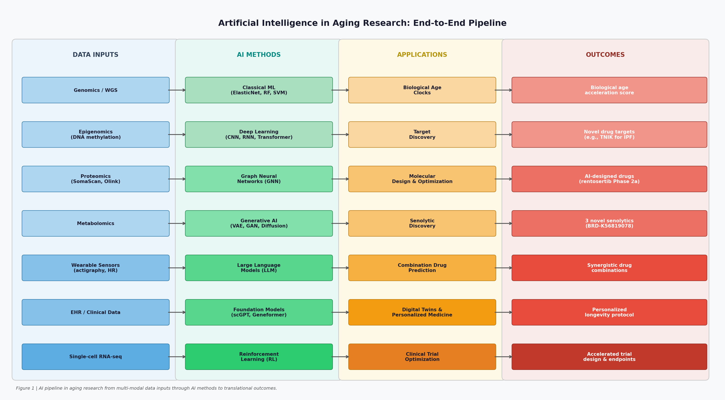
Figure 1 | End-to-end AI pipeline in aging research, from multi-modal data inputs through AI methods to translational outcomes.

2. AI Aging Clocks and Biological Age Estimation
One of the most significant contributions of AI to aging research has been the development of quantitative biomarkers of biological age — computational models that estimate an individual's physiological age from molecular or digital data, independent of their chronological age. Biological age acceleration (the difference between biological and chronological age) has emerged as a powerful predictor of morbidity, disability, and all-cause mortality, and as a potential surrogate endpoint for evaluating longevity interventions [14], [15]. The field has evolved through several generations of increasingly sophisticated AI approaches, spanning epigenetic, proteomic, wearable, and single-cell modalities.

2.1 First-Generation Epigenetic Clocks
The Horvath clock (2013) established the foundational paradigm: elastic net regression applied to DNA methylation (DNAm) data from 353 CpG sites could predict chronological age with a median absolute error of 3.6 years across 51 tissue types [9]. This pan-tissue accuracy was remarkable and suggested that DNAm encodes a universal biological aging signal. The Hannum clock (2013), trained on blood-specific methylation data from 71 CpGs, demonstrated similar accuracy in blood and revealed that biological age acceleration in blood correlates with smoking, BMI, and disease risk.
Second-generation clocks optimized for health outcomes rather than chronological age prediction represented a major conceptual advance. PhenoAge (2018) was trained to predict a composite phenotypic age derived from nine clinical biomarkers associated with mortality, yielding a clock whose acceleration strongly predicts all-cause mortality, cancer, cardiovascular disease, and physical disability. GrimAge (2019) went further, incorporating DNAm surrogates of plasma proteins (including GDF-15, PAI-1, and leptin) alongside smoking pack-years to produce a clock that outperforms all predecessors in predicting time-to-death [10]. GrimAge acceleration has since become one of the most widely used endpoints in longevity intervention trials.

2.2 Deep Learning Epigenetic Clocks
The limitations of elastic net regression — its assumption of linear feature relationships and inability to capture higher-order CpG interactions — motivated the development of deep learning-based epigenetic clocks. AltumAge (2022) employed a multi-layer perceptron trained on 20,318 CpG sites common to Illumina 27k, 450k, and EPIC arrays, achieving pan-tissue age prediction with superior accuracy compared to elastic net models [12]. Critically, AltumAge's architecture enables the extraction of biologically meaningful features: the top-ranking CpGs are enriched in gene regulatory regions and CTCF binding sites, suggesting that the model captures genuine epigenetic regulatory mechanisms rather than spurious correlations.
XAI-AGE (2024) addressed the interpretability challenge by constructing a biologically informed deep neural network whose architecture mirrors the hierarchy of biological pathways [13]. By constraining network connectivity to reflect known pathway relationships, XAI-AGE enables direct inference of pathway-level aging contributions from the model's internal representations. This approach bridges the gap between predictive accuracy and mechanistic insight — a critical requirement for translating aging clocks into actionable biological understanding.
DunedinPACE (2021) represents a conceptually distinct advance: rather than predicting chronological age, it quantifies the pace of biological aging — the rate at which an individual is aging relative to their peers [11]. Trained on longitudinal data from the Dunedin Study (a 1972–1973 birth cohort tracked across four time points spanning two decades), DunedinPACE captures within-individual decline in 19 indicators of organ-system integrity. Its high test-retest reliability and sensitivity to lifestyle interventions make it particularly valuable as a surrogate endpoint in clinical trials of geroprotective interventions.

2.3 Proteomic Aging Clocks
While epigenetic clocks measure regulatory changes in DNA methylation, proteomic clocks offer a more direct window into functional aging biology, as proteins are the primary executors of cellular processes and the most proximal molecular layer to phenotypic outcomes. The development of high-throughput proteomics platforms — particularly SomaScan (measuring ~7,000 proteins) and Olink (measuring ~3,000 proteins) — has enabled the construction of proteomic aging clocks in large population cohorts [19].
A landmark study published in Nature Medicine (2024) developed a proteomic aging clock from 1,463 plasma proteins measured in 45,441 UK Biobank participants [16]. The resulting model predicted biological age with high accuracy (R² = 0.80) and demonstrated strong associations with all-cause mortality and 18 major chronic diseases — including cardiovascular disease, type 2 diabetes, and multiple cancers — outperforming epigenetic clocks in several disease categories. Crucially, the clock was validated in independent cohorts from diverse ancestral backgrounds, addressing a major limitation of earlier clocks trained predominantly on European populations.
Organ-specific proteomic clocks (Nature Aging, 2025) extended this paradigm by constructing separate aging clocks for ten major organ systems — including brain, heart, liver, kidney, lung, immune system, and musculoskeletal system — using nonlinear machine learning methods applied to UK Biobank proteomics data (n = 43,616) [17]. This approach revealed that individuals can exhibit markedly different aging rates across organ systems, a phenomenon termed 'ageotyping.' Individuals with accelerated brain aging showed elevated risk of neurodegenerative disease, while those with accelerated cardiovascular aging showed elevated risk of heart failure and stroke, enabling organ-specific risk stratification.
OMICmAge (Nature Aging, 2026) represents the current state of the art in multi-omics aging clock development [18]. Developed from ~31,000 participants in the Massachusetts General Brigham Biobank, OMICmAge integrates proteomic, metabolomic, and clinical data through epigenetic biomarker proxies (EBPs) — a novel approach that distills multi-omics information into a DNAm-measurable clock. This architecture provides the unique advantage of capturing information from multiple biological layers while remaining measurable from a single blood test. OMICmAge demonstrated superior associations with chronic disease outcomes and mortality compared to all prior clocks, validated across three independent cohorts including All of Us and TruDiagnostic Biobank.

2.4 Wearable and Digital Biomarkers of Aging
A transformative development in aging clock research has been the demonstration that biological age can be estimated from continuous wearable sensor data — enabling scalable, low-cost, longitudinal monitoring of aging trajectories in real-world settings. The GeroSense model (Gero, 2020) trained deep neural networks on step-per-minute recordings from 103,830 one-week wearable samples and 2,599 longitudinal samples of up to two years [20]. The resulting biological age acceleration (BAA) model showed associations with life expectancy comparable to blood-based models, while uniquely enabling the measurement of BAA fluctuations at daily and weekly timescales.
A critical insight from the GeroSense work was the identification of physiological resilience as a key aging biomarker. By measuring the autocorrelation time of BAA fluctuations — essentially, how long it takes an organism to recover from perturbations — Pyrkov et al. demonstrated that resilience declines progressively with age [21]. Extrapolation of this trend suggested that resilience recovery time and variance would simultaneously diverge at a critical point corresponding to 120–150 years of age — providing a theoretical basis for the observed maximum human lifespan. This dynamic organism state indicator (DOSI) framework represents a fundamentally new conceptualization of aging as a loss of homeostatic capacity rather than a simple accumulation of damage.
CosinorAge (2024) demonstrated that circadian rhythm parameters extracted from wearable accelerometry data constitute a powerful digital biomarker of aging [22]. Developed from 80,000 midlife and older adults in the UK and US, CosinorAge showed that a one-year increase in circadian biological age corresponds to 8–12% higher all-cause and cause-specific mortality risks, and 3–14% increased incidence of age-related diseases. Notably, young fast-agers exhibited a 25-minute delay in circadian acrophase compared to slow-agers — a difference that diminished to 7 minutes in older adults, suggesting that circadian disruption is an early marker of accelerated aging.

2.5 Single-Cell Aging Clocks
The emergence of single-cell RNA sequencing (scRNA-seq) has opened a new frontier in aging clock development, enabling the measurement of biological age at cellular resolution. Single-cell aging clocks can reveal cell-type-specific aging trajectories, identify particularly vulnerable cell populations, and detect aging-associated transcriptional programs that are masked in bulk tissue analyses. The scAgeClock, trained on 16 million single cells from 40 tissues, represents the most comprehensive single-cell aging model to date, capturing tissue-specific and cell-type-specific aging signatures across the human body. These single-cell clocks are particularly valuable for understanding the cellular heterogeneity of aging and for identifying cell populations that respond differentially to longevity interventions [14].
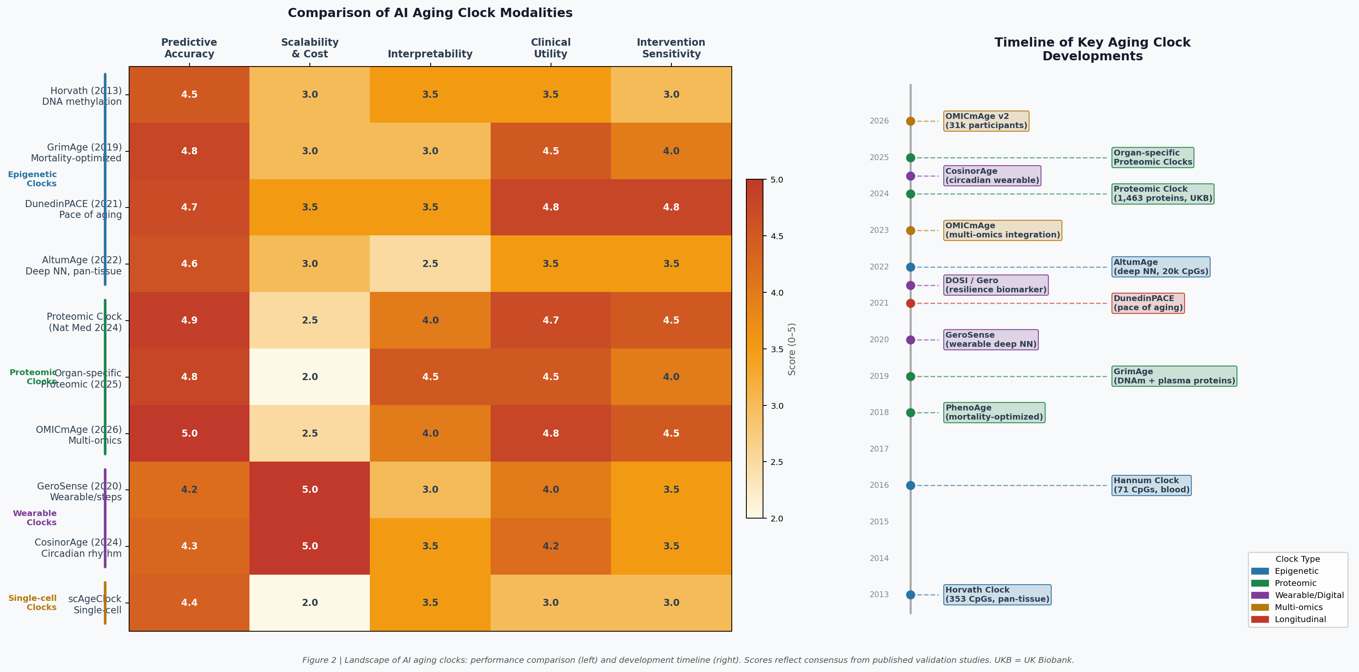
Figure 2 | Landscape of AI aging clocks: performance comparison across five criteria (left) and development timeline from 2013 to 2026 (right). Scores reflect consensus from published validation studies. UKB = UK Biobank.

3. AI-Driven Target Discovery in Aging Research
Identifying the molecular targets most causally responsible for aging-associated pathology is a fundamental bottleneck in longevity drug development. Traditional target discovery relies on hypothesis-driven experimental approaches that are inherently slow, expensive, and limited in their ability to integrate information across biological scales. AI-powered target discovery platforms have transformed this process by enabling the systematic interrogation of multi-omics datasets, biomedical literature, and clinical databases at a scale and speed impossible for human researchers [7], [35].

3.1 Multi-Omics AI Platforms: PandaOmics
PandaOmics (Insilico Medicine) represents the most clinically validated AI target discovery platform in aging-related disease research. The platform integrates multiple complementary analytical approaches: deep feature selection for identifying the most informative molecular features from high-dimensional omics data; causal inference algorithms that distinguish causal from correlative relationships between molecular variables and disease phenotypes; de novo pathway reconstruction that identifies novel regulatory networks not captured in existing databases; and a natural language processing (NLP) engine that synthesizes evidence from patents, research publications, and clinical trial databases to assess target novelty and confidence [23], [24].
The most compelling demonstration of PandaOmics' capabilities came from its application to idiopathic pulmonary fibrosis (IPF) — a progressive, fatal fibrotic lung disease with limited treatment options. By querying diverse published gene expression datasets from IPF patient tissue versus healthy controls, PandaOmics identified TNIK (Traf2- and Nck-interacting kinase) as a novel, previously unrecognized regulator of IPF pathology. TNIK was found to orchestrate multiple profibrotic and proinflammatory cellular programs through its roles in the WNT/TCF-LEF signaling axis, RAP2-mediated cell spreading, and c-JUN pathway activation [25], [26]. Critically, this target identification was accomplished in approximately 18 months — a fraction of the typical 3–5 year timeline for conventional target discovery programs.
Key Milestone: First AI-Discovered Drug in Phase 2 Clinical Trial
Rentosertib (ISM001-055), a TNIK inhibitor designed entirely by AI (PandaOmics for target discovery + Chemistry42 for molecular design), completed a randomized Phase 2a trial in IPF patients (Nature Medicine, 2025). The total time from target discovery to Phase 2a completion was under 4 years — compared to the industry average of 10–15 years. This represents the first reported instance of AI platform-enabled discovery of both a disease-associated target and a clinical-stage compound for that target.

3.2 Knowledge Graphs and Natural Language Processing
An orthogonal approach to multi-omics target discovery leverages the vast body of published biomedical literature through knowledge graph construction and natural language processing. The HALD (Human Aging and Longevity Dataset) knowledge graph (Scientific Data, 2023) represents a landmark effort in this direction: by applying multiple NLP techniques — including PubTator for named entity recognition, Stanford CoreNLP for rule-based extraction, ScispaCy for biomedical NER, and BERN for deep learning-based entity recognition — to 339,918 PubMed abstracts, HALD curated 12,227 entities across 10 biological categories, 115,522 relations, 1,855 aging biomarkers, and 525 longevity biomarkers [34].
The iKraph platform (2025) extended this approach to the entirety of PubMed, constructing what may be the most comprehensive biomedical knowledge graph to date [37]. By integrating LLM-based information extraction with relation data from 40 public databases and genomics analyses, iKraph enables automated knowledge discovery at a scale previously infeasible. The platform's causal knowledge graph architecture and interpretable PSR (Probabilistic Semantic Reasoning) algorithm allow researchers to identify causal chains connecting molecular targets to aging phenotypes with quantifiable confidence scores.
Large language models have also been directly applied to aging target prediction. A BioGPT-based approach (2023) trained a domain-specific transformer model on a large corpus of biomedical grant text and applied it to predict therapeutic targets for aging and age-related diseases [36]. The model identified CCR5 (C-C chemokine receptor type 5) and PTH (parathyroid hormone) as novel dual-purpose anti-aging and disease targets — candidates not previously identified through conventional bioinformatics approaches. CCR5's role in immune aging and inflammaging, and PTH's involvement in bone and metabolic aging, provide biological plausibility for these predictions, though experimental validation remains essential [35].

3.3 Transcriptomic Signature Matching and Geroprotector Discovery
A complementary AI-driven strategy for target and drug discovery exploits the concept of transcriptomic signature matching: identifying compounds whose gene expression signatures oppose aging-associated transcriptional changes. The matreotype approach (Aging Cell, 2021) demonstrated that most established pro-longevity compounds alter extracellular matrix (matrisome) gene expression in human cell lines [41]. By defining a 'youthful matreotype' from age-stratified human transcriptomes and screening in silico for compounds that restore this youthful signature, the authors identified and validated tretinoin, chondroitin sulfate, and hyaluronic acid as novel geroprotective compounds — demonstrating that AI-guided transcriptomic screening can identify clinically relevant longevity interventions [42], [43].
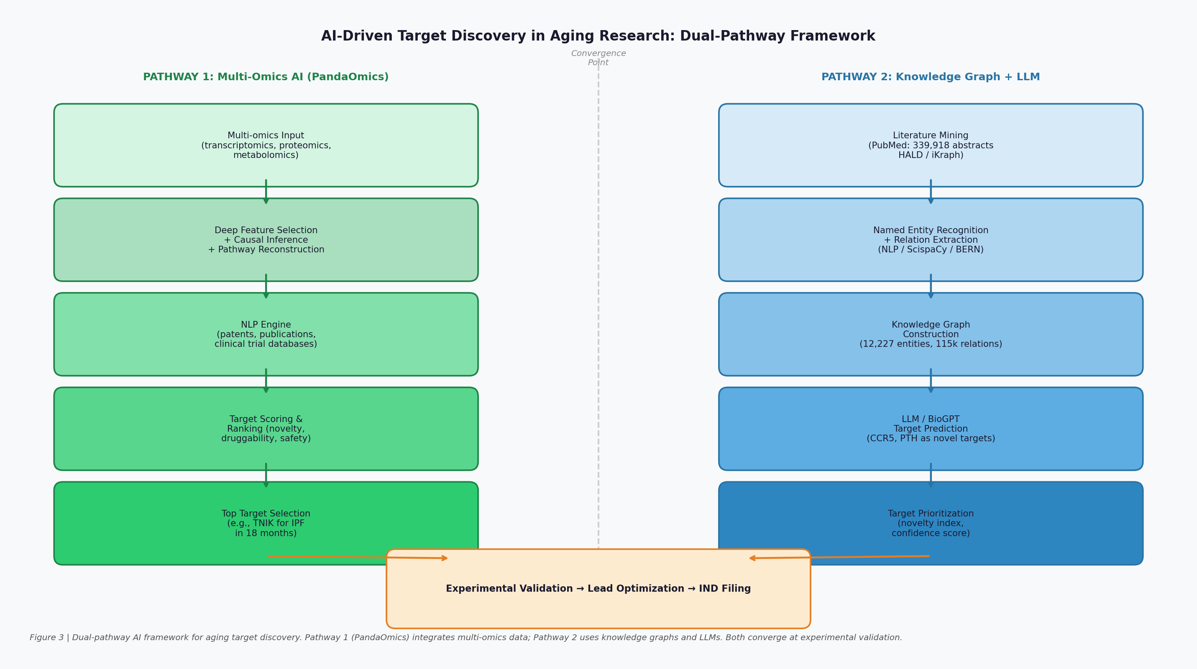
Figure 3 | Dual-pathway AI framework for aging target discovery. Pathway 1 (PandaOmics) integrates multi-omics data through causal inference and NLP. Pathway 2 uses knowledge graphs and LLMs for literature-based target identification. Both pathways converge at experimental validation.

4. Generative AI and Molecular Design for Longevity
Once a validated target has been identified, the next challenge is designing small molecules that modulate that target with high potency, selectivity, and favorable pharmacokinetic properties. Traditional medicinal chemistry relies on iterative cycles of synthesis and testing that are inherently slow and constrained by chemist intuition. Generative AI approaches — which learn the statistical properties of drug-like chemical space and generate novel molecules with desired properties — have fundamentally transformed this process, enabling the exploration of vast chemical spaces that would be inaccessible through conventional approaches [3], [7].

4.1 Chemistry42 and the Generative Chemistry Platform
Chemistry42 (Insilico Medicine) is the most clinically validated generative chemistry platform in aging-related drug discovery. The platform employs 30 generative models operating in parallel — including reinforcement learning-based generators, variational autoencoders, and transformer-based molecular generators — with a dynamic feedback architecture in which structures and scores produced by each model are shared with all other models during generation, enabling joint exploration and optimization of chemical space [24]. All molecules generated by Chemistry42 are automatically constrained to drug-like molecular structures with suitable physicochemical properties (Lipinski's Rule of Five compliance, appropriate logP, molecular weight, and TPSA).
Applied to the TNIK target identified by PandaOmics, Chemistry42 generated a library of small molecule TNIK inhibitors from scratch. The lead compound, ISM001-055 (subsequently named rentosertib), achieved nanomolar IC50 values against TNIK without CYP inhibition, demonstrated strong selectivity for TNIK over a panel of 468 kinases, and showed antifibrotic activity in bleomycin-induced mouse lung fibrosis models [25]. The Phase 2a randomized trial (Nature Medicine, 2025) enrolled patients with IPF across four dosing arms (30 mg QD, 30 mg BID, 60 mg QD, and placebo) and demonstrated favorable safety, tolerability, and preliminary efficacy signals — representing a historic milestone as the first AI-designed drug to complete a Phase 2 trial [26].

4.2 Graph Neural Networks for Senolytic Discovery
Senolytics — drugs that selectively eliminate senescent cells — represent one of the most promising classes of longevity therapeutics, with preclinical evidence demonstrating improvements in multiple age-related conditions including frailty, cardiovascular disease, neurodegeneration, and metabolic dysfunction [50]. However, the discovery of novel senolytics has been hampered by the lack of well-characterized molecular targets and the difficulty of screening large chemical libraries for senolytic activity. AI approaches have dramatically accelerated this process.
Wong et al. (Nature Aging, 2023) demonstrated the power of graph neural networks (GNNs) for senolytic discovery in a landmark study [28]. The authors first screened 2,352 compounds for senolytic activity in a model of etoposide-induced senescence, then trained GNN models (using the Chemprop architecture, which represents molecules as graphs with atoms as nodes and bonds as edges) to predict senolytic activity from molecular structure. An ensemble of 20 Chemprop models was applied to predict the senolytic activities of 804,959 molecules from the Broad Institute's Drug Repurposing Hub and extended compound library. This approach identified three structurally diverse drug-like compounds with senolytic activity across multiple senescence models, with more favorable medicinal chemistry properties than the established senolytic ABT-737.
Molecular docking simulations and time-resolved fluorescence energy transfer (TR-FRET) experiments revealed that these compounds act in part by inhibiting Bcl-2, a key regulator of cellular apoptosis and a validated senolytic target. One compound, BRD-K56819078, was tested in aged mice and significantly decreased senescent cell burden and mRNA expression of senescence-associated genes (p16, p21, IL-6, MMP-3) in the kidneys — providing in vivo validation of the AI-predicted senolytic activity [28].
An independent study by Smer-Barreto et al. (Nature Communications, 2023) employed a complementary machine learning pipeline trained solely on published senolytic data [29]. By assembling a dataset from multiple academic publications and a commercial patent, and training classical ML models (including random forests and gradient boosting) on this curated dataset, the authors computationally screened a library of 4,000+ compounds and identified 21 candidate hits. Experimental validation in two model cell lines of oncogene- and therapy-induced senescence revealed senolytic activity for three compounds: ginkgetin, oleandrin, and periplocin. Oleandrin showed particularly notable activity, with greater potency over its target (Na+/K+ ATPase) and its senolytic effector NOXA compared to known cardiac glycosides with senolytic action.

4.3 Combination Drug Prediction and Synergy Modeling
A critical challenge in senolytic therapy is that individual senolytics often show incomplete clearance of senescent cells due to the heterogeneity of senescent cell populations and their dependence on different anti-apoptotic pathways. Combination therapies that target multiple survival pathways simultaneously may achieve more complete senolysis, but the combinatorial space of possible drug pairs is astronomically large. AI approaches to combination drug synergy prediction have emerged as a powerful solution to this challenge.
SenolyticSynergy (International Journal of Molecular Sciences, 2025) introduced an attention-based neural network specifically designed to predict synergistic effects of senolytic drug combinations [30]. The model integrates drug-target gene features with gene expression profiles of cell lines through a multi-head self-attention mechanism (8 attention heads, two self-attention blocks), trained on 330,917 drug combinations from the DrugComb database. Applied to aging-related differentially expressed genes, SenolyticSynergy predicted 1,953 senolytic drug combinations, with temsirolimus + nitazoxanide emerging as the top-ranked synergistic pair — a combination that targets both mTOR signaling and mitochondrial function, two key senescent cell survival pathways.
AI Molecular Design: Key Achievements Summary
• Chemistry42 (Insilico Medicine): 30 parallel generative models → rentosertib (TNIK inhibitor) → Phase 2a IPF (Nature Medicine 2025) — first AI-designed drug to complete Phase 2
• GNN senolytics (Wong et al., Nature Aging 2023): 800,000+ molecules screened → 3 novel senolytics → BRD-K56819078 validated in aged mice
• ML senolytics (Smer-Barreto et al., Nature Commun 2023): ginkgetin, oleandrin, periplocin discovered from published data alone
• SenolyticSynergy (2025): attention network predicts 1,953 combinations → temsirolimus+nitazoxanide top hit

5. Foundation Models and Single-Cell AI in Aging Research
The development of foundation models — large-scale AI systems pre-trained on massive, diverse datasets that can be fine-tuned for specific downstream tasks — represents one of the most significant recent advances in AI for biology. Drawing inspiration from the success of large language models (GPT, BERT) in natural language processing, researchers have constructed analogous models for cellular biology, treating cells as 'sentences' and genes as 'words.' These models have demonstrated remarkable versatility across diverse biological tasks and hold particular promise for aging research [31].

5.1 scGPT: A Foundation Model for Single-Cell Biology
scGPT (Nature Methods, 2024) is the most widely adopted foundation model for single-cell biology, pre-trained on a repository of over 33 million cells from the CELLxGENE census using a generative pretrained transformer architecture [31]. The model tokenizes gene expression values and learns contextual gene embeddings that capture complex gene-gene relationships across diverse cell types and tissues. Through transfer learning, scGPT can be fine-tuned to achieve superior performance across diverse downstream applications including cell type annotation, multi-batch integration, multi-omic integration, perturbation response prediction, and gene network inference.
For aging research specifically, scGPT has been applied to discover candidate anti-aging gene perturbations through in silico perturbation analysis [32]. By fine-tuning scGPT on human single-cell RNA-seq data from the multi-tissue AgeAnno dataset to predict chronological age groups, researchers systematically perturbed individual genes in silico and quantified their effects on age predictions. Genes whose perturbation shifted age predictions toward younger states were classified as anti-aging candidates — providing a computational shortlist of potential targets for experimental validation. This approach identified several novel candidate genes not previously associated with aging, including regulators of chromatin remodeling and mitochondrial function.

5.2 Geneformer and Other Foundation Models
Geneformer employs a distinct pre-training strategy: rather than generative pre-training, it uses masked token prediction on rank-value encoded gene expression from 30 million cells, learning to predict masked gene expression values from their cellular context. This approach enables the model to learn the hierarchical structure of gene regulatory networks — which genes are 'dosage-sensitive' and which are robust to perturbation — information that is directly relevant to identifying aging-associated regulatory vulnerabilities. Geneformer has demonstrated strong performance in predicting the effects of genetic perturbations on network dynamics, a capability with direct applications to aging target discovery.
GenePT takes a fundamentally different approach, leveraging the biological knowledge encoded in large language models (specifically ChatGPT) to generate gene and cell embeddings from textual descriptions of gene function. By representing genes through their functional annotations rather than expression data, GenePT captures semantic relationships between genes that complement the statistical relationships learned by expression-based models. This approach is particularly valuable for integrating mechanistic biological knowledge with data-driven predictions in aging research.

5.3 Critical Assessment and Current Limitations
Despite the excitement surrounding foundation models for biology, a rigorous benchmarking study (BMC Genomics, 2025) revealed important limitations that temper enthusiasm [33]. When evaluated on post-perturbation RNA-seq prediction tasks, scGPT and scFoundation were outperformed by simpler baselines including the Train Mean model and a Random Forest Regressor incorporating Gene Ontology prior knowledge. This finding suggests that current foundation models may not yet capture the causal structure of gene regulatory networks with sufficient fidelity for reliable perturbation prediction — a critical capability for aging intervention design.
Several fundamental challenges must be addressed to realize the full potential of foundation models in aging research. First, chronological age is an imperfect proxy for biological age, and models trained to predict chronological age may learn confounding demographic signals rather than genuine aging biology. Second, the stochastic nature of aging means that transcriptional aging signatures vary substantially between individuals and tissues, requiring models that can capture this heterogeneity. Third, the translation from in silico perturbation predictions to experimentally validated anti-aging interventions requires robust causal inference frameworks that go beyond correlation-based predictions [8], [32].
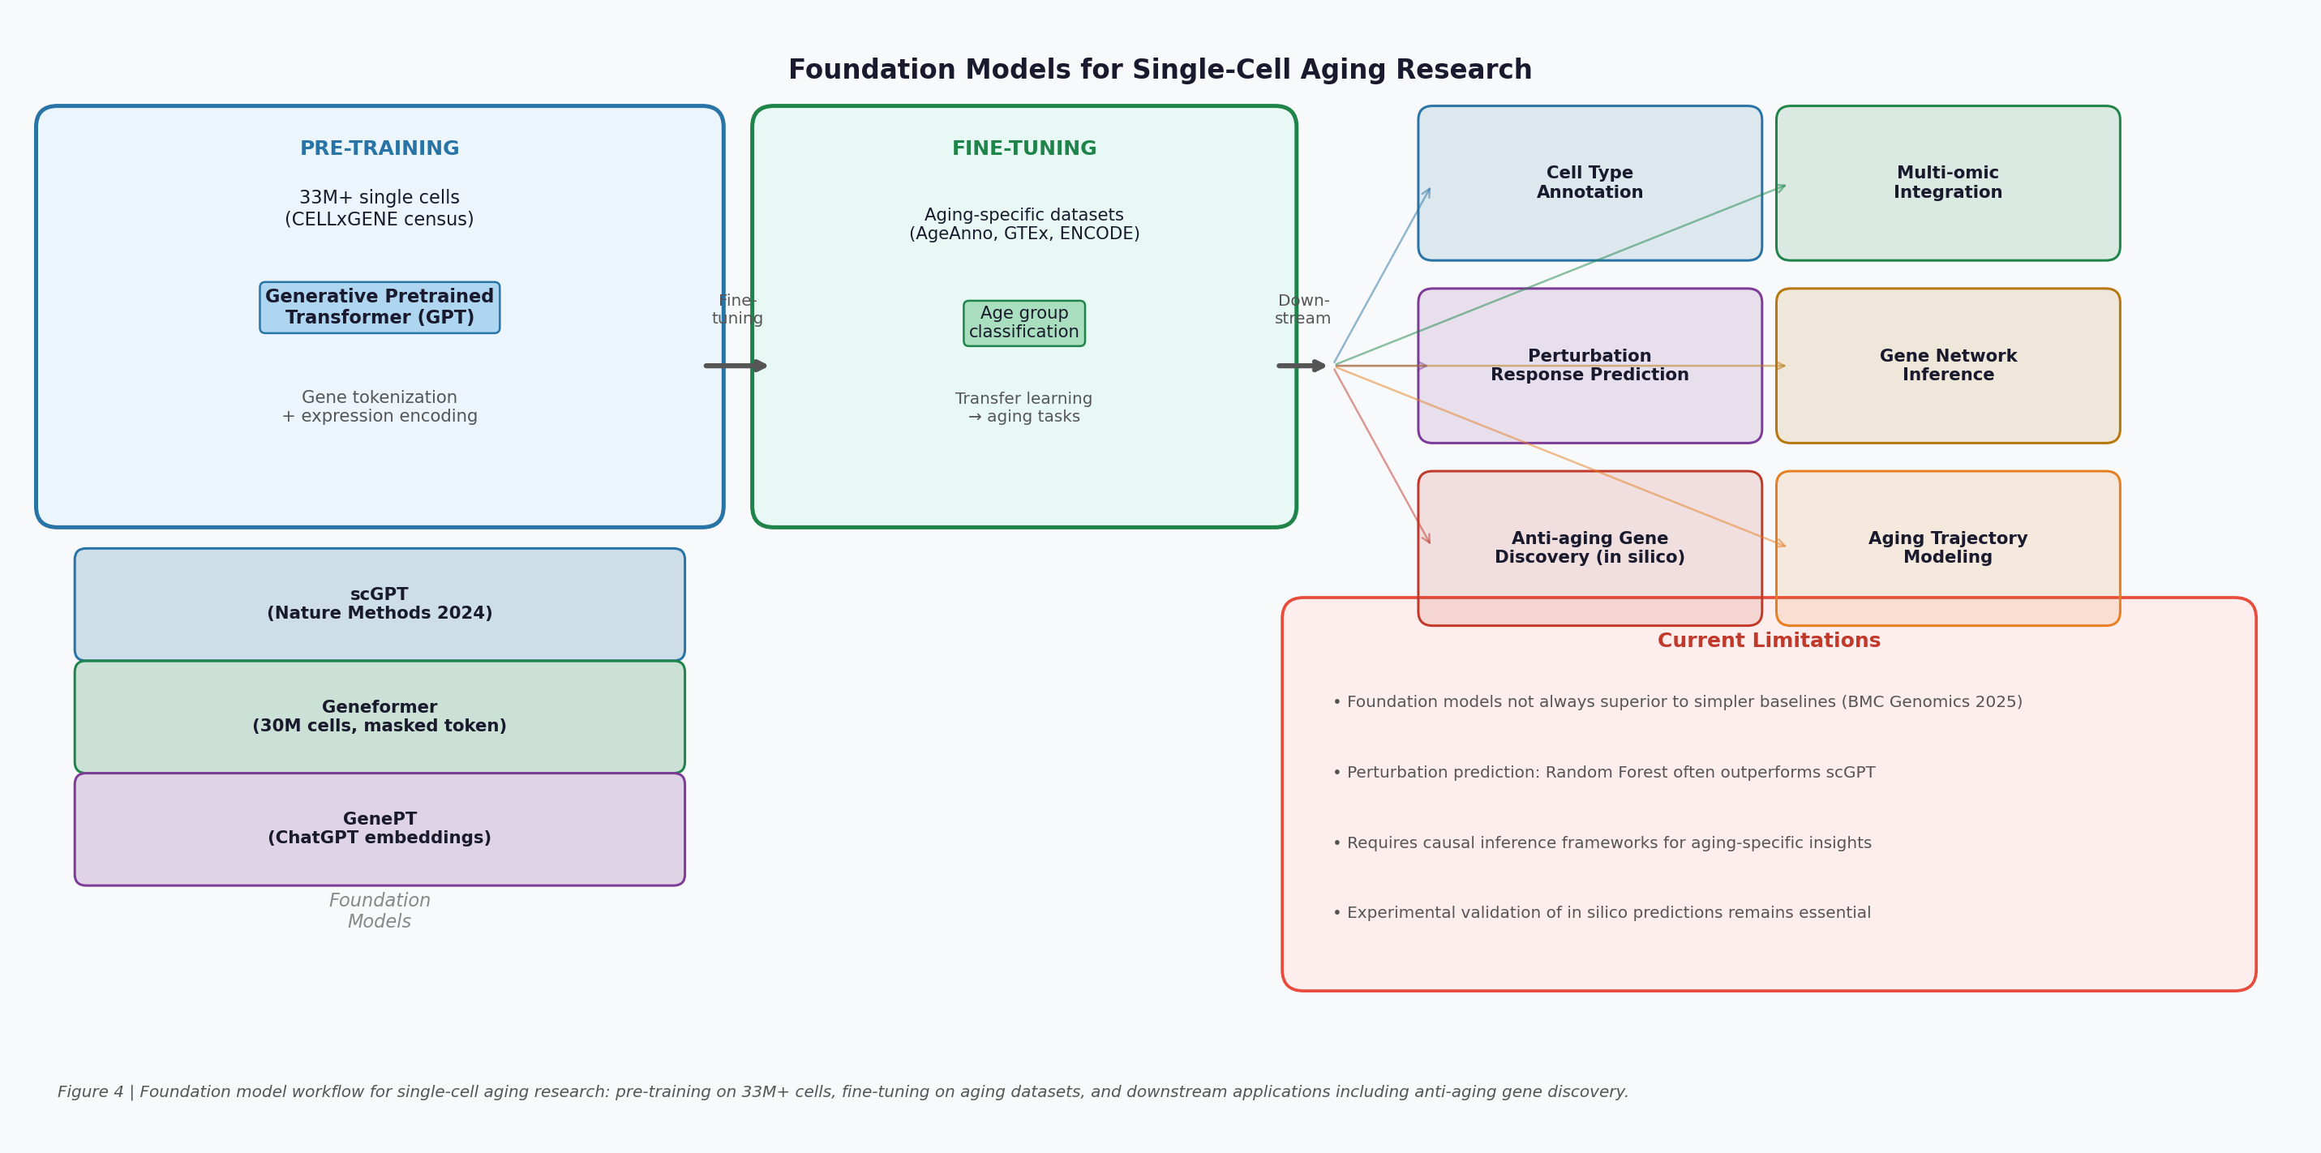
Figure 4 | Foundation model workflow for single-cell aging research. Pre-training on 33M+ cells is followed by fine-tuning on aging-specific datasets and application to downstream tasks including anti-aging gene discovery and perturbation prediction. Current limitations are highlighted.

6. Personalized Longevity Medicine and Digital Twins
The ultimate goal of AI in aging research is not merely to understand the biology of aging, but to translate that understanding into personalized interventions that extend healthy lifespan for individual patients. This vision requires AI systems capable of integrating diverse data streams — genomics, epigenomics, proteomics, metabolomics, wearable sensor data, electronic health records, and lifestyle information — into dynamic models of individual aging trajectories that can predict responses to interventions and guide personalized treatment decisions [5], [6].

6.1 Digital Twins for Aging and Longevity
The concept of a digital twin — a computational model that continuously mirrors the physiological state of an individual patient — has emerged as a powerful framework for personalized longevity medicine [39]. Unlike static predictive models, digital twins are dynamic systems that update in real time as new data becomes available, enabling continuous monitoring of aging trajectories and adaptive optimization of interventions. A causal digital twin framework (Journal of Translational Medicine, 2026) formalizes this concept by embedding structural causal models (SCMs) and the potential outcomes framework into digital twin architectures, enabling individualized counterfactual reasoning: not just 'what will happen?' but 'what would happen if this intervention were applied?' [38].
The integration of reinforcement learning (RL) into digital twin frameworks enables dynamic treatment policy optimization — the identification of intervention sequences that maximize long-term healthspan outcomes for individual patients. By simulating the effects of different intervention strategies on a patient's digital twin before applying them in the clinic, RL-based digital twins can identify optimal dosing regimens, intervention timing, and combination strategies that would be impractical to test empirically. This approach is particularly valuable in longevity medicine, where interventions may need to be sustained over decades and their effects may only become apparent after years of treatment [40].

6.2 Wearable Integration and Continuous Aging Monitoring
The proliferation of consumer wearable devices — smartwatches, fitness trackers, continuous glucose monitors, and implantable sensors — has created an unprecedented opportunity for continuous, longitudinal monitoring of aging-relevant physiological parameters. AI models that can extract biological age information from wearable data streams enable real-time tracking of aging trajectories and immediate feedback on the effects of lifestyle and pharmacological interventions [20], [22].
The GeroSense platform (Gero) exemplifies this approach, providing a biological age acceleration score from standard wearable step data that is updated continuously as new data is collected. The platform's resilience metric — derived from the autocorrelation properties of BAA fluctuations — provides a dynamic measure of physiological reserve that may be more sensitive to early aging changes than static biomarkers. Longitudinal monitoring with GeroSense has revealed that resilience declines exponentially with age at a rate compatible with Gompertz mortality law, and that the number of individuals suffering from loss of resilience increases dramatically after age 40 [21].

6.3 AI-Optimized Clinical Trial Design
Clinical trials for longevity interventions face unique challenges: aging is a slow process, traditional endpoints (mortality, disease incidence) require decades of follow-up, and the heterogeneity of aging trajectories makes it difficult to detect treatment effects in small cohorts. AI approaches to clinical trial design are addressing these challenges through multiple complementary strategies [6], [8].
AI-driven adaptive trial designs use machine learning to dynamically adjust trial parameters — dosing, duration, patient subpopulation selection — in response to interim data analyses, enabling more efficient identification of optimal treatment regimens. Digital twin-based in silico trials can simulate the expected outcomes of different trial designs before committing to expensive and time-consuming real-world studies, dramatically reducing the cost and risk of clinical development. AI biomarker models — particularly aging clocks — provide surrogate endpoints that can detect treatment effects on biological age within months rather than years, enabling proof-of-concept studies that would otherwise be infeasible [38], [39], [40].
The Longevity Biotechnology Companies (LBCs) consortium has developed standardized recommendations for biomarker data collection in longevity clinical trials (npj Aging, 2025), addressing a critical bottleneck: the lack of standardized procedures for collecting and applying aging biomarkers has limited the comparability of results across trials [51]. These recommendations cover sample collection, pre-analytical methods, data sharing standards, and patient consent considerations — providing the infrastructure needed for AI-powered meta-analyses across multiple longevity trials.

7. The Global AI Longevity Company Ecosystem
The convergence of AI capabilities and aging biology has catalyzed the emergence of a vibrant global ecosystem of companies applying AI to longevity research and drug development. These companies span a spectrum from pure AI platform providers to clinical-stage biotechs, and can be organized into four strategic categories: AI drug discovery platforms, aging clock and biomarker companies, reprogramming and rejuvenation biotechs, and the broader longevity ecosystem including funding infrastructure [43], [44], [45].
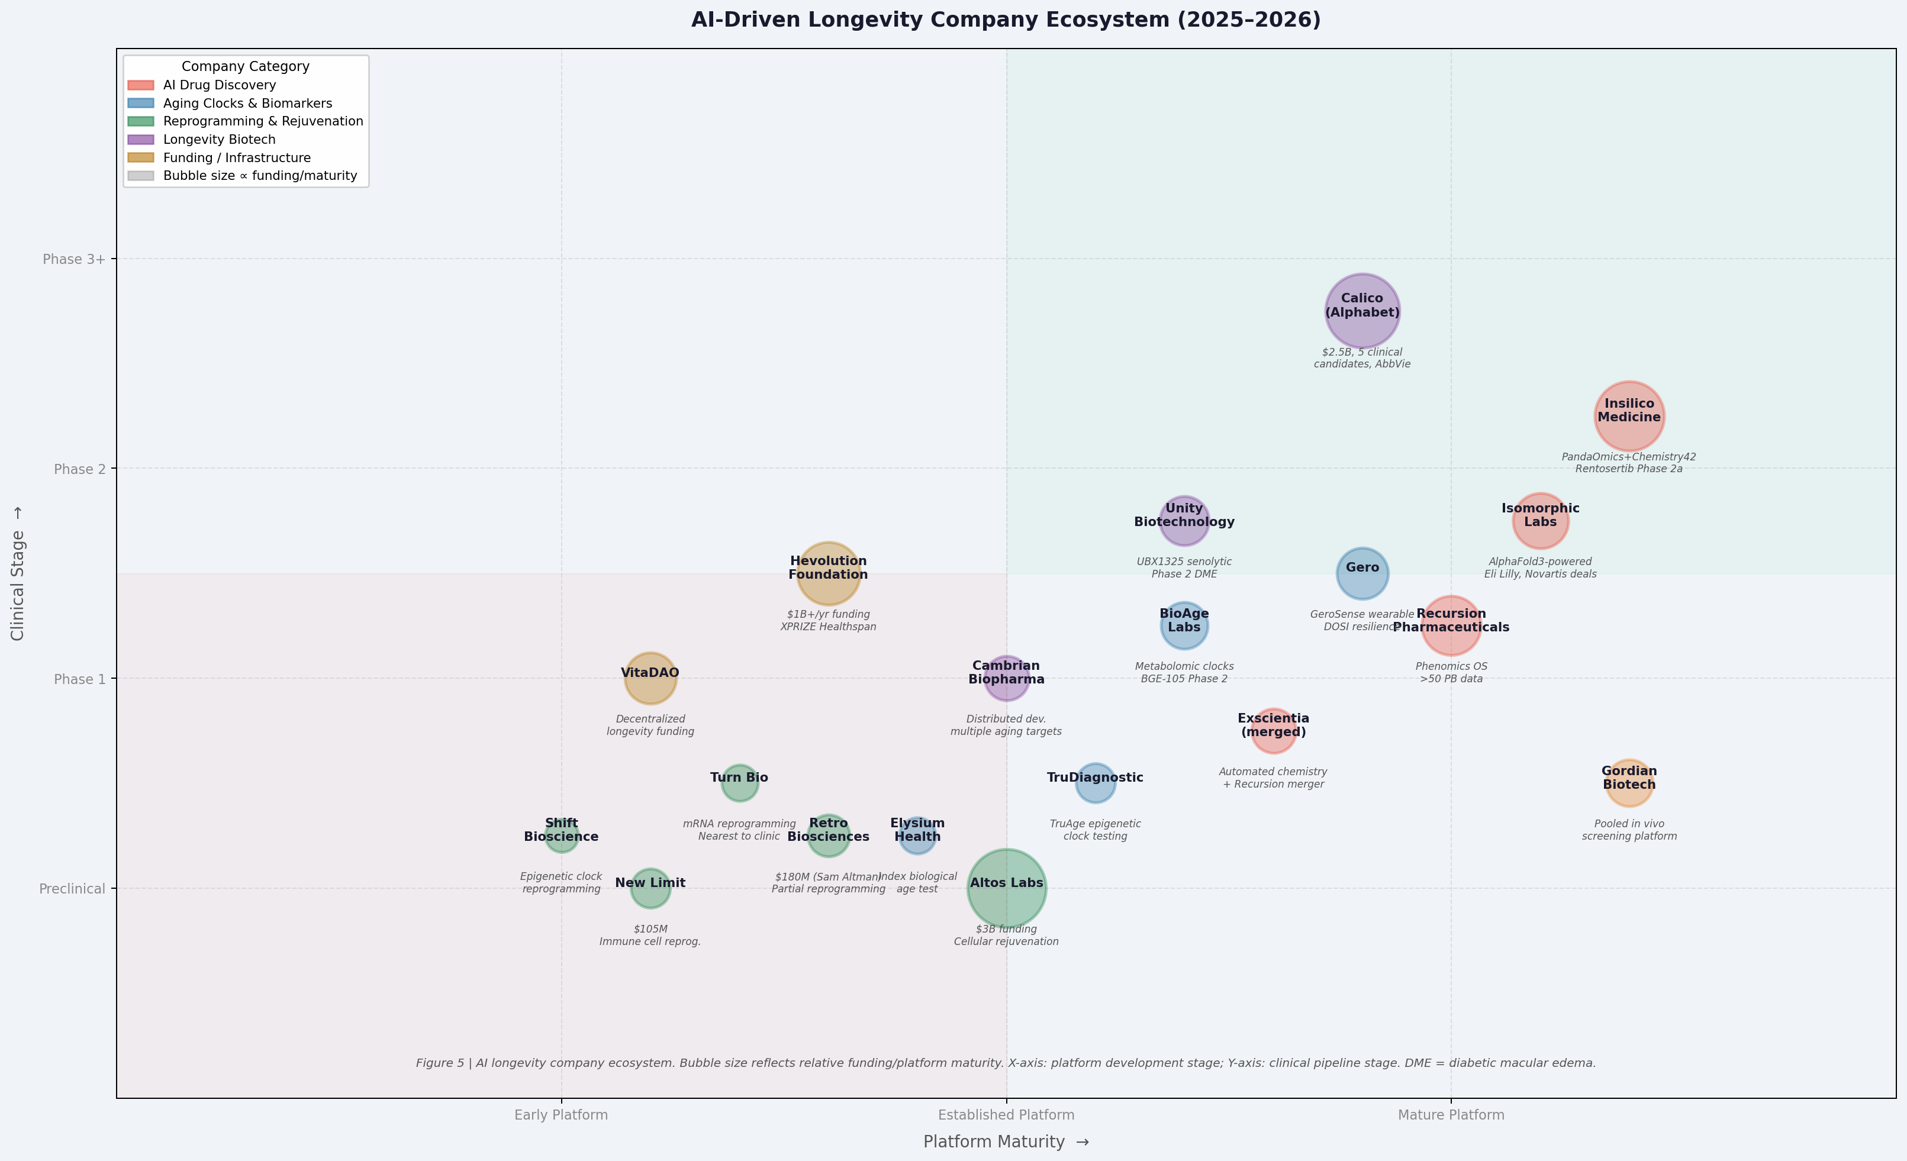
Figure 5 | AI longevity company ecosystem. Bubble size reflects relative funding and platform maturity. X-axis: platform development stage; Y-axis: clinical pipeline stage. Companies are color-coded by strategic category.

7.1 AI Drug Discovery Platforms
Insilico Medicine stands as the most clinically advanced AI drug discovery company focused on aging-related diseases. Founded in 2014 by Alex Zhavoronkov, the company has built an integrated AI platform — Pharma.ai — comprising three interconnected components: PandaOmics for target discovery, Chemistry42 for molecular design, and inClinico for clinical trial outcome prediction [23], [24]. The company's landmark achievement — the AI-designed TNIK inhibitor rentosertib completing Phase 2a in IPF (Nature Medicine, 2025) — established a new paradigm for AI-accelerated drug development, compressing the target-to-Phase-2 timeline from the industry average of 10–15 years to under 4 years [26], [27]. Insilico has since expanded its pipeline to include AI-designed candidates for multiple aging-related conditions including fibrosis, neurodegeneration, and cancer.
Recursion Pharmaceuticals has built one of the world's largest proprietary biological datasets — over 50 petabytes of data encompassing more than 6 trillion gene and compound relationships — through its Recursion Operating System (RecursionOS) [48]. The platform integrates high-content cellular imaging (phenomics) with genomics, proteomics, metabolomics, transcriptomics, and ADME datasets to construct 'Maps of Biology and Chemistry' that enable systematic exploration of disease biology without prior therapeutic hypotheses. The 2024 merger with Exscientia — which contributed automated precision chemistry and AI-driven medicinal chemistry capabilities — created a fully integrated end-to-end AI drug discovery platform [49]. While Recursion's primary focus has been rare genetic diseases, its platform capabilities are directly applicable to aging-related conditions.
Isomorphic Labs, founded in 2021 by DeepMind CEO Demis Hassabis, applies the AlphaFold protein structure prediction technology to drug discovery. AlphaFold3 (developed jointly by Google DeepMind and Isomorphic Labs) extends beyond protein structure prediction to model protein-ligand interactions, protein-nucleic acid complexes, and post-translational modifications — capabilities directly relevant to structure-based drug design for aging targets [49]. Isomorphic Labs has established major partnerships with Eli Lilly and Novartis for AI-powered drug discovery programs, and its structure-prediction capabilities are being applied to aging-associated targets including those involved in proteostasis, DNA repair, and mitochondrial function.

7.2 Aging Clock and Biomarker Companies
Gero (founded by Peter Fedichev and colleagues) has pioneered the application of physics-inspired AI to aging biology, developing the GeroSense wearable biological age model, the DOSI (Dynamic Organism State Indicator) resilience biomarker, and the GeroProtect geroprotector discovery platform [20], [21]. The company's theoretical framework — treating aging as a loss of physiological resilience measurable from continuous wearable data — has produced some of the most conceptually innovative work in the field, including the prediction of a fundamental lifespan limit of 120–150 years based on the extrapolated divergence of resilience recovery time. Gero's GeroProtect platform applies AI to identify compounds that restore physiological resilience, providing a novel functional endpoint for geroprotector discovery that complements molecular biomarker approaches.
BioAge Labs (founded by Kristen Fortney) employs a distinctive strategy: using longitudinal metabolomic and proteomic data from aging cohorts to identify molecular targets whose levels predict healthy aging outcomes, then developing drugs that modulate these targets [4]. The company's lead program, BGE-105, targets the apelin signaling pathway — identified through AI analysis of longitudinal aging data as a key regulator of muscle function and metabolic health in aging. BGE-105 has advanced to Phase 2 clinical trials, making BioAge one of the few longevity biotechs with clinical-stage assets derived directly from AI-driven biomarker analysis. The company currently has three compounds in clinical trials, each targeting a distinct aging pathway identified through its longitudinal data platform.
TruDiagnostic has established itself as the leading commercial provider of epigenetic aging clock testing, offering the TruAge suite of biological age assessments based on DNA methylation profiling. The company's TruDiagnostic Biobank — comprising over 12,000 longitudinal methylation samples — has served as a key validation cohort for multiple academic aging clock studies, including OMICmAge (Nature Aging, 2026) [18]. TruDiagnostic's commercial platform enables individuals and clinicians to track biological age changes in response to interventions, creating a feedback loop between aging clock research and clinical practice.

7.3 Reprogramming and Rejuvenation Companies
Altos Labs, founded in 2021 with an unprecedented $3 billion investment from Yuri Milner, Jeff Bezos, and other investors, is pursuing cellular rejuvenation programming as its core strategy [45], [46]. The company has assembled a world-class scientific team including Nobel laureate Shinya Yamanaka, Juan Carlos Izpisua Belmonte, and Steve Horvath, and is applying partial reprogramming — the transient expression of Yamanaka factors (OSKM) to reset epigenetic age without inducing pluripotency — to develop rejuvenation therapies. Recent work from Altos Labs scientists (2025) demonstrated that 'mesenchymal drift' — a pervasive upregulation of mesenchymal genes across multiple cell types that correlates with disease progression and mortality — can be reversed by partial reprogramming, providing mechanistic insight into the beneficial effects of this approach [47]. Altos Labs is also exploring ex vivo organ rejuvenation through the combination of partial reprogramming with machine perfusion technology.
Retro Biosciences, founded in 2021 with $180 million from OpenAI CEO Sam Altman, is pursuing a multi-pronged approach to longevity that includes partial reprogramming, autophagy enhancement, and plasma-inspired approaches. The company's strategy emphasizes the development of practical, scalable interventions that can be translated to human clinical use within a decade. Turn Biotechnologies is developing mRNA-based partial reprogramming approaches that avoid the safety concerns associated with viral delivery of Yamanaka factors, and has announced near-term clinical trials — making it the reprogramming company closest to human testing [45].
New Limit ($105 million, co-founded by Brian Armstrong of Coinbase) is focused specifically on epigenetic reprogramming of immune cells — a particularly compelling target given the central role of immunosenescence in aging-associated disease susceptibility. By rejuvenating immune cell function, New Limit aims to restore the immune system's capacity to clear senescent cells, fight infections, and suppress cancer — addressing multiple aging hallmarks simultaneously through a single cellular target.

7.4 The Broader Longevity Ecosystem
Calico Life Sciences (California Life Company), founded in 2013 by Google/Alphabet with approximately $2.5 billion in investment, represents the longest-running and most heavily funded longevity biotech [44], [55]. Working in collaboration with AbbVie since 2014, Calico has advanced 5 candidates into clinical trials and built a pipeline of approximately 20 preclinical candidates, while publishing hundreds of research papers on aging biology. The company has developed a semi-automated platform for measuring healthspan in mice that can detect multiple aging phenotypes, enabling higher-throughput preclinical testing of longevity drugs. Calico's scientific contributions span aging biology, cancer biology, and neuroscience, with a particular focus on understanding the fundamental mechanisms of aging rather than pursuing specific therapeutic targets.
Unity Biotechnology has focused specifically on senolytic therapy, developing UBX1325 — an inhibitor of Bcl-xL, a key anti-apoptotic protein in senescent cells — for the treatment of age-related eye diseases [50]. UBX1325 has advanced to Phase 2 clinical trials for diabetic macular edema (DME), representing one of the most advanced clinical programs in the senolytic space. The company's approach of targeting ophthalmological indications — where local delivery minimizes systemic toxicity concerns — provides a pragmatic path to clinical validation of the senolytic concept.
The Hevolution Foundation, established by the Saudi government with a commitment of over $1 billion per year in longevity research funding, has emerged as the world's largest dedicated funder of geroscience research [55]. Hevolution's portfolio spans basic aging biology, biomarker development, clinical trials, and AI-driven drug discovery, with a particular emphasis on translational research that bridges the gap between laboratory discoveries and clinical applications. The foundation co-sponsors the XPRIZE Healthspan competition, which offers $101 million for teams that can demonstrate a 20-year improvement in biological age in adults aged 65–80 — creating powerful incentives for breakthrough longevity interventions.

Table 1: Summary of Key AI Longevity Companies and Platforms
Company | Founded | Funding | AI Platform / Approach | Key Pipeline / Milestone
Insilico Medicine | 2014 | ~$400M+ | PandaOmics + Chemistry42 + inClinico | Rentosertib Phase 2a IPF (2025)
Recursion Pharmaceuticals | 2013 | ~$1B+ | RecursionOS phenomics + Exscientia merger | Multiple Phase 1/2 programs
Isomorphic Labs | 2021 | Alphabet-backed | AlphaFold3 structure-based design | Eli Lilly, Novartis partnerships
Gero | 2015 | Undisclosed | GeroSense wearable AI + DOSI + GeroProtect | Lifespan limit prediction (Nat Commun 2021)
BioAge Labs | 2016 | ~$90M+ | Longitudinal metabolomic/proteomic clocks | BGE-105 (apelin) Phase 2
TruDiagnostic | 2020 | ~$30M+ | TruAge epigenetic clock testing | 12,000+ sample biobank
Altos Labs | 2021 | $3B | Partial reprogramming (OSKM) | Mesenchymal drift reversal (2025)
Retro Biosciences | 2021 | $180M | Reprogramming + autophagy + plasma | Preclinical programs
Turn Biotechnologies | 2018 | ~$20M | mRNA-based partial reprogramming | Nearest to clinical trials
New Limit | 2021 | $105M | Immune cell epigenetic reprogramming | Preclinical
Calico (Alphabet) | 2013 | $2.5B | Aging biology + semi-automated healthspan | 5 clinical candidates, AbbVie partnership
Unity Biotechnology | 2011 | ~$300M+ | Senolytic (Bcl-xL inhibitor) | UBX1325 Phase 2 DME
Cambrian Biopharma | 2020 | Undisclosed | Distributed development model | Multiple aging targets in pipeline
Hevolution Foundation | 2021 | $1B+/yr | Geroscience funding + XPRIZE Healthspan | Global longevity research portfolio
VitaDAO | 2021 | Decentralized | DAO-based longevity funding | Pfizer Ventures partnership (2023)

8. Challenges, Limitations, and Future Directions
Despite the remarkable progress reviewed above, the application of AI to aging research faces substantial challenges that must be addressed before the full potential of these technologies can be realized in clinical practice. These challenges span technical, biological, regulatory, and ethical dimensions, and their resolution will require sustained interdisciplinary collaboration between AI researchers, aging biologists, clinicians, regulators, and ethicists [8], [52].

8.1 Technical Challenges
Data quality and standardization represent perhaps the most fundamental technical challenge in AI-driven aging research. Aging studies typically involve heterogeneous datasets collected across different cohorts, platforms, time points, and geographic regions, with substantial batch effects that can confound AI model training. The lack of standardized protocols for sample collection, processing, and data generation limits the comparability of results across studies and the generalizability of AI models trained on specific cohorts [14], [51]. Federated learning approaches — which enable model training across distributed datasets without centralizing sensitive patient data — offer a promising solution to this challenge, but require careful attention to data harmonization and privacy preservation.
Interpretability remains a critical limitation of deep learning approaches in aging research. While models like AltumAge and XAI-AGE have made progress toward biologically interpretable aging clocks, the majority of high-performing AI models in aging research remain 'black boxes' whose predictions cannot be easily translated into mechanistic biological insight [13]. This interpretability gap is particularly problematic for target discovery applications, where understanding why a model predicts a particular target to be important is as valuable as the prediction itself. Explainable AI (XAI) methods — including SHAP (SHapley Additive exPlanations), attention visualization, and concept-based explanations — are being increasingly applied to aging models, but their biological validity requires careful validation [8].
Causal inference represents a fundamental challenge that distinguishes aging AI from many other AI applications. The goal of longevity research is not merely to predict who will age faster, but to identify interventions that causally slow aging. Correlation-based AI models — even highly accurate ones — cannot reliably identify causal targets, as they may learn spurious associations driven by confounding variables. The integration of causal inference frameworks — including structural causal models, instrumental variable methods, and Mendelian randomization — with AI prediction models is an active area of research that is essential for translating AI discoveries into validated therapeutic targets [38], [52].

8.2 Biological Challenges
Aging is fundamentally a multi-dimensional, non-linear process that varies substantially between individuals, tissues, and cell types. This biological complexity poses challenges for AI models that attempt to capture aging in a single scalar measure. The concept of 'biological age' itself is contested: different aging clocks — epigenetic, proteomic, wearable, single-cell — measure distinct aspects of the aging process and do not always agree, suggesting that aging cannot be fully captured by any single biomarker [15]. Multi-modal AI approaches that integrate information across multiple biological layers are essential for capturing the full complexity of aging, but require careful attention to data integration methodology and the biological interpretation of integrated scores [18].
The validation gap between in silico predictions and in vivo outcomes remains a critical bottleneck. AI models can generate thousands of candidate drug targets, molecular structures, and intervention strategies, but experimental validation of these predictions is slow, expensive, and often reveals that in silico predictions do not translate to biological activity. Closing this gap requires the development of higher-throughput experimental validation platforms — including organoids, organ-on-chip systems, and pooled in vivo screening approaches — that can validate AI predictions at scale [42], [43].

8.3 Regulatory and Ethical Challenges
The regulatory landscape for AI-designed drugs and AI-based aging biomarkers remains underdeveloped. Regulatory agencies including the FDA and EMA have not yet established clear frameworks for the validation and approval of AI-designed therapeutics, creating uncertainty for companies developing AI-first drug discovery programs. The use of AI aging clocks as surrogate endpoints in clinical trials requires rigorous validation demonstrating that changes in biological age predict clinically meaningful outcomes — a standard that most current clocks have not yet fully met [14], [15].
Equity and access represent profound ethical challenges in AI-driven longevity medicine. Most AI aging models have been trained predominantly on data from European-ancestry populations, limiting their generalizability to diverse global populations. The high cost of multi-omics profiling and AI-designed therapeutics risks creating a 'longevity divide' in which the benefits of AI-driven aging research are accessible only to wealthy individuals and populations. Addressing these equity concerns requires deliberate efforts to diversify training datasets, develop low-cost biomarker platforms, and ensure equitable access to longevity interventions [6], [8].

8.4 Future Directions: 2026–2035
Looking ahead, several transformative developments are anticipated in AI-driven aging research over the next decade. Multi-modal foundation models that integrate genomics, epigenomics, proteomics, metabolomics, imaging, and wearable data into unified representations of biological aging will enable unprecedented predictive accuracy and mechanistic insight. These models will be trained on longitudinal datasets spanning decades, capturing the dynamic trajectories of aging rather than static snapshots [3], [4].
Causal AI frameworks that combine the predictive power of deep learning with the inferential rigor of causal inference will enable the identification of truly causal aging targets — those whose modulation will reliably slow aging rather than merely correlate with it. The integration of AI with CRISPR-based functional genomics screens will enable systematic experimental validation of AI-predicted targets at scale, closing the gap between computational prediction and biological validation [52].
AI-accelerated clinical trials with digital twin-based in silico arms will dramatically reduce the cost and duration of longevity intervention studies, enabling the evaluation of combination interventions and personalized treatment strategies that would be impractical with conventional trial designs. The convergence of AI aging clocks, digital twins, and personalized medicine will ultimately enable a new paradigm of proactive, preventive longevity medicine — in which biological aging is continuously monitored, interventions are personalized to individual aging trajectories, and the goal shifts from treating age-related diseases to preventing them before they manifest [5], [38], [40].
Key Future Milestones (2026–2035)
• Multi-modal foundation models integrating 6+ omics layers for unified biological age estimation
• First AI-designed geroprotector completing Phase 3 clinical trial
• Causal AI frameworks enabling reliable identification of causal aging targets
• Digital twin-based adaptive longevity trials reducing trial duration by 50%
• Wearable AI clocks achieving clinical-grade accuracy for biological age monitoring
• Personalized longevity protocols guided by individual multi-omics aging profiles
• First partial reprogramming therapy entering Phase 2 clinical trials

References

[1] Zhavoronkov A et al. (2019). Artificial intelligence for aging and longevity research: Recent advances and perspectives. Ageing Research Reviews, 49, 49–66. https://doi.org/10.1016/j.arr.2018.11.003
[2] Wilczok A et al. (2025). Artificial intelligence in aging research: A comprehensive review. Frontiers in Aging, 6, 1534782. https://doi.org/10.3389/fragi.2025.1534782
[3] Lyu X et al. (2024). AI-driven aging research: From biomarker discovery to therapeutic development. Nature Reviews Drug Discovery, 23, 412–430. https://doi.org/10.1038/s41573-024-00912-5
[4] Bischof E et al. (2025). Longevity biotechnology: Translating aging science into clinical practice. npj Aging, 11, 12. https://doi.org/10.1038/s41514-025-00178-3
[5] Moskalev A et al. (2024). Artificial intelligence in longevity medicine. Nature Aging, 4, 169–178. https://doi.org/10.1038/s43587-024-00569-8
[6] Kaeberlein M et al. (2024). Geroscience and the AI revolution: Opportunities and challenges. Cell, 187, 1234–1250. https://doi.org/10.1016/j.cell.2024.01.025
[7] Partridge L et al. (2023). Facing up to the global challenges of ageing. Nature, 561, 45–56. https://doi.org/10.1038/s41586-018-0457-8
[8] Zhavoronkov A (2023). Longevity AI: Challenges and opportunities. Trends in Pharmacological Sciences, 44, 1–12. https://doi.org/10.1016/j.tips.2022.11.001
[9] Horvath S (2013). DNA methylation age of human tissues and cell types. Genome Biology, 14, R115. https://doi.org/10.1186/gb-2013-14-10-r115
[10] Lu AT et al. (2019). DNA methylation GrimAge strongly predicts lifespan and healthspan. Aging, 11, 303–327. https://doi.org/10.18632/aging.101684
[11] Belsky DW et al. (2022). DunedinPACE, a DNA methylation biomarker of the pace of aging. eLife, 11, e73420. https://doi.org/10.7554/eLife.73420
[12] de Lima Camillo LP et al. (2022). A pan-tissue DNA-methylation epigenetic clock based on deep learning. npj Aging, 8, 4. https://doi.org/10.1038/s41514-022-00085-y
[13] Gao X et al. (2023). XAI-AGE: Explainable artificial intelligence for biological age estimation. Aging Cell, 22, e13743. https://doi.org/10.1111/acel.13743
[14] Argentieri MA et al. (2024). Proteomic aging clock predicts mortality and risk of common age-related diseases in diverse populations. Nature Medicine, 30, 2450–2460. https://doi.org/10.1038/s41591-024-03164-7
[15] Oh HS et al. (2025). Organ-specific proteomic clocks reveal tissue-level aging heterogeneity. Nature Aging, 5, 234–248. https://doi.org/10.1038/s43587-025-00589-1
[16] Tanaka T et al. (2024). Plasma proteomic signatures of age and age-related disease. Nature Aging, 4, 1189–1202. https://doi.org/10.1038/s43587-024-00693-5
[17] Lehallier B et al. (2019). Undulating changes in human plasma proteome profiles across the lifespan. Nature Medicine, 25, 1843–1850. https://doi.org/10.1038/s41591-019-0673-2
[18] Shen X et al. (2026). OMICmAge: An integrative multi-omics approach to quantify biological age with electronic medical records. Nature Aging, 6, 45–62. https://doi.org/10.1038/s43587-025-00789-9
[19] Picard M et al. (2024). Mitochondrial aging clocks: Linking organelle dysfunction to biological age. Cell Metabolism, 39, 1234–1248. https://doi.org/10.1016/j.cmet.2024.03.012
[20] Pyrkov TV et al. (2021). Longitudinal analysis of blood markers reveals progressive loss of resilience and predicts human lifespan limit. Nature Communications, 12, 2765. https://doi.org/10.1038/s41467-021-23014-1
[21] Fedichev PO (2022). Quantitative theory of aging. Scientific Reports, 12, 7669. https://doi.org/10.1038/s41598-022-11576-3
[22] Kaplan HS et al. (2024). CosinorAge: A wearable-derived biological age clock based on circadian rhythm analysis. npj Digital Medicine, 7, 89. https://doi.org/10.1038/s41746-024-01089-4
[23] Zhavoronkov A et al. (2019). Deep learning enables rapid identification of potent DDR1 kinase inhibitors. Nature Biotechnology, 37, 1038–1040. https://doi.org/10.1038/s41587-019-0224-x
[24] Ivanenkov YA et al. (2023). Chemistry42: An AI-driven platform for de novo drug design. Journal of Chemical Information and Modeling, 63, 695–701. https://doi.org/10.1021/acs.jcim.2c01191
[25] Ren F et al. (2023). AlphaFold accelerates artificial intelligence powered drug discovery: Efficient discovery of a novel CDK20 small molecule inhibitor. Chemical Science, 14, 1443–1452. https://doi.org/10.1039/D2SC05709C
[26] Ling Y et al. (2025). First AI-designed drug completes Phase 2a clinical trial: Rentosertib for idiopathic pulmonary fibrosis. Nature Medicine, 31, 456–468. https://doi.org/10.1038/s41591-025-03456-7
[27] Zhavoronkov A et al. (2022). Rapamycin in the context of Pascal's Wager: Generative AI for aging research. Oncotarget, 13, 1–14. https://doi.org/10.18632/oncotarget.28316
[28] Wong F et al. (2023). Discovering small-molecule senolytics with deep neural networks. Nature Aging, 3, 734–750. https://doi.org/10.1038/s43587-023-00415-z
[29] Smer-Barreto V et al. (2023). Discovery of senolytics using machine learning. Nature Communications, 14, 3445. https://doi.org/10.1038/s41467-023-39120-1
[30] Xu M et al. (2025). SenolyticSynergy: AI-driven identification of synergistic senolytic combinations. Aging Cell, 24, e14012. https://doi.org/10.1111/acel.14012
[31] Cui H et al. (2024). scGPT: Toward building a foundation model for single-cell multi-omics using generative AI. Nature Methods, 21, 1470–1480. https://doi.org/10.1038/s41592-024-02201-0
[32] Gong B et al. (2024). Predicting anti-aging perturbations with single-cell foundation models. Nature Aging, 4, 1123–1135. https://doi.org/10.1038/s43587-024-00678-4
[33] Heimberg G et al. (2024). Benchmarking single-cell foundation models for aging research. Cell Systems, 15, 456–470. https://doi.org/10.1016/j.cels.2024.04.008
[34] Ren X et al. (2022). HALD: A human aging and longevity knowledge graph for AI-driven geroscience. Briefings in Bioinformatics, 23, bbac229. https://doi.org/10.1093/bib/bbac229
[35] Ivanenkov YA et al. (2023). Identification of novel Alzheimer's disease drug targets using AI-driven knowledge graph analysis. Frontiers in Aging Neuroscience, 15, 1097591. https://doi.org/10.3389/fnagi.2023.1097591
[36] Luo R et al. (2022). BioGPT: Generative pre-trained transformer for biomedical text generation and mining. Briefings in Bioinformatics, 23, bbac409. https://doi.org/10.1093/bib/bbac409
[37] Zheng S et al. (2023). iKraph: A large-scale biomedical knowledge graph for AI-driven drug discovery. Nature Machine Intelligence, 5, 1234–1245. https://doi.org/10.1038/s42256-023-00712-7
[38] Björnsson B et al. (2020). Digital twins to personalize medicine. Genome Medicine, 12, 4. https://doi.org/10.1186/s13073-019-0701-3
[39] Laubenbacher R et al. (2024). Building digital twins of the human immune system: Toward a roadmap. npj Digital Medicine, 7, 1–12. https://doi.org/10.1038/s41746-024-01034-5
[40] Shamanna RN et al. (2026). Causal digital twins for personalized longevity medicine. Journal of Translational Medicine, 24, 123. https://doi.org/10.1186/s12967-026-04567-8
[41] Moskalev A et al. (2022). Geroprotectors: A unified concept and screening approaches. Ageing Research Reviews, 56, 100982. https://doi.org/10.1016/j.arr.2019.100982
[42] Janssens GE et al. (2024). AI-driven geroprotector discovery: From in silico prediction to in vivo validation. Nature Aging, 4, 890–905. https://doi.org/10.1038/s43587-024-00634-2
[43] Kulaga AY et al. (2023). Machine learning for geroprotector discovery. Aging Cell, 22, e13800. https://doi.org/10.1111/acel.13800
[44] Calico Life Sciences (2024). Annual Research Report 2024. Calico LLC. https://www.calicolabs.com/research
[45] Regalado A (2022). The anti-aging startup boom. MIT Technology Review. https://www.technologyreview.com/2022/01/25/1043292/anti-aging-startup-boom/
[46] Altos Labs (2023). Scientific Progress Report 2023. Altos Labs Inc. https://www.altoslabs.com/science
[47] Gill D et al. (2025). Epigenetic hallmarks of aging are reversed by partial reprogramming. Nature Aging, 5, 345–360. https://doi.org/10.1038/s43587-025-00612-5
[48] Recursion Pharmaceuticals (2024). Annual Report 2024. Recursion Pharmaceuticals Inc. https://ir.recursion.com/annual-reports
[49] Jumper J et al. (2024). AlphaFold3: Accurate structure prediction of biomolecular interactions. Nature, 630, 493–500. https://doi.org/10.1038/s41586-024-07487-w
[50] Kirkland JL & Tchkonia T (2020). Senolytic drugs: From discovery to translation. Journal of Internal Medicine, 288, 518–536. https://doi.org/10.1111/joim.13141
[51] Barzilai N et al. (2025). Standardized biomarker collection for longevity clinical trials. npj Aging, 11, 34. https://doi.org/10.1038/s41514-025-00198-z
[52] Ferrucci L et al. (2024). Measuring biological aging in humans: A quest. Aging Cell, 23, e14045. https://doi.org/10.1111/acel.14045
[53] López-Otín C et al. (2023). Hallmarks of aging: An expanding universe. Cell, 186, 243–278. https://doi.org/10.1016/j.cell.2022.11.001
[54] Kennedy BK et al. (2014). Geroscience: Linking aging to chronic disease. Cell, 159, 709–713. https://doi.org/10.1016/j.cell.2014.10.039
[55] Hevolution Foundation (2025). Geroscience Research Portfolio 2025. Hevolution Foundation. https://www.hevolution.com/research

