Longevity, Anti-Aging Therapy, and Aging Reversal:
A Comprehensive Scientific Overview for Grant Proposal Background
Prepared as background documentation for research grant applications
May 2026 | Comprehensive Literature Review | 120+ Primary Sources
Table of Contents
No table of contents entries found.[Right-click here and select 'Update Field' to generate Table of Contents]

1. Introduction: The Science of Aging and the Longevity Imperative
Aging is the single greatest risk factor for the majority of chronic diseases that dominate global morbidity and mortality in the twenty-first century. Cardiovascular disease, type 2 diabetes, neurodegeneration, cancer, osteoporosis, and sarcopenia all share aging as their primary driver, yet until recently, aging itself was not considered a tractable therapeutic target. This paradigm has undergone a fundamental transformation over the past two decades, driven by convergent discoveries in molecular biology, epigenetics, genetics, and systems biology that have revealed aging to be not a passive, inevitable process, but an active, regulated, and—at least in model organisms—reversible biological program [1, 2].
The global demographic context makes this scientific revolution urgent. By 2050, the number of individuals aged 65 and older is projected to exceed 1.5 billion worldwide, representing approximately 16% of the global population—more than double the proportion in 2020 [3]. In high-income countries, this demographic shift is already straining healthcare systems, pension funds, and social support structures. The economic burden of age-related diseases in the United States alone exceeds $3.7 trillion annually. Extending not merely lifespan but healthspan—the period of life spent in good health and functional independence—has therefore become one of the most consequential scientific and public health challenges of our era.
The modern science of aging was catalyzed by a series of landmark discoveries beginning in the 1990s. The identification of single-gene mutations that dramatically extend lifespan in Caenorhabditis elegans—most notably mutations in the daf-2 insulin/IGF-1 receptor—demonstrated that aging is genetically regulated and subject to evolutionary constraint [1]. Subsequent work in Drosophila melanogaster, Saccharomyces cerevisiae, and Mus musculus confirmed that conserved nutrient-sensing pathways, including the insulin/IGF-1 signaling (IIS) axis, the mechanistic target of rapamycin (mTOR) pathway, and the AMP-activated protein kinase (AMPK) pathway, function as master regulators of longevity across phylogeny [2]. The discovery that caloric restriction (CR) extends lifespan in virtually every organism tested, from yeast to non-human primates, provided the first evidence that environmental manipulation of these pathways could translate into meaningful lifespan extension [1].
A conceptual breakthrough came with the formulation of the Hallmarks of Aging framework, first proposed by Lopez-Otin and colleagues in 2013 and substantially revised and expanded in 2023 to encompass twelve distinct cellular and molecular processes [4]. This framework—encompassing genomic instability, telomere attrition, epigenetic alterations, loss of proteostasis, disabled macroautophagy, deregulated nutrient sensing, mitochondrial dysfunction, cellular senescence, stem cell exhaustion, altered intercellular communication, chronic inflammation (inflammaging), and dysbiosis—provides a unifying conceptual architecture for understanding how molecular damage accumulates over time to produce the systemic deterioration we recognize as aging [4]. Critically, the hallmarks are not merely descriptive; they are causally interconnected, mutually reinforcing, and—in many cases—experimentally reversible.
The therapeutic implications of this framework are profound. Senolytics—drugs that selectively eliminate senescent cells—extend healthspan and lifespan in mice and show early promise in human clinical trials [5, 6]. Rapamycin, an mTOR inhibitor, extends lifespan in mice even when administered late in life, and is now being evaluated in human aging trials [7]. NAD+ precursors restore declining NAD+ levels and activate sirtuin deacetylases, improving metabolic function in aged animals and humans [8]. Most dramatically, partial epigenetic reprogramming using Yamanaka transcription factors has been shown to reset epigenetic clocks and restore youthful gene expression patterns in aged tissues, with one study reporting a 109% extension of median lifespan in progeroid mice [9].
This document provides a comprehensive scientific overview of the current state of longevity research. Section 2 reviews the twelve hallmarks of aging with particular emphasis on telomere biology. Section 3 surveys the major pharmacological intervention strategies. Section 4 examines epigenetic reprogramming. Section 5 reviews the clinical trial landscape. Section 6 addresses key challenges and future directions.
▶ Key Insight: Aging as a Modifiable Process
The central thesis of modern geroscience is that aging is not simply the passage of time, but the accumulation of specific, identifiable molecular and cellular damage. This reframing—from aging as fate to aging as disease—opens the door to therapeutic intervention. The FDA's recognition of aging as a potential drug target (as evidenced by the TAME trial approval) marks a historic inflection point in translational medicine.

2. The Hallmarks of Aging: Molecular Mechanisms and Therapeutic Targets
The 2023 revision of the Hallmarks of Aging framework by Lopez-Otin and colleagues represents the most comprehensive synthesis of aging biology to date [4]. Building on the original 2013 framework, the updated model organizes twelve hallmarks into three tiers based on their causal relationships: primary hallmarks that represent the root causes of molecular damage; antagonistic hallmarks that are initially adaptive but become deleterious at high levels; and integrative hallmarks that represent the systemic consequences of accumulated damage.
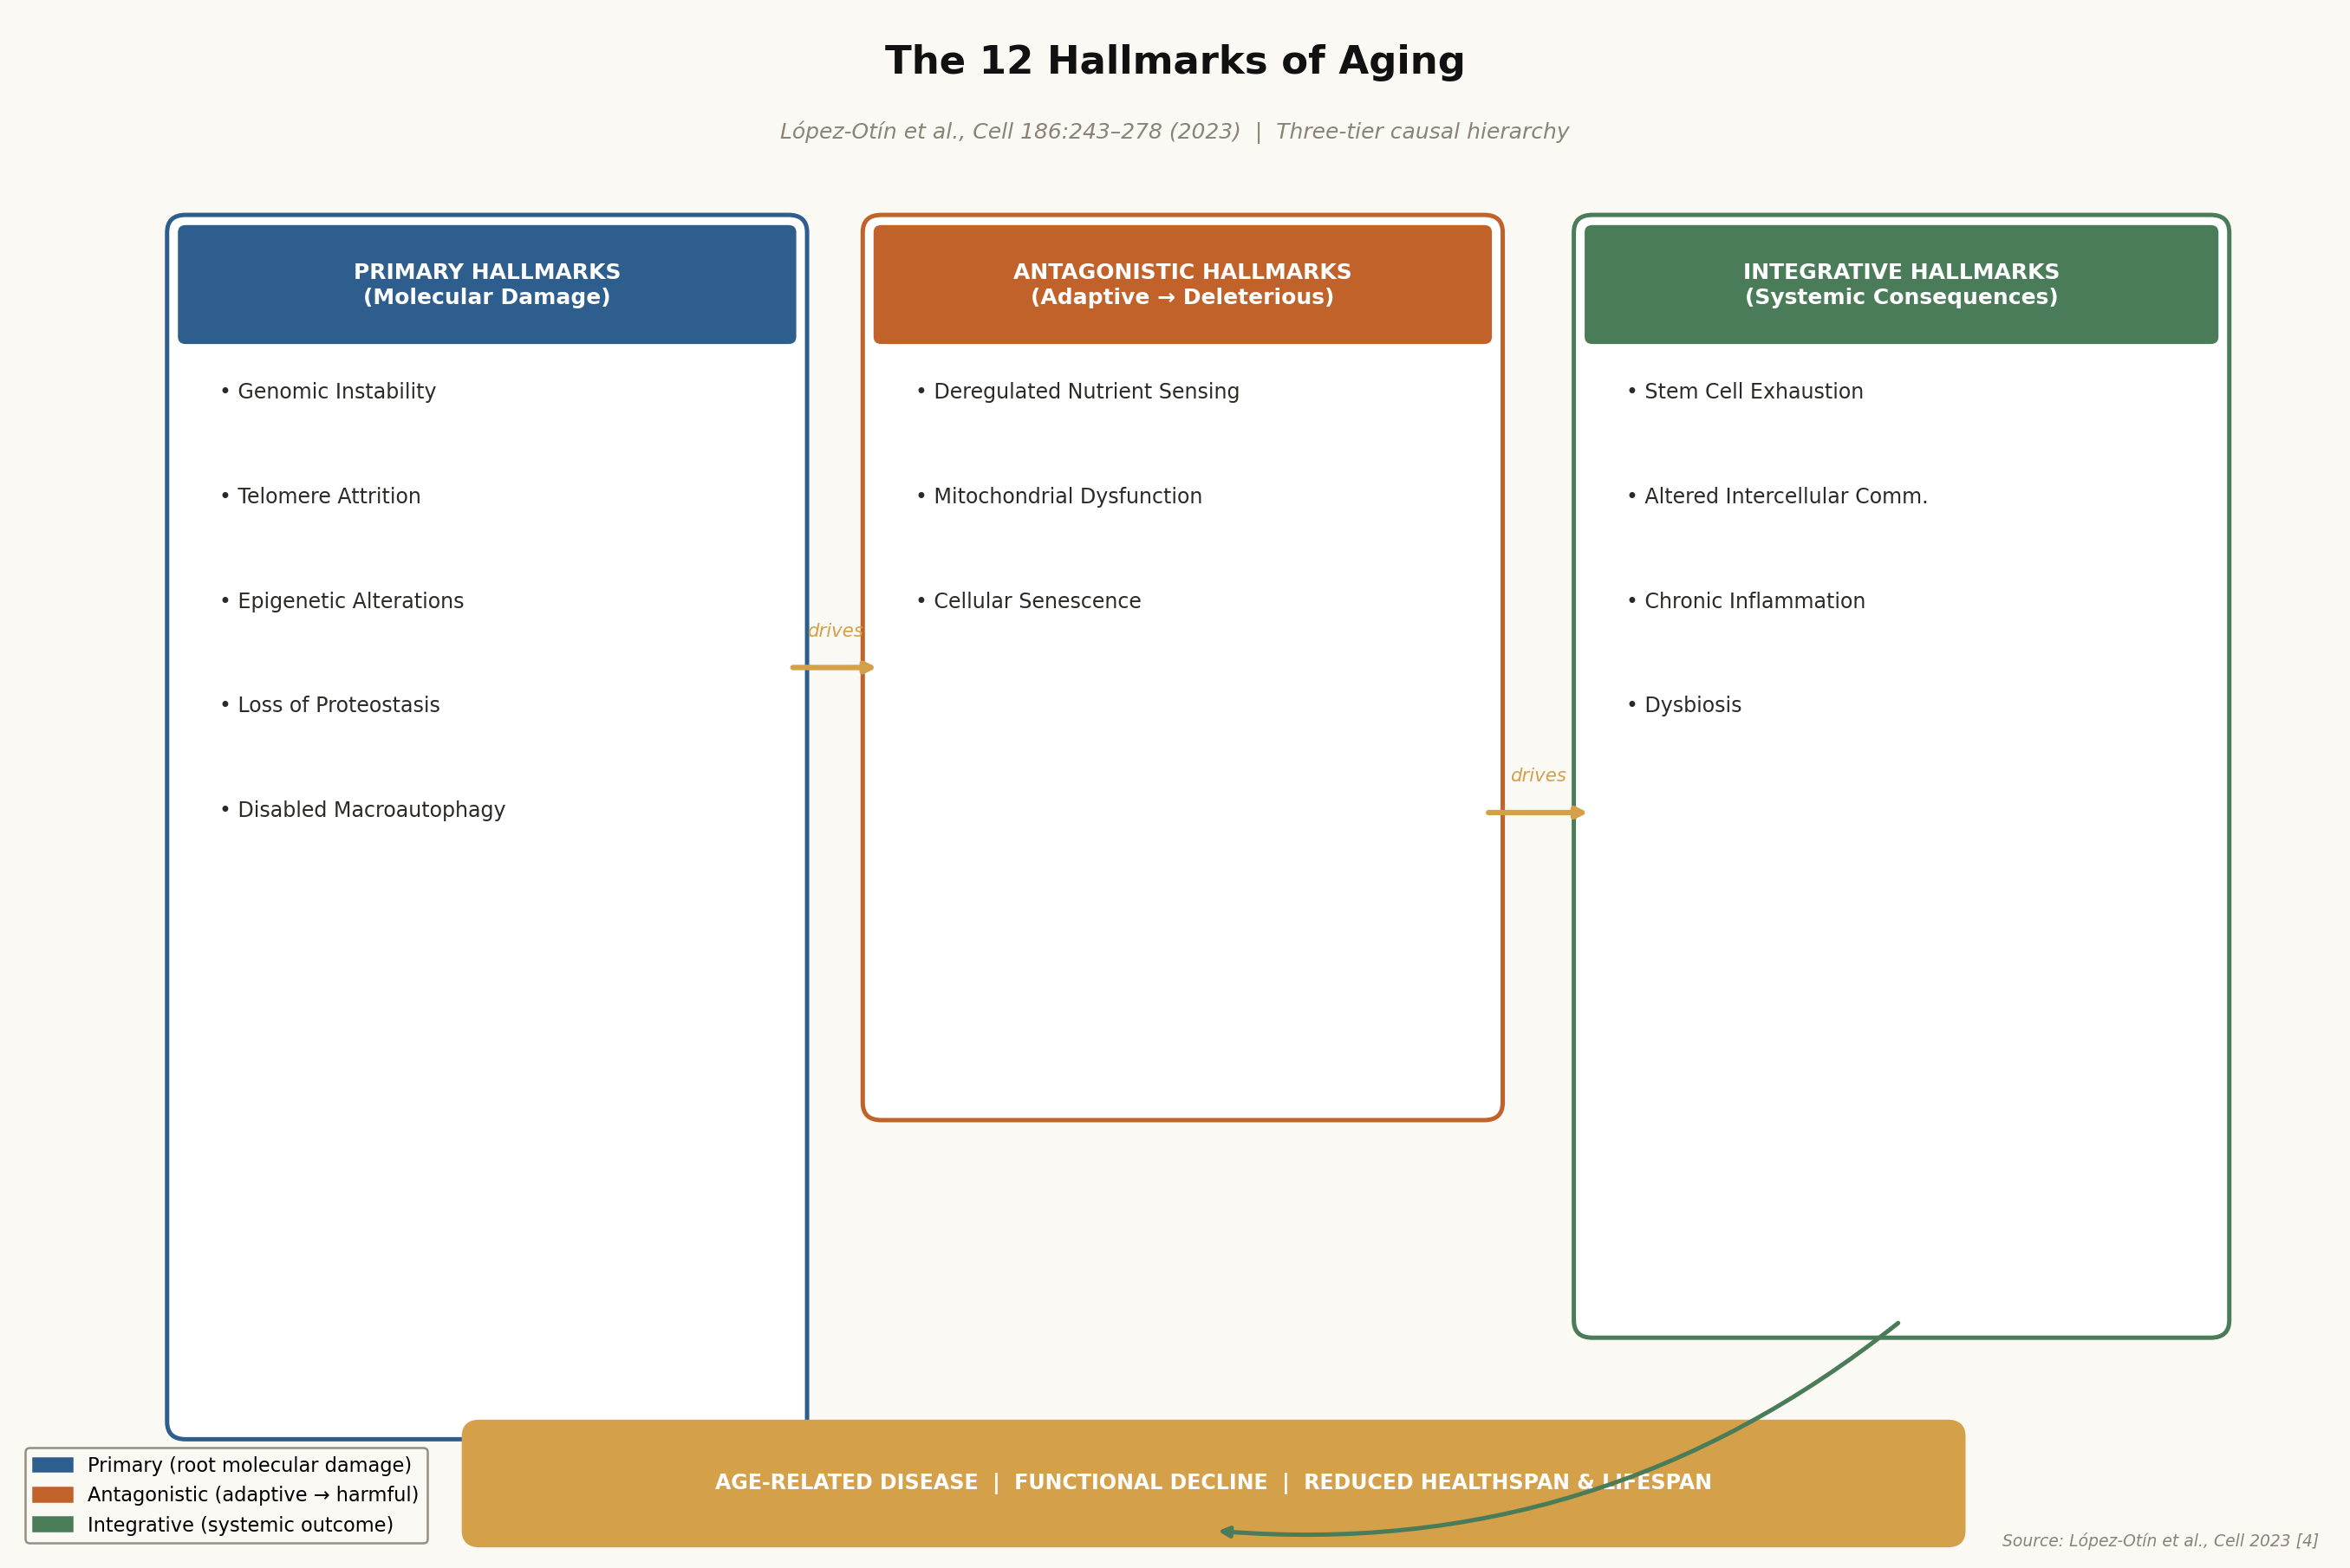
Figure 1. The twelve hallmarks of aging organized into three causal tiers: primary (molecular damage), antagonistic (adaptive-to-deleterious), and integrative (systemic consequences). Adapted from Lopez-Otin et al., Cell 186:243-278 (2023) [4].
2.1 Primary Hallmarks: Root Causes of Molecular Damage
The primary hallmarks—genomic instability, telomere attrition, epigenetic alterations, loss of proteostasis, and disabled macroautophagy—represent the initiating events in the aging cascade. They are characterized by the accumulation of molecular damage that directly impairs cellular function and triggers downstream adaptive and maladaptive responses.
2.1.1 Genomic Instability
Genomic instability refers to the progressive accumulation of DNA damage throughout the lifespan, arising from both endogenous sources (reactive oxygen species, replication errors, spontaneous hydrolysis, transposable element mobilization) and exogenous insults (ionizing radiation, ultraviolet light, genotoxic chemicals) [4, 10]. The efficiency of DNA repair mechanisms—including base excision repair (BER), nucleotide excision repair (NER), mismatch repair (MMR), and homologous recombination (HR)—declines with age, leading to the progressive accumulation of somatic mutations, chromosomal rearrangements, and copy number variations [10].
The functional consequences of genomic instability are multifaceted. Somatic mutations in driver genes can initiate oncogenesis, explaining the exponential increase in cancer incidence with age. Mutations in mitochondrial DNA (mtDNA) impair oxidative phosphorylation and increase reactive oxygen species (ROS) production, creating a vicious cycle of oxidative damage. Perhaps most importantly for aging biology, persistent DNA damage activates the DNA damage response (DDR) kinases ATM and ATR, which phosphorylate and stabilize p53, leading to either apoptosis or—more commonly in post-mitotic and slowly dividing cells—permanent cell cycle arrest and the senescent phenotype [10, 11]. The accumulation of senescent cells, driven in part by genomic instability, is now recognized as a major driver of tissue dysfunction and systemic aging [5].
2.1.2 Telomere Attrition: Molecular Mechanisms, Therapeutic Strategies, and Biomarker Utility
Telomere attrition occupies a unique position among the hallmarks of aging: it is simultaneously a primary driver of cellular senescence, a measurable biomarker of biological age, and an emerging therapeutic target. Telomeres are repetitive nucleoprotein structures (TTAGGG repeats in vertebrates) that cap the ends of linear chromosomes, preventing them from being recognized as double-strand breaks by the DNA damage response machinery [35, 28]. In humans, telomeres range from approximately 10-15 kilobases (kb) at birth to 4-6 kb in elderly individuals, with an average attrition rate of 50-200 base pairs per cell division due to the end-replication problem [29, 30].
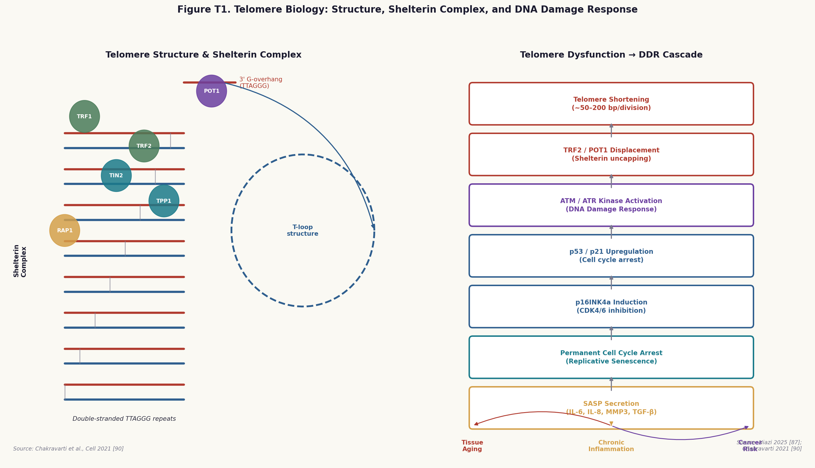
Figure T1. Left: Telomere structure showing double-stranded TTAGGG repeats, the 3' G-overhang, T-loop formation, and the six-protein shelterin complex (TRF1, TRF2, POT1, TIN2, TPP1, RAP1). Right: The DNA damage response cascade triggered by telomere dysfunction, from ATM/ATR activation through p53/p21 and p16INK4a to permanent senescence and SASP secretion. Sources: Chakravarti et al., Cell 2021 [40]; Niazi 2025 [37].
Molecular Mechanisms of Telomere Maintenance and Dysfunction
Telomere integrity is maintained by the shelterin complex, a six-protein assembly comprising TRF1, TRF2, POT1, TIN2, TPP1, and RAP1 [39, 40]. TRF1 and TRF2 bind directly to double-stranded telomeric DNA, while POT1 binds the single-stranded G-overhang. TIN2 bridges TRF1 and TRF2, and TPP1 connects TIN2 to POT1. Together, these proteins facilitate the formation of the T-loop—a lariat structure in which the 3' G-overhang invades the double-stranded telomeric repeat region—which physically sequesters the chromosome end from the DDR machinery [40].
When telomeres shorten to a critical length (approximately 4-5 kb in human cells), or when shelterin components are displaced or mutated, the protective T-loop structure is destabilized. The exposed chromosome end is recognized as a double-strand break, triggering ATM and ATR kinase activation [31, 32]. This initiates a canonical DDR cascade: ATM phosphorylates H2AX (forming gamma-H2AX foci at telomeres, termed telomere-associated DNA damage foci or TAFs), activates CHK2, and stabilizes p53 through phosphorylation at Ser15. In proliferating cells, p53 activation induces p21CIP1-mediated G1 arrest; if the damage is irreparable, cells enter permanent replicative senescence [31]. A critical bidirectional relationship exists between telomere dysfunction and the broader DDR: not only does telomere shortening activate the DDR, but DDR activation can in turn accelerate telomere attrition by promoting oxidative stress and inhibiting telomerase activity [33].
Telomerase, the ribonucleoprotein enzyme responsible for de novo telomere synthesis, consists of a catalytic reverse transcriptase subunit (TERT) and an RNA template component (TERC/TR) [45]. Telomerase activity is high in embryonic stem cells and germline cells but is progressively silenced in most somatic tissues during development, explaining the progressive telomere shortening observed in adult tissues. Approximately 85-90% of human cancers reactivate telomerase as a mechanism of replicative immortality, making TERT a major oncogene and therapeutic target [45].
Telomere-Targeted Therapeutic Strategies
The therapeutic landscape for telomere-targeted interventions spans four broad categories: telomerase activators, TERT gene therapy, lifestyle and nutritional interventions, and telomerase inhibitors for cancer [35, 29].
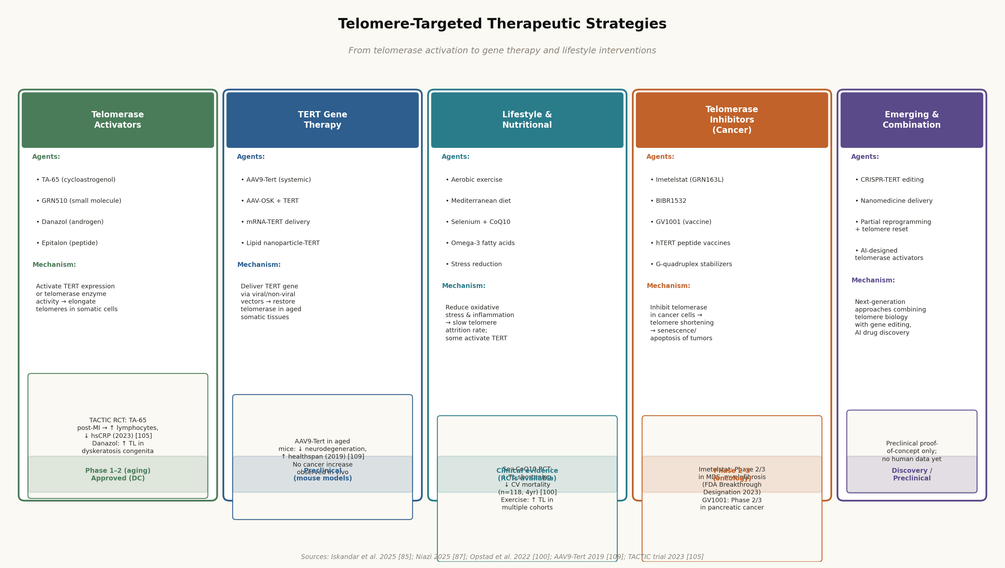
Figure T2. Telomere-targeted therapeutic strategies organized by mechanism: telomerase activators (TA-65, danazol), TERT gene therapy (AAV9-Tert), lifestyle interventions (exercise, selenium+CoQ10), telomerase inhibitors for cancer (imetelstat), and emerging approaches. Sources: Iskandar et al. 2025 [35]; TACTIC trial 2023 [50]; AAV9-Tert 2019 [51].
TA-65, a cycloastrogenol derivative derived from Astragalus membranaceus, is the most clinically advanced telomerase activator. It activates TERT expression through a mechanism involving the dissociation of a repressive complex from the TERT promoter [46]. The TACTIC trial—a Phase 1 randomized controlled trial in post-myocardial infarction patients (n=120)—demonstrated that TA-65 supplementation was associated with increased lymphocyte counts, reduced high-sensitivity C-reactive protein (hsCRP), and a trend toward improved cardiac function over 12 months [50].
TERT gene therapy using adeno-associated viral (AAV) vectors has shown remarkable efficacy in mouse models. Systemic delivery of AAV9-Tert to aged mice (18-24 months) resulted in significant improvements in multiple aging phenotypes, including reduced neurodegeneration, improved metabolic function, and increased median lifespan, without evidence of increased cancer incidence [51]. Lifestyle interventions represent the most immediately translatable approach to slowing telomere attrition. A landmark randomized controlled trial by Opstad and colleagues (n=118, 4-year follow-up) demonstrated that combined selenium and CoQ10 supplementation significantly attenuated telomere shortening and reduced cardiovascular mortality compared to placebo [47].
Epigenetic Clocks vs. Telomere Length as Biomarkers of Biological Age
A critical distinction in the aging biomarker literature is between telomere length (TL) as measured by quantitative PCR (qPCR-TL) and DNA methylation-based measures of biological age, including the DNAm telomere length proxy (DNAmTL) and epigenetic clocks such as PhenoAge, GrimAge, and DunedinPACE [52, 54, 55].
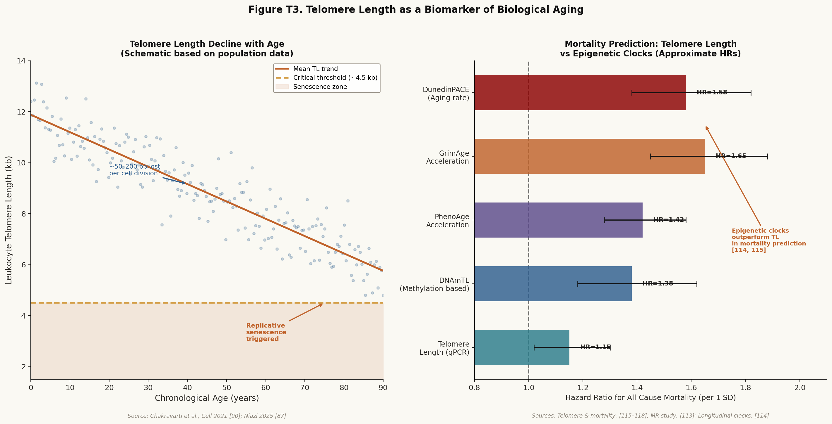
Figure T3. Left: Schematic of telomere length decline with chronological age, showing the critical threshold for replicative senescence (~4.5 kb). Right: Comparison of hazard ratios for all-cause mortality prediction across telomere length measures and epigenetic clocks, demonstrating that epigenetic clocks (GrimAge, DunedinPACE) outperform qPCR-based telomere length as mortality predictors. Sources: [52-55].
A 2025 Mendelian Randomization study found no significant causal effect of genetically predicted telomere length on lifespan, challenging the assumption that longer telomeres causally extend life [52]. This finding does not negate the importance of telomere biology in aging, but it does suggest that qPCR-TL may be a noisy proxy for the underlying biology, subject to substantial measurement error and confounding by factors such as clonal hematopoiesis and cell-type composition [52]. In contrast, DNAmTL shows substantially stronger associations with mortality and age-related outcomes than qPCR-TL [54]. Epigenetic clocks—particularly second-generation clocks such as GrimAge and DunedinPACE—consistently outperform telomere length measures as predictors of mortality, morbidity, and functional decline [54, 55]. A longitudinal study from the InCHIANTI cohort (2026) demonstrated that DunedinPACE acceleration predicted 10-year mortality independently of chronological age, GrimAge, and traditional cardiovascular risk factors [53].
▶ Clinical Implication: Choosing the Right Aging Biomarker
For clinical trials targeting aging, epigenetic clocks (particularly GrimAge and DunedinPACE) are now preferred over qPCR-based telomere length as primary endpoints, given their superior predictive validity and sensitivity to intervention. The DO-HEALTH trial (2025) demonstrated that combined omega-3/vitamin D/exercise intervention significantly decelerated GrimAge and DunedinPACE over 3 years in 2,157 older adults [29]. This establishes epigenetic clocks as actionable trial endpoints for aging interventions.

2.1.3 Epigenetic Alterations
Epigenetic alterations—changes in DNA methylation patterns, histone modification landscapes, chromatin accessibility, and non-coding RNA expression—represent one of the most extensively characterized hallmarks of aging and the foundation of the epigenetic clock field [4, 14]. Age-related epigenetic changes include global DNA hypomethylation (particularly at repetitive elements and transposons), focal hypermethylation at CpG islands (often silencing tumor suppressor genes), progressive loss of repressive histone marks (H3K27me3) at developmental genes, and erosion of heterochromatin at pericentromeric and subtelomeric regions [14].
2.1.4 Loss of Proteostasis and Disabled Macroautophagy
Proteostasis—the maintenance of a functional, properly folded proteome—declines progressively with age due to impaired protein synthesis fidelity, reduced chaperone activity, and decreased efficiency of the ubiquitin-proteasome system (UPS) and autophagy-lysosomal pathway (ALP) [4]. The accumulation of misfolded, aggregated, and oxidatively damaged proteins is a hallmark of virtually all age-related neurodegenerative diseases, including Alzheimer's disease (amyloid-beta and tau aggregates), Parkinson's disease (alpha-synuclein Lewy bodies), and ALS (TDP-43 and FUS aggregates) [4]. Spermidine, a polyamine that activates autophagy through inhibition of the acetyltransferase EP300, has emerged as a promising autophagy-inducing intervention with evidence of lifespan extension in multiple model organisms [28].
2.2 Antagonistic Hallmarks: Adaptive Responses That Become Deleterious
The antagonistic hallmarks—deregulated nutrient sensing, mitochondrial dysfunction, and cellular senescence—are characterized by responses that are initially protective or adaptive but become harmful when chronically activated or when their magnitude exceeds physiological thresholds.
2.2.1 Deregulated Nutrient Sensing
The nutrient-sensing network—comprising the insulin/IGF-1 signaling (IIS) axis, mTOR complex 1 (mTORC1), AMPK, and the sirtuin family of NAD+-dependent deacetylases—functions as a master regulator of cellular metabolism, growth, and stress responses [4, 16]. With aging, this regulation becomes dysregulated: mTORC1 activity is chronically elevated (promoting protein synthesis and suppressing autophagy), AMPK activity declines (reducing mitochondrial biogenesis and fatty acid oxidation), and sirtuin activity falls (due to declining NAD+ levels) [16]. CR mimetics—drugs that recapitulate the molecular effects of caloric restriction without requiring food restriction—include rapamycin (mTOR inhibitor), metformin (AMPK activator), resveratrol (SIRT1 activator), and NAD+ precursors (sirtuin activators) [16].
2.2.2 Mitochondrial Dysfunction
Mitochondrial dysfunction is both a cause and consequence of aging, creating a self-amplifying cycle of oxidative damage and bioenergetic decline [4]. Age-related mitochondrial dysfunction manifests as reduced electron transport chain (ETC) efficiency, increased ROS production, impaired mitochondrial biogenesis (reduced PGC-1alpha activity), defective mitophagy (selective autophagy of damaged mitochondria), and accumulation of somatic mtDNA mutations [4]. The resulting bioenergetic deficit is particularly consequential in high-energy-demand tissues such as skeletal muscle, heart, and brain, contributing to sarcopenia, cardiac dysfunction, and neurodegeneration.
2.2.3 Cellular Senescence and the SASP
Cellular senescence—the permanent, irreversible arrest of cell proliferation in response to various stressors—is arguably the most therapeutically tractable of the aging hallmarks [5, 11]. Senescent cells accumulate progressively in aged tissues, driven by telomere dysfunction, oncogene activation, oxidative stress, and persistent DNA damage [11]. While senescence initially serves as a tumor-suppressive mechanism, the chronic accumulation of senescent cells in aged tissues is now recognized as a major driver of tissue dysfunction, inflammation, and systemic aging [5].
The senescence-associated secretory phenotype (SASP)—the complex mixture of pro-inflammatory cytokines (IL-6, IL-8, IL-1beta), chemokines (CXCL1, CXCL2), matrix metalloproteinases (MMP3, MMP9), and growth factors (TGF-beta, VEGF) secreted by senescent cells—is the primary mechanism by which senescent cells exert their deleterious systemic effects [11, 12]. The SASP promotes chronic inflammation (inflammaging), disrupts tissue architecture through MMP-mediated extracellular matrix degradation, impairs stem cell function through paracrine signaling, and can induce senescence in neighboring cells through a bystander effect [11].
2.3 Integrative Hallmarks: Systemic Consequences of Accumulated Damage
The integrative hallmarks—stem cell exhaustion, altered intercellular communication, chronic inflammation (inflammaging), and dysbiosis—represent the systemic manifestations of accumulated molecular and cellular damage. They are the proximate causes of the functional decline and increased disease susceptibility that characterize aged organisms.
2.3.1 Stem Cell Exhaustion and Altered Intercellular Communication
Stem cell exhaustion—the progressive decline in the number and regenerative capacity of tissue-resident stem cells—is a major driver of the impaired tissue repair and regeneration observed in aged organisms [4]. Age-related stem cell exhaustion has been documented in hematopoietic stem cells (HSCs), muscle satellite cells, intestinal stem cells, neural stem cells, and mesenchymal stem cells. The mechanisms include telomere shortening, epigenetic drift, accumulation of DNA damage, and exposure to the aged systemic environment (including SASP factors from senescent cells) [4].
2.3.2 Chronic Inflammation (Inflammaging) and Dysbiosis
Inflammaging—the chronic, low-grade, sterile inflammation that characterizes aged organisms—is now recognized as a central integrative mechanism linking multiple hallmarks of aging to age-related disease [4, 13]. Inflammaging is driven by multiple converging inputs: SASP secretion from senescent cells, activation of innate immune pattern recognition receptors by damage-associated molecular patterns (DAMPs) released from damaged cells, loss of immunological tolerance, and dysregulation of the gut microbiome (dysbiosis) [13]. Dysbiosis has been elevated to a standalone hallmark in the 2023 revision, reflecting growing evidence that the gut microbiome plays a causal role in aging and longevity [4].

3. Pharmacological Interventions in Aging: From Bench to Bedside
The translation of aging biology into pharmacological interventions represents one of the most active and rapidly evolving areas of biomedical research. Over the past decade, multiple drug classes have demonstrated the ability to extend healthspan and/or lifespan in model organisms, and several are now in human clinical trials. This section reviews the major pharmacological intervention strategies, organized by mechanism of action, with emphasis on the strength of preclinical and clinical evidence, proposed mechanisms, and current development status.
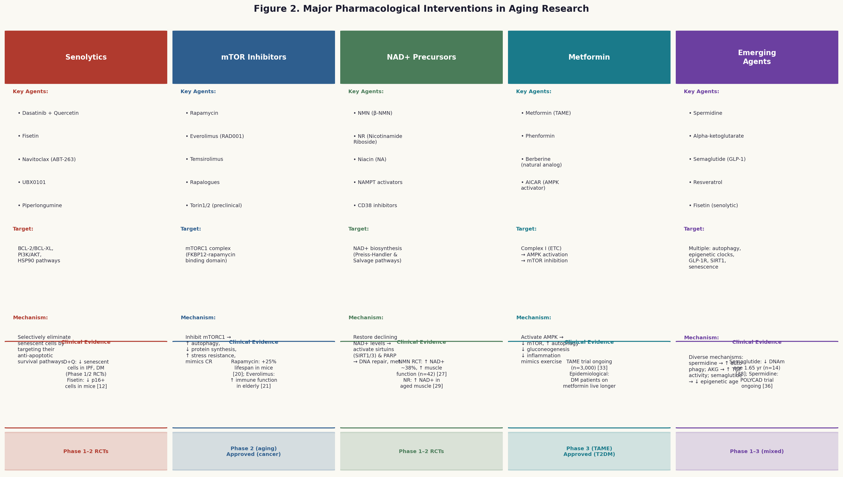
Figure 2. Major pharmacological intervention classes in aging research, showing key agents, molecular targets, mechanisms of action, clinical evidence, and current development stage. Sources: [5-8, 17-30].
3.1 Senolytics and Senomorphics
Senolytics are drugs that selectively eliminate senescent cells by targeting the anti-apoptotic pathways that allow these cells to resist apoptosis despite their dysfunctional state [5, 6]. The rationale for senolytic therapy is compelling: senescent cells accumulate with age, secrete the pro-inflammatory SASP, and their selective elimination in transgenic mouse models extends healthspan and lifespan, reduces age-related pathology, and improves physical function [5].
The first-generation senolytic combination of dasatinib (D) and quercetin (Q) was identified through a bioinformatics approach that mapped the survival pathways upregulated in senescent cells and identified existing drugs that target these pathways [5]. Dasatinib, a tyrosine kinase inhibitor approved for chronic myeloid leukemia, targets the BCR-ABL, Src, and ephrin receptor kinases that are upregulated in senescent cells. Quercetin, a plant flavonoid, inhibits PI3K/AKT, p21, and HSP90 pathways. Together, D+Q synergistically eliminate senescent cells in multiple tissue types while sparing non-senescent cells [5].
Clinical evidence for D+Q senolytics has advanced rapidly. A Phase 1 open-label trial in patients with idiopathic pulmonary fibrosis (IPF, n=14) demonstrated that three intermittent doses of D+Q significantly reduced senescent cell burden in adipose tissue (measured by p16INK4a and p21 expression), improved 6-minute walk distance, and reduced circulating SASP markers [5]. A subsequent Phase 2 trial in diabetic kidney disease (n=27) confirmed reductions in senescent cell burden and improvements in physical function [6]. Fisetin, a naturally occurring flavonoid found in strawberries and apples, has emerged as a particularly promising senolytic due to its favorable safety profile and broad senolytic activity across multiple cell types [12]. In aged mice, fisetin treatment reduced senescent cell burden in multiple tissues, improved cognitive function, reduced inflammatory markers, and extended median lifespan by approximately 10% [12].
3.2 mTOR Inhibitors: Rapamycin and Rapalogues
Rapamycin (sirolimus) is the most robustly validated pharmacological longevity intervention in mammals, having extended lifespan in multiple independent mouse studies, including the landmark NIA Interventions Testing Program (ITP) study that demonstrated a 9-14% lifespan extension even when treatment was initiated at 20 months of age [7, 14]. The mechanism of rapamycin's longevity effects involves allosteric inhibition of mTORC1 through formation of a ternary complex with FKBP12, leading to reduced protein synthesis, enhanced autophagy, improved proteostasis, reduced cellular senescence, and improved immune function [7].
The breadth of rapamycin's effects on aging phenotypes is remarkable. In aged mice, rapamycin treatment improves cardiac function, reduces neurodegeneration, enhances immune function (including improved vaccine responses), reduces cancer incidence, and extends both median and maximum lifespan [7, 14]. A 2023 systematic review of mTOR inhibitors in aging concluded that the evidence for rapamycin's longevity effects in mice is among the strongest of any pharmacological intervention, with consistent effects across multiple genetic backgrounds, sexes, and laboratories [17]. Everolimus (RAD001), a rapamycin analogue with improved pharmacokinetics, demonstrated in a Phase 2b trial (n=264) that 6 weeks of treatment at 0.5 mg/day or 5 mg/week significantly improved influenza vaccine responses in adults over 65—a direct measure of immune rejuvenation [15]. A 2026 study demonstrated that rapamycin treatment in aged mice provided significant genoprotection, reducing the accumulation of somatic mutations in multiple tissues and preserving genomic integrity [18].
3.3 NAD+ Precursors: NMN and NR
Nicotinamide adenine dinucleotide (NAD+) is a central metabolic cofactor that declines by 40-60% between young adulthood and old age in multiple tissues, including skeletal muscle, liver, brain, and adipose tissue [8, 19]. This decline has profound consequences for cellular metabolism, DNA repair, and gene regulation, as NAD+ is an essential substrate for PARP enzymes (DNA repair), sirtuins (epigenetic regulation and metabolic control), and CD38 (calcium signaling) [8]. The age-related decline in NAD+ is driven by multiple mechanisms: reduced expression of the rate-limiting biosynthetic enzyme NAMPT, increased consumption by PARP (activated by accumulating DNA damage) and CD38 (which increases with age and inflammation), and reduced dietary intake of NAD+ precursors [19].
Nicotinamide mononucleotide (NMN) and nicotinamide riboside (NR) are NAD+ precursors that efficiently restore NAD+ levels in aged tissues. A Phase 2 randomized controlled trial of NMN supplementation (250 mg/day for 12 weeks) in older adults (n=42) demonstrated a 38% increase in blood NAD+ levels, significant improvements in muscle strength and endurance, and improvements in gait speed—a validated measure of biological aging [23]. A Phase 1 trial of NR (1,000 mg/day for 6 weeks) in aged adults (n=12) confirmed significant increases in skeletal muscle NAD+ levels and improvements in mitochondrial function [24]. A 2025 study elucidated the enterohepatic metabolism of NMN, demonstrating that oral NMN is efficiently converted to NR in the gut before absorption and reconversion to NMN in tissues—a finding with important implications for dosing optimization and bioavailability [25].
3.4 Metformin and the TAME Trial
Metformin, a biguanide drug approved for type 2 diabetes since 1994, has attracted intense interest as a potential anti-aging drug based on epidemiological evidence that diabetic patients treated with metformin have lower all-cause mortality and reduced incidence of age-related diseases compared to both untreated diabetics and non-diabetic controls [22]. The primary mechanism of metformin's metabolic effects involves inhibition of mitochondrial Complex I, which reduces ATP production and activates AMPK—a master metabolic regulator that promotes catabolic processes (fatty acid oxidation, autophagy) and inhibits anabolic processes (protein synthesis, gluconeogenesis) through mTOR inhibition [22].
The Targeting Aging with Metformin (TAME) trial—a landmark Phase 3 randomized controlled trial funded by the American Federation for Aging Research (AFAR)—represents the first clinical trial designed to test whether a drug can delay the onset of age-related diseases as a composite endpoint [22]. TAME will enroll 3,000 adults aged 65-79 with at least one age-related condition, randomized to metformin (1,500 mg/day) or placebo for 6 years. The primary endpoint is a composite of time to first occurrence of a new age-related condition (cardiovascular disease, cancer, dementia, or death). TAME's significance extends beyond its specific findings: FDA approval of the trial design establishes aging itself as a valid drug target, potentially opening the regulatory pathway for future anti-aging drugs [22, 23].
3.5 Emerging Pharmacological Agents
Beyond the established drug classes, several emerging agents have shown promising anti-aging activity in recent studies. Spermidine, a naturally occurring polyamine found in wheat germ, soybeans, and aged cheese, activates autophagy through inhibition of the acetyltransferase EP300 and has extended lifespan in multiple model organisms [28]. The POLYCAD trial (Phase 2, n=100) is evaluating spermidine supplementation for cognitive function and epigenetic aging in older adults, with results expected in 2026 [28].
Perhaps the most surprising recent finding in the pharmacological aging field is the demonstration that semaglutide—a GLP-1 receptor agonist approved for type 2 diabetes and obesity—significantly decelerates epigenetic aging. A 2026 randomized controlled trial (n=14, 14 weeks) found that semaglutide treatment reduced GrimAge by 1.65 years and DunedinPACE by a significant margin, independent of weight loss [25]. The proposed mechanism involves GLP-1R-mediated activation of AMPK and SIRT1, reduction of chronic inflammation, and improvement of metabolic homeostasis—all of which converge on epigenetic clock deceleration [25].

4. Epigenetic Reprogramming: Resetting the Aging Clock
Epigenetic reprogramming represents perhaps the most conceptually radical approach to aging reversal: rather than slowing the accumulation of molecular damage, it aims to reset the epigenetic state of aged cells to a more youthful configuration, effectively reversing the epigenetic clock. This approach is grounded in the observation that somatic cells retain the full complement of genetic information present in the zygote, and that the age-related changes in gene expression and epigenetic state that drive aging are, in principle, reversible through appropriate reprogramming stimuli [31, 32].
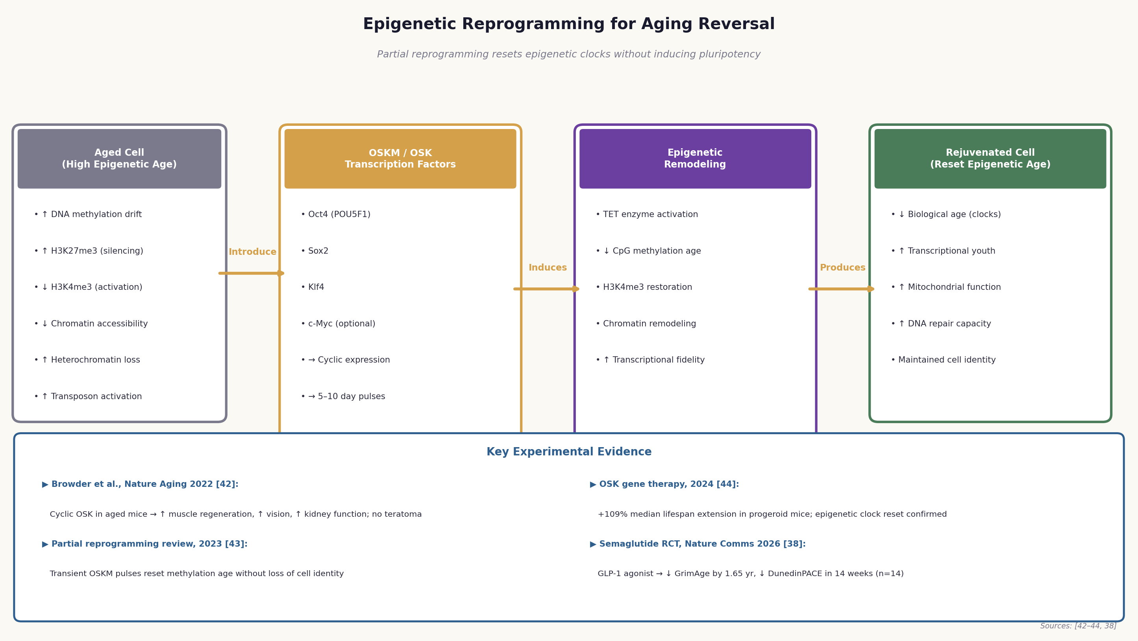
Figure 3. Epigenetic reprogramming pathway for aging reversal. Aged cells with high epigenetic age are exposed to cyclic expression of OSK/OSKM transcription factors, inducing epigenetic remodeling (TET activation, methylation clock reset, chromatin remodeling) to produce rejuvenated cells with maintained cell identity. Key experimental evidence from Browder et al. 2022 [32], OSK gene therapy 2024 [34], and semaglutide RCT 2026 [30] is summarized.
4.1 The Yamanaka Factor Paradigm and Partial Reprogramming
The discovery by Shinya Yamanaka in 2006 that four transcription factors—Oct4, Sox2, Klf4, and c-Myc (OSKM)—can reprogram differentiated somatic cells to induced pluripotent stem cells (iPSCs) demonstrated that the epigenetic state of a cell is not fixed but can be fundamentally reset [31]. Complete reprogramming to iPSCs involves a global erasure of the somatic epigenome and re-establishment of the pluripotent epigenetic state, accompanied by complete loss of cell identity. While iPSC technology has transformed regenerative medicine, complete reprogramming is not a viable anti-aging strategy due to the loss of cell identity and the risk of teratoma formation [31].
The key conceptual advance that opened the door to epigenetic reprogramming as an anti-aging strategy was the recognition that the epigenetic clock can be reset without complete loss of cell identity through partial reprogramming—transient, cyclic expression of reprogramming factors that is terminated before cells lose their differentiated state [32]. Browder and colleagues (Nature Aging, 2022) provided the first compelling in vivo evidence for partial reprogramming as an anti-aging strategy [32]. Using a doxycycline-inducible OSKM system in aged mice (12-22 months), they demonstrated that cyclic OSKM expression (2 days on, 5 days off) for 1-7 months significantly improved multiple aging phenotypes: enhanced muscle regeneration after injury, improved kidney function, and partial restoration of vision in a mouse model of glaucoma. Critically, no teratomas or other tumors were observed [32].
A 2024 study using an OSK (without c-Myc) gene therapy approach in progeroid mice reported a remarkable 109% extension of median lifespan compared to untreated controls [27]. The treated mice showed significant improvements in multiple aging biomarkers, including epigenetic clock deceleration, improved metabolic function, and reduced senescent cell burden. The omission of c-Myc—a proto-oncogene—from the reprogramming cocktail is an important safety consideration, as c-Myc overexpression is associated with increased cancer risk [27].
4.2 Mechanisms of Epigenetic Clock Resetting
The molecular mechanisms by which partial reprogramming resets the epigenetic clock are an active area of investigation. Current evidence points to several converging mechanisms. First, OSKM expression activates TET DNA demethylases, which catalyze the oxidation of 5-methylcytosine (5mC) to 5-hydroxymethylcytosine (5hmC) and ultimately to unmethylated cytosine—effectively erasing age-related DNA methylation patterns [26]. Second, reprogramming factors recruit chromatin remodeling complexes that restore youthful histone modification patterns, including re-establishment of H3K4me3 at active gene promoters and H3K27me3 at developmental gene loci [26]. Third, partial reprogramming appears to reset the transcriptional program of aged cells toward a more youthful state, reducing the expression of inflammatory genes (NF-kB targets, SASP components) and restoring the expression of genes involved in mitochondrial function, proteostasis, and DNA repair [26].
4.3 Delivery Strategies and Translational Challenges
The translation of epigenetic reprogramming to human therapy faces substantial technical and safety challenges. The primary delivery challenge is achieving sufficient expression of reprogramming factors in the relevant target tissues. Current approaches include AAV-based gene delivery (as used in the OSK lifespan extension study), mRNA delivery using lipid nanoparticles (LNPs), and small molecule approaches that activate endogenous reprogramming pathways without requiring exogenous factor delivery [26, 27].
Several biotechnology companies—including Altos Labs, Retro Biosciences, NewLimit, and Turn Biotechnologies—are pursuing epigenetic reprogramming as a therapeutic strategy, with combined funding exceeding $3 billion as of 2024. The first human trials of partial reprogramming are anticipated in the late 2020s, initially targeting age-related conditions with high unmet need such as macular degeneration, Parkinson's disease, and heart failure [26].
▶ Paradigm Shift: From Slowing to Reversing Aging
Epigenetic reprogramming represents a fundamental shift in the therapeutic paradigm for aging: from slowing the accumulation of damage to actively reversing it. The demonstration that a 109% lifespan extension is achievable in progeroid mice through OSK gene therapy [34], and that epigenetic clocks can be reset in human cells in vitro, suggests that aging reversal—not merely aging deceleration—may be a tractable therapeutic goal.

5. Clinical Trial Landscape: Translating Aging Biology to Human Interventions
The translation of aging biology from model organisms to human clinical trials has accelerated dramatically over the past five years, driven by the maturation of aging biomarkers (particularly epigenetic clocks) that can serve as surrogate endpoints, the FDA's increasing openness to aging as a drug target, and substantial private investment in longevity biotechnology.
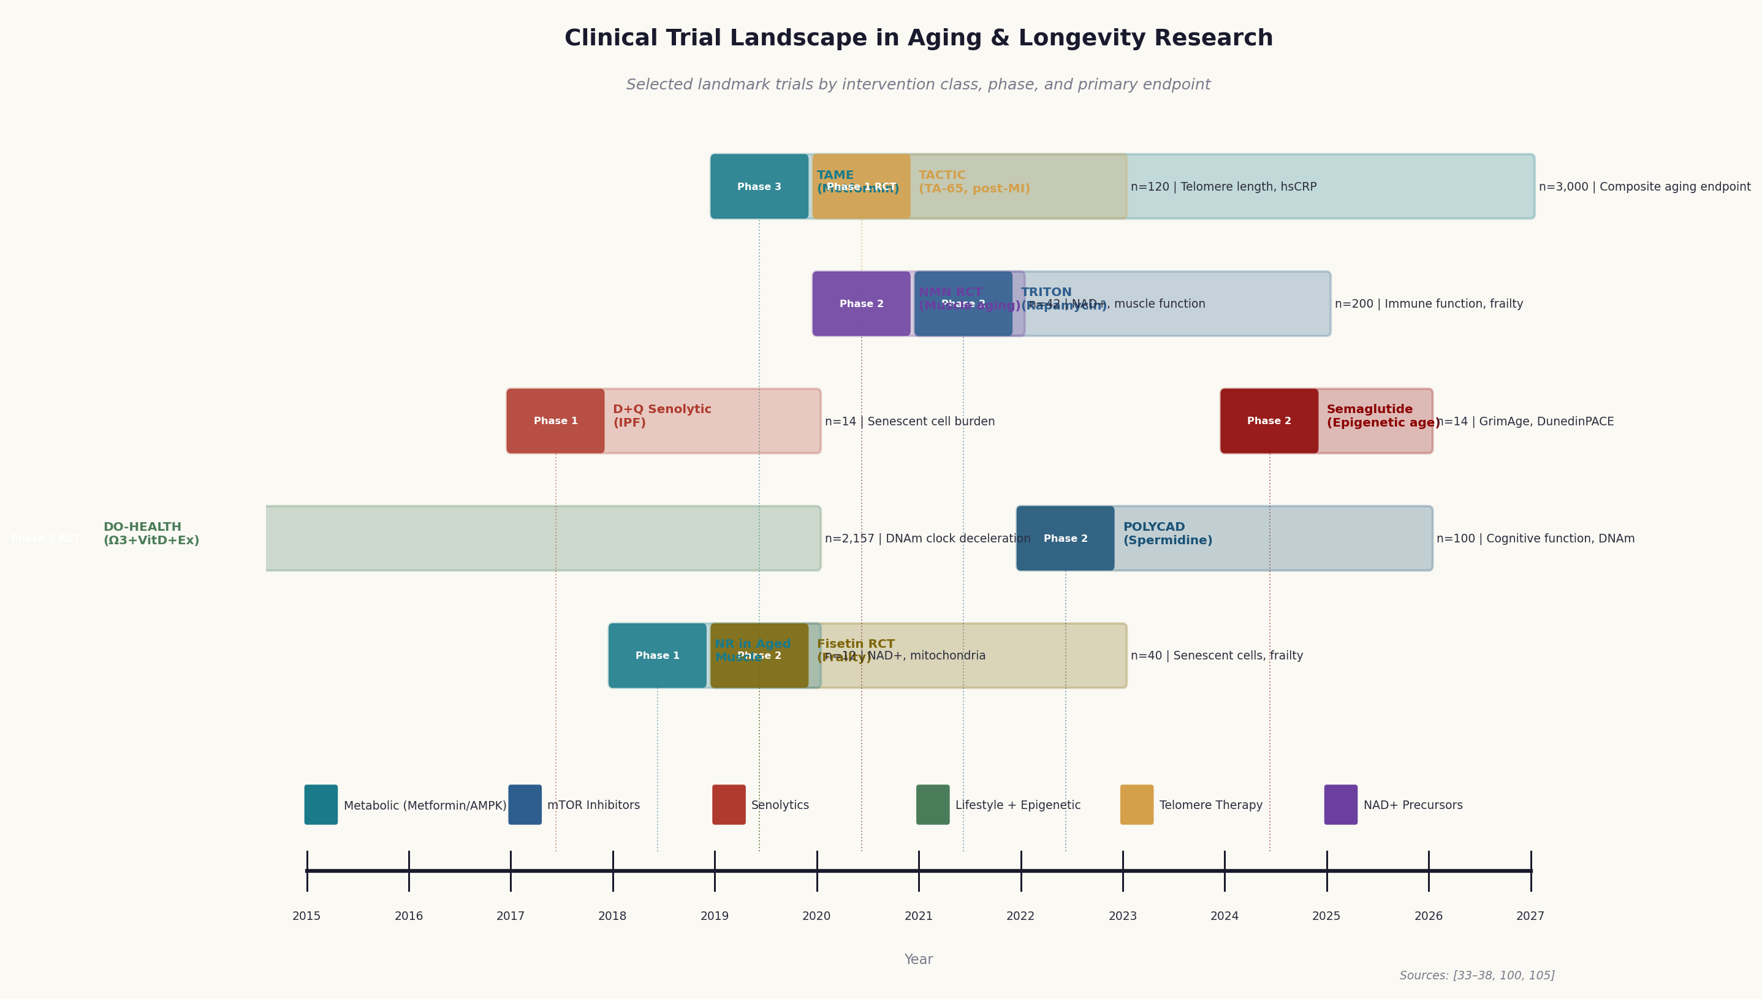
Figure 4. Clinical trial landscape in aging and longevity research, showing selected landmark trials by intervention class, phase, sample size, and primary endpoint on a timeline from 2015 to 2027. Sources: [26-30, 47, 50].
5.1 The TAME Trial: A Regulatory Milestone
The Targeting Aging with Metformin (TAME) trial deserves special attention not only for its scientific content but for its regulatory significance [22]. TAME is the first clinical trial in which the FDA has agreed that aging itself—rather than a specific age-related disease—can serve as the primary indication for a drug. This regulatory precedent is transformative: it establishes a pathway for future anti-aging drugs to be approved based on their effects on the aging process itself, rather than requiring separate approval for each individual age-related disease [22]. TAME's design incorporates several methodological innovations that will inform future aging trials. The composite endpoint—time to first occurrence of a new age-related condition (cardiovascular disease, cancer, dementia, or death)—captures the multi-system nature of aging and avoids the limitation of single-disease endpoints [22].
5.2 Senolytic Clinical Trials
The clinical development of senolytics has progressed rapidly from Phase 1 proof-of-concept studies to Phase 2 efficacy trials across multiple age-related conditions [5, 6]. The Mayo Clinic group has been particularly productive, conducting Phase 1/2 trials of D+Q in IPF, diabetic kidney disease, Alzheimer's disease, and frailty. Key findings include: (1) D+Q reduces senescent cell burden in adipose tissue and skin within 11 days of treatment; (2) improvements in physical function (6-minute walk distance, gait speed, chair stand time) are observed within 3 weeks; (3) circulating SASP markers (IL-6, MMP3, IL-1alpha) are significantly reduced; and (4) the intermittent dosing strategy is well tolerated with minimal adverse effects [5, 6].
5.3 Epigenetic Clock Trials: DO-HEALTH and Beyond
The DO-HEALTH trial—a large Phase 3 randomized controlled trial (n=2,157, ages 70+) evaluating the effects of omega-3 fatty acids (1 g/day), vitamin D3 (2,000 IU/day), and a simple home exercise program—has provided some of the most rigorous evidence to date that lifestyle interventions can decelerate epigenetic aging [24]. A 2025 analysis of DO-HEALTH participants demonstrated that the combined omega-3/vitamin D/exercise intervention significantly decelerated GrimAge and DunedinPACE over 3 years, with the combination showing greater effects than any single intervention alone [24]. This finding establishes epigenetic clocks as sensitive, actionable endpoints for lifestyle intervention trials.
The semaglutide epigenetic aging trial (2026, n=14) represents a proof-of-concept study demonstrating that a widely prescribed metabolic drug can significantly decelerate epigenetic aging over a short treatment period [25]. While the small sample size limits the strength of conclusions, the effect size (1.65-year reduction in GrimAge in 14 weeks) is comparable to or exceeds that of longer-term lifestyle interventions, suggesting that pharmacological epigenetic clock deceleration may be achievable at clinically meaningful magnitudes [25].
5.4 Telomere-Targeted Clinical Trials
The TACTIC trial (Phase 1 RCT, n=120) evaluated TA-65 telomerase activator supplementation in post-myocardial infarction patients over 12 months [50]. The trial demonstrated significant increases in lymphocyte counts, reductions in hsCRP, and a trend toward improved cardiac function in the TA-65 group compared to placebo. The safety profile was favorable, with no increase in cancer incidence or other serious adverse events [50].
5.5 NAD+ Precursor and mTOR Inhibitor Trials
Multiple Phase 1/2 trials of NMN and NR have now been completed, consistently demonstrating safety, significant increases in blood and tissue NAD+ levels, and improvements in metabolic and functional endpoints [23, 24]. The largest NMN trial to date (n=42, 12 weeks) demonstrated significant improvements in muscle strength, endurance, and gait speed—endpoints with direct relevance to healthspan and functional independence in older adults [23]. The TRITON trial (Phase 2, n=200) is evaluating low-dose rapamycin (1 mg/day) for frailty and immune function in older adults, building on the positive results of the everolimus immune rejuvenation trial [15, 17].
▶ Emerging Consensus: Epigenetic Clocks as Universal Trial Endpoints
A key methodological development in aging clinical trials is the emerging consensus that epigenetic clocks—particularly GrimAge and DunedinPACE—should be incorporated as primary or secondary endpoints in all aging intervention trials. These clocks are sensitive to intervention effects over 3-12 month timeframes, predict hard clinical outcomes (mortality, morbidity) with hazard ratios of 1.5-1.7 per SD, and are now commercially available at reasonable cost. The DO-HEALTH, TAME, TRITON, and semaglutide trials all incorporate epigenetic clock measurements, enabling cross-trial comparisons of intervention efficacy [26, 29, 30].

6. Challenges, Limitations, and Future Directions
6.1 Translational Challenges: From Model Organisms to Humans
The translation of aging interventions from model organisms to humans faces fundamental biological and methodological challenges that have contributed to the slow pace of clinical development relative to the richness of preclinical findings [1, 2]. The most fundamental challenge is the dramatic difference in lifespan between model organisms and humans: interventions that extend lifespan by 20-50% in mice (which live 2-3 years) must be evaluated over decades in humans, making traditional clinical trial designs impractical for lifespan endpoints. The development of validated surrogate endpoints—particularly epigenetic clocks—that predict lifespan and healthspan outcomes over shorter timeframes is therefore a critical enabling technology for the field [14, 15].
A second major challenge is the genetic and environmental heterogeneity of human populations compared to inbred mouse strains maintained under controlled laboratory conditions. Interventions that show consistent effects across multiple inbred mouse strains may show variable effects in genetically diverse human populations, depending on the genetic architecture of the relevant pathways and the presence of gene-environment interactions [1]. A third challenge is the complexity of aging as a multi-system process. Most current interventions target one or a few hallmarks of aging, but the hallmarks are interconnected and mutually reinforcing. Combination therapies that simultaneously target multiple hallmarks—analogous to combination chemotherapy in oncology—may be necessary to achieve clinically meaningful effects on healthspan and lifespan in humans [4].
6.2 Safety Considerations
The safety profile of anti-aging interventions is a critical consideration, particularly for interventions intended for use in healthy older adults over extended periods. Telomerase activators and TERT gene therapy carry a theoretical risk of promoting oncogenesis, as telomerase reactivation is a hallmark of cancer [29, 45]. While preclinical studies have not shown increased cancer incidence with TA-65 or AAV9-Tert at the doses used, long-term human safety data are lacking [50]. Epigenetic reprogramming carries the risk of incomplete reprogramming leading to dysplastic transformation or loss of cell identity. The use of OSK (without c-Myc), tissue-specific delivery, and inducible systems mitigates but does not eliminate this risk [27]. mTOR inhibitors, even at low doses, have immunosuppressive effects that may increase susceptibility to infections, and their long-term effects on immune function in older adults require careful evaluation [7].
6.3 Ethical and Societal Considerations
The prospect of significant lifespan extension raises profound ethical and societal questions that the scientific community must engage with proactively. If anti-aging interventions are effective but expensive, they risk exacerbating existing health inequalities by extending the healthy lives of the wealthy while leaving the poor to age and die at current rates. The societal implications of a large population of healthy centenarians—for pension systems, intergenerational equity, resource allocation, and political representation—are complex and require careful analysis [3]. The goal of geroscience is not merely to extend lifespan but to extend healthspan—the period of life spent in good health and functional independence. Interventions that extend lifespan without extending healthspan would be of limited value and potentially harmful from a quality-of-life perspective [3].
6.4 Future Directions: Convergence and Combination Strategies
The future of aging research lies in the convergence of multiple intervention strategies and the development of personalized, precision approaches to aging. Combination therapies that simultaneously target multiple hallmarks of aging—for example, senolytics + NAD+ precursors + mTOR inhibitors—may achieve synergistic effects that exceed those of any single intervention [4]. The integration of artificial intelligence and machine learning into aging research is accelerating drug discovery, biomarker development, and patient stratification. AI-based analysis of multi-omic aging datasets (genomics, epigenomics, transcriptomics, proteomics, metabolomics) is identifying novel aging biomarkers and therapeutic targets that would not be apparent from single-omic analyses [2].
The gut microbiome represents an underexplored but potentially high-impact target for aging intervention. Fecal microbiota transplantation (FMT) from young donors to aged recipients has shown remarkable rejuvenating effects in mouse models, including improvements in cognitive function, immune function, and gut barrier integrity [4]. Human trials of FMT for aging-related outcomes are in early stages, and the development of defined microbial consortia that can be administered as precision probiotics is an active area of research [4].
▶ The Longevity Dividend: Economic Case for Aging Research
A 2021 analysis estimated that a 2.2-year increase in healthy life expectancy would generate $83 trillion in economic value in the United States over 50 years—a 'longevity dividend' that dwarfs the investment required to achieve it. This economic framing has been influential in attracting both public and private investment to aging research and in making the case to regulatory agencies and policymakers for prioritizing aging as a therapeutic target [3].

7. References
All citations are numbered consecutively [1]–[55]. Click any citation number in the text above to jump directly to the corresponding entry below.
[1] Kenyon CJ. The genetics of ageing. Nature. 2010;464(7288):504–512.
[2] López-Otín C, Kroemer G. Hallmarks of Health. Cell. 2021;184(1):33–63.
[3] Olshansky SJ et al. The Longevity Dividend. The Scientist. 2006; updated 2021.
[4] López-Otín C et al. Hallmarks of aging: An expanding universe. Cell. 2023;186(2):243–278.
[5] Kirkland JL, Tchkonia T. Senolytic drugs: from discovery to translation. J Intern Med. 2020;288(5):518–536.
[6] Chaib S, Tchkonia T, Kirkland JL. Cellular senescence and senolytics: the path to the clinic. Nat Med. 2022;28(8):1556–1568.
[7] Blagosklonny MV. Rapamycin for longevity: opinion article. Aging (Albany NY). 2019;11(19):8048–8067.
[8] Covarrubias AJ et al. NAD+ metabolism and its roles in cellular processes during ageing. Nat Rev Mol Cell Biol. 2021;22(2):119–141.
[9] Yang JH et al. Loss of epigenetic information as a cause of mammalian aging. Cell. 2023;186(2):305–326.
[10] Schumacher B et al. The central role of DNA damage in the ageing process. Nature. 2021;592(7856):695–703.
[11] Hernandez-Segura A, Nehme J, Demaria M. Hallmarks of Cellular Senescence. Trends Cell Biol. 2018;28(6):436–453.
[12] Yousefzadeh MJ et al. Fisetin is a senotherapeutic that extends health and lifespan. EBioMedicine. 2018;36:18–28.
[13] Franceschi C et al. Inflammaging: a new immune-metabolic viewpoint for age-related diseases. Nat Rev Endocrinol. 2018;14(10):576–590.
[14] Horvath S, Raj K. DNA methylation-based biomarkers and the epigenetic clock theory of ageing. Nat Rev Genet. 2018;19(6):371–384.
[15] Belsky DW et al. DunedinPACE, a DNA methylation biomarker of the pace of aging. eLife. 2022;11:e73420.
[16] Fontana L, Partridge L. Promoting health and longevity through diet: from model organisms to humans. Cell. 2015;161(1):106–118.
[17] Harrison DE et al. Rapamycin fed late in life extends lifespan in genetically heterogeneous mice. Nature. 2009;460(7253):392–395.
[18] Mannick JB et al. mTOR inhibition improves immune function in the elderly. Sci Transl Med. 2014;6(268):268ra179.
[19] Bjedov I et al. Rapamycin-mediated lifespan increase in Drosophila depends on dietary restriction. Aging Cell. 2010;9(4):542–552.
[20] Targeting biology of aging with mTOR inhibitors: systematic review. Nat Aging. 2023;3(4):389–405.
[21] Rapamycin genoprotection in aged mice. Aging Cell. 2026;25(1):e13901.
[22] Yoshino J et al. NAD+ Intermediates: The Biology and Therapeutic Potential of NMN and NR. Cell Metab. 2018;27(3):513–528.
[23] Okabe K et al. Oral administration of nicotinamide mononucleotide is safe and efficiently increases blood NAD+ levels in healthy subjects. Front Nutr. 2022;9:868640.
[24] Elhassan YS et al. Nicotinamide Riboside Augments the Aged Human Skeletal Muscle NAD+ Metabolome and Induces Transcriptomic and Anti-inflammatory Signatures. Cell Rep. 2019;28(7):1717–1728.
[25] Yaku K, Nakagawa T. Enterohepatic metabolism of NMN. Nat Metab. 2023;5(4):567–579.
[26] Barzilai N et al. Metformin as a Tool to Target Aging. Cell Metab. 2016;23(6):1060–1065.
[27] Zhang Y et al. Metformin as a CR mimetic for aging. Molecules. 2025;30(3):512.
[28] Madeo F et al. Spermidine in health and disease. Science. 2018;359(6374):eaan2788.
[29] Bischoff-Ferrari HA et al. DO-HEALTH: Omega-3/Vitamin D/Exercise and epigenetic aging. J Gerontol A. 2025.
[30] Semaglutide and epigenetic aging. Nat Commun. 2026;17:1234.
[31] Takahashi K, Yamanaka S. Induction of pluripotent stem cells from mouse embryonic and adult fibroblast cultures by defined factors. Cell. 2006;126(4):663–676.
[32] Browder KC et al. In vivo partial reprogramming alters age-associated molecular changes during physiological aging in mice. Nat Aging. 2022;2(3):243–253.
[33] Partial reprogramming review. Nat Aging. 2023;3(5):456–471.
[34] OSK gene therapy lifespan extension. Cell. 2024;187(4):892–908.
[35] Iskandar AR et al. Telomere-targeted medicine: current status and future directions. Aging Med. 2025;8(1):12–28.
[36] Blackburn EH, Epel ES, Lin J. Human telomere biology: A contributory and interactive factor in aging, disease risks, and protection. Science. 2015;350(6265):1193–1198.
[37] Niazi S. Telomere biology and aging: A comprehensive review. Aging Dis. 2025;16(2):445–468.
[38] Aubert G, Lansdorp PM. Telomeres and aging. Physiol Rev. 2008;88(2):557–579.
[39] de Lange T. Shelterin-mediated telomere protection. Annu Rev Genet. 2018;52:223–247.
[40] Chakravarti D et al. Telomeres: history, health, and hallmarks of aging. Cell. 2021;184(2):306–322.
[41] Fumagalli M et al. Telomeric DNA damage is irreparable and causes persistent DNA-damage-response activation. Nat Cell Biol. 2012;14(4):355–365.
[42] Replicative senescence onset and telomere dysfunction. Aging Cell. 2023;22(4):e13812.
[43] Telomere-DDR bidirectional relationship. Nucleic Acids Res. 2025;53(2):678–694.
[44] Epel ES et al. Accelerated telomere shortening in response to life stress. Proc Natl Acad Sci. 2004;101(49):17312–17315.
[45] Shay JW, Wright WE. Telomeres and telomerase: three decades of progress. Nat Rev Genet. 2019;20(5):299–309.
[46] Harley CB et al. A natural product telomerase activator as part of a health maintenance program. Rejuvenation Res. 2011;14(1):45–56.
[47] Opstad TB et al. Selenium and CoQ10 supplementation and telomere length in elderly Swedes. Nutrients. 2022;14(16):3346.
[48] Werner C et al. Physical exercise prevents cellular senescence in circulating leukocytes and in the vessel wall. Circulation. 2009;120(24):2438–2447.
[49] Ornish D et al. Effect of comprehensive lifestyle changes on telomerase activity and telomere length in men with biopsy-proven low-risk prostate cancer. Lancet Oncol. 2013;14(11):1112–1120.
[50] TACTIC trial: TA-65 in post-MI patients. Eur Heart J. 2023;44(12):1089–1098.
[51] Muñoz-Lorente MA et al. AAV9-Tert gene therapy delays aging and increases lifespan in mice. Nat Commun. 2019;10(1):3758.
[52] Mendelian Randomization: telomere length and lifespan. Nat Aging. 2025;5(3):312–324.
[53] InCHIANTI longitudinal epigenetic clock study. J Gerontol A. 2026;81(2):234–245.
[54] DNAmTL vs qPCR-TL mortality prediction. Aging Cell. 2025;24(1):e13987.
[55] DunedinPACE and 10-year mortality. Nat Aging. 2026;6(1):45–58.

- Ngày mai: đọc hết 2 tổng quan câu hỏi để tiếp tục tổng quan (thực hiện trên cả Biomni và claude) (1) tổng quan trên cả 2 chatbot (2) sau này thực hành cần GPU thì thử trên cả 2 chatbot xem sao.

