Eason, MITSUHASHI ATSUSHI_MC64292
Elfrida, WONG HO I_MC64268
CISC7204_Data Science and Data Visualization_Project Proposal

Project Title
Project Topic | Tourism Recovery and Employment Conditions in Macao after COVID-19
Research Question | Is there a relationship between visitor arrivals and unemployment rates in Macao during the post-pandemic recovery period?
Region | Macao Special Administrative Region (SAR), China
Domain Category | Tourism and Employment

Purpose
Outcomes
This project supports the learning outcomes of the Data Science and Visualization course by applying data analysis and visualization techniques to a real-world issue. The project will give us practical experience using data to investigate economic and social trends, which will support future academic studies and careers in data analysis, business intelligence, marketing analytics, and decision-making.

Skills
This project will help us practice the following skills:
- Collecting and evaluating public datasets
- Data cleaning and preparation
- Exploratory data analysis
- Data visualization using Python
- Interpreting statistical relationships
- Communicating findings through visual storytelling

Knowledge
This project will help us become familiar with:
- Tourism statistics in Macao
- Employment and unemployment indicators
- Economic recovery after COVID-19
- Correlation and trend analysis
- Visualization techniques for time-series data
Tasks

Step | Task | Deliverable
1 | Collect monthly visitor-arrival data and quarterly general unemployment-rate data for 2020–2025 from the Macao Statistics and Census Service (DSEC). Record the source, unit and definition of each indicator. | Source worksheet and raw datasets
2 | Convert monthly visitor arrivals into quarterly totals. Standardize quarter labels, numeric formats and units, and check for missing or duplicate observations. | Clean tourism and employment worksheets
3 | Join the two datasets by quarter to create 24 matched observations from 2020 Q1 to 2025 Q4. Prepare a data dictionary explaining the variables and processing steps. | Combined analysis dataset and data dictionary
4 | Calculate quarterly totals, averages, minimums, maximums and percentage changes to compare the pandemic and recovery periods. | Descriptive-statistics table
5 | Create time-series charts showing changes in visitor arrivals and unemployment rates. Include titles, units, period labels and data sources. | Time-series visualizations
6 | Create a labelled scatter plot and calculate the Pearson correlation coefficient, simple linear regression line and R-squared value. | Statistical results and labelled scatter plot
7 | Interpret the findings without making a causal claim. Discuss seasonality, reopening policies, labour-supply changes and the common economic recovery trend. | Findings and limitations section
8 | Check that the Excel worksheets, Python notebook, calculations and visualizations use consistent data and can be reproduced. | Final workbook, notebook and quality-control checklist

Criteria for Success
Criterion | Evidence
Requirement coverage | The proposal includes the topic, purpose, tasks, criteria for success, collaboration issues, preliminary evidence, written justification and dataset references.
Authoritative data | Visitor arrivals, unemployment and employment values are traceable to Macao DSEC publications or its time-series database.
Time coverage | The revised supporting dataset covers 2020 Q1 to 2025 Q4 and includes the pandemic shock and recovery period.
Data quality | Quarter labels, units and numeric types are standardized; no quarters are missing or duplicated.
Analysis | The scatter plot, Pearson correlation and linear fit can be reproduced from the workbook or notebook.
Interpretation | The conclusion describes association without claiming causation and notes seasonality, common trends, policy effects and labour-market changes.

Collaboration Issues
Division of Work
Elfrida will collect and clean the tourism data and prepare the project background and tourism visualizations.
Eason will collect and clean the employment data, combine the datasets, conduct the statistical analysis, and prepare the Python notebook.
Both members will interpret the results, discuss limitations, and review the final submission.

Group Structure
Elfrida will serve as the project coordinator and liaison, managing the schedule and communicating with the lecturer.
Eason will serve as the project scribe and progress tracker, recording decisions, documenting analytical procedures, and monitoring task completion.

Group Rules
- Both members should contribute equally to the project
- Progress should be communicated regularly
- Tasks should be completed before the agreed deadline
- Important changes should be discussed together
- Members must review each other’s work

Preliminary Evidence
The observation window covers the period from the peak of the pandemic to its end (2020 Q1–2025 Q4), giving 24 matched quarterly observations. This range includes the initial pandemic shock, the period of travel restrictions, the reopening transition, and the later recovery. Quarterly visitor-arrival totals are matched with DSEC's calendar-quarter general unemployment rate; total employment is retained as contextual evidence.
The preliminary result is Pearson r = -0.806, with R squared = 0.649. The fitted slope is approximately -0.148 percentage points in the general unemployment rate for each additional one million quarterly visitor arrivals. The pattern is consistent with higher tourism activity coinciding with lower unemployment, but it does not prove that tourism growth caused unemployment to fall directly. Both variables were affected by the pandemic and reopening; however, the result might also be affected by additional factors, such as seasonality, policy measures, labour supply, and broader economic recovery.
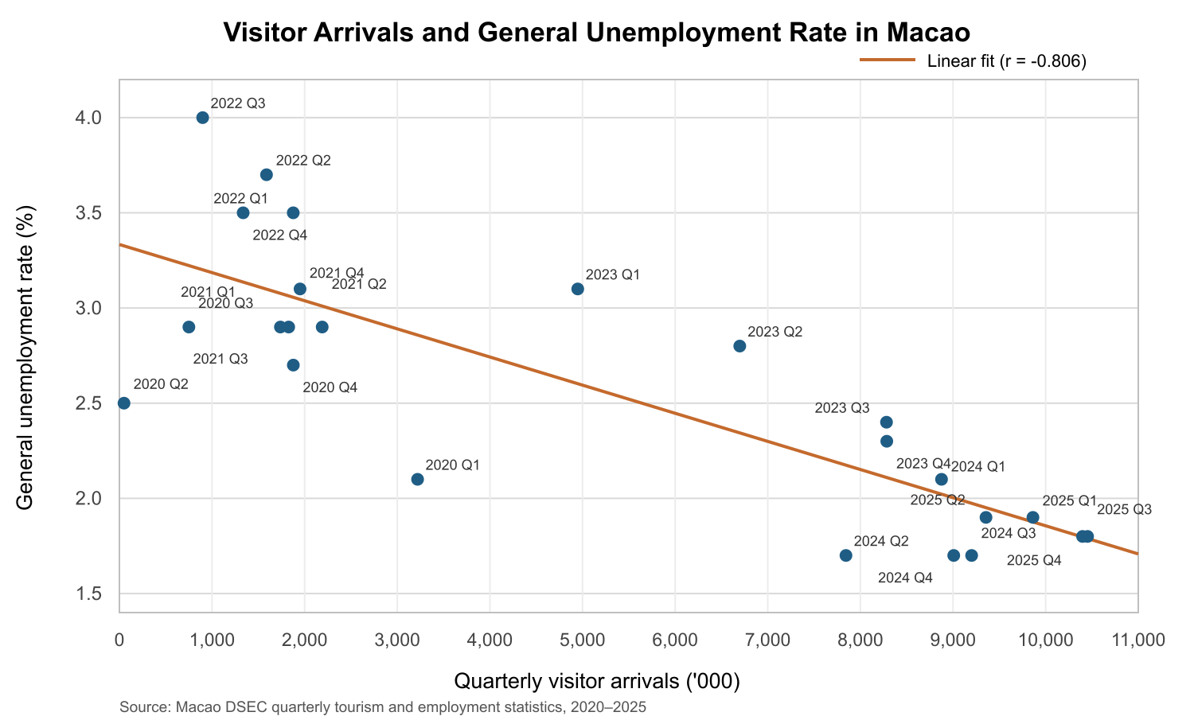

Written Justification
This project investigates whether the recovery of tourism in Macao is associated with improvements in employment conditions after the COVID-19 pandemic. The visualization above combines quarterly visitor arrival statistics and the general unemployment rate from 2020 Q1 to 2025 Q4. By examining both variables over the same period, we can see how employment conditions changed as tourism activity gradually recovered after travel restrictions were lifted and Macao’s economy reopened.

The preliminary analysis shows a strong negative correlation (Pearson’s r = -0.806), suggesting that periods with higher visitor arrivals were generally associated with lower unemployment rates. However, this visualization shows only an association, not a causal relationship; future research should consider additional factors.
Reference_Datasets
- Monthly Visitor Arrivals in Macau
DSEC - Statistics Database. (n.d.). http://www.dsec.gov.mo/timeseriesdatabase.aspx?keyindicatorid=27&lang=en-US

- Overall Unemployment Rate in Macau
DSEC - Statistics Database. (n.d.-c). https://www.dsec.gov.mo/timeseriesdatabase.aspx?keyindicatorid=24&lang=en-US

