Class M Pair 05
Eason, MITSUHASHI ATSUSHI_MC64292
Elfrida, WONG HO I_MC64268
CISC7204_Data Science and Data Visualization
Tourism Recovery and Overall Unemployment in Macao
Revised Pair Project Proposal

1. Project Overview
Item | Project specification
Region | Macao Special Administrative Region (SAR), China
Domain | Tourism and employment
Study period | 2020 Q1 – 2025 Q4 (24 calendar quarters)
Primary variables | Quarterly visitor arrivals (persons; displayed in millions) and overall unemployment rate (%)

Research Question
How strongly were quarterly visitor arrivals associated with Macao's overall unemployment rate from 2020 Q1 to 2025 Q4, and how did that relationship change between the pandemic disruption and the reopening recovery?

Purpose
Macao experienced a major contraction in visitor arrivals during the COVID-19 pandemic, followed by an expansion in tourism after travel restrictions were relaxed. Using official statistics, this project will examine whether quarters with higher visitor arrivals also tended to have lower overall unemployment. A second objective is to compare patterns across the pandemic disruption and reopening recovery, using 2023 Q1 as a practical dividing point in light of changes to entry measures beginning on 8 January 2023. The project will describe relationships in the observed data; it will not assume that visitor arrivals caused changes in unemployment. Policy changes, seasonality, labour supply and wider economic recovery may have influenced both indicators.

Learning Outcomes
- Apply reproducible data cleaning, aggregation and validation to two official time series.
- Create clear time-series and relationship visualizations with Python.
- Interpret correlation and regression results with appropriate limits on causal claims.

Skills Knowledge and Development
Compared with Assignment 01, this proposal narrows the topic to one testable 24-quarter question, adds a second official dataset, defines reproducible matching and validation, and includes preliminary correlation, regression, and visual evidence. This progression follows the workflow of project planning, data collection, data cleaning, exploratory analysis, initial model building, and documentation. The project develops Python, pandas, Matplotlib, statistical interpretation, and visual storytelling skills, while building knowledge of Macao tourism and labour indicators.

Data Sources and Scope
Indicator | Source and coverage | Use in analysis
Visitor arrivals (persons) | Monthly visitor arrivals; key indicator 27 (monthly). | Sum three monthly counts for each calendar quarter from 2020 to 2025
Overall unemployment rate (%) | Overall unemployment rate; key indicator 24 (three consecutive months). | Select the Jan–Mar, Apr–Jun, Jul–Sep and Oct–Dec three-month observations for each year

The resulting dataset will contain one row per quarter from 2020 Q1 to 2025 Q4. Each visitor-quarter total must be based on exactly three monthly counts, and every unemployment observation must correspond to the same calendar-quarter window. The analysis therefore avoids treating the overlapping three-month unemployment series as if each published period were a separate non-overlapping quarter.

Measurement boundary: The DSEC Employment Survey covers people living in sampled residential units in Macao; people who work in Macao but live outside the territory are excluded from the survey population.

Project Tasks and Deliverables
Step | Task | Deliverable
1 | Download both DSEC workbooks and record source definitions units and retrieval details | Source register and raw files
2 | Clean year and month labels then aggregate visitor counts into calendar-quarter totals | Clean tourism table
3 | Select four non-overlapping calendar-quarter unemployment periods per year and validate uniqueness | Clean unemployment table
4 | Join both series by year and quarter and verify 24 complete one-to-one matches | Analysis dataset and quality checks
5 | Produce descriptive statistics time-series charts scatter plot Pearson correlation and linear fit | Notebook tables and visuals
6 | Compare level correlation with quarter-to-quarter changes and interpret findings and limits | Robustness check and written discussion

Planned Analytical Method
6.1 Exploratory Data Analysis (EDA)
Descriptive statistics will summarize both indicators over 2020–2025 and within each study phase. A phase-coloured scatter plot will illustrate their association, while two aligned time-series charts will show quarterly trends and highlight the reopening period beginning in 2023 Q1.

6.2 Correlation and Simple Regression
Pearson correlation will be calculated for the full 24-quarter sample and separately for the pandemic (2020–2022) and recovery (2023–2025) periods. Simple linear regression will examine the relationship between visitor arrivals and unemployment, reporting the slope and R-squared. Period comparisons will be interpreted cautiously due to the small sample size.

6.3 Robustness and Model Diagnostics
First-difference correlation will examine quarter-to-quarter changes to assess the influence of shared trends. Regression residuals will also be checked for unusual observations and systematic patterns. These analyses will support cautious interpretation rather than causal or predictive conclusions.

Preliminary Evidence
The revised dataset contains 24 matched quarters with no missing or duplicate observations. The level correlation is r = -0.806 and R-squared = 0.649. The fitted slope is -0.148 percentage points in the overall unemployment rate for each additional one million quarterly visitors. The first-difference correlation is r = -0.513, which is weaker but remains negative. This comparison shows why the final interpretation must distinguish a broad shared recovery trend from quarter-to-quarter co-movement.
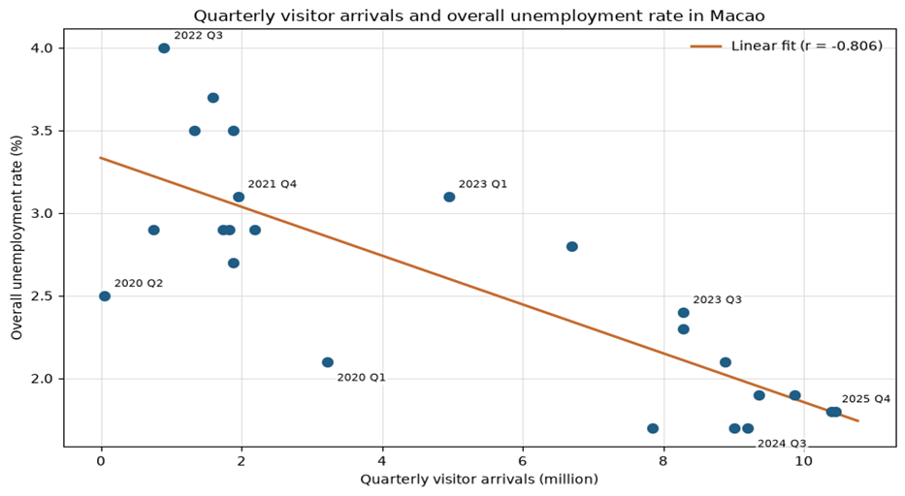
Figure 1 Visitor arrivals and overall unemployment rate 2020 Q1 to 2025 Q4

Written Justification
The scatter plot directly addresses the research question because every point represents the two indicators for the same quarter. Labels make the pandemic and recovery sequence visible, while the fitted line summarizes the overall direction of the association. The chart shows that high-visitor quarters generally coincide with lower unemployment, but the dispersion around the line also shows that tourism volume alone does not explain every quarterly change.
The time-series view on the next page adds the chronology that the scatter plot cannot show. Reading both visuals together will help us explain the 2020 collapse, the slower 2021-2022 adjustment, and the strong 2023-2025 recovery without presenting correlation as proof that visitor growth directly caused unemployment to fall.

Visual Story and Interpretation Plan
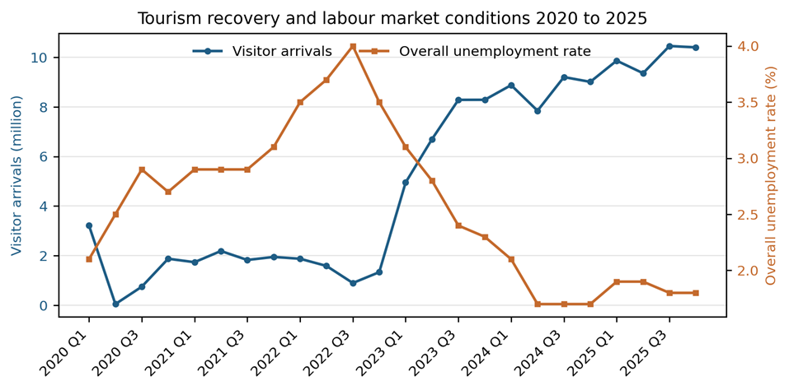
Figure 2 Quarterly tourism activity and overall unemployment 2020 to 2025

Interpretation Boundaries
- Correlation does not establish causation. Border policy, economic reopening, and labour supply influenced both indicators.
- Quarterly visitor totals remain seasonal. Comparisons will identify the quarter and avoid treating all changes as trend movements.
- Both series are time-ordered and autocorrelated. The first-difference check will be reported beside the level correlation.
- The overall unemployment rate covers the full labour force and is not a tourism-employment measure. Conclusions will refer to economy-wide unemployment.
- The 24-quarter sample supports a focused descriptive study but not a broad structural or forecasting claim.

Criteria for Success
Criterion | Completion evidence
Coverage and alignment | Exactly 24 quarters from 2020 Q1 to 2025 Q4, with both official indicators present and dates aligned.
Data integrity | Exactly three visitor months per quarter; four selected non-overlapping unemployment periods per year; no duplicate quarter keys.
Reproducibility | A clean Jupyter Notebook reads the original workbooks and regenerates the analysis table, statistics and final figures.
Analytical completeness | Full-period metrics, descriptive period comparison, first-difference check and basic diagnostic observations are reported.
Visual clarity | Readable axes, units, legends and source notes; the pandemic and recovery periods are visibly distinguished.
Responsible interpretation | Claims match the evidence; observational limits, labour-force coverage and uncertainty are explained.
Submission consistency | Proposal, notebook, figures and source register use the same definitions, period coverage and final values.

Collaboration and Project Control
Member | Primary responsibilities | Review responsibilities
Elfrida, WONG HO I | Tourism data cleaning, contextual research and visualization narrative; coordinator/liaison. | Check DSEC references, figure labels and interpretation.
Eason,  MITSUHASHI ATSUSHI | Unemployment-period alignment, merging, statistical analysis and main notebook; scribe/progress tracker. | Check reproducibility, units, and visual outputs.
Both members | Agree research decisions, inspect preliminary results and approve the final narrative. | Cross-check calculations, filenames, completeness, and submission copy.

Group Rules
- Both members should contribute equally to the project
- Progress should be communicated regularly
- Tasks should be completed before the agreed deadline
- Important changes should be discussed together
- Members must review each other’s work

Milestones
Milestone | Completion evidence
Data lock | Two DSEC source files retained and the 24-quarter table validated
Analysis lock | Statistics and both visuals regenerated without errors
Narrative review | Question method findings, limitations and terminology agree across files
Submission check | Both members verify the final Word document name, page count, and upload status

Dataset References
- Monthly Visitor Arrivals in Macau
DSEC - Statistics Database. (n.d.). http://www.dsec.gov.mo/timeseriesdatabase.aspx?keyindicatorid=27&lang=en-US

- Overall Unemployment Rate in Macau
DSEC - Statistics Database. (n.d.-c). https://www.dsec.gov.mo/timeseriesdatabase.aspx?keyindicatorid=24&lang=en-US

