
Practical Activity: Spark SQL
Practical Activity: Spark SQL

2025/2026
Encadrent : Abdelmajid BOUSSELHAM
ELGHOUALI Zakariae

Exercise 1:

1. Data Loading & Exploration

1. Load the CSV file into a Spark DataFrame.
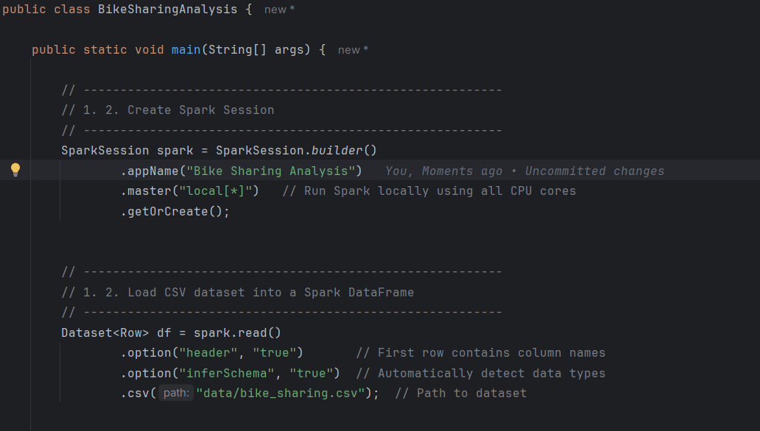
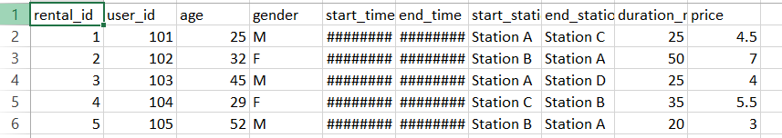

2. Display the schema.

