**Gonglian International Trade (Nanjing) Co., Ltd.**

**26/F., TOWER ONE, TIME SQUARE 1 MATHESON STREET CAUSEWAY BAY HK**

Mob.+ 86 13601580152 Email: [tonychai@gongliangm.cn](mailto:tonychai@gongliangm.cn)

**COMMERCIAL INVOICE**

Buyer : GARLIC LLC

Date : 25.08.2025

**A**ddress :

Phone:+99477 442 22 23

e-mail address:info@accessbank.az

Fax:+99412 510 37 71

|  |  |  |  |  |  |
| --- | --- | --- | --- | --- | --- |
| Commodity | Size  [CM] | Quantity  [SET] | Weight  [KG] | Unit Price  [US$] | Amount  [US$] |
| Foldable hanger bending machine  196F9986B6B6243F7E5C034C92D955A7 | 90*48*65 | 1 | 35 | 510 | 510 |
| **Total** |  | **1** | **35** | **510** | **510** |

**PACKING LIST**

**Buyer :** SPAN Innovations Pvt. Ltd. Date : 25.08.2025

**Address :**

Phone:+99477 442 22 23

e-mail address:info@accessbank.az

Fax:+99412 510 37 71

|  |  |  |  |  |  |
| --- | --- | --- | --- | --- | --- |
| Commodity | Quantity  [SET] | Case Size  [CM] | Unit CBM  [CBM] | N.W.  [KG] | G.W.  [KG |
| Foldable hanger bending machine  196F9986B6B6243F7E5C034C92D955A7 | 1 | 90*48*65 | 0.2808 | 35 | 35 |
| **Total** | **1** |  | 0.2808 | **5.2** | **35** |

**Remarks:**

**1.Payment Terms: By T/T,10o% payment before delivery.**

**2. Packing: As seller's usual packing, no logo carton.**

**3.Trade term:EXW.**

**Dearcustomers,payattentiontothefollowedbankaccount information,please.Anyfromotheremails arenoted.**

**Account Information:**

**Benefieiary: Gonglian International Trade (Nanjing) Co., Ltd.**

**Address: 26/F., TOWER ONE, TIME SQUARE 1 MATHESON STREET CAUSEWAY BAY HK**

**Bank: CITIBANK, N.A., HONG KONG BRANCH**

**Bank address:Champion Tower, Three Garden Road, Central, Hong Kong**

**Swift Code:CITIHKHX or CITIHKHXXXX**

**Account number: 3996000863423**

The total order price is **510 US** dollars, including the shipping cost to the buyer's freight forwarding address in China.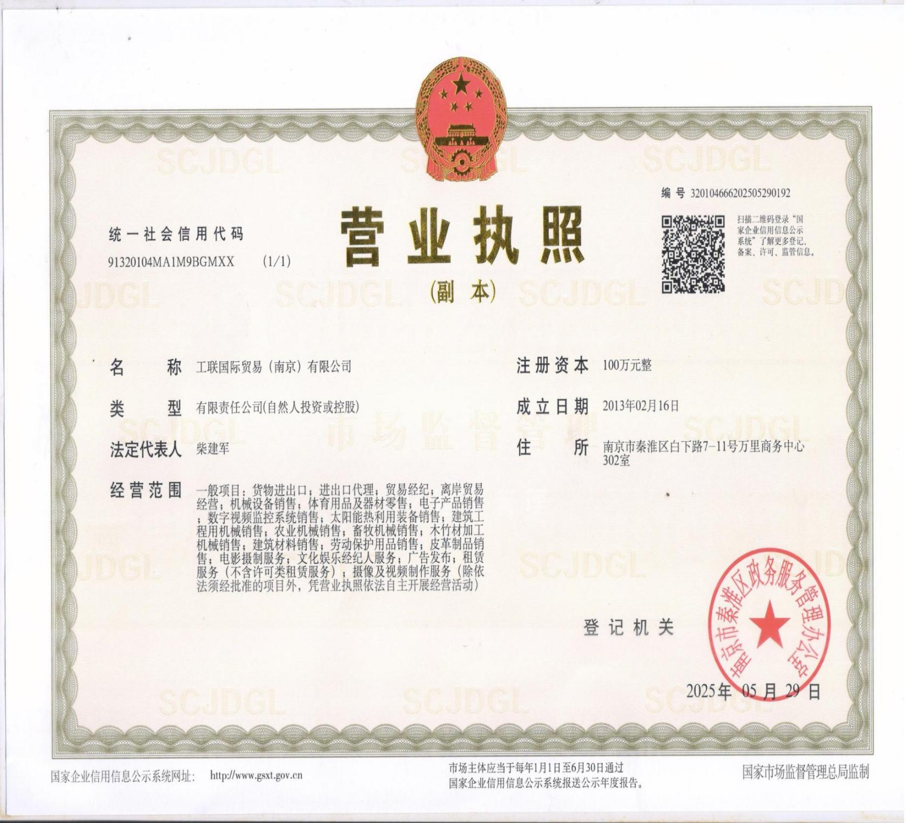

**（The above is the business license of our company, which has been authorized by the Chinese government.）**