**ASLAM SIKDER** 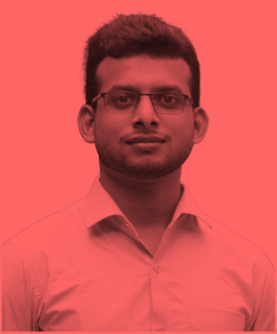

Holding: C-102, Baupara

Post: Kaultia-1703

Sub Dist.: Gazipur Sadar, Dist.: Gazipur

Division: Dhaka

Cell    : +88 01

E-mail: @gmail.com

**CAREER OBJECTIVE**

To prove myself as a highly energetic person to face any challenges and leverage my academic knowledge, work experiences, strong analytical & communication skills to promote relationship with other members to increase the overall effectiveness of your company’s workforce.

**CAREER SUMMARY**

**Company Name:** BGIFT Institute of Science & Technology

**From:** May 20, 2021 **to** Present

**Designation:** Lecturer (Dept. of CSE)

**Responsibility:**

* Give lectures to the undergraduate students, conducted some researches and directed some training courses.
* Responsible for planning, organizing, and directing the completion of the specific project of the organization.

**EDUCATIONAL BACKGROUND**

|  |  |  |  |  |
| --- | --- | --- | --- | --- |
| **Degree Obtained and Department** | **Institution’s Name** | **Board/ University** | **Year of Passing** | **Results Obtained** |
| B. Sc. Engineering in Computer Science and Engineering (CSE) | Southeast University (SEU) | SEU | 2018 | CGPA:  (Out of 4) |
| H.S.C. (Science) | Rover Palli College | Dhaka | 2014 | CGPA:  (Out of 5) |
| S.S.C. (Science) | Bhawal Mirzapur Public School | Dhaka | 2012 | CGPA:  (Out of 5) |

**Professional SKILLS**

* Good programming skills (Python, R, C, C++ & SQL).
* Supervised Learning: Linear and Logistic Regression, Decision Trees, Support Vector Machine (SVM).
* Unsupervised Learning: k-means Clustering.
* Deep Learning: LSTM.
* Machine Learning Libraries: NumPy, Pandas, Matplotlib, Seaborn, Scikit-learn.

**MEMBERSHIP**

* **Associate Member** of Bangladesh Computer Society.
* Ex-Member of Southeast University Debating Club.

**LANGUAGE PROFICIENCY**

* Excellent Writing & Speaking skill in communication in Bangla (Native).
* Excellent Writing & Speaking skill in communication in English.

**PERSONAL DETAILS**

|  |  |
| --- | --- |
| **Mother’s Name** | : |
| **Father’s Name** | : |
| **Date of Birth** | :  DD MM, YYYY |
| **National ID** | :  **\*\*\*\*\*\*\*\*\*\*\*\*\*\*\*\*\*\*\*\*\*\*** |
| **Birth ID** | :  **\*\*\*\*\*\*\*\*\*\*\*\*\*\*\*\*\*\*\*\*\*\*** |
| **Permanent Address** | : |
| **Marital Status** | : Unmarried |
| **Nationality** | :  Bangladeshi |

**REFERENCE (S)**

|  |  |
| --- | --- |
| **Engr. Aslam Sikder**  Head, Department of FDT  BGIFT Institute of Science & Technology (BIST)  Email: *aslamsikdersir@gmail.com*  Cell: (+88) 01968 878709 | **Engr. Md. Manirul Islam**  Head, Department of AMT  BGIFT Institute of Science & Technology (BIST)  Email: manirdu92@gmail.com  Cell: (+88) 01967 100208 |