**CSE 4207 CT 4 Assignment**

**Roll No: 1903048**

**Assignment Problem:**

**Category:** A

**Word Size = 7bits**

**ALU Operations = NOT ,ROR**

**HDL Code:**

|  |  |
| --- | --- |
| **Check List:** Have you added all the modules written in verilog including ALU, ALU_OP1, ALU_OP2, ALU_TESTBENCH? | YES |

**ALU_OP1.v**

|  |
| --- |
| **module ALU_OP1**  **(**  **input wire [6:0] A,**  **output wire [6:0] R**  **);**  **assign R = ~A;**  **endmodule** |

**ALU_OP2.v**

|  |
| --- |
| **module ALU_OP2**  **(**  **input wire [6:0] A,**  **input wire [2:0] B, // Number of bits to rotate (0–7)**  **output reg [6:0] R**  **);**  **always @(*) begin**  **case (B)**  **3'd0: R = A; // No rotation**  **3'd1: R = {A[0], A[6:1]};**  **3'd2: R = {A[1:0], A[6:2]};**  **3'd3: R = {A[2:0], A[6:3]};**  **3'd4: R = {A[3:0], A[6:4]};**  **3'd5: R = {A[4:0], A[6:5]};**  **3'd6: R = {A[5:0], A[6]};**  **3'd7: R = A; // Full rotate results in original**  **default: R = A;**  **endcase**  **end**  **endmodule** |

**ALU.v**

|  |
| --- |
| **module ALU**  **(**  **input wire [6:0] A, B,**  **input wire [1:0] OP, // 00 = NOT, 01 = ROR**  **output reg [6:0] R,**  **output wire CF,**  **output wire SF,**  **output wire ZF**  **);**  **wire [6:0] R_NOT, R_ROR;**  **// Submodules**  **ALU_OP1 NOT1 (.A(A), .R(R_NOT));**  **ALU_OP2 ROR1 (.A(A), .B(B[2:0]), .R(R_ROR));**  **always @(*) begin**  **case (OP)**  **2'b00: R = R_NOT;**  **2'b01: R = R_ROR;**  **default: R = 7'b0000000;**  **endcase**  **end**  **assign CF = (OP == 2'b01) ? A[B % 7] : 1'b0; // CF is last bit rotated out**  **assign SF = R[6]; // Sign flag (MSB)**  **assign ZF = ~(|R); // Zero flag**  **endmodule** |

**ALU_TESTBENCH.v**

|  |
| --- |
| **module ALU_TESTBENCH;**  **reg [6:0] A, B;**  **reg [1:0] OP;**  **wire [6:0] R;**  **wire CF, SF, ZF;**  **ALU uut (**  **.A(A),**  **.B(B),**  **.OP(OP),**  **.R(R),**  **.CF(CF),**  **.SF(SF),**  **.ZF(ZF)**  **);**  **initial begin**  **$dumpfile("test7.vcd");**  **$dumpvars(0, ALU_TESTBENCH);**  **// Test NOT operation**  **A = 7'b1010101; B = 7'b0000000; OP = 2'b00; #10;**  **A = 7'b0000000; B = 7'b0000000; OP = 2'b00; #10;**  **// Test Rotate Right by various amounts**  **A = 7'b1000001; B = 7'b0000001; OP = 2'b01; #10; // Rotate by 1**  **A = 7'b1100001; B = 7'b0000010; OP = 2'b01; #10; // Rotate by 2**  **A = 7'b1111111; B = 7'b0000101; OP = 2'b01; #10; // Rotate by 5**  **A = 7'b1000000; B = 7'b0000011; OP = 2'b01; #10; // Rotate by 3**  **A = 7'b0000001; B = 7'b0000011; OP = 2'b01; #10; // Rotate by 3**  **A = 7'b1000001; B = 7'b0000000; OP = 2'b01; #10; // Rotate by 0**  **A = 7'b1000001; B = 7'b0000111; OP = 2'b01; #10; // Rotate by 7 (same as original)**  **$finish;**  **end**  **initial begin**  **$monitor("Time=%0t A=%b B=%b OP=%b -> R=%b CF=%b ZF=%b SF=%b", $time, A, B, OP, R, CF, ZF, SF);**  **end**  **endmodule** |

**RTL Timing Diagram:**

|  |  |
| --- | --- |
| **Check List:** Have you added all the timing diagrams of ALU_TESTBENCH? | YES |

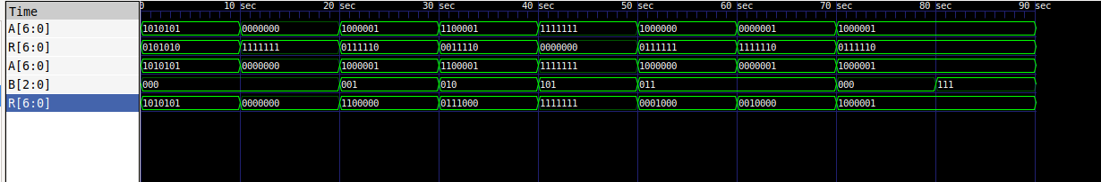

**Category: B**

**Word Size = 7bits**

**ALU Operations = NOT ,ROR**

**RTL Synthesis (130nm Skywater PDK with OpenLane toolchain):**

|  |  |
| --- | --- |
| **Check List:** Have you added *RTL synthesis summary*, *RTL synthesized design figure* and *Standard cell usage in synthesized design*? | YES |

**RTL synthesis summary**

=== ALU ===

METRIC COUNT

Number of wires: 134

Number of wire bits: 153

Number of public wires: 7

Number of public wire bits: 26

Number of ports: 7

Number of port bits: 26

Number of memories: 0

Number of memory bits: 0

Number of processes: 0

Number of cells: 137

**Standard cell usage in synthesized design**

sky130_fd_sc_hd__a2111oi_2 1

sky130_fd_sc_hd__a211o_2 4

sky130_fd_sc_hd__a21bo_2 2

sky130_fd_sc_hd__a21o_2 5

sky130_fd_sc_hd__a21oi_2 4

sky130_fd_sc_hd__a221o_2 3

sky130_fd_sc_hd__a221oi_2 3

sky130_fd_sc_hd__a22o_2 1

sky130_fd_sc_hd__a311o_2 1

sky130_fd_sc_hd__a31o_2 4

sky130_fd_sc_hd__a31oi_2 1

sky130_fd_sc_hd__a32o_2 2

sky130_fd_sc_hd__and2_2 4

sky130_fd_sc_hd__and2_4 1

sky130_fd_sc_hd__and3_2 4

sky130_fd_sc_hd__and4b_2 1

sky130_fd_sc_hd__buf_2 1

sky130_fd_sc_hd__inv_2 12

sky130_fd_sc_hd__mux2_1 3

sky130_fd_sc_hd__mux2_2 4

sky130_fd_sc_hd__mux4_2 8

sky130_fd_sc_hd__nand2_2 9

sky130_fd_sc_hd__nand2b_2 2

sky130_fd_sc_hd__nand3_2 2

sky130_fd_sc_hd__nand3b_2 1

sky130_fd_sc_hd__nor2_2 7

sky130_fd_sc_hd__nor2b_2 1

sky130_fd_sc_hd__nor3_2 1

sky130_fd_sc_hd__nor3b_2 1

sky130_fd_sc_hd__nor4_4 1

sky130_fd_sc_hd__nor4b_2 1

sky130_fd_sc_hd__o211a_2 8

sky130_fd_sc_hd__o211a_4 2

sky130_fd_sc_hd__o211ai_2 1

sky130_fd_sc_hd__o21a_2 5

sky130_fd_sc_hd__o21bai_2 1

sky130_fd_sc_hd__o22a_2 1

sky130_fd_sc_hd__o2bb2a_2 1

sky130_fd_sc_hd__o311a_2 1

sky130_fd_sc_hd__o31a_2 3

sky130_fd_sc_hd__o31ai_2 1

sky130_fd_sc_hd__o32ai_2 1

sky130_fd_sc_hd__or2_2 6

sky130_fd_sc_hd__or2_4 2

sky130_fd_sc_hd__or3_2 1

sky130_fd_sc_hd__or3_4 2

sky130_fd_sc_hd__or3b_2 1

sky130_fd_sc_hd__or4_4 1

sky130_fd_sc_hd__xnor2_2 2

sky130_fd_sc_hd__xor2_2 2

**RTL synthesized design figure**

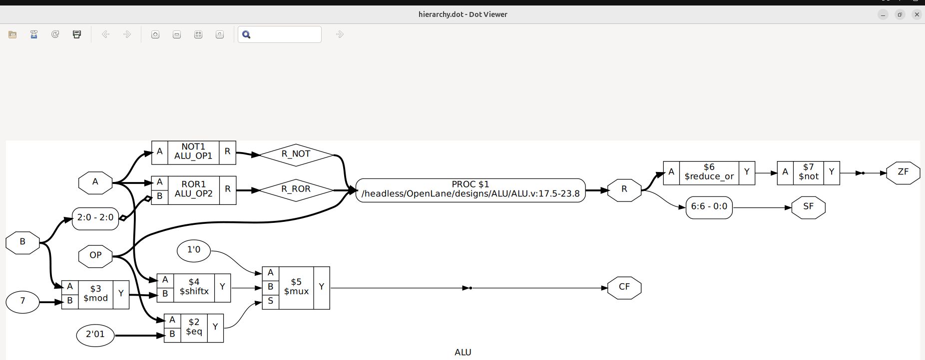

**RTL Floorplan (130nm Skywater PDK with OpenLane toolchain)**

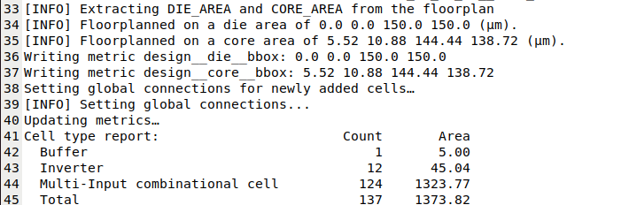

**RTL Power Analysis (130nm Skywater PDK with OpenLane toolchain)**

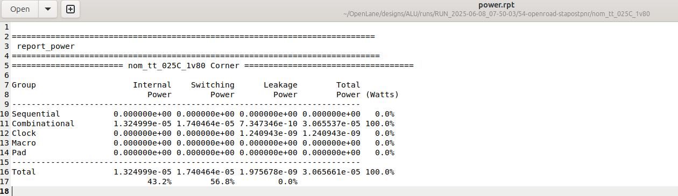

**GDS Layout (130nm Skywater PDK with OpenLane toolchain)**

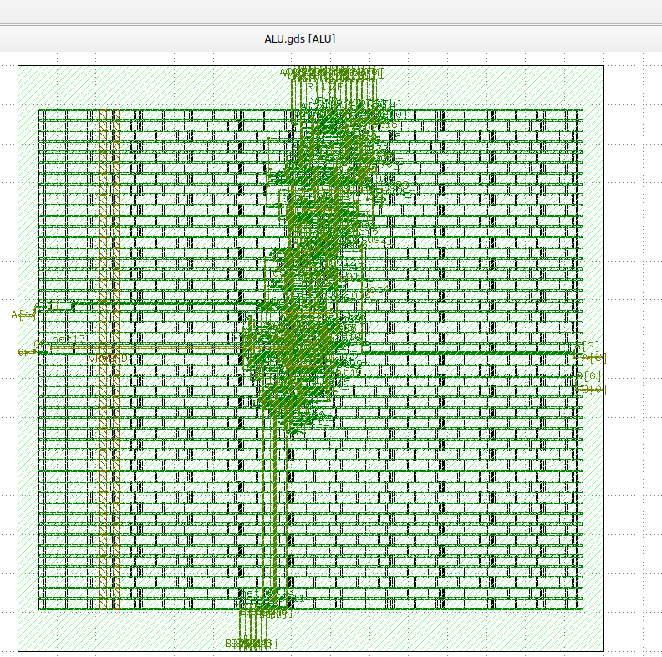

**Heatmap (130nm Skywater PDK with OpenLane toolchain)**

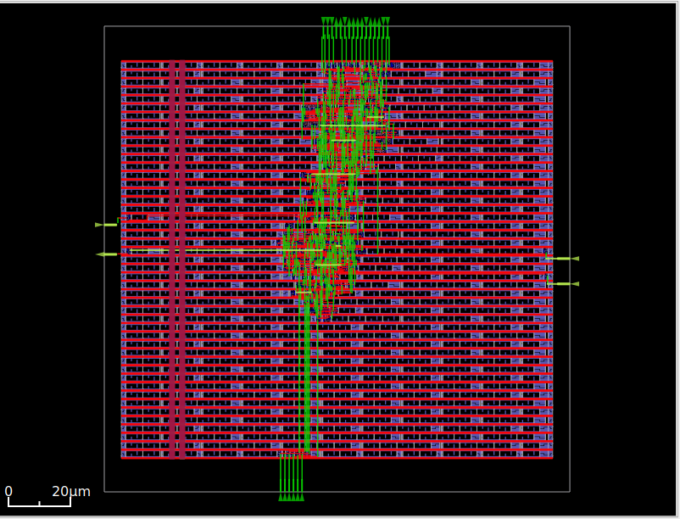

**Category: C**

**Word Size = 7bits**

**ALU Operations = NOT ,ROR**

**HDL Code:**

|  |  |
| --- | --- |
| **Check List:** Have you added all the modules written in verilog including CONTROLLER,TOP, TOP_TESTBENCH,CONTROLLER_TESTBENCH? | YES |

**TOP.v**

|  |
| --- |
| **module TOP(**  **input wire clk, reset,**  **output wire [6:0] result,**  **output wire flag**  **);**  **wire [6:0] a, b;**  **wire [2:0] op;**  **wire [6:0] res;**  **wire f;**  **CONTROLLER controller(**  **.clk(clk), .reset(reset),**  **.a(a), .b(b), .op(op),**  **.result(res),**  **.flag(f)**  **);**  **CONTROLLER_TESTBENCH datapath(**  **.a(a), .b(b), .op(op),**  **.result(res), .flag(f)**  **);**  **assign result = res;**  **assign flag = f;**  **endmodule** |

**TOP_CONTROLLER.v**

|  |
| --- |
| **`timescale 1ns/1ns**  **module TOP_TESTBENCH;**  **reg clk, reset;**  **wire [6:0] result;**  **wire flag;**  **TOP top (**  **.clk(clk), .reset(reset),**  **.result(result), .flag(flag)**  **);**  **initial begin**  **clk = 0;**  **forever #5 clk = ~clk;**  **end**  **initial begin**  **$dumpfile("alu_fsm.vcd");**  **$dumpvars(0,TOP_TESTBENCH);**  **reset = 1;**  **#10;**  **reset = 0;**  **#100; // Run for a few clock cycles**  **$finish;**  **end**  **endmodule** |

**CONTROLLER.v**

|  |
| --- |
| **module CONTROLLER(**  **input wire clk, reset,**  **output reg [6:0] a, b,**  **output reg [2:0] op,**  **input wire [6:0] result,**  **input wire flag**  **);**  **reg [2:0] state, next_state;**  **parameter START = 3'b000,**  **ONE = 3'b001,**  **TWO = 3'b010,**  **THREE = 3'b011,**  **FINISH = 3'b100;**  **always @(posedge clk or posedge reset) begin**  **if (reset) state <= START;**  **else state <= next_state;**  **end**  **always @(*) begin**  **a = 7'd0; b = 7'd0; op = 3'd0;**  **case (state)**  **START: next_state = ONE;**  **ONE: begin**  **a = 7'b0101010; op = 3'd0; // NOT**  **next_state = TWO;**  **end**  **TWO: begin**  **a = 7'b0001101; op = 3'd1; // ROTATE RIGHT**  **next_state = THREE;**  **end**  **THREE: begin**  **a = 7'd0; op = 3'd2; // NOP or final test case**  **next_state = FINISH;**  **end**  **FINISH: next_state = FINISH;**  **default: next_state = START;**  **endcase**  **end**  **endmodule** |

**CONTROLLER_TESTBENCH.v**

|  |
| --- |
| **module TOP(**  **input wire clk, reset,**  **output wire [6:0] result,**  **output wire flag**  **);**  **wire [6:0] a, b;**  **wire [2:0] op;**  **wire [6:0] res;**  **wire f;**  **CONTROLLER controller(**  **.clk(clk), .reset(reset),**  **.a(a), .b(b), .op(op),**  **.result(res),**  **.flag(f)**  **);**  **CONTROLLER_TESTBENCH datapath(**  **.a(a), .b(b), .op(op),**  **.result(res), .flag(f)**  **);**  **assign result = res;**  **assign flag = f;**  **endmodule** |

**RTL Timing Diagram:**

|  |  |
| --- | --- |
| **Check List:** Have you added all the timing diagrams of CONTROLLER_TESTBENCH, TOP_TESTBENCH? | YES |

