
AI Challenge in Service of Islamic Content 2026

e-Tasmi AI Learning Loop
Pre-Challenge Baseline Documentation
Track 03 — Interactive Experiences & Learning Journeys for Islam
Participant
Elhessan Abdelrahman Adam
Status
Pre-Challenge Source Baseline
Source snapshot: commit a358719
Tag: baseline-pre-ai-challenge-2026
This report records the system that already existed. It does not record challenge-period implementation.
Repository: https://github.com/Elhessan2000/e-tasmi-ai-learning-loop

Document Control
This report documents the pre-challenge source state. The source baseline is identified by the Git commit and tag below.
Item | Record
Project | e-Tasmi AI Learning Loop
Challenge | AI Challenge in Service of Islamic Content 2026
Track | Track 03 — Interactive Experiences & Learning Journeys for Islam
Participant | Elhessan Abdelrahman Adam
Repository | https://github.com/Elhessan2000/e-tasmi-ai-learning-loop
Branch | master
Baseline commit | a358719
Full commit | a35871918907d7a403c9469537c25f940009b340
Baseline tag | baseline-pre-ai-challenge-2026
The tag points at commit a358719. Later local inspection addresses are not part of that commit. They are recorded in Section 13 so the source snapshot is not confused with the machine setup used to view it.
This report documents the starting state. It is not a claim that challenge work has been accepted, completed, or scored.

1. Baseline Scope and Boundary
e-Tasmi already existed as a web platform for Qur'an recitation learning. This baseline records that system before the official challenge development period, so later work can be compared with a known starting point.
Pre-challenge baseline means the source in commit a358719 and the behaviour confirmed by the existing system audit, the application code, and the screenshots in this report. The project is being extended. It is not presented as a system created for the challenge.
Challenge-period implementation is outside this report. It will be documented separately, and only after that work is actually done.
Boundary | What it covers
PRE-CHALLENGE | Existing system and capabilities already present in the source snapshot.
CHALLENGE PERIOD | New work performed during the official challenge development period. Not described here as present.
The following were not part of the baseline and are not described as implemented: persistent structured AI findings; per-finding Accept, Edit, or Reject; an instructor verification gate for individual findings; Verified Learning Focus; a student learning-focus display; Practice Again; resubmission linkage; and a trusted Qur'an Library verse key used as the recitation comparison reference.

2. Existing System Overview
At baseline, e-Tasmi was a server-rendered JSP and Java Servlet application. A student enrols in a tasmi session, submits recitation audio, and later views the instructor's score and feedback. An instructor manages sessions, plays submitted audio, may run an on-screen analysis, and saves the official evaluation. An administrator manages users and approves instructors.
Access is session-based. The audit records no separate course entity. The live path uses three roles only: Student, Instructor, and Admin.
Area | Already present
Learning unit | Tasmi session, including a free-text Qur'an portion
Enrolment | Student linked to a session
Recitation | Uploaded or recorded audio stored for that enrolment
Evaluation | One official score and feedback per recitation
Progress | Student progress updated from the saved evaluation
Qur'an Library | Reading, reference, and listening, separate from recitation comparison
The confirmed recitation path is shown below. AI analysis sits beside instructor review. It is optional, and only the instructor starts it.
Instructor creates session
↓ Student enrols
↓ Student submits recitation
↓ Audio stored
↓ Instructor reviews
↓ Optional: instructor starts AI analysis
↓ Instructor evaluates
↓ Student views result

3. Existing Student Experience
A student signs in, uses a dashboard, chooses a session, and submits audio by recording or by file upload. After the instructor saves an evaluation, the student opens the result, plays the submission, and reads the score and feedback. A submission can also remain waiting for review.
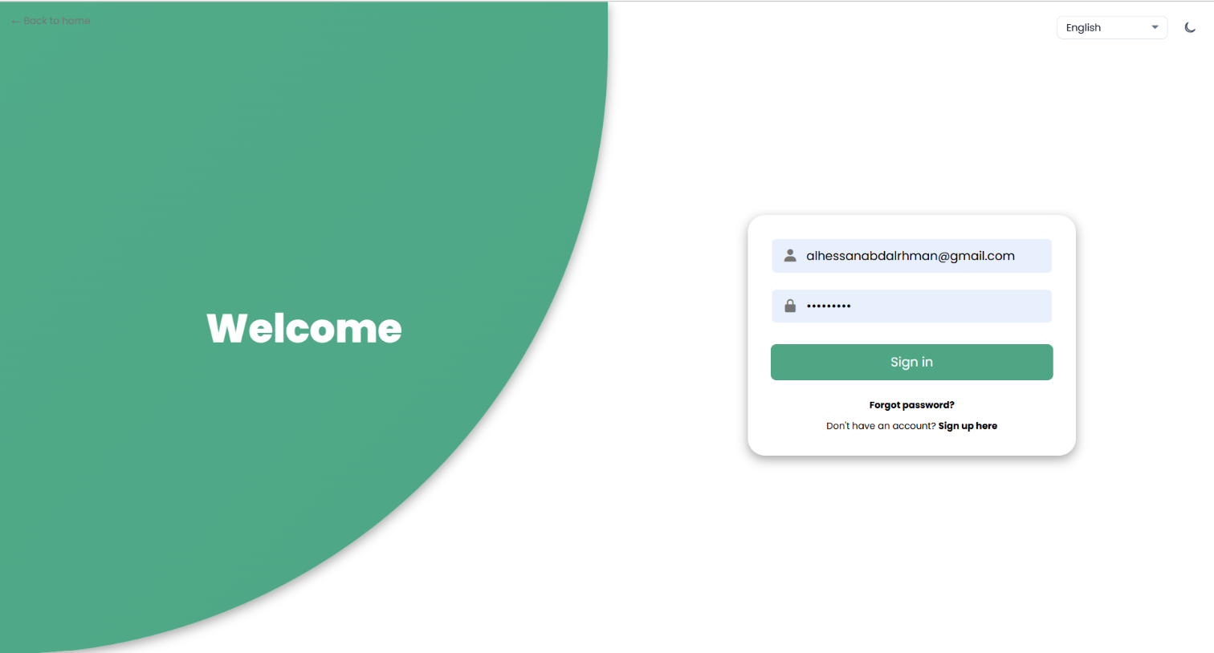Figure 1. Existing login interface. The screen shows a welcome panel, email and password fields, Sign in, Forgot password, and Sign up. 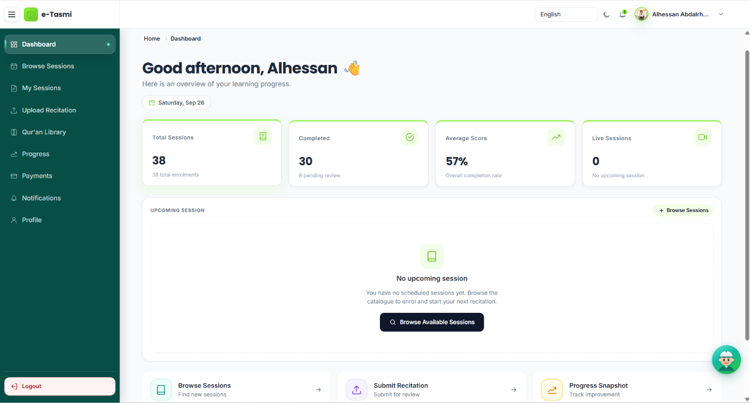Figure 2. Existing student dashboard at the pre-challenge baseline. Visible items include session totals, completed sessions, an average score, and links to browse sessions, submit a recitation, and open progress. 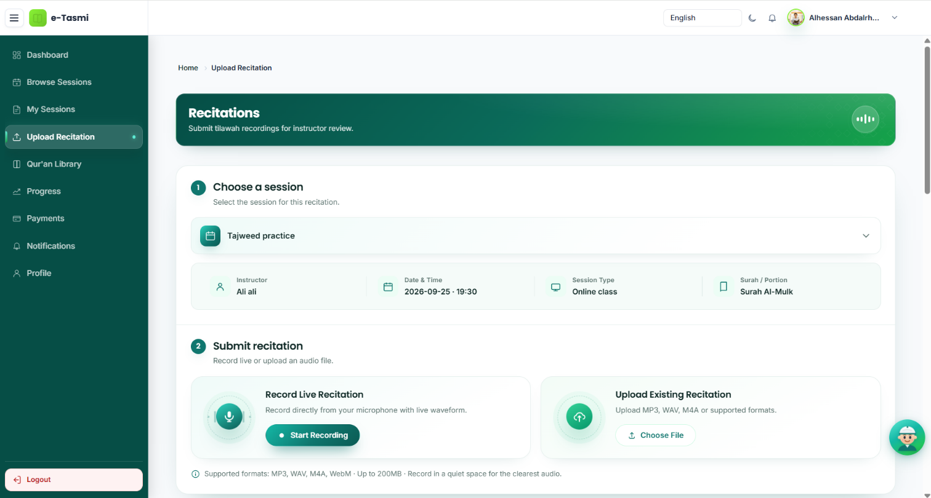Figure 3. Existing student recitation submission interface. The screen shows session selection, the assigned surah or portion, Record Live Recitation, and Upload Existing Recitation. 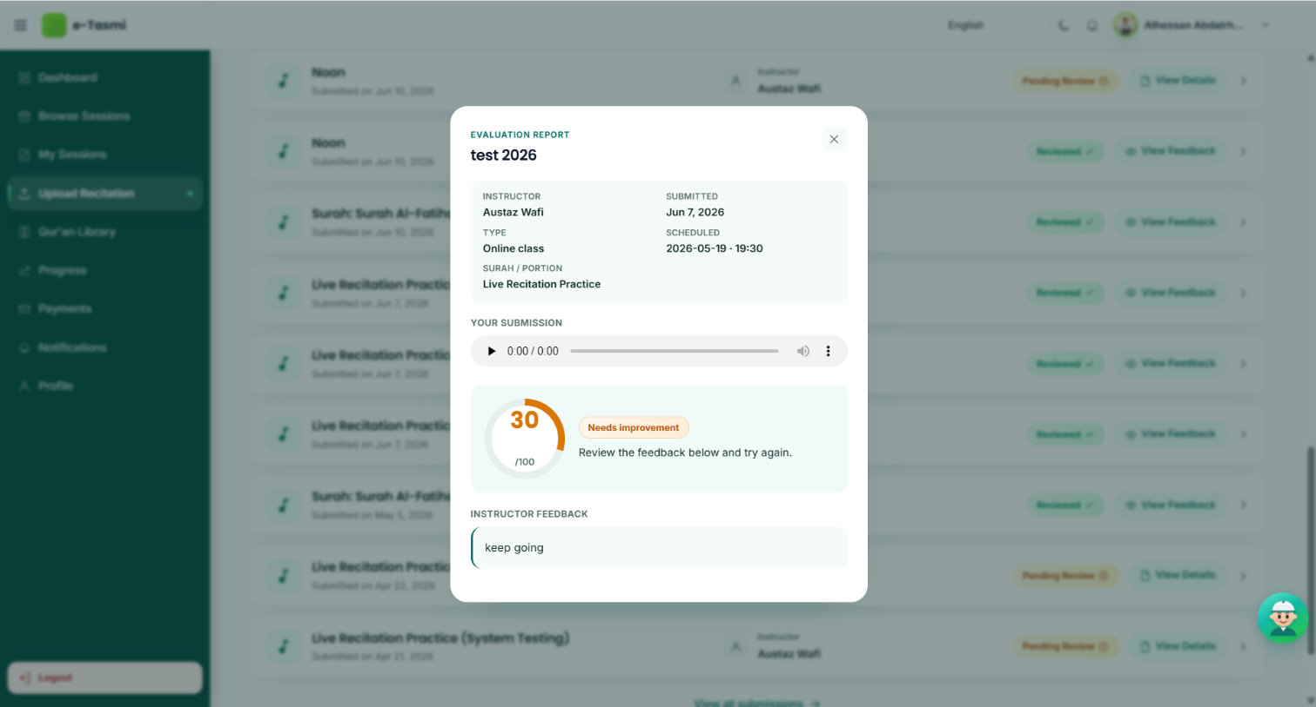Figure 4. Existing student result and feedback interface. The open report shows playback, a score out of 100, a status, and an instructor feedback note.
Payment, notifications, and live join exist beside this path. They are not required for every recitation. The message on the result screen is the stored evaluation view. It is not the planned Practice Again learning loop.
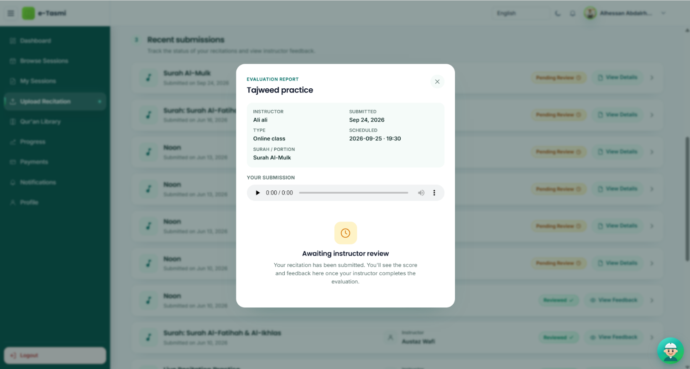Figure 5. Existing student-side recitation workflow evidence. This report is waiting for instructor review and shows the session, portion, and submission playback.

4. Existing Instructor Experience
An approved instructor sees sessions, submissions, and a teaching calendar. On the evaluations page the instructor opens a session roster, plays submitted audio, and can start the existing analysis. The on-screen result is advisory. The instructor types the official score and feedback and saves them. That saved row is what the student sees.
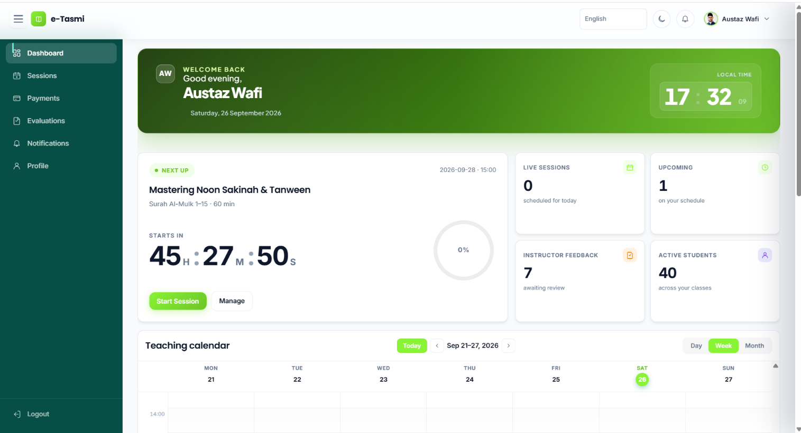Figure 6. Existing instructor dashboard. Visible items include the next session, live and upcoming counts, feedback awaiting review, active students, and a teaching calendar. 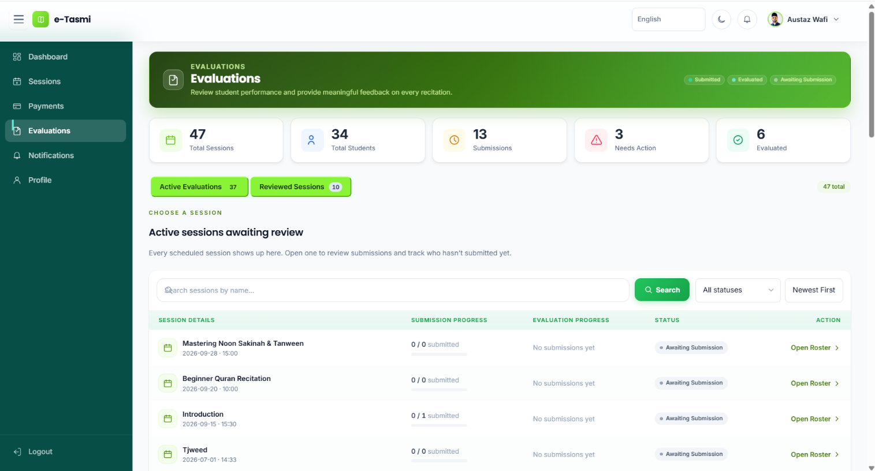Figure 7. Existing instructor evaluation interface. The page lists sessions, submission progress, and evaluation status, with Active and Reviewed session groups. 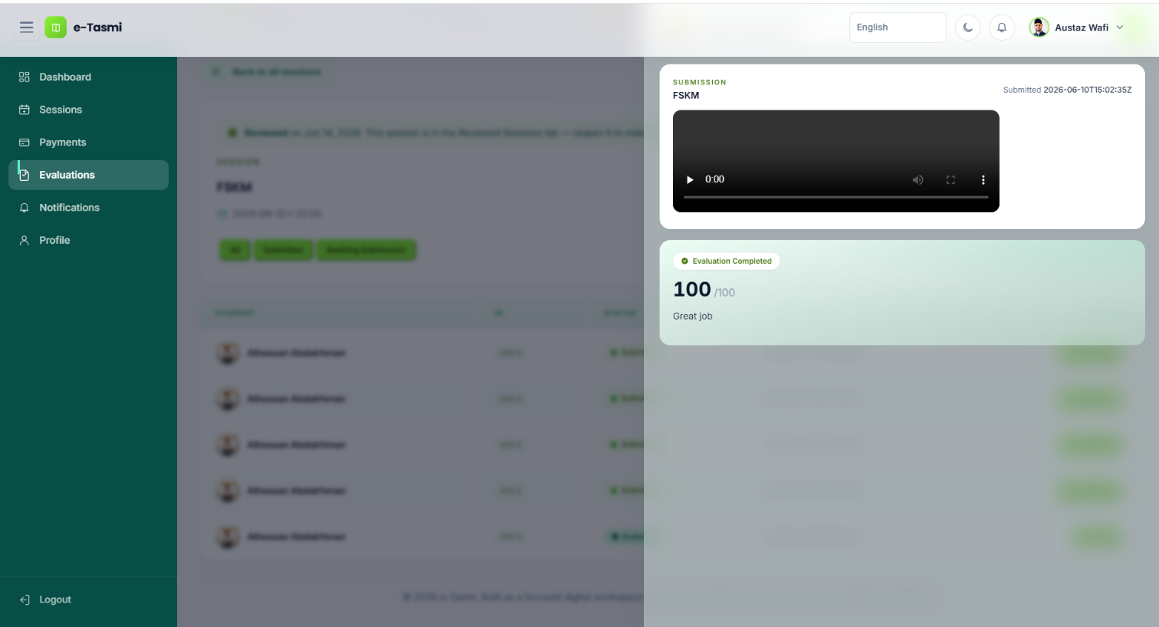Figure 8. Existing instructor-side completed recitation workflow. The panel shows the submitted audio and a completed evaluation with a score out of 100 and feedback.
The score on the analysis report is a suggestion. The score stored for the student is the score the instructor enters and saves.

5. Existing AI-Assisted Recitation Analysis
Instructor-triggered analysis already existed. The student cannot start it. The service reads the stored audio, requests a transcription, then requests an evaluation against the session text. The result is shown on the evaluations page. It is not written as a durable structured finding. Saving the official evaluation clears that on-screen state, and a later page load does not restore it as a finding record.
Recitation audio
↓ Audio retrieval
↓ Transcription
↓ AI evaluation
↓ Analysis result
↓ Instructor review
↓ Official human evaluation
A successful result can include a transcript, correct words, missing words, incorrect words, extra words, pronunciation notes, passage flags, a suggested score from 0 to 100, a summary, and feedback text. Pronunciation notes are limited to the transcript. The audit records no acoustic Tajweed engine. If the evaluator call fails, the same service can show a local word comparison instead.
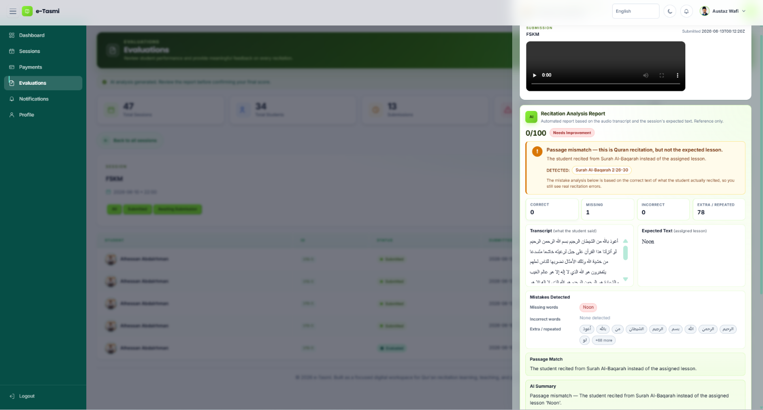Figure 9. Existing instructor AI-assisted recitation analysis. The visible report includes playback, a suggested score, a passage-mismatch notice, word counts, a transcript, the assigned expected text, and a summary. The page tells the instructor to review the report before confirming a final score.
The comparison text is the session's quran_portion value: free text entered for that session, not a Qur'an Library verse key. On this screen the report labels that text as the assigned lesson and can flag a passage mismatch without turning the suggestion into the official score.
Java defaults, used only when the environment variables are absent, are gpt-4o-transcribe for transcription and gpt-4o for evaluation. Baseline Compose, when the host does not set the variables, passes whisper-1 for transcription and gpt-4o-mini on the classifier path. No runtime test of either pair is claimed here.

6. Existing Qur'an Library and Reference
The Qur'an Library already existed on the student path. Quran Foundation supplies chapters, verses, and related resources when configured. Reciter audio is served for listening. There is no local mushaf database in the application.
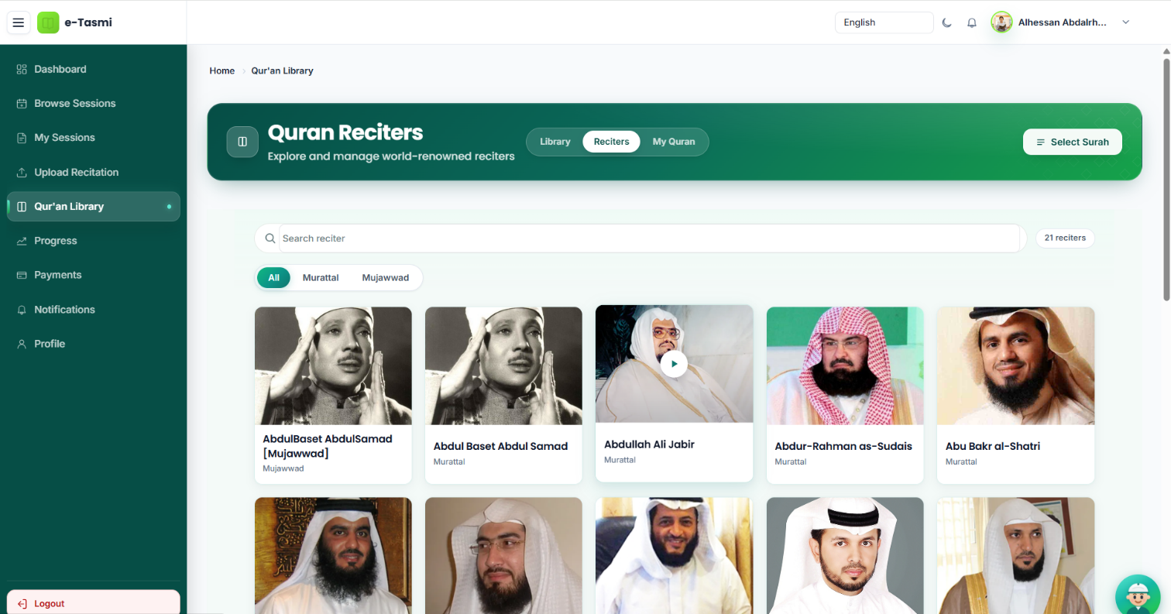Figure 10. Existing Qur'an Library. The screen shows the reciters catalogue, search, and a play control. 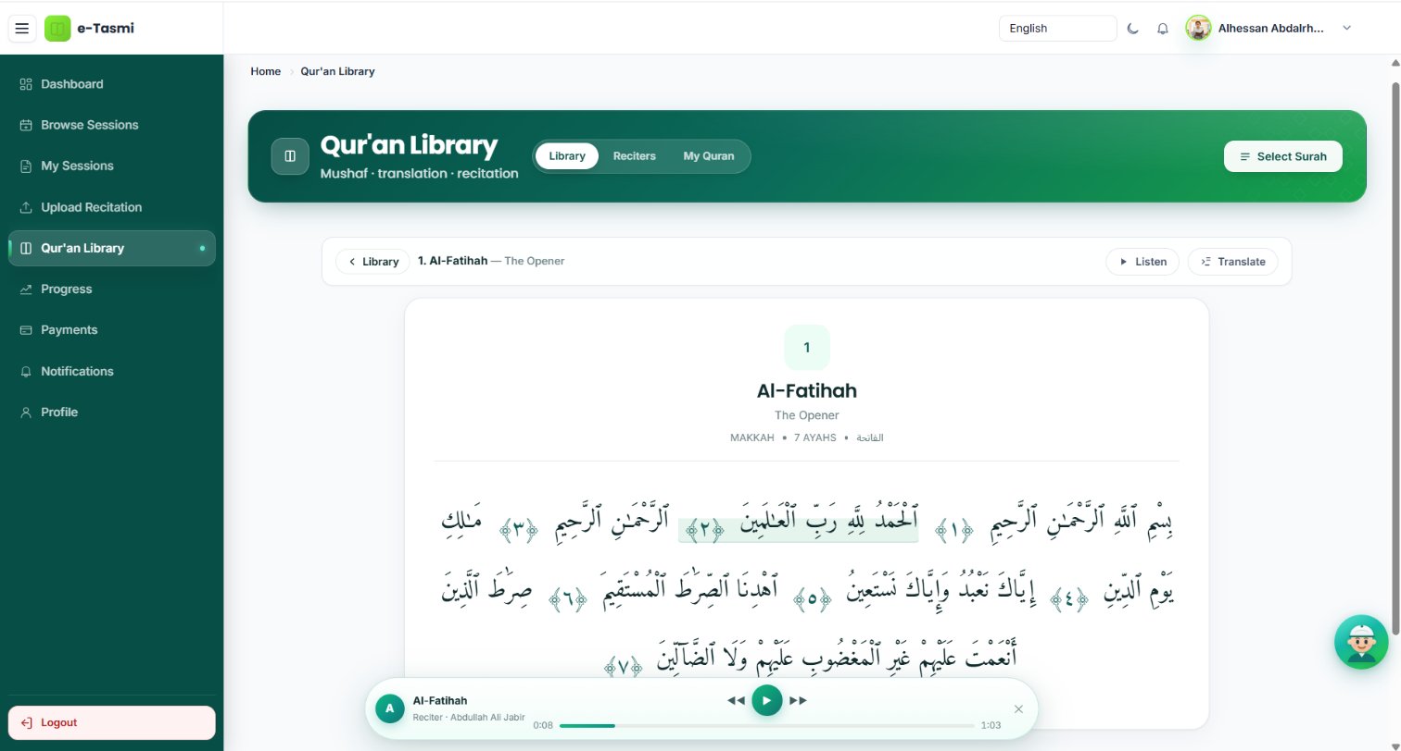Figure 11. Existing Qur'an reference and library view. The screen shows Surah Al-Fatihah in Arabic, Listen and Translate controls, and a reciter player.
At baseline, the Qur'an Library reference path was separate from the recitation AI comparison path. The recitation comparison used the session's free-text quran_portion rather than a Qur'an Library verse key.

7. Existing System Architecture
The source is a servlet and JSP application with controller, service, and JDBC data-access code. This is a functional view. The audit does not define a separate formal framework. Not every external service is required for every feature.
Student browser and instructor browser
↓ JSP / Java Servlet application
↓ Application services
↓ MySQL · OpenAI · Quran Foundation · Cloudinary or local audio
Zoom, optional, for live sessions only
MySQL stores accounts, sessions, enrolments, recitations, evaluations, and progress. OpenAI is used for the instructor analysis and, separately, for the student assistant, voice, and translation fallback when those features are configured. Quran Foundation supplies library content. Audio is read back from Cloudinary or from local /uploads for playback and for analysis.
The database name is etasmi. Inside Docker the application uses jdbc:mysql://db:3306/etasmi. Compose initialises a new database volume from e-Tasmi/e-Tasmi/setup/etasmi_schema.sql. The application can also apply its bundled schema script when the user table is missing.

8. Existing Data Model
The relationships below are foreign keys in the baseline schema. Challenge-specific tables are omitted. No durable AI-findings table existed.
From | Relationship | To
user | one profile | student or instructor
instructor | owns | tasmi_session
student + session | unique pair | enrollment
enrollment | holds | recitation
recitation | one official row | evaluation
instructor | records | evaluation
student | one row | progress
evaluation.recitation_id is unique, so one official evaluation is stored per recitation. progress uses the student as its key. The audit records that progress is updated when an evaluation is saved. quran_portion is a free-text column on tasmi_session. It is not a foreign key to a verse.

9. Technical Environment
Component | Version or technology | Role
Java | 17 | Application runtime and build
Apache Tomcat | 9 | Web and application server
MySQL | 8.4 | Relational database
JSP | Existing | Server-rendered interface
Java Servlets | Existing | Request handling
Docker | Existing | Containerization
Docker Compose | Existing | Local multi-container environment
Caddy | Image caddy:2-alpine | Optional reverse proxy
phpMyAdmin | Image phpmyadmin:5-apache | Local database inspection

Service | Baseline role
OpenAI | Instructor transcription and evaluation; separate student assistant features
Quran Foundation | Qur'an Library content when configured
Cloudinary | One audio and upload store; local /uploads is the other path
Zoom | Optional live sessions; a manual link or non-live mode can be used instead
Environment configuration can override the Java model defaults. Baseline Compose sets OPENAI_RECITATION_MODEL to whisper-1 and OPENAI_CLASSIFIER_MODEL to gpt-4o-mini when the host does not supply other values. It does not set OPENAI_EVALUATOR_MODEL, so that classifier value is the evaluation path. gpt-4o-transcribe and gpt-4o remain the defaults in source when those variables are absent. This report does not claim a runtime measurement of either pair.

10. Existing System vs Planned Challenge Contribution
The challenge column is a plan. It is not a record of finished work.
Capability | Baseline | Planned contribution
Student recitation submission | Existing | Extend and reuse
Instructor evaluation | Existing | Extend and reuse
AI-assisted analysis | Existing; instructor-triggered | Extend
Structured AI findings | Partially existing on screen only | Persist as structured records
Trusted Qur'an reference | Existing in the library; not the comparison path | Connect to recitation analysis
Instructor Accept | Not present | Planned
Instructor Edit | Not present | Planned
Instructor Reject | Not present per finding | Planned
Instructor verification | Not present per finding | Planned
Verified Learning Focus | Not present | Planned
Student learning-focus display | Not present | Planned
Practice Again | Not present | Planned
Resubmission linkage | Not present | Planned
Continuous learning loop | Not present | Planned
PLANNED CHALLENGE-PERIOD FLOW
Student recitation ↓ AI analysis ↓ Instructor review ↓ Accept / Edit / Reject
↓ Verified Learning Focus ↓ Student practice ↓ Practice Again ↓ Next recitation
At baseline the path stops at instructor review of an on-screen analysis, an instructor-entered score and feedback, and the student viewing that stored result.

11. Third-Party Components, Rights and Permissions
Roles below are confirmed. Licence names are not stated from memory. Where terms have not been collected, the status remains To be verified.
Component | Baseline use | Licence or terms
OpenAI | Recitation transcription and evaluation; student assistant features | To be verified
Quran Foundation | Library chapters, verses, and related resources | To be verified
Cloudinary | Audio and other uploads, with local storage as the alternative | To be verified
Zoom | Optional live sessions | To be verified
MySQL | Database server | To be verified
Apache Tomcat | Application server | To be verified
Docker and Compose | Local containers | To be verified
phpMyAdmin | Local database inspection | To be verified
The e-Tasmi application is pre-existing project work. The participant must have the rights needed to submit and publish the repository. That requirement is not a record that those rights have already been confirmed. University, employer, and other ownership questions are To be verified. No ownership agreement is stated here. No root LICENSE file was found. Images, audio, fonts, icons, and front-end libraries still need a source and licence check before final submission.

12. Data Privacy and Public Repository Handling
The public repository must not contain API keys, passwords, access tokens, private credentials, real beneficiary records, or other personal records. This is a preparation rule, not a certification.
NO SECRETS
NO PRODUCTION DATA
NO REAL BENEFICIARY RECORDS
A local .env file is ignored by Git. .env.example is the tracked template and uses placeholders. This repository's current history contains one commit, a358719. .env is not in that history and is not tracked. That check applies only to this repository's current history.
The schema script is included for reproducibility. Production dumps and real user recordings are not part of this documentation. uploads/ and mysql-data/ are ignored. Demo material should be synthetic or anonymized. Screenshots still require a manual privacy review for names, email addresses, phone numbers, payment details, passwords, and tokens. This report does not claim that review is complete. External-service retention terms must be checked against the providers' current terms. They are not stated here.

13. Git Baseline and Source Integrity
Item | Value
Branch | master
Baseline commit | a358719
Full hash | a35871918907d7a403c9469537c25f940009b340
Commit message | chore: establish pre-challenge baseline
Tag | baseline-pre-ai-challenge-2026
The tag points at that commit. The baseline history has not been rewritten, and the baseline commit has not been amended. Later challenge work will be represented by subsequent commits, not by moving the tag.
The source snapshot itself was clean when it was created. The working tree used to prepare this report also contains later uncommitted isolation edits and untracked documentation. Those files are not part of commit a358719.
Later local inspection environment — not part of the baseline source commit
Application: http://localhost:8084
phpMyAdmin: http://localhost:8083
MySQL host port: 3317
These host ports were introduced after a358719 so this copy could run beside the original installation. The snapshot itself publishes MySQL on 3306, the application on 8080, Caddy on 8443, and phpMyAdmin on 8081.

14. Baseline Evidence Index
The eleven screenshots below are the interface evidence embedded in this report. Filenames match the files in documentation/baseline/screenshots/.
File | What it demonstrates
login.png | Existing login interface
student-dashboard.png | Existing student dashboard
recitation-submission.png | Existing student recitation submission
student-recitation-result.png | Existing student result and feedback
instructor-dashboard.png | Existing instructor dashboard
instructor-evaluation.png | Existing instructor evaluation interface
existing-ai-analysis.png | Existing instructor AI-assisted recitation analysis
quran-library.png | Existing Qur'an Library
quran-reference.png | Existing Qur'an reference/library view
existing-recitation-workflow-student.png | Existing student-side recitation workflow
existing-recitation-workflow-instructor-completed.png | Existing instructor-side completed recitation workflow
Supporting baseline documents, kept with this report: baseline declaration; existing system; existing AI capabilities; existing system versus planned contribution; architecture; technical environment; Git baseline; third-party rights; data privacy; screenshot index; evidence index. The evidence folder is an index for material still to be collected. It does not hold a separate evidence file beyond that index.

15. Baseline Conclusion
Commit a358719 captures a working pre-challenge e-Tasmi platform. It already supports recitation submission, instructor evaluation, instructor-side AI assistance, a Qur'an Library and reference view, and the supporting Java, Tomcat, MySQL, and Docker environment.
The AI assistance is instructor-triggered, shown on screen, and compared with the session's free-text quran_portion. The library path is separate. Official scores and feedback are entered by the instructor. The planned learning loop, including per-finding review and Practice Again, is not part of this baseline.
The challenge contribution is intentionally separated from this baseline. It will be documented through later implementation commits and evidence. This report makes no competitive claim.
Baseline commit: a358719
Baseline tag: baseline-pre-ai-challenge-2026

Appendix
Primary sources for this report are the baseline Markdown set in documentation/baseline/, the schema file e-Tasmi/e-Tasmi/setup/etasmi_schema.sql, RecitationAiAnalysisService, InstructorEvaluationServlet, and the existing system audit in the repository. No secret values are included.

