Eli Furland

Programming and Logic 1

8th Block

# MorseGUI

A Morse translation program.

Intended Use

MorseGUI's intended use is to translate English text to Morse or to translate Morse text to English. The tool is designed to be simple and easily used by anybody in need of translation. It is also designed to be ran locally with minimal external dependencies so that it may be used anywhere on any operating system. If you have downloaded the full source code there should be a document titled "LICENSE" included with the file outlining usage of the source code.

Requirements

The program requires a Java Runtime Environment of 6 or higher to run. The latest version of Java can be downloaded at: <https://www.java.com/en/>

If you wish to compile the code without using the built in build system. you will need a version of Scala 2.11.X or higher.

If you wish to use our build system you will need Scala 2.11.X or higher and a copy of Python 3.4.X or higher and a Windows machine to execute build.bat with. If you are not running Windows it should be trivial to convert build.bat to a UNIX compatible shell script.

Running The Program

**For Windows Users**

Starting MorseGUI.bat in the directory MorseGUI will start the application.

**For UNIX based OS users (MacOS, Linux)**

Starting MorseGUI.sh in the directory MorseGUI will start the application.

Using The Program

After starting the program following the steps detailed in Running The Program, a window should appear in a few seconds. This window looks like: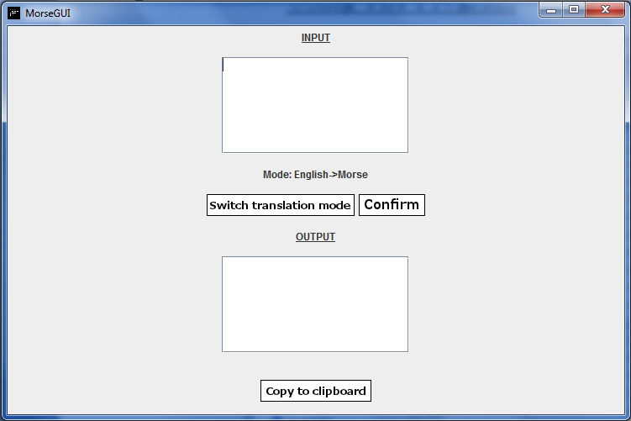

In order to translate text you must first determine which language you would like to translate to or from. The default setting is English to Morse. If you would like to change this you may click the button titled "Switch translation mode". This will change your translation setting to the opposite of what it is currently set to, e.g.: it will change to "English to Morse" if you are currently on "Morse to English".

After determining which language you are translating to, you may type any text you wish to translate into the text box labeled "INPUT". After you have entered any text that you wish to translate you may click the button labeled "Confirm". The translated text will appear in the text box labeled "OUTPUT".

If any error is encountered in attempting to translate the text an error will appear above the "Copy to clipboard" button and below the "OUTPUT" textbox. An error will occur if you enter any language characters not supported by the program. This error will include a list of the unknown characters. A list of supported characters is available in the section of this document labeled Supported Characters.

If you wish to copy the text from the output text box you may press the button labeled "Copy to clipboard". This button will copy any text located in the text box "OUTPUT" to your operating systems clipboard so that you may paste it and use it as you please.

After you are finished with the program you may follow your operating systems standard procedures to close a program, e.g.: pressing the red "x" button located in the top right of the programs GUI interface on a Windows machine.

An image of all described interface components follows: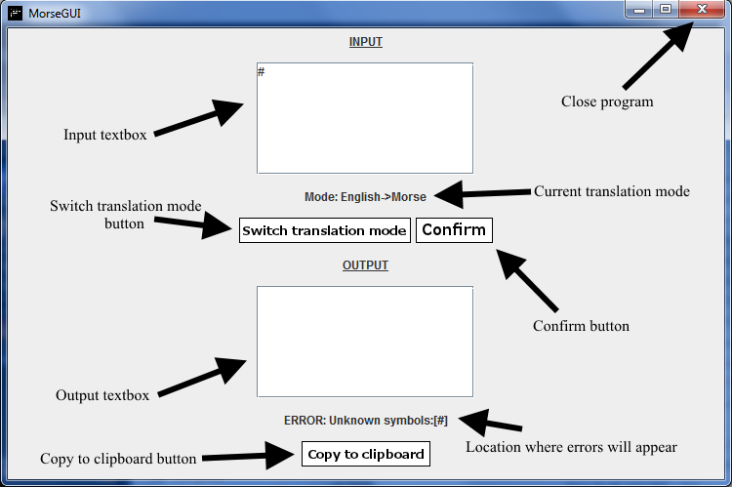

Supported Characters

A list of supported characters follows:

English:

A B C D E F G H I J K L M N P

P Q R S T U V W X Y Z

1 2 3 4 5 6 7 8 9 0

. , ? :

; ! / \

- ' " _

( ) !

NOTE: Backslashes and forward slashes are translated as the same thing.

Morse:

.- -- -... -. -.-. --- -.. .--.

. --.- ..-. .-. --. ... .... -

.. ..- .--- ...- -.- .-- .-.. -.--

.-- --..

.---- ..--- ...-- ....- .....

-.... --... ---.. ----. -----

.-.-.- --..-- ..--.. ---...

-.-.- -..-. -....- .----.

-.--. ..__._ -.--.- /

---. .-..-.

NOTE: "/" is used to delimit spaces in Morse.

Advanced Functionality

**Note:** The following section is intended for advanced users of this program who are familiar with starting programs from the command line interface and wish to explore internal testing arguments. This should not be used by any common consumer. This section assumes you have knowledge of how to provide arguments to programs from the command line.

**'--cmd'** Argument: Providing the following argument will start the program in CLI mode. There will be no GUI present and will be based on text inputs to the console. Do note that this version of the program was only used in early testing and is not supported any longer. What this means is that there is NO error checking present in the program. If you supply the incorrect input an exception will be thrown and the process will crash. There is no point in using this mode unless you have an innate curiosity.

**'--test'** Argument: Providing the following argument will start the program in Unit Testing mode. The program will run with no GUI or CLI present and then close itself. It will log the results of the internal unit test specifications in a file called "unit_tests.log". This file is viewable in any text editor and will provide information on if the program's translations are working properly. There is no reason to use this unless you are modifying the source code of the program.

Testing the Program

A list of input tests and their resulting output follows. The format of this list is: input -> output. These tests can be automatically run by executing the MorseGUI_UnitTests.bat if you are on a Windows machine. This will automatically generate a log of which unit tests passed and which failed in a file called unit_tests.log. This functionality is enabled by using the ‘—test’ argument specified in the section Advanced Functionality.

ENGLISH TO MORSE:

rekt-9 -> .-. . -.- - -....- ----.

*(#mcx 3)Ps; ;. -> ERROR: Unknown symbols:[* #]

[hey_haha@gmail.com](mailto:hey_haha@gmail.com) -> ERROR: Unknown symbols:[@]

this worked right? -> - .... .. ... / .-- --- .-. -.- . -.. / .-. .. --. .... - ..--..

Eli Furland -> . .-.. .. / ..-. ..- .-. .-.. .- -. -..

Multiple Lines Should Work! -- ..- .-.. - .. .--. .-.. . / .-.. .. -. . ... / ... .... --- ..- .-.. -.. / .-- --- .-. -.- ---.

Right? -> .-. .. --. .... - ..--..

They Do Right? - .... . -.-- / -.. --- / .-. .. --. .... - ..--..

MORSE TO ENGLISH:

-- --- .-. ... . / - --- / . -. --. .-.. .. ... .... / .. ... / .- .-.. ... --- / --. --- --- -..

-> MORSE TO ENGLISH IS ALSO GOOD

-- ..- .-.. - .. .-.. .. -. . ... MULTILINES

.- .-. . -> ARE

-.-. --- --- .-.. COOL

asdfasdfasfd blah -> ERROR: Unknown symbols:[asdfasdfasdf blah]

Concerns and Issues

Any concerns and issues encountered while using the program can be reported at <www.github.com/Eli45/MorseGUI/issues>