K64 - TCP , UDP , Uart

* TCP to UART
* Uart to TCP
* UDP to Uart
* Uart to UDP

To start you need:

1. Kinetis Design studio 3.0

https://community.nxp.com/docs/DOC-330211

2. Kinetis SDK

<https://mcuxpresso.nxp.com/en/welcome>

Select a board from the dashboard:

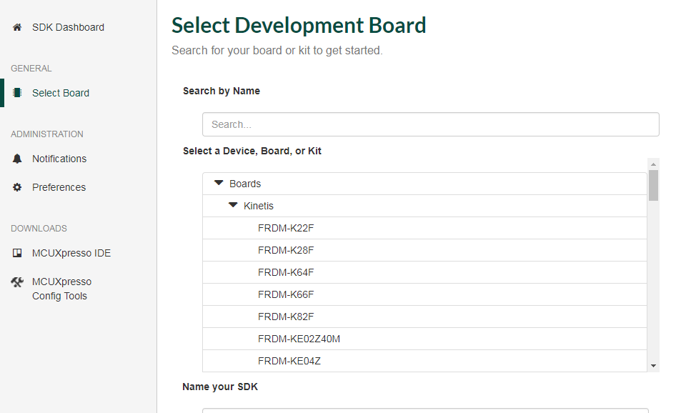

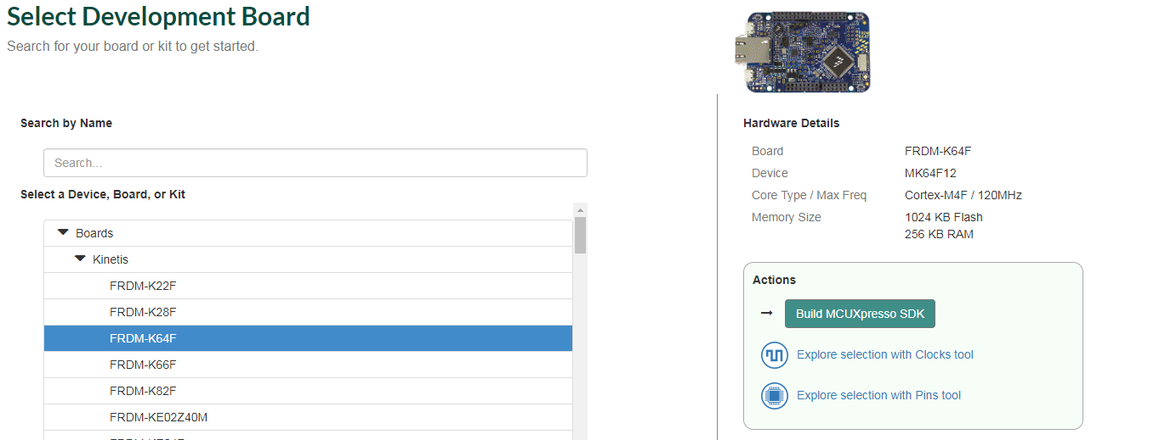

Make sure the selected components include lwip, and free rtos

I selected all ☺

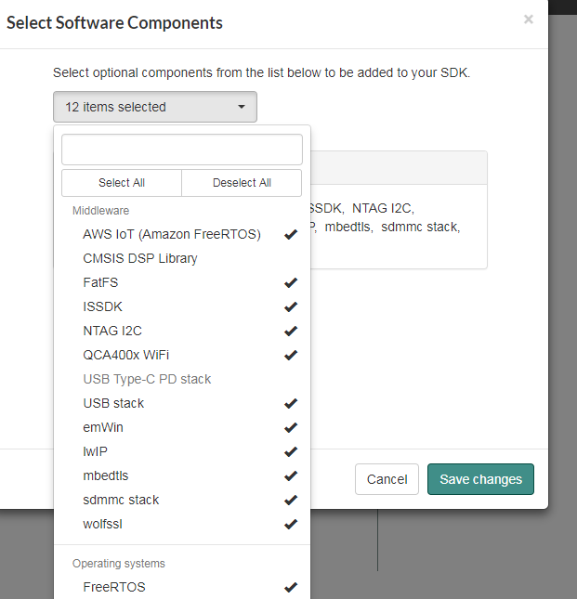

We are ready to download our SDk

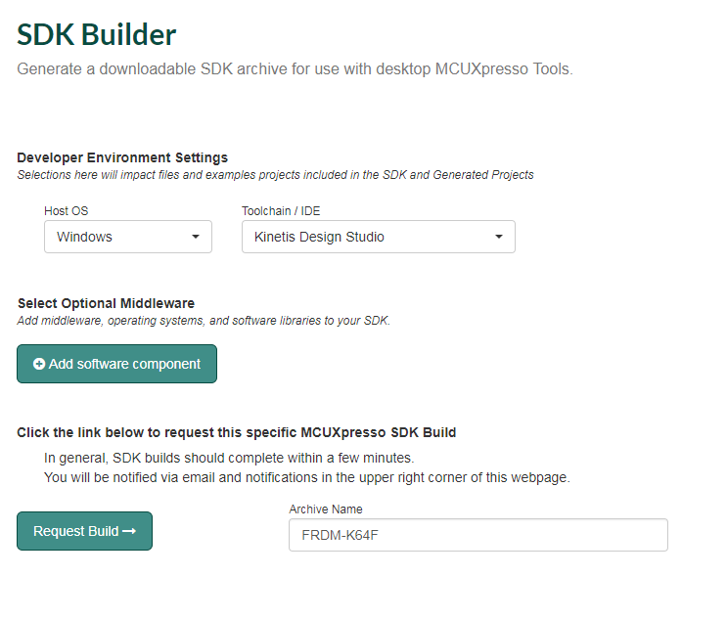

The builder is preparing our build:

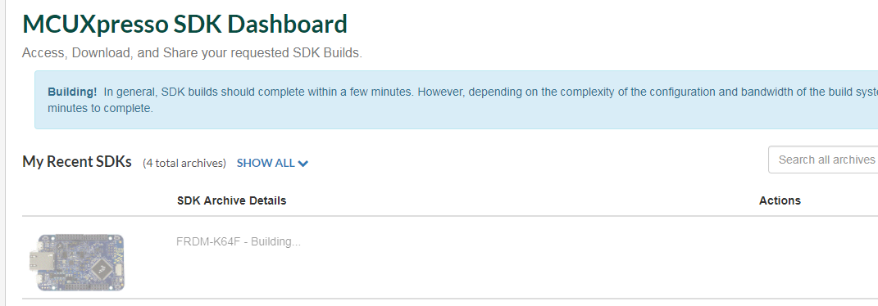

It is ready for download

Version 2.3.2

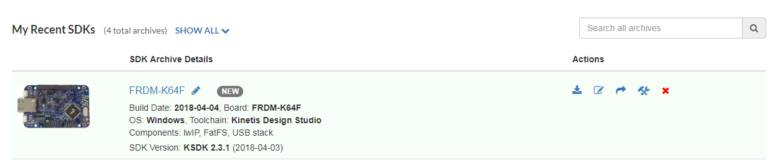

We will build the following projects:

Echo Windows form app in c# TCP -> Uart -> windows form c# app

A Windows C# TCP application to K64 to accept some messaging and send back via uart

Echo Windows c# Uart - > k64 -> Windows c# TCP

A Windows C# TCP application to K64 to accept some messaging and send back via uart

Extract the zip file

SDK_2.3.1_FRDM-K64F.zip

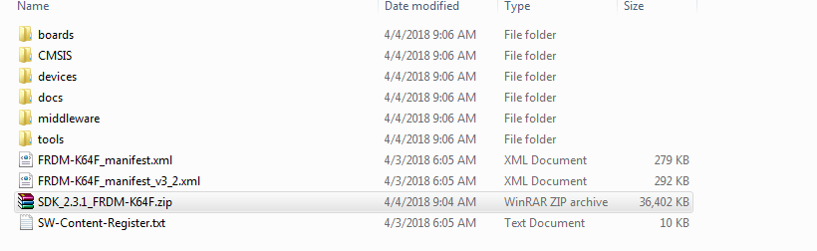

Starting from Hello world – free rtos example

To make sure our board is setup correct, lets build the hello world free rtos example

K64\boards\frdmk64f\rtos_examples\freertos_hello

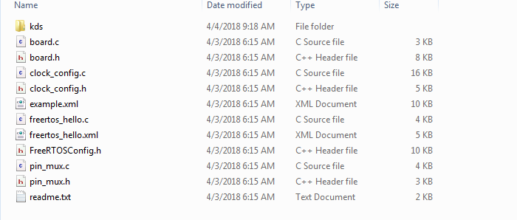

Select in kinetis design studio to import proeject

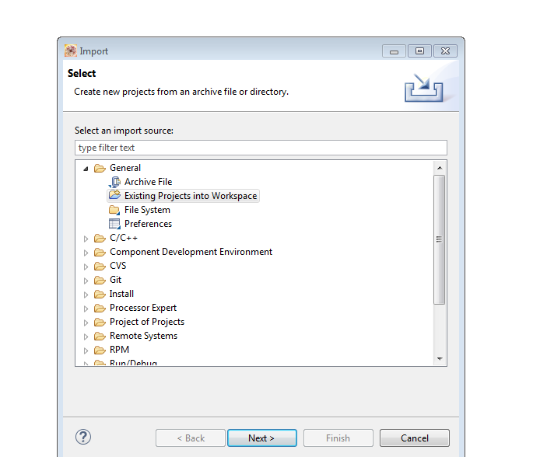

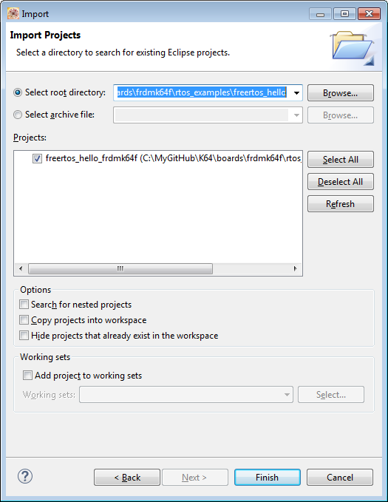

And click finish.

The K64 support MBED to download firmware to the board.

You need to prepare hex file and drag it to the disk drive.

I have another document:

<https://github.com/EliArad/MyDocuments/blob/master/Kinetis_K64/First%20steps%20with%20Kinetis%20SDk.docx>

explaining the steps to compile , download using MBED.

Quick screens:

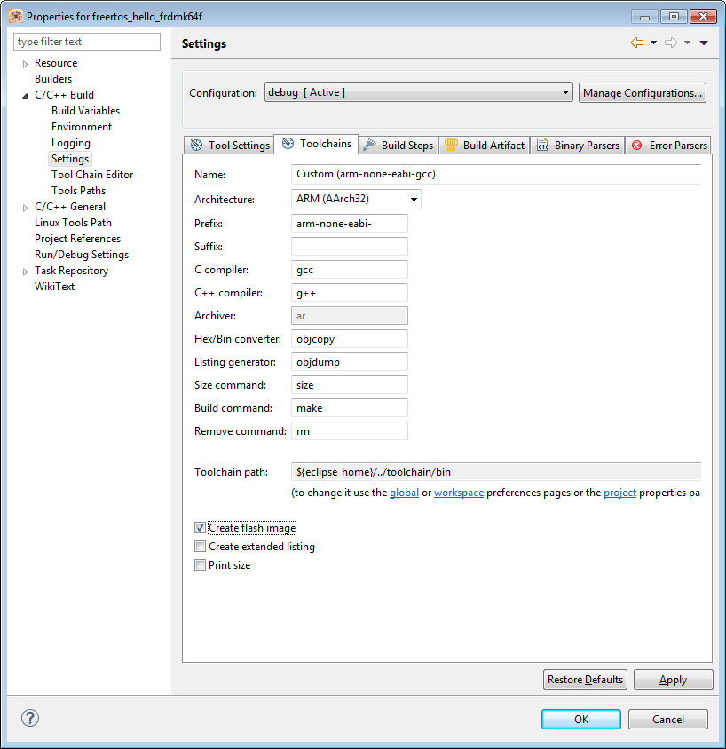

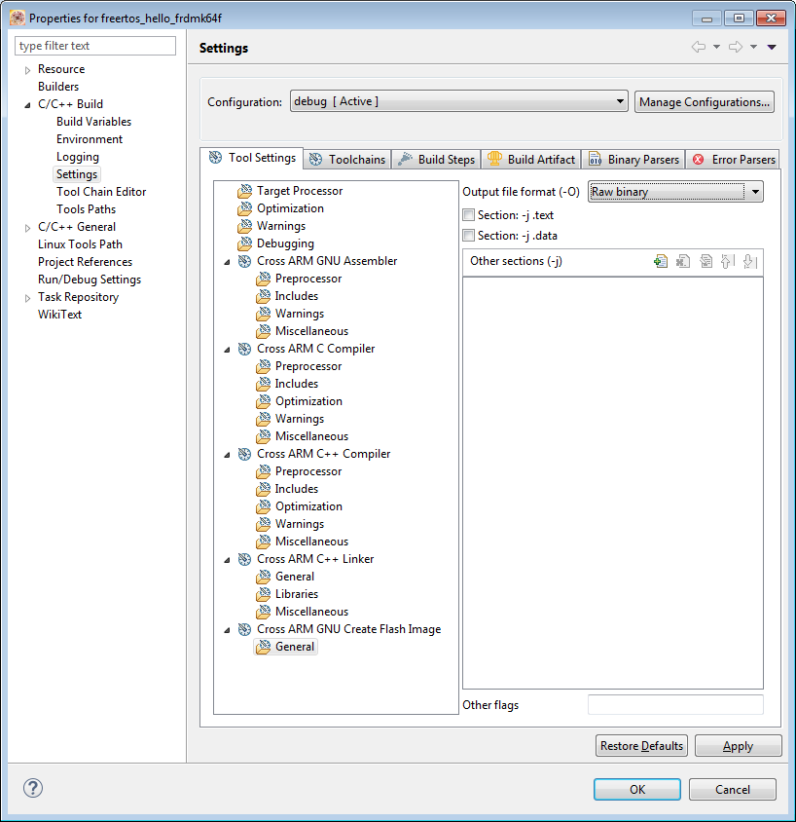

Build the project

We can see that in the debug directory we have the bin file

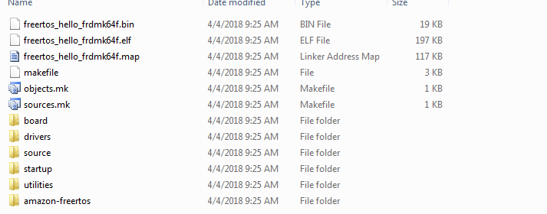

This file need to be copied like we copy a file to a disk on key in the computer

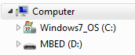

Open putty terminal ( see the first steps doc) and you can see the hello world

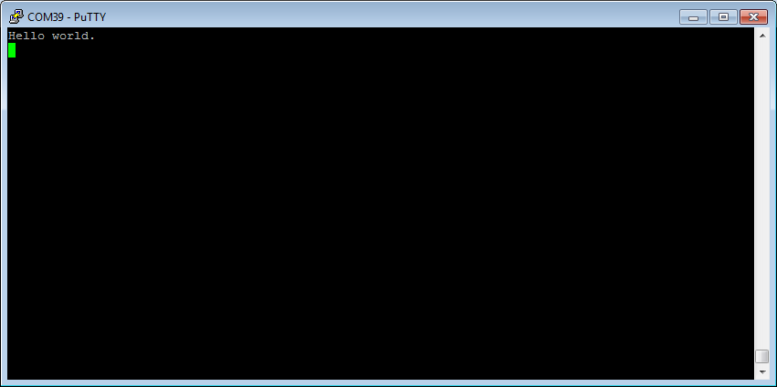

We are ready to continue with out TCP.

Using free rtos or bm LWIP examples are planty:

K64\boards\frdmk64f\demo_apps\lwip

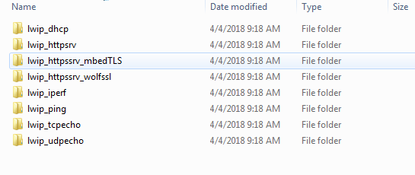

Insert tco echo:

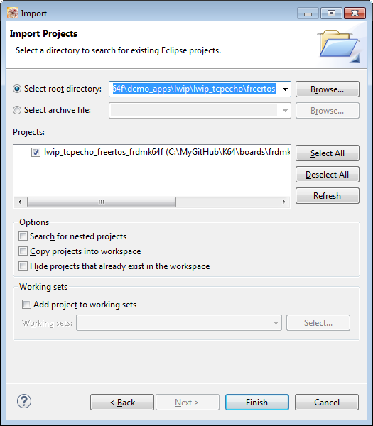

In the main file ,

Change the IP address to your subnet mask

My subnet with a USB to Ethernet convertor is 1.

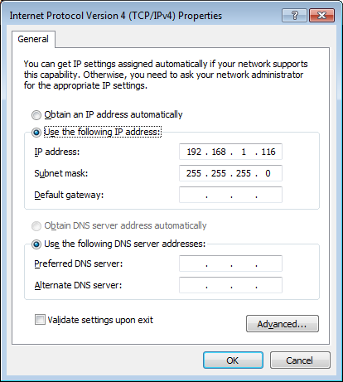

/* IP address configuration. */

**#define** configIP_ADDR0 192

**#define** configIP_ADDR1 168

**#define** configIP_ADDR2 1

**#define** configIP_ADDR3 102

/* Netmask configuration. */

**#define** configNET_MASK0 255

**#define** configNET_MASK1 255

**#define** configNET_MASK2 255

**#define** configNET_MASK3 0

/* Gateway address configuration. */

**#define** configGW_ADDR0 192

**#define** configGW_ADDR1 168

**#define** configGW_ADDR2 1

**#define** configGW_ADDR3 100

So I changed it to 1.116

I also changed to output to row binary

lwip_tcpecho_freertos_frdmk64f.bin and copy it to the MBED disk

we can see on the terminal the message:

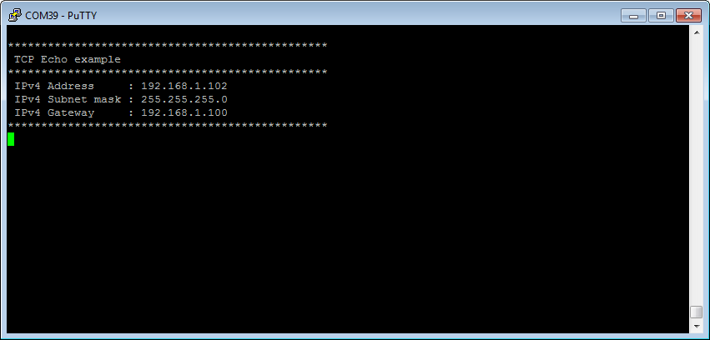

Make sure you have ping to the board ( connect the Ethernet cable and make same subnet)

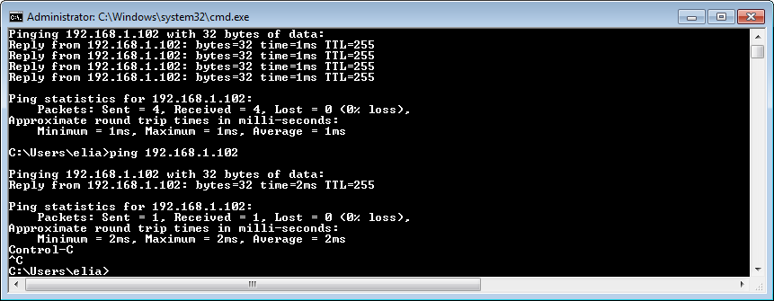

The Ethernet example is ready to be use , modify now,

In tcpecho.c the port is 7

Lets change it to 80 ( more resnoable)

**tcpecho_thread**(**void** *arg)

{

**struct** netconn *conn, *newconn;

err_t err;

LWIP_UNUSED_ARG(arg);

/* Create a new connection identifier. */

/* Bind connection to well known port number 7. */

**#if** LWIP_IPV6

conn = netconn_new(NETCONN_TCP_IPV6);

netconn_bind(conn, IP6_ADDR_ANY, 7);

**#else** /* LWIP_IPV6 */

conn = netconn_new(*NETCONN_TCP*);

netconn_bind(conn, IP_ADDR_ANY, 80);

reduce the timeout in fsl_phy.c ( board directory)

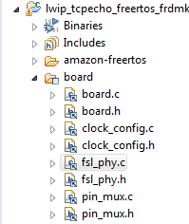

/*! @brief Defines the timeout macro. */

**From #define** PHY_TIMEOUT_COUNT 0x3FFFFFFU

To:

**#define** PHY_TIMEOUT_COUNT 0xFFFFU

I added some print in the code to see that we are connected and how many bytes was sent:

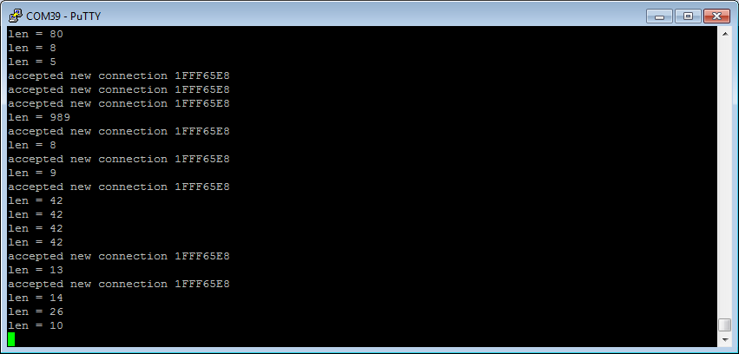

C# Application:

There are several ways to work as tcp client in c#

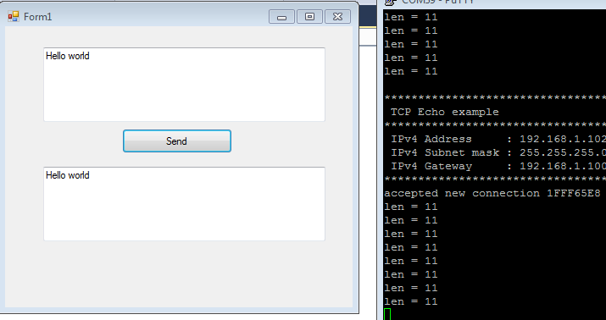

I will show several of them.