This is a driver for the RSA306B

<http://www.tek.com/spectrum-analyzer/rsa306>

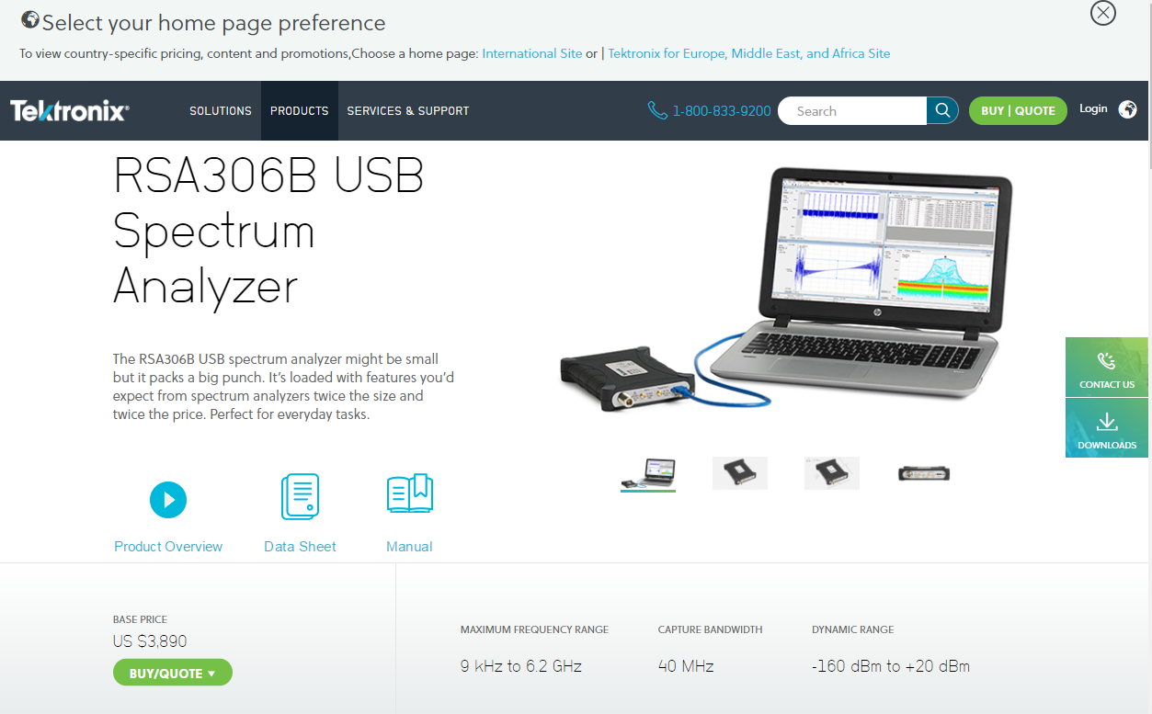

The original driver is in C.

And there is a console application in Cpp

A DLL and a c# wrapper with DLL import