<https://www.picotech.com/data-logger/tc-08/thermocouple-data-logger>

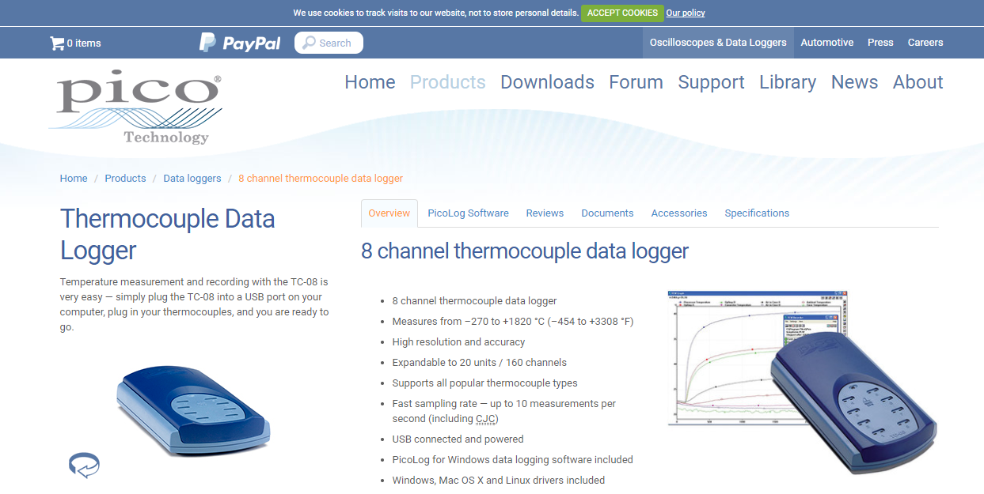

This is a c# driver for the following product

The solution

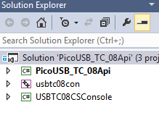

* You need to install the drivers and dll for this product

Like almost any C# API , it depends on the native DLL , most of the times , C dll’s