**ADC128D818**

<http://www.ti.com/tool/ADC128D818SW-LINUX>

# Linux Driver for ADC128D818

##### Description

The Linux driver supports the ADC128D818 System Monitor. The Linux driver supports communication through the I2C bus and interfaces with the Hardware Monitoring sub-system.

## Linux Mainline Status

Available in Linux Main line: Yes

### Supported Devices:

* adc128d818

### Source Files

[drivers/hwmon/adc128d818.c](https://git.kernel.org/cgit/linux/kernel/git/torvalds/linux.git/tree/drivers/hwmon/adc128d818.c)

Enable the driver:

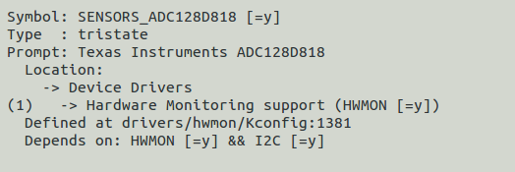

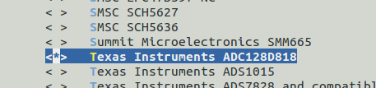

Device tree:

<https://github.com/torvalds/linux/blob/master/Documentation/devicetree/bindings/hwmon/adc128d818.txt>

|  |
| --- |
| adc128d818@1d { |
|  | compatible = "ti,adc128d818"; |
|  | reg = <0x1d>; |
|  | ti,mode = <0>; |
|  | }; |

|  |
| --- |
| compatible: must be set to "ti,adc128d818" |
| - reg: I2C address of the device |

So from the hardware document:

* 8 channels, 12bit A/D used for reading voltage from some points in RF card. The A/D is TI ADC128D818CIMTX. The ADC I2C address is 1Dh and operation mode should be set to MODE 0 (see ADC128D818 datasheet section 8.4.1 pg. 16). Following inputs are connected to the ADC:

Mode 0: 7 single-ended voltage readings (IN0-IN6),

1 temperature reading (internal)

So it looks like the hardware engineer already did a project in IMX and make the hardware compatible with the software by choosing the devices that already have driver in the Linux mainline

* Following inputs are connected to the ADC:

| CH # | Description | Range | Out of range operation | Comments |
| --- | --- | --- | --- | --- |
| 0 | TX PIN diode RF detector | TBD | TBD |  |
| 1 | TX Laser drive RF detector | TBD |  |  |
| 2 | TX Laser light PDI monitor | TBD |  |  |
| 3 | TX Laser current monitor | TBD |  |  |
| 4 | RX main PDI monitor | TBD |  |  |
| 5 | RX main Power output RF detector | TBD |  |  |
| 6 | RX detector PDI monitor | TBD |  |  |
| 7 | Internal temperature sensor | TBD |  |  |

For now we only need to add this entry:

adc128d818@1d {

+ compatible = "ti,adc128d818";

+ reg = <0x1d>;

+ mode = /bits/ 8 <0>;

+ };

Into the device tree of the i2c.

How to read from the chip: answer HWMON

<https://www.kernel.org/doc/Documentation/hwmon/sysfs-interface>

Each chip gets its own directory in the sysfs /sys/devices tree. To

find all sensor chips, it is easier to follow the device symlinks from

/sys/class/hwmon/hwmon*.

This github is very good explain two ways to read from the hardware monitor interface

<https://github.com/Mellanox/mlxsw/wiki/Temperature-and-Fan-Control>

The code will be written once the device will appear at the sysfs hwmon