K70

The linux package is from

<http://www.emcraft.com/products/95>

Uboot:

Following this document to install UBoot:

<http://www.emcraft.com/docs/linux-TWR-K70F120M-bspg-1.12.0.pdf>

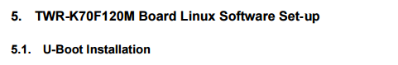

Downloading first code warior 10.7 for windows:

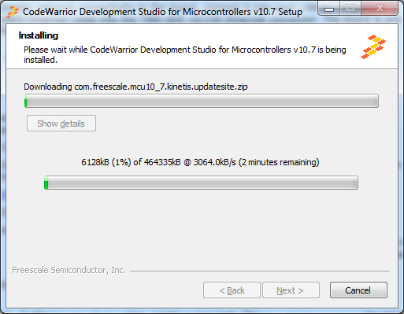

Now we follow the document:

Create a new bare board project

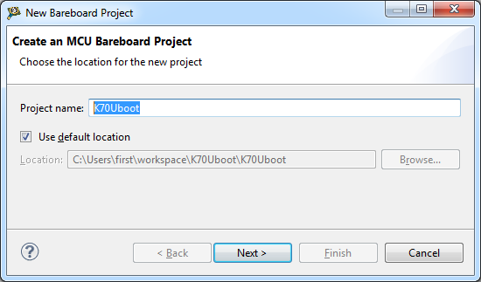

Btw, I tried that on the KDS 3.0 and the menus and the windows a slight different, so let’s work with the eclipse 10.7 code Warrior.

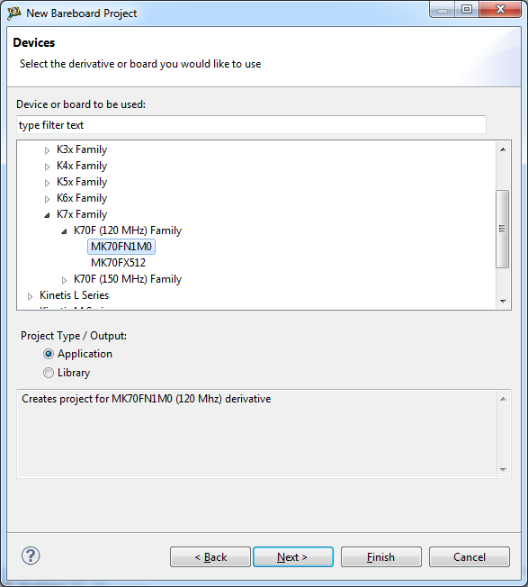

The instructions told us next to select Open source JTAG only

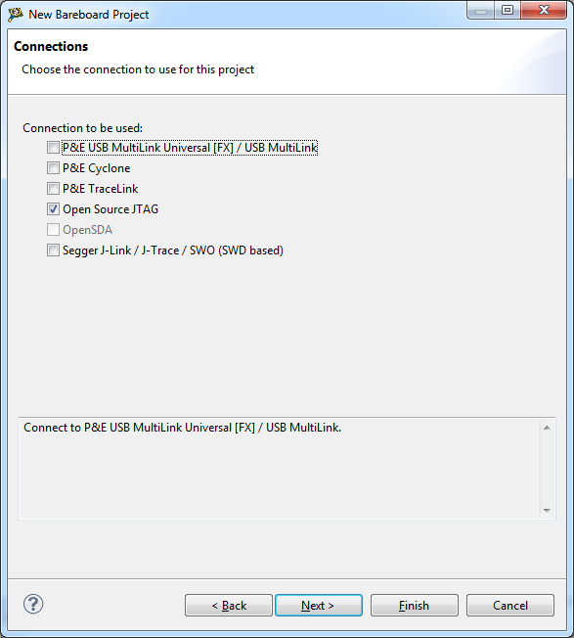

Skip the next page

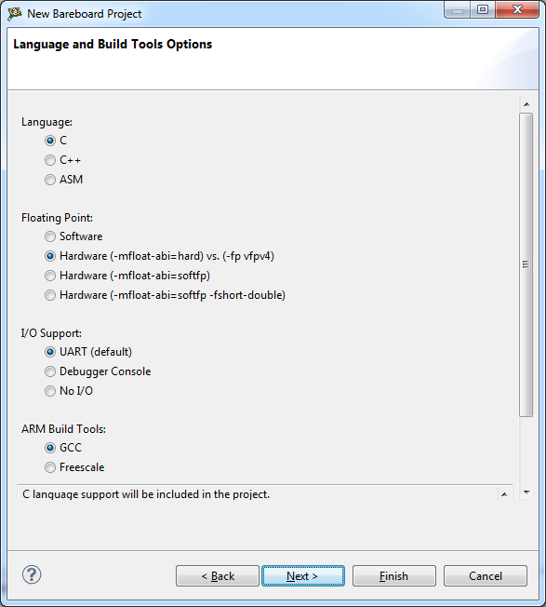

Or just click finished.

We are not going to develop the project with the code warrior, just to burn the UBoot.

The development will be done with the linux package.

The target task window is located under debug in windows->other views

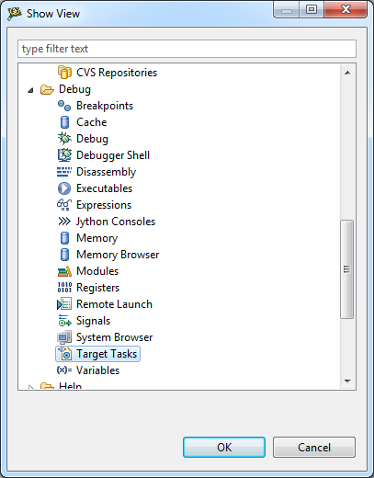

Btw, in KDS 3.0 it does not appear.

Next we need to create new task by right click on the task view:

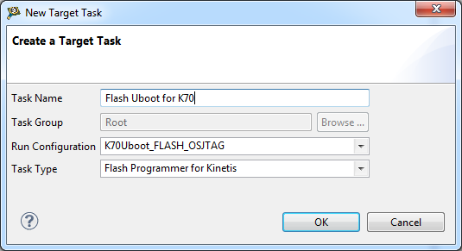

We got the flash programmer task view opened:

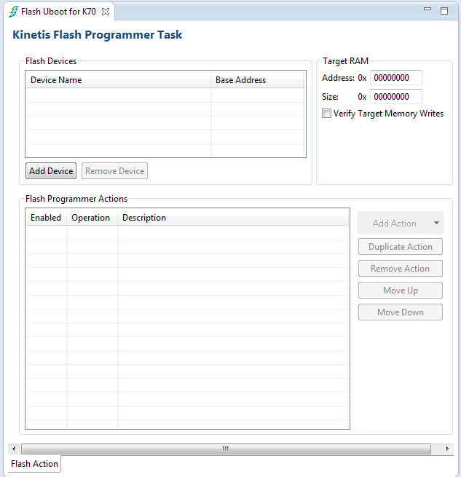

Press Add device:



We need to select the flash type: FTFE_PFlash1M0 ( 128Kx64x1)

We can filter the search be easily find it.

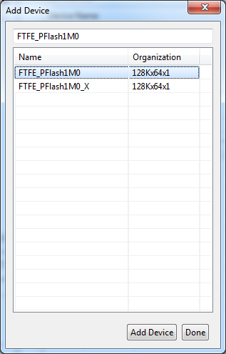

We are here now:

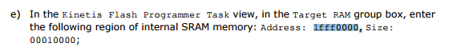

After adding , save the changes:

We will save to frame work only.

The save to file probably helps later to burn the JTAG using a command line tool of the eclipse.

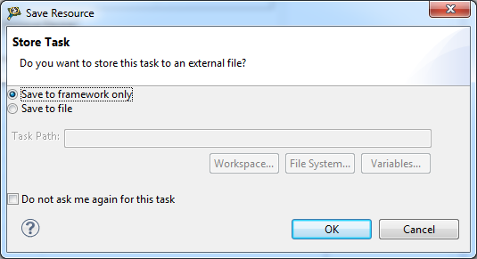

Before we dot the next step , we need to download , if did not already the UBoot srec file.

Why srec? This is what the code warrior ide works with.

Uboot can come as elf, bin and probably more image format that are fit to the target and the environment.

Add action to verify:

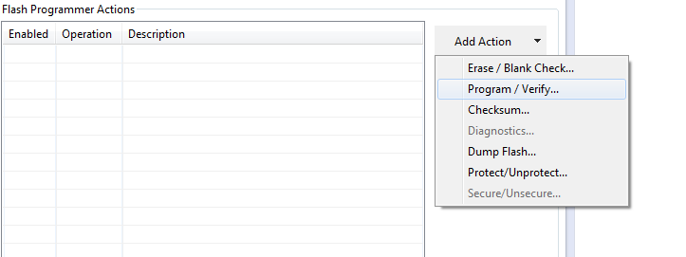

We jump back to the PDF document that we are reading to the download software section:

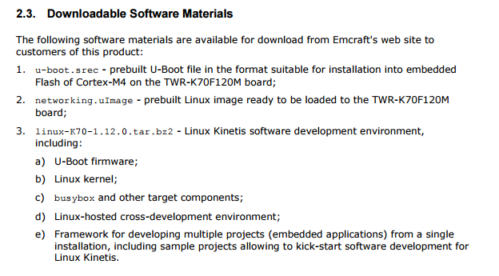

After performing registration and login we can download the prebuilt Uboot srec file

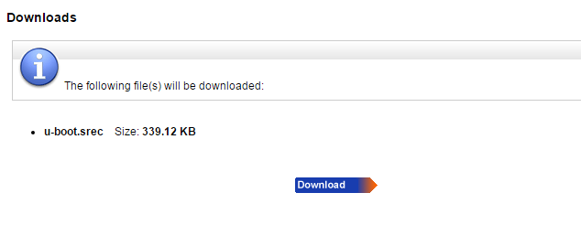

And download the networking.uImage

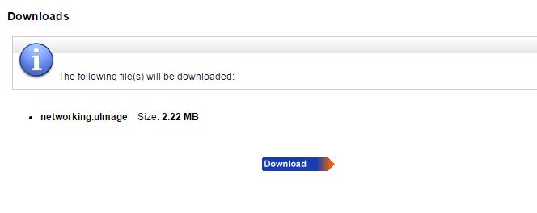

The BSP code money:

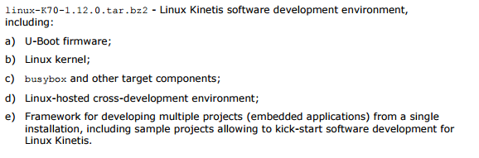

We back to our Action:

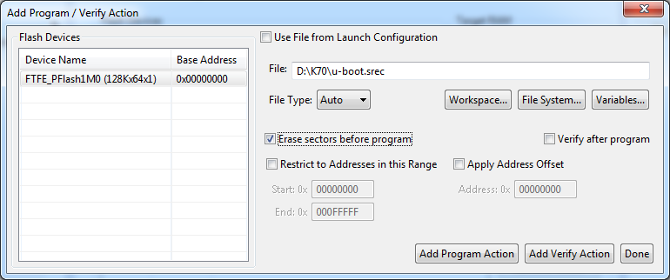

Press Done!

We should have now action:

