Buildroot image with Qt5 . OPEGN GLS 2.0 , mesa VC4 driver in 32 bit

Starting from the raspberry pi configuration for 32 bit:

make raspberrypi3_defconfig

nothing to be change in Target architecture
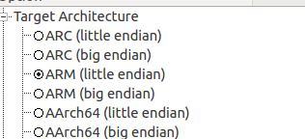

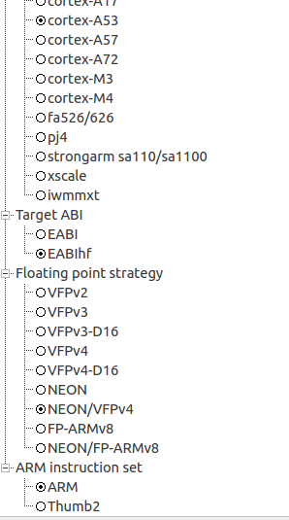

Change as usual the savedefconfig and download location

to the same place where all the builds you do. It could save time if downloaded package already there.

Before I will go over the QT5 VC4 settings, I will start with the compiler.
While adding QT5 in 32 bit I am getting compiler error when using external download compiler and external pre built

I tried to compile several times with external toolchain

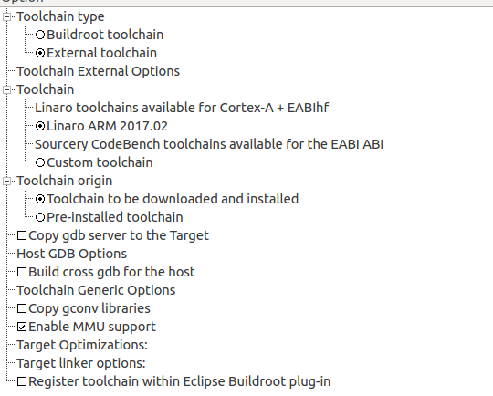

But I got the following error when compiling with QT5 in the 32bit.
This is a problem of the compiler.

D_FILE_OFFSET_BITS=64 -Os --sysroot=/home/first/buildroot/blrpi3_32/buildroot-2017.05/output/host/usr/arm-buildroot-linux-gnueabihf/sysroot -O3 -O3 -std=c++1z -fvisibility=hidden -fvisibility-inlines-hidden -Wall -W -Wvla -Wdate-time -Wshift-overflow=2 -Wduplicated-cond -D_REENTRANT -fPIC -DQT_NO_USING_NAMESPACE -DQT_NO_FOREACH -DQT_USE_ICU -DQT_HAVE_POLL -DQT_HAVE_PPOLL -DQT_BUILD_CORE_LIB -DQT_BUILDING_QT -DQT_NO_CAST_TO_ASCII -DQT_ASCII_CAST_WARNINGS -DQT_MOC_COMPAT -DQT_USE_QSTRINGBUILDER -DQT_DEPRECATED_WARNINGS -DQT_DISABLE_DEPRECATED_BEFORE=0x050000 -D_LARGEFILE64_SOURCE -D_LARGEFILE_SOURCE -DQT_NO_DEBUG -I. -Iglobal -I../3rdparty/harfbuzz/src -I../3rdparty/md5 -I../3rdparty/md4 -I../3rdparty/sha3 -I../3rdparty/double-conversion/include -I../3rdparty/double-conversion/include/double-conversion -I../3rdparty/forkfd -I../../include -I../../include/QtCore -I../../include/QtCore/5.8.0 -I../../include/QtCore/5.8.0/QtCore -I.moc -I../../mkspecs/devices/linux-buildroot-g++ -o .obj/qhash.o tools/qhash.cpp
tools/qhash.cpp:148:54: error: attribute(target("+crc")) is unknown
static uint crc32(const Char *ptr, size_t len, uint h)

to solve this I edit the qhash.cpp and add at the top
#undef __ARM_FEATURE_CRC32
This solve the compilation problem

The internal build root compiler , complains about other error that I don't konw why.
Never mind , I don't want the internal toolchain any case.

One thing left to check is external pre build compiler from cross tol ng for 32 bit
The armv8-rpi3-linux-gnueabihf

so I run cr-ng armv8-rpi3-linux-gnueabihf
and ct-ng build
to bulid that compiler.
Once does I will write about the success or not when compiling build root 32 bit + Qt5
with that compiler

Qt settings

VC4 is a DRM driver.

https://en.wikipedia.org/wiki/Direct_Rendering_Manager
From wikipedia
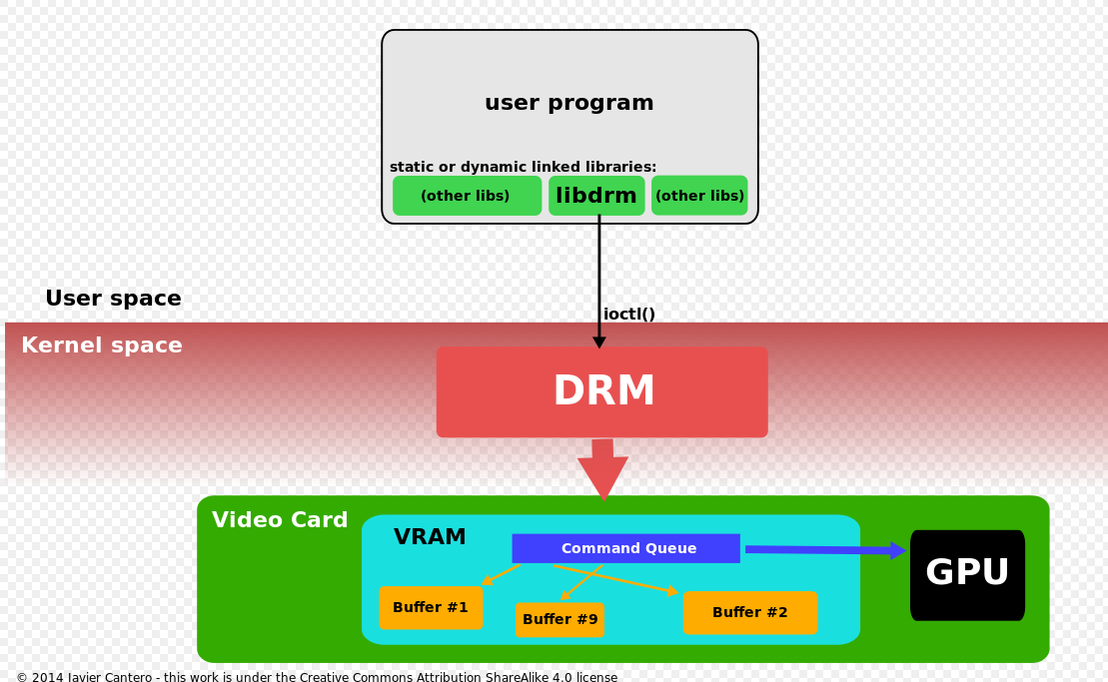

Enable mesa 3d in graphics libraries and applications
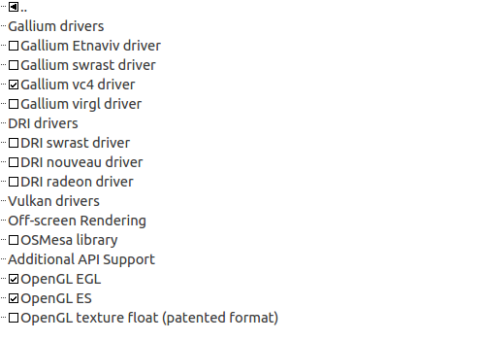

* from this list Gallium Etnaviv driver:

Enable the masa drivers
and the VC4 open gl driver by Broadcom.

The kernel Is configured as module = m

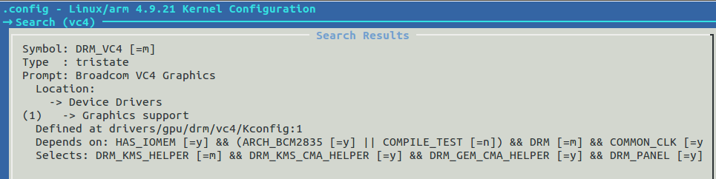
means , if the vc4 will find the Broadcom GPU it will be loaded.

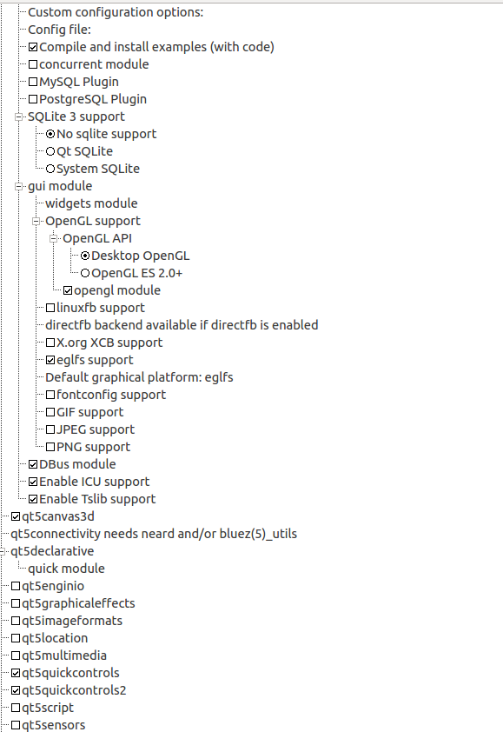

QT5 configurations.
Enable qt quick

Loading overlays

If we dont load the vc4 overlay , the VC4 DRM driver will not be loaded.
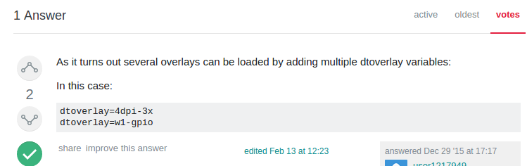
And we will get from the raspberry pi 3 an error that DRM device was not loaded

in output/images/rpi-firmware/overlays

The VC4 driver needs is device tree blob
to load the device tree, open config.txt in output/images/rpi-firmware/config.txt

So in config.txt:

I will load two overlays
dtoverlay=pi3-miniuart-bt
dtoverlay=vc4-kms-v3d

There is a note:
# You should override this file using a post-build script.
I will deal with it later

output/images/rpi-firmware/cmdline.txt

I will add:
cma=128M
at the end

change:
gpu_mem_1024=256

in buildroot mesa we need libinput

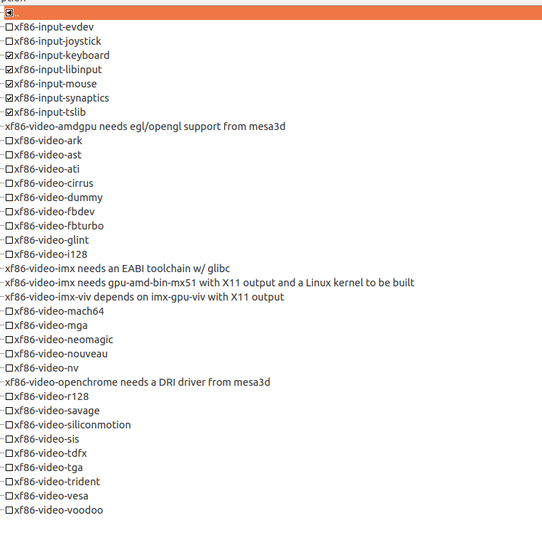

running examples

Some examples does run but many don't for now

For example , the marron example in quick\demos
run on ubunto but not on my target raspberry pi 3.



Mouse

In some examples, the mouse works but the mouse pointer is hidden.

Saving this configuration

make savedefconfig

will save to:

This I will upload to my github
https://github.com/EliArad/buildroot

