Summery of compiling QT 5 in command line

After we created a buildroot image , with QT5
we have two thing we need:

1. Compiler
2. Sysroot

Create a project in Qt Creator.

Open command terminal
and create two scripts files

1. ACTIVATE.sh for adding the path of the buildroot compilers

export PATH=$PATH:/home/first/buildroot/blrpi3_32/buildroot-2017.05/output/host/usr/bin

2. compile script

/home/first/buildroot/blrpi3_32/buildroot-2017.05/output/host/usr/bin/qmake $1 -spec /home/first/Qt/5.9/Src/qtbase/mkspecs/arm-linux-gnueabihf-g++ CONFIG+=debug CONFIG+=qml_debug

The compile script run buildroot qmake

we need to specify:
1. full path of the qmake in buildroot

2. the full path of the mkspecs

If we are not working inside the QT SRC the qmake will not know where the mkspcs.

The mkspec need to be created, in most cases it is not exist.
So copy from one of the arm-linux-unkonwn... using cp-r

and change all the compiler name to the buildroot compiler name

arm-linux-gnueabihf

The result of the new mkspec qmake.conf files should be:

#
# qmake configuration for building with arm-linux-gnueabihf-g++
#

MAKEFILE_GENERATOR = UNIX
CONFIG += incremental
QMAKE_INCREMENTAL_STYLE = sublib

include(../common/linux.conf)
include(../common/gcc-base-unix.conf)
include(../common/g++-unix.conf)

# modifications to g++.conf
QMAKE_CC = arm-linux-gnueabihf-gcc
QMAKE_CXX = arm-linux-gnueabihf-g++
QMAKE_LINK = arm-linux-gnueabihf-g++
QMAKE_LINK_SHLIB = arm-linux-gnueabihf-g++

# modifications to linux.conf
QMAKE_AR = arm-linux-gnueabihf-ar cqs
QMAKE_OBJCOPY = arm-linux-gnueabihf-objcopy
QMAKE_NM = arm-linux-gnueabihf-nm -P
QMAKE_STRIP = arm-linux-gnueabihf-strip
load(qt_config)

running compile script (which rans qmake with the cross compiler)
will generate make files for us

run
make
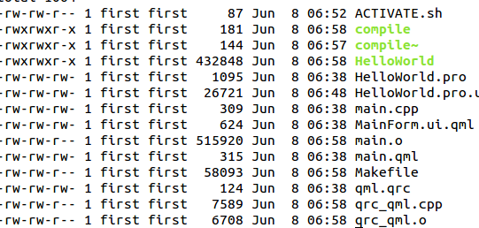

And the HelloWorld will be ready to transfer to target using SCP

