Beaglebone SPI
To ->
Kinetis K64F

This project require several keys points
1. Configure beaglebone device tree to be able to get SPI device
2. How to physically connect the two chips
3. How to setup K64F

When everything is ready , we can start talk about the software , protocol and how to to write the C code in both sides to get everything going.

Requirements:
1. Buildroot
2. Beaglebone black
3. K64F

Let's start.

Download buildroot from:
https://buildroot.org/download.html
extract it and select the config
make beaglebone_defconfig

1. Add dropbear
2. Enter password , dont leave it empty ( dropbear ssh does not like it)
3. change the toolchain to Linaro external

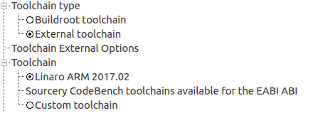

select that:
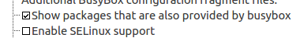
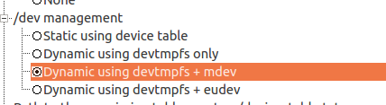

some text editors:
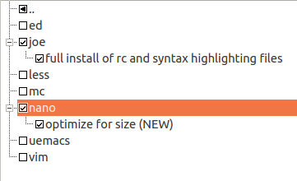

Spi , search Spi using CTRL + F

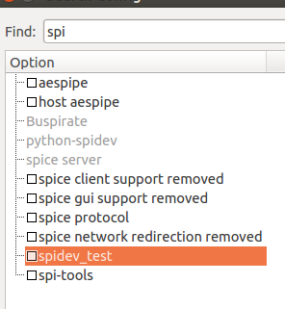

and enable spidev_test and spi-tools

save and build using
make

The result is an sdard.img in output/images.

You can burn it using Etcher
https://etcher.io/
perfect for any operating system.
It will format and partition the sdcard according the generated sdcard.img
Configure beaglebone device tree to be able to get SPI device

We learned before how to get an overlay of beagle bone black into buildroot.
We cannot use cape manager on the fly to assign those device tree overlays, but we can modify the device tree and compile.

Starting from am335x-bone-common.dtsi

spi1_pins_s0: spi1_pins_s0 {
pinctrl-single,pins = <
0x190 0x33 /* mcasp0_aclkx.spi1_sclk, INPUT_PULLUP | MODE3 */
0x194 0x33 /* mcasp0_fsx.spi1_d0, INPUT_PULLUP | MODE3 */
0x198 0x13 /* mcasp0_axr0.spi1_d1, OUTPUT_PULLUP | MODE3 */
0x19c 0x13 /* mcasp0_ahclkr.spi1_cs0, OUTPUT_PULLUP | MODE3 */
>;
};

Note , according to that page:
http://elinux.org/BeagleBone_Black_Enable_SPIDEV

We have two options of who is who.

The overlay here:
https://github.com/beagleboard/bb.org-overlays/blob/master/src/arm/BB-SPIDEV1-00A0.dts

have more details that we need:

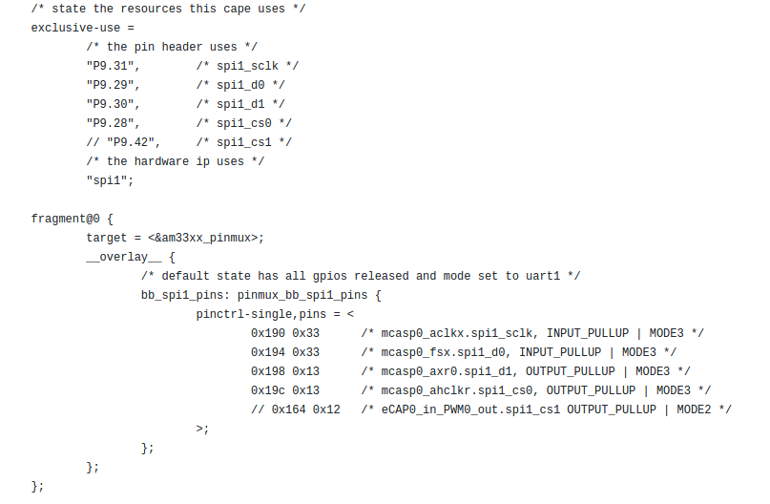
The BBB SPI 1 has two CS.
CS0 and CS1
The CS1 is at pin P9.42
The above comment at 0x164 select the cs1.

We can see the PINs numbering in the P9 header.

P9.29 , SPI1_D0 input
P9.30 , SPI1_D1 output
P9.28 , SPI1_CS0, output.
P9.31 , CLK1, output.

We will need that information to connect it to K64F.
All pins was declared with internal pull up.

In am335x-boneblack.dts we define the spi1 node.

&spi1 {

#address-cells = <1>;
#size-cells = <0>;
status = "okay";
pinctrl-names = "default";
pinctrl-0 = <&spi1_pins_s0>;

spidev@1 {
spi-max-frequency = <24000000>;
reg = <0>;
compatible = "linux,spidev";
};
};

Some notes:
a. the status is okay – active
the spedev@1 means the device will be spidev1.0
pinctr-0 is the pins from the bone-common file that we just declared.

Two more thing
in linux-menuconfig
make linux-menuconfig

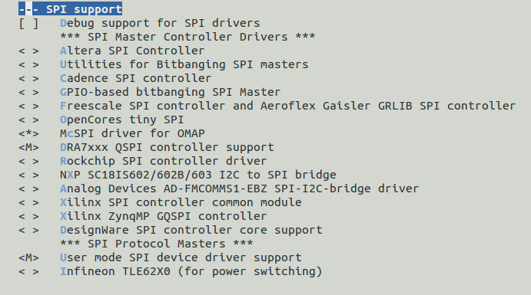
We need to enable user mode SPI driver support.

Once the image is ready , we need to load spidev driver

modprobe spidev.ko

lsmod will show:
spidev 7467 0

More:

You can change the model name of am335x-boneblack.dts
model = "TI AM335x BeagleBone Black buildroot 3.0";

It will help you determine that the changed you did are really loaded.
Using
cat /proc/device-tree/model

When the image is ready modprobe spidev and you are ready.
You can add a script to do it automatically.

You can create an init script in /etc/init.d/Smine
with
modprobe spidev.ko
rcS will start it automatically.
How to physically connect the two chips

P9 header:
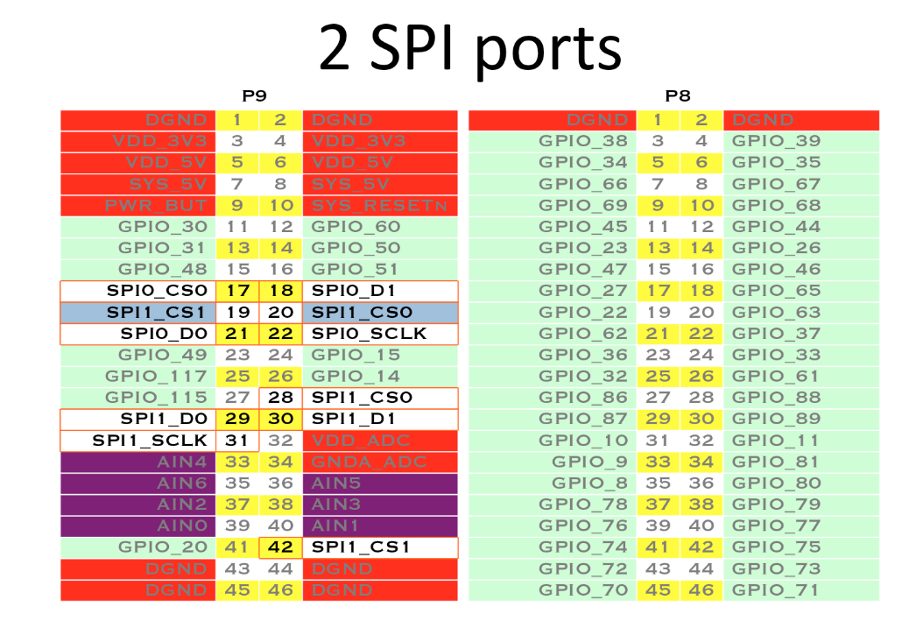
We need to connect MISO to MISO and MOSI to MOSI.
CS will be grounded because we have only one slave.
Shared ground.

In BBB the pin does not name as MISO or MOSI but D0 and D1.
We configure above the D1 to be output so

D1 is master out
D0 is master in

We will be back to the physical connection after we get introduce with the K64F.

NXP Kinetis K64F
http://www.nxp.com/products/developer-resources/hardware-development-tools/freedom-development-boards/freedom-development-platform-for-kinetis-k64-k63-and-k24-mcus:FRDM-K64F

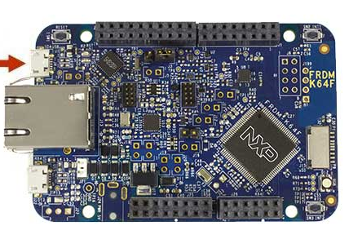

BBB 31 (CLK) → K64 J2 Pin 12(CLK) → Yellow
BBB 28 (SPI1_CS0) → K64 J2 Pin 6(CS) → Orange
BBB 30 (SPI1_D0) → K64 J2 Pin 8(MOSI) → Red
BBB 29 (SPI1_D1) → K64 J2 Pin 10 (MISO) → White
BBB 1 (Ground) → K64 J2 Pin 14( Ground) → Black

NXP have improved their software packages to highest level.
Introducing Kinetis SDK.

To start work with K64 , lets do the bring up quickly:

1. Install Kinetis Design studio ( windows or Linux , as you wish)
2. Install Kinetis Sdk ( 2.x)
3. Open one the DSPI slave examples.

rpm -ivh and the file name

I tried rpm , the deb just hang for ever..

Datasheet:
http://www.mouser.com/ds/2/813/K64P144M120SF5RM-1074828.pdf

Kinetis Sdk:

from the FRDM K64
http://www.nxp.com/products/developer-resources/hardware-development-tools/freedom-development-boards/freedom-development-platform-for-kinetis-k64-k63-and-k24-mcus:FRDM-K64F?tab=Design_Tools_Tab

we should go to the MCUXpresso Sdk builder

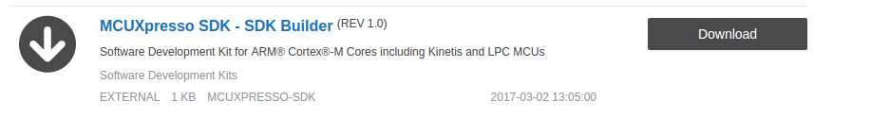
https://mcuxpresso.nxp.com/en/welcome


Here we can can login to use our already build Sdk
or create new one using the Sdk builder

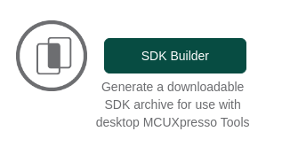

We can select the FRDM-K64
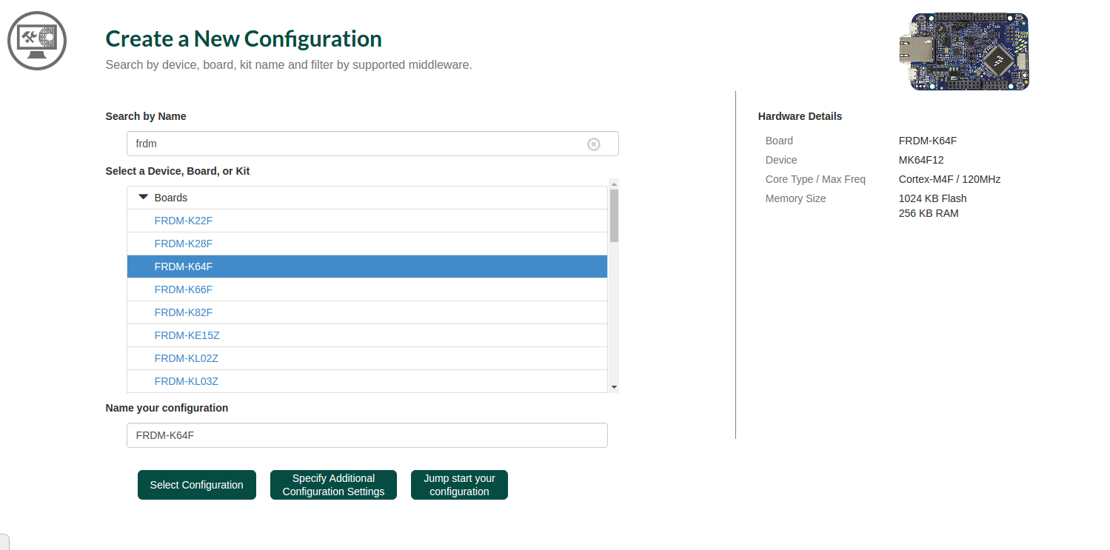
After updating preferences ( as requested) F5 and we are ready to download the Sdk for frdm k64



You can view my full getting started with K64 , for windows here

Actually for Linux ( which this manual was written with) it is almost the same.

Using the SPI User Mode Device Driver
https://armbedded.taskit.de/node/318
There are two ways of of using the user mode spi device driver.
1. You can call either the read/write functions or an ioctl(). With calling read/write you can only read or write at a time.
2.If you need full-duplex read and write, you have to call the ioctl's. Examples for both are provided.
This is the read/write example.
#include <stdio.h>
#include <fcntl.h>
#include <stdlib.h>

#define ARRAY_SIZE(array) sizeof(array)/sizeof(array[0])

int main(int argc, char **argv)
{
int i,fd;
char wr_buf[]={0xff,0x00,0x1f,0x0f};
char rd_buf[10];;

if (argc<2) {
printf("Usage:\n%s [device]\n", argv[0]);
exit(1);
}

fd = open(“/dev/spidev1.0”, O_RDWR);
if (fd<=0) {
printf("Device spidev1.0 not found“);
exit(1);
}

if (write(fd, wr_buf, ARRAY_SIZE(wr_buf)) != ARRAY_SIZE(wr_buf))
perror("Write Error");
if (read(fd, rd_buf, ARRAY_SIZE(rd_buf)) != ARRAY_SIZE(rd_buf))
perror("Read Error");
else
for (i=0;i<ARRAY_SIZE(rd_buf);i++) {
printf("0x%02X ", rd_buf[i]);
if (i%2)
printf("\n");
}

close(fd);
return 0;
}
So first , we will check that our hardware setup is ok ,
we will cross compile this example:
Again , we will use the ACTIVATE.sh script that will enter the cross compiler into path
BBB_C_COMP=/mnt/b/buildroot/bbb_processor_sdk/buildroot-2017.05.1/output/host/usr/bin export PATH=$PATH:$BBB_C_COMP
And the Makefile:
CC = arm-linux-gnueabihf-gcc
SRC=$(wildcard *.c)
spitest_halfdup: $(SRC)
$(CC) -o $@ $^ $(CFLAGS) -I$(INCLUDE) -L$(LIBS)
clean:
rm *.o spitest_halfdup
I created a copy script called replace for fast copy to target:
sudo sshpass -p "eliarad" scp spitest_halfdup root@192.168.7.2:/home

For OTG , to copy to target , we need to run on target

modprobe musb_am335x.ko
modprobe musb_hdrc.ko
modprobe musb_dsps.ko
modprobe cppi41.ko
modprobe g_ether.ko
HOST_USB_IP=192.168.7.3
TARGET_USB_IP=192.168.7.2
ifconfig usb0 $TARGET_USB_IP netmask 255.255.255.0
route add default gw $HOST_USB_IP
route
The complete example (for write only)

#include <stdint.h>
#include <unistd.h>
#include <stdio.h>
#include <stdlib.h>
#include <getopt.h>
#include <fcntl.h>
#include <sys/ioctl.h>
#include <linux/types.h>
#include <linux/spi/spidev.h>

#define ARRAY_SIZE(a) (sizeof(a) / sizeof((a)[0]))

static void pabort(const char *s)
{
perror(s);
abort();
}

static const char *device = "/dev/spidev1.1";
static uint8_t mode = 0;
static uint8_t bits = 8;
static uint32_t speed = 10000;
static uint16_t delay;

static void transfer(int fd)
{
int ret;
uint8_t tx[] = {
0xFF, 0xFF, 0xFF, 0xFF, 0xFF, 0xFF,
0x40, 0x00, 0x00, 0x00, 0x00, 0x95,
0xFF, 0xFF, 0xFF, 0xFF, 0xFF, 0xFF,
0xFF, 0xFF, 0xFF, 0xFF, 0xFF, 0xFF,
0xFF, 0xFF, 0xFF, 0xFF, 0xFF, 0xFF,
0xDE, 0xAD, 0xBE, 0xEF, 0xBA, 0xAD,
0xF0, 0x0D,
};
uint8_t rx[ARRAY_SIZE(tx)] = {0, };
struct spi_ioc_transfer tr = {
.tx_buf = (unsigned long)tx,
.rx_buf = (unsigned long)rx,
.len = ARRAY_SIZE(tx),
.delay_usecs = delay,
.speed_hz = 0,
.bits_per_word = 0,
};

ret = ioctl(fd, SPI_IOC_MESSAGE(1), &tr);
if (ret == 1)
pabort("can't send spi message");

for (ret = 0; ret < ARRAY_SIZE(tx); ret++) {
if (!(ret % 6))
puts("");
printf("%.2X ", rx[ret]);
}
puts("");
}

void print_usage(const char *prog)
{
printf("Usage: %s [-DsbdlHOLC3]\n", prog);
puts(" -D --device device to use (default /dev/spidev1.1)\n"
" -s --speed max speed (Hz)\n"
" -d --delay delay (usec)\n"
" -b --bpw bits per word \n"
" -l --loop loopback\n"
" -H --cpha clock phase\n"
" -O --cpol clock polarity\n"
" -L --lsb least significant bit first\n"
" -C --cs-high chip select active high\n"
" -3 --3wire SI/SO signals shared\n");
exit(1);
}

void parse_opts(int argc, char *argv[])
{
while (1) {
static const struct option lopts[] = {
{ "device", 1, 0, 'D' },
{ "speed", 1, 0, 's' },
{ "delay", 1, 0, 'd' },
{ "bpw", 1, 0, 'b' },
{ "loop", 0, 0, 'l' },
{ "cpha", 0, 0, 'H' },
{ "cpol", 0, 0, 'O' },
{ "lsb", 0, 0, 'L' },
{ "cs-high", 0, 0, 'C' },
{ "3wire", 0, 0, '3' },
{ NULL, 0, 0, 0 },
};
int c;

c = getopt_long(argc, argv, "D:s:d:b:lHOLC3", lopts, NULL);

if (c == -1)
break;

switch (c) {
case 'D':
device = optarg;
break;
case 's':
speed = atoi(optarg);
break;
case 'd':
delay = atoi(optarg);
break;
case 'b':
bits = atoi(optarg);
break;
case 'l':
mode |= SPI_LOOP;
break;
case 'H':
mode |= SPI_CPHA;
break;
case 'O':
mode |= SPI_CPOL;
break;
case 'L':
mode |= SPI_LSB_FIRST;
break;
case 'C':
mode |= SPI_CS_HIGH;
break;
case '3':
mode |= SPI_3WIRE;
break;
default:
print_usage(argv[0]);
break;
}
}
}

int main(int argc, char *argv[])
{
int ret = 0;
int fd;

parse_opts(argc, argv);

fd = open("/dev/spidev2.0", O_RDWR);
if (fd < 0)
pabort("can't open device");

/*
* spi mode
*/
ret = ioctl(fd, SPI_IOC_WR_MODE, &mode);
if (ret == -1)
pabort("can't set spi mode");

ret = ioctl(fd, SPI_IOC_RD_MODE, &mode);
if (ret == -1)
pabort("can't get spi mode");

/*
* bits per word
*/
ret = ioctl(fd, SPI_IOC_WR_BITS_PER_WORD, &bits);
if (ret == -1)
pabort("can't set bits per word");

ret = ioctl(fd, SPI_IOC_RD_BITS_PER_WORD, &bits);
if (ret == -1)
pabort("can't get bits per word");

/*
* max speed hz
*/
ret = ioctl(fd, SPI_IOC_WR_MAX_SPEED_HZ, &speed);
if (ret == -1)
pabort("can't set max speed hz");

ret = ioctl(fd, SPI_IOC_RD_MAX_SPEED_HZ, &speed);
if (ret == -1)
pabort("can't get max speed hz");

printf("spi mode: %d\n", mode);
printf("bits per word: %d\n", bits);
printf("max speed: %d Hz (%d KHz)\n", speed, speed/1000);

//transfer(fd);

unsigned char buf[2];
for (int i = 0 ; i < 2000; i++)
{
buf[0] = i;
write(fd , buf , 1);
}

close(fd);

return ret;
}

